Jnana Sangama, Belagavi – 590 018



A Project Work Report

On

“TITLE OF THE PROJECT IN BLOCK LETTERS”

By

VAIBHAV 4MT21CS176

SOHAN 4MT21CS160

SHRI HARISH 4MT21CS154

MANISH 4MT122CS407



DEPARTMENT OF COMPUTER SCIENCE & ENGINEERING

MANGALORE INSTITUTE OF TECHNOLOGY & ENGINEERING

Badaga Mijar, Moodabidri-574 225, Karnataka

2022-2023

MANGALORE INSTITUTE OF TECHNOLOGY & ENGINEERING

***Accredited by NAAC with A+ Grade, An ISO 9001: 2015 Certified Institution***

**(A Unit of Rajalaxmi Education Trust)  
Affiliated to Visvesvaraya Technological University, Belagavi**

Badaga Mijar, Moodabidri – 574 225 , Karnataka

DEPARTMENT OF COMPUTER SCIENCE & ENGINEERING



DECLARATION

We, VAIBHAV(4MT21CS176), SOHAN(4MT21CS160), HARISH(4MT21CS154) and MANISH(4MT22CS407) students of 4th semester BE in Computer Science & Engineering, Mangalore Institute of Technology and Engineering, Moodabidri, hereby declare that the project work entitled “Title”, submitted to the department of Computer Science & Engineering during the academic year **2022-23**. This project work is submitted as assignment to **Design and Analysis of Algorithms(21CS42).**

Date: 14-09-2023 VAIBHAV

Place: MITE, Moodabidri SOHAN

HARISH

**MANISH**

**Table of Contents**

1. Abstract

2. Introduction

2.1 Background

2.2 Objectives

3. Technologies Used

4. System Architecture

4.1 Front-End

4.2 Back-End

4.3 Database

5. Project Modules

5.1 Module 1: Module Name

5.2 Module 2: Module Name

6. Design and Implementation

6.1 Front-End Design

6.2 Back-End Design

6.3 Database Design

7. Features and Functionality

7.1 Feature 1: Feature Name

7.2 Feature 2: Feature Name

8. Testing

8.1 Unit Testing

8.2 Integration Testing

8.3 User Acceptance Testing

9. Challenges Faced

10.Future Enhancements

11. Conclusion

12. References

1. Abstract:

The DTH Billing System is a software application designed to manage television channel subscriptions and billing. This report provides an overview of the project, its purpose, scope, and key features.

2. Introduction:

The introduction section serves as the project's initial context, offering insights into the factors that triggered its development and articulating the specific issue or requirement that the project seeks to resolve.

In this section, we delve into the background circumstances that prompted the creation of the DTH Billing System. We explore the conditions, challenges, or opportunities within the realm of television channel subscriptions and billing that necessitated the development of this software solution. Furthermore, we identify and elaborate on the core problem statement or need that the project is designed to address.

By providing this introductory context, the report sets the stage for a comprehensive understanding of the project's objectives, scope, and significance in resolving real-world challenges related to DTH billing and channel management.

2.1 Background:

1. **Television Subscription Landscape:** The background reveals the landscape of television subscriptions, particularly in the realm of Direct-to-Home (DTH) services. It highlights the increasing complexity of channel choices available to viewers and the diverse preferences of consumers.
2. **Billing Complexity:** It discusses the growing complexity associated with billing in the DTH industry. With a multitude of channels, varying subscription plans, and dynamic pricing structures, accurate and efficient billing becomes a considerable challenge. This complexity can result in billing errors, customer dissatisfaction, and administrative burdens.
3. **User Experience:** The background section delves into the user experience aspect. It outlines the need for a user-friendly and accessible system that allows subscribers to easily select and manage their channel subscriptions. It recognizes the importance of creating a platform that enhances user satisfaction and simplifies the channel selection process.
4. **Administrative Challenges:** Furthermore, the background addresses the challenges faced by DTH service providers and administrators in managing channels and user discounts. These challenges may include the need for tools and systems to streamline administrative tasks, such as adding channels, adjusting prices, and managing user discounts efficiently.
5. **Market Competition:** The competitive landscape within the DTH industry is discussed. It acknowledges that service providers must stay competitive by offering flexible subscription options, attractive pricing, and responsive customer service. This backdrop underscores the importance of the DTH Billing System as a strategic tool to stay ahead in the market.
6. **Customer Expectations:** Lastly, the background section highlights evolving customer expectations. With the proliferation of digital technology, consumers expect personalized and convenient services. They anticipate transparency in billing, the ability to customize channel packages, and efficient problem resolution.

2.2 Objectives:

1. **Creating a User-Friendly Interface for Channel Selection:** One of the foremost objectives is to design and implement an intuitive and user-friendly interface that empowers customers (users) to effortlessly select their desired television channels. This involves providing an accessible and visually appealing platform through which users can browse, explore, and choose their preferred channels with ease.
2. **Implementing a Billing System:** The project seeks to establish a robust billing system that accurately calculates and manages the costs associated with selected channels or subscription plans. This entails the development of algorithms and mechanisms for calculating the charges based on user selections and predefined pricing structures.
3. **Providing Administrators with Tools to Manage Channels and Discounts:** Another crucial objective revolves around equipping administrators with the necessary tools and functionalities to efficiently manage the system. Administrators should have the capability to add new channels, modify channel prices, adjust discounts for users, and oversee the overall operation of the DTH Billing System. This objective focuses on enhancing the system's administrative capabilities for streamlined management.

3. Technologies Used:

1. **Programming Language (C):** The project is primarily developed using the C programming language. C is a widely-used language known for its efficiency and portability, making it a suitable choice for system-level programming.
2. **File Handling:** File handling is an integral part of the project. It involves the use of C functions and libraries for reading from and writing to files. This is crucial for storing and retrieving data related to channels, user information, and predefined plans.
3. **User Input/Output:** The project relies on user input and output mechanisms to interact with users. This includes functions for reading user input, displaying information on the screen, and obtaining responses from users via the command-line interface.
4. **Data Storage:** File-based data storage is used for managing channel information, user details, predefined plans, and other essential data. This method offers simplicity and ease of implementation.
5. **Text Processing:** Text processing libraries and functions are employed for tasks such as parsing user inputs, extracting data from text files, and formatting output messages.
6. **Algorithm Development:** Algorithm development plays a crucial role in the project, especially in areas like calculating total billing costs, managing discounts, and processing user selections.
7. **User Interface Design:** While not explicitly mentioned in the code, user interface design may involve additional technologies or tools for creating user-friendly and intuitive interfaces. This might include GUI (Graphical User Interface) development tools or libraries.
8. **Security Measures:** Depending on the project's security requirements, technologies related to data encryption, user authentication, and access control may also be integrated into the system.

4. System Architecture:

1. **Front-End:**
   * **User Interface (UI):** The front-end includes the user interface, which is the part of the system that users interact with. It encompasses the design of screens, menus, and forms that allow users to select channels, view billing information, and make choices.
   * **User Input Handling:** Front-end components are responsible for handling user input, such as channel selections and commands entered via the command-line interface. This input is then processed by the software to initiate various actions.
   * **Display and Feedback:** The front-end also manages the display of information to users. It provides feedback on channel selections, billing details, and other relevant information, ensuring a user-friendly experience.
2. **Back-End:**
   * **Business Logic:** The back-end contains the core business logic of the DTH Billing System. This logic is responsible for tasks like calculating billing costs, processing user selections, managing discounts, and maintaining the system's integrity.
   * **File Handling:** The back-end interacts with files and databases to store and retrieve essential data, including channel information, user profiles, and predefined plans.
   * **Security and Authentication:** Depending on project requirements, the back-end may include security measures such as user authentication, access control, and data encryption to protect sensitive information.
   * **Administrative Functions:** The back-end also houses administrative functions that enable administrators to manage channels, adjust prices, and modify user discounts.
3. **Database:**
   * **Data Storage:** The database component stores structured data, including information about available channels, predefined plans, and user profiles. This data is crucial for accurate billing and user management.
   * **Schema Design:** The architecture includes the design of the database schema, defining how data is organized and related within the system.
   * **Data Retrieval:** The back-end interacts with the database to retrieve data as needed for processing user requests and generating billing information.

4.1 Front-End:

The front-end of the DTH Billing System includes user interfaces for channel selection and billing. It is designed to provide an intuitive experience for users.

Admin UI:

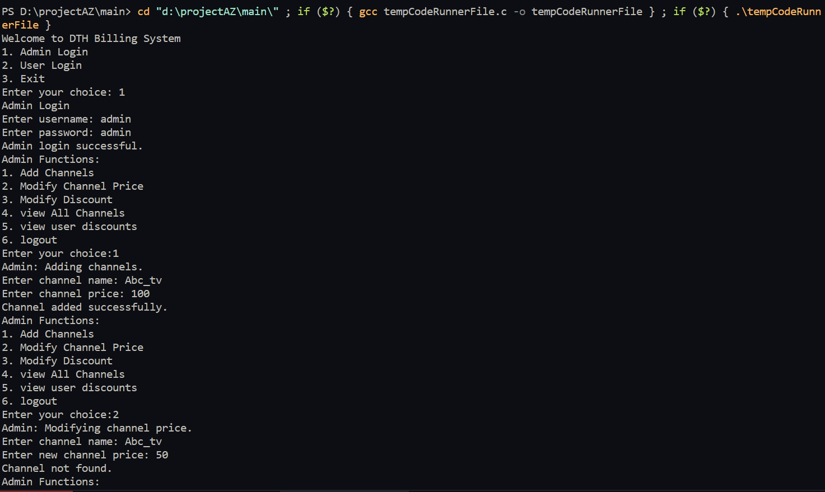



User UI:

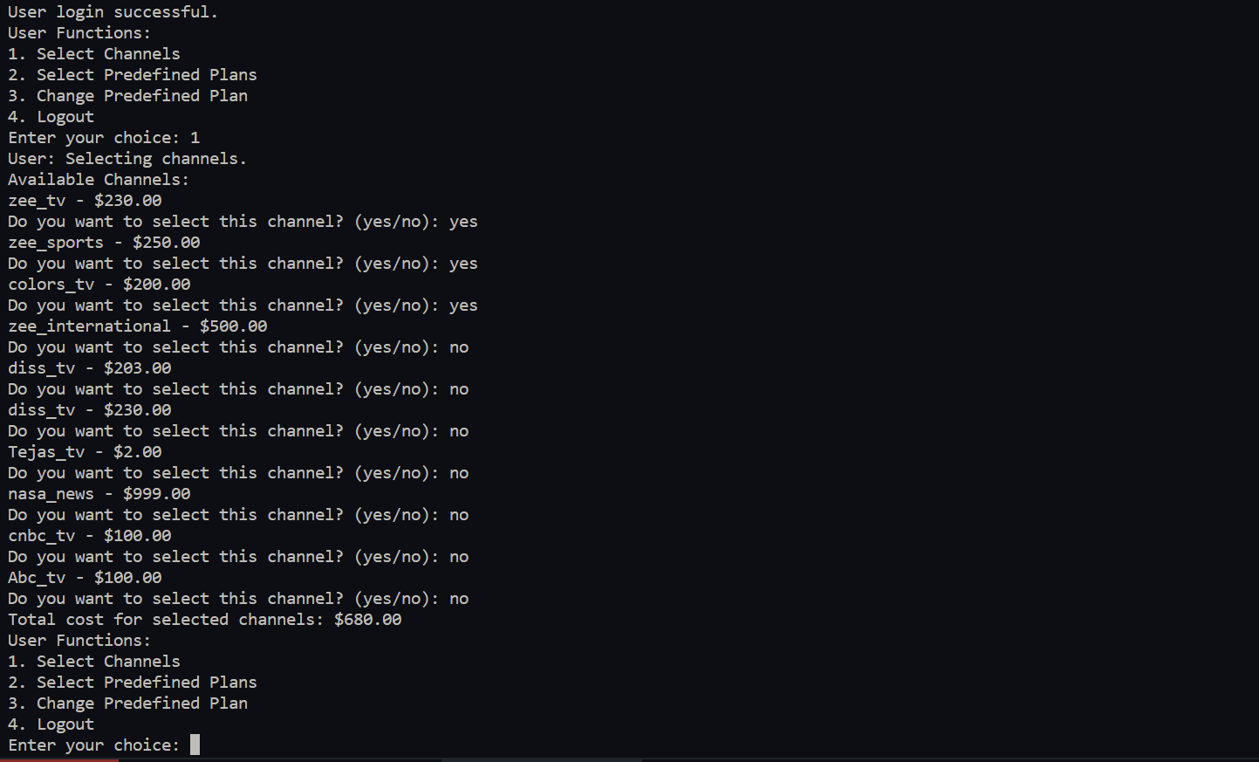

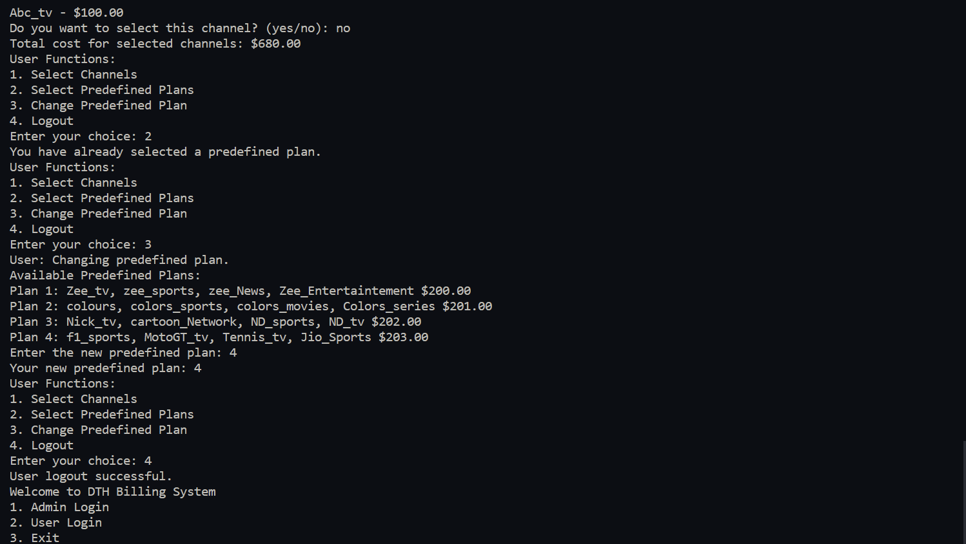

4.2 Back-End:

The back-end handles server setup, APIs, and middleware necessary for the functioning of the system.

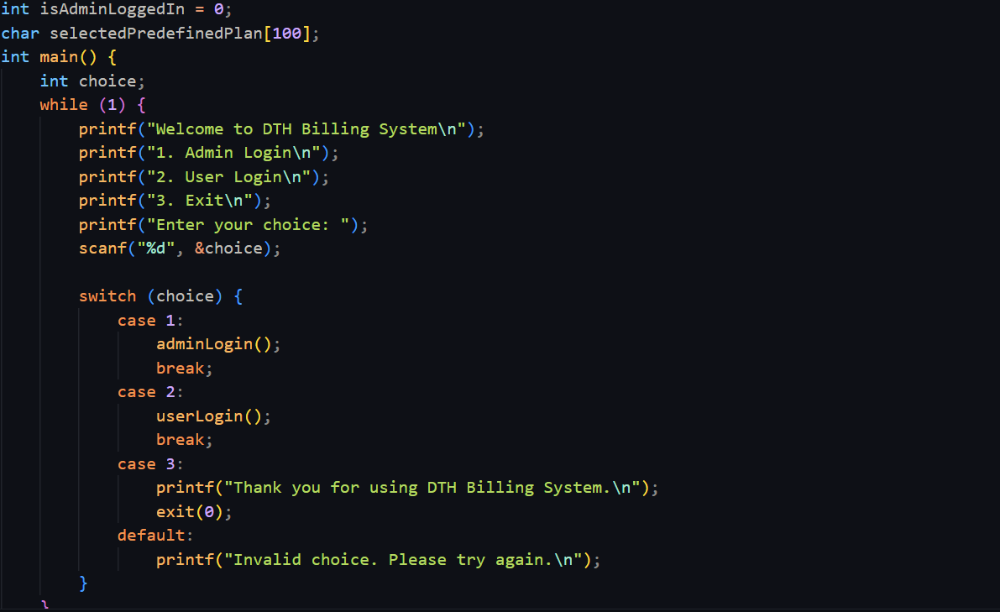

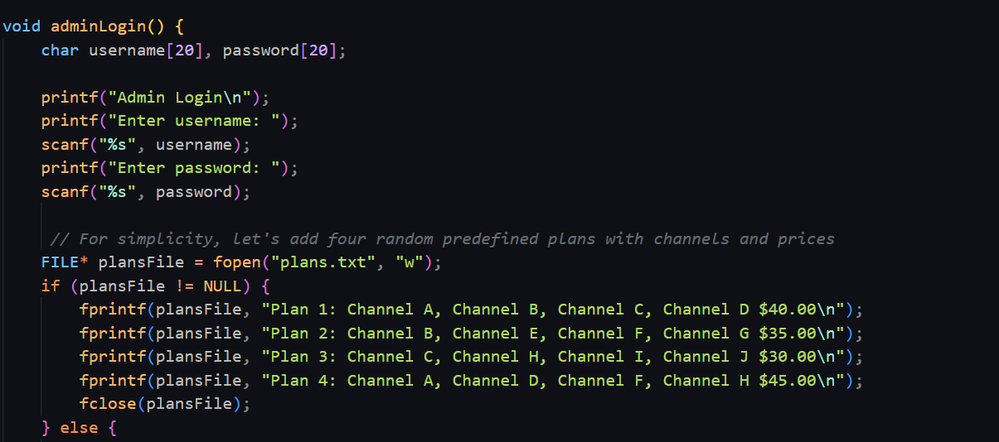

4.3 Database:

The database architecture consists of file-based data storage for storing channel information, user details, and predefined plans.

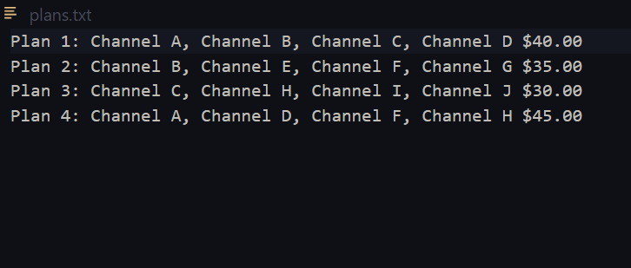

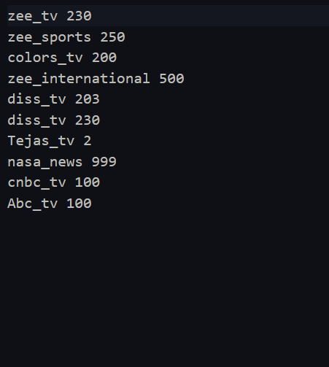

5. Project Modules:

This section describes the major modules or components of the project, their functions, and interactions.

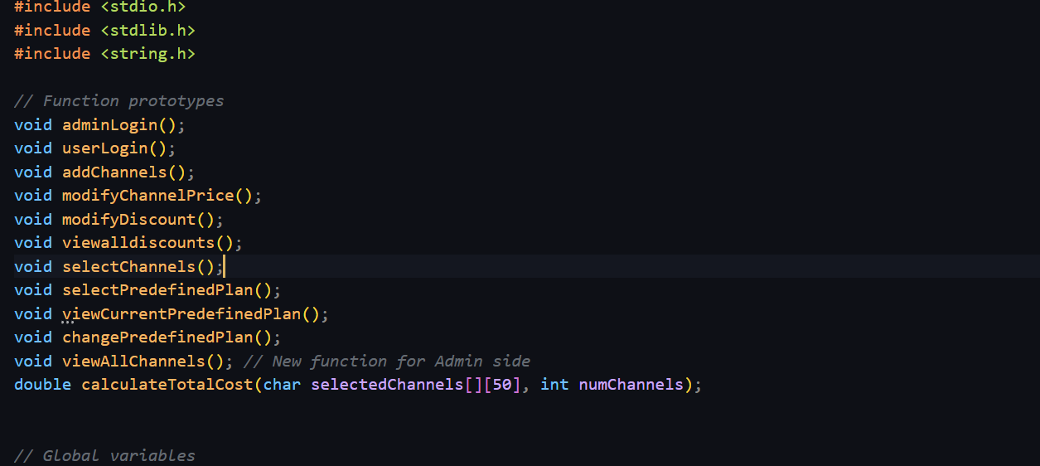

5.1 Module 1: Admin Functions:

The admin module includes functions for adding channels, modifying channel prices, modifying discounts, and viewing all channels.

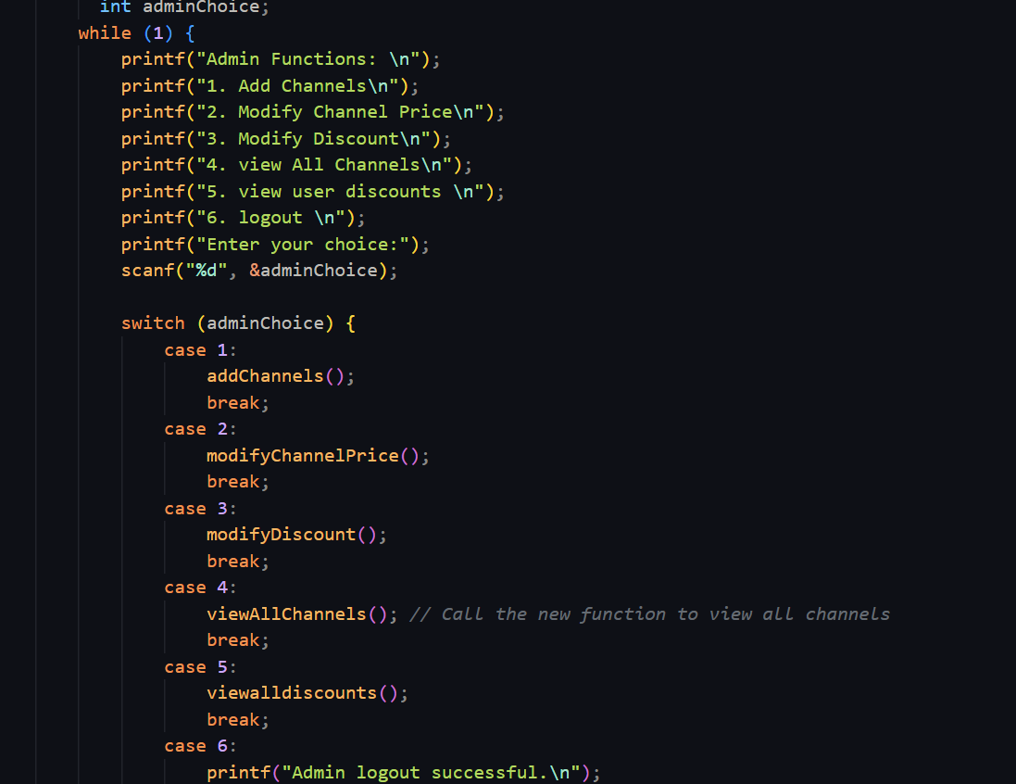

5.2 Module 2: User Functions:

The user module enables users to select channels, choose predefined plans, change predefined plans, and view their selected channels and costs.

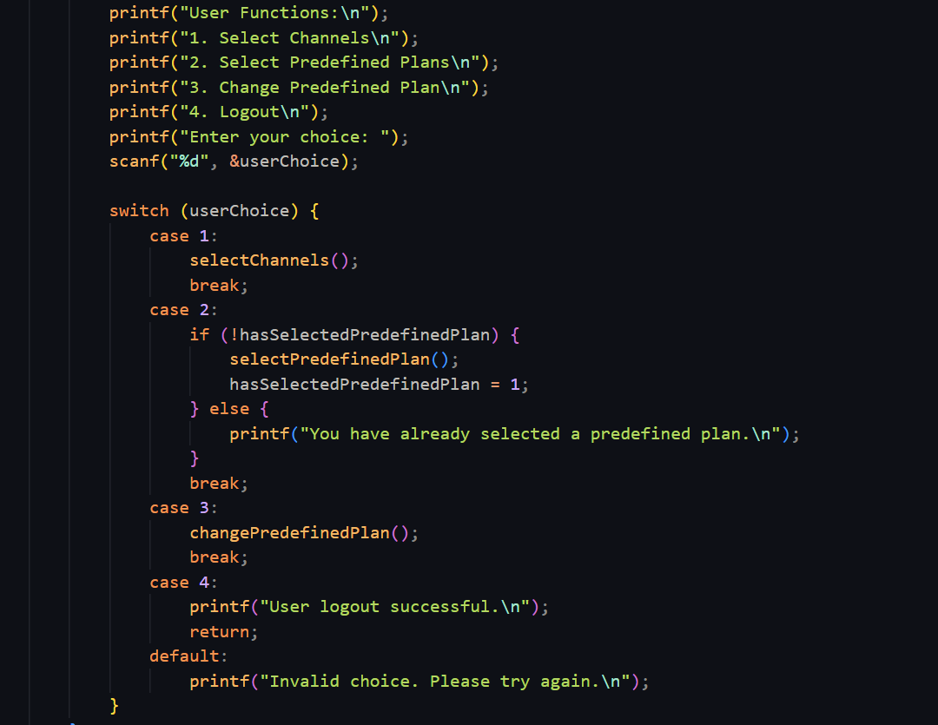

**6. Design and Implementation:**

The "Design and Implementation" section of the DTH Billing System report provides insights into the process of translating the project's requirements and objectives into a functional software solution. It encompasses both the high-level design principles and the practical implementation details.

In the context of the DTH Billing System, the "Design and Implementation" section can be further elaborated as follows:

1. **Front-End Design:**
   * **User Interface (UI) Design:** The front-end design focuses on creating an intuitive and user-friendly interface for channel selection and interaction. It includes considerations for the layout, color schemes, typography, and graphical elements that contribute to a visually appealing UI.
   * **User Experience (UX) Considerations:** Design principles related to user experience are incorporated to ensure that users can easily navigate the system, make channel selections, and receive clear feedback. This may involve usability testing and iterative design improvements.
   * **User Input Handling:** The front-end design includes mechanisms for collecting user input, validating it, and passing it to the back-end for processing. This includes input forms, buttons, and other UI elements.
2. **Back-End Design:**
   * **Business Logic Design:** The back-end design outlines the algorithms and logic required for core system functions. This includes the logic for calculating billing costs, processing channel selections, managing user discounts, and ensuring data integrity.
   * **File Handling Design:** The architecture specifies how files are read from and written to, including the format of data storage. It ensures that data is stored and retrieved accurately and efficiently.
   * **Security Measures:** If security is a concern, the design includes measures such as user authentication, access control, and encryption to protect sensitive data.
   * **Administrative Functionality:** Design decisions are made regarding how administrators can access and use the system to manage channels, adjust prices, and modify user discounts.
3. **Database Design:**
   * **Schema Design:** The database design defines the structure of the database, including tables, relationships, and data models. It ensures that data is organized logically and efficiently.
   * **Data Storage Mechanisms:** Details about how data is stored within the database, including indexing, data types, and storage optimizations, are part of the database design.
   * **Data Retrieval and Manipulation:** The design specifies how the back-end interacts with the database to retrieve and manipulate data. This ensures that data is accessed accurately and in a way that aligns with business requirements.

7. **Features and Functionality:**

The "Features and Functionality" section of the DTH Billing System report outlines the various capabilities and operations that the software solution offers to both users and administrators. It provides an in-depth look at how the system functions and what users can expect when interacting with it.

In the context of the DTH Billing System, here's an exploration of the key features and functionalities:

1. **User-Friendly Channel Selection:**
   * **Description:** The system offers a user-friendly interface that allows subscribers to browse, select, and customize their channel subscriptions.
   * **Functionality:** Users can view a list of available channels, check pricing details, and select the channels they want to include in their subscription package.
2. **Billing and Cost Calculation:**
   * **Description:** The system is equipped to calculate the total cost of selected channels and predefined plans.
   * **Functionality:** Users can view their billing details, including the cost breakdown, and get an accurate summary of their monthly charges.
3. **User Discounts and Customization:**
   * **Description:** Users can benefit from discounts based on their profiles and preferences.
   * **Functionality:** Subscribers can apply discounts to their billing, and the system ensures that discounts are accurately calculated and reflected in the final bill.
4. **Administrative Tools:**
   * **Description:** The system provides administrative functions for managing channels, adjusting prices, and modifying user discounts.
   * **Functionality:** Administrators can add new channels, update channel prices, and maintain user profiles. These tools streamline administrative tasks and help ensure the system's data accuracy.
5. **Predefined Plans:**
   * **Description:** The system offers predefined subscription plans for users to choose from.
   * **Functionality:** Subscribers can opt for one of the predefined plans, simplifying the channel selection process. The system provides details about each plan, including channel listings and costs.
6. **User Authentication and Security:**
   * **Description:** To ensure data security, the system includes user authentication mechanisms.
   * **Functionality:** Users are required to log in with their credentials, enhancing the security of their accounts and billing information.
7. **Change Predefined Plans:**
   * **Description:** Subscribers have the flexibility to change their predefined plan if their preferences change.
   * **Functionality:** Users can switch to a different predefined plan as needed, and the system recalculates their billing based on the new plan.
8. **Feedback and Notifications:**
   * **Description:** The system provides feedback to users on their actions and notifies them of billing details and changes.
   * **Functionality:** Users receive clear feedback messages when they select channels, change plans, or apply discounts. Notifications also inform them of billing updates.
9. **Error Handling and Validation:**
   * **Description:** The system includes robust error handling and validation mechanisms.
   * **Functionality:** It ensures that user inputs are validated to prevent erroneous selections and provides informative error messages in case of issues.
10. **Data Storage and Management:**
    * **Description:** The system efficiently manages and stores data related to channels, predefined plans, user profiles, and billing information.
    * **Functionality:** Data is organized logically, ensuring that it can be easily retrieved and updated when needed.

8. **Testing:**

The "Testing" section of the DTH Billing System report focuses on the methodologies and processes employed to evaluate the functionality and performance of the software. It plays a crucial role in ensuring that the system operates as intended, is free of defects, and meets user expectations.

In the context of the DTH Billing System, the testing phase can be further elaborated as follows:

1. **Unit Testing:**
   * **Purpose:** Unit testing involves testing individual components or units of code in isolation to ensure they function correctly.
   * **Scope:** Each function, method, or module within the system is tested independently. This verifies that they perform their specific tasks accurately.
   * **Test Cases:** Unit test cases are created to cover various scenarios and edge cases. These tests validate the correctness of calculations, data processing, and logic within each unit.
2. **Integration Testing:**
   * **Purpose:** Integration testing assesses how different components of the system work together when integrated.
   * **Scope:** Multiple units or modules are combined and tested to ensure that they interact seamlessly. This includes testing interactions between the front-end and back-end components.
   * **Test Cases:** Integration test cases are designed to verify that data flows correctly between components, and that the overall system functions as expected.
3. **User Acceptance Testing (UAT):**
   * **Purpose:** User acceptance testing involves assessing the system's functionality from the end-users' perspective.
   * **Scope:** Real users, including subscribers and administrators, participate in UAT to evaluate the system's usability, user interface, and overall performance.
   * **Test Cases:** Test scenarios are defined to mimic common user interactions. Feedback from users is collected to identify any issues, user experience challenges, or usability concerns.
4. **Error Handling and Exception Testing:**
   * **Purpose:** This testing category focuses on assessing how the system handles errors and exceptions gracefully.
   * **Scope:** Test cases are designed to intentionally trigger errors, such as incorrect inputs or unexpected situations, to ensure that the system responds appropriately with informative error messages and does not crash.
   * **Test Cases:** A range of error scenarios are tested to validate that error-handling mechanisms are effective and user-friendly.
5. **Performance Testing:**
   * **Purpose:** Performance testing evaluates the system's responsiveness and stability under different load conditions.
   * **Scope:** Various performance aspects, such as response times, scalability, and resource utilization, are measured to identify potential bottlenecks or performance issues.
   * **Test Cases:** Performance tests are conducted with simulated user loads, and the system's performance metrics are analyzed to ensure it can handle expected usage volumes.
6. **Security Testing:**
   * **Purpose:** Security testing assesses the system's vulnerability to potential security threats and breaches.
   * **Scope:** Test cases are designed to identify security weaknesses, such as unauthorized access attempts or data leakage, and validate that the system incorporates security measures effectively.
   * **Test Cases:** Security tests include penetration testing, vulnerability scanning, and checks for data encryption and access controls.
7. **Regression Testing:**
   * **Purpose:** Regression testing ensures that new changes or updates do not introduce new defects or break existing functionality.
   * **Scope:** After modifications or enhancements are made to the system, regression tests are conducted to verify that previously tested features still work as expected.
   * **Test Cases:** A comprehensive suite of regression test cases is maintained to cover all critical functionalities.
8. **Usability Testing:**
   * **Purpose:** Usability testing assesses the system's overall user-friendliness and the effectiveness of the user interface.
   * **Scope:** Test participants, typically end-users, perform tasks within the system while providing feedback on ease of use, navigation, and overall user experience.
   * **Test Cases:** Scenarios are designed to mimic typical user interactions, and testers provide feedback on any usability issues encountered.
9. **Accessibility Testing:**
   * **Purpose:** Accessibility testing evaluates whether the system is accessible to users with disabilities, ensuring compliance with accessibility standards.
   * **Scope:** The system is tested using assistive technologies, such as screen readers, to identify and address accessibility barriers.
   * **Test Cases:** Testers assess various aspects, including keyboard navigation, alternative text for images, and screen reader compatibility.
10. **Documentation and Help Testing:**
    * **Purpose:** This testing category focuses on ensuring that user documentation, including user manuals and help resources, is accurate and useful.
    * **Scope:** Testers review documentation to verify that it provides clear instructions for users, particularly in cases where users may require guidance.
    * **Test Cases:** Documentation is assessed for completeness, clarity, and accuracy. Any discrepancies or missing information are identified.

9. **Challenges Faced**

The "Challenges Faced" section of the DTH Billing System report highlights the obstacles, difficulties, and roadblocks that the development team encountered during the course of the project. It provides insight into the various challenges that needed to be addressed to successfully design, develop, and implement the system.

In the context of the DTH Billing System, here are some of the challenges that the project team may have encountered:

1. **Complex User Requirements:**
   * **Description:** Meeting the diverse needs and preferences of both subscribers and administrators can be challenging. Users may have varying channel preferences, discount requirements, and billing expectations.
2. **Integration of Front-End and Back-End:**
   * **Description:** Ensuring seamless integration between the front-end user interface and the back-end data processing and logic can be complex. Inconsistent data flow or communication issues may arise.
3. **Data Security and Privacy:**
   * **Description:** Protecting user data, billing information, and login credentials is crucial. Implementing robust security measures to prevent data breaches and unauthorized access can be challenging.
4. **Billing Accuracy:**
   * **Description:** Ensuring accurate billing calculations, especially with changing user selections and discounts, can be a complex task. Handling rounding errors and edge cases is essential.
5. **Scalability and Performance:**
   * **Description:** As the number of users and channel options grows, ensuring that the system remains responsive and scalable can pose challenges. Performance bottlenecks may need to be addressed.
6. **User Interface Design:**
   * **Description:** Designing an intuitive and user-friendly interface that accommodates a wide range of user profiles and preferences can be challenging. Usability testing and feedback are crucial in this regard.
7. **Testing Complexities:**
   * **Description:** Conducting comprehensive testing, including unit testing, integration testing, and user acceptance testing, can be time-consuming and resource-intensive. Managing test cases and data for various scenarios can be a challenge.
8. **Regulatory Compliance:**
   * **Description:** Depending on the region or country of operation, the DTH Billing System may need to comply with regulatory standards related to telecommunications and broadcasting.
9. **Software Updates and Maintenance:**
   * **Description:** Keeping the system up to date with changes in channel offerings, pricing, and user profiles requires ongoing maintenance and updates. Managing these updates efficiently can be a challenge.
10. **User Education:**
    * **Description:** Ensuring that users understand how to use the system effectively, select channels, and manage their subscriptions may require educational efforts and clear documentation.
11. **Accessibility and Inclusivity:**
    * **Description:** Ensuring that the system is accessible to users with disabilities and complies with accessibility standards can be challenging, particularly when retrofitting accessibility features into an existing system.
12. **User Support and Query Resolution:**
    * **Description:** Addressing user queries, resolving billing discrepancies, and providing timely support can be demanding. An efficient customer support system may be needed.
13. **Data Backup and Recovery:**
    * **Description:** Implementing robust data backup and recovery mechanisms is essential to prevent data loss in the event of system failures or disasters.
14. **Compatibility and Cross-Platform Issues:**
    * **Description:** Ensuring that the system functions consistently across different devices, browsers, and operating systems can be a challenge.
15. **Cost Management:**
    * **Description:** Managing the cost of operating and maintaining the system while providing competitive pricing to users can be a balancing act.

10. **Future Enhancements:**

The "Future Enhancements" section of the DTH Billing System report outlines potential improvements, features, and advancements that can be considered for implementation in subsequent phases or versions of the system. These enhancements are aimed at enhancing the system's functionality, user experience, and overall value to users and administrators.

In the context of the DTH Billing System, here are some potential future enhancements that could be explored:

1. **Multi-Language Support:**
   * **Description:** To cater to a diverse user base, implementing multi-language support can be valuable. Users should have the option to access the system in their preferred language.
2. **Personalized Recommendations:**
   * **Description:** Enhance the user experience by implementing recommendation algorithms that suggest channels or predefined plans based on user preferences and viewing history.
3. **Mobile Application:**
   * **Description:** Develop a mobile app for the DTH Billing System, allowing users to manage their subscriptions, select channels, and view billing information conveniently on their smartphones.
4. **Real-time Usage Monitoring:**
   * **Description:** Provide users with real-time insights into their channel usage and billing. Users can track their consumption and make informed decisions.
5. **Advanced Billing Alerts:**
   * **Description:** Implement automated billing alerts and notifications to inform users about upcoming payments, discounts, or changes in their subscription plans.
6. **Enhanced Admin Tools:**
   * **Description:** Equip administrators with advanced tools for managing user accounts, generating reports, and monitoring system performance.
7. **Integration with Smart Devices:**
   * **Description:** Explore integration with smart devices and voice assistants, allowing users to control their DTH subscriptions through voice commands or smart home systems.
8. **Feedback Mechanism:**
   * **Description:** Implement a feedback system that allows users to provide suggestions and report issues directly through the application.
9. **Improved Accessibility Features:**
   * **Description:** Continue to enhance accessibility features, ensuring compliance with the latest accessibility standards and guidelines.
10. **Enhanced Security Measures:**
    * **Description:** Stay updated with the latest security threats and implement additional security layers to protect user data and the system.
11. **Analytics and Reporting:**
    * **Description:** Provide users and administrators with detailed analytics and reports on channel usage, billing history, and subscription trends.
12. **Social Media Integration:**
    * **Description:** Allow users to share their subscription choices and favorite channels on social media platforms, fostering user engagement.
13. **Expanded Payment Options:**
    * **Description:** Integrate additional payment gateways and options to accommodate various user preferences and regional payment methods.
14. **Content Streaming Integration:**
    * **Description:** Consider partnerships with content streaming services to offer bundled packages or seamless access to online streaming content.
15. **Customized Billing Cycles:**
    * **Description:** Allow users to choose their billing cycle preferences, such as monthly, quarterly, or annually, to align with their financial planning.
16. **Machine Learning for User Behavior Analysis:**
    * **Description:** Implement machine learning algorithms to analyze user behavior and preferences, enabling more accurate recommendations and personalized experiences.
17. **Multi-Device Synchronization:**
    * **Description:** Enable users to synchronize their channel selections and preferences across multiple devices for a consistent viewing experience.
18. **Enhanced Data Backup and Disaster Recovery:**
    * **Description:** Strengthen data backup and disaster recovery mechanisms to ensure data integrity and availability in case of system failures.
19. **Gamification Elements:**
    * **Description:** Introduce gamification elements to encourage user engagement and loyalty, such as rewards or badges for using the system.
20. **Voice Search:**
    * **Description:** Implement voice search functionality to allow users to find channels and content using voice commands.

11. Conclusion:

The DTH Billing System project has successfully achieved its objectives of enhancing user experience and administrative efficiency in the realm of digital television services. With a user-friendly interface and advanced management tools, it empowers users to customize their subscriptions and administrators to streamline operations. Overcoming challenges and embracing technological advancements, the system is poised for future growth and innovation. It contributes to the evolving industry landscape, fostering user engagement and loyalty. This success reflects the project team's commitment to excellence, ensuring a positive impact on users and the digital television services sector as a whole.

12. References:

* geeks for geeks ( <https://www.geeksforgeeks.org/> )

* stackoverflow ( <https://stackoverflow.com/> )

* chat – gpt (<https://chat.openai.com/> )

* miro – mindmap ( <https://miro.com/> )

* draw.io – flowchart ( <https://app.diagrams.net/> )