# **Calculator app (Android)**

1. This is a functional calculator app for Android, built using Kotlin and the MVVM (Model-View-ViewModel) architectural pattern.
2. It supports basic arithmetic operations (addition, subtraction, multiplication, and division), and sign change.

## **Features**

1. **Basic Arithmetic:** Addition, subtraction, multiplication, and division.
2. **Sign Change:** Changes the sign of the current number. (+/-)
3. **Clear/Delete:**
4. **AC**: Clears the entire equation and result.
5. **C:** Deletes the last entered character.
6. **Error Handling:** Displays "Error" if a calculation error occurs, preventing app crashes.
7. **MVVM Architecture:** Improves code organization, testability, and maintainability by separating concerns.

## **Technologies Used**

1. **Kotlin:** The primary programming language for Android development.
2. **Android SDK:** The software development kit for building Android applications.
3. **Android Architecture Components:** Specifically, LiveData and ViewModel are used to manage UI-related data and the UI lifecycle.

## **Installation**

1. **Clone the Repository:**

git clone https://github.com/your-username/calculator.git

1. **Open in Android Studio:** Open the cloned project in Android Studio.
2. **Build and Run:** Build the app and run it on an Android emulator or a physical Android device.

## 

## 

## **Screenshots**

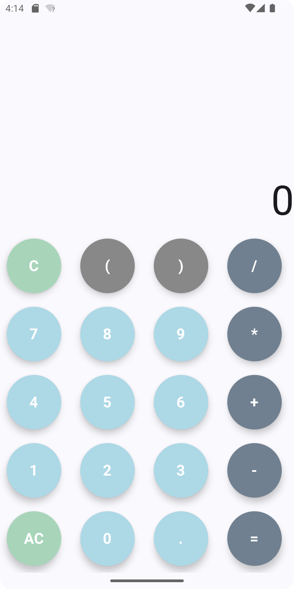

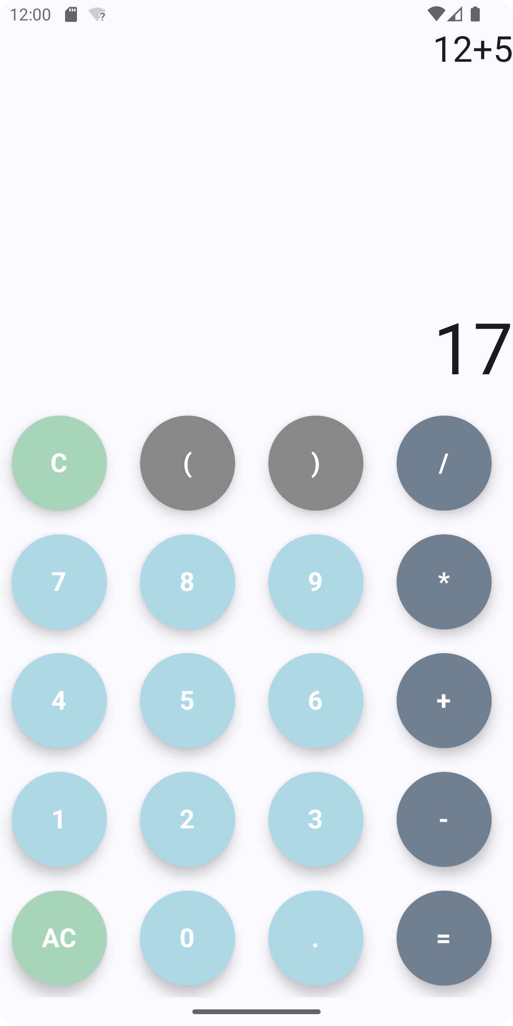



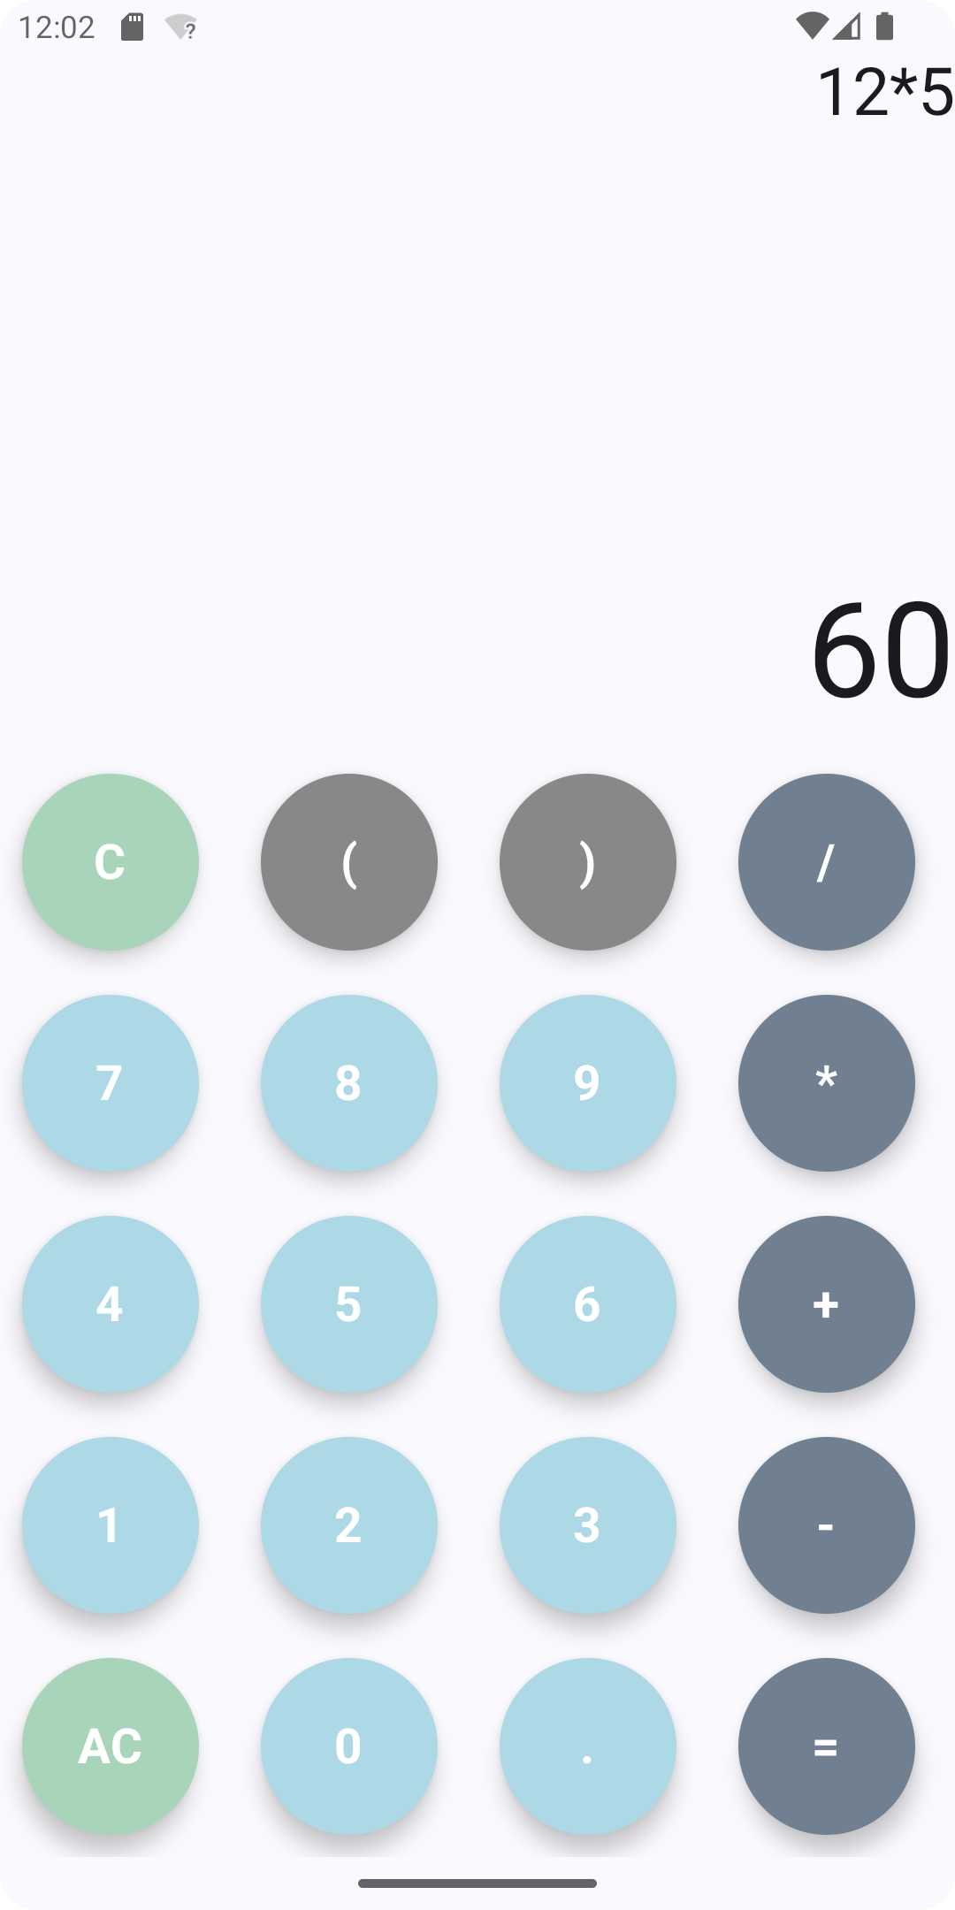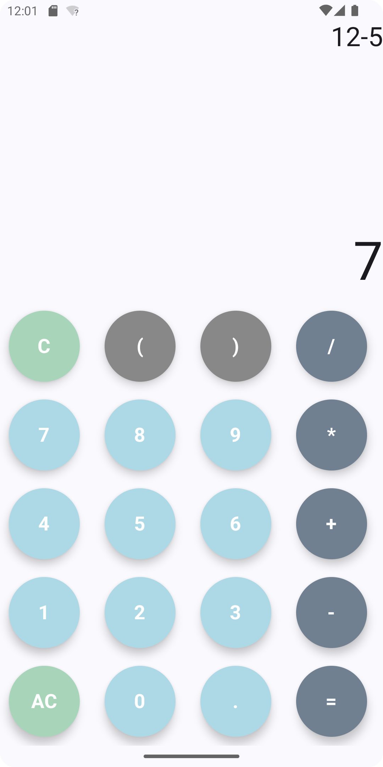

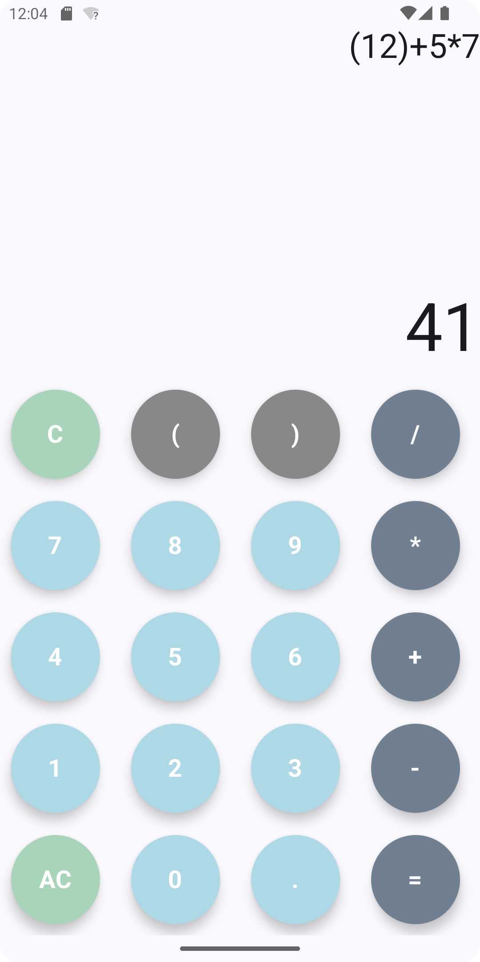

## **How to Use**

1. **Input:** Use the number buttons (0-9) and operator buttons (+, -, *, /) to enter your mathematical expression.
2. **Calculate:** Press the "=" button to calculate the result.
3. **Clear:**
4. Press the "AC" button to clear the entire display (the equation and the result).
5. Press the "C" button to delete the last entered character.
6. **Sign Change:** Press the "+/-" button to change the sign (positive to negative, or negative to positive) of the current number in the display.