Report
Of

Civic Safe
Smart Civic Complaint & Public Safety Management System

Submitted To:
School of Computer Science and Engineering
IILM University, Greater Noida, U.P.

In partial fulfilment of the requirement of degree of
Bachelor's of Technology in Computer Science and Engineering



Submitted By:
Roll Number: 25SCS1003000500
Name of Student: VAIBHAV PANDEY
Batch: 2026-27

2026-27

CANDIDATE'S DECLARATION

I, Vaibhav Pandey do hereby declare that the internship report titled “Civic Safe” has been completed by me to fulfil the requirement for the award of the degree of Bachelor of Technology in CSE. All the references have been quoted and I have not taken as such any material from any other source. I affirm to you that this report is my own and has not been submitted to any other institute for any degree/diploma requirement and further I shall be solely responsible for any kind of copyright violation in this regard.
Signature:
Student Name: Vaibhav Pandey
Roll no: 25SCS1003000500

ACKNOWLEDGEMENT

I am using this opportunity to express my gratitude to everyone who supported me throughout the Internship Program. I am thankful for their aspiring guidance, invaluably constructive criticism and friendly advice during this work. I am sincerely grateful to them for sharing truthful and illuminating views on a number of issues related to this work.
I express my gratitude to my parents for their blessings.
Signature:
Student Name: Vaibhav Pandey
Roll no: 25SCS1003000500

3. INTERNSHIP COMPLETION CERTIFICATE
The following certificate, issued by MARS – Centre for Sustainable Community Development, confirms the successful completion of the internship during which this project was carried out.
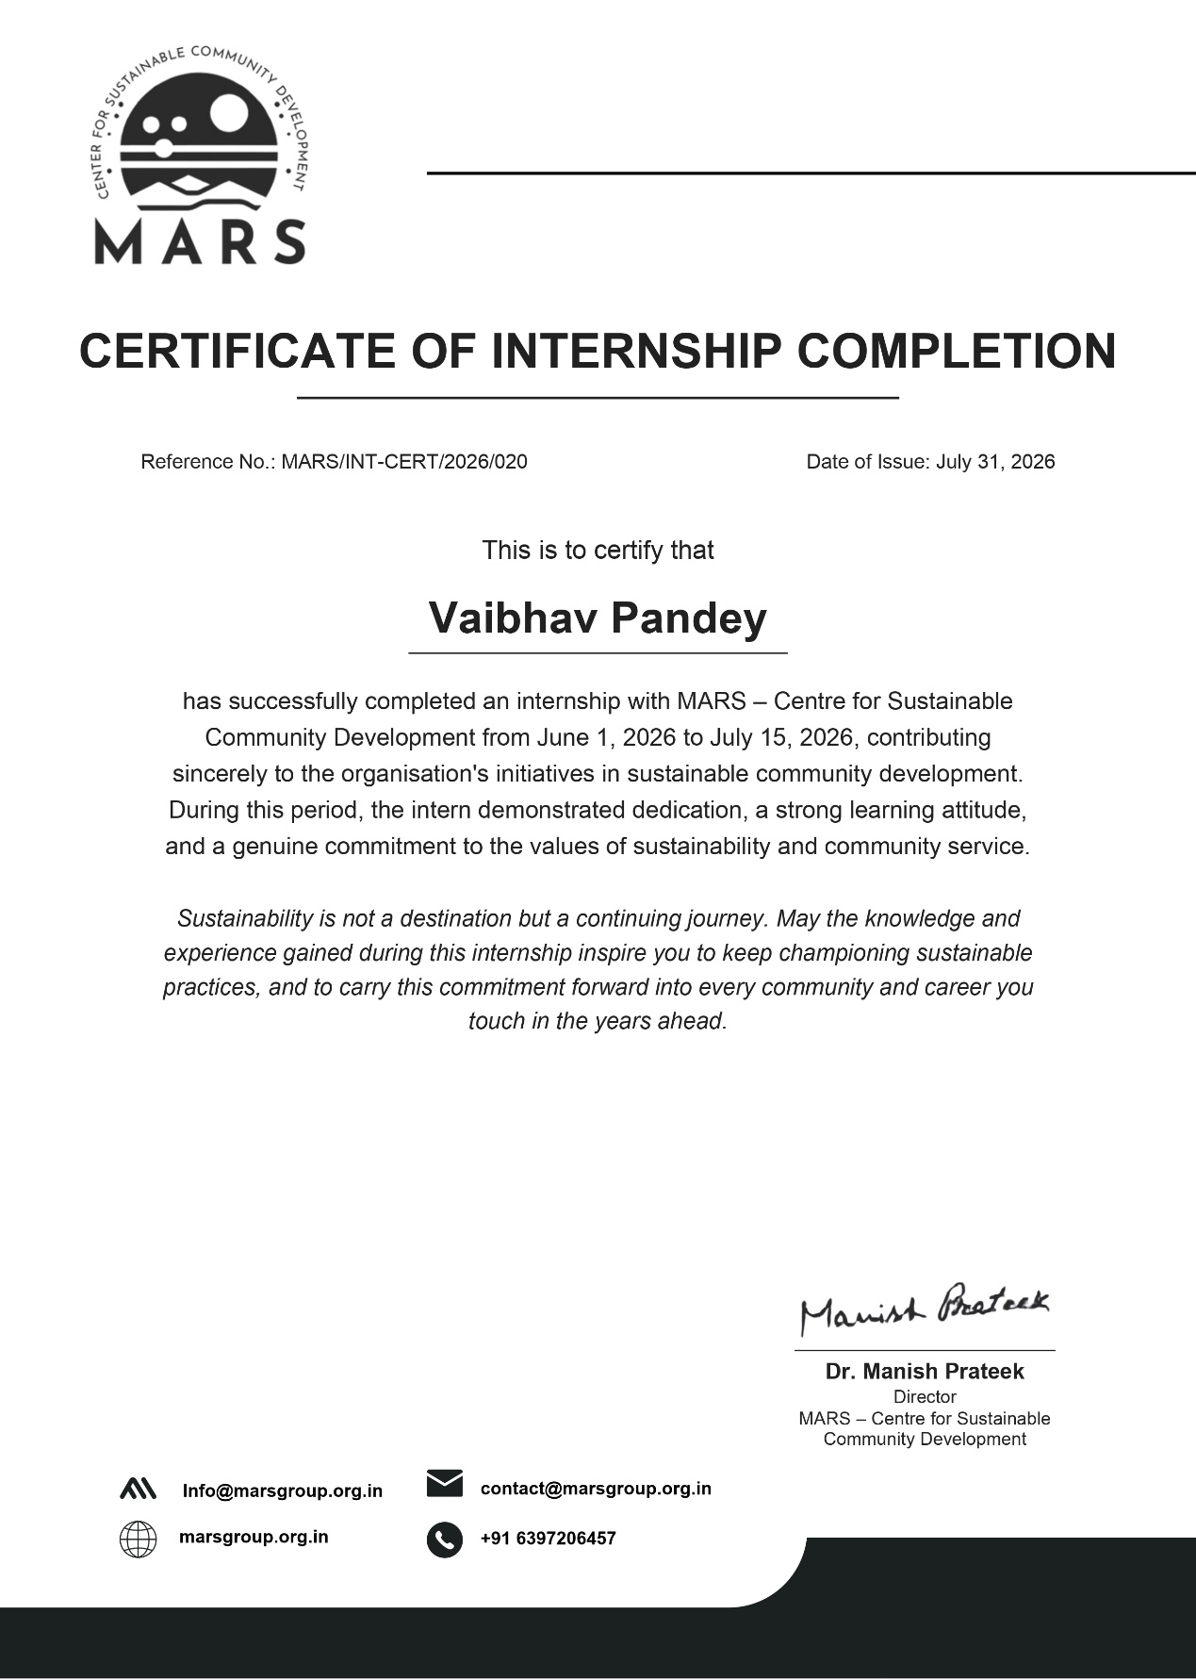

TABLE OF CONTENTS

Cover Page —
1. Candidate's Declaration ............................................................................................i
2. Acknowledgement ...................................................................................................ii
3. Internship Completion Certificate ..........................................................................iii
4. Project Description .................................................................................................. 1
4.1 Introduction ..................................................................................................... 1
4.2 Organization Profile ........................................................................................ 2
4.3 Problem Statement .......................................................................................... 3
4.4 Project Objectives ........................................................................................... 4
4.5 Scope of the Project ........................................................................................ 5
4.6 Technologies and Tools Used ......................................................................... 6
4.7 System Architecture ........................................................................................ 7
4.8 Methodology ................................................................................................... 8
4.9 Expected Outcomes ........................................................................................ 9
4.10 Certificates of Completion and Communication Proof ............................... 10
5. Bibliography / References...................................................................................... 11

4. PROJECT DESCRIPTION

4.1 Introduction
Civic issues such as uncollected garbage, plastic dumping, waste accumulation, water pollution, and public-safety hazards are a daily reality in most Indian towns and cities. Citizens who notice these issues frequently have no simple way to report them: complaints are made by phone calls, in-person visits to municipal offices, or scattered social-media posts, none of which capture the exact location, arrive at the right department, or give the complainant any visibility into what happens next.
CivicSafe is a full-stack mobile platform designed to close this gap. It gives citizens a single app to photograph an issue, auto-tag its GPS location, classify it into a category, and submit it directly to the responsible authority, while giving government administrators a live map, a prioritised queue, and an audit trail from first report to final resolution.

4.2 Organization Profile
This project was carried out during an internship with MARS – Centre for Sustainable Community Development, an organisation working on sustainable community development initiatives. The internship, from June 1, 2026 to July 15, 2026, provided guidance, mentorship, and the environment needed to design and build CivicSafe as a project with genuine civic and social relevance.

4.3 Problem Statement
Municipal and civic complaint handling in most cities suffers from five recurring problems:
- Citizens do not know where or how to report a civic issue.
- Manual complaint processes (calls, paper forms, in-person visits) are slow and tedious.
- Complaints lack precise location data, making field verification difficult.
- Authorities cannot prioritise issues they cannot see on a map or dashboard.
- There is little to no transparency for the citizen after a complaint is filed.

4.4 Project Objectives
- Provide citizens with a simple mobile flow to capture a photo, auto-attach GPS coordinates and a timestamp, and submit an incident report in under a minute.
- Automatically route every submitted report to the correct government department based on its category.
- Give administrators a live incident map, a prioritised report queue, and an analytics dashboard to monitor citywide trends.
- Maintain a full status-history timeline for every report, from Submitted through Under Review, Assigned, Action Started, to Resolved.
- Support one-tap emergency dialling for time-critical safety situations.
- Explore AI-assisted image classification to auto-suggest an issue category and flag invalid submissions.

4.5 Scope of the Project
The current build of CivicSafe covers citizen-side incident reporting across six categories (Garbage Dump, Plastic Pollution, Waste Accumulation, Water Pollution, Suspicious Object, and Emergency Situation), citizen report tracking, and an administrator/authority portal with a live map, report management, resolution upload, and analytics. The project targets municipal corporations, smart-city bodies, pollution-control boards, disaster-management cells, police departments, and university campuses as prospective deployment environments.

4.6 Technologies and Tools Used
- Mobile app: React Native, Expo, TypeScript - The mobile client is built with React Native and the Expo tooling layer, written entirely in TypeScript (.tsx). Expo provides simplified access to native camera and location APIs and streamlines builds across Android and iOS.
- Backend: Node.js, Express.js, TypeScript - The backend REST API runs on Node.js with the Express.js framework, written in TypeScript for type safety across controllers, services, and models.
- Database: MongoDB with Mongoose ODM - MongoDB is the primary data store, accessed through Mongoose schemas that enforce structure on Users, Reports, Status History, Feedback, and OTP documents.
- Authentication: JWT and Firebase Admin SDK - Firebase Admin SDK integration supports identity verification alongside the platform's own JWT-based session tokens and role-based middleware.
- Media storage: Cloudinary - handles image upload, storage, and delivery for both incident photos and resolution-proof photos.
- AI services: Google Gemini API - The Gemini API powers the AI-assisted detection service, which estimates an issue category/priority and validates that a submitted image plausibly shows a real civic issue.
- State management & networking: React Navigation, Zustand, Axios - React Navigation manages separate stacks for Auth, Citizen, and Admin flows. Zustand provides lightweight global state for authentication and settings. A centralised Axios-based API service layer handles all network requests.
- Version control: Git - Expo Camera and Expo Location provide the live photo capture and GPS tagging that anchor CivicSafe's evidence-based reporting model.

4.7 System Architecture
CivicSafe follows a three-tier architecture: a React Native mobile client, an Express.js REST API backend, and a MongoDB data store, supported by external cloud services for authentication, media storage, and AI inference. The platform is organised into eight functional modules shared across the citizen and admin experiences — Authentication & Onboarding, Incident Reporting, AI Detection & Validation, Report Tracking, Admin Dashboard & Analytics, Live Map, Report Management & Resolution, and Notification & Feedback.
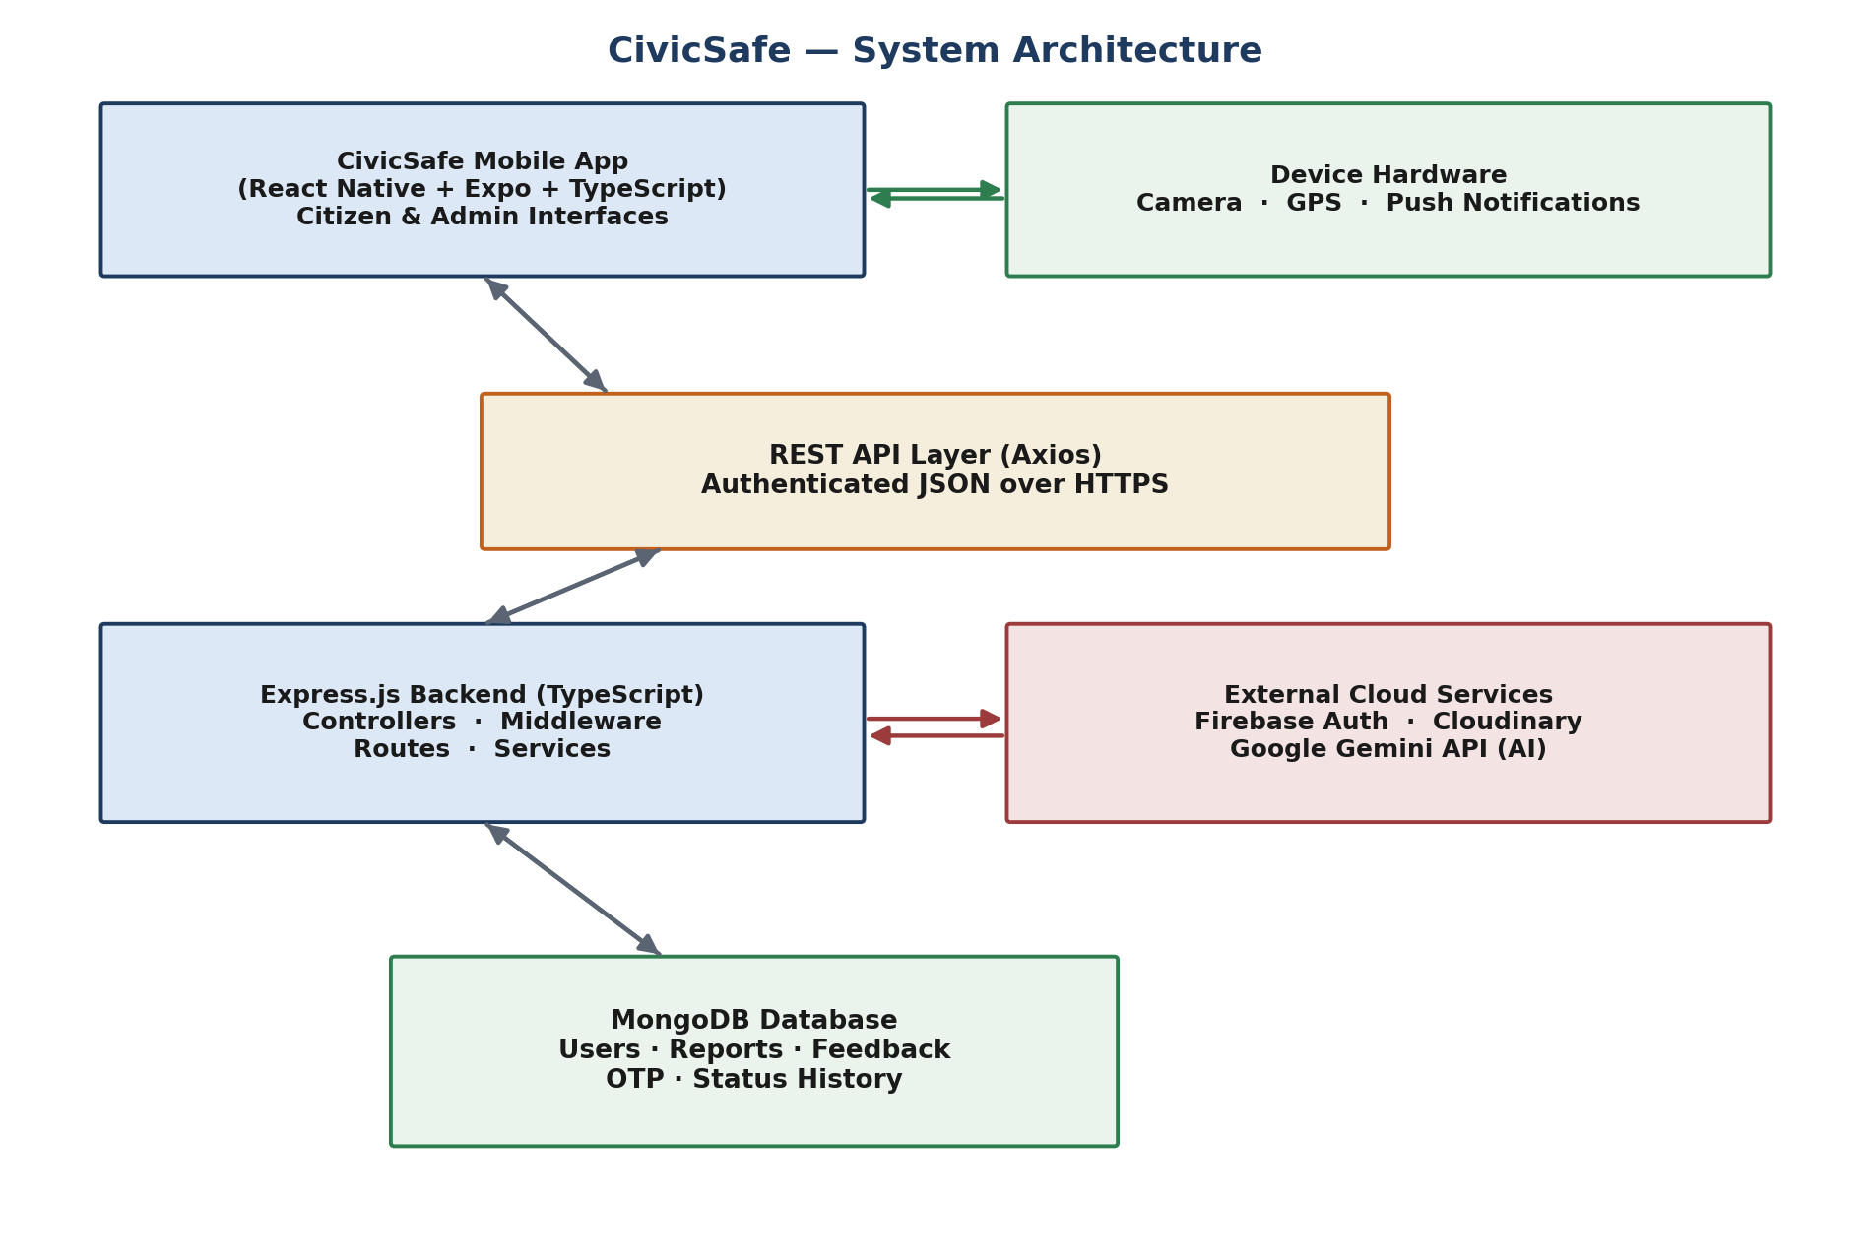
Figure 4.1 — CivicSafe system architecture

4.8 Methodology

Step 1 — Requirement Gathering & Data Modelling
The team identified the six incident categories, the citizen and admin roles, and the report status lifecycle, then modelled these as Mongoose schemas (User, Report, StatusHistory, Feedback, OTP).

Step 2 — UI/UX Design
Screens were designed around a minimal, guided flow: onboarding → authentication → home → category → camera → description → review → submit, mirroring the six user-facing taps behind the thirteen backend steps.

Step 3 — Backend Development
The Express.js API was built module by module: configuration (env, db, Firebase, Cloudinary), middleware (auth, role, error handling, upload), controllers (auth, report, admin, feedback), services (routing, AI, notification, email, image upload), and routes.

Step 4 — Frontend Development
The React Native app was built screen by screen across Auth, Citizen (Dashboard, Report, Tracking, Profile), and Admin (Dashboard, Map, Reports, Resolution, Analytics) navigation stacks, backed by a shared API service layer and Zustand stores.

Step 5 — Integration & Testing
Frontend screens were wired to backend endpoints through the Axios API layer, with functional, integration, database, UI/UX, performance, security, usability, stress, and regression testing performed across both codebases (see Chapter 8).

Step 6 — Deployment & Demonstration
The backend was containerised/deployed to a cloud runtime with a managed MongoDB instance, and the mobile app was built and demonstrated via Expo, with the walkthrough video and presentation deck used for the final evaluation.

4.9 Expected Outcomes
- A working mobile application (React Native / Expo) usable by citizens on Android and iOS.
- A working REST API backend (Node.js / Express / TypeScript) with a MongoDB data store.
- An administrator experience covering live mapping, report triage, and resolution workflows.
- A prototype AI-assisted detection layer that can be moved to a production backend model in a future iteration.
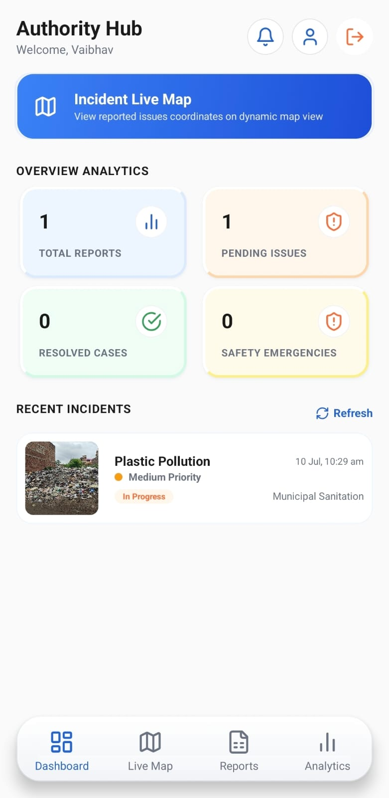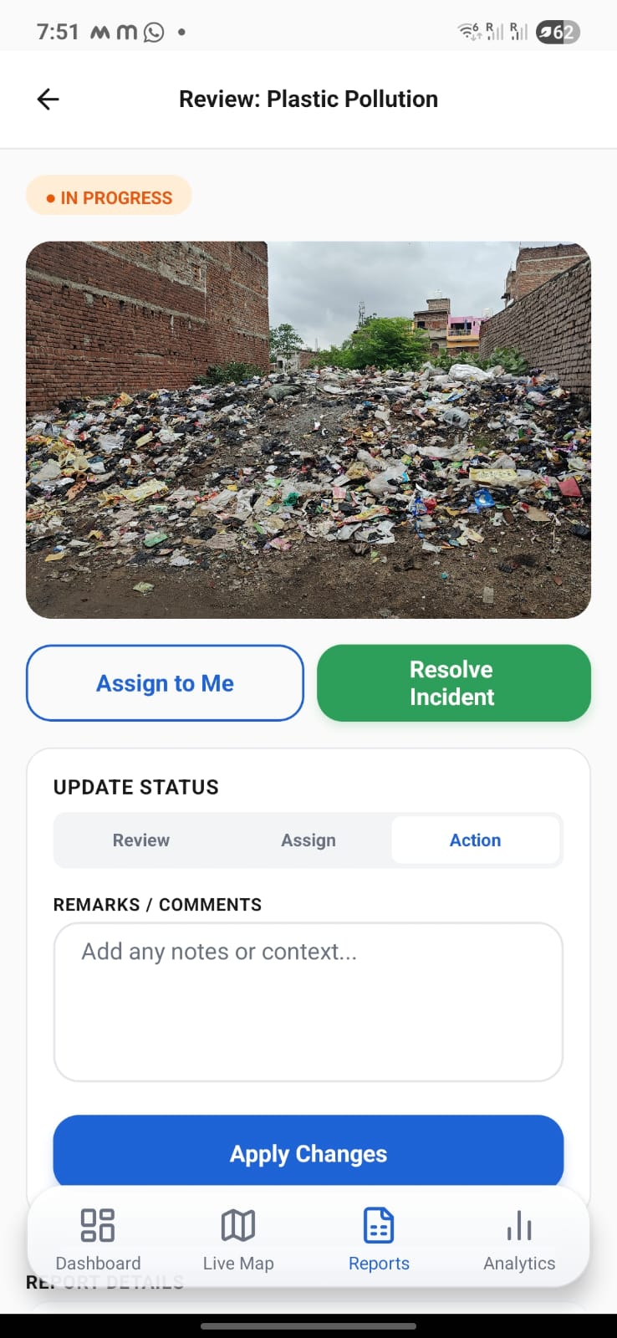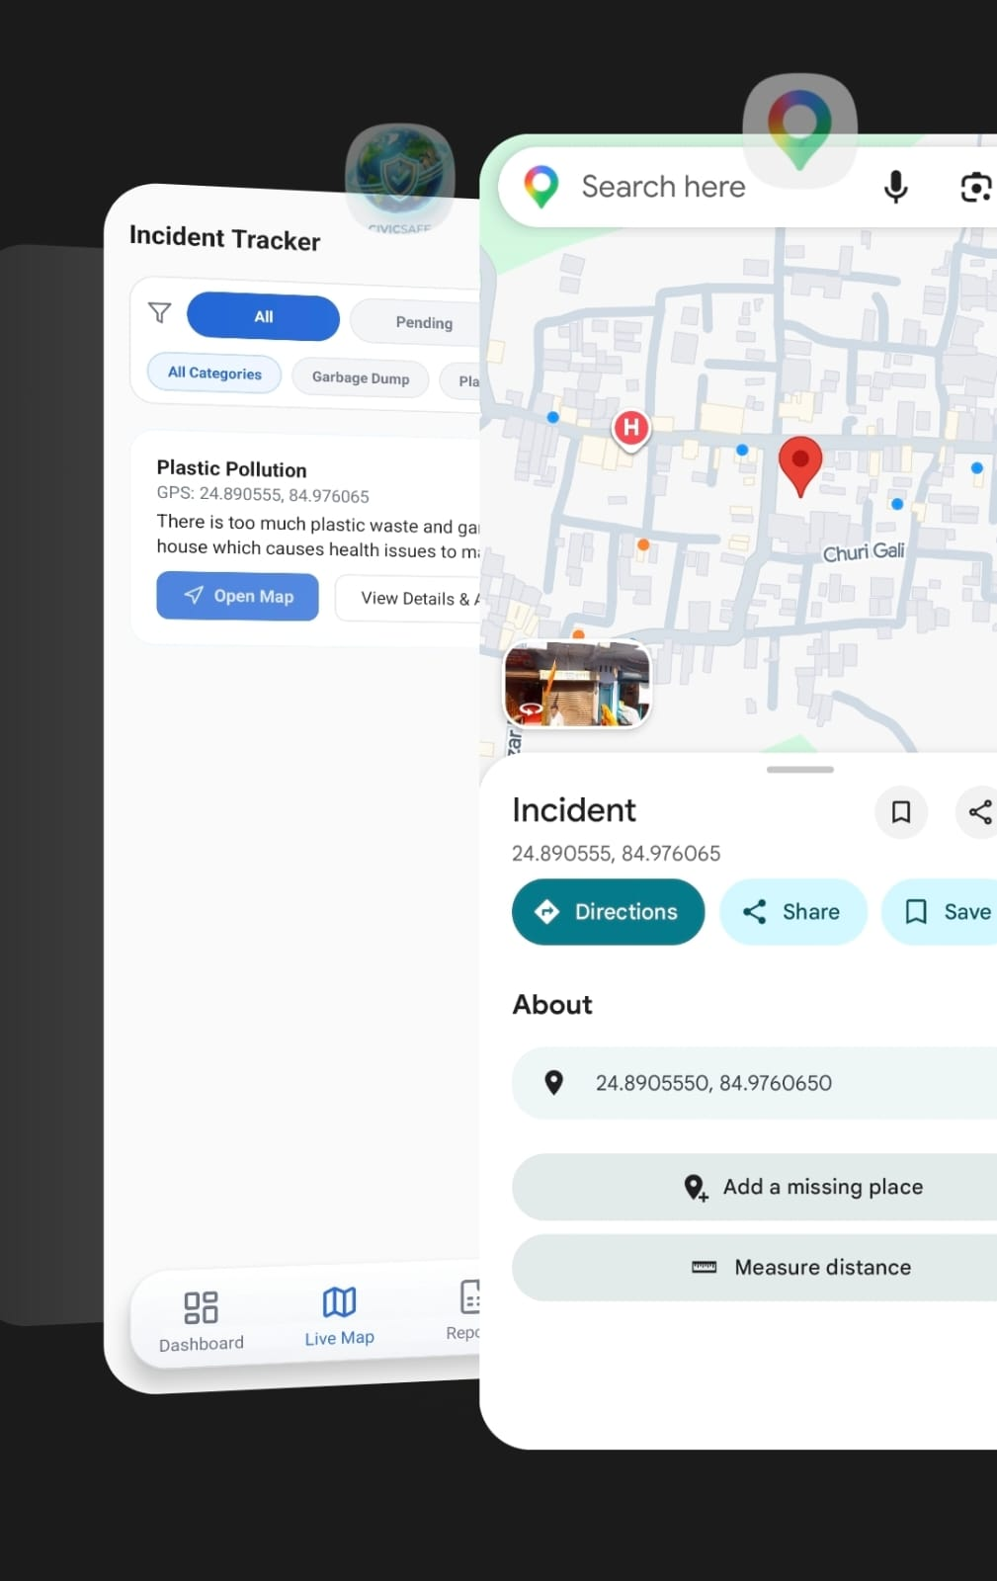
Figure 4.2 - Live map view, Authority Hub dashboard and Admin report review screen

4.10 Certificates of Completion and Other Communication Mail Proof
The Internship Completion Certificate issued by MARS – Centre for Sustainable Community Development is attached in Section 3 of this report (Internship Completion Certificate), certifying successful completion of the internship from June 1, 2026 to July 15, 2026, during which this project was undertaken.
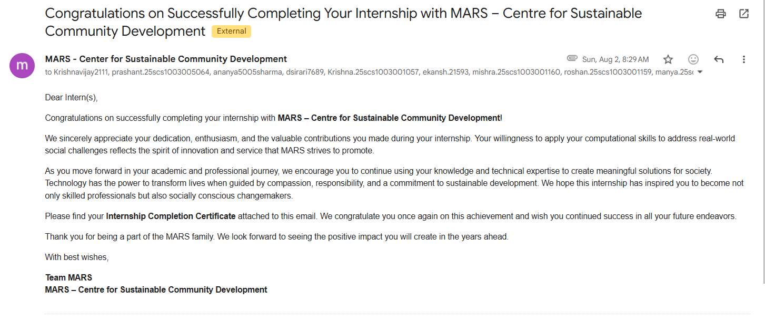
5. BIBLIOGRAPHY / REFERENCES

- React Native Documentation. Meta Platforms, Inc. Available at: https://reactnative.dev/docs/getting-started.

- Expo Documentation. Expo Technology Inc. Available at: https://docs.expo.dev/.

- Express.js Guide. OpenJS Foundation. Available at: https://expressjs.com/.

- MongoDB Manual and Mongoose ODM Documentation. MongoDB, Inc. Available at: https://www.mongodb.com/docs/.

- Firebase Admin SDK Documentation. Google LLC. Available at: https://firebase.google.com/docs/admin/setup.

- Cloudinary Developer Documentation. Cloudinary Ltd. Available at: https://cloudinary.com/documentation.

- Google Gemini API Documentation. Google LLC. Available at: https://ai.google.dev/gemini-api/docs.

- JSON Web Tokens (JWT) Introduction. Available at: https://jwt.io/introduction.

