**IT-575 Exam**

**Vaibhav Amit Patel**

**201401222**

**Question -1c**:

Fig-1

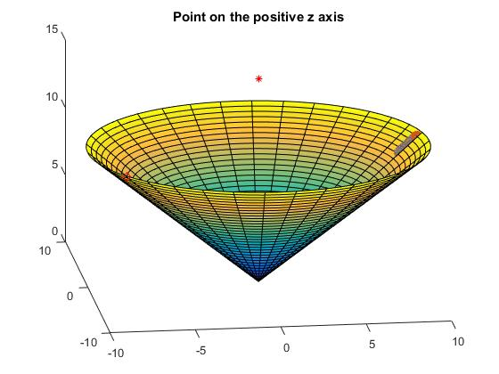

Fig-1 Point on the positive z axis. P = (P1, P2, P3)

Red star= Point P, we want to find its projection.

We can see the decreasing function using gradient descent.

This is the main axis of the cone. Minimas are at P3/2 centered circle’s points.

Fig-2

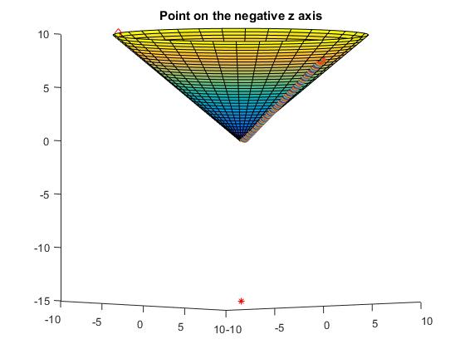

Fig-2 Point on the negative z axis. P = (P1, P2, P3)

Red star= Point P, we want to find its projection.

We can see the decreasing function using gradient descent.

This is the main axis of the cone. Minima is not defined but code goes to origin. No minima. Minima is limit tends to origin (If you think in terms of limits)

Fig-3

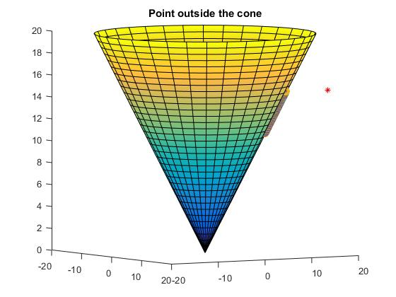

Fig-3 Point outside the cone. P = (P1, P2, P3)

Red star= Point P, we want to find its projection.

Fig-4

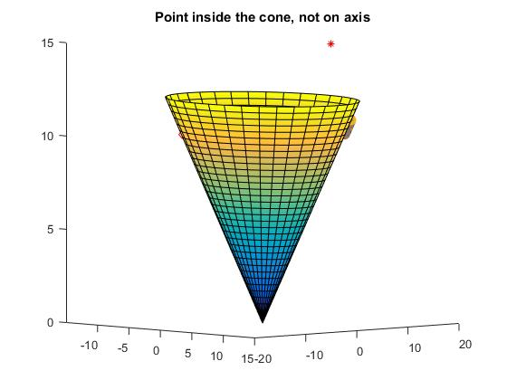

Fig-4 Point inside the cone. P = (P1, P2, P3)

Red star= Point P, we want to find its projection.

Fig-5

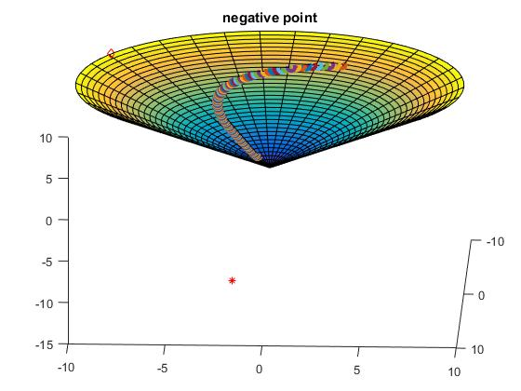

Fig-3 Point outside the cone. P = (P1, P2, P3)

Red star= Point P, we want to find its projection.

All coordinate negative points comes to origin. Other negative positive mixture points can find their minima on the surface.

Question -2 B

Fig-1

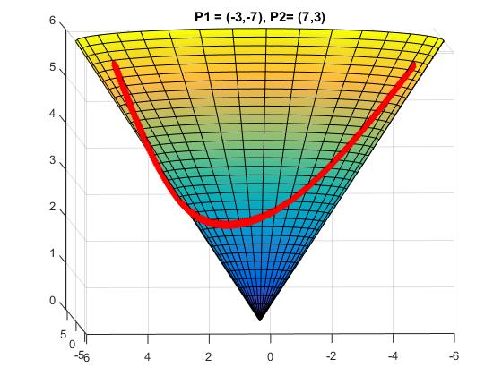

If the origin lies between these two points in the plane then it goes through origin in the cone as well. Otherwise it will find its distance using the zero tangential curvature rule.

Fig-2

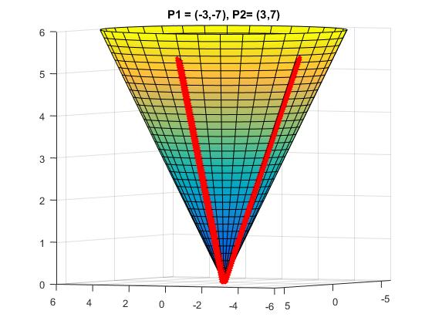

Here the origin lies between these two points. That is why it goes through origin in the cone as well.

Question -3 A

Fig-1

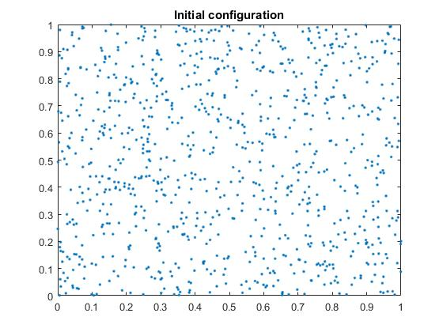

Initial configuration of the system(random)

Fig-2

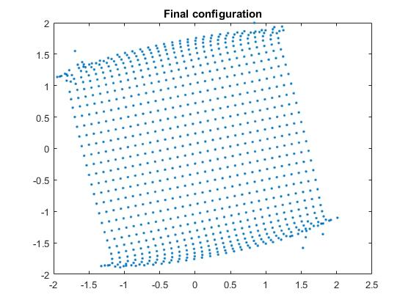

Final configuration of the system

Fig-3

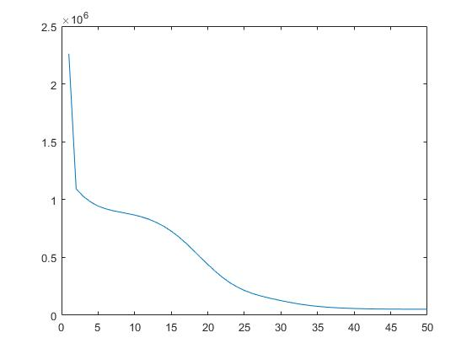

Error decreasing as the function

References for the helper codes:

Copied straight from open source.

Hard constraint

Hard constraint Solve

https://github.com/areslp/matlab/tree/master/MeshLP/MeshLP