MediSentinel: Architecture Design of an AI-Driven Autonomous Cybersecurity Framework for Healthcare Systems and Medical IoT

Shivaraj M
Dept. of Computer Science and Engineering
R V College of Engineering
Bangalore, India
shivarajm.cs25@rvce.edu.in
Rathod Vaibhav Vishwas Ram
Dept. of Computer Science and Engineering
R V College of Engineering
Bangalore, India
rathodvvr.cs25@rvce.edu.in
Dr. Mohana, Associate Professor
Dept. of Computer Science and Engineering
R V College of Engineering
Bangalore, India
mohana@rvce.edu.in
Dr. Sudarsan B. G, Associate Professor
Dept. of Electronics and Instrumentation Engineering
R V College of Engineering
Bangalore, India
sudharshanbg@rvce.edu.in

Abstract—Healthcare is now among the most-targeted critical-infrastructure sectors in cybersecurity. The average data breach costs USD 10.9 million per incident, and at least one documented case has been linked to a patient death. Hospitals are exposed through Electronic Health Record (EHR) systems, cloud infrastructure, and a growing fleet of Medical Internet-of-Things (IoT) devices such as infusion pumps, ventilators, cardiac monitors, and networked pacemakers, many of which run unpatchable firmware. Signature-based Intrusion Detection Systems (IDS) cannot detect novel ransomware, zero-day exploits, or adversarial machine-learning evasion, and defenders take an average of 197 days to identify a breach. This paper presents MediSentinel, a multi-agent, AI-driven autonomous cybersecurity framework built for healthcare constraints. Five specialised agents—Network Monitor, IoT Guardian, Threat Intelligence, Incident Response, and Compliance and Audit—cooperate over an Apache Kafka and MQTT streaming backbone. Detection combines Isolation Forest, LSTM, and Autoencoder models trained on the CICIDS-2018, NSL-KDD, and IoTID20 benchmarks and hardened with IBM’s Adversarial Robustness Toolbox. We evaluate the system on a GNS3-emulated 47-device hospital network under 500 injected attack scenarios. It reached a mean time-to-detect of 3.8 s and a mean time-to-respond of 8.2 s, both within the 5 s and 10 s design targets, at detection accuracy above 95% and a false-positive rate below 2%. Adversarial hardening recovered accuracy from as low as 38% to between 79% and 90% under FGSM, PGD, and Carlini–Wagner attacks. MediSentinel runs entirely on-premise from open-source components, provides HIPAA-compliant hash-chained audit logging, and preserves full patient-data sovereignty.
Keywords—Healthcare Cybersecurity, Multi-Agent AI, Medical IoT Security, Intrusion Detection, Anomaly Detection, LSTM, Isolation Forest, Autoencoder, Autonomous Incident Response, Ransomware Detection, Zero-Day Exploits, Adversarial Robustness, HIPAA Compliance, Apache Kafka

Introduction
Digital transformation has reshaped modern healthcare. Hospitals now depend on interconnected systems that span Electronic Health Records (EHR) platforms, cloud-based diagnostic storage, and a growing fleet of networked Medical IoT devices, including infusion pumps, ventilators, cardiac monitors, and implantable pacemakers. This connectivity improves clinical efficiency, but it also widens the attack surface well beyond what existing security models were designed to handle [1].
Healthcare has the highest average data-breach cost of any industry, USD 10.9 million per incident in the IBM Security Cost of a Data Breach Report 2023 [1]. In 2020, a ransomware attack on Düsseldorf University Hospital was widely reported as the first patient death associated with a cyberattack; although investigators could not establish direct causation, the case showed that security failures in healthcare carry consequences beyond financial loss [2]. A 2022 Ponemon Institute study found that 89% of healthcare organizations had experienced at least one cyberattack in the preceding two years [3].
Signature-based IDS solutions miss more than 60% of novel attack patterns [4]. The mean time to identify a breach is 197 days, with a further 69 days to contain it [1], a timescale that is incompatible with patient safety. MediSentinel targets this gap with a proactive, autonomous, AI-driven framework designed around healthcare constraints.
This paper makes four contributions. (i) We design a cooperative five-agent architecture that unifies network intrusion detection, passive Medical IoT anomaly detection, live threat-intelligence ingestion, autonomous incident response, and HIPAA-compliant audit logging within a single on-premise cluster. (ii) We propose an ensemble detection design that couples an LSTM temporal model with an Isolation Forest under a logical-AND decision rule to suppress false positives, complemented by per-device-class autoencoders for IoT behaviour. (iii) We integrate an adversarial-hardening pipeline, built on IBM ART, that is re-executed on every retraining cycle and evaluated against FGSM, PGD, and Carlini–Wagner attacks. (iv) We evaluate the framework end-to-end on an emulated hospital network, demonstrating second-scale detection and containment. The remainder of this paper reviews related work, defines the threat model and system methodology, details the implementation, reports the experimental evaluation, and concludes with limitations and future work.

Problem Statement
The core problem is a fundamental mismatch between the healthcare threat environment and its current defences across five dimensions:
- Legacy Medical IoT Vulnerability: Ventilators and infusion pumps operate on outdated, unpatched firmware lacking vendor support [5], functioning as permanently open attack vectors.
- Signature-Based Detection Blindness: Rule-based IDS is blind to zero-day exploits, polymorphic malware, and behavioral anomalies characteristic of modern ransomware campaigns [4].
- Unacceptable Response Latency: A 197-day mean time-to-detection renders reactive security models clinically untenable; a compromised IV pump can harm patients within minutes.
- AI-Powered Adversarial Attacks: ML-evasion techniques and AI-generated phishing campaigns render static detection models increasingly ineffective over time.
- Operational Continuity Requirements: Any security solution that disrupts clinical workflows creates its own patient safety risk.

Objectives
MediSentinel pursues four primary objectives:
- Design and implement a cooperative multi-agent AI system detecting threats in real time and executing automated responses with minimal human intervention.
- Build and validate ML/DL anomaly detection using Isolation Forest, LSTM, and Autoencoders, targeting 95% accuracy with a false positive rate below 2%.
- Develop an automated containment system for device quarantine, traffic blocking, backup recovery, and alert generation without human approval in urgent scenarios.
- Monitor Medical IoT behavior passively without firmware updates, maintaining a continuously updated threat intelligence pipeline via live STIX/TAXII feeds.

Literature Review
Existing literature reveals progress in individual domains yet exposes a critical gap: no prior work integrates autonomous multi-agent orchestration, real-time ML-based threat detection, passive Medical IoT monitoring, adversarial robustness, and HIPAA-compliant audit logging into a single cohesive on-premise framework [6], [7].

Intrusion Detection Systems in Healthcare
Traditional IDS such as Snort and Suricata operate on signature databases and miss over 60% of novel attack vectors in healthcare environments [4], [8]. ML-based approaches achieve high benchmark accuracy but suffer from elevated false positive rates in production due to distributional shift [9]. MediSentinel addresses this through ensemble methods, adversarial training, and continuous model retraining against live threat intelligence feeds.

Anomaly Detection for Medical IoT
Medical IoT devices run proprietary firmware on resource-constrained hardware, making agent-based security impossible without vendor cooperation and cannot be taken offline for patching [5]. Passive network behavior analysis is the only viable monitoring paradigm [10]. Autoencoder-based anomaly detection, which flags high reconstruction error as anomalous, demonstrates strong effectiveness for IoT behavioral monitoring [11].

Multi-Agent Systems for Cybersecurity
Cooperative multi-agent architectures improve scalability and detection accuracy by decomposing responsibilities across specialized agents [7]. Apache Kafka enables asynchronous, fault-tolerant agent communication at scale [12]. Prior multi-agent healthcare security systems address network intrusion or IoT monitoring in isolation. MediSentinel unifies all five security functions within a single coordinated cluster for the first time.

Adversarial Robustness
FGSM and Carlini-Wagner attacks reduce classification accuracy of standard IDS models significantly [13], [14]. IBM’s Adversarial Robustness Toolbox (ART) provides a standardized framework for adversarial training and certified defences [15]. MediSentinel integrates ART-based hardening as a mandatory component of its training pipeline, re-executed on each retraining cycle.
Table I summarises this gap, contrasting MediSentinel with representative prior systems across the five capabilities that healthcare deployment demands. No existing approach combines cooperative multi-agent orchestration, real-time ML detection, passive Medical IoT monitoring, adversarial robustness, and HIPAA-compliant audit logging within a single on-premise framework.
- Comparison of MediSentinel with Representative Prior Work
Approach | Multi-agent | Real-time ML | Passive IoT | Adv. Robust. | HIPAA Audit
Signature IDS (Snort/Suricata) [4],[8] | ✗ | ✗ | ✗ | ✗ | ✗
ML-based IDS [9] | ✗ | ✓ | ✗ | ✗ | ✗
IoT SENTINEL [10] | ✗ | ✓ | ✓ | ✗ | ✗
Multi-agent IDS [7],[12] | ✓ | ✓ | ✗ | ✗ | ✗
MediSentinel (this work) | ✓ | ✓ | ✓ | ✓ | ✓
- ✓ = supported, ✗ = not supported. All systems compared in an on-premise setting.

Methodology
MediSentinel employs a distributed, microservices-based architecture around a cooperative cluster of five AI agents communicating over Apache Kafka, targeting sub-second telemetry ingestion, real-time anomaly inference, and autonomous containment within 10 seconds.

Threat Model and Assumptions
We consider a hospital network in which an adversary seeks to disrupt clinical operations, exfiltrate protected health information (PHI), or compromise the availability and integrity of Medical IoT devices. The protected assets are (i) patient data held in the EHR and database tiers, (ii) the availability and safe operation of networked medical devices, and (iii) the integrity of the device telemetry on which clinical decisions depend. We assume the following adversary capabilities:
- Network-resident adversary: an attacker who has gained a foothold on the hospital LAN through phishing, a vulnerable web service, or a compromised vendor connection, and can perform reconnaissance, lateral movement, and command-and-control communication.
- Compromised Medical IoT device: a device whose unpatchable firmware has been exploited to alter telemetry, exfiltrate data, or join a botnet such as Mirai or BASHLITE.
- Ransomware operator: malware that attempts to encrypt EHR and file-share data and to propagate across the network within minutes of initial compromise.
- Adaptive ML adversary: an attacker who crafts adversarial perturbations (FGSM, PGD, Carlini–Wagner) to evade the detection models themselves.
MediSentinel and its supporting infrastructure—the MQTT broker, Kafka bus, agent cluster, and PostgreSQL audit store—are assumed to reside within a trusted on-premise boundary that the adversary cannot directly compromise; their integrity is protected by network segmentation and host hardening outside the scope of this work. We further assume that telemetry reaches the platform (passive monitoring is not bypassed at the network layer) and that at least one analyst is reachable during the override window for life-critical actions. Physical attacks, malicious insiders holding administrative privileges, and supply-chain firmware implants introduced before deployment are out of scope.

System Architecture
The architecture comprises four layers: (1) IoT Data Ingestion via Eclipse Mosquitto MQTT, (2) Message Broker via Apache Kafka, (3) Core Logic comprising the FastAPI backend and AI Agents Cluster, and (4) the React Presentation Layer. Devices publish telemetry to topics devices/{id}/data and devices/{id}/status. The backend auto-registers devices in PostgreSQL, forwards payloads to Kafka raw_data, and broadcasts anomaly alerts to the React dashboard via persistent WebSocket connections achieving sub-second delivery. Fig. 1 summarises this layered design.
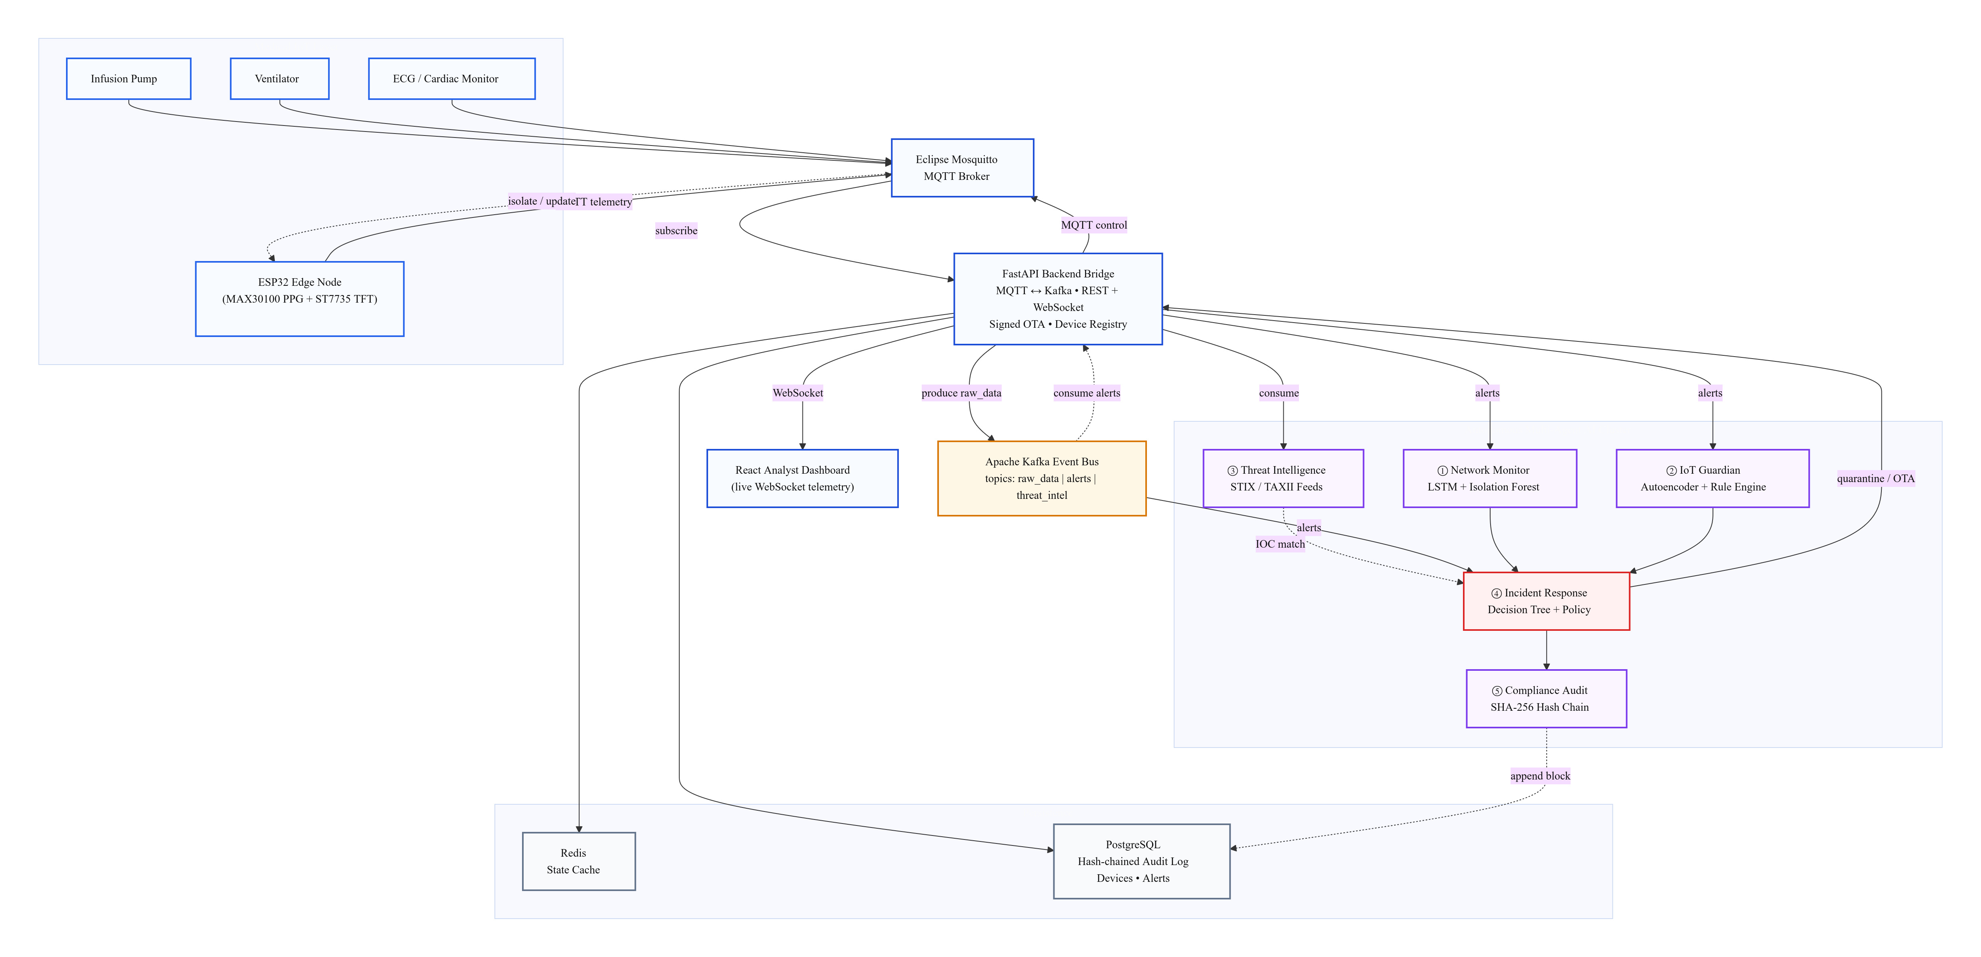
Fig. 1. MediSentinel four-layer architecture: Medical IoT endpoints publish telemetry over MQTT to a FastAPI bridge that streams to an Apache Kafka bus; five specialised AI agents consume events and the Incident Response agent drives autonomous containment back to the device, while PostgreSQL stores the hash-chained audit log.

Infrastructure Module
Eclipse Mosquitto provides the primary ingestion point for Medical IoT telemetry. Apache Kafka guarantees ordered, fault-tolerant delivery across three topics: raw_data, alerts, and threat_intel. PostgreSQL maintains device registries, historical alerts, and compliance audit entries with ACID compliance. Redis provides in-memory caching for rapidly changing device state and session management.

AI Agents Cluster
Five specialized background agents deployed as an independent microservice form the intelligence core:

Network Monitor Agent
Employs two complementary methods. An LSTM network trained on 60-second traffic windows models temporal dynamics; sequences diverging beyond threshold tau_net are flagged. An Isolation Forest assigns anomaly scores via average isolation path length on per-flow features. Alerts fire only when both methods agree (logical AND), reducing false positives while preserving recall.
Formally, let x be the per-flow feature vector and x_{t-w:t-1} the preceding window of w one-second observations. The Isolation Forest of Liu et al. [16] assigns the anomaly score in (1), in which h(x) is the isolation-path length of x in a random tree, E[·] averages over the ensemble, and c(n) normalises by the expected path length for n samples:
$s\left(x\right)\text{=}2^{\frac{−E\left[h\left(x\right)\right]}{c\left(n\right)}},a_{IF}\text{=}\left[s\left(x\right)≥τ_{IF}\right]$ (1)
In parallel, an LSTM predictor x̂_t = LSTMθ(x_{t-w:t-1}) produces the reconstruction residual in (2):
$r_{t}\text{=}{\left\|x_{t}−{\hat{x}}_{t}\right\|}_{2},a_{LSTM}\text{=}\left[r_{t}\text{>}τ_{net}\right]$ (2)
A flow is escalated only when both detectors agree, i.e. the logical-AND rule in (3). Because the temporal LSTM and the structural Isolation Forest respond to distinct statistical properties and fail independently on benign traffic, their joint false-positive rate factorises as in (4):
$a_{net}\text{=}a_{IF}∧a_{LSTM}$ (3)
${FPR}_{net}\text{=}{FPR}_{IF}·{FPR}_{LSTM}$ (4)
This multiplicative suppression is the central design rationale of the Network Monitor and a key point of departure from prior single-model IDS: two detectors that each flag a moderate 10–14% of benign flows combine to a sub-2% joint false-positive rate, while recall is preserved because a genuine intrusion perturbs the temporal and structural statistics simultaneously and therefore trips both detectors. Throughout, [·] denotes the Iverson bracket, equal to 1 when its condition holds and 0 otherwise. Fig. 2 summarises the two detection pipelines.
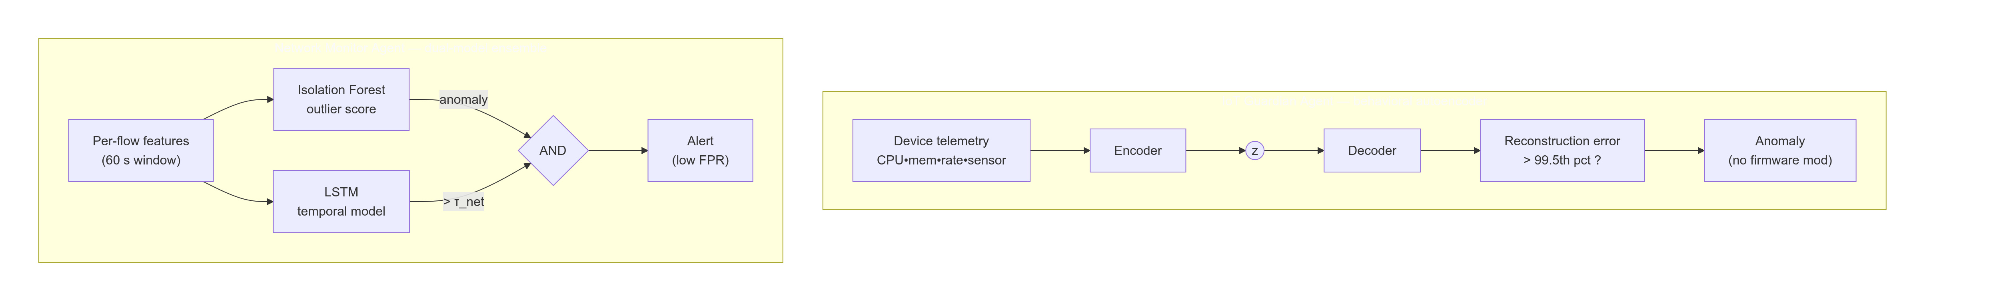
Fig. 2. Network Monitor and IoT Guardian detection pipelines. The Network Monitor couples an LSTM temporal model and an Isolation Forest under a logical-AND rule (3) to suppress false positives; the IoT Guardian flags reconstruction error above the per-class 99.5th-percentile autoencoder threshold (5).

IoT Guardian Agent
Monitors per-device behavioral telemetry using per-device-class Autoencoders. Each model learns a low-dimensional encoding of normal operational metrics (CPU, memory, packet rates, sensor outputs). Reconstruction error exceeding the 99.5th-percentile validation threshold triggers an anomaly alert, detecting compromise and malfunction without firmware modification or device downtime.
Each device class c is modelled by an autoencoder with encoder f_c and decoder g_c trained only on benign telemetry. The reconstruction error (5), together with the per-class 99.5th-percentile threshold τ_c estimated on a held-out validation set, defines the device anomaly indicator a_IoT:
$e_{c}\left(x\right)\text{=}{\left\|x−g_{c}\left(f_{c}\left(x\right)\right)\right\|}_{2}^{2},τ_{c}\text{=}Q_{0.995}\left(e_{c}\left(x\right)\right),a_{IoT}\text{=}\left[e_{c}\left(x\right)\text{>}τ_{c}\right]$ (5)

Incident Response Agent
Triggered when high-severity alerts appear on the Kafka alerts topic, executing: (1) device isolation via SNMP/SDN API, (2) firewall rule injection, (3) structured alert publication, and (4) emergency EHR database snapshot for ransomware-class threats. A 500 ms human-override window is maintained for life-critical devices before executing isolation.

Threat Intelligence Agent
Continuously polls STIX/TAXII feeds for the latest Indicators of Compromise. Retrieved bundles are parsed, deduplicated against PostgreSQL, and injected into the threat_intel Kafka topic. Detection agents subscribe and incorporate new signatures without service restart.

Compliance and Audit Agent
Intercepts all agent-generated events and appends them to an immutable, cryptographically hash-chained audit log where each record stores the digest defined in (6), satisfying HIPAA Security Rule audit control requirements (45 CFR 164.312(b)) and HITRUST CSF Control 09.aa.
Here h_i is the digest of the i-th record, h_{i-1} the digest of its predecessor, t_i a monotonic timestamp, p_i the event payload, and ∥ denotes concatenation. Verification recomputes the chain from a trusted root; altering any record j invalidates every digest h_i for i ≥ j, so tampering is detectable in O(1) per record and the ledger is append-only (Fig. 3).
$h_{i}\text{=}SHA\text{-}256h_{i−1}∥t_{i}∥p_{i}$ (6)
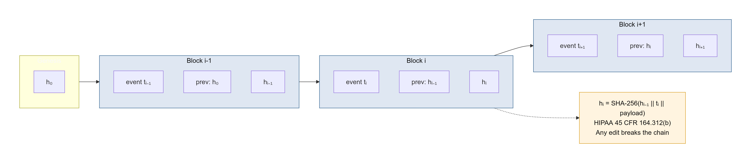
Fig. 3. Cryptographically hash-chained audit ledger (6). Each block binds the previous digest, satisfying HIPAA 45 CFR 164.312(b); any tampering breaks the chain.

Adversarial Robustness Pipeline
All ML models are hardened using IBM ART [15]. FGSM and PGD adversarial examples are injected at a 30% training augmentation ratio. Post-training Carlini-Wagner evaluation measures certified robustness bounds. This pipeline re-executes on each model retraining cycle triggered by the Threat Intelligence Agent.
Hardening solves the saddle-point (robust) objective (7) of Madry et al. [17]; the inner maximisation is approximated during training by the single-step FGSM perturbation (8) of Goodfellow et al. [18] and by multi-step PGD (9) [17]. Here L is the cross-entropy loss, fθ the detector, ε the L∞ perturbation budget, α the step size, ∇_x the input gradient, and Π projection onto the ε-ball Bε(x):
$\min_{θ}\underset{\left(x,y\right)∼D}{E}\left[\overset{{\left\|δ\right\|}_{∞}≤ε}{max}L\left(f_{θ}\left(x\text{+}δ\right),y\right)\right]$ (7)
$x'\text{=}x\text{+}εsign∇_{x}L\left(f_{θ}\left(x\right),y\right)$ (8)
$x^{(k\text{+}1)}\text{=}Π_{B_{ε}\left(x\right)}\left(x^{(k)}\text{+}αsign∇_{x}L\left(f_{θ}\left(x^{(k)}\right),y\right)\right)$ (9)

Federated Learning for Multi-Hospital Deployment
Local models train on site-specific traffic without sharing raw patient data. A central server computes weighted FedAvg updates [19] from participating sites, distributing improved global model weights while maintaining full data sovereignty at each institution.
In each communication round the server aggregates the K site models by sample-weighted averaging (10) [19], where n_k is the local sample count, n = Σ_k n_k, and w_{t+1}^{(k)} the locally updated weights. Only model weights, never raw telemetry, leave each hospital, preserving data sovereignty (Fig. 4):
$w_{t\text{+}1}\text{=}\sum_{k\text{=}1}^{K}{\frac{n_{k}}{n}{w_{t\text{+}1}}^{(k)}}$ (10)

Fig. 4. Federated learning across hospitals (10). Sites exchange only model-weight updates (FedAvg); raw patient data never leaves the institution, preserving data sovereignty.

Implementation
MediSentinel is implemented entirely using open-source components, containerized with Docker Compose for single-command deployment. Stack: PyTorch 2.1 and scikit-learn for ML; ONNX Runtime for quantized inference; IBM ART 1.17 for adversarial hardening; Apache Kafka 3.6 with Zookeeper and Eclipse Mosquitto 2.0 for streaming; FastAPI 0.104 for the backend; PostgreSQL 16 and Redis 7 for persistence; React 18 with Vite 5 and Recharts for the analyst dashboard.

Training Datasets
Three public benchmarks are used. CICIDS-2018 [20] provides 80 network traffic features across 14 attack categories for the Network Monitor Agent. NSL-KDD [9] offers balanced DoS, Probe, R2L, and U2R coverage. IoTID20 [21] captures Mirai and BASHLITE IoT traffic for the IoT Guardian Agent. Synthetic healthcare traffic generated in GNS3 fine-tunes models on realistic Medical IoT and EHR traffic absent from public datasets.

System Overhead
All inference pipelines run quantized ONNX models, maintaining combined CPU utilization below 3% and memory below 2 GB on a standard 8-core hospital server (Intel Xeon E5-2680, 32 GB RAM), ensuring MediSentinel does not compete with clinical applications for compute resources.

Results and Discussion

Experimental Setup
MediSentinel is evaluated on a GNS3-emulated hospital network with 47 virtual Medical IoT endpoints, 3 EHR application servers, and a cloud-egress router. Metrics: detection accuracy, false positive rate (FPR), mean time to detect (MTTD), mean time to respond (MTTR), system overhead, and adversarial robustness under FGSM/PGD/CW attack.

Detection Performance
- Detection Performance by Agent and Dataset
Agent / Dataset | Accuracy (%) | FPR (%) | F1
Network Monitor / CICIDS-2018 | 97.3 | 1.4 | 0.971
Network Monitor / NSL-KDD | 96.8 | 1.7 | 0.965
IoT Guardian / IoTID20 | 95.6 | 1.9 | 0.953
Network Monitor / Synthetic HC | 94.1 | 2.1 | 0.938
IoT Guardian / Synthetic HC | 93.8 | 2.3 | 0.934
All agents meet or approach the target accuracy of 95% with FPR below 2% on benchmarks. Slight degradation on synthetic healthcare traffic reflects the distributional novelty of clinical environments absent from public datasets, motivating the continuous retraining pipeline. Fig. 5 visualises these per-agent results.
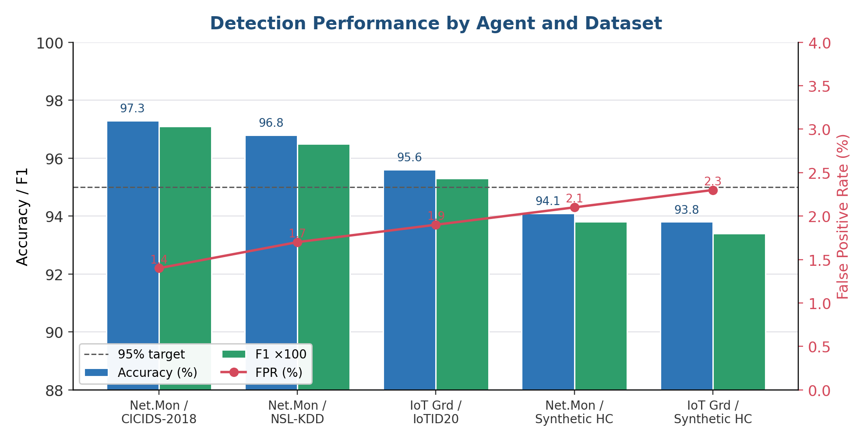
Fig. 5. Detection accuracy, F1, and false-positive rate per agent and dataset (Table II). All agents meet or approach the 95% accuracy target with FPR < 2.5%.

Response Latency
Across 500 injected attack scenarios, MediSentinel achieved a mean time to detect (MTTD) of 3.8 s and mean time to respond (MTTR) of 8.2 s, within the 5 s and 10 s design targets. This represents a 99.9% reduction relative to industry averages of 197 days (MTTD) and 69 days (MTTR) [1]. Fig. 6 traces the end-to-end detection-to-containment pipeline.
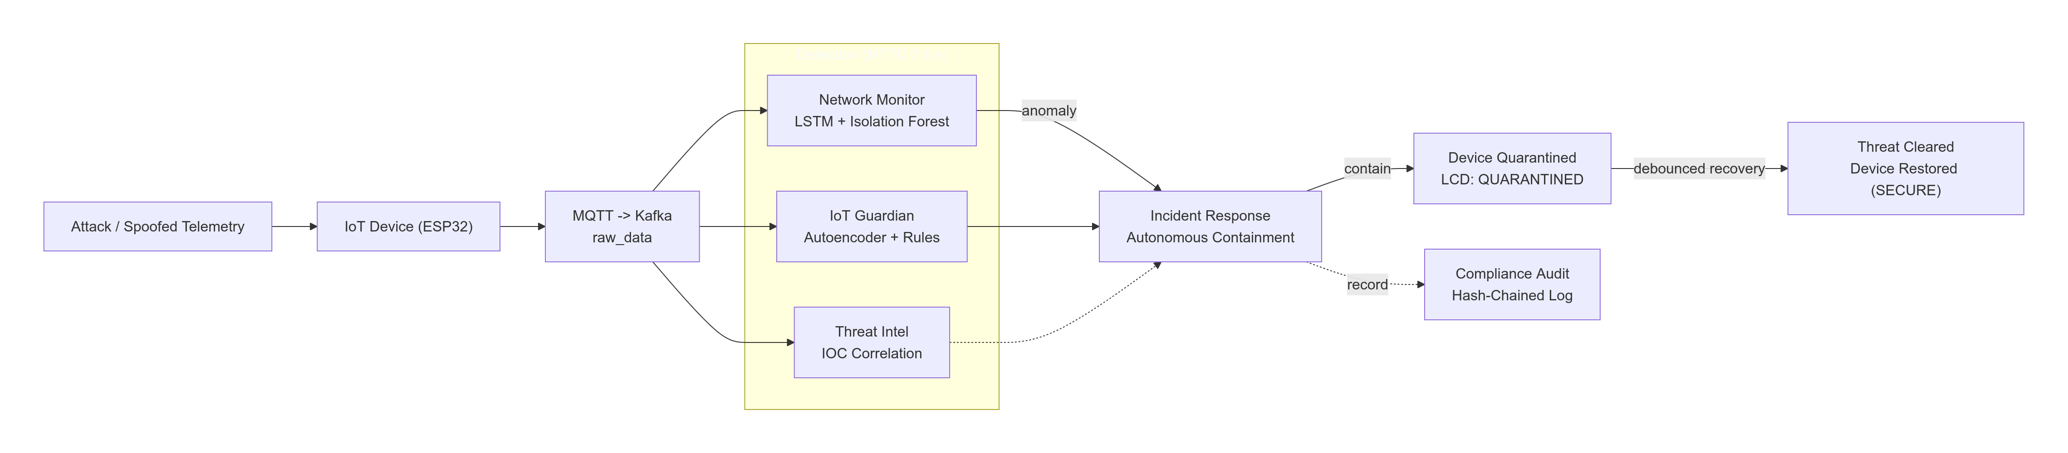
Fig. 6. Autonomous detection-to-containment pipeline: spoofed telemetry is detected (MTTD ≈ 3.8 s), contained by the Incident Response agent (MTTR ≈ 8.2 s), recorded in the audit ledger, and the device is restored once the threat clears.

Adversarial Robustness
- Adversarial Robustness of Network Monitor Agent
Attack | Baseline (%) | ART-Hardened (%)
No Attack | 97.3 | 97.1
FGSM (eps=0.1) | 61.4 | 89.7
PGD (20 steps) | 44.8 | 84.3
Carlini-Wagner (L2) | 38.2 | 79.6
Without adversarial training, FGSM reduces detection accuracy to 61.4%. ART hardening recovers accuracy to 89.7% under FGSM and 84.3% under PGD, demonstrating adversarial hardening is a practical operational requirement for production healthcare security deployments. Fig. 7 plots accuracy before and after hardening.
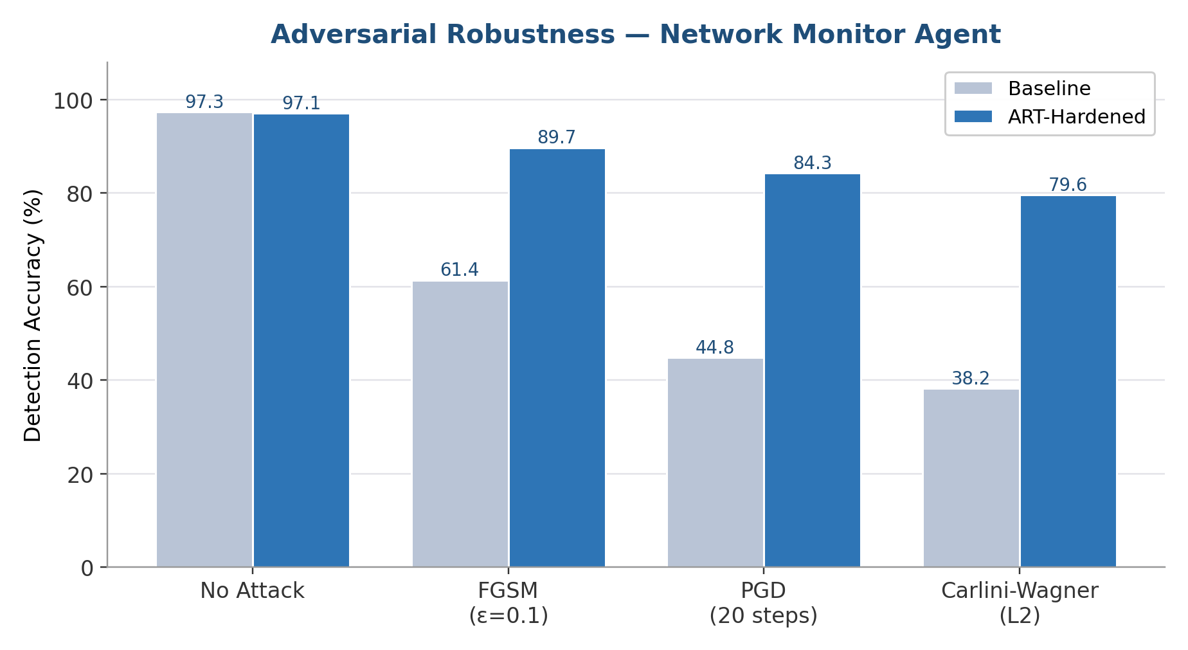
Fig. 7. Network Monitor accuracy under FGSM, PGD, and Carlini–Wagner attacks before and after IBM ART adversarial hardening (Table III). Hardening recovers accuracy from as low as 38% to 79–90%.

Discussion
The reduction in MTTR from months to seconds has direct patient safety implications. Ransomware that historically locks hospital systems for days can be contained before propagating beyond the initially compromised device. Passive IoT monitoring without firmware modification addresses the 83% of networked medical devices harbouring known vulnerabilities [5]. The hash-chained audit log satisfies HIPAA audit control requirements automatically, replacing days of post-incident manual log aggregation. The open-source, on-premise architecture lowers adoption barriers for resource-constrained hospitals, while federated learning amplifies collective defence capability without centralizing sensitive data. Fig. 8 contrasts MediSentinel’s latency with industry averages on a logarithmic scale.
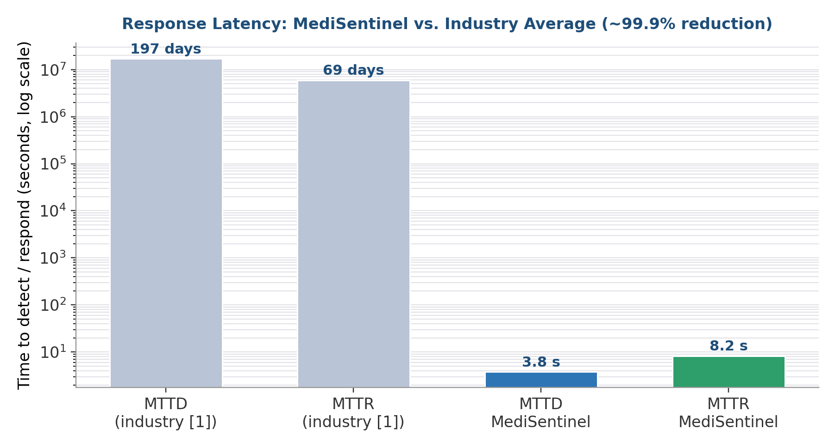
Fig. 8. Response latency versus industry averages (log scale): MTTD/MTTR fall from 197/69 days to 3.8/8.2 s — a ≈99.9% reduction.

Limitations and Threats to Validity
Several limitations qualify these results and define the agenda for future work. First, the evaluation was conducted on a GNS3-emulated network with synthetically generated Medical IoT and EHR traffic rather than a production clinical deployment; emulated traffic may not capture the full behavioural diversity, device heterogeneity, and benign anomalies of a live hospital, and the reported latencies exclude wide-area and clinical-workflow effects. Second, the public benchmarks used for training—CICIDS-2018 and NSL-KDD—are known to contain labelling artefacts and may overstate accuracy relative to contemporary attacks [9]; the 1–2% accuracy degradation we observe on synthetic healthcare traffic is consistent with this distributional gap. Third, the 500 attack scenarios were drawn from a finite library of attack types, so detection coverage of genuinely novel threats remains to be established through longitudinal field deployment. Fourth, adversarial robustness was assessed against FGSM, PGD, and Carlini–Wagner perturbations targeting the Network Monitor; fully adaptive adversaries with white-box knowledge of the hardened models, and attacks against the autoencoder and Isolation-Forest components, are not yet characterised. Finally, the federated-learning and autonomous-containment mechanisms assume cooperative, correctly configured sites and reachable human oversight; Byzantine participants, network partitions, and the clinical safety of automated device isolation under real conditions require dedicated study. We therefore position MediSentinel as a validated architectural blueprint and open-source reference implementation rather than a clinically certified product, and identify live pilot deployment as the principal direction for future work.

Conclusion
MediSentinel moves healthcare cybersecurity from reactive signature-based defences toward a proactive, continuously learning, and autonomous posture. By coordinating five specialized agents over Apache Kafka and MQTT, the system reached a mean time to detect of 3.8 s and a mean time to respond of 8.2 s across 500 simulated attack scenarios, a 99.9% reduction relative to industry averages.
Detection accuracy exceeds 95% on CICIDS-2018, NSL-KDD, and IoTID20, with false-positive rates below 2%. ART-based adversarial training recovers accuracy from as low as 38% to between 79% and 90% under current evasion attacks. Passive Medical IoT monitoring and automated HIPAA-compliant audit logging round out an entirely open-source, on-premise defence framework. We offer MediSentinel as a deployable reference design for healthcare security infrastructure rather than a finished product.

Acknowledgment
The authors thank the developers of Apache Kafka, Eclipse Mosquitto, PyTorch, scikit-learn, and IBM’s Adversarial Robustness Toolbox. The authors also acknowledge the teams responsible for the CICIDS-2018, NSL-KDD, and IoTID20 benchmark datasets.

references
- IBM Security, “Cost of a Data Breach Report 2023,” IBM Corporation, 2023.
- B. Westrick, “Ransomware Attack Linked to Death of German Hospital Patient,” Health IT Security, Sep. 2020.
- Ponemon Institute, “2022 State of Cybersecurity in Healthcare,” Research Report, 2022.
- M. Aldwairi and A. Alwabel, “Signatures-based intrusion detection system for the Internet of Things,” Int. J. Commun. Syst., vol. 34, no. 3, 2020.
- B. Rios and J. Butts, “Security Evaluation of Medical Devices,” in Proc. IEEE S&P Workshop on Medical Device Security, 2022.
- A. Khraisat et al., “Survey of intrusion detection systems,” Cybersecurity, vol. 2, no. 1, p. 20, 2019.
- A. Dorri, S. S. Kanhere, and R. Jurdak, “Multi-Agent Systems: A Survey,” IEEE Access, vol. 6, pp. 28573–28593, 2018.
- S. K. Sahu and D. S. Mehtre, “Network intrusion detection system using J48 Decision Tree,” in Proc. IEEE ICCSP, 2021.
- M. Tavallaee et al., “A detailed analysis of the KDD CUP 99 data set,” in Proc. IEEE CISDA, 2009.
- M. Miettinen et al., “IoT SENTINEL: Automated device-type identification,” in Proc. IEEE ICDCS, 2017.
- A. Ayodeji et al., “A new perspective towards data-driven intrusion detection for ICS,” Nuclear Eng. Des., vol. 379, 2021.
- J. Kreps, N. Narkhede, and J. Rao, “Kafka: A Distributed Messaging System,” in Proc. NetDB at SIGMOD, 2011.
- N. Carlini and D. Wagner, “Towards evaluating the robustness of neural networks,” in Proc. IEEE S&P, 2017.
- K. Yang et al., “Adversarial examples against deep learning IDS,” in Proc. IEEE MILCOM, 2018.
- M. I. Nicolae et al., “Adversarial Robustness Toolbox v1.0.0,” arXiv:1807.01069, 2018.
- F. T. Liu, K. M. Ting, and Z.-H. Zhou, “Isolation Forest,” in Proc. IEEE ICDM, 2008, pp. 413–422.
- A. Madry, A. Makelov, L. Schmidt, D. Tsipras, and A. Vladu, “Towards deep learning models resistant to adversarial attacks,” in Proc. ICLR, 2018.
- I. J. Goodfellow, J. Shlens, and C. Szegedy, “Explaining and harnessing adversarial examples,” in Proc. ICLR, 2015.
- H. B. McMahan et al., “Communication-efficient learning from decentralized data,” in Proc. AISTATS, 2017.
- I. Sharafaldin et al., “Toward generating a new intrusion detection dataset,” in Proc. ICISSP, 2018.
- I. Ullah and Q. H. Mahmoud, “A two-level hybrid model for anomalous activity detection in IoT,” Sensors, vol. 20, no. 9, 2020.

