Adaptive Packet Routing with Deep Reinforcement Learning: Topology Generalization, Multi-Objective Trade-offs, Robustness, and Continual Adaptation
Vaibhav Rathod
Department of Computer Science
rathodvaibhav401@gmail.com

Abstract—Reinforcement learning (RL) is a promising route to adaptive packet forwarding, but most studies report a single algorithm on a single topology under a single objective. We present a unified empirical study of learned routing on a 10-node network simulated with an M/M/1 queuing-delay model, autocorrelated congestion and stochastic link failures. Five learners (vanilla DQN, Rainbow DQN, a graph-neural-network DQN, tabular Q-Routing, and a continual-learning variant) are compared against Dijkstra, ECMP and random routing with bootstrap confidence intervals over multiple seeds. Beyond the headline comparison we probe four practical questions that aggregate metrics hide: (i) does a structure-aware GNN policy transfer zero-shot to larger unseen graphs? (ii) where does the latency-reliability trade-off lie? (iii) how do policies degrade under worst-case rather than random failures? and (iv) does an agent forget an old traffic regime when adapting to a new one? We find the GNN policy is the sole Pareto-optimal method (lowest delay and highest delivery), keeps near-optimal route quality on graphs up to 5x its training size, and resists targeted attacks that collapse a vanilla DQN from 0.91 to 0.60 delivery. We further show that naive sequential training forgets catastrophically (delivery on the old task drops from 0.77 to 0.09), that experience rehearsal fully prevents it, and that Elastic Weight Consolidation does not transfer to this destination-conditioned setting. All code, tests and results are released.
Keywords—reinforcement learning; packet routing; graph neural networks; multi-objective optimization; continual learning; network simulation

Introduction
Routing decides the path each packet takes through a network. Classical protocols such as OSPF compute shortest paths over a link-state metric (Dijkstra) and ECMP balances load over equal-cost paths. These methods are robust and well understood, but they react to congestion and failures only through periodic metric updates and do not learn from experience. Reinforcement learning offers an alternative: an agent observes link state and learns a forwarding policy that optimizes a long-horizon objective such as end-to-end delay and delivery.
The RL-routing literature, however, is fragmented. Papers typically demonstrate one algorithm, on one topology, under one scalarized objective, and report a single aggregate delivery or delay number. Several questions that matter for deployment are rarely answered together: whether a learned policy generalizes beyond its training graph; where it sits on the latency-reliability trade-off; how it behaves under adversarial rather than random failures; whether it can keep learning new regimes without forgetting old ones; and whether the aggregate metric is hiding per-flow starvation.
This paper makes these questions concrete on a common simulator and a common set of agents. Our contributions are: (1) a reproducible, multi-seed comparison of five learners and three classical baselines with statistical confidence intervals; (2) a zero-shot scalability study showing a graph-neural-network (GNN) policy transfers route quality to graphs up to five times larger than its training graph; (3) a multi-objective (Pareto) view, both across algorithms and within a single learner by sweeping its reward weights; (4) an adversarial-robustness study contrasting worst-case and average-case link failures; and (5) a continual-learning study quantifying catastrophic forgetting in learned routing and two remedies. We release the full code base, a 73-case test suite, and all result artifacts.

Related Work
Q-Routing [1] introduced distributed, online RL for routing with per-node Q-tables. Deep value-based RL [2] replaced tables with neural networks; Dueling architectures [3], prioritized replay [4] and their combination in Rainbow [5] improved sample efficiency and stability. Graph neural networks [6] and network-specific models such as RouteNet [7] encode topology directly, enabling generalization across graphs. Reproducibility concerns in deep RL [8] and robust evaluation protocols [9] motivate multi-seed training and confidence intervals. Continual learning addresses catastrophic forgetting with weight-space methods such as Elastic Weight Consolidation (EWC) [10] and data-space rehearsal. Fairness across flows is classically measured with Jain's index [11], and queuing delay with the M/M/1 model [12]. Our work differs by evaluating these dimensions jointly, on one simulator, with an honest account of where learned routing helps and where it does not.

System Model and Methods

Environment
We model the network as a graph of 10 nodes and 17 bidirectional links, each with a bandwidth and a base propagation delay. The agent forwards a packet hop-by-hop from a random source to a random destination. Per-link queuing delay follows the M/M/1 sojourn-time model [12], W = base_delay + tx/(1-rho), so delay rises sharply as utilization rho approaches one. Background congestion evolves as an AR(1) process with bursty injections; loss rate rises with utilization in a RED-like manner; and links fail and recover under a two-state Markov process. The observation is a 70-dimensional vector of four features per link (congestion, normalized delay, loss, up/down) plus the normalized current and destination node identifiers.

Reward
The per-step reward combines a delivery bonus, a per-hop delay penalty weighted by w_delay, a packet-drop penalty weighted by w_drop, and penalties for loops and invalid actions. Latency and reliability are competing objectives, so exposing (w_delay, w_drop) lets us trace a Pareto front rather than commit to one scalarization (Section V-C).

Agents
We evaluate vanilla DQN, Rainbow DQN (Dueling + prioritized replay + n-step + Double-DQN), a GNN-DQN that performs GraphSAGE-style message passing over the live link features and is therefore topology-agnostic, and tabular Q-Routing. Classical baselines are Dijkstra (OSPF analog), ECMP and random forwarding. All neural agents are trained for multiple seeds with curriculum-increasing difficulty; evaluation uses greedy policies. We report bootstrap confidence intervals and effect sizes [8], [9].

Headline Comparison
Table I reports packet delivery ratio (PDR) and end-to-end delay across link-failure rates (200 episodes per setting). The GNN-DQN is the strongest learner: it maintains PDR = 1.00 at every failure rate while achieving the lowest delay (about 9-10 ms), because it routes from graph structure and reroutes around failures without degradation. Rainbow is competitive (PDR 0.90-0.94); vanilla DQN trails the classical baselines on PDR, which motivates the architectural additions. Q-Routing, an online table method, adapts slowly and degrades under failures. We note that in this simulator failed links are penalized but still traversable, so PDR measures successful navigation within a hop budget; this is why well-trained policies saturate near 1.0 and why we report additional, more discriminating metrics below.
- TABLE I. DELIVERY (PDR) AND DELAY (ms) VS LINK-FAILURE RATE
Method | PDR @0% | PDR @60% | Delay @60%
GNN-DQN | 1.00 | 1.00 | 10.2
Rainbow | 0.93 | 0.90 | 15.4
DQN | 0.86 | 0.83 | 12.8
Q-Routing | 0.54 | 0.40 | 37.1
Dijkstra | 0.95 | 0.91 | 15.1
ECMP | 0.95 | 0.92 | 12.6
Random | 1.00 | 0.86 | 36.5
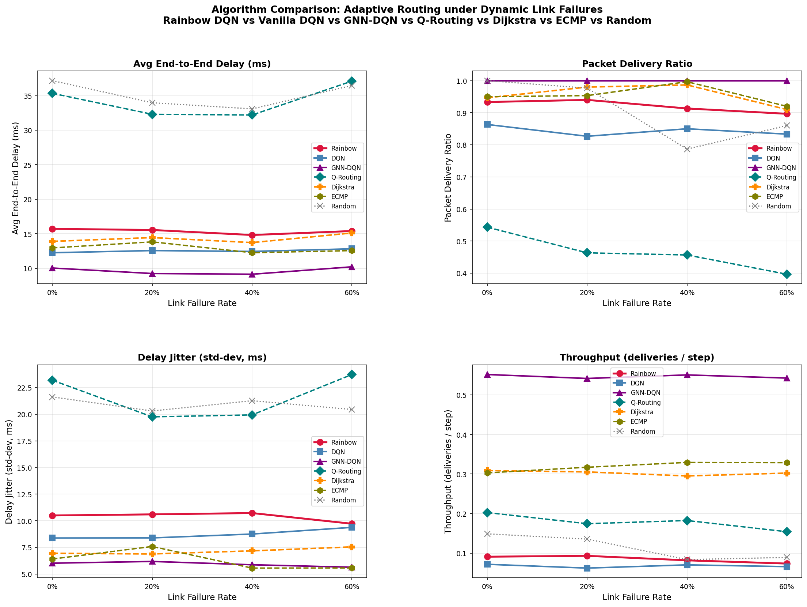
- Fig. 1. Seven-algorithm comparison across link-failure rates (PDR, delay, jitter, throughput).

Zero-Shot Scalability of the GNN Policy
Because the GNN operates on fixed-width node/edge features rather than a fixed node count, its trained weights apply to any graph. We evaluate the 10-node-trained policy zero-shot on Barabasi-Albert scale-free graphs of 20, 30 and 50 nodes. On well-connected graphs PDR is uninformative (any router eventually delivers), so we report delay stretch: the policy's mean delivered-path delay divided by Dijkstra's optimal. As Table II shows, the GNN holds stretch near 1.1-1.2 even at 50 nodes (five times its training size), while a random walk degrades from 3.2 to 10.7. The learned policy thus transfers route quality, not merely reachability.
- TABLE II. ZERO-SHOT TRANSFER TO LARGER UNSEEN GRAPHS (GNN PDR = 1.00 throughout; stretch = delay / optimal)
Nodes | Edges | GNN stretch | Random stretch
10 | 17 | 1.14 | 3.24
20 | 36 | 1.09 | 5.81
30 | 56 | 1.09 | 7.58
50 | 96 | 1.22 | 10.71
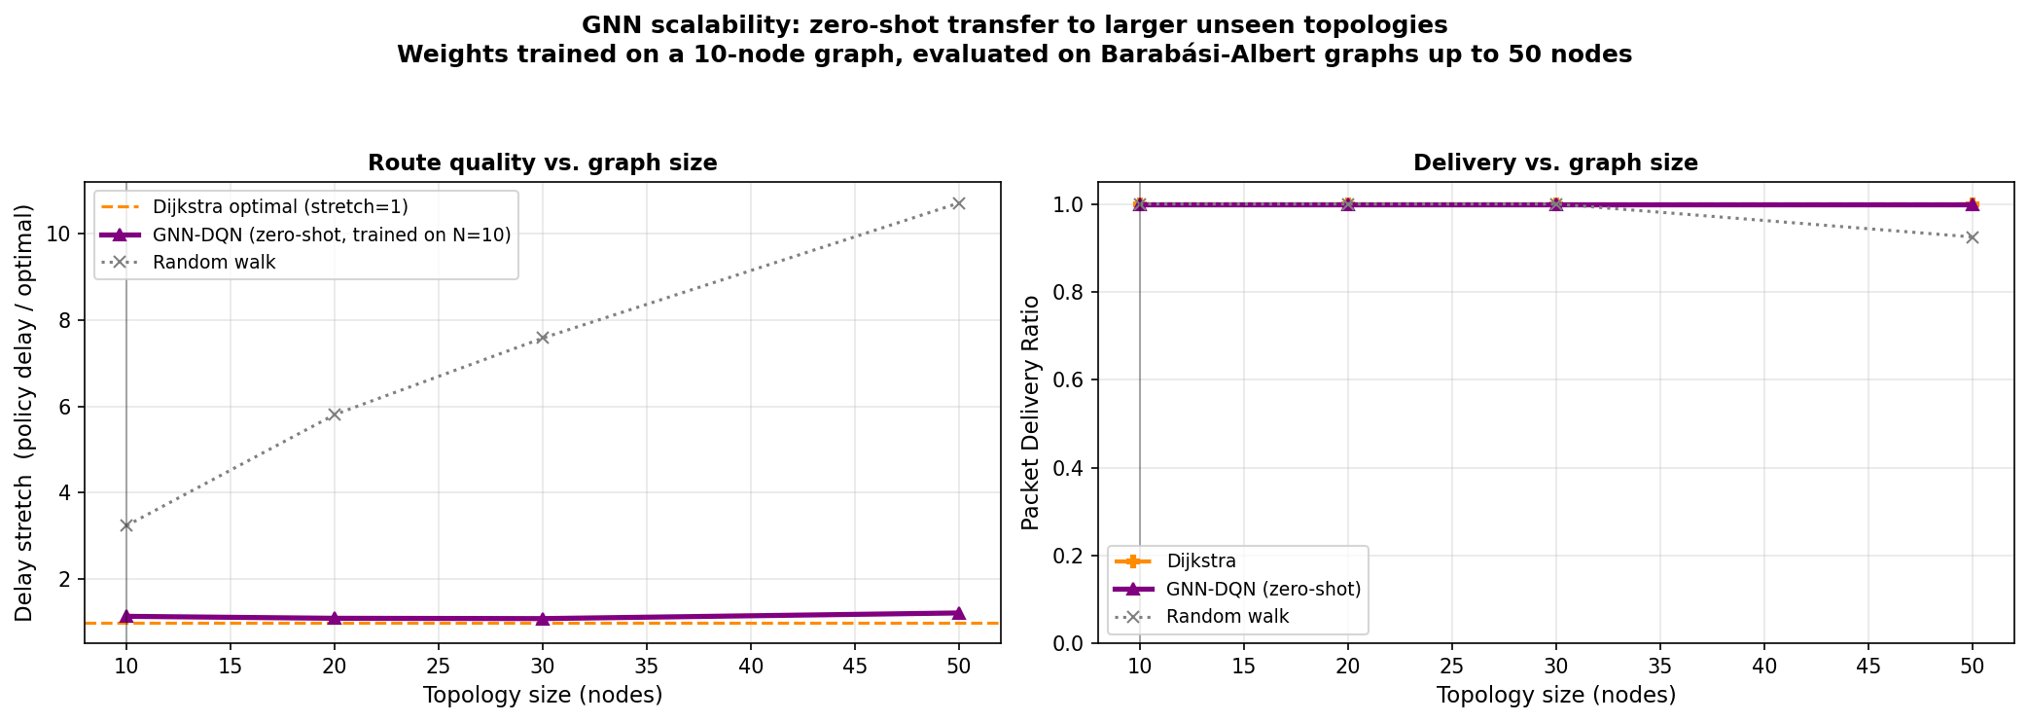
- Fig. 2. Delay stretch and PDR vs graph size for the GNN trained on 10 nodes and applied zero-shot up to 50 nodes.

Multi-Objective Trade-offs
Latency and reliability cannot both be maximized; a single reported operating point hides the trade-off. Plotting all algorithms in (delay, PDR) space at 20% failure, the GNN-DQN is the sole Pareto-optimal point (delay 9.24 ms, PDR 1.00), dominating every baseline. We also trace the trade-off within a single learner by training a DQN at a sweep of drop-penalty weights w_drop and measuring the achieved (mean delay, mean drops) operating point; the non-dominated weights w_drop = 15 and 30 form the learned policy's own latency-reliability frontier.
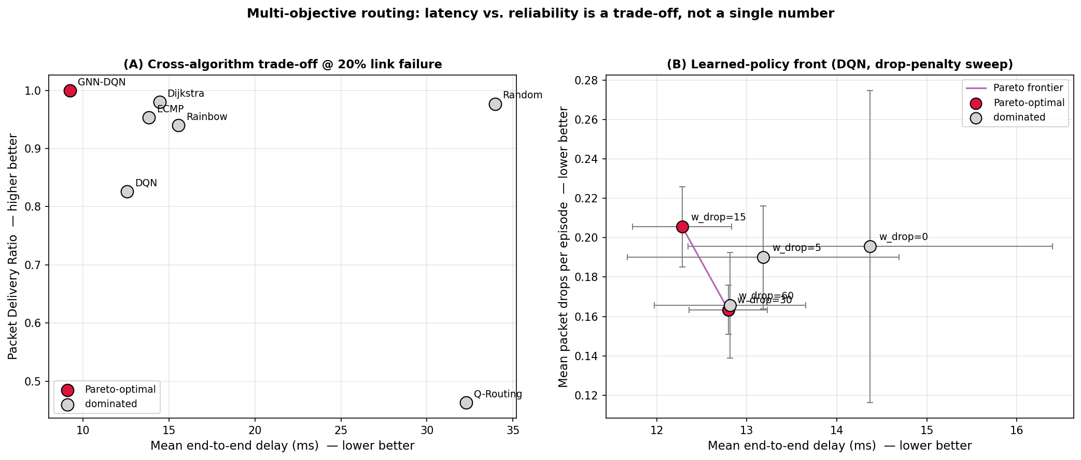
- Fig. 3. Cross-algorithm Pareto front (left) and the learned policy's own front obtained by sweeping the reward's drop-penalty weight (right).

Adversarial Robustness
Random link failures are average-case; a correlated outage or an attacker removes the most critical links. We compare random failures with a targeted attack that disables the highest edge-betweenness links at the same budget. At a 20% budget the GNN keeps PDR = 1.00 under both, whereas vanilla DQN collapses from 0.91 under random failures to 0.60 under the targeted attack, an exposure invisible to random-failure testing. (Dijkstra, which routes only the active subgraph, is shown as a hard-cut reachability reference rather than a competing policy.)
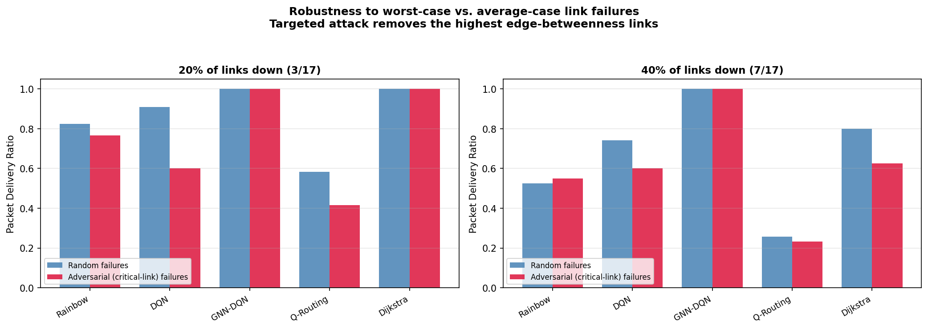
- Fig. 4. Delivery under random vs targeted (critical-link) failures.

Per-Flow Fairness
Aggregate PDR can hide starvation of individual source-destination flows. Computing Jain's index [11] over per-flow delivery at 20% failure, the GNN, Dijkstra and ECMP are perfectly fair (index 1.0, minimum per-flow PDR 1.0), whereas vanilla DQN and Q-Routing starve some flows (minimum per-flow PDR 0.0) despite high means (Jain 0.92 each). Fairness is therefore a distinct axis from mean delivery.

Continual Adaptation and Catastrophic Forgetting
A deployed agent must keep learning as demands change, but training on a new regime can overwrite the policy for the old one. We train a single DQN sequentially on two conflicting destination tasks on the same topology (deliver to nodes {7,8,9}, then to {0,1,2}) and measure the drop in delivery on the first task after learning the second (four seeds). Table III shows naive sequential training forgets catastrophically: Task-A delivery collapses from 0.77 to 0.09. Experience rehearsal, which simply retains old transitions in the replay buffer, fully prevents forgetting (it even improves slightly). EWC [10], the standard supervised continual-learning remedy, does not transfer here: because the policy is conditioned on the destination as an input feature, both tasks share the same weights, and a diagonal-Fisher anchor cannot isolate task-specific computation, so it performs no better than naive. The practical takeaway is that data-space rehearsal, nearly free in RL via the replay buffer, is the robust remedy.
- TABLE III. CATASTROPHIC FORGETTING AND REMEDIES. A|A = Task-A PDR after training A; A|B = after training B.
Method | PDR A|A | PDR A|B | Forgetting
Naive | 0.77 | 0.09 | +0.67
Rehearsal | 0.80 | 0.83 | -0.03
EWC | 0.82 | 0.11 | +0.71
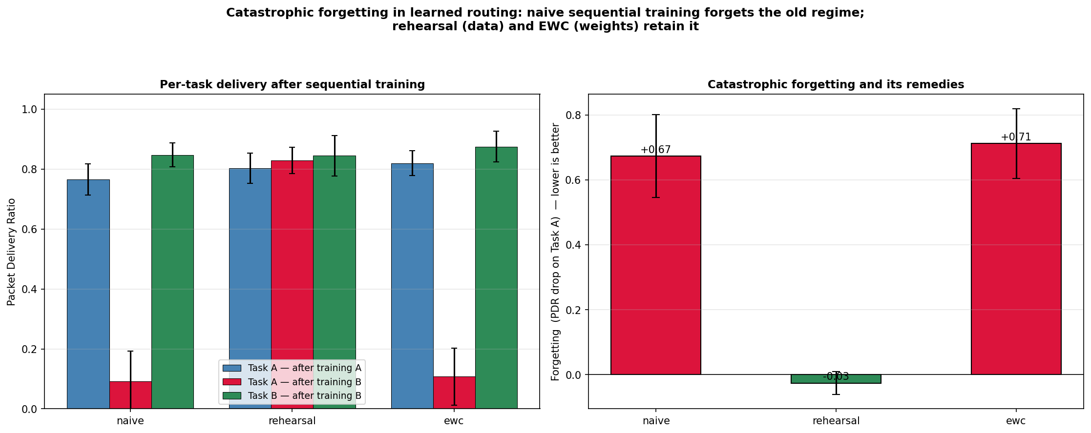
- Fig. 5. Per-task delivery after sequential training (left) and forgetting on the old task (right).

Discussion and Limitations
Three honest caveats frame these results. First, the simulator models failed links as high-penalty but traversable, so PDR saturates and the more discriminating metrics (delay stretch, targeted-failure delivery, fairness, forgetting) carry the analysis. Second, most experiments use a single 10-node topology; the scalability study addresses size but only for the GNN and without failures. Third, all results are in simulation; a localhost data-plane prototype forwards real packets and reroutes on failure, but a hardware testbed remains future work. These do not affect the qualitative findings, but they bound the strength of the claims.

Conclusion
We presented a unified, reproducible study of RL-based routing that looks past a single aggregate number. A structure-aware GNN policy is Pareto-optimal, transfers zero-shot to graphs five times larger, and resists targeted attacks that break a vanilla DQN. We further quantified catastrophic forgetting in learned routing and showed that simple experience rehearsal is a robust remedy where EWC is not. The code, tests and results are released to support reproduction and extension to larger and hardware testbeds.

References
- [1] J. A. Boyan and M. L. Littman, “Packet routing in dynamically changing networks: A reinforcement learning approach,” in Adv. Neural Inf. Process. Syst. (NeurIPS), 1994.
- [2] V. Mnih et al., “Human-level control through deep reinforcement learning,” Nature, vol. 518, pp. 529–533, 2015.
- [3] Z. Wang et al., “Dueling network architectures for deep reinforcement learning,” in Proc. ICML, 2016.
- [4] T. Schaul, J. Quan, I. Antonoglou, and D. Silver, “Prioritized experience replay,” in Proc. ICLR, 2016.
- [5] M. Hessel et al., “Rainbow: Combining improvements in deep reinforcement learning,” in Proc. AAAI, 2018.
- [6] W. L. Hamilton, R. Ying, and J. Leskovec, “Inductive representation learning on large graphs,” in Adv. Neural Inf. Process. Syst. (NeurIPS), 2017.
- [7] K. Rusek et al., “RouteNet: Leveraging graph neural networks for network modeling and optimization in SDN,” IEEE J. Sel. Areas Commun., 2020.
- [8] P. Henderson et al., “Deep reinforcement learning that matters,” in Proc. AAAI, 2018.
- [9] R. Agarwal et al., “Deep reinforcement learning at the edge of the statistical precipice,” in Adv. Neural Inf. Process. Syst. (NeurIPS), 2021.
- [10] J. Kirkpatrick et al., “Overcoming catastrophic forgetting in neural networks,” Proc. Natl. Acad. Sci. (PNAS), vol. 114, no. 13, 2017.
- [11] R. Jain, D. Chiu, and W. Hawe, “A quantitative measure of fairness and discrimination for resource allocation in shared systems,” DEC Research Report TR-301, 1984.
- [12] L. Kleinrock, Queueing Systems, Volume 1: Theory. Wiley, 1975.

