CHAT MESSENGER

Product Description

This system demonstrates the working of the single server multiple clients chat messenger using Linux system programming and C language. The system enables clients to send messages through server to each other on the same system. The system lets the user creates a file on each user client’s sign up and verifies the login of clients through those files. The system shows the list of all online clients on the login and allows the client to message them. The system logs all the messages on the server sent by one client to another.

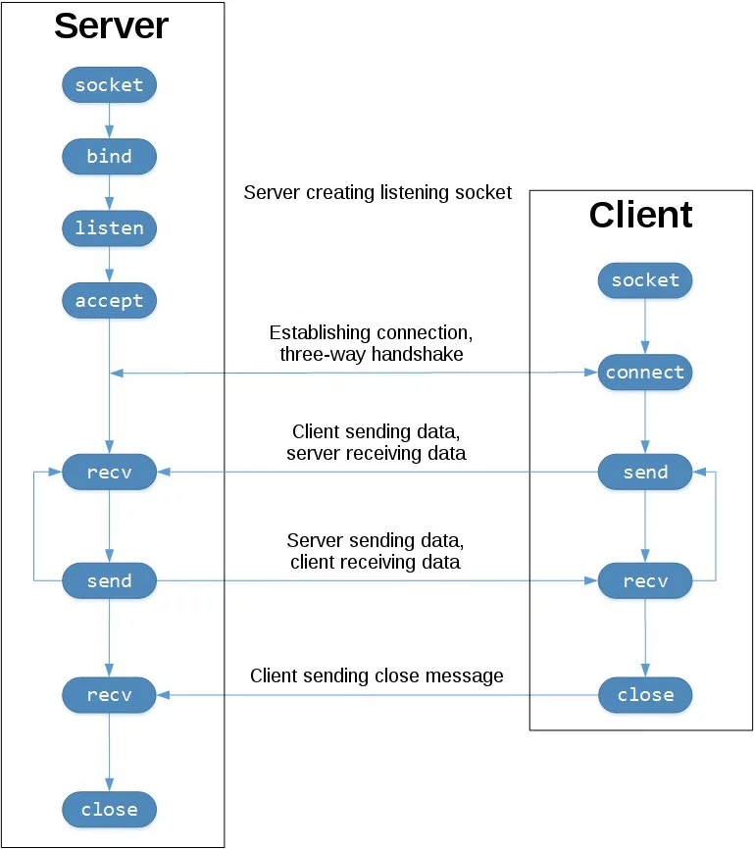

Note:

Through this project, we have demonstrated the software behind the working of a chat messenger, the input parameters may or may not be on the scale of the real world application.
This project solely based on the implementation of Processes, File Handling, GUI, IPC Techniques, Threads and TCP/IP Socket Protocol.

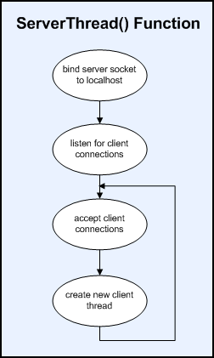

SOFTWARE REQUIREMENTS

Since this application is running on the Linux PC as proof of concept for constructing chat messenger using Linux process management system calls and IPC mechanisms, the GTK GUI is used to provide the system input parameters. The input parameters are username, password, and the message to be sent.

The software requirements for the chat messenger is identified and listed below:

SRS_01 | The software shall open the GUI Application on start of the server.
SRS_02 | The software shall create a file on the sign up of the client.
SRS_03 | The software shall verify the login credentials of the client
SRS_04 | The software shall log in the client to the server by creating a socket.
SRS_05 | The software shall monitor all the clients online continously and display it as a list on the screen.
SRS_06 | The software shall enable online clients to send message to each other.
SRS_07 | The software shall display all the messages sent and received to a particular client as a scrollable list.
SRS_08 | The software shall clear the list of all the messages sent and received to a particular client on the press of Clear Button.
SRS_09 | The software shall log the client out of the server by closing the socket.
SRS_10 | The software shall shutdown the server on the closing of the GUI Application.

DETAILED DESIGN

The Linux processes are created using fork and exec system calls. The communication between processes is possible using the Inter Process Communication techniques using Message Queues for the processes to send/receive messages to/from each other. Common information shared among different processes in the system is shared in the Shared Memory for proper read access to all the processes. Standard File Handling functions are used in the process to read from and write to a text file for recording the events taking place throughout the system.

The functionalities of the processes are listed in the table below:

S.No. | Process Name | Functions | Input Messages | Output Messages
1. | Server | 1. Responsible for creating master socket and child sockets.  2. Responsible for adding new accounts/users/clients to the server through sockets.  3. Responsible for displaying all the accounts.  4. Selects the client to which the message is need to send. | 1. Add account  2. Display account  3. Select account | 1. Display online users
2. | Client | 1. Responsible for sending messages to other clients.  2. Responsible for clearing all the messages sent.  3. Refreshes list of clients online. | 1. Send message.  2. Clear list of messages. | 1. Display list of online clients.  2. Display the messages sent and received.

