*Machine Learning and Pattern Recognition: CA2 Individual report Task 2 and 3*

Submitted By : Vaibhav Tiwari  
Student Number : 10621051  
Lecturer: Courtney Ford

In this report I have highlighted my contribution and reflection of learning in doing Task 2 and Task 3 of CA assigned. Furthermore, I have elaborated the three major topics that I had to learn and implement as a part of this assessment, which are – CNN, Transfer Learning and Text mining in Machine Learning.  
  
By definition a **Convolutional Neural Network** (CNN), is a class of neural networks that specializes in processing data that has a grid-like topology, such as an image. A digital image is a binary representation of visual data. It contains a series of pixels arranged in a grid-like fashion that contains pixel values to denote how bright and what colour each pixel should be. The data that falls under the receptive field is perceived and processed by the CNN. The various layers of CNN are arranged in a manner so as to detect all simple (lines, curves) and complex (faces, objects) patterns.

  
  
The different layers of a CNN architecture perform operations which will alter and learn according to the data. Some of these layers are –

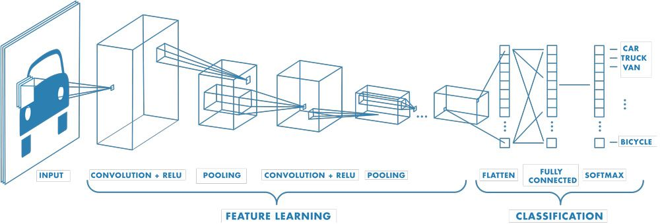

Convolution: puts the input images through a set of convolutional filters, each of which activates certain features from the images.

Rectified linear unit (ReLU): for faster and more effective training by mapping negative values to zero and maintaining positive values. This is sometimes referred to as activation, because only the activated features are carried forward into the next layer.

Pooling: Simplifies by reducing the number of parameters for the network.

These operations are repeated multiple times, with each layer learning to identify different features.

The final layer of the CNN architecture uses a classification layer to provide the final classification output.

**Transfer Learning** is a machine learning method where we reuse a pre-trained model as the starting point for a model on a new task.

we have implemented the Transfer Learning model using the following steps:

1. Obtain pre trained model

2. Create a base model

3. Freeze the layers

4. Add new trainable layers

5. Train the new layers

6. Fine-tune your model  
NLP is one of the most attractive applications of transfer learning. Transfer learning uses the knowledge of pre-trained AI models that can understand linguistic structures to solve cross-domain tasks. Everyday NLP tasks like next word prediction, question-answering, machine translation use deep learning models like BERT, XLNet, Albert, TF Universal Model, etc.

**Text Mining** is an artificial intelligence (AI) technology that uses natural language processing (NLP) to transform the free (unstructured) text in documents and databases into normalized, structured data suitable for analysis or to drive machine learning (ML) algorithms.  
For Text Mining, we used the following steps to plot the wine dataset –

1. Data Pre-processing - converting sentences to words, removal of punctuations and stop words, stemming and lemmatization.

2. Feature Extraction - The mapping from textual data to real valued vectors is called feature extraction. In text processing, words of the text represent discrete, categorical features.

3. Choosing ML Algorithms

We built the Sentiment Analyzer over the wine dataset using the steps mentioned above.  
  
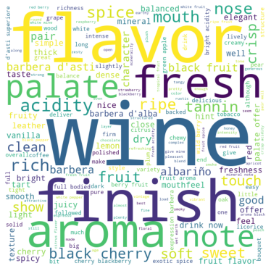

**REFERENCES -**

1. CNN -   
   https://towardsdatascience.com/convolutional-neural-networks-explained-9cc5188c4939

https://uk.mathworks.com/discovery/convolutional-neural-network-matlab.html

1. Transfer Learning in ML -   
   https://www.v7labs.com/blog/transfer-learning-guide#:~:text=In%20other%20words%2C%20transfer%20learning,when%20modeling%20the%20second%20task
2. Text Miner in ML -   
   https://towardsdatascience.com/machine-learning-text-processing-1d5a2d638958