

Machine Learning and Pattern Recognition: CA2 repeat.

Submitted By : Vaibhav Tiwari
Student Number : 10621051
Lecturer: Courtney Ford

VAIBHAV TIWARI | 1

In the subsequent analysis, I have employed a Naïve Bayes Classifier to ascertain if a patient has COVID-19 based on the provided dataset, using a mathematical approach.

Suppose X represents the variables and Y signifies the Result. In this case, X is a set rather than individual factors, therefore, X consists of {X1,X2,X3,X4,X5}, where each attribute represents distinct variables like Fever, Sore Throat, etc. The probability of the result, denoted by P(Y), is referred to as the prior probability. P(Y|X) is the conditional probability that denotes the likelihood of a result given the value of X. All the computations were carried out using the Bayes Theorem formula, which can be stated as:

P(Y|X) = (P(Y)* P(X|Y))/ P(X)

Step 1: Calculate the Prior Probability P(Y)
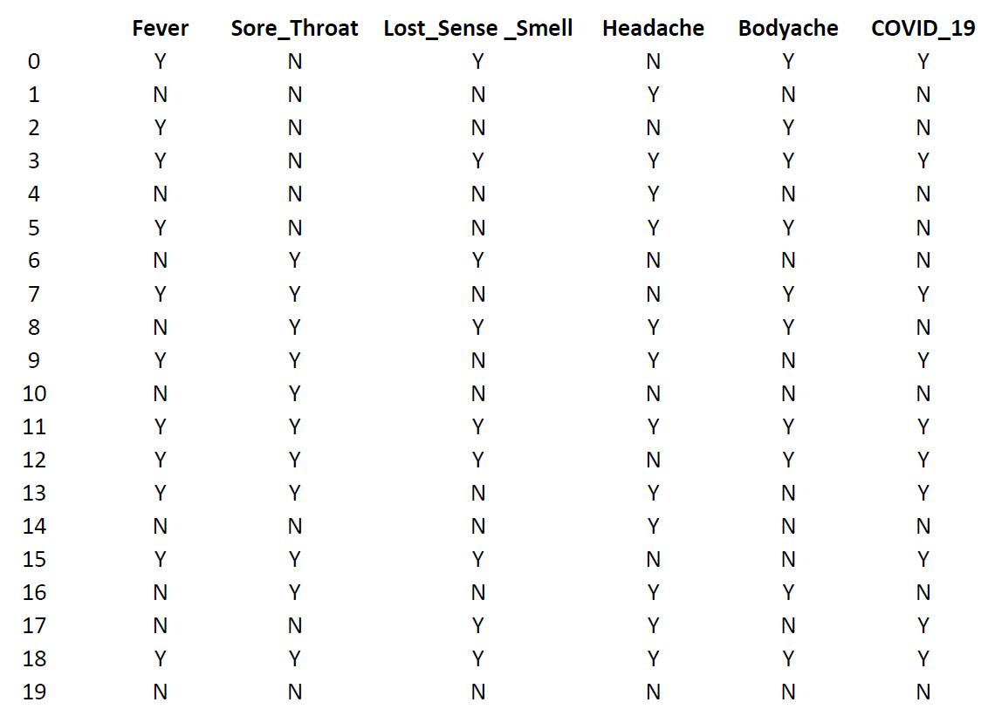

This dataset includes two potential outcomes: COVID_19 can either be 'Yes' or 'No'.

Considering the provided dataset, we have 20 entries in total, with 10 entries for the 'Yes'
class and 10 entries for the 'No' class. The outcome probabilities are therefore calculated as
follows:
P(Y=No) = 10/20
P(Y=Yes) = 10/20

VAIBHAV TIWARI | 2

Step 2: Calculating the Class Conditional Probability P(Xi | Y)

Given that class conditional probability is the likelihood of each possible value for an attribute relative to each potential outcome, I have executed the same computations for all the attributes. These attributes include Fever (X1), Sore Throat (X2), Loss of Sense of Smell (X3), Headache (X4), and Bodyache (X5), and have been computed for every distinct outcome value.

Class Conditional Probability of Fever:
Fever (X1) | P(X1|Y)=No | P(X1|Y)=Yes
Yes | 2/10 | 9/10
No | 8/10 | 1/10
Class Conditional Probability of Sore Throat:
Sore Throat (X2) | P(X2|Y)=No | P(X2|Y)=Yes
Yes | 4/10 | 7/10
No | 6/10 | 3/10
Class Conditional Probability of Lost Sense Smell:
Lost Sense Smell (X3) | P(X3|Y)=No | P(X3|Y)=Yes
Yes | 2/10 | 7/10
No | 8/10 | 3/10
Class Conditional Probability of Headache:
Headache (X4) | P(X4|Y)=No | P(X4|Y)=Yes
Yes | 6/10 | 6/10
No | 4/10 | 4/10
Class Conditional Probability of Bodyache:
Bodyache (X5) | P(X5|Y)=No | P(X5|Y)=Yes
Yes | 4/10 | 6/10
No | 6/10 | 4/10

Step 3: Create Test Record:

Having established the class conditional probabilities, these can now be used for prospective predictive tasks. I have formulated a new, unlabelled test record consisting of the following attributes:
 | Fever | Sore | Lost Sense | Headache | Bodyache | COVID-19
 | (X1) | Throat | Smell | (X4) | (X5) | (Y)
 |  | (X2) | (X3)
Unlabelled | Y | Y | N | N | N | ?
Test 1
Unlabelled | Y | N | N | N | N | ?
Test 2
Unlabelled | N | N | Y | Y | Y | ?
Test 3

VAIBHAV TIWARI | 3

Step 4: Predicting the outcome using Bayes’ Theorem:

Consider the first case from the above created table:
 | Fever | Sore | Lost Sense | Headache | Bodyache | COVID-19
 | (X1) | Throat | Smell | (X4) | (X5) | (Y)
 |  | (X2) | (X3)
Unlabelled | Y | Y | N | N | N | ?
Test 1

P(Y=Yes|X) = P(Y=Yes)* {P(Fever=Y|Y=Yes)*P(Sore_Throat=Y|Y=Yes)*
P(Lost_Sense_Smell=N|Y=Yes)*P(Sore_Headache=N|Y=Yes)* P(Bodyache=N|Y=Yes)} / P(X)

- 10/20*{9/10*7/10*2/10*6/10*4/10}/P(X)
=0.5*0.0302/P(X)

=0.0151/P(X)

Similarly,

P(Y=No|X)= 10/20*{1/10*3/10*8/10*4/10*6/10}/P(X)
=0.0028/P(X)

Normalizing both the estimates by dividing both by (0.0151+0.0028) to get:

Likelihood of (COVID_19=Yes) = 0.0151/0.0179 = 84.35%
Likelihood of (COVID_19=No) = 0.0028/0.0179 = 15.64%

In this case, P(Y=Yes|X) > P(Y=No|X), hence the prediction of our selected unlabelled test record will be COVID_19 = Yes

Step 5: Applying the above to other test samples:

Similarly, Using the next two created test sample cases:

 | Fever | Sore | Lost Sense | Headache | Bodyache | COVID-19
 | (X1) | Throat | Smell | (X4) | (X5) | (Y)
 |  | (X2) | (X3)
Unlabelled | N | N | Y | Y | Y | ?
Test 2

P(Y=Yes|X) = P(Y=Yes)* {P(Fever=N|Y=Yes)*P(Sore_Throat=N|Y=Yes)*
P(Lost_Sense_Smell=Y|Y=Yes)*P(Sore_Headache=Y|Y=Yes)* P(Bodyache=Y|Y=Yes)} / P(X)
=10/20*{2/10*4/10*7/10*6/10*6/10}/P(X)
=0.5*0.02016/P(X) = 0.01008/P(X)

P(Y=No|X) = 0.01152 /P(X)

VAIBHAV TIWARI | 4

Normalizing both the estimates by dividing both by (0. 01008+0. 01152) to get:

Likelihood of (COVID_19=Yes) = 0. 01008/0.0216 = 47%
Likelihood of (COVID_19=No) = 0. 01152/0.0216 = 53%

In this case, P(Y=Yes|X) < P(Y=No|X), hence the prediction of our selected unlabelled test record will be COVID_19 = No

 | Fever | Sore | Lost Sense | Headache | Bodyache | COVID-19
 | (X1) | Throat | Smell | (X4) | (X5) | (Y)
 |  | (X2) | (X3)
Unlabelled | Y | N | N | N | N | ?
Test 3

P(Y=Yes|X) = P(Y=Yes)* {P(Fever=Y|Y=Yes)*P(Sore_Throat=N|Y=Yes)*

P(Lost_Sense_Smell=N|Y=Yes)*P(Sore_Headache=N|Y=Yes)* P(Bodyache=N|Y=Yes)} / P(X)
=10/20*{9/10*4/10*2/10*6/10*4/10}/P(X)
=0.5*0.01728/P(X) = 0.00864/P(X)

P(Y=No|X) = 0.00576/P(X)

Normalizing both the estimates by dividing both by (0.00864+0.00576) to get:

Likelihood of (COVID_19=Yes) = 0.00864/0.0144 = 60%
Likelihood of (COVID_19=No) = 0.00576/0.0144 = 40%

In this case, P(Y=Yes|X) > P(Y=No|X), hence the prediction of our selected unlabelled test record will be COVID_19 = Yes

REFERENCES:

EXAM Naive Bayes - Working an ExampleFile - https://elearning.dbs.ie/mod/resource/view.php?id=1373911

VAIBHAV TIWARI | 5

