DocProjectNameStr
DocMainTitleStr
DocSubTitleStr
tmpAdditionalMetaData
DocControlledInfoFront

 |  | Total pages: | 52

Doc. Title: | Flash EPG - Search Feature High Level Design

Doc. No.: | DocDesignationStr |  | Classification: | DocClassificationStr

Revision: | 2.00 |  | Restriction: | DocDistributionStr

Date: | DocReleaseDate |  | Customer: | DocCustomerNameStrNA

Owner: | Madhusudhan Reddy |  | Reviewers/  Approvers: | FLAG
Author: | Madhusudhan Reddy |  | Reviewers/  Approvers: | FLAG

Contents
1 Preface 5
1.1 Purpose of This Document 5
1.2 References 5
1.3 Concepts and Terms 6
2 Abstract 7
3 Requirements 8
3.1 Functional Requirements 8
3.2 Non-Functional Requirements 8
3.3 Assumptions 8
3.4 Constraints 8
4 State machine 9
5 Use Cases 11
5.1 Keypad with next available char enabled 11
5.2 Keypad to support multi keyword without characters disable 11
5.3 Auto population of keywords 12
5.4 Advance criteria selection 12
5.5 Display search result count on each criteria selection 13
5.6 Display search result 13
5.7 Retrieval of collapsed item and display its contents 14
5.8 Sorting on search results 14
5.9 Retrieval of related items of selected search result item 16
5.10 Auto population of results 16
5.11 Genre & Time search 16
6 Use case mapping 18
6.1 Screens to use case mapping 18
6.2 Screens to use case mapping 19
7 Detailed Design 20
7.1 Data Model 20
7.1.1 SearchDataSource 20
7.1.2 AutoCompleteModel 21
7.1.3 AdvancedSearchModel 21
7.1.4 SearchWindowModel 21
7.1.5 SearchResultModel 22
7.2 Search screens and business widgets 22
7.2.1 Keyword search business widget (new change for new multi keyword search) 22
7.2.2 Keyword search screen 27
7.2.3 Advance search screen 29
7.2.4 Search result screen 30
7.3 Use Case Realization 32
7.3.1 Keypad with next available char enabled 33
7.3.2 Auto population of keywords 34
7.3.3 Advance criteria selection 35
7.3.4 Advance criteria selection for leaf criteria 36
7.3.5 Display search result 37
7.3.6 Retrieval of collapsed item and display its contents 38
7.3.7 Sorting on search results 39
7.3.8 Retrieval of related items of selected search result 40
7.3.9 Auto population of search results 40
8 Actions menu 41
9 Exception handling 42
9.1 Abstract 42
10 Design Open Issue 43
11 System Open Issues 44
12 EPG Tailoring 45
13 Keyword caching 46
13.1 Class diagram 46
13.1.1 CachedSuggestedKeyword 46
13.1.2 KeywordCache 47
13.1.3 CacheSearchDataSource 47
13.2 Sequence diagram 48
13.2.1 Caching the results and reading 48
14 Appendix 51
14.1 Search context 51
Change History 52
List of Tables
Table 1 References 4
Table 5 Technical Glossary 4

Preface

Purpose of This Document
The purpose of this document is to present the high level design of the Search feature in Flash EPG. This document is intended to provide the high level design as a reference to the EPG developer modifying/customizing/enhancing the Store auxiliary application for Flash EPG.
Enhancement:
From Canal Digital project new multi keyword search is introduced. The design document is updated for the same in below section 7.2.1.

References
Table 1 lists documents and other reference sources containing information that may be essential to understanding topics in this document.
Table 1 References
No. | Designation | Title
 | EPG Architecture | http://doogle:90/Download.aspx?ObjectID=!V3!ILDMPRODUCTION1!C!D$234096!D (view only)  http://doogle/worksitemp/link/V3/ILDMPRODUCTION1/C/D$234096/ (launch in Doogle)
 | Inter Aux App State Transition | http://doogle:90/Download.aspx?ObjectID=!V3!ILDMPRODUCTION1!C!D$221863!D (view only)  http://doogle/worksitemp/link/V3/ILDMPRODUCTION1/C/D$221863/ (launch in Doogle)
3. | State Event Dispatcher | http://doogle:90/Download.aspx?ObjectID=!V3!ILDMPRODUCTION1!C!D$236895!D (view only)  http://doogle/worksitemp/link/V3/ILDMPRODUCTION1/C/D$236895/ (launch in Doogle)
4. | Multi keyword search | FSION-DSN-3294 WP2439 - New Search  http://doogle:90/Download.aspx?ObjectID=!V3!ILDMPRODUCTION1!C!D$274061!D (view only)  http://doogle/worksitemp/link/V3/ILDMPRODUCTION1/C/D$274061/ (launch in Doogle)

Concepts and Terms
NA.

Abstract
Search application provides the following features.

- Keyword search, auto population of keywords for selected characters.
- Advanced search (or More Options), selecting multiple search criteria to narrow down the results on following criteria
  - Keyword
  - Genre
  - Channel
  - Day
  - Day part
  - Video format
- Search result based on the selected keyword or criteria from advance search.
- Sorting on the Search results, supports following sorts based on
  - Availability
  - Price
  - Source
  - Relevancy
- Retrieve related content based on the result selection.
- Context based search, the context depend on the place of Search app launch, refer Appendix 12.1.
- Actions on the search result based on the content type.

Requirements

Functional Requirements
Below is the list of main use cases in Search:
- Keypad with next available char enabled.
- Keypad to support multi keyword without characters disables.
- Auto population of keywords.
- Advance criteria selection.
- Display search result count on each criteria selection.
- Display search result.
- Retrieval of collapsed item and display its contents.
- Sorting on search results.
- Retrieval of related items of selected search result.
- Auto population of results.

Non-Functional Requirements
None.

Assumptions
None.

Constraints
None

State machine
This section show the state diagram of Store feature.
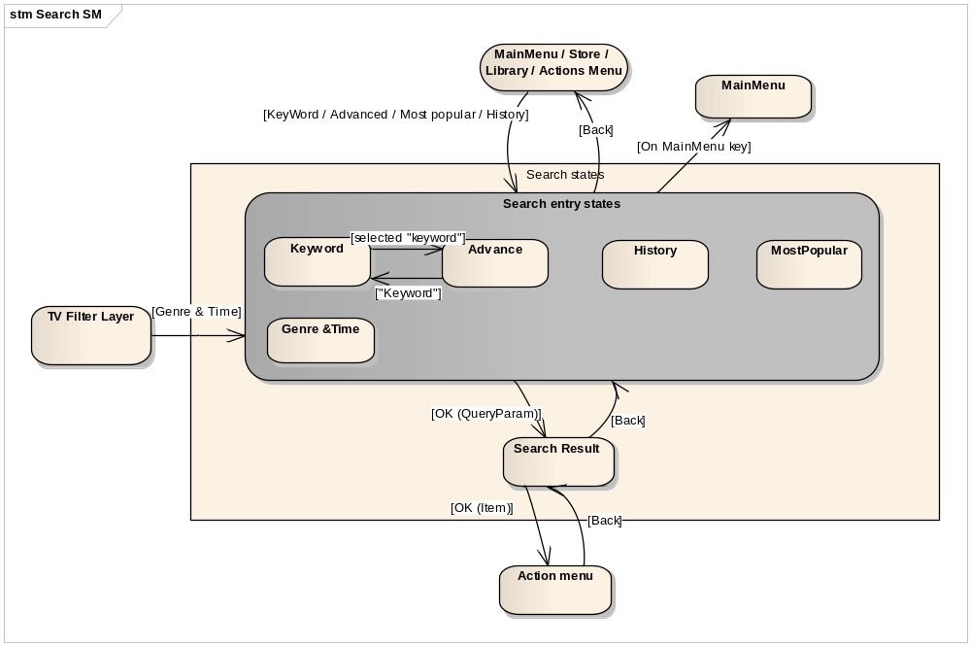
Fig 1: Search app state machine
- Keyword state
Display Keypad, and auto populate keyword on each character enter.
- Advance state
Display all criteria for selection, on each selection auto search result and display result count for the selection.
- Most Popular state
Retrieves and display most popular search from head end.
- History state
Retrieve and display past search history.
- Genre & Time state
Introduced as part of the CD project, it displays the genre list when enter the state, after user selected Genre, displays Time options, and after time selection directly go to search result screen.
- Search result state
Start search based on the search criteria in search entry states, retrieve and display results.

Use Cases

Keypad with next available char enabled
Use Case Section | Comment
Use case name | Enables keypad dynamically based on the result availability.
Use Case Number | UC_SRCH_1
Preconditions | Search application launched and SearchEngine instance get created.
Post condition | Keypad with language specific char set displayed.
Main Success Scenario | - For first time the keypad displayed with all char of selected language.  - After each user selection, it automatically enables only the next available char to search.
Extensions | Any success or failure alternative scenario.  - If any failure in search, display error message.
Miscellaneous | NA

Keypad to support multi keyword without characters disable
Use Case Section | Comment
Use case name | Keypad to support multi keyword without characters disable.
Use Case Number | UC_SRCH_2
Preconditions | Search application launched and SearchEngine instance get created.
Post condition | Keypad with language specific char set displayed.
Main Success Scenario | - In new search, user can enter multi keywords with space in between.  - After each character entry, it fetches the suggestions for the entered keyword.
Extensions | Any success or failure alternative scenario.  - If any failure in search, display error message.
Miscellaneous | NA

Auto population of keywords
Use Case Section | Comment
Use case name | Search and retrieve keyword for each char entered.
Use Case Number | UC_SRCH_3
Preconditions | Search application launched and SearchEngine instance created.
Post condition | Keywords are displayed.
Main Success Scenario | - Build keyword search QueryParam with user entered chars.  - Start keyword search, after search complete event, keywords are retrieved and displayed.
Extensions | Any success or failure alternative scenario.  - If any failure in search, display error message.
Miscellaneous | NA

Advance criteria selection
Use Case Section | Comment
Use case name | Select multiple criteria to narrow down the search.
Use Case Number | UC_SRCH_4
Preconditions | Search application launched, SearchEngine instance created and Advance criteria displayed.
Post condition | Search result count is displayed for selected criteria.
Main Success Scenario | - Start search after each criteria selection.  - After search complete notification, retrieve result count and displayed.
Extensions | Any success or failure alternative scenario.  - If any failure in search, display error message.
Miscellaneous | NA

Display search result count on each criteria selection
Use Case Section | Comment
Use case name | Display result count after each criteria selection.
Use Case Number | UC_SRCH_5
Preconditions | Advance option selected and entered to advance screen, and all criteria is displayed.
Post condition | Results count displayed.
Main Success Scenario | - Start search with the selected advance criteria.  - After search complete, retrieve and display result count.
Extensions | Alternative flow  - If any failure in search, display error message..
Miscellaneous | NA

Display search result
Use Case Section | Comment
Use case name | Display result for either keyword or Advance search.
Use Case Number | UC_SRCH_6
Preconditions | Keyword or advance criteria selected.
Post condition | Results are retrieved and displayed.
Main Success Scenario | - Start search with the criteria keyword or advanced.  - After search complete, retrieve and display results.
Extensions | Alternative flow  - If any failure in search, display error message..
Miscellaneous | NA

Retrieval of collapsed item and display its contents
Use Case Section | Comment
Use case name | Retrieve and display contents of collapsed item.
Use Case Number | UC_SRCH_7
Preconditions | Search results are retrieved and displayed.
Post condition | Contents of collapsed item displayed.
Main Success Scenario | - Build Query and start search.  - After search complete, receive and display contents.
Extensions | Any success or failure alternative scenario.  - If any failure to retrieve, display error message.
Miscellaneous | NA

Sorting on search results
Use Case Section | Comment
Use case name | Sort and display search results.
Use Case Number | UC_SRCH_8
Preconditions | Search results are displayed.
Post condition | Search results are displayed according to the sort criteria.
Main Success Scenario | - Add sort criteria to previous Query and start search.  - After search completion, retrieve and display contents.
Extensions | Any success or failure alternative scenario.  - If any failure to retrieve, display error message.
Miscellaneous | NA

Retrieval of related items of selected search result item
Use Case Section | Comment
Use case name | For each selection on search result, retrieve its related content and display.
Use Case Number | UC_SRCH_9
Preconditions | Search results are retrieved and displayed.
Post condition | Related items are retrieved and displayed.
Main Success Scenario | - Build Query and add selected item and start search.  - After search complete, retrieve and display search results.
Extensions | Any success or failure alternative scenario.  - If any failure to retrieve, display error message.
Miscellaneous | NA

Auto population of results
Pending, Cogeco work.

Genre & Time search
Use Case Section | Comment
Use case name | New search introduced from Canal Digital.
Use Case Number | UC_SRCH_11
Precondition | STB is booted and initialized and EPG running.
Post condition | Search result displayed for the selected genre and time.
Main Success Scenario | - User selected Genre&Time search sub-option from the TV filter menu.  - User presented with list of Genres, and after selection, present with Time options.  - After user selected Time, goto search result screen to search based on the user selected genre and time.  - This is a sub-set of the options in advanced search.
Extensions | Any success or failure alternative scenario.  - If any failure to retrieve, display error message.
Miscellaneous | NA

Use case mapping

Screens to use case mapping
- Search application support three screens 1. Keyword, 2. Advance, 3. Search result.
- Uses the EPG action menu framework to display user actions for the selected item.
This section provides the mapping of screen to use cases.

 | Use cases/ Screens | Keyword screen | Multi word screen | Advance screen | Genre & Time | Search result screen | Actions Menu
UC_SRCH_1 | Auto keypad with next available char enabled | YES | NO
UC_SRCH_2 | Multi word search |  | YES
UC_ SRCH _3 | Auto population of keywords. | YES | YES
UC_ SRCH _4 | Advance criteria selection. |  |  | YES
UC_ SRCH _5 | Display search results. |  |  | YES
UC_ SRCH _6 | Retrieval of collapsed item and display its contents. |  |  |  |  | YES
UC_ SRCH _7 | Sorting on search results. |  |  |  |  | YES
UC_ SRCH _8 | Retrieval of related items of selected search result item. |  |  |  |  | YES
UC_ SRCH _9 | Search actions menu. |  |  |  |  |  | YES
UC_SRCH_10 | Auto population of results
UC_SRCH_11 | Genre & Time selection. |  |  |  | YES

Screens to use case mapping

 | Use cases/ Screens | UPC | Cogeco | Canal Digital
UC_SRCH_1 | Auto keypad with next available char enabled | YES | YES
UC_SRCH_2 | Multi word search |  |  | YES
UC_ SRCH _3 | Auto population of keywords. | YES | YES
UC_ SRCH _4 | Advance criteria selection. | YES
UC_ SRCH _5 | Display search results. | YES | YES
UC_ SRCH _6 | Retrieval of collapsed item and display its contents.
UC_ SRCH _7 | Sorting on search results. | YES
UC_ SRCH _8 | Retrieval of related items of selected search result item. | YES
UC_ SRCH _9 | Search actions menu. | YES | YES
UC_SRCH_10 | Auto population of results
UC_SRCH_11 | Genre & Time selection. |  |  | YES

Detailed Design

Data Model
Store has two data models 1. StoreDataModel to retrieve the VOD catalogue and purchase the VOD content and 2. AssetBarkerModel to retrieve barker asset. Class diagram
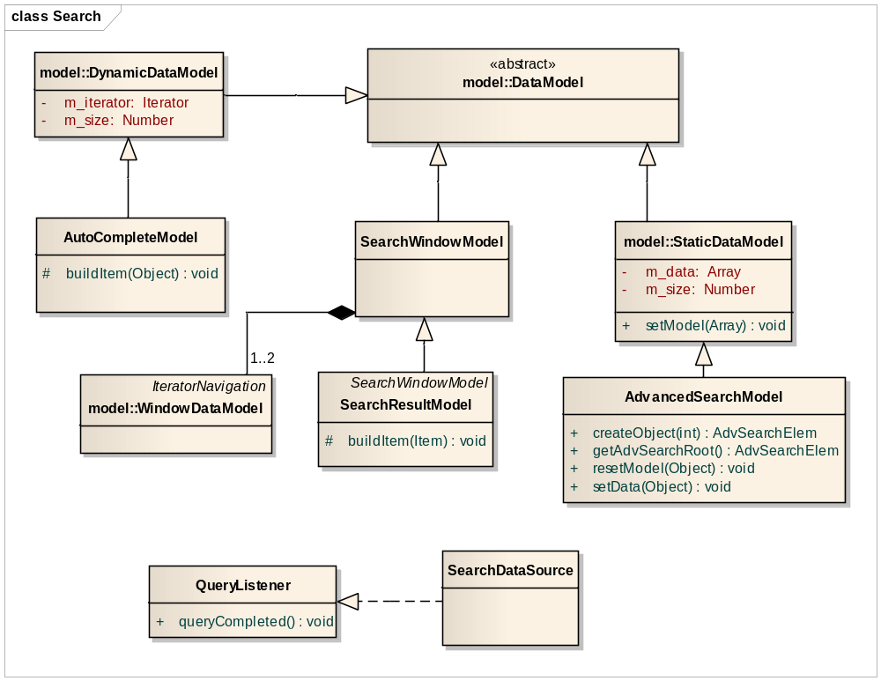
Fig 2. Search app model class diagram

SearchDataSource
CRC Card
SearchDataSource
Responsibilities | Collaborators
- Starts the search request. If any previous ongoing requests, it cancel and start new search.  - Listen to search complete event and notifies the registered listener.  - Provides the API to retrieve keywords, next enabled char set and search result. | FUAPI: SearchEngine, QueryResult

AutoCompleteModel
CRC Card
AutoCompleteModel
Responsibilities | Collaborators
- Derives from StaticDataModel, and build value object with keyword string and available search result count.

AdvancedSearchModel
CRC Card
AdvancedSearchModel
Responsibilities | Collaborators
- Builds candidate filters for the given criteria and start search.  - Builds filter criteria from search result iterator.  - Build final content query param to search. | - SearchDataSource  - QueryParam, QueryResult(FUAPI)

SearchWindowModel
CRC Card
SearchWindowModel
Responsibilities | Collaborators
- Derive from DataModel and provides the window based mechanism to navigate on the search result. | - QueryResult(FUAPI)

SearchResultModel
CRC Card
SearchResultModel
Responsibilities | Collaborators
- Derive from SearchWindowModel and override buildItem() to build value object based on content type.

Search screens and business widgets
This section lists the screens in search app and business widgets.

Keyword search business widget (new change for new multi keyword search)

The new search brings following changes to EPG keyword search functionality.
- EPG to implement the smart search of suggestions when user entering characters from soft keypad or from remote (only numeric keys from remote) based on the rules defined in the section x.x.
- Use new FUAPI for multi keyword suggestions.
- The WP suggests the EPG caching latest suggestion for configured number to allow quick retrieval on back keys.

Note: EPG is not in favor of implementing the result caching. If all agreed this use case can be dropped. Deferring the design for this until the common agreement.

This section address points 1 and 2, and point 3 will be implemented after the common agreements.

Class diagram

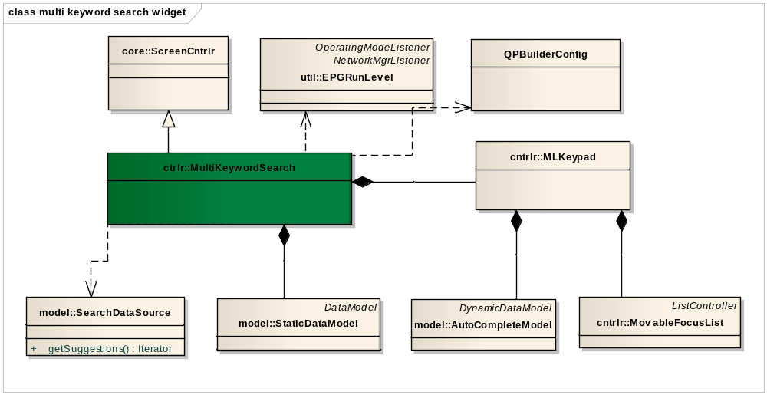
Fig 3: Multi keyword search

SearchDataSource
CRC Card
SearchDataSource
Responsibilities | Collaborators
- Provide extra API to get the possible suggestions.  - Modify queryCompleted() for suggestions not to update the possible next available characters. | - SearchEngine

SearchDataSource
CRC Card
SearchDataSource
Responsibilities | Collaborators
- Provide extra API to get the possible suggestions.  - Modify queryCompleted() for suggestions not to update the possible next available characters. | - SearchEngine

AutoCompleteModel
CRC Card
AutoCompleteModel
Responsibilities | Collaborators
1.Update the model to build the VO for suggestions.

QPBuilderConfig
CRC Card
QPBuilderConfig
Responsibilities | Collaborators
1.Update the CTXT_KEYWORD to add title/cast/synopsis’ filter to the suggestions Query.. | - QueryParam

Sequence diagram – suggestion fetch

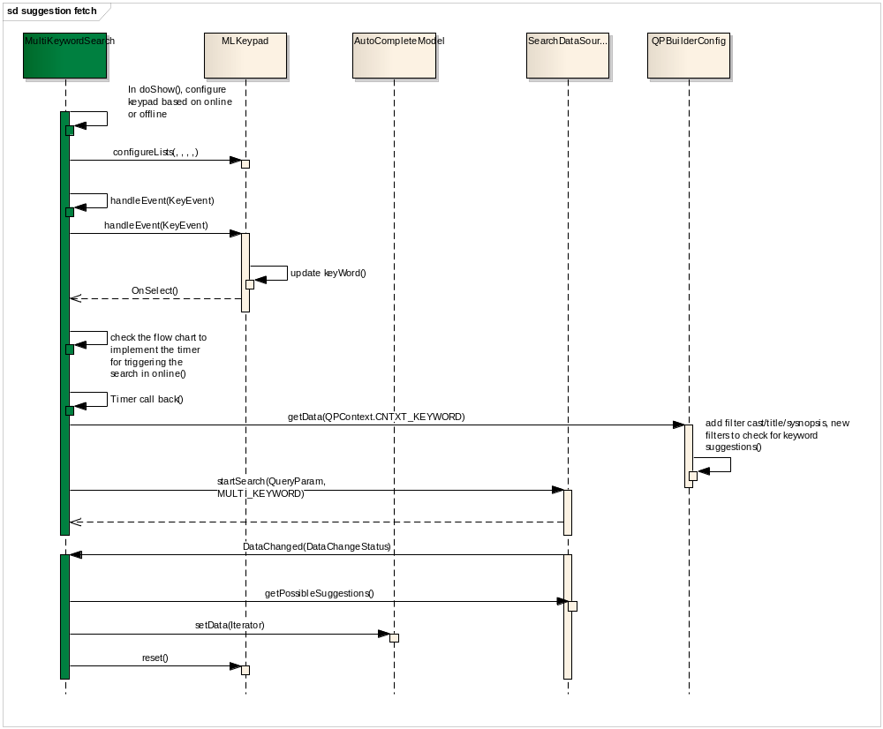
Fig 4: fetching multi keyword suggestions

Flow chart to implement Timer for smart fetch of suggestions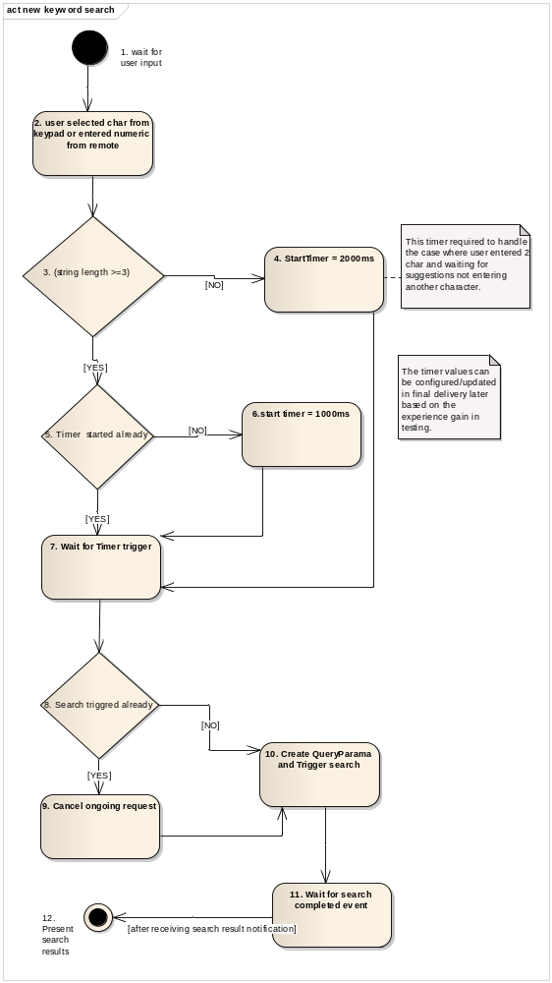

Changes to KeyPad and keys hard coding

In present implementation the keys are hardcoded in the CORE component, which is not flexible to allow different character set for different projects.
Following changes required to keypad filters, model and controller.
- EPG should not hardcode the keys registered to receive keys from key manager? Changes to SearchCtrl, KeyboardCtrl.
- The keys are duplicated in both SearchCtrl, KeyboardCtrl. Can move the keys to search configuration files.
- In KeypadModelFilter.buildModel() again the keys are hardcoded, can move all hard coding to configuration.
- The basic keys is mapped to its corresponding character and also disable/enable status, this can be completely removed.

Multi line keypad for the design.
Flash_EPG_MultiLine_KeyPad_design
http://doogle:90/Download.aspx?ObjectID=!V3!ILDMPRODUCTION1!C!D$277868!D (view only)
http://doogle/worksitemp/link/V3/ILDMPRODUCTION1/C/D$277868/ (launch in Doogle)

Keyword search screen
It preset with keypad and on each char entered it auto populate the keywords and display.
Following are the list of features.
- Initial keypad with all char enabled.
- Aft each char entered, based on the available keywords, it fetches next available char set and enable only those, and disable all other char in the keypad.
- For each keyword, present the number of available results.
- On keyword selection it navigates to Search result screen.

Class diagram
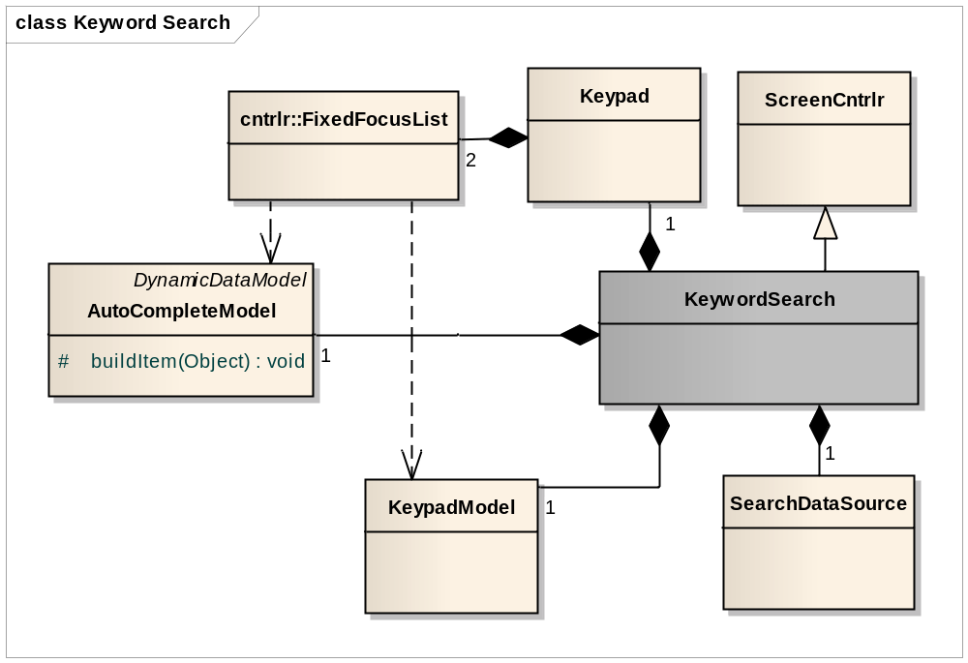
Fig 3. Keyword search screen class diagram

KeywordSearch screen ctrl
CRC Card
KeywordSearch
Responsibilities | Collaborators
- Creates Keypad, its models and associate.  - On each char entered build keyword QueryParam and start search for keyword using SearchDataSource.  - On search complete, retrieve next enabled char set and pass it to keypad model to update, and list of keywords to AutoCompleteModel to update the list.  - On keyword selection, build content QueryParam and navigate to Search Result screen with QueryParam. | SearchDataSource, KeyPad.

Keypad
CRC Card
Keypad
Responsibilities | Collaborators
- Business widget to handle both keypad widget and the vertical list for keywords.

Advance search screen
The screen is to select multiple search criteria to narrow down the search results.
It present user with all root level criteria and sub-criteria on selection. After each selection it retrieves the number of search results available for the current selection.

Class diagram
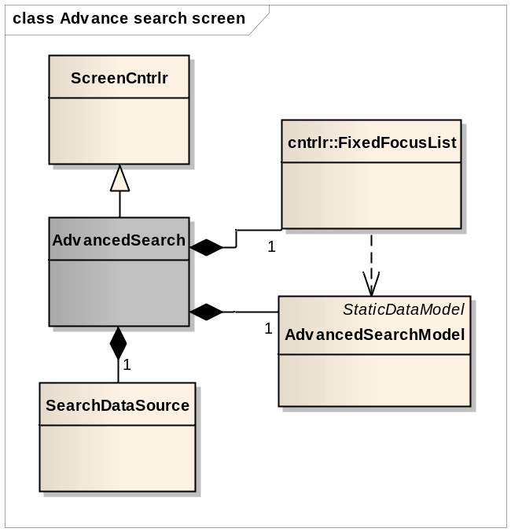
Fig 4. Advance search screen class diagram

AdvanceSearch
CRC Card
AdvanceSeacrh
Responsibilities | Collaborators
- Presents user with root criteria and sub-criteria to select.  - On each criteria selection, retrieves sub-criteria and present.  - After criteria selection, builds content QueryParam and navigate to Search result screen. | SearchDataSource.

Search result screen
The screen present user with search results, along with the options like sort and re-define search.
On each selection of the result item, it automatically fetches the related items for the selected item and present.

Class diagram
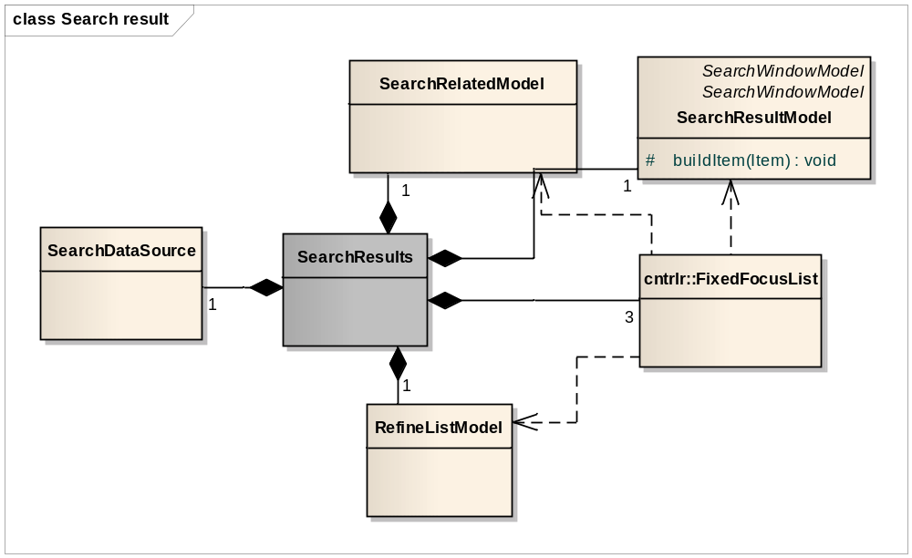Fig 5. Search result screen class diagram

Searchresult
CRC Card
Seacrhresult
Responsibilities | Collaborators
- Presents user with search result and options to sort the results along with related information of selected item. | SearchDataSource.

SearchRelatedModel
CRC Card
SearchRelatedModel
Responsibilities | Collaborators
- Presents user with search result and options to sort the results along with related information of selected item.

Use Case Realization
The following use cases are explained through sequence diagrams here.

Keypad with next available char enabled
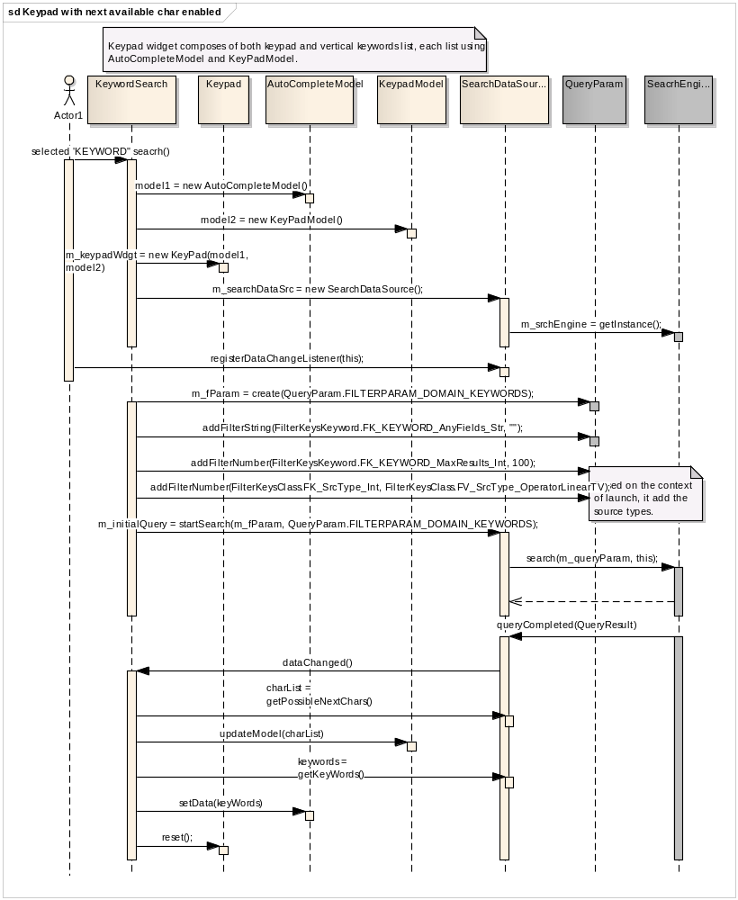
Fig 6. Keypad with next available char enabled

Auto population of keywords
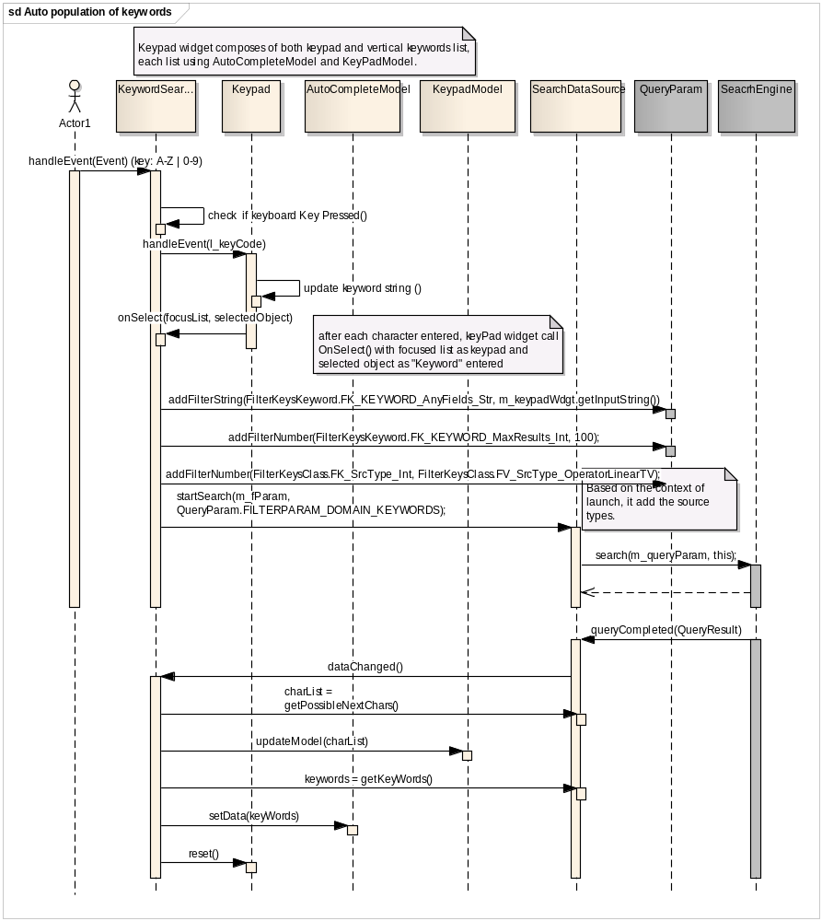
Fig 7. Auto population of keywords

Advance criteria selection
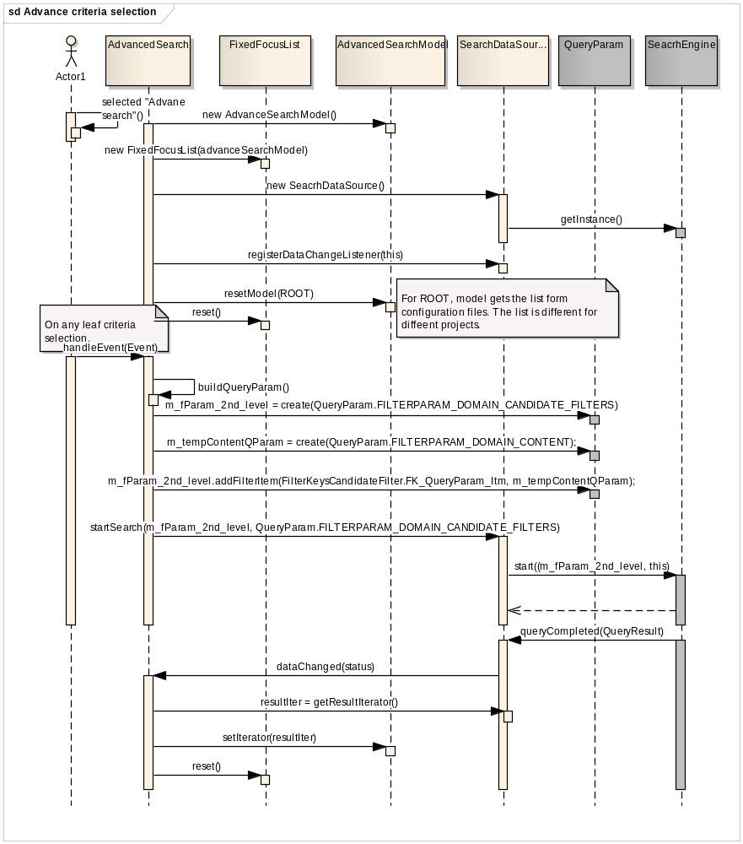
Fig 8. Advance criteria selection

Advance criteria selection for leaf criteria
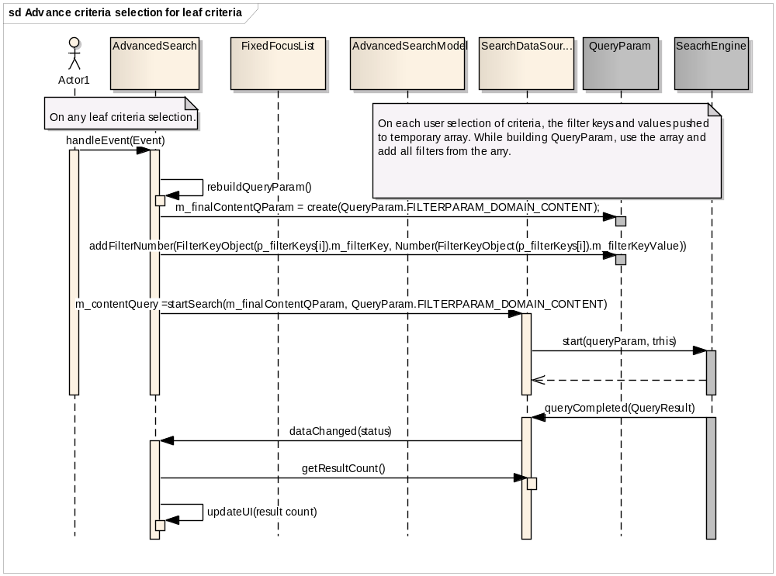
Fig 9. Advance criteria selection for leaf criteria

Display search result
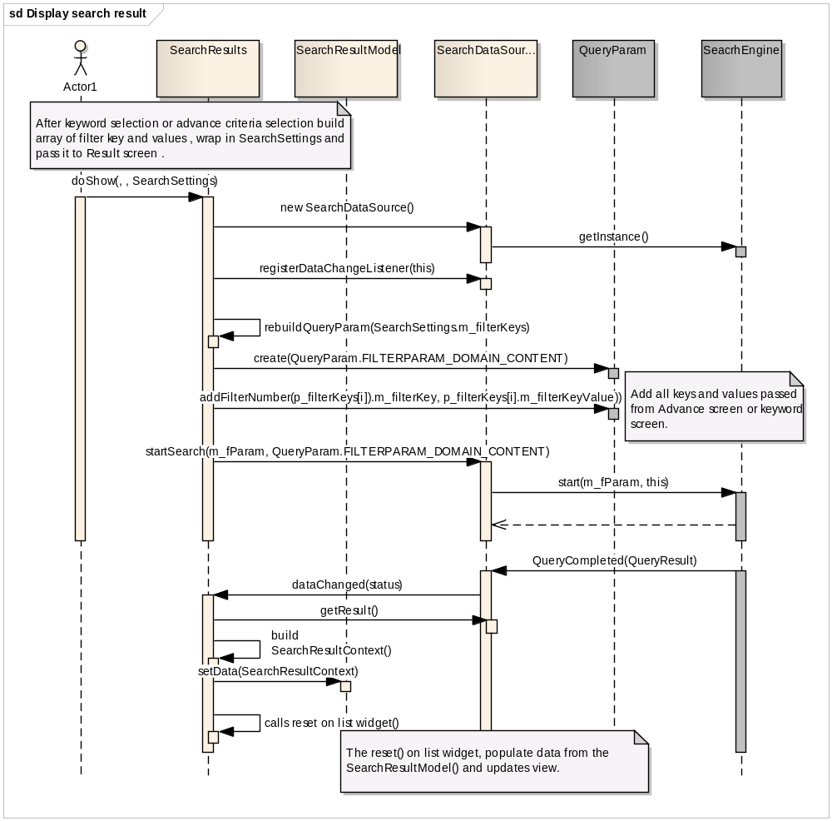
Fig 10. Display search result

Retrieval of collapsed item and display its contents
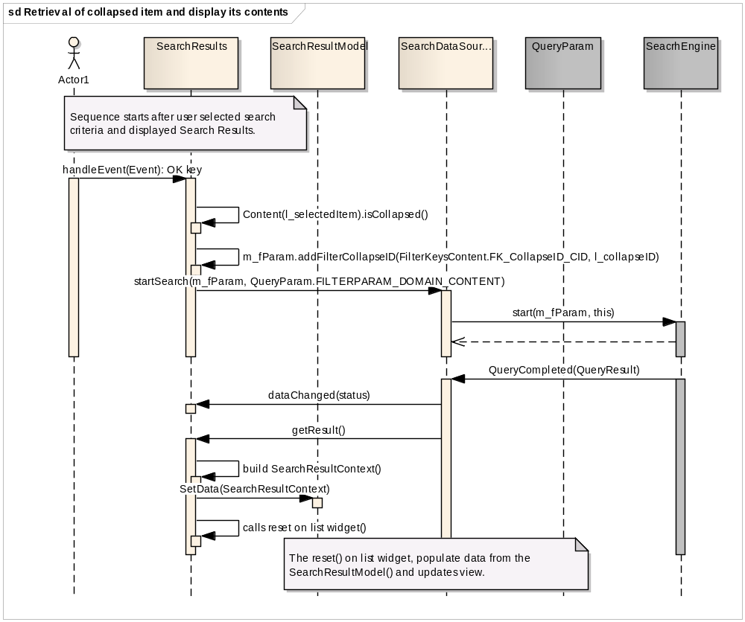
Fig 11. Retrieval of collapsed item and display its contents

Sorting on search results
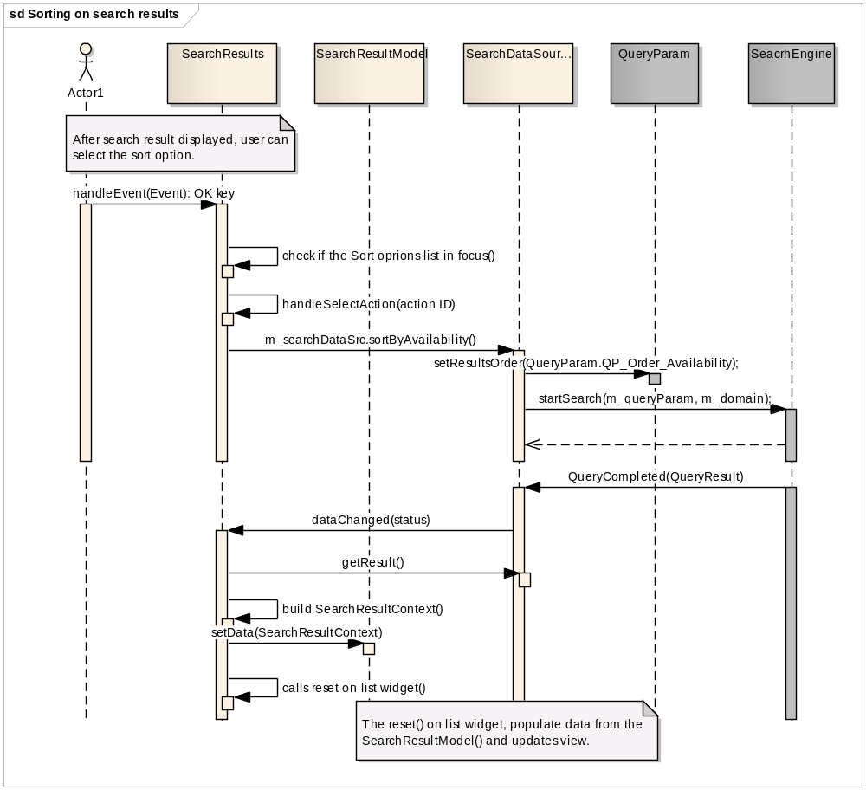
Fig 12. Sorting on search results

Retrieval of related items of selected search result
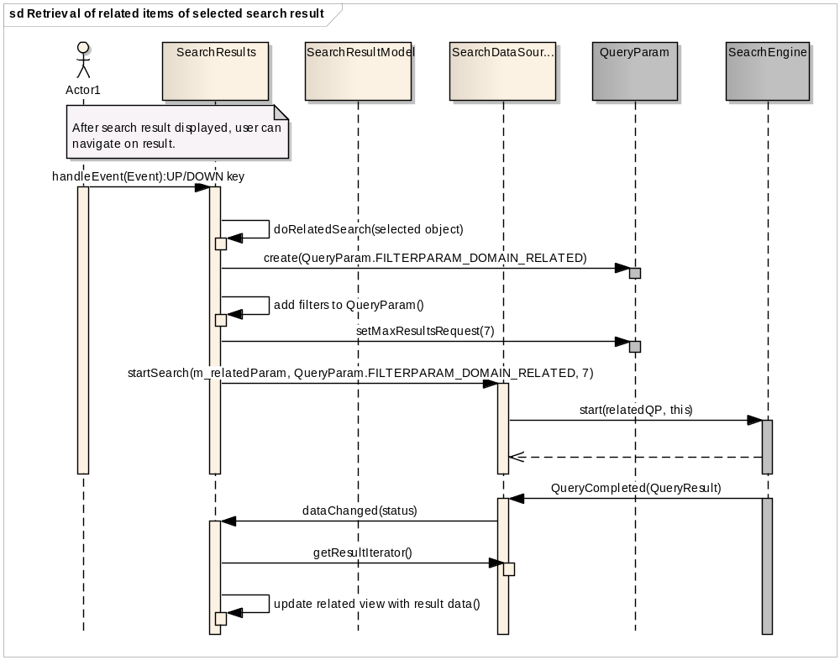
Fig 13. Retrieval of related items of selected search result

Auto population of search results
Pending, for Cogeco.

Actions menu

Exception handling

Abstract

Design Open Issue
- Feature configuration (EPG tailoring)

System Open Issues

EPG Tailoring
Pending.

Keyword caching
While user deleting the characters from the back of the entered keyword, EPG can improve the performance by caching the previously received results for the keyword, rather triggering search each time user enter a character.

This section provides the design for the keyword result caching in EPG.

Class diagram
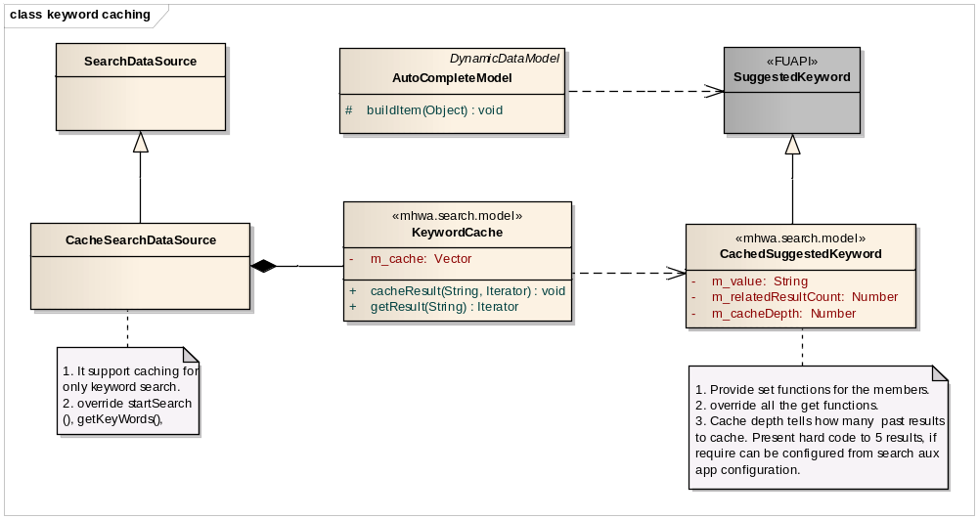
Fig 14: Caching keyword search results in EPG

CachedSuggestedKeyword
CRC Card
CachedSuggestedKeyword
Responsibilities | Collaborators
- It extends FUAPI class SuggestedKeyword and store value and related result count in class variables and override get functions to get from the class variables.

KeywordCache
CRC Card
KeywordCache
Responsibilities | Collaborators
- Caches the given keyword result Iterator along with the word used for the search.
- Converts SuggestedKeyword to CachedSuggestedKeyword.
- Stores all converted CachedSuggestedKeyword in an Array and store in vector for the given word.
- When requesting result, return null, if not cached, otherwise convert to Iterator and return.
- After result returned, remove from the cache.

CacheSearchDataSource
CRC Card
CacheSearchDataSource
Responsibilities | Collaborators
- It extends SearchDataSource and adds caching mechanism to keyword search, and no change for other searches. | - Keyword cache

Sequence diagram

Caching the results and reading
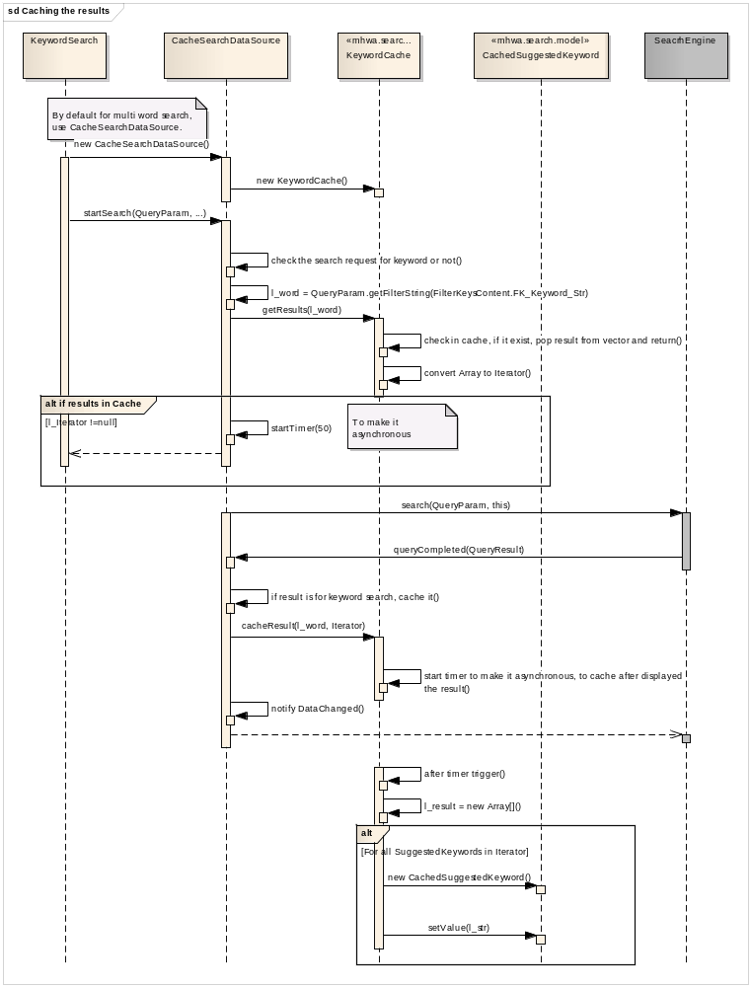
Fig 15: cache usage for keyword search

Appendix

Search context

The search application can be launched from UPC main menu, My library, store and Action menu.

The launch can direct the Search application to any of its high level state, listed below.
Depending from where the search is launched, it shall restrict the search results according to the following rules.

Main menu: All sources.
Store: only VOD, SVOD catalogue and Interactive applications.
Brand Store with in Store: Only VOD, SVOD catalogue and Interactive applications available for this brand.
Library: Only PVR content including VoD asset purchased (and still valid) and SVoD (purchased, started and still valid).
Actions menu: context-dependent (meaning from where the action menu has been initiated which leads to a specific channel brand/store for example.)

Change History

Issue DocReleaseStr.DocReleaseDraftStr
Issue date: DocReleaseDate2

Issue 1.2
Issue date: 27 Mar 2013
Updated document for new multi keyword search.

Issue 2.0
Issue date: 10 Sep 2013
Added keyword caching for Canal-D.

