Please use MSSQL/MYSQL/Oracle for the following, First question(Q1) is mandatory:

1. Write a SQL query to create these tables in your database with the following characteristics:

**ANS** Tables were imported directly from Table Data Import Wizard

**Create table designation_table(**

|  |
| --- |
| **EMP_REF_ID int,** |
| **EMP_TITLE varchar(20)** |
| **AFFECTED_FROM datetime)** |
|  |

|  |  |
| --- | --- |
|  |  |
|  |  |
|  |  |

1. Add the primary key “Emp_ID” to the Employees Table. Also, mention what are the constraints used in SQL.

**ALTER TABLE employees**

**ADD PRIMARY KEY (EMP_ID);**

***Constraints Used:***

* ***Not Null***
* ***Unique***
* ***Primary Key***
* ***Foreign Key***
* ***Check***
* ***Default***

1. Add foreign key “EMP_REF_ID” in Variables Details and Designation Table that references “Emp_ID” in Employees Table

**ALTER TABLE designation_table**

**ADD FOREIGN KEY (EMP_REF_ID) REFERENCES employees(EMP_ID);**

**ALTER TABLE variable**

**ADD FOREIGN KEY (EMP_REF_ID) REFERENCES employees(EMP_ID);**

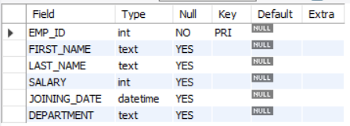

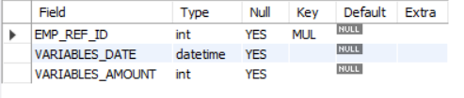

1. What are the four different types of joins? Give examples of each by performing the joins on the Employees table and Designation Table.

|  |  |  |
| --- | --- | --- |
| INNER | **use assignment;**  **SELECT * FROM designation_table d**  **INNER JOIN employees e**  **on d.EMP_REF_ID=e.EMP_ID** |  |
| LEFT | **use assignment;**  **SELECT * FROM designation_table d**  **LEFT JOIN employees e**  **on d.EMP_REF_ID=e.EMP_ID** |  |
| RIGHT | use assignment;  SELECT * FROM designation_table d  right JOIN employees e  on d.EMP_REF_ID=e.EMP_ID |  |
| FULL OUTER | use assignment;  SELECT * FROM designation_table d  right JOIN employees e  on d.EMP_REF_ID=e.EMP_ID  UNION  SELECT * FROM designation_table d  LEFT JOIN employees e  on d.EMP_REF_ID=e.EMP_ID |  |

1. Write a query to get the employee details(full name and department) who received the highest and the least variables

**MINIMUM**

|  |  |  |  |
| --- | --- | --- | --- |
| **Asutosh** | **Kapoor** | **HR** | **14500** |

*use assignment;*

*SELECT FIRST_NAME,LAST_NAME,DEPARTMENT, VARIABLES_AMOUNT*

*FROM employees e*

*JOIN variable v*

*on v.EMP_REF_ID=e.EMP_ID*

*order by VARIABLES_AMOUNT*

*LIMIT 1*

**MAXIMUM**

|  |  |  |  |
| --- | --- | --- | --- |
| **Vivek** | **Singh** | **DA** | **42000** |

*SELECT FIRST_NAME,LAST_NAME,DEPARTMENT, VARIABLES_AMOUNT*

*FROM employees e*

*JOIN variable v*

*on v.EMP_REF_ID=e.EMP_ID*

*order by VARIABLES_AMOUNT desc*

*LIMIT 1*

1. Write a query to get the designation which has got the highest and second lowest amount (salary + variables)  for the whole year of 2019. Get the corresponding amount values.

use assignment;

*SELECT EMP_TITLE,sum(VARIABLES_AMOUNT+SALARY ) as t*

*FROM employees e*

*JOIN variable v*

*on v.EMP_REF_ID=e.EMP_ID*

*JOIN designation_table d*

*ON d.EMP_REF_ID=e.EMP_ID*

*group by 1*

*order by 2 desc*

|  |  |
| --- | --- |
| **Asst. Manager** | **1429500** |
| **Manager** | **323500** |
| **Senior Analyst** | **192000** |

1. What is cross join? Write a query to give an example of the same by performing it on the Employees table and Designation table.

*A cross join produces a cartesian product between the two tables, returning all possible combinations of all rows.*

*use assignment;*

*SELECT \**

*FROM employees*

*CROSS JOIN designation_table;*

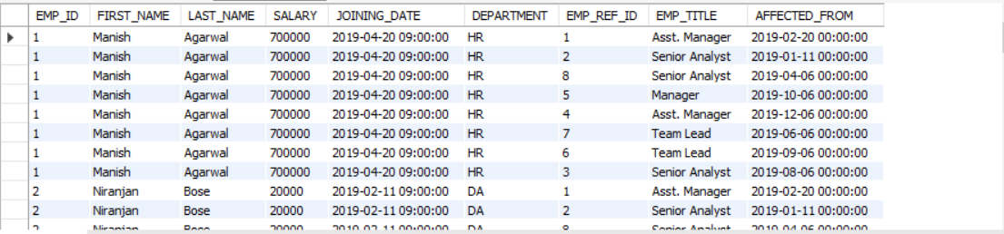

1. What are the clauses used with Select statements and what are the orders of it? Write a query to get the employee details who got their designations updated in the second half of the year 2019(July to December), sorted by the “variables_amount” (highest to lowest) where the department name of the Employee has the letter ‘A’ in it.

*use assignment;*

*SELECT \**

*FROM employees e*

*JOIN designation_table d*

*on e.EMP_ID=d.EMP_REF_ID*

*JOIN variable v*

*on e.EMP_ID=v.EMP_REF_ID*

*WHERE AFFECTED_FROM between '2019-07-01' and '2019-12-31' AND DEPARTMENT LIKE '%A%'*

*order by VARIABLES_AMOUNT*

1. What is a Cursor? Write a query/queries to use the cursor to store the Employees Name( full name) for the HR department into a variable called ‘emp_names’

*use assignment;*

*DELIMITER $$*

*CREATE PROCEDURE createNameLists (*

*INOUT fullnamelist varchar(400)*

*)*

*BEGIN*

*DECLARE finished INTEGER DEFAULT 0;*

*DECLARE fullname varchar(100) DEFAULT "";*

*DEClARE curfullname*

*CURSOR FOR*

*SELECT CONCAT(FIRST_NAME,' ',LAST_NAME) as f from employees where DEPARTMENT='HR';*

*-- declare NOT FOUND handler*

*DECLARE CONTINUE HANDLER*

*FOR NOT FOUND SET finished = 1;*

*OPEN curfullname;*

*getName: LOOP*

*FETCH curfullname INTO fullname;*

*IF finished = 1 THEN*

*LEAVE getName;*

*END IF;*

*-- build email list*

*SET fullnamelist = CONCAT(fullname,";",fullnamelist);*

*END LOOP getName;*

*CLOSE curfullname;*

*SELECT fullnamelist;*

*END$$*

*DELIMITER ;*

*SET @fullnamelist = "";*

*CALL createNameLists(@fullnamelist);*

*SELECT @fullnamelist;*



a.  What is Normalization and explain different forms of normalization with examples. (preferable with the above tables)

b.   What is the stored procedure? Write a stored procedure to call the query that you have written for Q2.a

*The stored procedure is a prepared SQL query that you can save so that the query can be reused over and over again. So, if the user has an SQL query that you write over and over again, keep it as a stored procedure and execute it.*

*use assignment;*

*DELIMITER $$*

*CREATE PROCEDURE MINVARIABLE()*

*BEGIN*

*SELECT FIRST_NAME,LAST_NAME,DEPARTMENT, VARIABLES_AMOUNT*

*FROM employees e*

*JOIN variable v*

*on v.EMP_REF_ID=e.EMP_ID*

*order by VARIABLES_AMOUNT*

*LIMIT 1;*

*END $$*

*CALL MINVARIABLE()*