Netflix Data Analysis
A Project Report
Submitted by

Krunal Dalvi

Sidhant Kar

Manas Kawlekar
Under the Guidance of
Prof. Kshamta Mathur
for the course “Data Analysis with Python”
in partial fulfillment for the award of the degree of
MCA
At

MPSTME, NMIMS.
APRIL, 2024

DECLARATION
We,________________, Roll No. __________ MCA, II semester understand that plagiarism is defined as anyone or combination of the following:
- Un-credited verbatim copying of individual sentences, paragraphs or illustration (such as graphs, diagrams, etc.) from any source, published or unpublished, including the internet.
- Un-credited improper paraphrasing of pages paragraphs (changing a few words phrases, or rearranging the original sentence order)
- Credited verbatim copying of a major portion of a paper (or thesis chapter) without clear delineation of who did wrote what. ( Source: IEEE, The institute, Dec. 2004)
- We have made sure that all the ideas, expressions, graphs, diagrams, etc., that are not a result of my work, are properly credited. Long phrases or sentences that had to be used verbatim from published literature have been clearly identified using quotation marks.
- We affirm that no portion of my work can be considered as plagiarism and I take full responsibility if such a complaint occurs. I understand fully well that the guide of the seminar/ project report may not be in a position to check for the possibility of such incidences of plagiarism in this body of work.

Names: Krunal Dalvi, Sidhant Kar, Manas Kawlekar
Roll Nos. : A010, A028, A029
Place: Mumbai
Date: 1st April,2023

Annexure-III

CERTIFICATE
This is to certify that the project entitled “ Netflix Data Analysis” is the bonafide work carried out by Krunal Dalvi, Sidhant Kar, Manas Kawlekar of MCA, MPSTME (NMIMS), Mumbai, during the II semester of the academic year 2023-24, in partial fulfillment of the requirements for the Course Data Analysis with Python .

___________________
Prof. Kshamta Mathur
Internal Mentor

_______________________ ________________________
Examiner 1 Examiner 2

Annexure IV

Table of contents

CHAPTER NO. TITLE PAGE NO.
- INTRODUCTION 5
- LIBRARIES USED 6
- DATASET USED WITH DESCRIPTION 7
- DATA CLEANING 8
- DATA ANALYSIS 9
- CONCLUSION 19

INTRODUCTION

The "Netflix Data Analysis" project aims to delve into the vast collection of data provided by Netflix, one of the world's leading streaming platforms. This project leverages Python's data analysis and visualization libraries to uncover insights, trends, and patterns within Netflix's content catalog, user preferences, and viewership metrics.
By analyzing Netflix data, we can gain valuable insights into popular genres, viewer demographics, content trends over time, and the impact of original programming. This analysis can be instrumental for content creators, marketers, and decision-makers in the entertainment industry to make informed decisions about content production, marketing strategies, and audience targeting.
Through Python programming and data analysis techniques, we aim to uncover meaningful patterns and trends that can drive strategic decision-making and enhance the viewer experience on Netflix.
Purpose of the Project:

Insight Generation: The project aims to generate valuable insights from Netflix's extensive data, including user preferences, content popularity, and viewership trends. These insights can inform decision-making processes for content creators, marketers, and stakeholders within the entertainment industry.

Audience Understanding: By analyzing user behavior, ratings, and viewing patterns, the project seeks to understand the preferences and demographics of Netflix's audience. This understanding can guide content curation, recommendation algorithms, and personalized user experiences.

Content Strategy: Through data analysis, the project aims to uncover trends in content consumption, identify successful genres and formats, and evaluate the impact of original programming. This information is vital for shaping content strategies, production investments, and content acquisition decisions.

Business Optimization: By leveraging data-driven insights, the project contributes to optimizing business strategies related to content licensing, marketing campaigns, and audience engagement. It enables stakeholders to make data-informed decisions that drive growth, retention, and competitiveness in the streaming media landscape.

Data Visualization: The project showcases the power of data visualization techniques in conveying complex insights effectively. Visual representations of data, such as charts, graphs, and interactive dashboards, enhance understanding and facilitate communication of key findings to stakeholders.

LIBRARY USED
For our Netflix Data Analysis project we have used various Libraries

Pandas
Numpy
Dateutil.parser
Matplotlib.pyplot
Seaborn
Plotly.graph_objects

nltk.corpus (Natural Language Toolkit):
Provides access to various corpora and lexical resources for tasks such as text classification, tokenization, stemming, and part-of-speech tagging.

rake_nltk (Rapid Automatic Keyword Extraction):
is a Python library that implements the RAKE algorithm for extracting keywords and key phrases from text documents.

sklearn.metrics.pairwise:
a powerful library for machine learning in Python. Sklearn.metrics.pairwise includes functions for pairwise similarity and distance computations, which are commonly used in text analysis, clustering, and recommendation systems.

sklearn.feature_extraction.text:
Provides tools for text feature extraction and vectorization.

wordcloud:
WordCloud is a Python library for creating word clouds, which visually represent the frequency of words in a text corpus.

crest_palette = sns.color_palette("crest", 2)

DATASET

The Netflix dataset contains information about various shows and movies available on the platform. Here's a short summary of the dataset:

There are 12 columns in the dataset with 8807 Records

- show_id: A unique identifier for each show or movie.
- type: Indicates whether the entry is a TV show or a movie.
- title: The title of the show or movie.
- director: The director(s) of the content.
- cast: The cast members starring in the content.
- country: The country or countries where the content was produced.
- date_added: The date when the content was added to Netflix.
- release_year: The year when the content was originally released.
- rating: The content's rating, such as PG, PG-13, R, etc.
- duration: The duration of the content (e.g., runtime for movies, number of seasons for TV shows).
- listed_in: The genre or categories the content belongs to.
- Discription: a short introduction about the plot of the show

This dataset is rich in metadata about the content available on Netflix, including details about its production, classification, and categorization. It can be used for various analyses and insights, such as exploring popular genres, analyzing release trends over time, studying regional preferences, and more.

DATA CLEANING

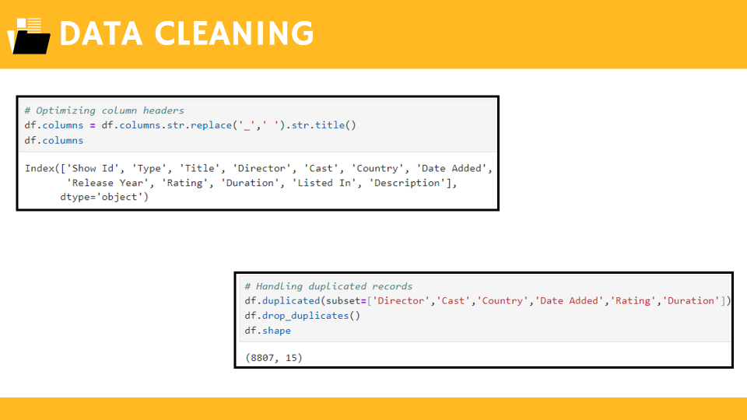

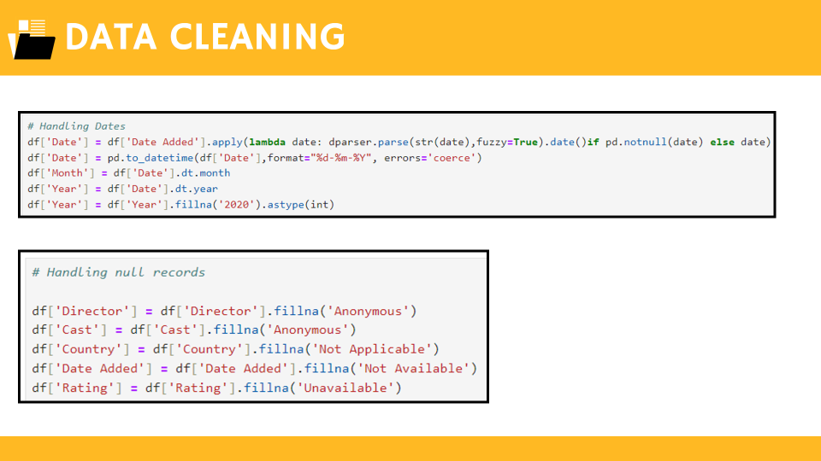
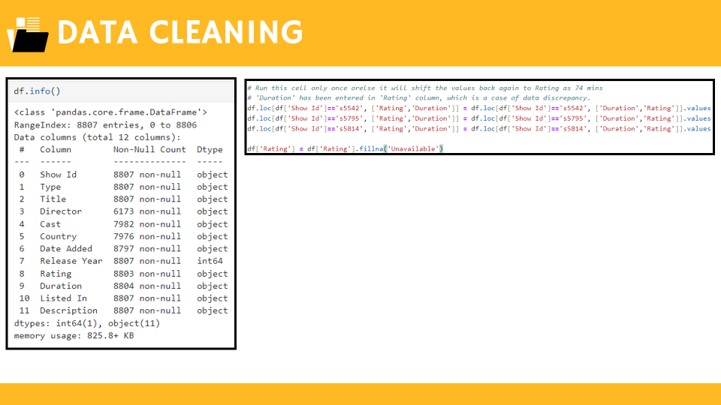

DATA ANALYSIS

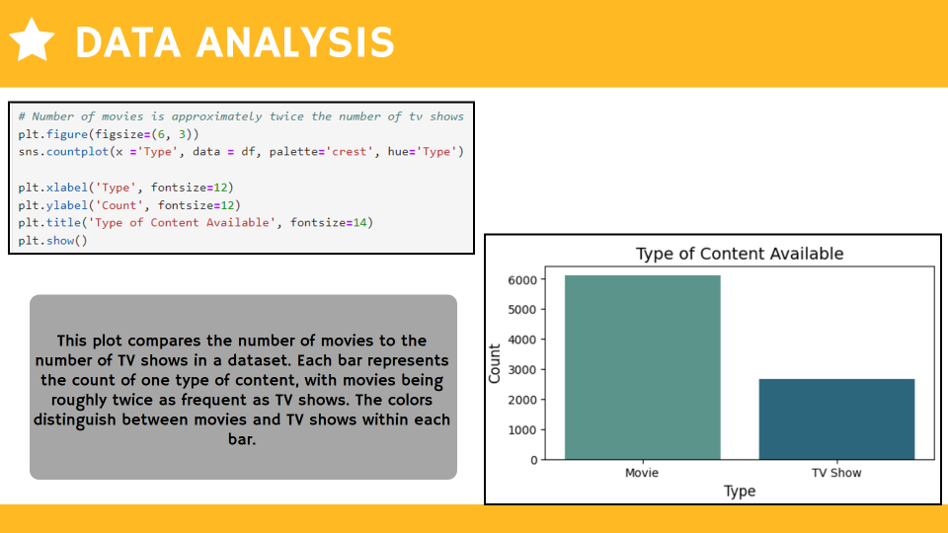

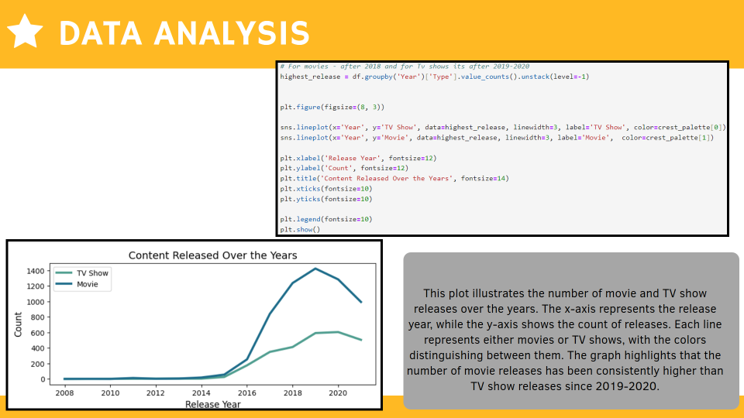

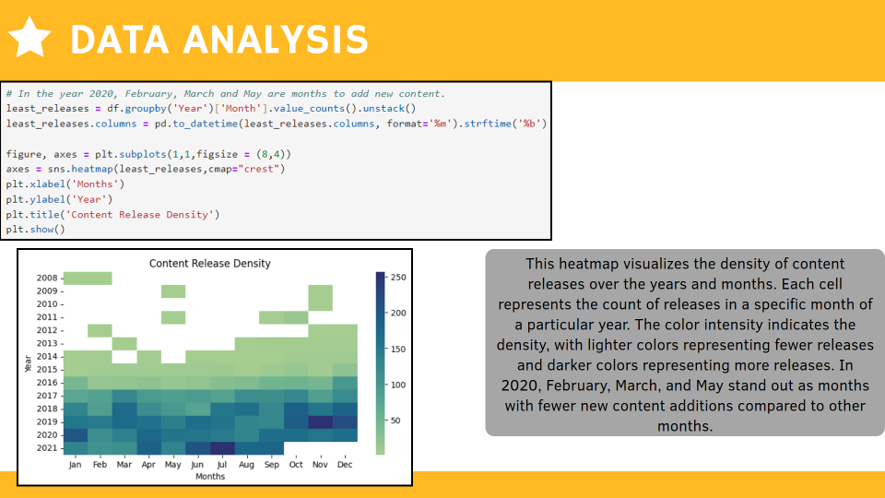

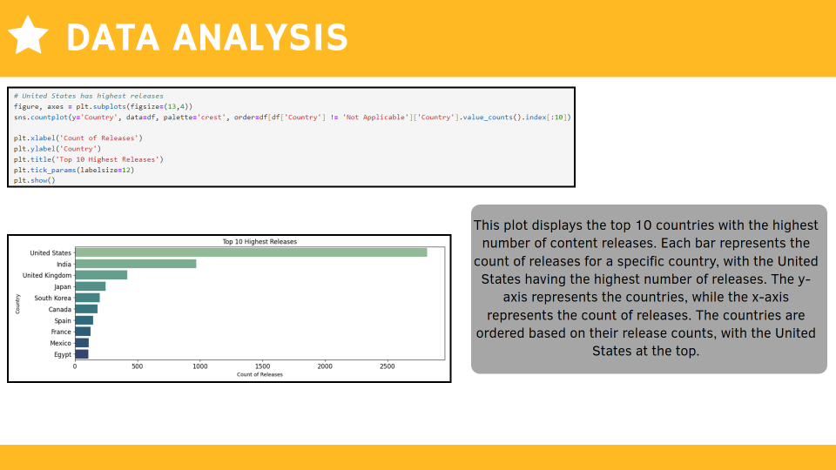

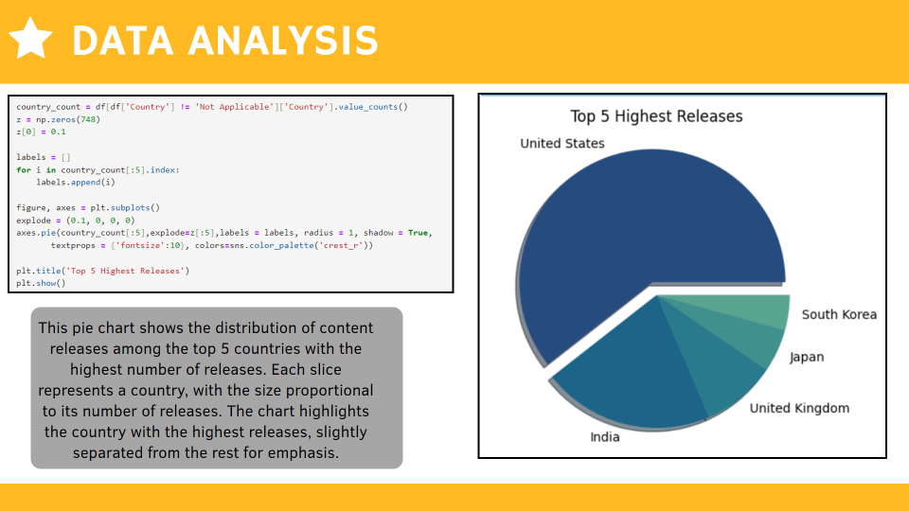

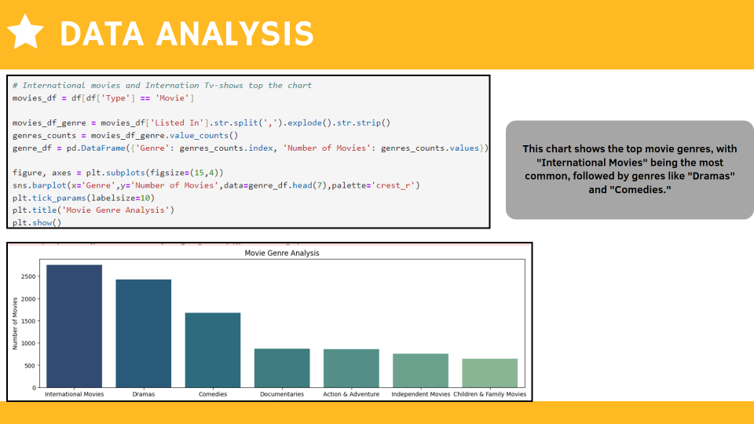
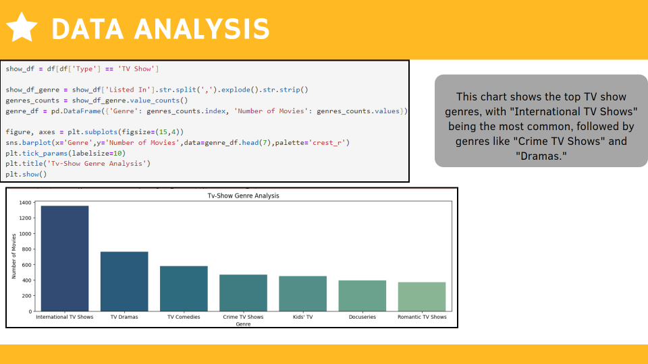

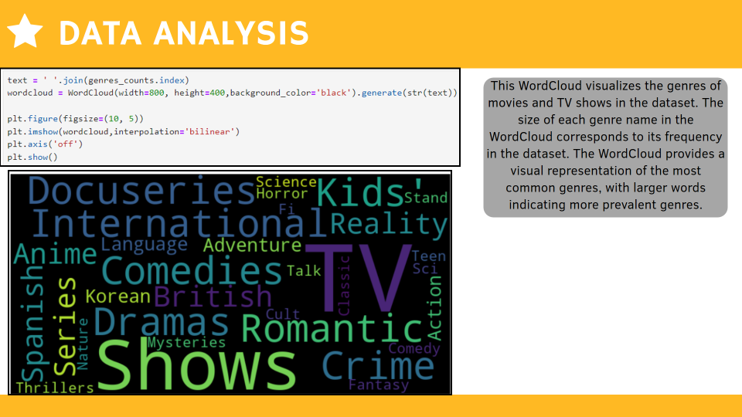

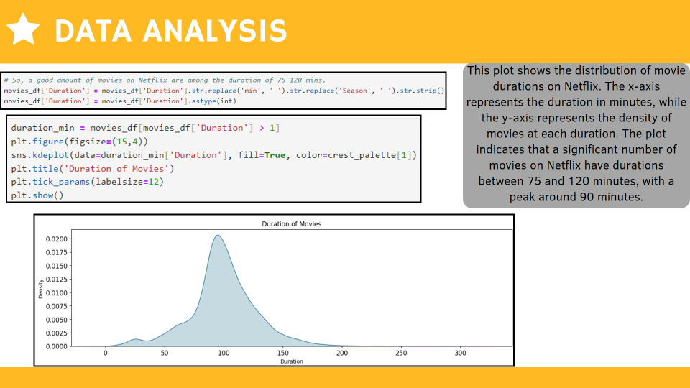

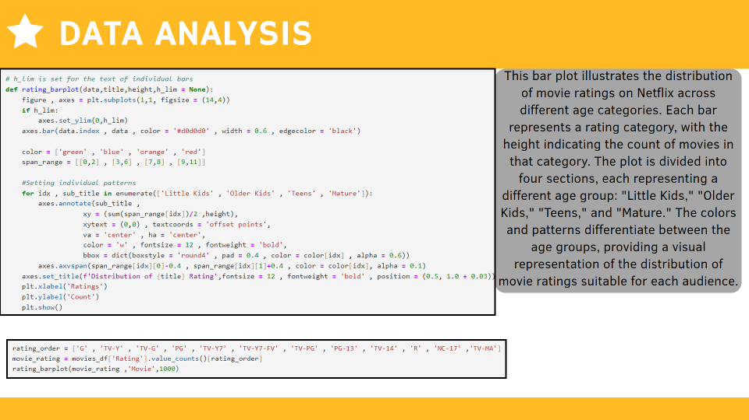
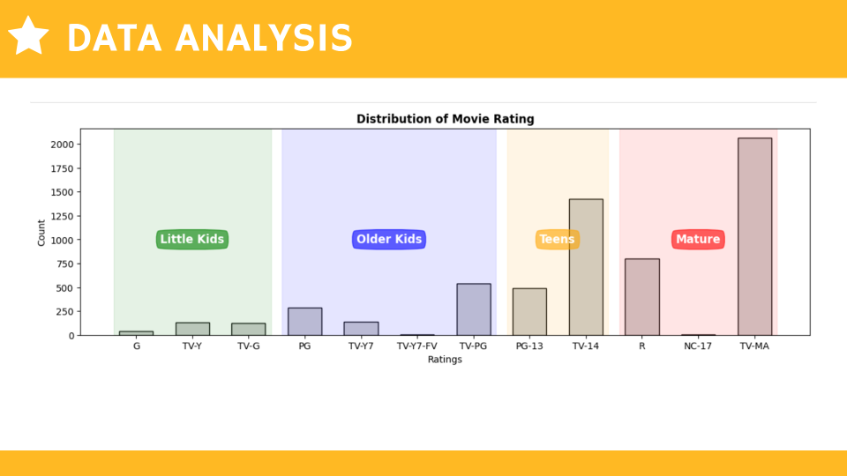

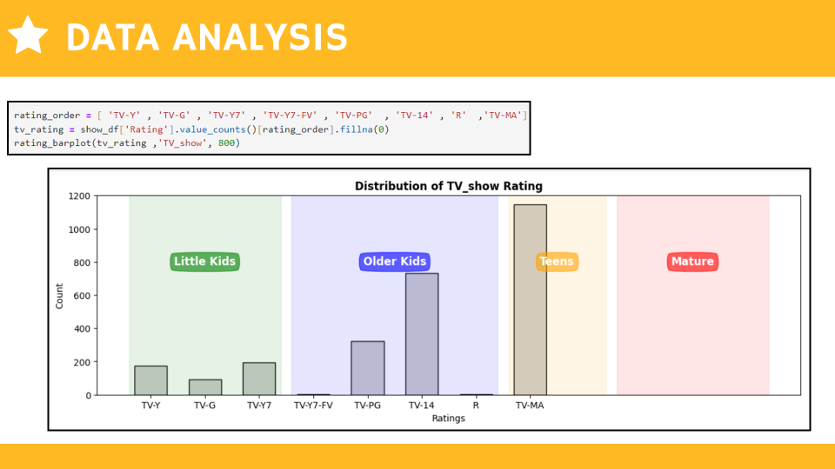

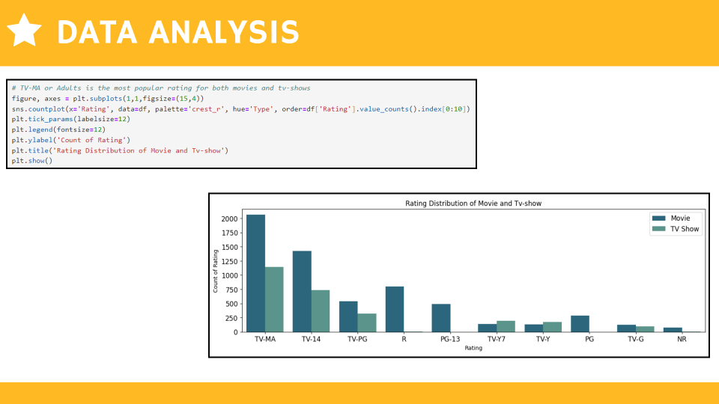

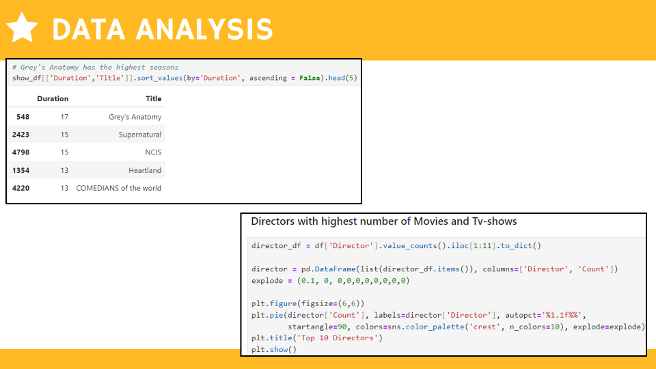

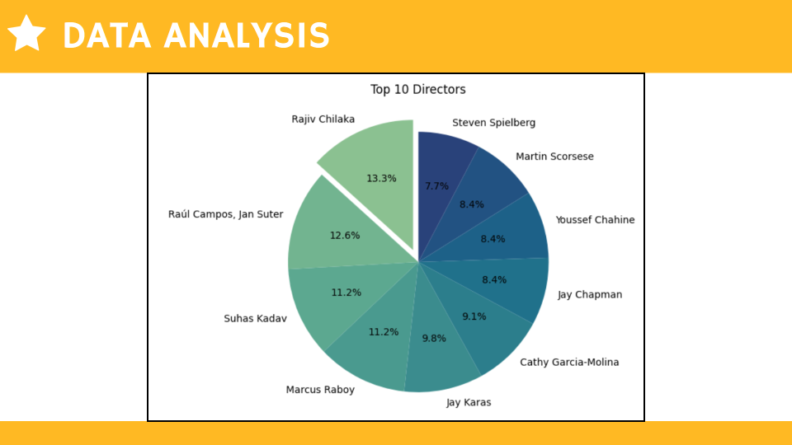

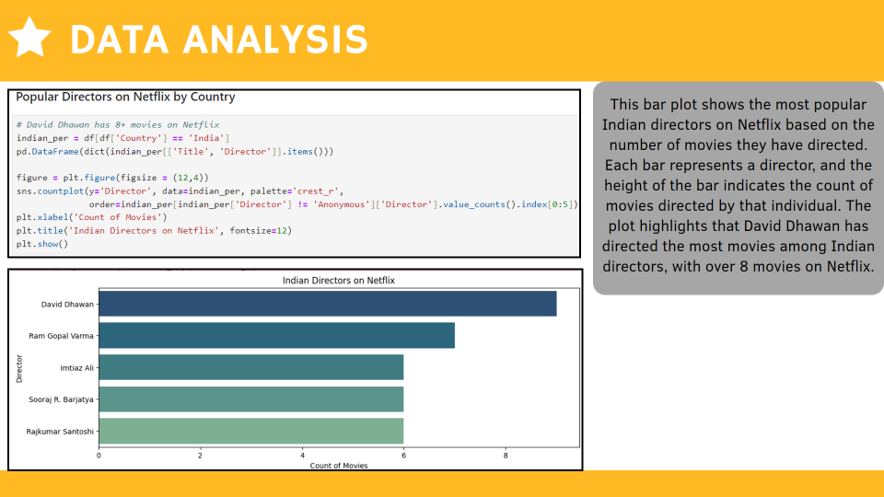

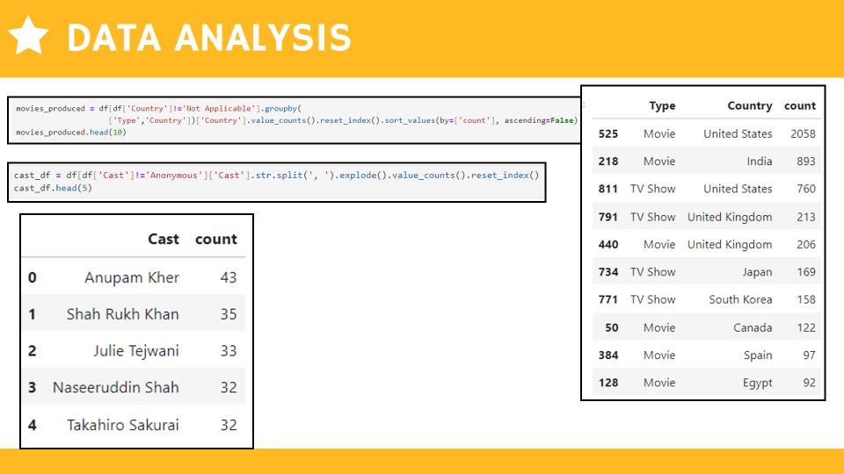

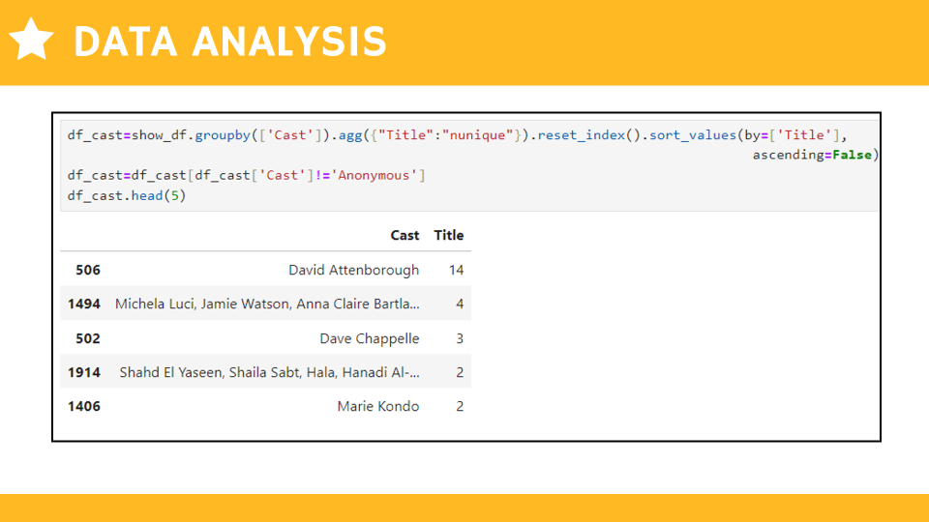

CONCLUSION

  - The Netflix dataset analysis reveals a strong emphasis on recent content, with movies and TV shows released after 2018 and 2019-2020, respectively, dominating the platform.

  - The United States leads in content releases, followed by India and the United Kingdom. "International Movies" and "International TV Shows" are the most common genres, reflecting Netflix's global content strategy.

  - Movie durations typically fall within the 75-120 minute range, and the platform offers a diverse range of ratings catering to different age groups.

  - David Dhawan emerges as a prominent Indian director on Netflix, with a substantial number of movies attributed to him in the dataset.

THANK YOU

