
EQUIPMENT RENTING SYSTEM
Why Buy When You Can Rent?

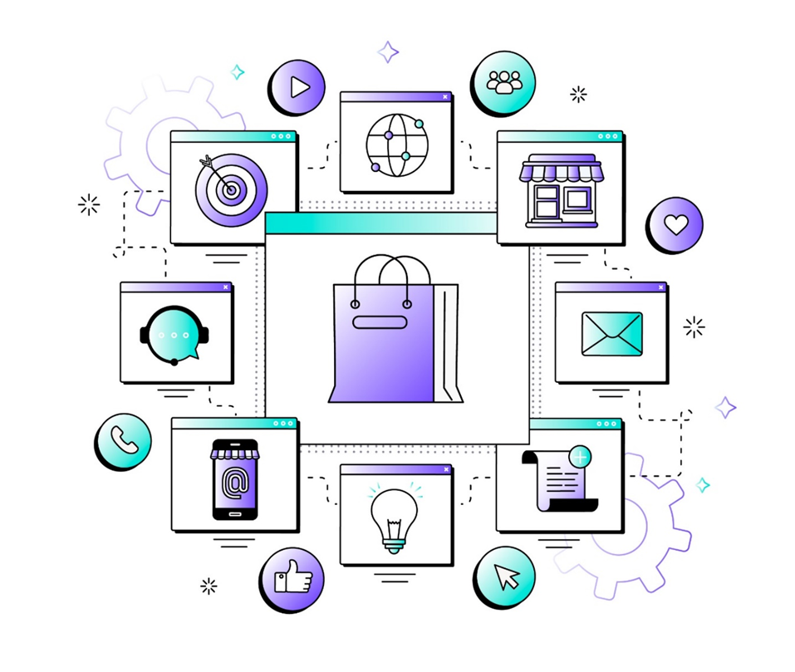

A PROJECT REPORT ON:
Equipment Renting System: Rent. Use. Return. Repeat.

Submitted to:

GUJARAT UNIVERSITY (2024-2025)


In partial fulfilment of Bachelor of Computer Applications (B.C.A)


President Institute of Computer Application
Shayona Study Campus, Shayona City, Ghatlodiya, Ahmedabad -380061

Developed By:
- Manish Kumar B. (Roll No. – 5125)
- Vaibhav Limbachiya (Roll No. – 5101)
- Krunal Prajapati (Roll No. – 5103)
(Semester – V Bachelor of Computer Applications)
Acknowledgment

As a team we would like to express our sincere appreciation to all those who have played a vital role in the successful completion of our project. The success and outcome require a lot of guidance and assistance from many people. We would like to extend our sincere thanks to all of them.

We thank our Internal Guide Asst. prof. Shailee Shah for providing us constant support and guidance as your mentorship played a vital role in shaping our project and ensuring its success.

We would like to express our gratitude toward our External project guide Ms. Janvi Panchal for their exceptional mentorship which provide us the necessary direction to steer our project toward success.

Lastly, we would like to thank our friends, families and project partners for there constant support and understanding throughout the project. We would like to thank to all those who helped us directly or indirectly in this project.

Sincerely,
Manish Kumar
Vaibhav Limbachiya
Krunal Prajapati

INDEX

Company Profile .....................................................................................................................4

Project Profile .........................................................................................................................5
Need For New System ..........................................................................................................6

Tools and Technologies...........................................................................................................7

Modules ....................................................................................................................................8

System Flow Diagram ...........................................................................................................10

UML Diagrams.......................................................................................................................12
Types of UML Diagram ......................................................................................................12
Use-Case Diagram ...............................................................................................................13
Activity Diagram .................................................................................................................17
Sequence Diagram ...............................................................................................................22
Class Diagram .....................................................................................................................28

ER Diagram ...........................................................................................................................30

Data Dictionaries ....................................................................................................................33

1. COMPANY PROFILE

_{Name} _____________________SYNC INFO SOLUTIONS

Contact____________________ 9875076625

Swastik Cross Road , Ahmedabad.
Address___________________

_{Email}___________________inquiry@syncinfosolutions.com

https://www.syncinfosolutions.com
Website________________
Ms.Janvi Panchal

External Guide_____________

2. PROJECT PROFILE

EQUIPMENT RENTING SYSTEM is the premier online platform for renting a wide range of equipment and devices. Whether you need the latest tech gadgets, outdoor gear, or specialized equipment for events, our website provides a convenient, affordable, and hassle-free solution.
We aim to promote sustainability and flexibility, allowing users to enjoy the latest technology and gear without the commitment of ownership. "Experience More, Own Less."
This website will provide very user-friendly access as we will provide payment through cash, credit and online UPI too.
Here is the detailed description of our project:

Project Name | EQUIPMENT RENTING SYSTEM
Objective | To provide an online Platform which will make it easy for everyone to rent different kinds of equipment and devices.
Group No. | 17
Group Members | 3
Team Members | Manish Kumar, Vaibhav Limbachiya, Krunal Prajapati
Institute | President Institute of Computer Applications

NEED FOR NEW SYSTEM!

LIMITATION OF EXISTING SYSTEM:
- Limited Selection
o High Costs
o Lack of online platform
- Security concerns
O No User Reviews
o Have to stick to limited
resource

ADVANTAGES OF PROPOSED SYSTEM:
- Improved user experience
- Wide Selection
- Payment options and security
- Customer reviews and complaint
- Convenient Delivery and Pickup
- User-Friendly Interface
- Affordable Pricing

3.TOOLS AND TECHNOLOGIES

Tools: | - VS Code
 | - Chrome Browser
 | - Draw.io
 | - Postman for API testing
Frontend: | - React.js
Backend: | - Node.js  - Express.js
Database: | - MongoDB atlas

4. MODULES

- Admin Module:

- Login
- Manage Users
- Manage Vendors
- Manage Product
- Manage Profile
- Manage Bookings
- Manage Payments
- Manage Feedbacks,Complaints

- User Module:

- Registrations
- Login
- Manage Profile
- Manage Product
- Manage Cart
- Make Payments
- Receive Confirmation
- Do feedback & Complaint
- Logout

- Vendor Module:

- Registrations
- Login
- Manage Profile
- Manage Product
- View Booking
- View Feedbacks

SYSTEM FLOW

▪ System flowcharts are the diagram type that shows you the flow of data and how decisions can affect the events surrounding it.
▪ Data flowcharts let you see the overall data flow in a system.

- System Flow Symbols and Notations:

Notations | Symbols | Descriptions
Start/End |  | This represents start or end point of system.
System Flow |  | This shows the direction of the system flow.
Input/Output |  | This represents the input or output of system.
Process |  | All the process are shown in this symbol.
Decision |  | A diamond indicates the decision of system.
❖Flowchart Diagram:
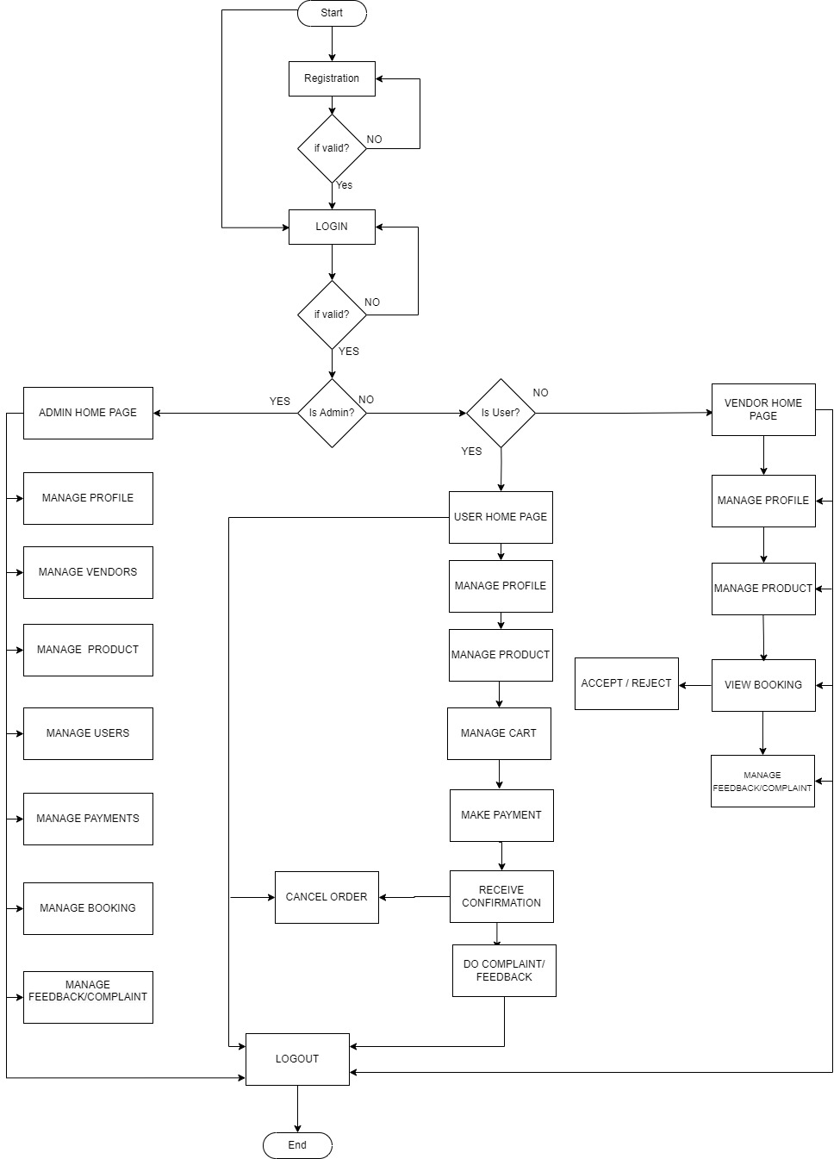

_________________________________________________

5. UML DIAGRAMS

Unified Modelling Language (UML) diagrams are graphical representation used for system design to illustrate various aspects of system.
The overall goal of UML diagrams is to allow teams to visualize how a project is or will be working. UML can be used to develop diagrams and provide users with ready-to-use expressive modelling examples.
Types of UML Diagrams:

- Use Case Diagram:

An UML use case diagram is the primary form of system/software requirements for a new software program underdeveloped.

- Activity Diagram:

An activity diagram is used by developers to understand the flow of programs on a high level.

- Sequence Diagram:

A sequence diagrams is used to document and understand the requirements to establish new systems or learn about existing systems.

- Class Diagram:

A Class Diagram is a type of static structure diagram that describes the structure of a system by showing the system's classes, their attributes, operations (or methods), and the relationships among objects.

USE-CASE DIAGRAM

A Use-Case diagram is a way to summarize details of a system and the users within that system. It enhances the system's functionality by incorporating use cases, actors, and their relationships.
It specifies the events and relationship of entities of system.

- Use-Case Symbols and Notations:

Notations | Symbols | Descriptions
Actor | 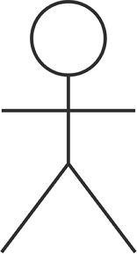 | Each actor performs a specific role in the system. Actors are always outside the system and interact directly with it by initiating a use case. An actor can be a person, such as a customer, or a computer, such as a database system.
Use-Case |  | An oval shaped use-case is used to represent the functionality of the system. It typically defines interactions between actor and system.
System |  | The system is used to define the scope of the use case and drawn as a rectangle
Communication  link |  | This link is used to show the  participation of actor in a use case. And is used to communicate
<<Include>> | 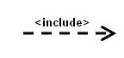 | It is represented by a dashed arrow in the direction of the base use case
<<Exclude>> | 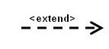 | It is represented by a dashed arrow in the direction of the included use case

- Use-Case for Admin Side:

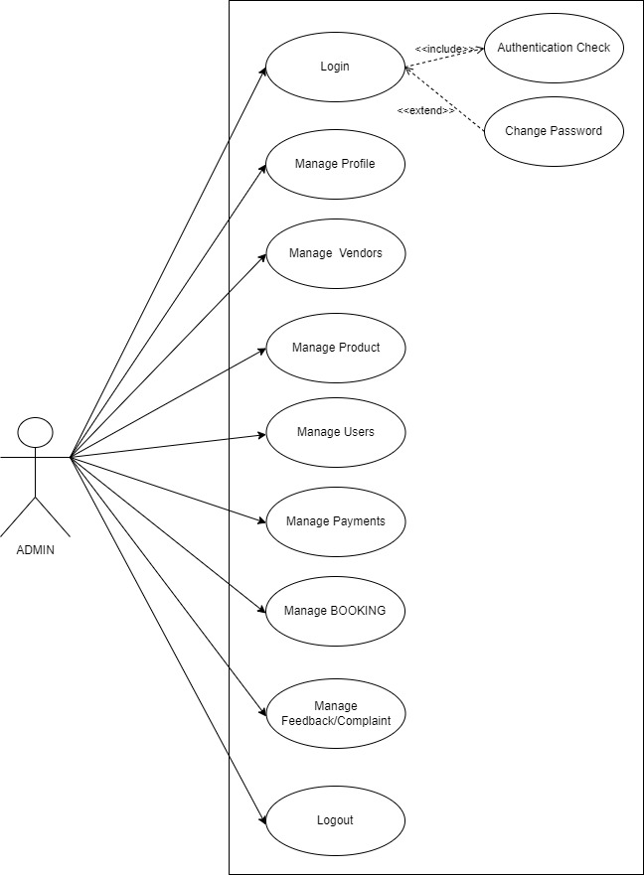
- Use-Case for User Side:

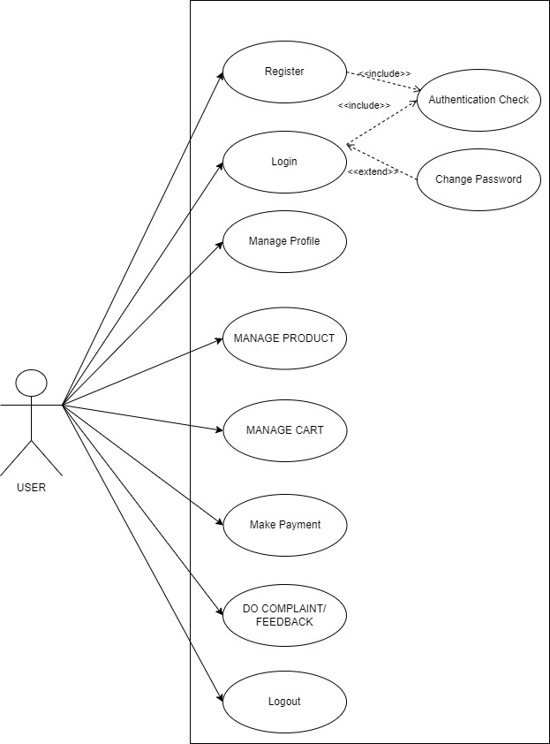
- Use-Case for Vendor Side:

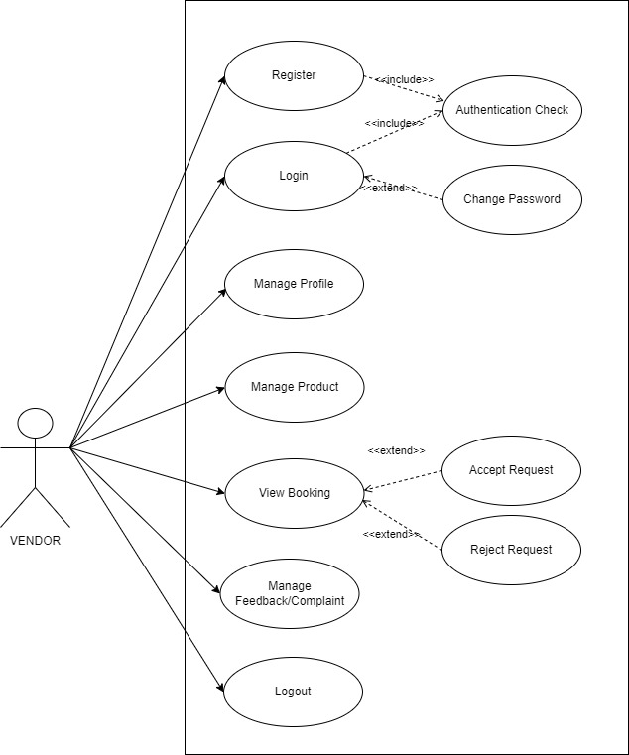

ACTIVITY DIAGRAM

- What is Activity Diagram?

Activity Diagram is one of the important diagrams of UML. It represents the flow from one activity to another activity which can be shown as operations of system.

An activity diagram portrays the control flow from a start point to a finish point showing
the various decision paths that exist while the activity is being executed.

It represents what activities can be done in parallel and whether there are alternative paths through the workflow.

- Benefits of Activity Diagram:

  - Shows the progress of workflow amongst the users, and the system.
O It provides the visual representation of logic of a particular algorithm.
o It represents the relationship between one activity to another activity.
  - It provides a better understanding of how the system works.
  - We can use Activity diagrams to depict concurrent activities easily.

- Activity Diagram Symbols and Notations:

Notations | Symbols | Descriptions
Start/Initial point | 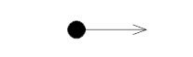 | Represents the beginning of the process
End point | 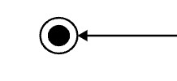 | Represents the completion of all the flow and end of process
Activity | 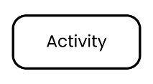 | Indicates the main activity with small description within the shape
Activity Flow | 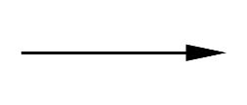 | Shows the directional flow of the activity
Decision Symbol | 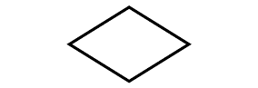 | Represents decision making with one input and multiple output
Fork | 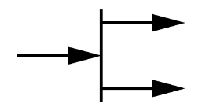 | Indicates flow that split single flow into multiple concurrent flow
Join/Merge | 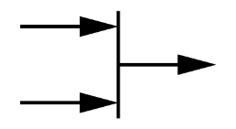 | Indicates flow that combine two or more concurrent flow into single flow

- Activity Diagram for Admin Side:

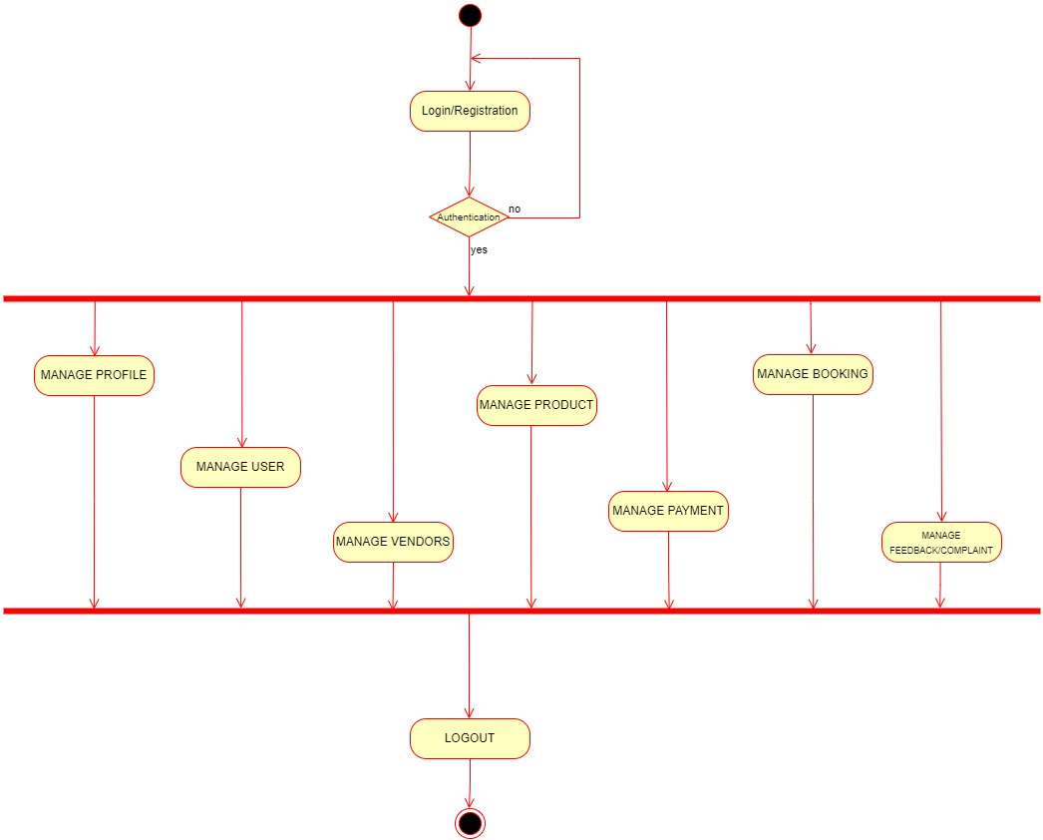
- Activity Diagram for User Side:

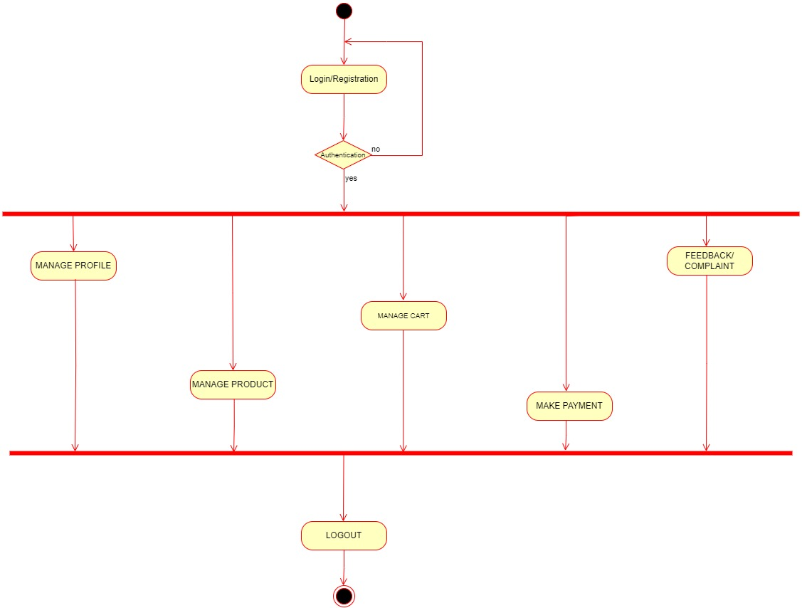

- Activity Diagram for Vendor Side:

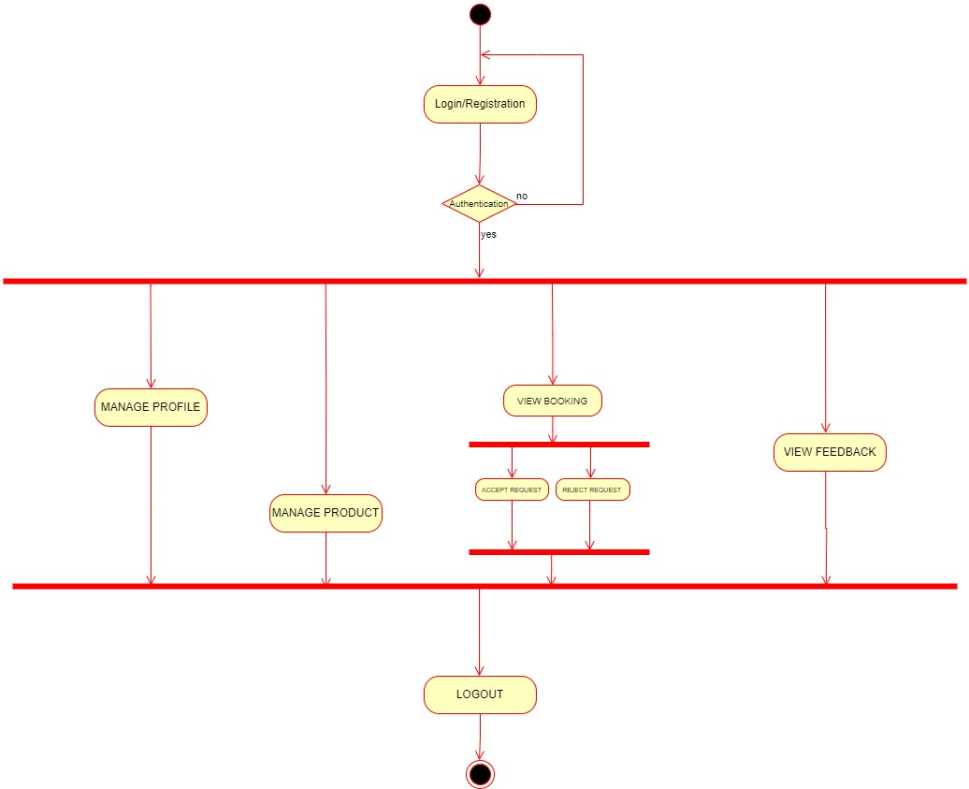

SEQUENCE DIAGRAM

- What is Sequence Diagram?

Sequence diagram is an interaction diagram which focuses on message interchange between number of timelines.
It represents the flow of messages in the system and can also be termed as Event Diagram.
It illustrates how the different parts of a system interact with each other to carry out a function, and the order in which the interactions occur when a particular use case is executed.

- Benefits of Sequence Diagram:

Following are some advantages of sequence Diagram:
- Sequence Diagram is used for high-level interactions hence helps in understanding developers design and complex system.
o It has easy maintenance.
- It depicts the message flow between the different objects.
- It can easily update as per the new change in the system.

- Sequence Diagram Symbols and Notations:

Notations | Symbols | Descriptions
Actor | 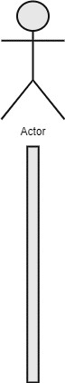 | It represents the role, which involves human users and external hardware or subjects
Lifeline | 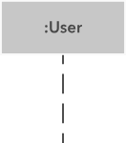 | It represents individual participants and interactions
Activations | 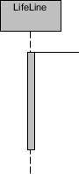 | It describes the time in which operations are performed by elements.
Object class |  | Represents a class or object in UML.
- Sequence Diagram Symbols and Notations for messages:

Notations | Symbols | Descriptions
Call Message | 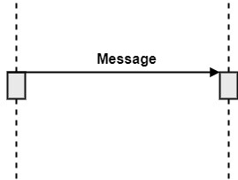 | This show both the call and the reply of the message.
Return Message | 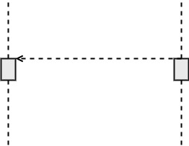 | This shows the replies to the messages.
Self Message | 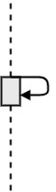 | This shows the interactions between the same lifelines.
Create Message | 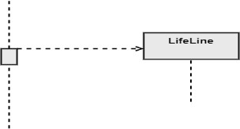 | This shows  communication between Lifelines of an Interaction.
Destroy Message | 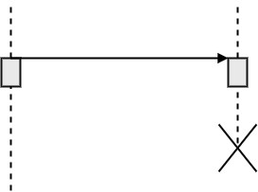 | Destroy message is a kind of message that represents the request of destroying the lifecycle of target lifeline.
- Sequence Diagram for admin login:

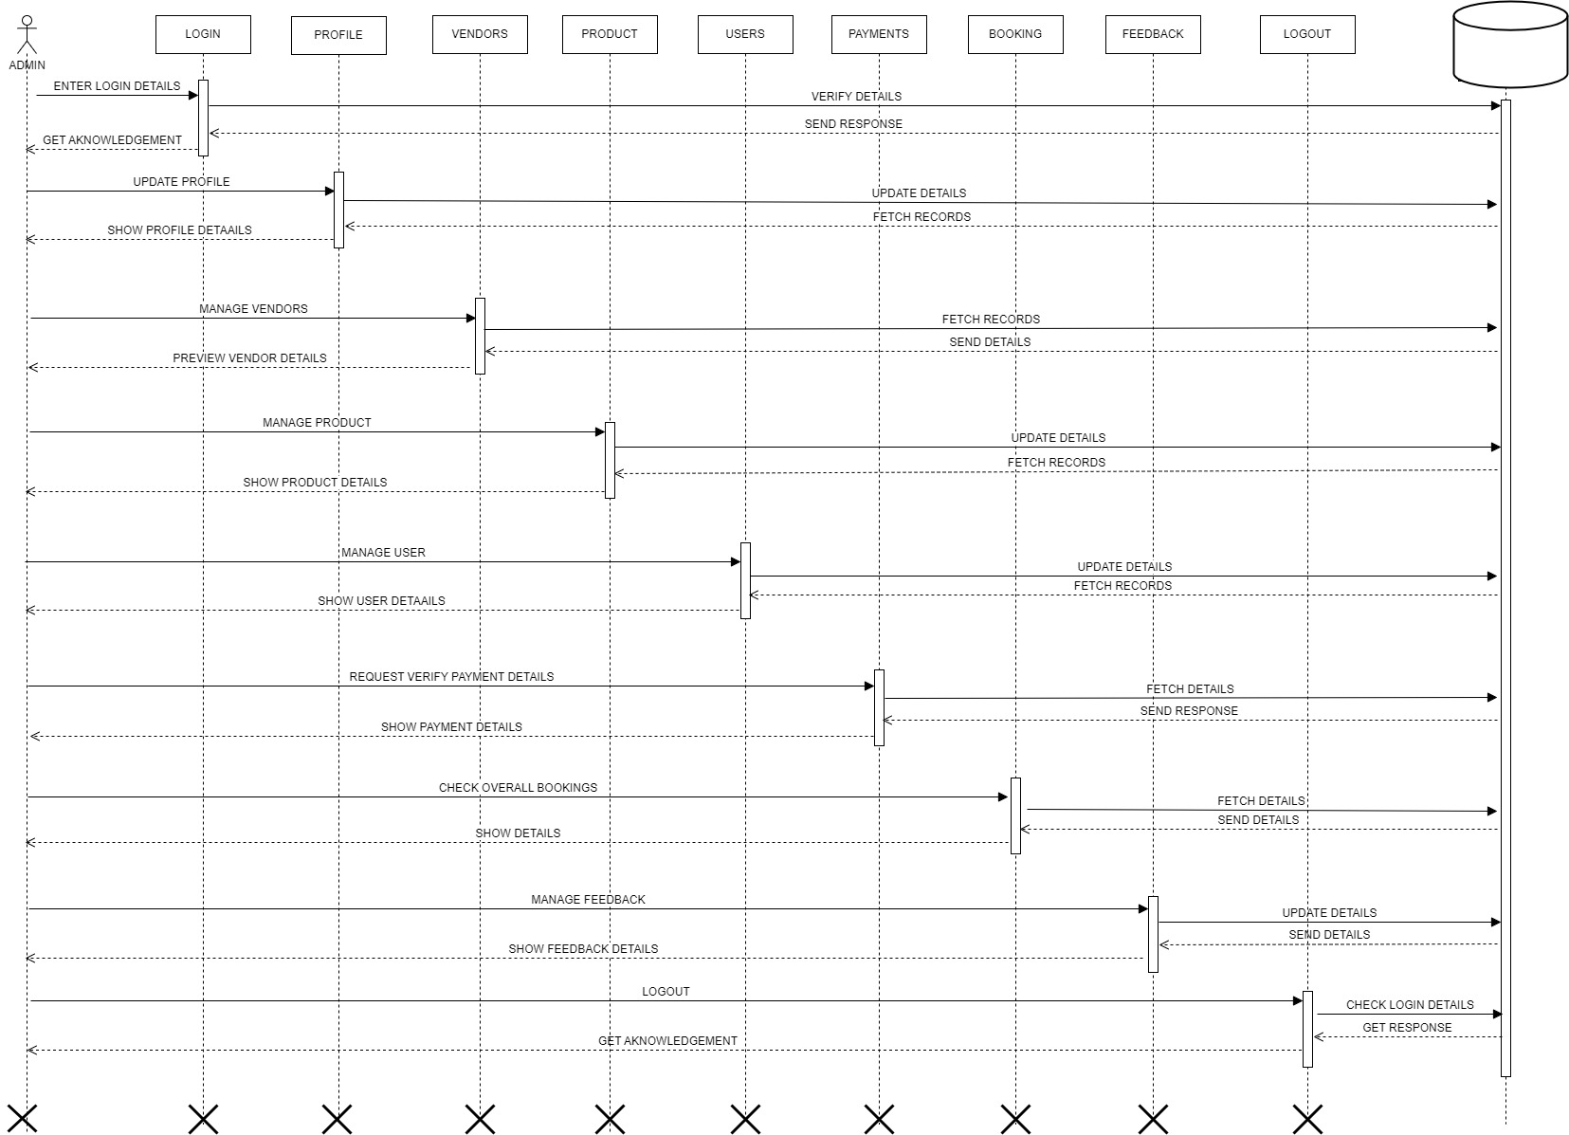
- Sequence Diagram for user login:

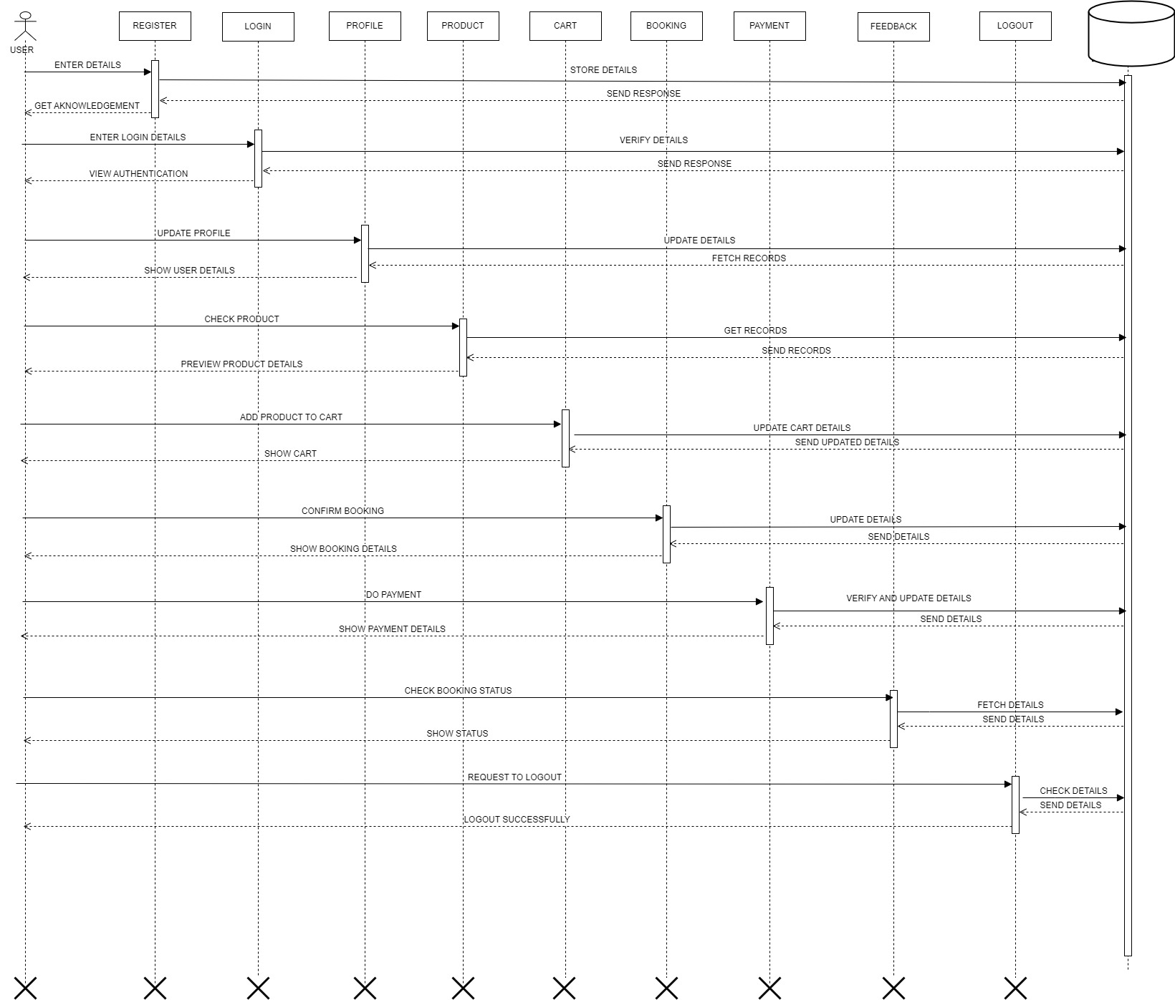

- Sequence Diagram for Vendor login:

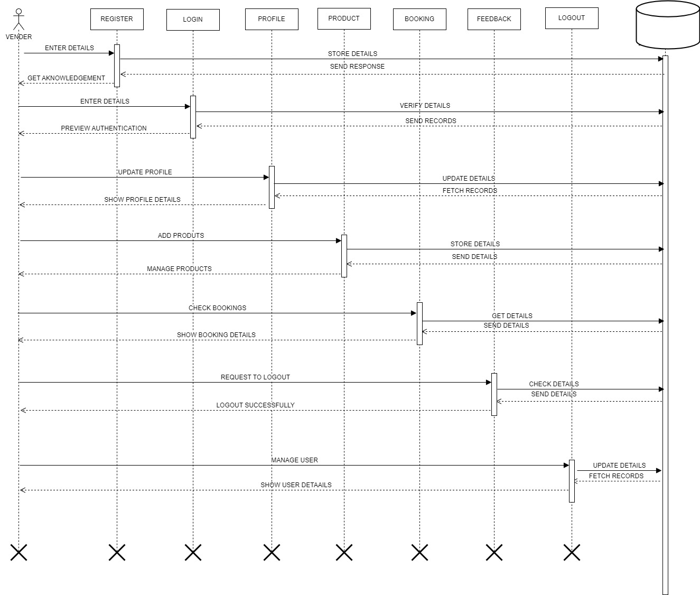

CLASS DIAGRAM
- What is Class Diagram?
Class Diagram shows the static view of application that gives overview of software system by displaying classes, attributes, operations, and relationship between each other.
It is the most popular UML diagram which is widely used for constructions and can be mapped with other languages.
It helps to construct the code for the software application development.
Class diagram is collection of things or concept that have the same characteristic.

- Benefits of Class Diagram:
o Class Diagram can easily represent the object model for complex systems.
o It provides the general schematic of an application for better understanding.
o It is helpful for the stakeholders and the development. o It enhances the code-reusability.
o It enhances the code-reusability.

- Components of Class Diagram:

Class Diagram is made up of three sections which are:

- Upper Section: This section consists of the name of the class.

- Middle Section: This section consists of attributes, which describe the quality of the class.
- Lower Section: The lower section contains methods or operations. The methods are represented in the form of a list.
The relationship between classes is described on some cardinality which are as follow:
- One-To-One o One-To-Many o Many-To-One
- 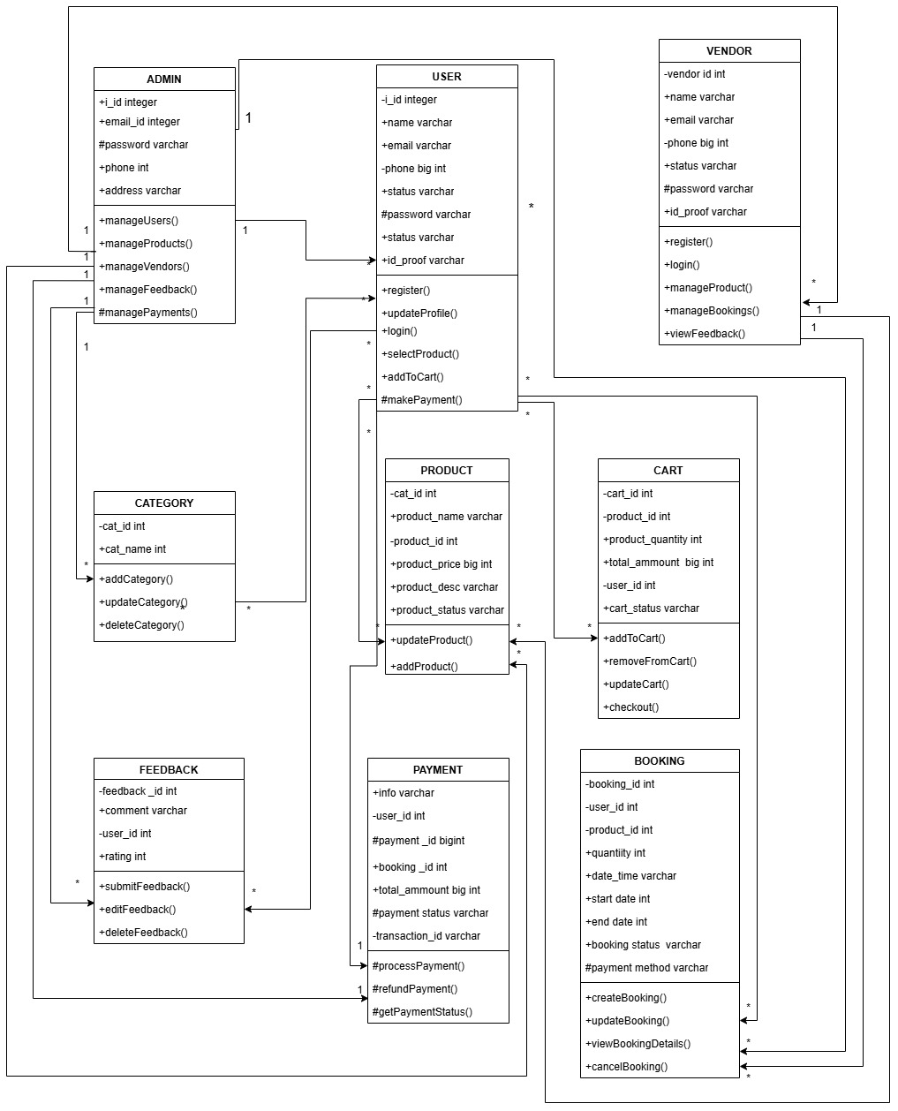

7. ER DIAGRAM

- What is ER Diagram?

ER - Entity Relationship diagram is a flowchart which shows how entities such as people, objects or concepts relate to each other within a system.

ER Diagram is a diagram which focus on the relationships of elements within entities instead of relationships between entities themselves.

Here are some benefits of using ER Diagram:
  - One of the main benefits of ER is it gives a clear and graphical depiction of relationships between elements. This makes it easy to understand.
  - ER models are less challenging to maintain, which lowers costs and increases production.
  - ER models are highly flexible which makes it easy to make any changes.
o ER diagrams can play a key role in setting up useful databases to analyse the data.

- ER Symbols and Notations:

Notations | Symbols | Descriptions
Entity |  | This shows the entity of entire system
Attribute |  | Shows the property or characteristic of an entity.
Relationship |  | This represents the relation between entities.
Relationship Link |  | This indicates the link of relationship between entities.
Multivalued Attribute |  | This represents multiple attributes of an entity.
Primary Key |  | This shows the value which holds primary key

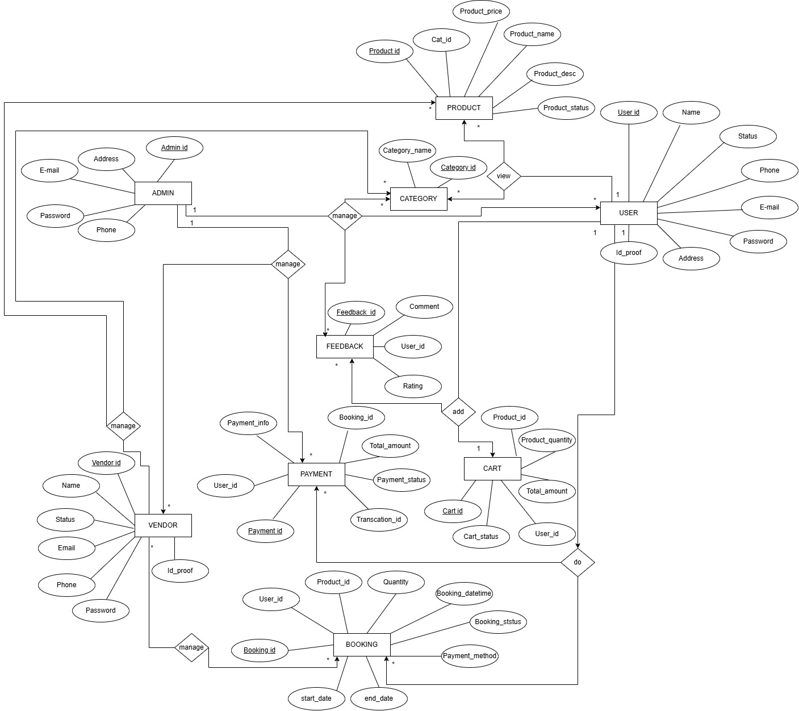

8.DATA DICTONARIES
- ADMIN_TABLE:
Table name: Admin_table Primary_key: ADMIN_ID Foreign_key: N/A

ATTRIBUTES | CONSTRAIN | DATATYPE | SIZE | DESCRIPTION
ADMIN_ID | PRIMARY_KEY | INT | 8 | PRIMARY KEY FOR THIS TABLE,UNIQUE FOR EVERY ROW
ADMIN_E-MAIL | NOT_NULL | VARCHAR | 25 | E-MAIL OF ADMIN
ADMIN_PHONE | NOT_NULL | BIG_INT | 10 | PHONE NUMBER OF ADMIN
ADDRESS | NOT_NULL | VARCHAR | 50 | ADDRESS OF ADMIN
PASSWORD | NOT_NULL | VARCHAR | 15 | PASSWORD OF ADMIN

- USER_TABLE:
Table name: User_table Primary_key: User_ID Foreign_key: N/A
ATTRIBUTES | CONSTRAIN | DATATYPE | SIZE | DESCRIPTION
USER_ID | PRIMARY_KEY | INT | 8 | PRIMARY KEY FOR THIS TABLE,UNIQUE FOR EVERY ROW
USER_NAME | NOT_NULL | VARCHAR | 30 | NAME OF USER
USER_E-MAIL | NOT_NULL | VARCHAR | 25 | E-MAIL OF USER
USER_PHONE | NOT_NULL | BIG_INT | 10 | PHONE NUMBER OF USER
ADDRESS | NOT_NULL | VARCHAR | 50 | ADDRESS OF USER
PASSWORD | NOT_NULL | VARCHAR | 15 | PASSWORD OF USER
ID_PROOF | NOT_NULL | VARCHAR | 50 | AADHAR CARD IMAGE OF USER
USER_STATUS | NOT_NULL | VARCHAR | 15 | STATUS OF USER
- VENDOR_TABLE:
Table name: Vendor_table
Primary_key: Vendor_ID
Foreign_key: N/A

ATTRIBUTES | CONSTRAIN | DATATYPE | SIZE | DESCRIPTION
VENDOR_ID | PRIMARY_KEY | INT | 8 | PRIMARY KEY FOR THIS TABLE,UNIQUE FOR EVERY ROW
PASSWORD | NOT_NULL | VARCHAR | 15 | PASSWORD OF VENDOR
VENDOR_NAME | NOT_NULL | VARCHAR | 30 | NAME OF VENDOR
VENDOR_PHONE | NOT_NULL | BIG INT | 10 | PHONE NUMBER OF VENDOR
VENDOR_E-MAIL | NOT_NULL | VARCHAR | 25 | EMAIL OF VENDOR
ID_PROOF | NOT_NULL | VARCHAR | 50 | AADHAR CARD IMAGE OF VENDOR
VENDOR_STATUS | NOT_NULL | VARCHAR | 15 | STATUS OF VENDOR

- CATEGORY_TABLE:
Table name: Category_Details
Primary_key: Cat_ID
Foreign_key: N/A

ATTRIBUTES | CONSTRAIN | DATATYPE | SIZE | DESCRIPTION
CAT_ID | PRIMARY_KEY | INT | 8 | PRIMARY KEY FOR THIS TABLE,UNIQUE FOR EVERY ROW
CAT_NAME | NOT_NULL | VARCHAR | 30 | NAME OF CATEGORY
- PRODUCT_TABLE:
Table name: Product_table
Primary_key: PRODUCT_ID
Foreign_key: CAT_ID

- CART_TABLE:
Table name: Cart_Table
Primary_key: CART_ID
Foreign_key: PRODUCT_ID, USER_ID

ATTRIBUTES | CONSTRAIN | DATATYPE | SIZE | DESCRIPTION
PRODUCT_ID | PRIMARY_KEY | INT | 8 | PRIMARY KEY FOR THIS TABLE,UNIQUE FOR EVERY ROW
CAT_ID | FOREIGN_KEY | INT | 8 | MAPPED WITH CATEGORY_TABLE
PRODUCT_NAME | NOT_NULL | VARCHAR | 30 | NAME OF PRODUCT
PRODUCT_STATUS | NOT_NULL | VARCHAR | 15 | 0-NOT AVAILABLE, 1-AVAILABLE
PRODUCT_PRICE | NOT_NULL | FLOAT | 15 | PRICE OF PRODUCT
PRODUCT_DESCRIPTON | NOT_NULL | VARCHAR | 30 | DESCRIPTION OF PRODUCT

ATTRIBUTES | CONSTRAIN | DATATYPE | SIZE | DESCRIPTION
CART_ID | PRIMARY_KEY | INT | 8 | PRIMARY KEY FOR THIS TABLE,UNIQUE FOR EVERY ROW
PRODUCT_ID | FOREIGN_KEY | INT | 8 | MAPPED WITH PRODUCT_TABLE
TOTAL_AMOUNT | NOT_NULL | FLOAT | 15 | TOTAL AMOUNT OF PRODUCTS
PRODUCT_QUANTITY | NOT_NULL | INT | 10 | PRODUCT ITEM QUANTITY
USER_ID | FOREIGN_KEY | INT | 8 | MAPPED WITH USER_TABLE
CART_STATUS | NOT_NULL | VARCHAR | 15 | 0-REMOVE PRODUCT,  1-ADD PRODUCT

- BOOKING_TABLE:
Table name: Booking_Table
Primary_key: BOOKING_ID
Foreign_key: PRODUCT_ID, USER_ID

ATTRIBUTES | CONSTRAIN | DATATYPE | SIZE | DESCRIPTION
BOOKING_ID | PRIMARY_KEY | INT | 8 | PRIMARY KEY FOR THIS TABLE,UNIQUE FOR EVERY ROW
PRODUCT_ID | FOREIGN_KEY | INT | 8 | MAPPED WITH PRODUCT_TABLE
USER_ID | FOREIGN_KEY | INT | 8 | MAPPED WITH USER_TABLE
QUANTITY | NOT_NULL | INT | 10 | PRODUCT ITEM QUANTITY
START_DATE | NOT_NULL | DATETIME | 15 | STARTING DATE OF BOOKING
END_DATE | NOT_NULL | DATETIME | 15 | ENDING DATE OF BOOKING
BOOKING_DATETIME | NOT_NULL | DATETIME | 30 | DATE AND DURATION TIME OF BOOKING
BOOKING_STATUS | NOT_NULL | VARCHAR | 30 | 0-PENDING,1-CANCELLED,2-DONE
PAYMENT_METHOD | NOT_NULL | VARCHAR | 30 | 0-ONLINE, 1-OFFINE

- PAYMENT_TABLE:
Table name: Payment_Table
Primary_key: PAYMENT_ID
Foreign_key: BOOKING_ID, USER_ID

ATTRIBUTES | CONSTRAIN | DATATYPE | SIZE | DESCRIPTION
PAYMENT_ID | PRIMARY_KEY | INT | 8 | PRIMARY KEY FOR THIS TABLE,UNIQUE FOR EVERY ROW
BOOKING_ID | FOREIGN_KEY | INT | 8 | MAPPED WITH BOOKING_TABLE
USER_ID | FOREIGN_KEY | INT | 8 | MAPPED WITH USER_TABLE
TOTAL_AMOUNT | NOT_NULL | INT | 20 | TOTAL AMONT OF CART
TRANSACTION_ID | NOT_NULL | VARCHAR | 10 | TRANSACTION ID OF USER
PAYMENT_STATUS | NOT_NULL | VARCHAR | 20 | 0-PENDING,1-CONFIRM
PAYMENT_INFO | NOT_NULL | VARCHAR | 30 | INFORMATION OF PAYMENT
- FEEDBACK_TABLE:
Table name: Feedback_Table
Primary_key: FEED_ID
Foreign_key: USER_ID

ATTRIBUTES | CONSTRAIN | DATATYPE | SIZE | DESCRIPTION
FEED_ID | PRIMARY_KEY | INT | 8 | PRIMARY KEY FOR THIS TABLE,UNIQUE FOR EVERY ROW
COMMENTS | NOT_NULL | VARCHAR | 30 | COMMENTS FROM USER
USER_ID | FOREIGN_KEY | INT | 8 | MAPPED WITH USER_TABLE
RATING | NOT_NULL | INT | 5 | RATING FROM USER

