* **Vaibhav Goel**
* **21MCME24**

**INITIAL STATUS OF OUR DATABASE**

* **DATABASE USED : COMPANY**

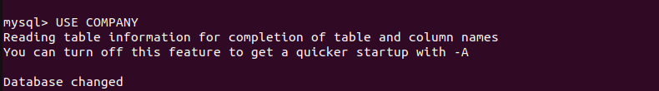

* **Employee Table**

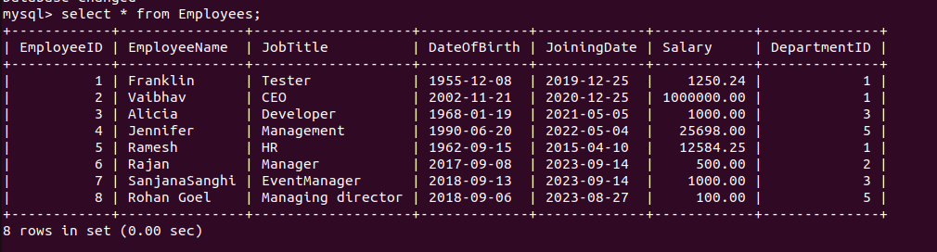

* **Department Table**

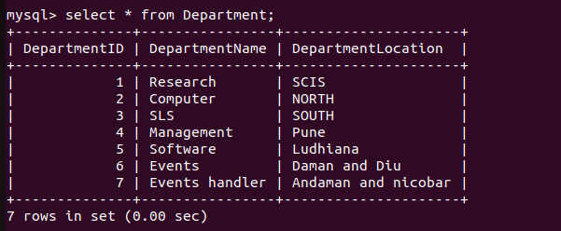

* In the db.properties file all the information related to url, user and password has already been written.

**QUESTION 7**

* Initially when we will run the code, it will ask the user which task he wants to perform, whether insertion of information or displaying the information.
* For differentiating the tasks I have used an if-else condition that will help to decide which option is selected by the user and it will run until user press the exit option which is number “5”.

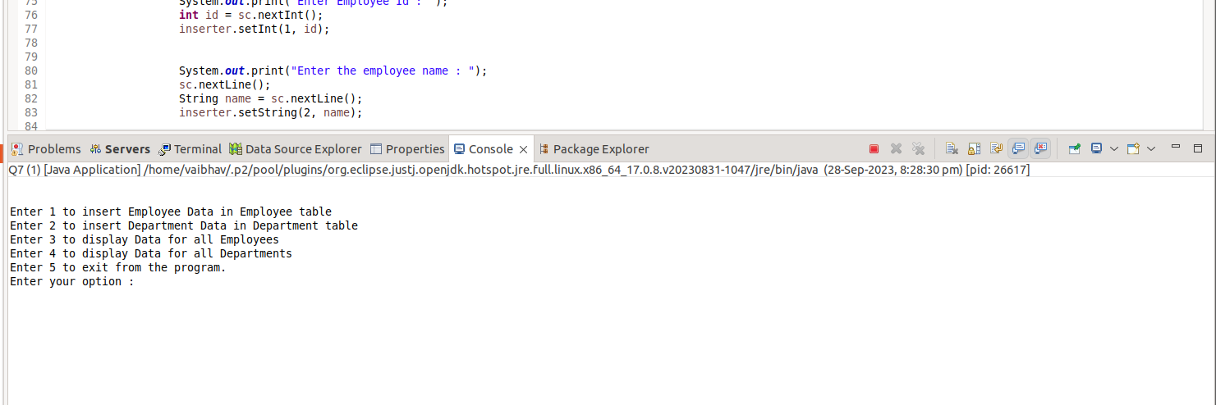

* **If the selected option is “1”**, then user can insert the Employee data in the database. He needs to make sure that that Employee ID is not repeating and Department ID is already present in the department table. If anyone of the constraint is not satisfied then the data won’t be inserted in the database. After addition in the Database, I have also shown the updated database and we can see that our input is accepted.

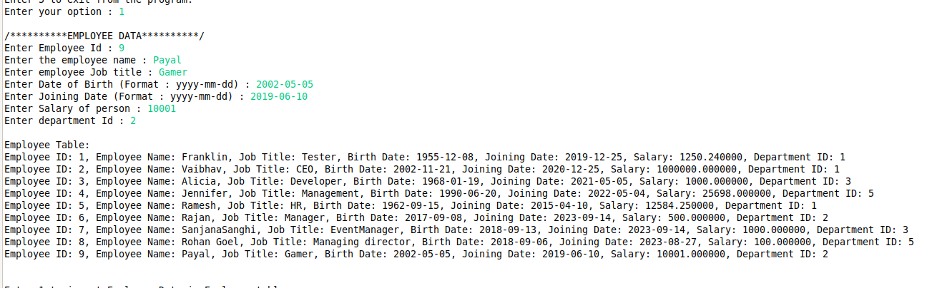

* If the above mentioned constraint are not satisfied, in that case data won’t be accepted and it will throw an error.

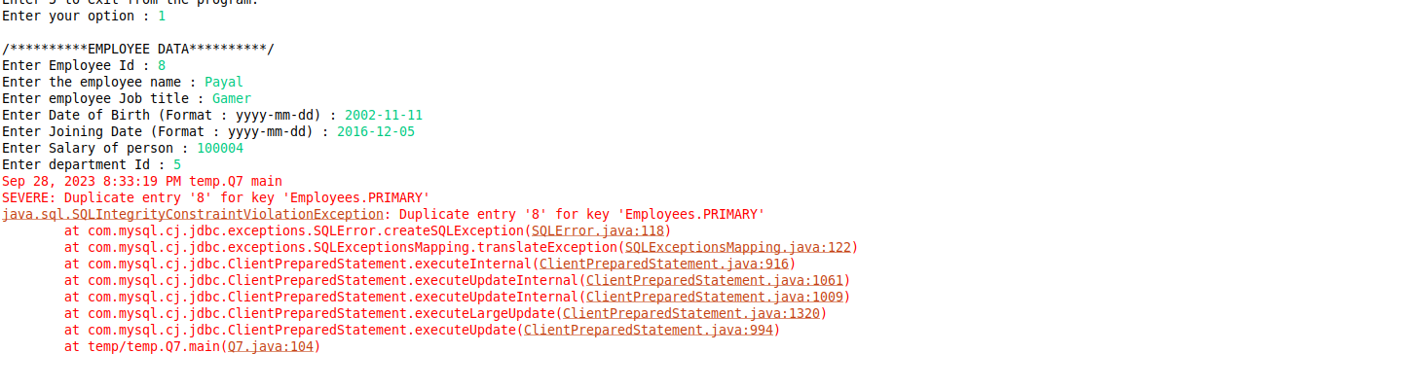

* **If the selected option is “2”**, then user can insert the Department data in the database. He needs to make sure that that Department ID is not repeating. If the constraint is not satisfied then the data won’t be inserted in the database. After addition in the Database, I have also shown the updated database and we can see that our input is accepted.

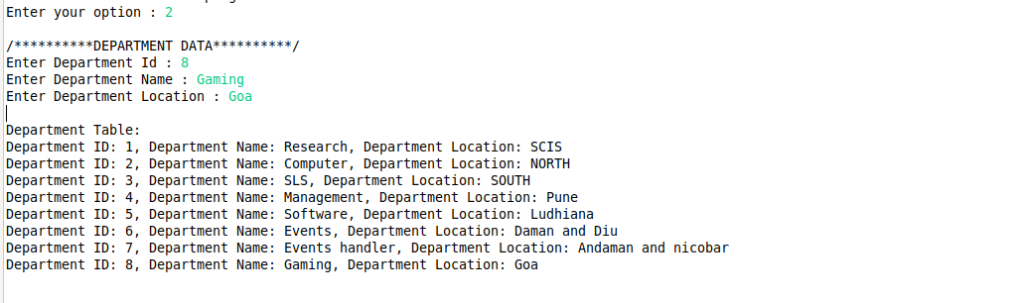

* If the above mentioned constraint are not satisfied, in that case data won’t be accepted and it will throw an error.

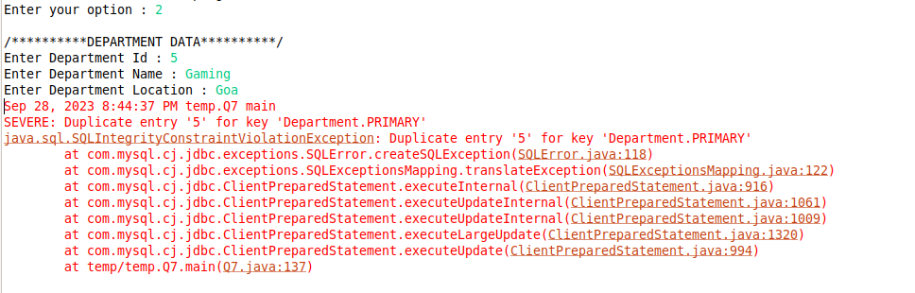

* **If the selected option is “3”**, then it will display the complete data of the Employee Table.

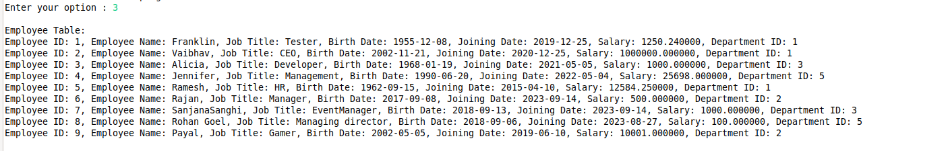

* **If the selected option is “4”**, then it will display the complete data of the Department Table.

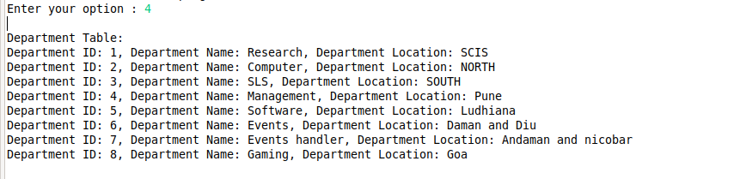

* **If the selected option is “5”**, in that case it will EXIT from the program.



**QUESTION 8**

* In this we are running a query such that, our output will show only those employees that have joined after an certain date **and** all are over n years old.
* Initially I have displayed the complete Employee Table and then the required inputs of joining date and age are asked from the user.

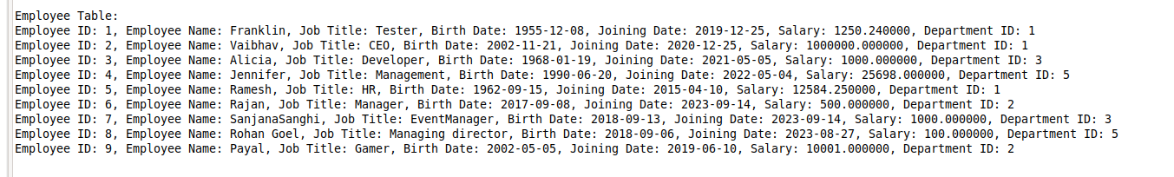

* Inputs are Taken from the user:-



* After this result has been displayed. The result consist of the complete information of the employee that satisfy the required constraint of our query.

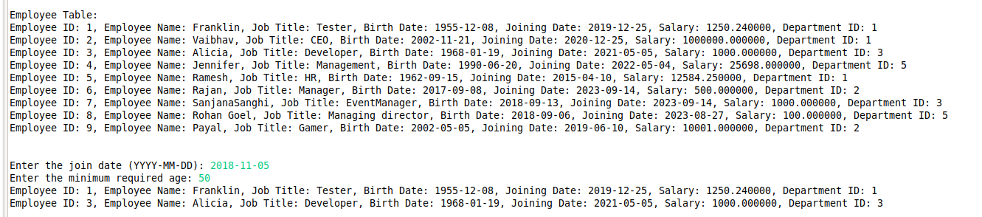

* The result of the query is shown above.

**QUESTION 9**

* Initially before running our query our database looks like this. So first of all the things, we will find the three senior most employees from our Employee table. After finding we will change the department ID of each of the resultant employees to the department ID of the **Management Department whose department ID is 4**. Once, there ID’s are changed we can say that they have been successfully shifted to management department. The employees that will be selected are highlighted in the following image.

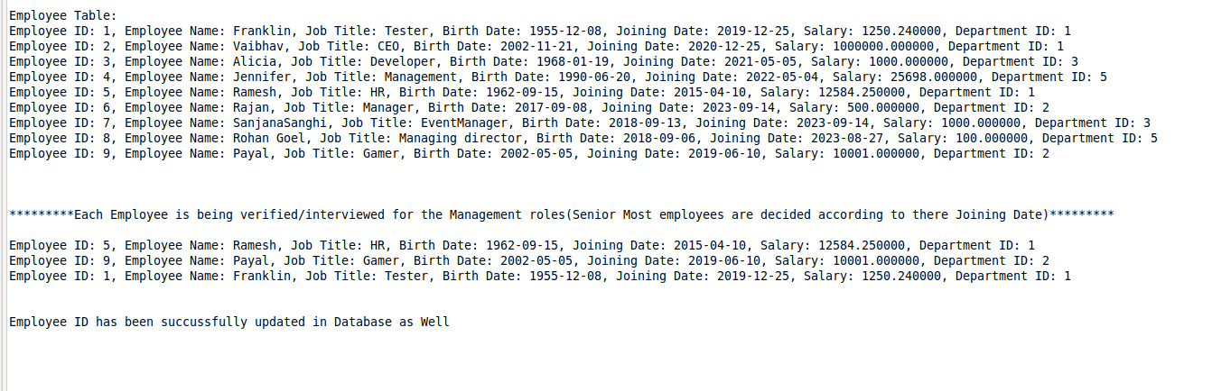

* We can see that the department ID of the three senior most employees has been changed. Seniority of the employees is decided on the basis of their joining date.

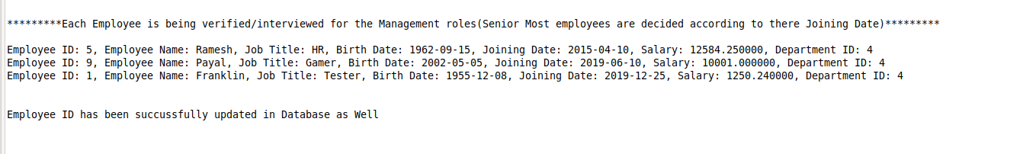

* We can see in the table that there Department ID has been changed.

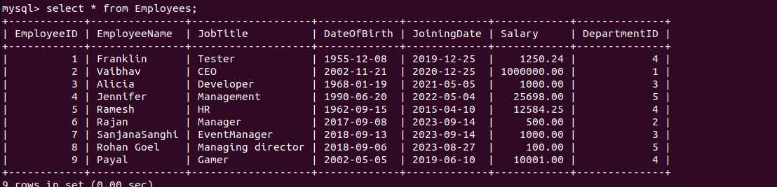

**QUESTION 10,11,12**

* The index.html from the webapp folder is being rendered on the web Browser when the url:-

**“localhost:8080/IT_Assignment_8_Q10_Q11_Q12”**

is specified in the search bar. When the page is loaded it looks like the following screenshot.

* It shows three links that will take us to different HTML pages.
* **The first link i.e. “EMPLOYEE INPUT FORM”** will take us to the page where we can enter the employee data and it will be added to the Employee table in our COMPANY database. After proper Validation only, data will be added to the employee table.
* **The second Link i.e. “DEPARTMENT INPUT FORM”** will take us to the page where we can enter department data and it will be added to the Department table in the COMPANY database. After proper Validation only, data will be added to the department table.
* **The third link i.e. “Employees who joined After a certain Date and are over n years old”** will take us to the HTML page where we can enter the joining Date and required date and it will run the query like we did in Q8.

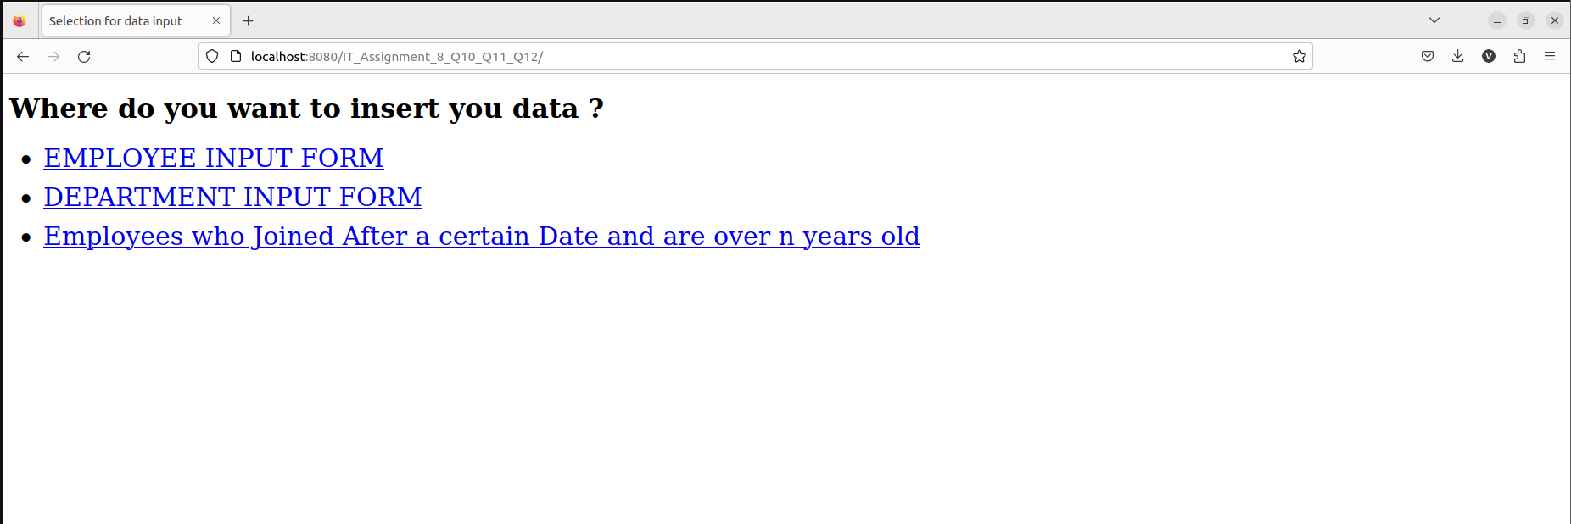

**WHEN THE FIRST LINK IS CLICKED**

* It will take us to the URL :-

[**http://localhost:8080/IT_Assignment_8_Q10_Q11_Q12/employeeForm.html**](http://localhost:8080/IT_Assignment_8_Q10_Q11_Q12/employeeForm.html)

The following page will be rendered where we can enter the Employee data which will get stored in the Employee table in our COMPANY Database.

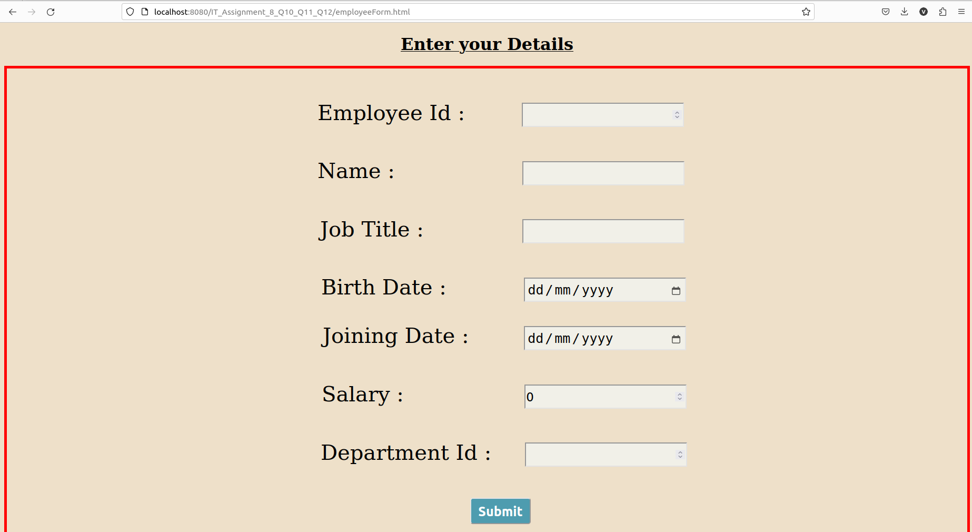

* In addEventListener(), a single parameter “event” has been passed which gives us the information of the button being pressed which results in an event.
  + - If the **information is invalid**, in that case event.preventDefault() is used that stops the default functionality of an event. In this case the default functionality of an submit button which is to submit the form data, has been prevented using this function in the case of invalid information.
    - If the **information is valid**, then the above mention function is not used and the data is being submitted.
* We have to fill each and every field in the input blocks. If any of the **fields are left empty** in that case it will display an error message telling which fields are left empty by the user.

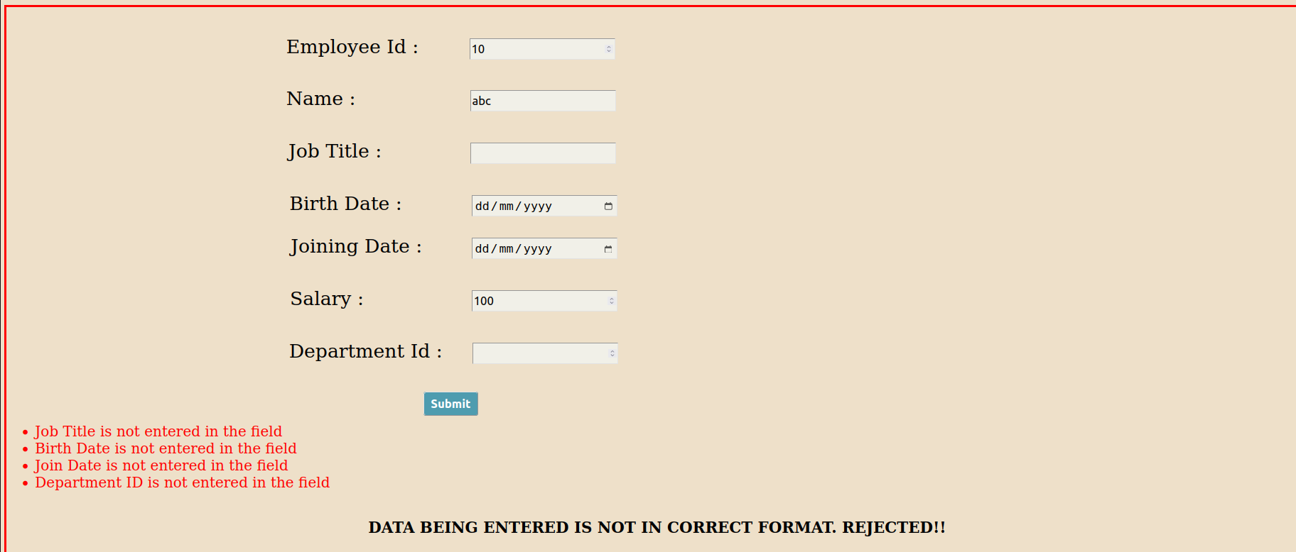

* If an **Invalid data is entered** in the input form, like writing numbers in the name, in that case as well form will not be submitted. A message saying “DATA BEING ENTERED IS NOT IN CORRECT FORMAT. REJECTED!!” will be displayed.

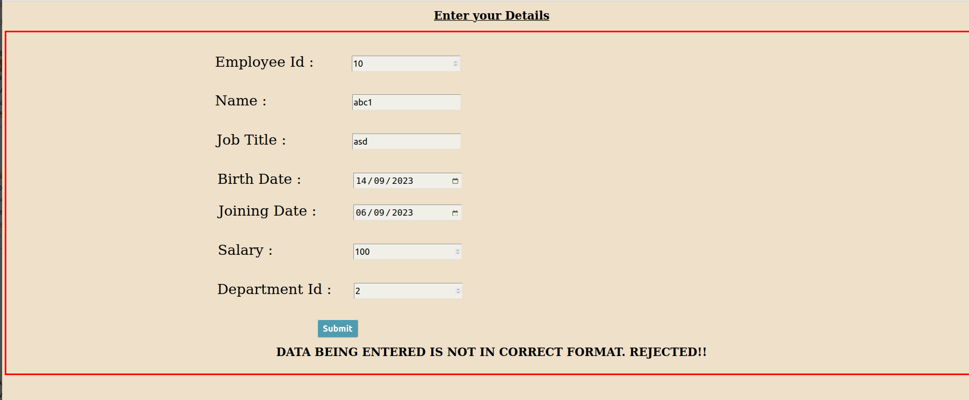

* Following is this input form that represents **valid entries** in all the input tags. In this case, it will get submit.

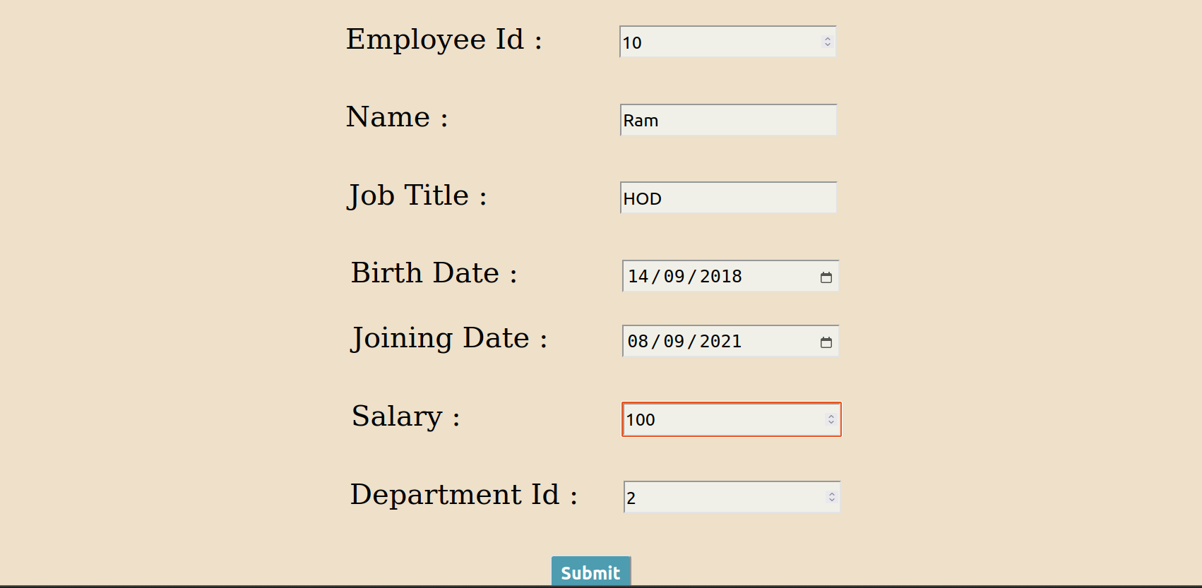

* Once the Data is successfully submitted it will show the message “Successfully Inserted!!” at the bottom of the web page.

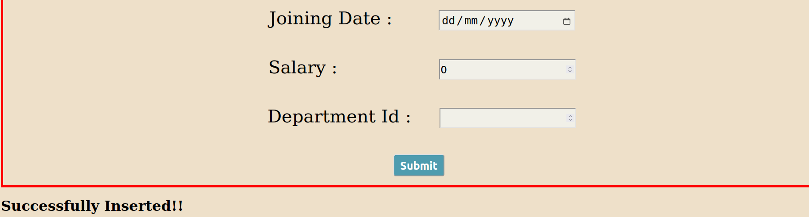

* We can see our database is updated as well.

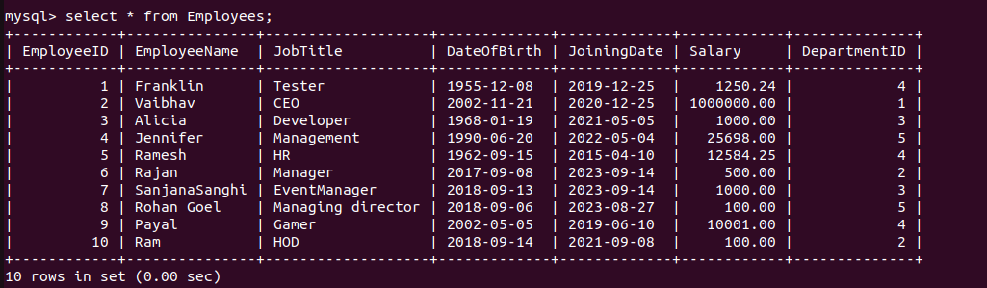

* In case any **constraint is Violated** like duplicate Employee ID or invalid Department ID in that case data will not be inserted and it will display a message “INSERTION FAILED”.

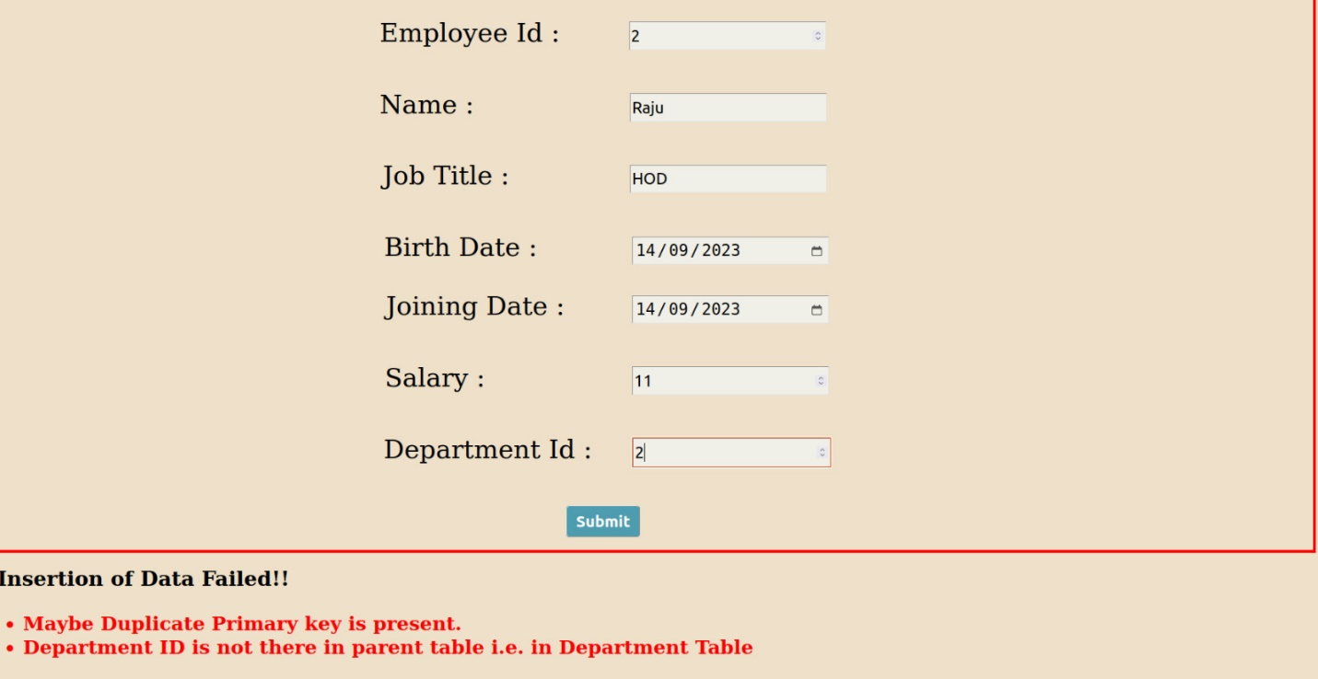

Employee with employee ID 2 is already there.

Table remains Unchanged.

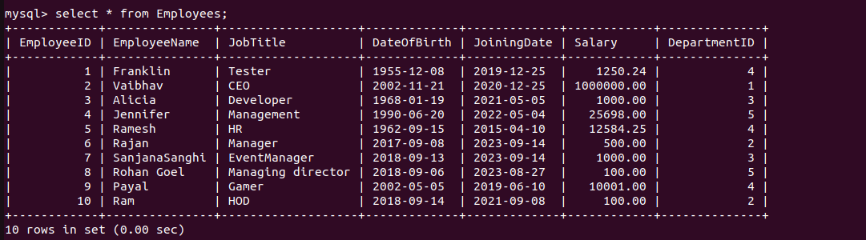

**WHEN THE SECOND LINK IS CLICKED**

* It will take us to the URL :-

[**http://localhost:8080/IT_Assignment_8_Q10_Q11_Q12/departmentForm.html**](http://localhost:8080/IT_Assignment_8_Q10_Q11_Q12/departmentForm.html)

The following page will be rendered where we can enter the Department data which will get stored in the Department table in our COMPANY Database.

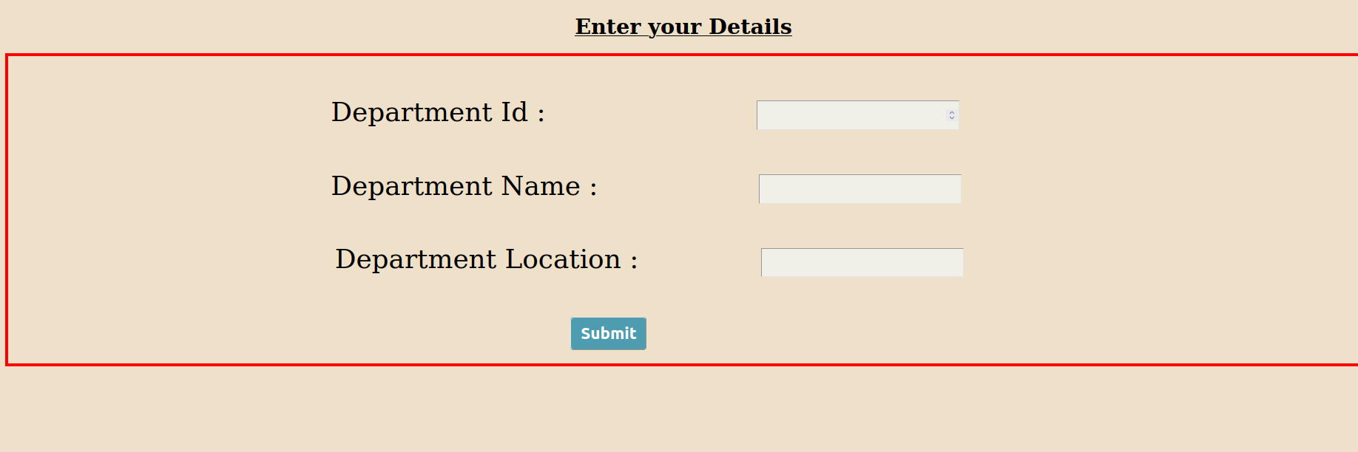

* In addEventListener(), a single parameter “event” has been passed which gives us the information of the button being pressed which results in an event.
  + - If the **information is invalid**, in that case event.preventDefault() is used that stops the default functionality of an event. In this case the default functionality of an submit button which is to submit the form data, has been prevented using this function in the case of invalid information.
    - If the **information is valid**, then the above mention function is not used and the data is being submitted.
* We have to fill each and every field in the input blocks. If any of the **fields are left empty** in that case it will display an error message telling which fields are left empty by the user.

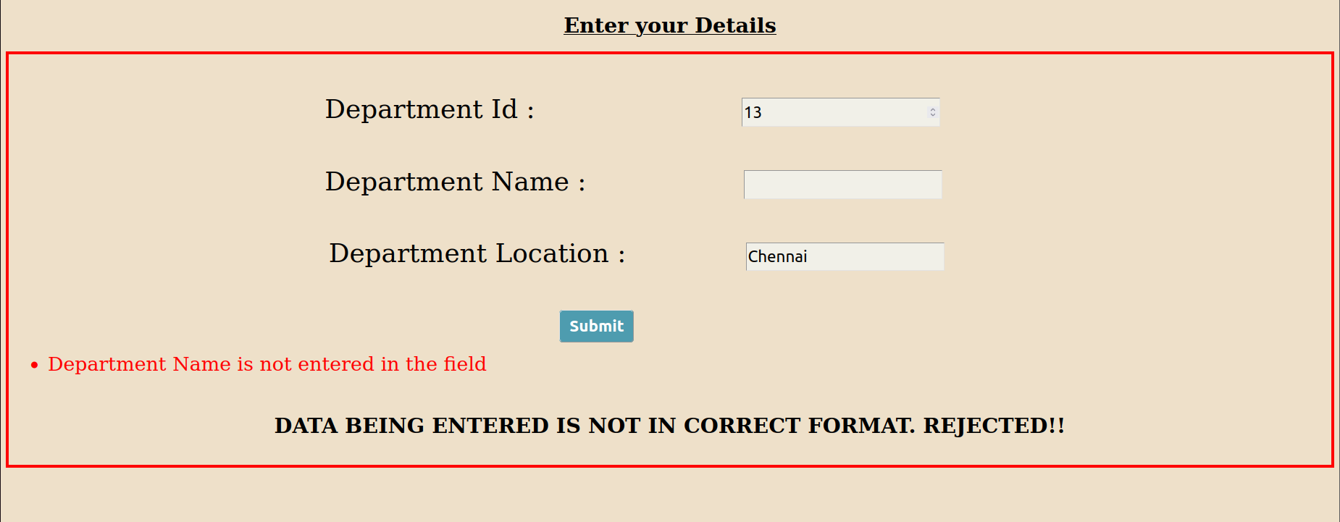

* If an **Invalid data is entered** in the input form, like writing numbers in the name, in that case as well form will not be submitted. A message saying “DATA BEING ENTERED IS NOT IN CORRECT FORMAT. REJECTED!!” will be displayed.

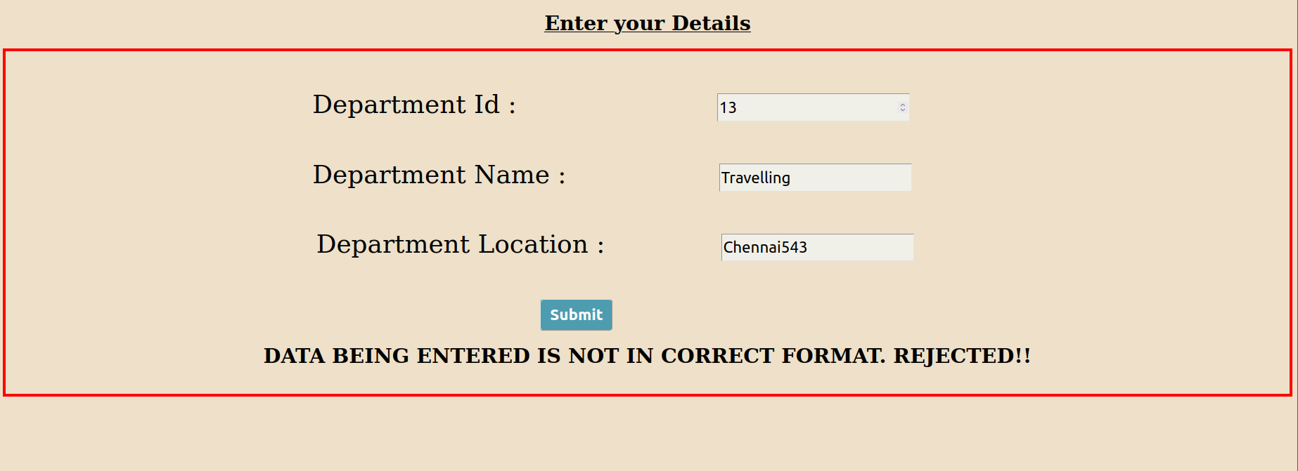

* Following is this input form that represents **valid entries** in all the input tags. In this case, it will get submit.

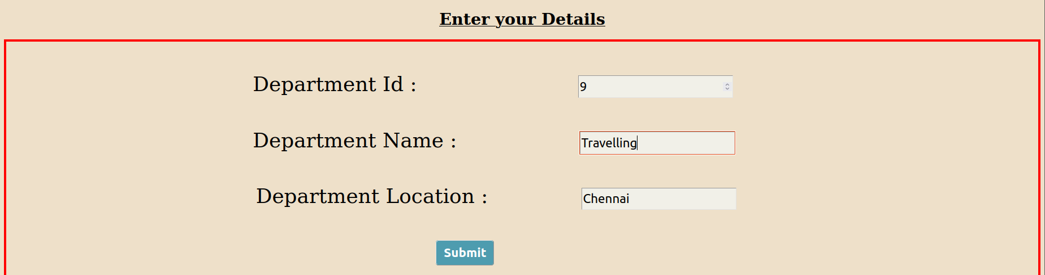

* Once the Data is successfully submitted it will show the message “Successfully Inserted!!” at the bottom of the web page.

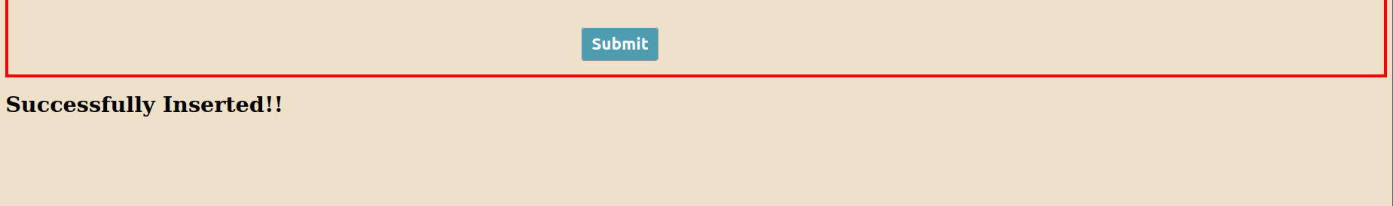

* We can see our database is updated as well.

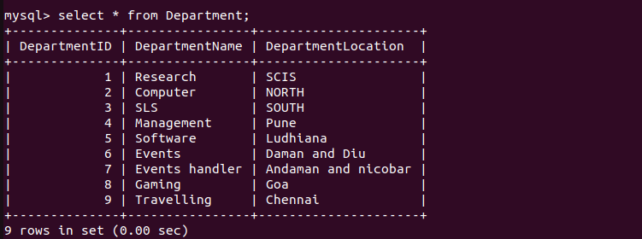

* In case any **constraint is Violated** like duplicate Department ID in that case data will not be inserted and it will display a message “INSERTION FAILED”.

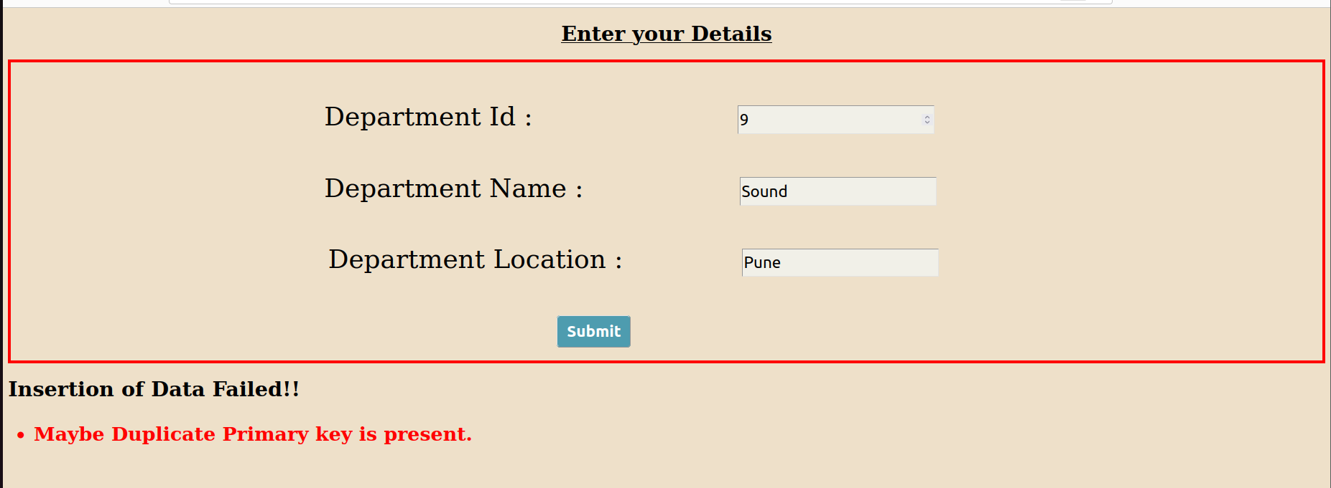

Department with department ID 9 is already there.

Table remains Unchanged.

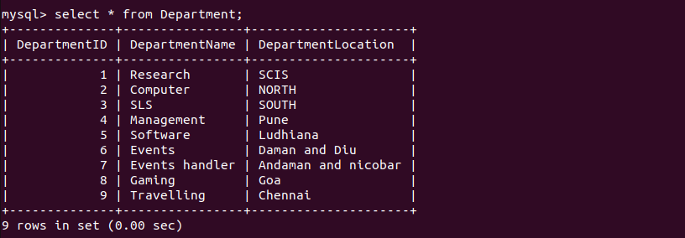

**WHEN THE THIRD LINK IS CLICKED**

* It will take us to the URL :-

[**http://localhost:8080/IT_Assignment_8_Q10_Q11_Q12/query1**](http://localhost:8080/IT_Assignment_8_Q10_Q11_Q12/query1)

The following page will be rendered where we can enter the Joining Date and the age for the required query and will display the complete information of all the resultant employees.

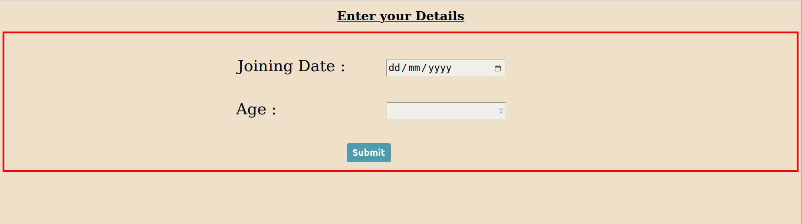

* We have to fill each and every field in the input blocks. If any of the **fields are left empty** in that case query won’t be executed and it will display a message “INVALID INPUT HAS BEEN ENTERED”.

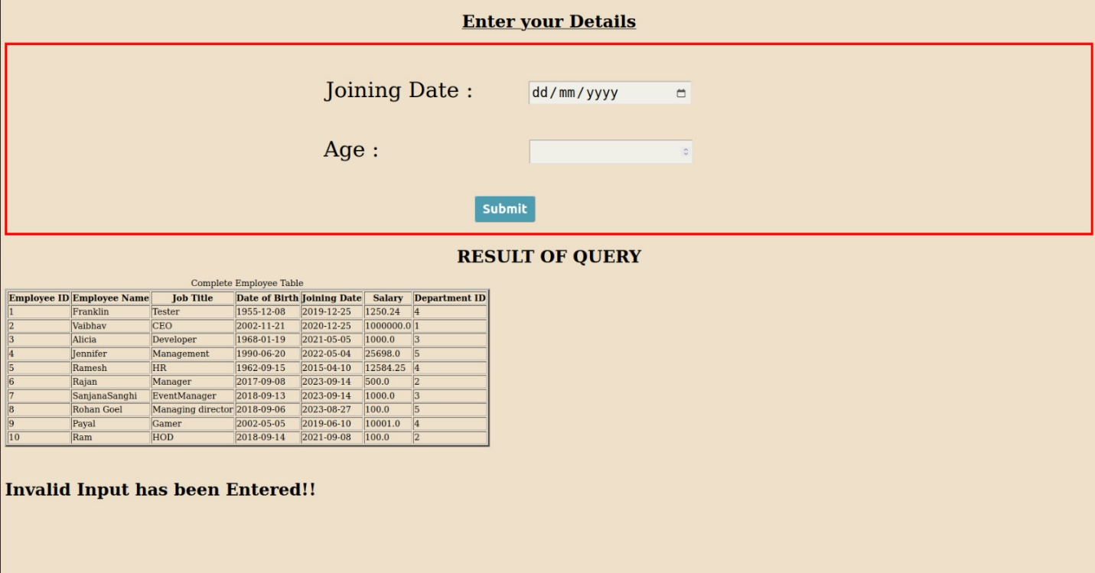

* If all the **fields are properly filled** in that case query will display a valid output.
* First it will display the Employee table in which complete information of all the employees is present.
* After that it displays the result of our entered query in a table format.

