**VAIBHAV RAJPAL**

**2020146**

**Ans 1:**

**Gaussian Filter:**

1. **Kernel Size 3x3:**

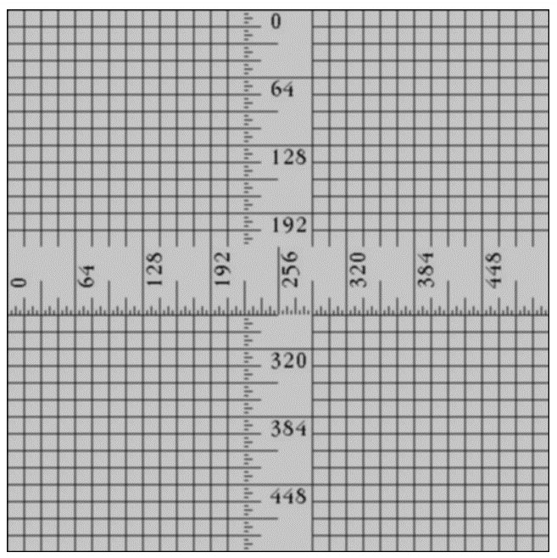

1. **Kernel Size 5x5:**

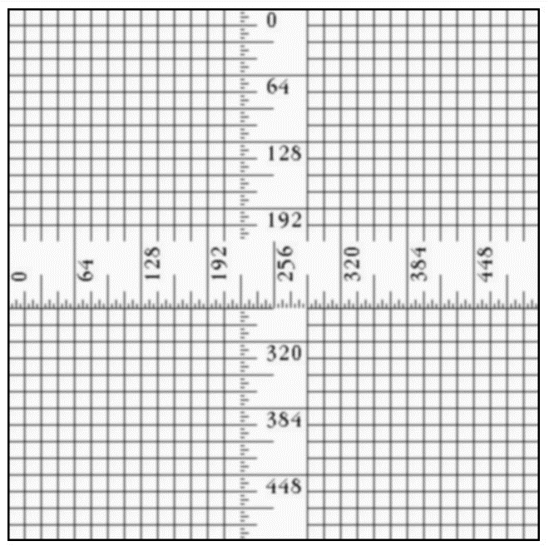

**Median Filter:**

1. **Kernel Size 3x3:**

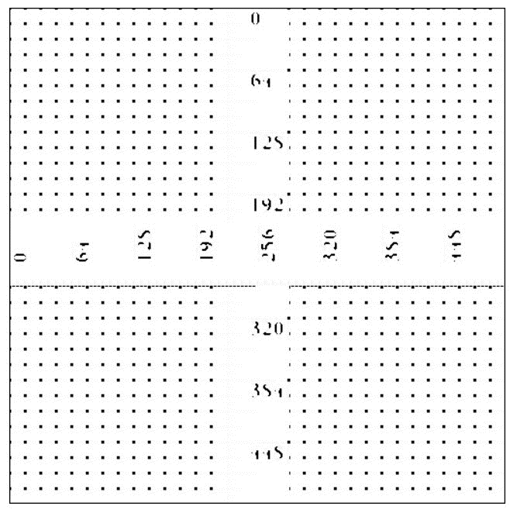

1. **Kernel Size 5x5:**

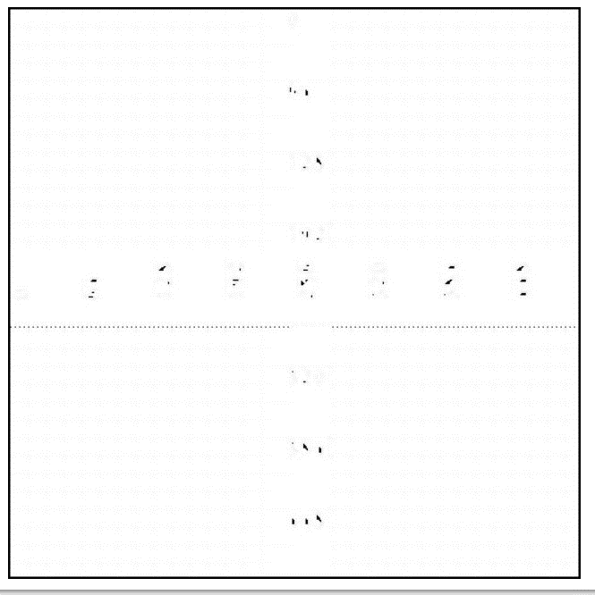

Out Of Gaussian and Median filter, the one that preserve the edge better is the **Median Filter** as for a median filter the median value is the value of one of the neighbouring pixels only and because it is one of the neighbouring value only the filter does not have to create any pixel which actually does not exist in reality and because of which there is no effect on the edges and thus they get preserved.

**Ans 2:**

**First Order Technique:**

1. **Robert Technique:**

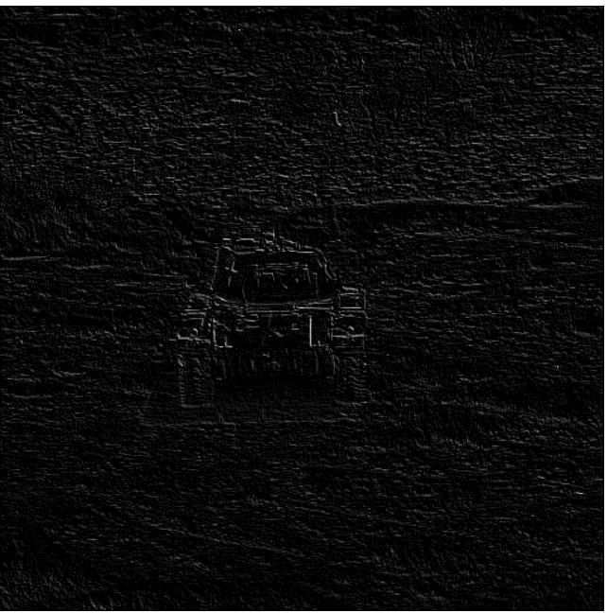

1. **Sobel Technique:**

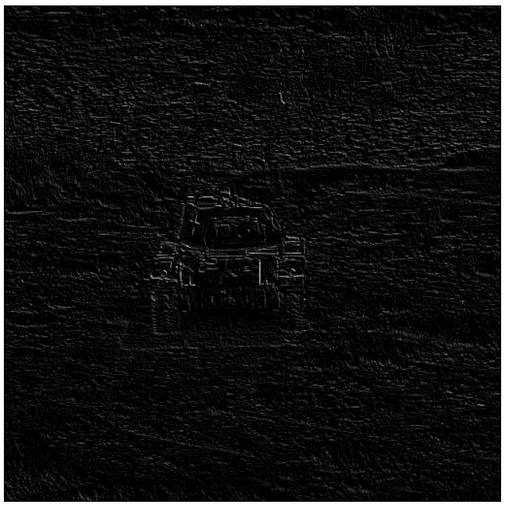

1. **Prewitt Technique:**

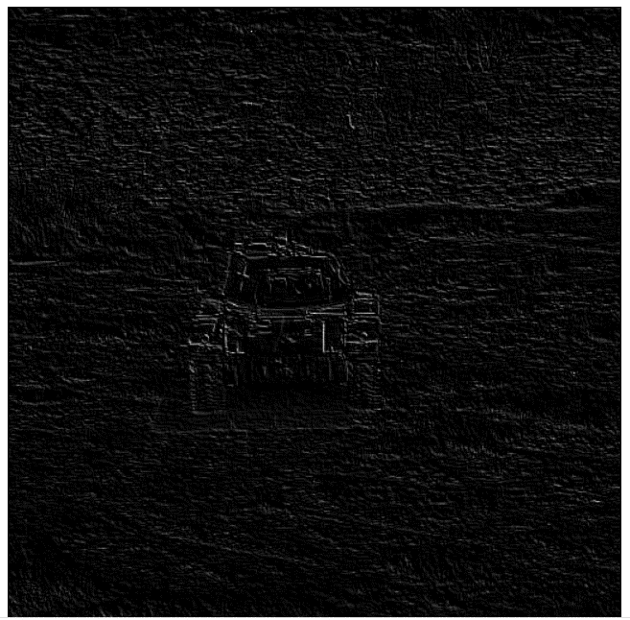

**Second Order Technique:**

1. **Laplacian Detector Technique:**

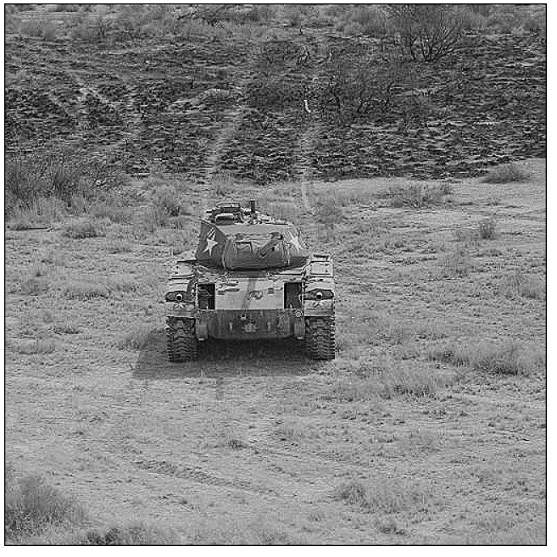

1. **Laplacian Filter with non-zero diagonal elements technique:**

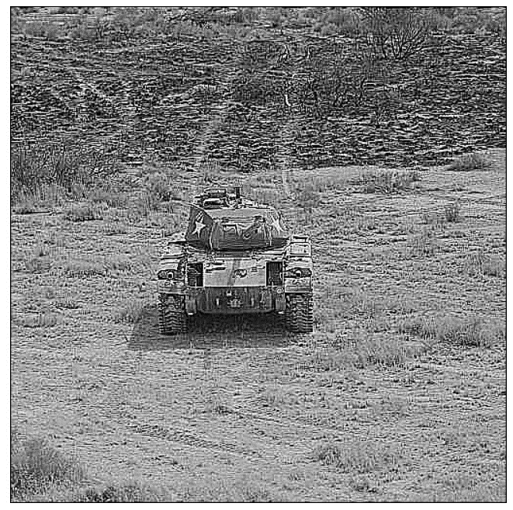

1. **Unsharpening Mask Technique:**

