***INSTRUCTIONS***

Run gameoflife.py

To run the program make sure to have the **pygame library** installed on the system.

In order to install pygame, use pip in Command Prompt.

*py -m pip install -U pygame --user*

Ensure that you have the images in the same folder.

The project is also uploaded online on GitHub at-

<https://github.com/vaibhav20325/GameOfLife>

Generation Number

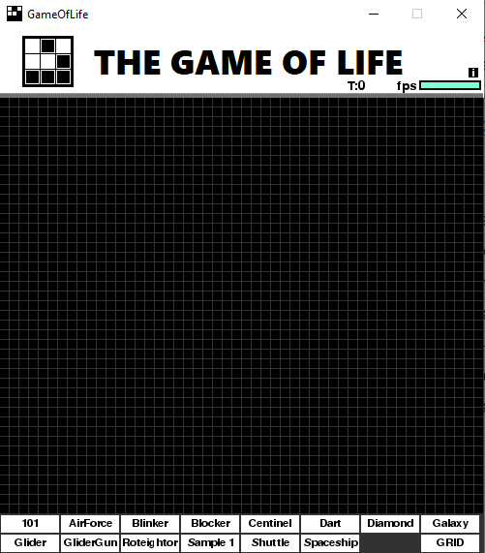

Fps bar

Click here to open the instructions page

Click Here to Switch GRID ON or OFF

Press c to switch between colour modes (Will work when the Game starts running i.e. when you have set the grid and pressed Enter)

Press q for an infinite grid simulation (Before setting the grid)

Click on the GRID button to switch btw GRID and NO GRID

Control the frame rate using *→* and  *←* arrow keys

Click on any Button to use the saved designs

To save your own designs use the **new_button** module present in the folder. Open new_button.py, Enter grid size and then make the design and Press ENTER.

You can also make a text file in the design folder and copy there a pattern from the list of designs or internet.

A button containing that design will be created automatically

Eg-

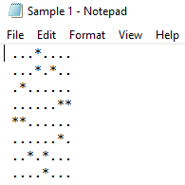

This created a button called Sample 1 which can be seen in first snip