MACHINE LEARNING – WORKSHEET (CLUSTERING)

Q1 to Q12 have only one correct answer. Choose the correct option to answer your question.

- What is the most appropriate no. of clusters for the data points represented by the following dendrogram:

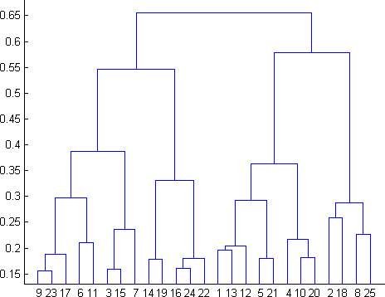

  - 2
  - 4
  - 6
  - 8
ANSWER: b(4)

- In which of the following cases will K-Means clustering fail to give good results?
- Data points with outliers
- Data points with different densities
- Data points with round shapes
- Data points with non-convex shapes Options:
  - 1 and 2
  - 2 and 3
  - 2 and 4
  - 1, 2 and 4
e. 1, 2, 3 and 4

ANSWER: d(1,2,4)
- The most important part of is selecting the variables on which clustering is based.
  - interpreting and profiling clusters
  - selecting a clustering procedure
  - assessing the validity of clustering
  - formulating the clustering problem
Answer: d(formulating the clustering problem)

- The most commonly used measure of similarity is the or its square.
  - euclidean distance
  - city-block distance
  - Chebyshev’s distance
  - Manhattan distance
Answer: a(euclidean distance)

- is a clustering procedure where all objects start out in one giant cluster. Clusters are formed by dividing this cluster into smaller and smaller clusters.
  - Non-hierarchical clustering
  - Divisive clustering
  - Agglomerative clustering
  - K-means clustering

- Which of the following is required by K-means clustering?
  - defined distance metric
  - number of clusters
  - initial guess as to cluster centroids
  - all answers are correct
Answer: d(all answers are correct)

- The goal of clustering is to-
  - Divide the data points into groups
  - Classify the data point into different classes
  - Predict the output values of input data points
  - All of the above
ANSWER: a(Divide the Data Points into Groups)

- Clustering is a-
  - Supervised learning
  - Unsupervised learning
  - Reinforcement learning
  - None
ANSWER: b(Unsupervised learning)

- Which of the following clustering algorithms suffers from the problem of convergence at local optima?
  - K- Means clustering
  - Hierarchical clustering
  - Diverse clustering
  - All of the above
Answer: d(All of the Above)
- Which version of the clustering algorithm is most sensitive to outliers?
  - K-means clustering algorithm
  - K-modes clustering algorithm
  - K-medians clustering algorithm
  - None
Answer: a(K-means clustering algorithm)

- Which of the following is a bad characteristic of a dataset for clustering analysis-
  - Data points with outliers
  - Data points with different densities
  - Data points with non-convex shapes
  - All of the above
Answer: d(All of the above)

- For clustering, we do not require-
  - Labeled data
  - Unlabeled data
  - Numerical data
  - Categorical data
Answer: a(Labeled Data)

Q13 to Q15 are subjective answers type questions, Answers them in their own words briefly.

- How is cluster analysis calculated?
Answer: The hierarchical cluster analysis follows three basic steps:
1) Calculate the distances,
2) Link the clusters, and
3) Choose a solution by selecting the right number of clusters.

For instance, by varying k from 1 to 10 clusters. For each k, calculate the total within-cluster sum of square (wss). Plot the curve of wss according to the number of clusters k. The location of a bend (knee) in the plot is generally considered as an indicator of the appropriate number of clusters.

- How is cluster quality measured?
Answer: A good clustering method will produce high quality clusters in which: – the intra-class (that is, intra intra-cluster) similarity is high. The quality of a clustering result also depends on both the similarity measure used by the method and its implementation.

You could proceed with "external clustering quality metrics". A widely used metric in this case is Purity. But you can proceed with others, like Homogeneity, Completeness, V-Measure, Precision, Recall, Normalized Mutual Information and CMM

- What is cluster analysis and its types?
Answer: Cluster analysis is a class of techniques that are used to classify objects or cases into relative groups called clusters. Cluster analysis is also called classification analysis or numerical taxonomy. In cluster analysis, there is no prior information about the group or cluster membership for any of the objects

Clustering itself can be categorized into two types viz.
Hard Clustering and Soft Clustering.
In hard clustering, one data point can belong to one cluster only.
But in soft clustering, the output provided is a probability likelihood of a data point belonging to each of the pre-defined numbers of clusters

Basically there are 3 types of clusters, Fail-over, Load-balancing and HIGH Performance Computing, The most deployed ones are probably the Failover cluster and the Load-balancing Cluster. Fail-over Clusters consist of 2 or more network connected computers with a separate heartbeat connection between the 2 hosts.

