Temporal and Multimodal Visual Intelligence
Technical Report - ML Research Engineer Assessment

1. Introduction
This report asks whether a model can extract and use information from a sequence of visual observations that is not available from any single frame. An order-free baseline and a small GRU are trained on the same frozen DINOv2 embeddings of Something-Something V2 clips. Controlled experiments (progressive observation, temporal order shuffling, per-class and error analysis) test whether the gain comes from temporal order or simply from seeing more frames. A VLM experiment, a research analysis and a system design follow.
Summary of findings. On a 5-class subset the GRU reaches 75.63% validation accuracy, against 55.58% for a mean-pooled baseline that sees all 8 frames without their order. Shuffling the frames returns the GRU to 55.58%. The gain sits in the directional classes (Push left to right: 32.99% to 78.35%), while Tearing is solved at 98.85% by both models. All results come from a single training run evaluated on 439 validation videos.

2. Dataset and Sequence Analysis
Something-Something V2 (220,847 clips, 174 classes of hand-object interaction) was used because many classes come in direction pairs whose individual frames look alike. Five classes form the subset: Pushing something from left to right, Pushing something from right to left, Moving something up, Moving something down, and Tearing something into two pieces. The first four are directional pairs. Tearing is the control, since the torn end state may be visible in a single frame. The subset has 4,763 training and 439 validation videos, each represented by 8 evenly spaced frames at 224x224.
Sequence integrity and what changes. Frame ordering was verified by checking that the extracted frame indices were strictly increasing for every video. Classes are roughly balanced, with about 920 to 970 training and 70 to 100 validation videos each (Figure 1). Figure 2 shows one frame strip per class. In the pushing and moving examples the object is static at first and the hand enters and moves it in later frames, so the direction becomes visible only around the middle of the clip. A single frame is therefore ambiguous within each directional pair (left vs right, up vs down). For Tearing, the final frames show two separate pieces, so one frame is often enough.
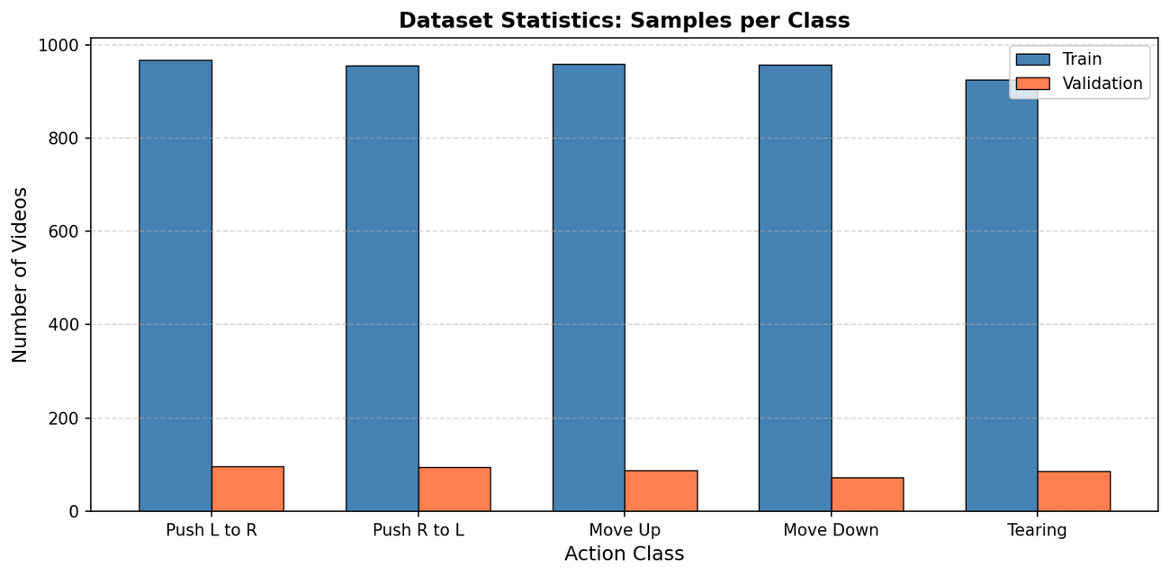
Figure 1: Videos per class in the train and validation splits.
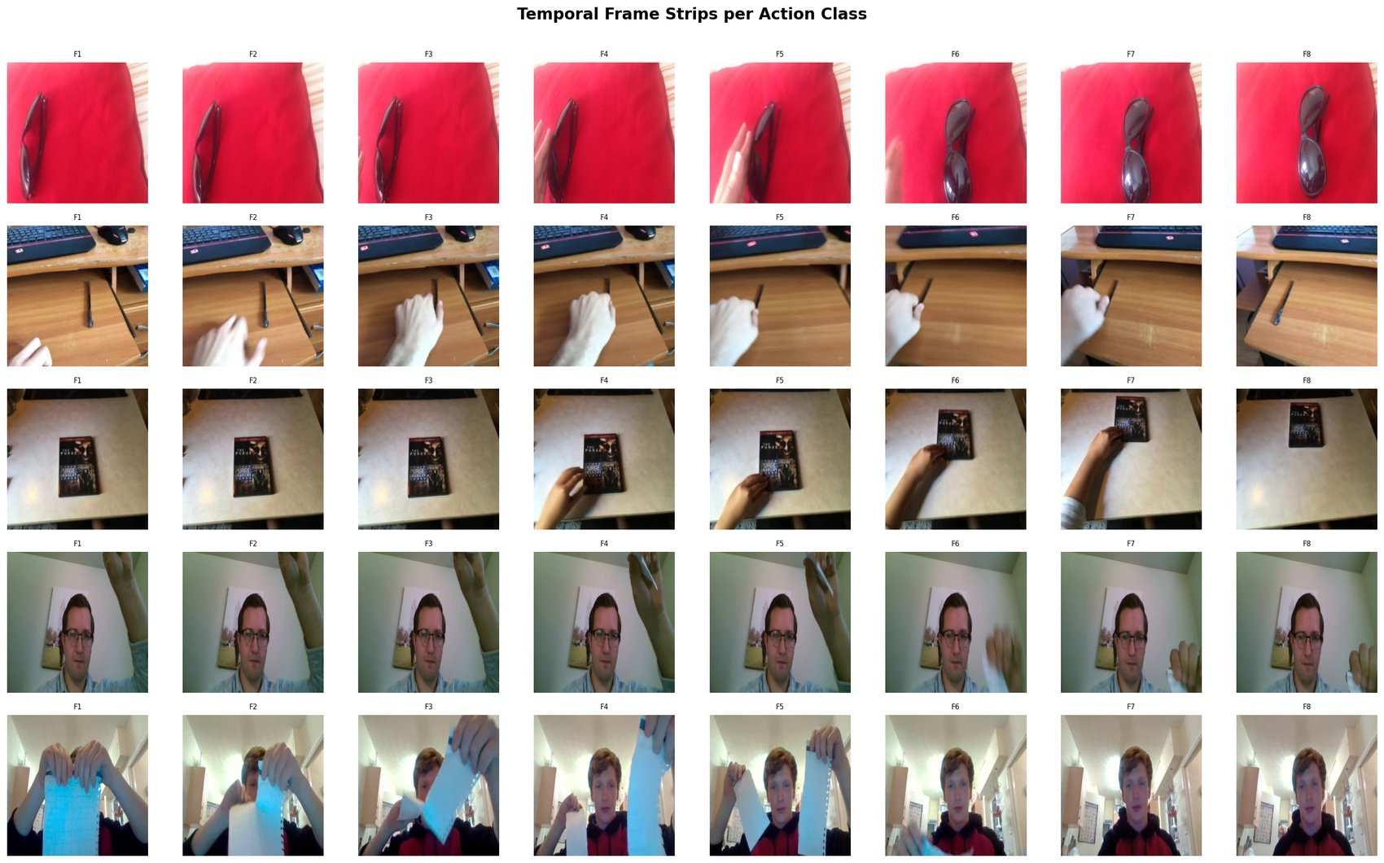
Figure 2: Temporal frame strips, 8 evenly spaced frames per class. Directional pairs look alike in any single frame.

3. Visual Representation and Embeddings
DINOv2 Small (facebook/dinov2-small) was used as a frozen encoder. Each frame is processed independently and its 384-dimensional CLS token is kept, giving an (8, 384) array per video. Caching these arrays lets every later experiment train on small numeric inputs with no image loading.
Figure 3 shows the mean cosine similarity between consecutive frame embeddings. For Push left to right, similarity falls from about 0.94 to about 0.81 by the F5 to F6 transition and then recovers slightly, so most of the change happens in the second half of the clip. Tearing changes more throughout (similarity mostly between 0.70 and 0.81) yet is the class that needs temporal information least. The size of the embedding change is therefore not a measure of whether order matters. The pushing drift does line up with the largest accuracy jump in the progressive experiment (Section 5.2).
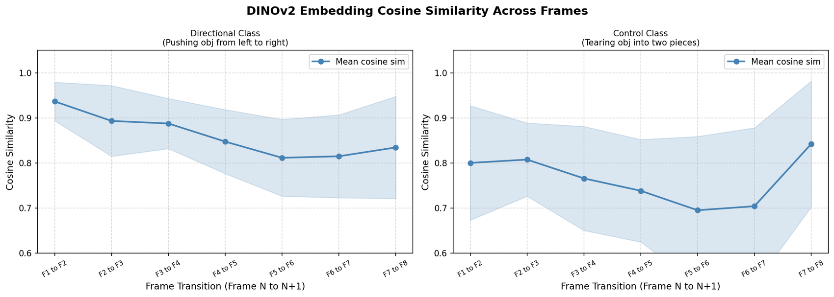
Figure 3: Mean cosine similarity between consecutive DINOv2 frame embeddings (shaded band: spread across videos).

4. Model Architecture
Baseline: mean-pooled MLP (order-free). The 8 frame embeddings are averaged into one 384-dimensional vector and passed through an MLP (384, 256, 128, 5 with ReLU and dropout). The model sees information from every frame but has no access to their order, and it uses a single pooled visual representation as the brief requires.
Temporal model: GRU. The 8 embeddings enter a single-layer GRU (hidden size 256) in chronological order, and the final hidden state feeds a linear classifier. A GRU was chosen for simplicity and stable training on under 5,000 examples. A Transformer encoder or temporal CNN was not compared here and is a natural extension.
Parameter | Value | Parameter | Value
Encoder | dinov2-small (frozen) | Learning rate | 1e-3
Frames per video | 8 | Batch size | 32
Optimizer | Adam | Epochs | 40
Training videos | 4,763 | Validation videos | 439

5. Experiments and Results

5.1 Baseline vs Temporal Model
Model | Input | Overall | Tearing | Push L to R
Mean-pooled MLP | 8 frames, no order | 55.58% | 98.85% | 32.99%
GRU | 8 frames, ordered | 75.63% | 98.85% | 78.35%
GRU, shuffled frames | 8 frames, random order | 55.58% | - | -

The GRU improves on the baseline by 20 points. The per-class numbers show where. Tearing is at 98.85% for both models, so order adds nothing when the end state is visible. Push left to right rises from 32.99% to 78.35%. A model that recognises the action family from appearance but can only guess direction would score about 60% on this class mix (four directional classes at 50% and Tearing at 100%). The baseline's 55.58% is consistent with that, which suggests it carries little or no direction information, although a confusion matrix would be needed to confirm it. With 439 validation videos each accuracy carries roughly 4 to 5 points of sampling uncertainty (95%), so a 20 point gap is well outside noise, but it comes from one training run.
Figure 4 shows the GRU overfitting: training accuracy approaches 98% while validation accuracy plateaus near 74 to 75% and validation loss rises after about epoch 10. The baseline overfits less but plateaus much lower.
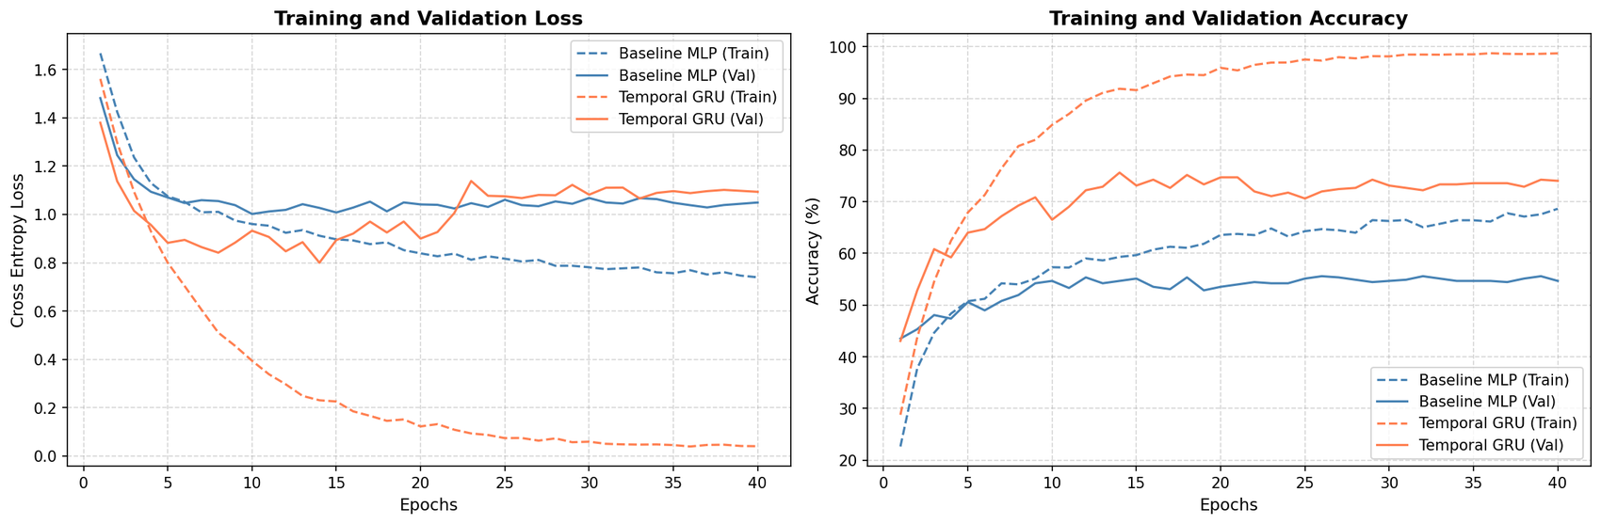
Figure 4: Training and validation loss and accuracy over 40 epochs for the baseline and the GRU.

5.2 Progressive Observation
The GRU was evaluated on only the first N frames, for N from 1 to 8.
Frames | 1 | 2 | 3 | 4 | 5 | 6 | 7 | 8
Accuracy (%) | 30.52 | 34.85 | 40.77 | 48.52 | 54.90 | 67.43 | 72.21 | 75.63

Accuracy rises monotonically. The largest jump (+12.5 points) is between frames 5 and 6, where the embeddings also change most (Figure 3), and the model needs most of the clip before direction is reliable. One caveat: the GRU was trained on full 8-frame sequences, so low accuracy at small N reflects both missing information and a train-test mismatch. The 1-frame figure of 30.52% is above the 20% chance level but should not be read as the accuracy of a model trained on single frames.

5.3 Temporal Order Shuffling
The 8 validation embeddings were randomly shuffled before being given to the trained GRU. Accuracy fell from 75.63% to 55.58%, the same as the mean-pooled baseline to the precision reported. The exact match is partly coincidental, since they are different models, so the point is the direction: with the same frames and the same information, removing order returns the GRU to the order-free level. This is the strongest evidence in the study that the GRU uses temporal order. A cleaner version of the control would also train a GRU on shuffled sequences.
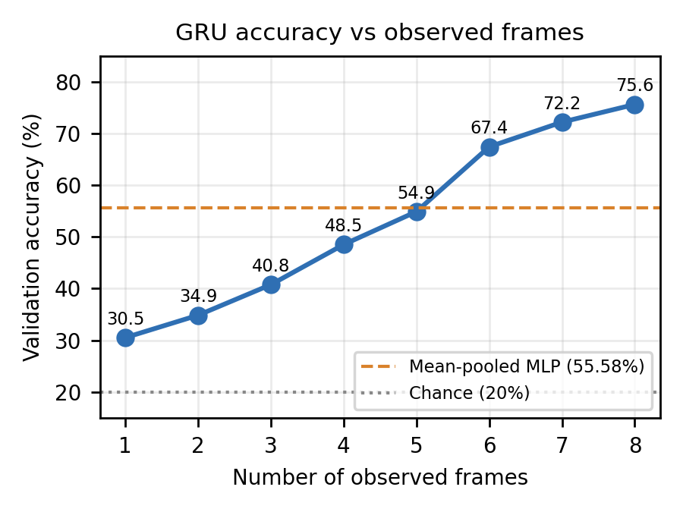 | 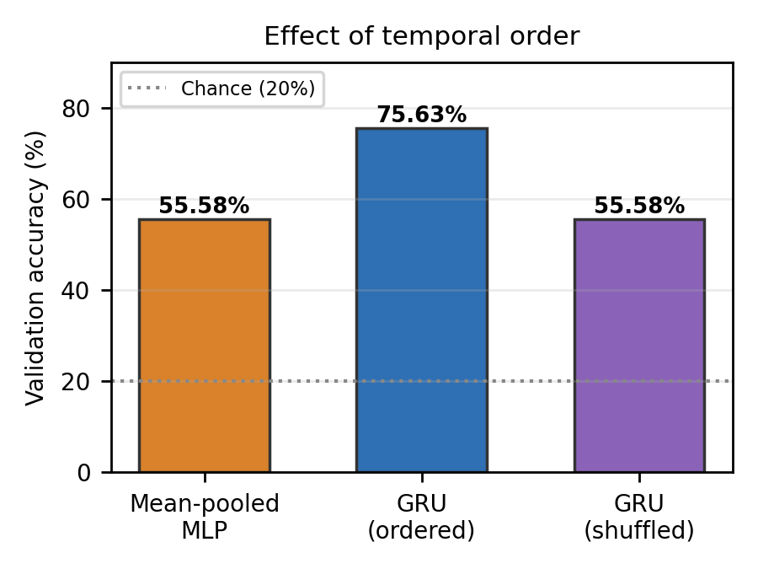
Figure 5: GRU accuracy vs number of observed frames. | Figure 6: Baseline, ordered GRU and shuffled GRU accuracy.

5.4 Qualitative Comparison and Error Analysis
Figure 7 shows four validation cases (case titles are illustrative labels; the causes were not verified). In Case 1 the GRU resolves a push direction that the baseline misreads as Moving down. In Case 2 (video 29999) both models are correct. In Case 3 both fail on a clip dominated by blur and camera motion, so heavy corruption removes the direction cue for either model. In Case 4 the baseline is right and the GRU predicts the wrong direction, a reminder that the GRU also makes errors the baseline does not.
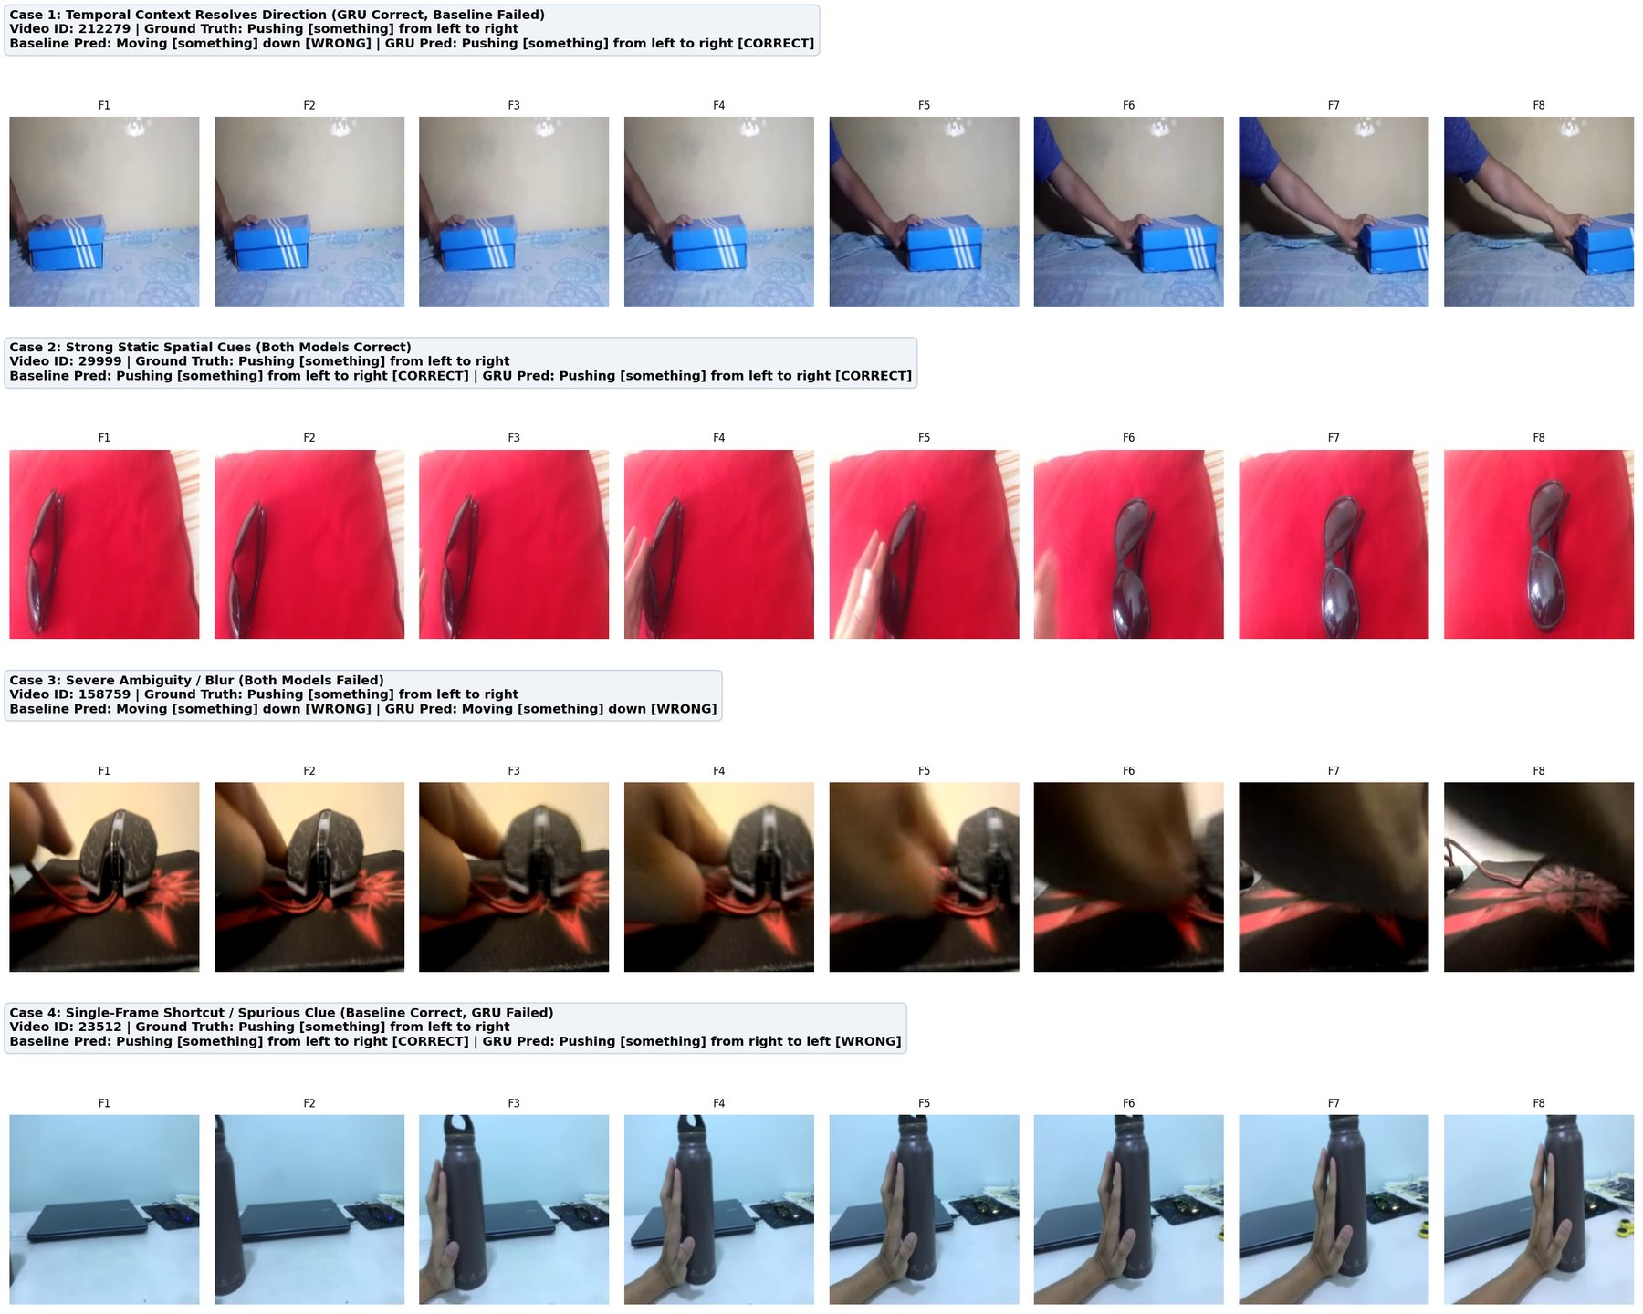
Figure 7: Four validation cases with the 8 input frames and each model's prediction.

6. Multimodal VLM Component
LLaVA 1.5 7B (4-bit quantised) was given 4 evenly spaced frames from each of 3 validation videos (Pushing, Moving, Tearing) with a structured prompt asking what changes across frames, what action and direction occur, and whether Frame 1 alone is ambiguous. The full outputs are in visualizations/vlm_experiment_report.pdf.
Observations. In all three cases LLaVA said Frame 1 alone is ambiguous and that movement becomes clear in later frames. This agrees with the progressive observation result, but it is weak evidence because the prompt asked that question directly. Perception was less reliable. On the Push left to right video (29999, sunglasses on a red cloth) LLaVA named the object correctly but described it being raised and put on, so the direction was wrong. On the Tearing video it did not track the change of state accurately. LLaVA 1.5 was trained on single images, so multi-image input is out of distribution for it.
Where the VLM adds value. For direction, the GRU is clearly better here: it is supervised for the task and reaches 78.35% on Push left to right, while the VLM failed on the one pushing case shown. The VLM adds value elsewhere: it names objects without task training and returns an explanation a person can read and challenge. A video-capable VLM and a larger sample are needed before drawing firm conclusions.

7. Research Analysis
A. When did temporal information help? Temporal information helped for the directional classes. Push left to right rose from 32.99% to 78.35%, and the overall gain was 20 points. The progressive curve shows the benefit arriving in the second half of the clip, when the object is moving.
B. When did it not help? It did not help for Tearing, where both models score 98.85% because the end state is visible in the frames. It also did not help in blurred or heavily moving clips (Case 3), and in Case 4 the GRU was worse than the baseline.
C. How can we tell the model uses temporal relationships, not just more visual information? By holding the input frames fixed and varying only order. The mean-pooled baseline and the shuffled GRU receive the same 8 frames, and both score 55.58%, while the ordered GRU scores 75.63%. The progressive curve is supporting evidence. A further check would be training on shuffled sequences, or inspecting temporal attention.
D. What result would show the temporal approach is not useful? A shuffled GRU matching the ordered GRU, a mean-pooled baseline matching the GRU, a flat progressive curve, or a gap that disappears across seeds or falls inside the sampling uncertainty. The results here point the other way, but only for one run.
E. What would give stronger evidence? Run several seeds with confidence intervals and hold out a test split. Add a confusion matrix, a shuffled-training control, and corruption experiments (blur, dropped frames). Use more classes, including non-directional controls, and the full dataset, then compare a Transformer or temporal CNN. Evaluate a video-capable VLM on many videos.

8. System Design
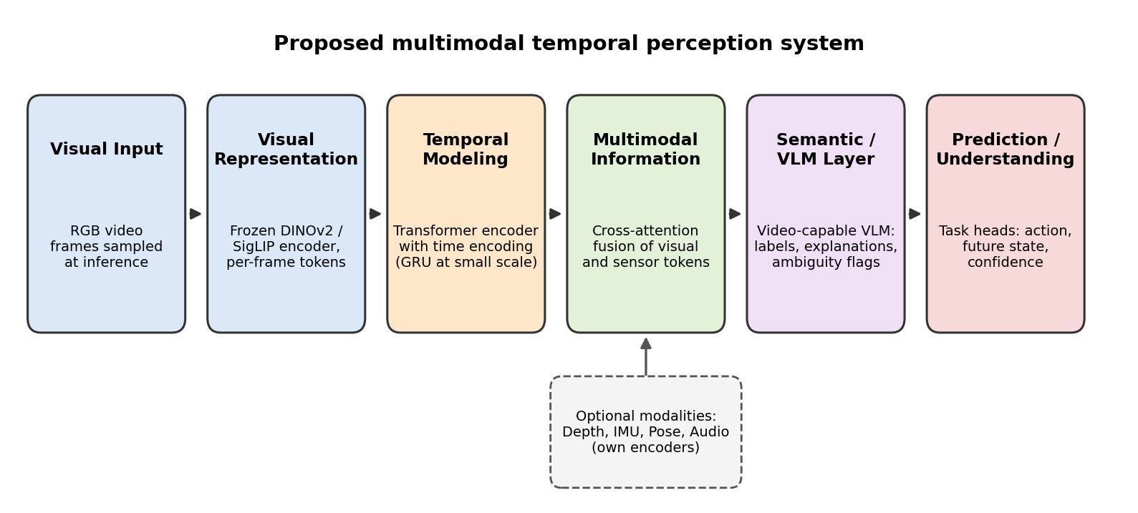
Figure 8: Proposed evolution of this experiment into a multimodal temporal perception system.
A frozen pretrained encoder keeps training cheap and is the choice already validated here. A Transformer encoder with time encoding replaces the GRU once data and clip length grow, since it handles long-range dependencies and can expose attention for interpretation, while the GRU stays preferable at small scale. Depth, IMU, pose and audio would each get their own encoder and join through cross-attention, which tolerates missing modalities. A video-capable VLM sits after fusion to give labels, explanations and ambiguity flags, and lightweight task heads (action, future state, confidence) let one backbone serve several objectives.

9. Limitations and Future Work
Results come from one training run on 439 validation videos, with no separate test split. Figure 4 shows validation accuracy fluctuating around 73 to 75% in later epochs, so 75.63% should be read as about 75% with mild selection optimism. The subset has only 5 classes, one of which is a control, and the claim that the baseline is near a direction-blind ceiling is not yet confirmed by a confusion matrix. The encoder is small and frozen, the VLM test covers 3 videos, and the occlusion and viewpoint experiments were not run. Future work includes the controls listed in Section 7E, contrastive or self-supervised temporal pretraining, and temporal attention visualisation.

10. Conclusion
On this 5-class subset, a GRU over frozen DINOv2 embeddings reached 75.63% validation accuracy against 55.58% for an order-free mean-pooled baseline. Shuffling the frames removed the entire gain, and the gain was concentrated in the directional classes while Tearing was solved without temporal information. Together these results indicate that frame order, and not just the amount of visual information, drives the improvement for direction-dependent actions. The evidence comes from a single run on a small validation set, so it should be confirmed with multiple seeds and a held-out test split.
Acknowledgements. Something-Something V2, DINOv2 (Meta AI), LLaVA 1.5 (Liu et al.), PyTorch, Hugging Face Transformers and BitsAndBytes were used as third-party resources.

