Vitamin C launch post
Meet the NEW Aurelle Vitamin-C serum!!! 100% natural, eco-friendly and clinically proven to fade dark spots by 60% in just 2 weeks.
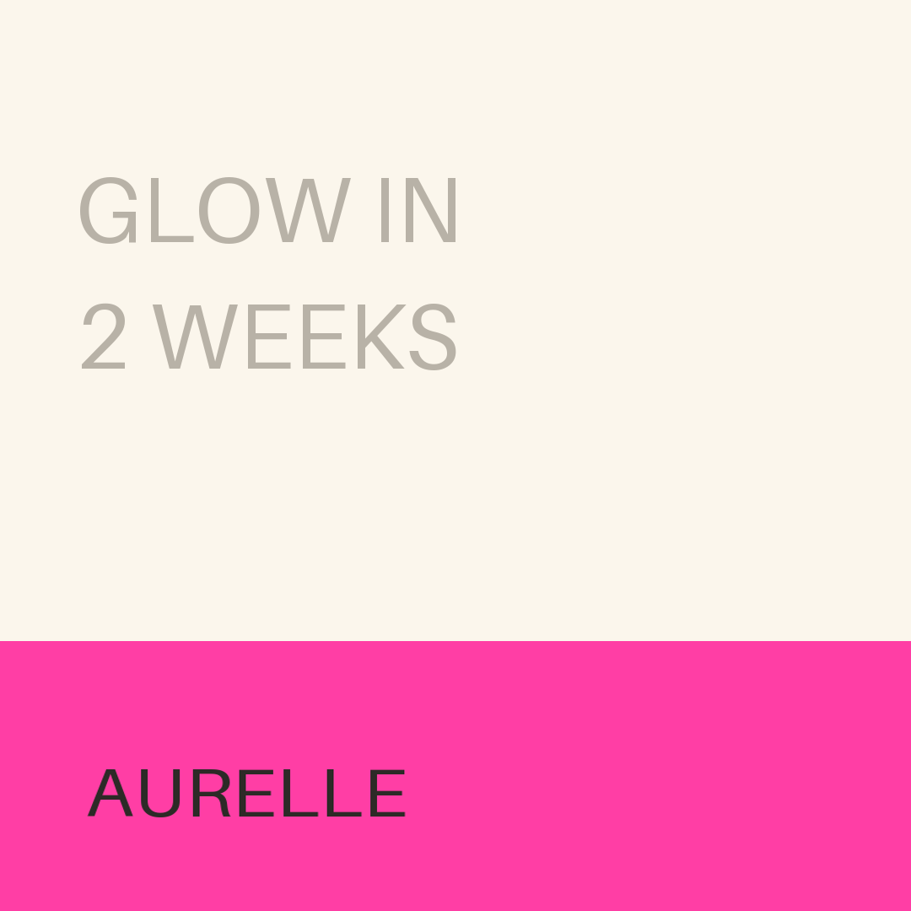

Shop the Vitamin C Brightening Serum.

