**StudySphere**

1. **User Personas:**
2. **Students:**

* User 1: As a student, I want to create a profile with my educational details.
* User 2: As a student, I want to post academic-related questions or doubts.
* User 3: As a student, I want to provide answers to other students' questions.
* User 4: As a student, I want to schedule one-on-one meetings with teachers.

1. **Teachers:**

* User 1: As a teacher, I want to create a profile with my educational and professional details.
* User 2: As a teacher, I want to accept or reject student connection requests.
* User 3: As a teacher, I want to receive notifications about new questions from students.

1. **Guest Faculties:**

* User 1: As a guest faculty, I want to create a profile with my expertise and availability.
* User 2: As a guest faculty, I want to browse and answer students' questions in my area of expertise.
* User 3: As a guest faculty, I want to receive notifications about new questions related to my expertise.

**2.The App functionalities for each type of users:**

**Common Functionalities:**

* **User Authentication**: All users can sign up, log in, and reset their passwords.
* **Profile Management**: Users can create and update their profiles with relevant information.
* **Notification System**: Users receive real-time notifications for interactions and updates related to their activities.

**Functionalities for Students:**

* **Ask Questions**: Students can post academic questions, doubts, and discussions.
* **Answer Questions**: Students can provide answers to questions posted by other students.
* **Search and Filter**: Students can search for questions and answers based on keywords or topics.
* **Connect with Teachers**: Students can send connection requests to teachers and schedule meetings.

**Functionalities for Teachers/Guest Faculties:**

* **Accept/Reject Requests:** Teachers can accept or reject connection requests from students.
* **Answer Questions**: Teachers can provide authoritative answers to student questions.
* **Schedule Meetings**: Teachers can schedule one-on-one meetings with students.
* **Provide Expertise**: Teachers offer subject-specific expertise and guidance.

**3.User Interface:**

**Screen-1**

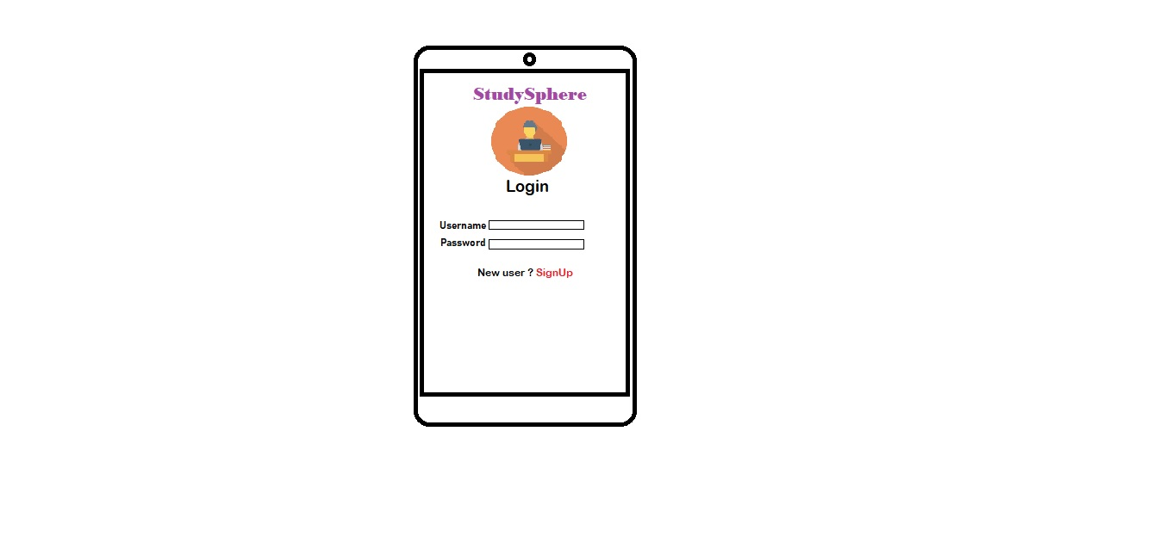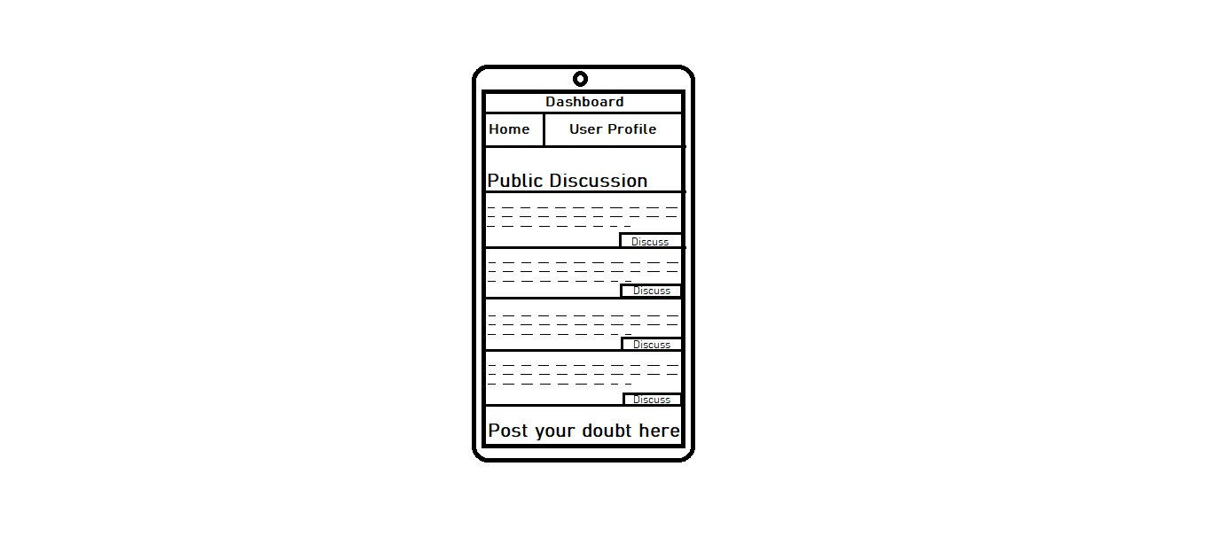

**Screen-2**

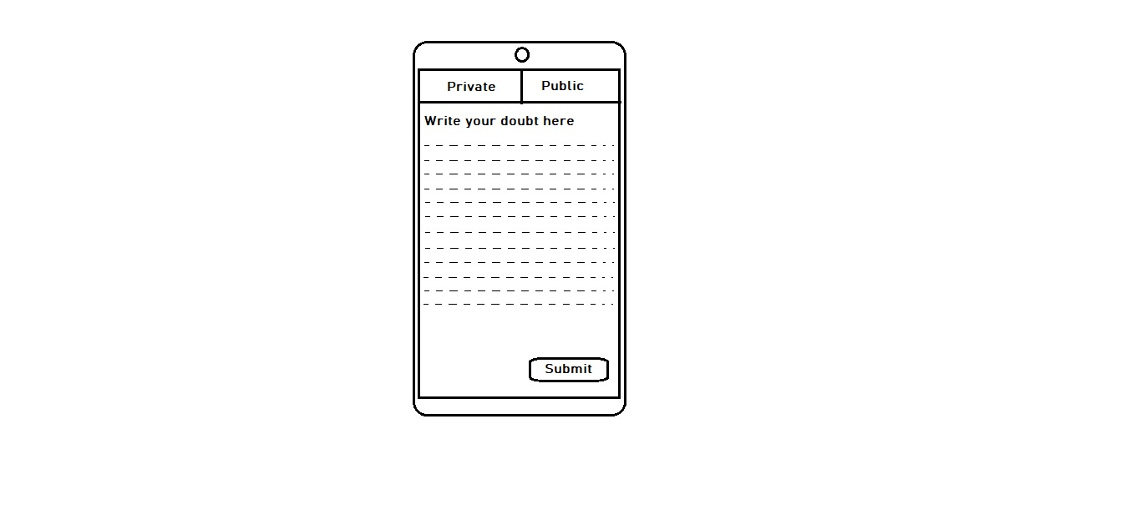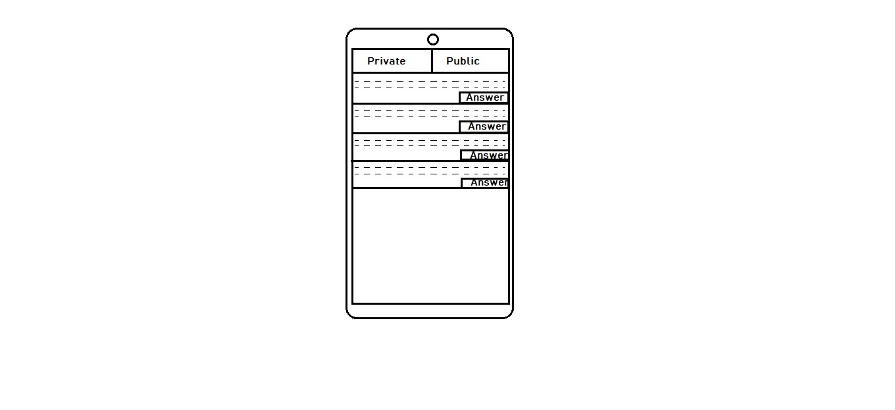

**Screen-4**

**Screen-3**

**4.Anything else which you think will be required to explain the requirements in detail to your developer friend:**

**Mention TechStack**

**Performance and scalability**

**Your App is a great success and Times of India asks you for a small writeup regarding your App. They will publish it as the “Most happening App of 2021”. Create a writeup within 250 words.**

**In a year marked by challenges and uncertainties, one innovative app has shone brightly as a beacon of academic collaboration and knowledge sharing. StudySphere, our groundbreaking platform, has been named "The Most Happening App of 2021" by Times of India, and for good reason.**

**StudySphere is not just another social network; it's a vibrant academic community where students, teachers, and guest faculties come together in a shared pursuit of knowledge. In a time when remote learning and social distancing have become the norm, our app bridges the gap between learners and educators, making learning a truly collaborative experience.**

**Students, empowered with the ability to post questions, discuss doubts, and connect with teachers and subject matter experts, find answers and guidance right at their fingertips. They can even schedule one-on-one meetings, making learning personal again.**

**For teachers, the app offers an opportunity to nurture the academic growth of their students. They can accept connection requests, answer questions, and schedule meetings, all within the platform. This holistic approach to teaching enables educators to make a meaningful impact on the lives of their students.**

**And for guest faculties, it's a chance to share their expertise with a global audience. They can participate in discussions, host webinars, and provide authoritative answers, all while building a network of knowledge seekers.**

**StudySphere is not just an app; it's a transformative force in education. It brings people together, fosters collaboration, and redefines how we learn. In a year when learning has undergone a major transformation, StudySphere stands out as the App of the Year, making education exciting and accessible to all.**