**A MINI PROJECT REPORT ON**

**Image Super-Resolution**

**BACHELOR OF TECHNOLOGY**

**IN**

**Artificial Intelligence & Machine Learning**

SUBMITTED BY

**GROUP NO:**

|  |  |
| --- | --- |
| **Name of the student** | **PRN** |
|  |  |
| **TEJAS THANGE**  **VAIBHAV SHARMA**  **JAYADITYA SHUKLA**  **SUYASH TAMBE** | **22070126121**  **22070126125**  **22070126109**  **22070126117** |
|  |  |

**SYMBIOSIS INSTITUTE OF TECHNOLOGY, PUNE – 412115**

**(A CONSTITUENT OF SYMBIOSIS INTERNATIONAL (DEEMED UNIVERSITY))**

**2023-24**

**TABLE OF CONTENTS**

|  |  |  |
| --- | --- | --- |
| **LIST OF FIGURES** | | i |
| **LIST OF TABLES** | | ii |
| **LIST OF ABBREVIATION** | | iii |
| **CHAPTER I: INTRODUCTION** | |  |
| **CHAPTER II: LITERATURE SURVEY** | |  |
| **CHAPTER III: METHODOLOGY OF IMPLEMENTATION (BLOCK DIAGRAM)** | |  |
| **CHAPTER IV: RESOURCES** | |  |
| **CHAPTER V: LEARNING OUTCOMES** | |  |
| **CHAPTER VI: CONCLUSION AND FUTURE SCOPE**  **REFERENCES:** | |  |
|  | |  |
|  | |  |
|  |  |  |
|  |  |  |
|  |  |  |
|  | |  |
|  |  |  |
|  |  |  |
|  | |  |
|  |  |  |
|  |  |  |
|  | |  |
|  | |  |

**LIST OF FIGURES**

|  |  |  |
| --- | --- | --- |
| **Sr. No** | **Figure Name** | **Page No** |
| Fig 1 | Loading Datasets |  |
| Fig 2 | Training Models |  |
| Fig 3 | Deployment |  |

**LIST OF TABLES**

|  |  |  |
| --- | --- | --- |
| **Sr. No** | **Table Name** | **Page No** |
| Table 1 | Literature Review |  |

**LIST OF ABBREVIATIONS**

|  |  |
| --- | --- |
| **Abbreviated Word** | **Expansion** |
| AIML | Artificial Intelligence & Machine Learning |
| SRCNN | Super-Resolution Convolutional Neural Network |
| CNN | Convolutional Neural Network |

**CHAPTER I:**

**Introduction**

In the world of image processing and computer vision, one of the most troublesome challenges is to enhance the quality of digital images. Whether it's restoring vintage photographs, improving the quality of surveillance footage, or upscaling graphics for high-definition displays, the quest for enhancing image resolution has never ceased.

This journey has significantly advanced through the application of Convolutional Neural Networks (CNNs), a class of deep learning models that have brought revolutionary image-related tasks. It pushes the boundaries of image enhancement. It involves the process of taking low resolution image and transform it into high-resolution image while preserving the important features of it.

This project delves into the still-uncharted world of Super-Image Resolution by using conventional image enhancement techniques along with a SRCNN model. Applications of this project can be extended to videos also.

**Code Snippets**

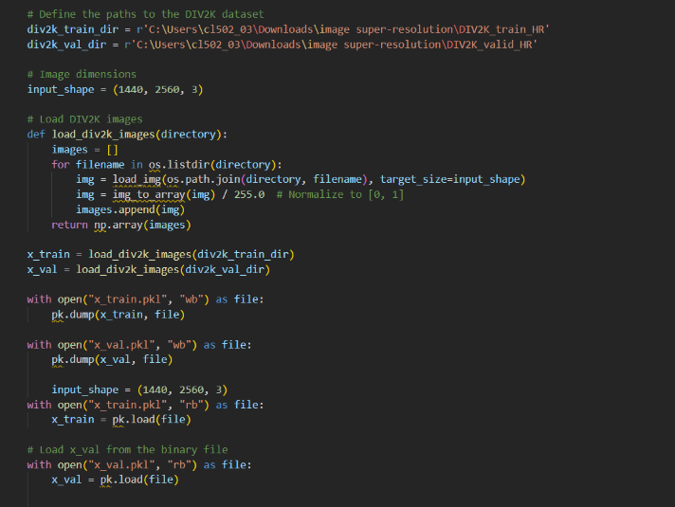

Fig. 1

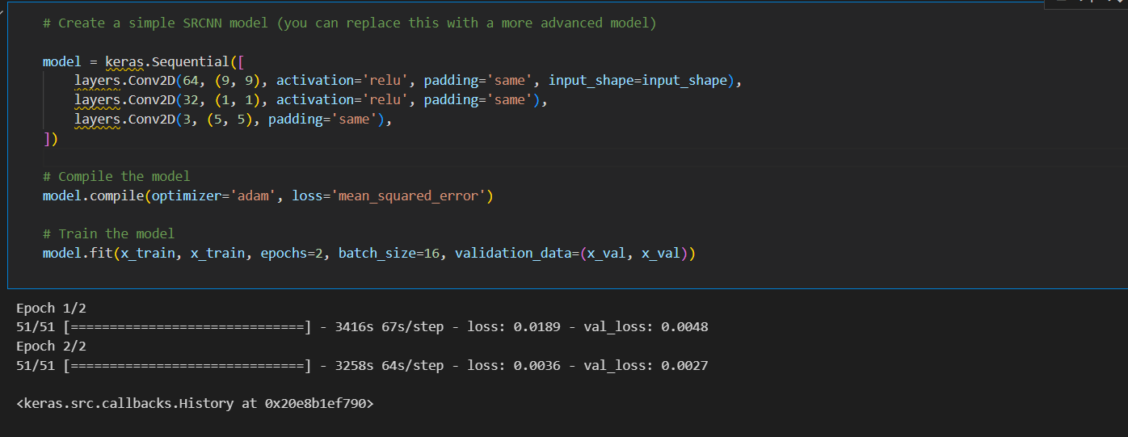

Fig. 2

Output Image:



Fig. 3

|  |  |  |  |  |  |  |  |  |  |  |  |  |  |  |  |  |  |  |  |  |  |  |  |  |  |  |  |  |  |  |  |  |  |  |  |  |  |  |  |  |  |  |  |  |  |  |  |  |  |  |  |
| --- | --- | --- | --- | --- | --- | --- | --- | --- | --- | --- | --- | --- | --- | --- | --- | --- | --- | --- | --- | --- | --- | --- | --- | --- | --- | --- | --- | --- | --- | --- | --- | --- | --- | --- | --- | --- | --- | --- | --- | --- | --- | --- | --- | --- | --- | --- | --- | --- | --- | --- | --- |
| **CHAPTER II:**   |  |  |  |  |  |  |  |  |  |  | | --- | --- | --- | --- | --- | --- | --- | --- | --- | --- | | **Sr. No** | **Research Paper** | **Citations** | **Methodology** | **Dataset** |  |  |  |  |  | |  |  |  |  |  |  |  |  |  |  | | 1 | <https://paperswithcode.com/paper/photo-realistic-single-image-super-resolution> | [Christian Ledig](https://paperswithcode.com/author/christian-ledig), [Lucas Theis](https://paperswithcode.com/author/lucas-theis), [Ferenc Huszar](https://paperswithcode.com/author/ferenc-huszar), [Jose Caballero](https://paperswithcode.com/author/jose-caballero), [Andrew Cunningham](https://paperswithcode.com/author/andrew-cunningham), [Alejandro Acosta](https://paperswithcode.com/author/alejandro-acosta), [Andrew Aitken](https://paperswithcode.com/author/andrew-aitken), [Alykhan Tejani](https://paperswithcode.com/author/alykhan-tejani), [Johannes Totz](https://paperswithcode.com/author/johannes-totz), [Zehan Wang](https://paperswithcode.com/author/zehan-wang" \t "_blank), [Wenzhe Shi](https://paperswithcode.com/author/wenzhe-shi" \t "_blank) | we present SRGAN, a generative adversarial network (GAN) for image super-resolution (SR) | <https://paperswithcode.com/dataset/ffhq> |  |  |  |  |  | | 2 | <https://paperswithcode.com/paper/perceptual-losses-for-real-time-style> | [Justin Johnson](https://paperswithcode.com/author/justin-johnson), [Alexandre Alahi](https://paperswithcode.com/author/alexandre-alahi), [Li Fei-Fei](https://paperswithcode.com/author/li-fei-fei) | methods for problems typically train feed-forward convolutional neural networks using a \emph{per-pixel} loss between the output and ground-truth images | 1. <https://paperswithcode.com/dataset/bsd> 2. <https://paperswithcode.com/dataset/coco> 3. <https://paperswithcode.com/dataset/set5> |  |  |  |  |  | | 3 | <https://paperswithcode.com/paper/image-super-resolution-using-deep> | [Chao Dong](https://paperswithcode.com/author/chao-dong), [Chen Change Loy](https://paperswithcode.com/author/chen-change-loy), [Kaiming He](https://paperswithcode.com/author/kaiming-he), [Xiaoou Tang](https://paperswithcode.com/author/xiaoou-tang" \t "_blank) | For single picture super-resolution (SR), we present a deep learning technique. Our technique teaches end-to-end mapping between low/high-resolution pictures directly. The mapping is represented by a deep convolutional neural network (CNN) that accepts a low-resolution picture as input and produces a high-resolution image | 1. <https://paperswithcode.com/dataset/imagenet> 2. <https://paperswithcode.com/dataset/msu-video-upscalers-quality-enhancement> |  |  |  |  |  |   Table 1 |  |

**CHAPTER III:**

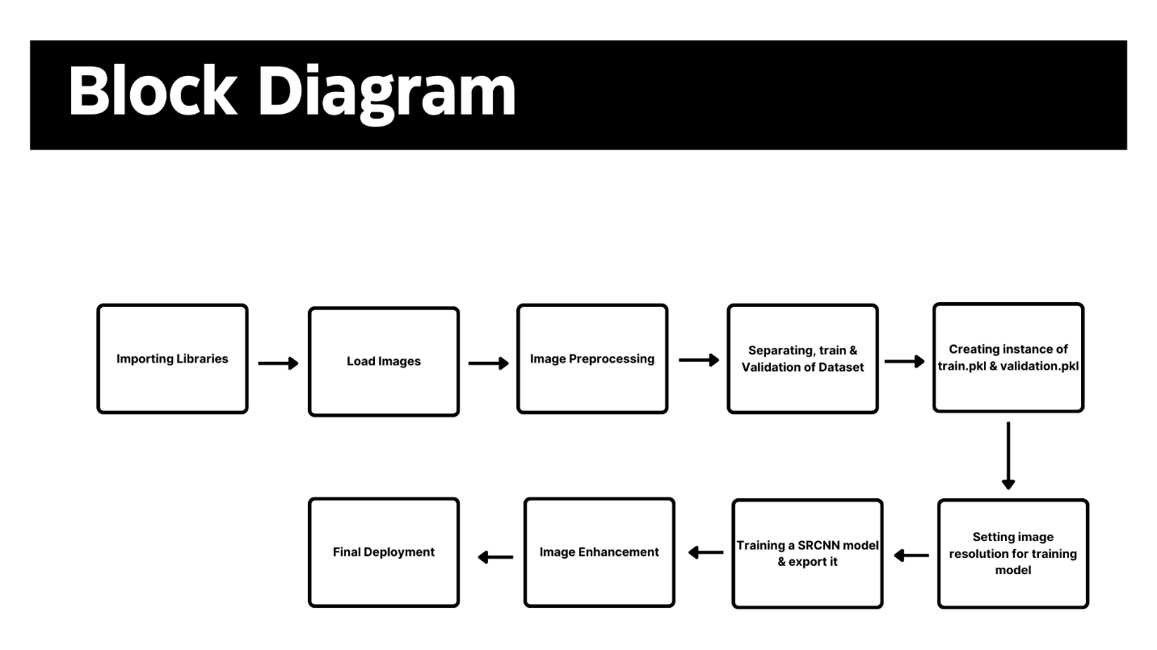

Explanation of Block Diagram **: -**

Importing Libraries **:** Pickle, Tensor Flow, Numpy, Keras, base64, Streamlit.

Image Preprocessing **:** Image preprocessing: Image Resizing and Image normalization.

Separating, train & Validation of Dataset: Training Dataset consists of 800 images and testing dataset consists of 100 images.

Creating Instance of train.pkl & validation.pkl **:** These files streamline data handling, allowing you to train and validate models efficiently.

Setting image resolution for training model **:** Implement image resolution settings by resizing training images to a standardized resolution

Training a SRCNN model & exporting **:** To implement SRCNN for image super-resolution, gather a dataset of high and low-resolution images, train the SRCNN model with proper architecture and loss function, split data into train, validation, and test sets, and fine-tune the model to prevent overfitting. Export the trained model for inference, where it takes a low-res image and generates a high-res version. Post-processing and deployment are done for optimal results.

Image Enhancement **:** we enhanced the image using sharpening and high-contrast

Final Deployment **:**  For the final deployment for our project "Super Image Resolution", we used tools like Streamlit to create a user-friendly GUI .

**CHAPTER IV:**

**Resources & Software Used**

The Intel HD Graphics 4000 Series

Intel Iris

128GB ram

Visual Studio Code

Python 3.11.6

**CHAPTER V:**

**LEARNING OUTCOMES:**

Computer Vision and Image Processing:

1. Improve your understanding of image processing and computer vision techniques.
2. Learn how to alter and improve image quality.

Neural Networks and Deep Learning:

1. Use technologies such as TensorFlow or PyTorch to construct deep learning models for super-resolution.
2. Convolutional neural networks (CNNs) and their use in picture super-resolution are discussed.

Handling and Preprocessing of Datasets:

1. Learn how to handle and preprocess picture collections.
2. Recognize the significance of data augmentation in deep learning model training.

Model Development and Optimization:

1. Deep learning models for super-resolution tasks may be trained and optimized.
2. Discover how to tune hyperparameters and use regularization approaches.

Practical Project Experience:

1. Gain hands-on experience leading a machine learning project from start to finish.

Application and deployment:

1. Investigate methods for deploying super-resolution models, either locally or on cloud systems.
2. Consider uses such as picture enhancement in medical imaging or satellite photography.
3. We learnt how to deploy an image model using streamlit and uploaded it on GitHub

**CHAPTER VI:**

**CONCLUSION AND FUTURE SCOPE**

Conclusion:

Super-Resolution Convolutional Neural Networks (SRCNN) have demonstrated their effectiveness in enhancing image quality and have practical applications in various fields such as medical imaging, satellite photography, and digital content upscaling. The project's successful implementation showcases the capability of deep learning techniques to improve image resolution.

Future Scope:

1. Real-Time Super-Resolution: Focus on optimizing models for real-time applications, enabling fast image enhancement in video streaming and live imaging.
2. Large-Scale Deployment: Extend deployment to cloud platforms or mobile apps to reach a broader user base, potentially targeting industries like entertainment, surveillance, and e-commerce.
3. Explainable AI: Investigate techniques for making the super-resolution process interpretable and explainable, especially in medical and legal contexts.
4. Continual Learning: Implement continual learning methods to enable models to adapt and improve over time with new data and evolving image characteristics.

|  |  |  |
| --- | --- | --- |
|  |  | References   1. Research paper 1  [Christian Ledig](https://paperswithcode.com/author/christian-ledig), [Lucas Theis](https://paperswithcode.com/author/lucas-theis), [Ferenc Huszar](https://paperswithcode.com/author/ferenc-huszar), [Jose Caballero](https://paperswithcode.com/author/jose-caballero), [Andrew Cunningham](https://paperswithcode.com/author/andrew-cunningham), [Alejandro Acosta](https://paperswithcode.com/author/alejandro-acosta), [Andrew Aitken](https://paperswithcode.com/author/andrew-aitken), [Alykhan Tejani](https://paperswithcode.com/author/alykhan-tejani), [Johannes Totz](https://paperswithcode.com/author/johannes-totz), [Zehan Wang](https://paperswithcode.com/author/zehan-wang), [Wenzhe Shi](https://paperswithcode.com/author/wenzhe-shi)  <https://paperswithcode.com/paper/photo-realistic-single-image-super-resolution> 2. Research paper 2 [Justin Johnson](https://paperswithcode.com/author/justin-johnson), [Alexandre Alahi](https://paperswithcode.com/author/alexandre-alahi), [Li Fei-Fei](https://paperswithcode.com/author/li-fei-fei)  <https://paperswithcode.com/paper/perceptual-losses-for-real-time-style> 3. Research paper 3 [Chao Dong](https://paperswithcode.com/author/chao-dong), [Chen Change Loy](https://paperswithcode.com/author/chen-change-loy), [Kaiming He](https://paperswithcode.com/author/kaiming-he), [Xiaoou Tang](https://paperswithcode.com/author/xiaoou-tang) <https://paperswithcode.com/paper/image-super-resolution-using-deep>   Check out our github for code**:**  GitHub Link **:** <https://github.com/vaibhav7766/super-image-resolution>  Dataset Link : <https://www.kaggle.com/datasets/joe1995/div2k-dataset> |
|  |  |  |
|  |  |  |
|  |  |  |
|  |  |  |