**\*\*Problem solving \*\***

**\*Easy\***

1. [**https://leetcode.com/problems/remove-element**](https://leetcode.com/problems/remove-element)

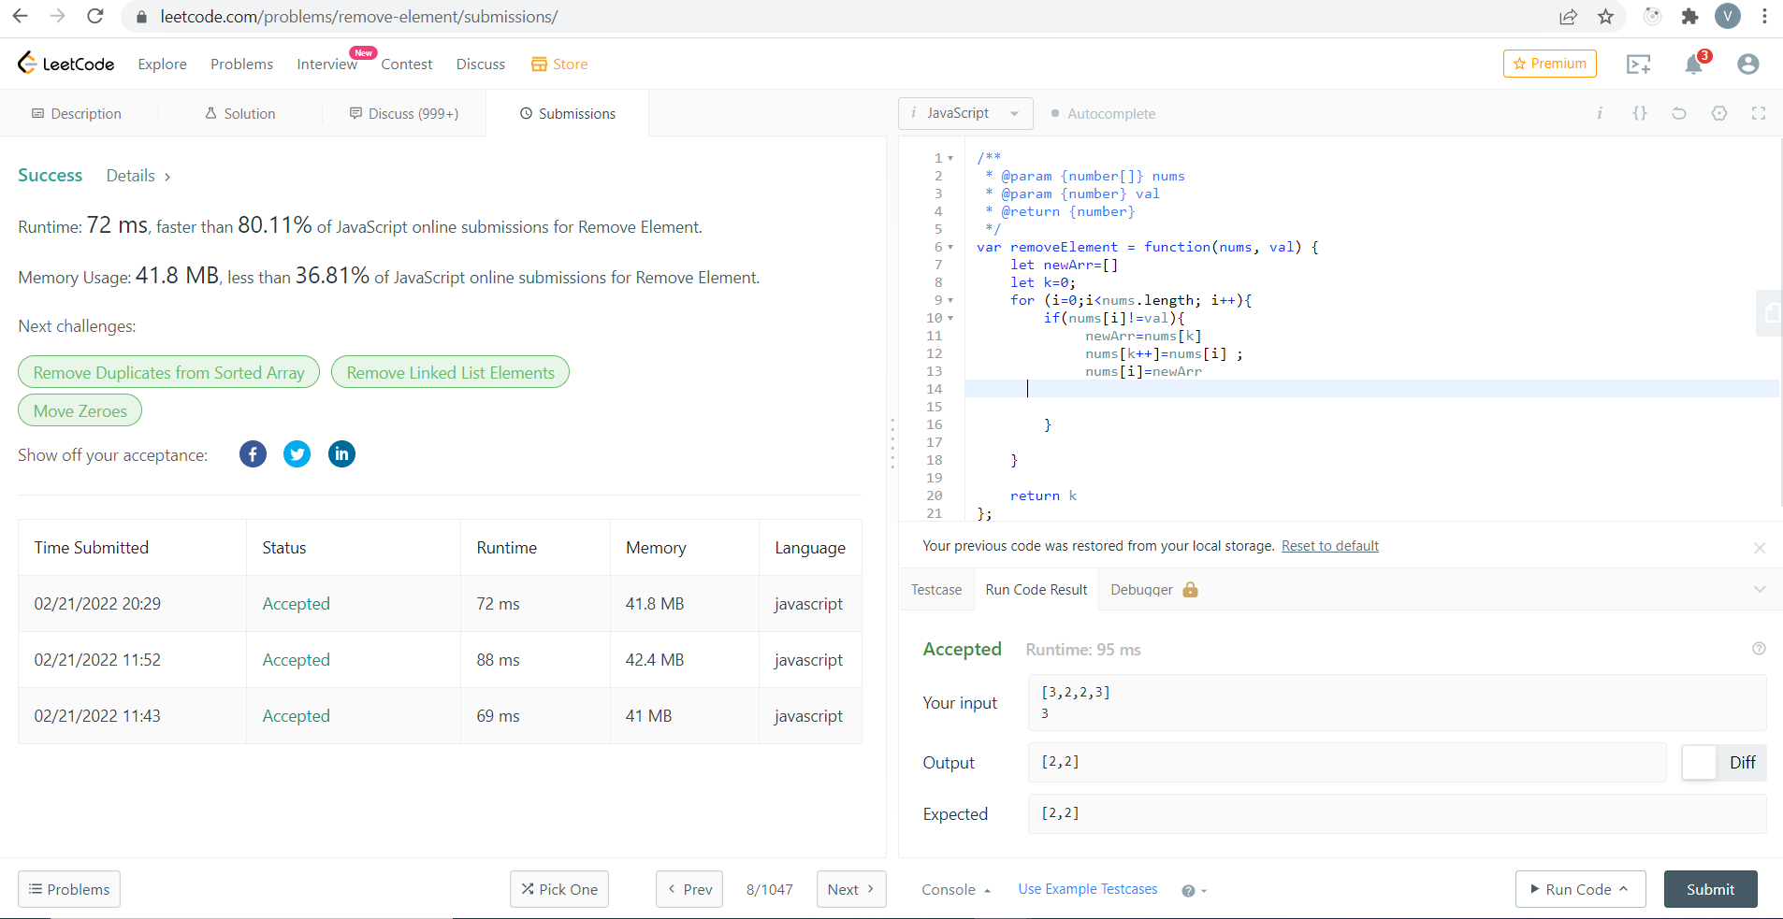

1. [**https://leetcode.com/problems/two-sum/**](https://leetcode.com/problems/two-sum/)

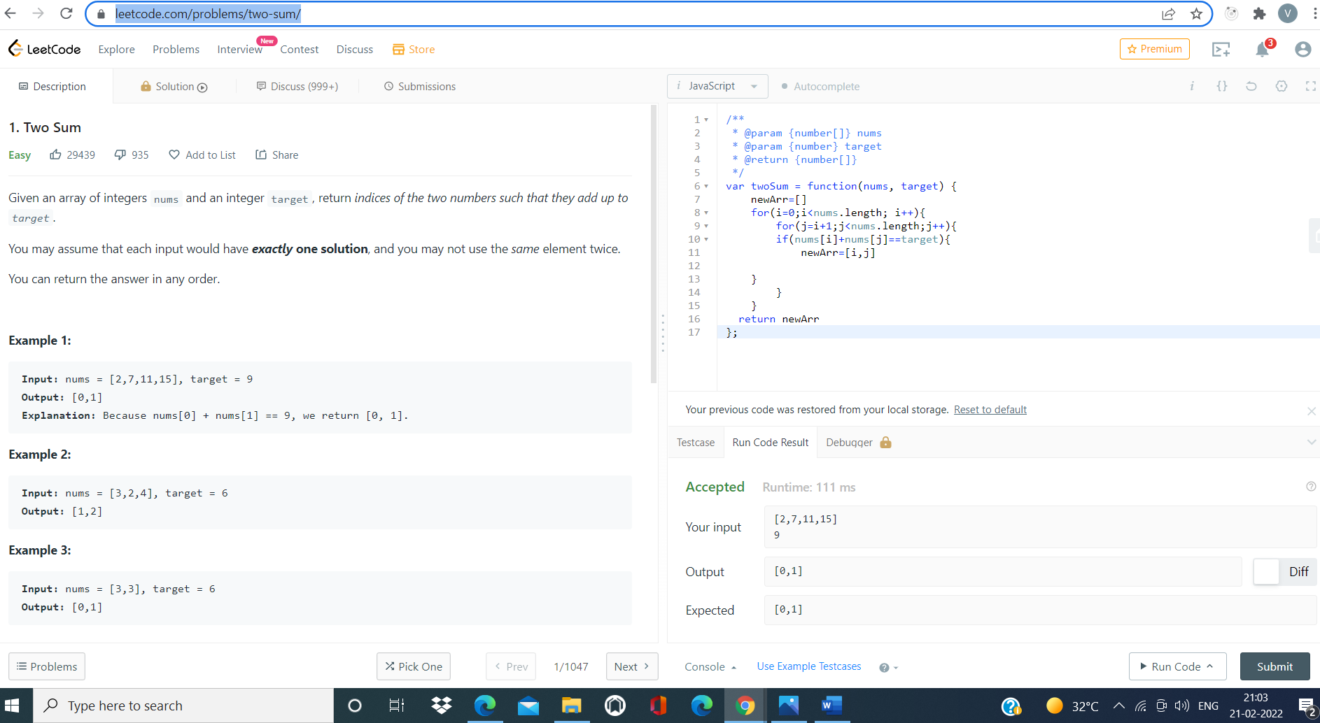

1. [**https://leetcode.com/problems/sort-colors/**](https://leetcode.com/problems/sort-colors/)

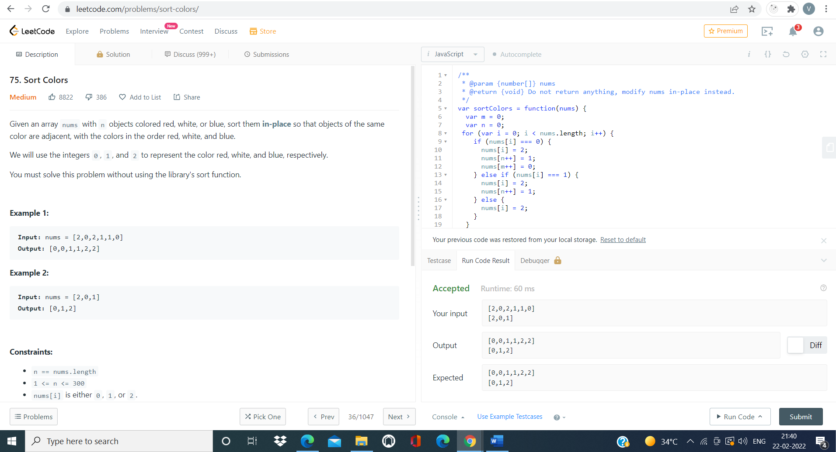

1. <https://leetcode.com/problems/length-of-last-word/>
2. 