Problem Solving

1. <https://leetcode.com/problems/sort-colors/>

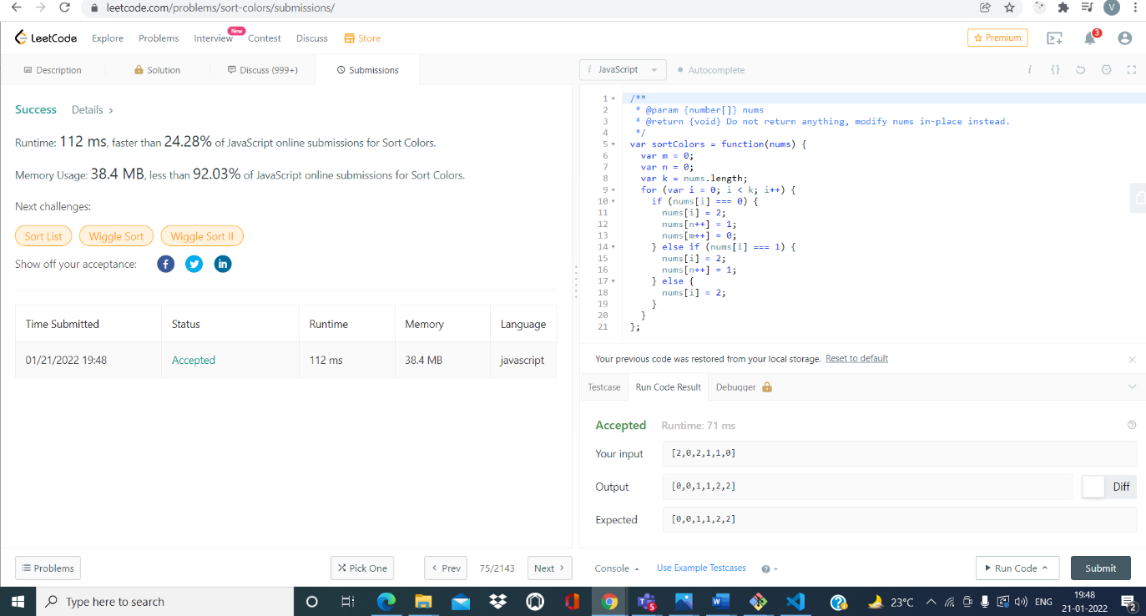

1. https://leetcode.com/problems/3sum/

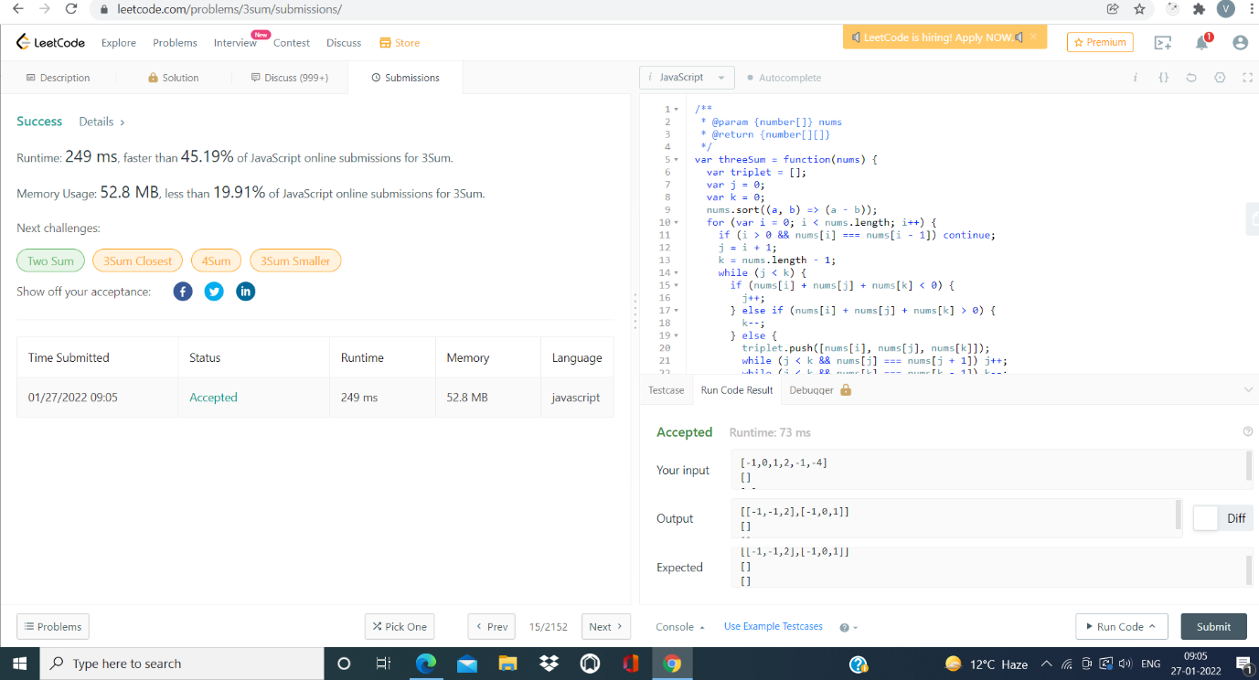

1. function to find smallest and largest element is array
2. 