Problem Solving

1. <https://leetcode.com/problems/largest-merge-of-two-strings/>

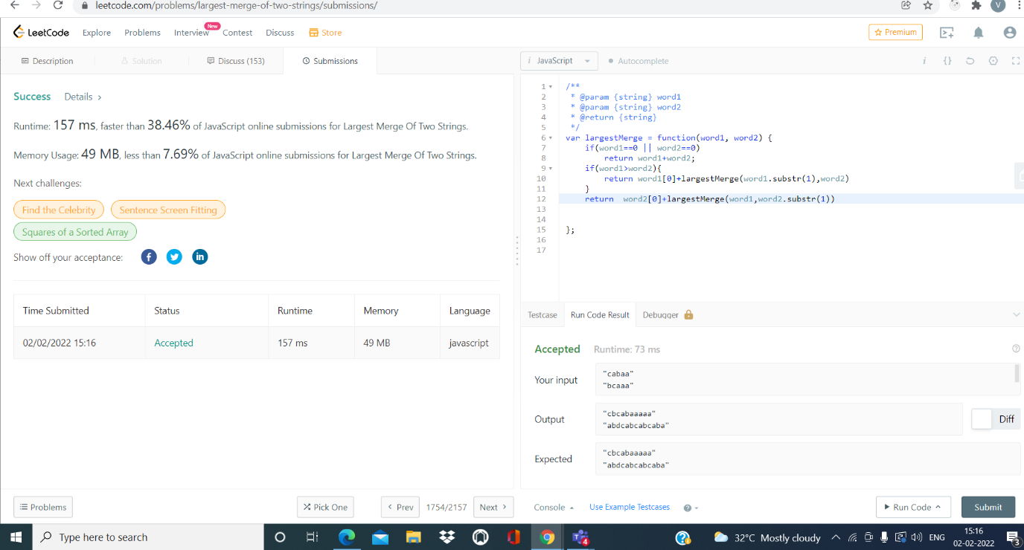

1. <https://leetcode.com/problems/maximum-repeating-substring/>

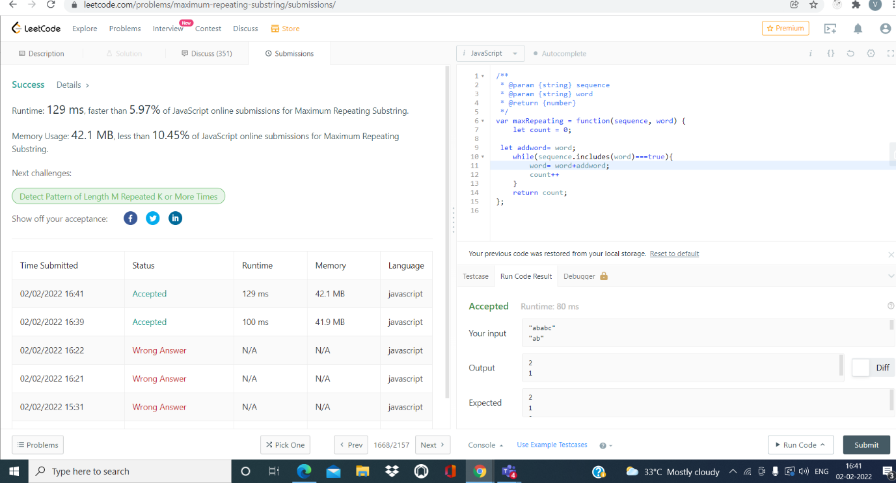

3)Program to check if given string is palindrome or not

