1. To install nodemon go to location “D:\NODE_JS_TRAINING\PernStack\PERN_TODO\server” and run command as below

**npm install nodemon -g**

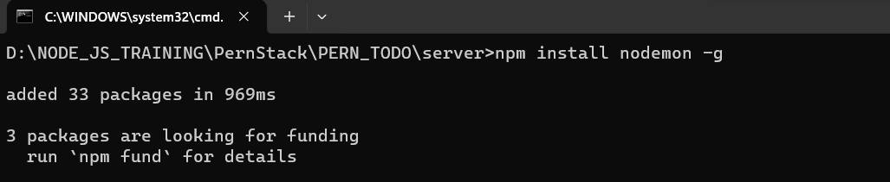

1. To start server open cmd and run below command:

**nodemon index**

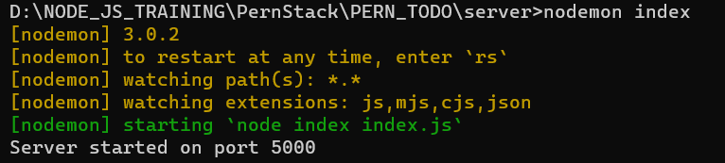

1. To run the application go to location PS D:\NODE_JS_TRAINING\PernStack\PERN_TODO\client\todo_demo and run command

**npm start**

