Facial Expression Recognition using Artificial Intelligence

Fatima Inamdar | Dhammadeep Salwe ,Vaibhav Pingale , Sanket Hodage
Assistant Professor, Department of Information Technology | Department of Information Technology
Vishwakarma Institute of Information Technology | Vishwakarma Institute of Information Technology
Pune | Pune
Fatima.inamdar@viit.ac.in

Abstract - Recognition of facial expressions is a part of facial recognition which is becoming more essential nowadays. In this project, the DeepFace framework and pretrained model are both employed. Deeface framework is developed by a research group working at Facebook which is a open-source framework. It is an extremely capable computer vision library that makes it simple to recognise and analyse objects in images, such as faces and forms. It is a hybrid facial recognition framework that incorporates models from DeepID, Facebook DeepFace, Google FaceNet, OpenFace, ArcFace, and Dlib.We have used FER-2013 dataset in this project..
It contains grayscale pictures of faces with the measurement of width 48 and 48 pixels.The faces automatically get recognized as it matches with the portraits in the dataset.
We have divided the facial expressions into seven categories i.e. Neutral,happy,fear,sad,surprise,disgust and anger. There are total 4,320 examples in our dataset.
We utilised the cv2 package to capture real-time video, and the haarcascade model for face recognition. With the use of haarcascade , we performed the face detection inspite of their size. This algorithm detects face in real time environment and it is not that complex. The first thing the programme does is load the image or video that has to be analysed. The face detection classifier is used to initialise the FER dataset. The input object (image or video) is then passed to the detect emotions function in this function Object() { [native code] }. The end result is a spectrum of emotions, each with a value listed next to it. The 'dominant emotion' function can finally isolate the object's emotion with the highest value and return it.
Index Terms – Face Recognition, Facial Emotion Recognition, DeepFace, HaarCascade..

I. Introduction
People express their intentions through emotions and it is most powerful way to find out someone’s intentions. Due to its practical significance in sociable robotics, medical treatment, driver tiredness detection, and many other human-computer interface systems, automatic facial expression analysis has been the subject of several studies. There are various techniques that uses Machine learning and Deep learning for detecting facial expression. Deep learning is employed in a variety of applications that call for performance that is comparable to that of a person, including speech and picture recognition in smartphones, smart home technology, and self-driving cars. Despite the fact that the discipline has seen significant advancements, results are frequently subpar compared to human performance. As a form of non-verbal communication and a crucial means of communicating one's emotions as a form of feelings, intentions, goals, and opinions to others, facial expression is the outcome of a facial gesture or expression that shows the position of the muscles on the human face. Accuracy can be improved by using real-time facial expression recognition powered by artificial intelligence in a system. So that it can directly identify facial expressions from consumers when presented at the cashier, for example.
There are various techniques that uses Machine learning and Deep learning for detecting facial expression. In the DeepFace framework , it include pretrained model which used deep CNN for face recognition. In the early 20th century, Ekman and Friesen named seven fundamental emotions on the basis of cross-cultural research that showed that people experience some fundamental emotions consistently across cultures. Anger, Neutral, fear, happiness, disgust, sad and surprise are examples of normal facial expressions. We showed some of the emotions the algorithm observed in the cases below.
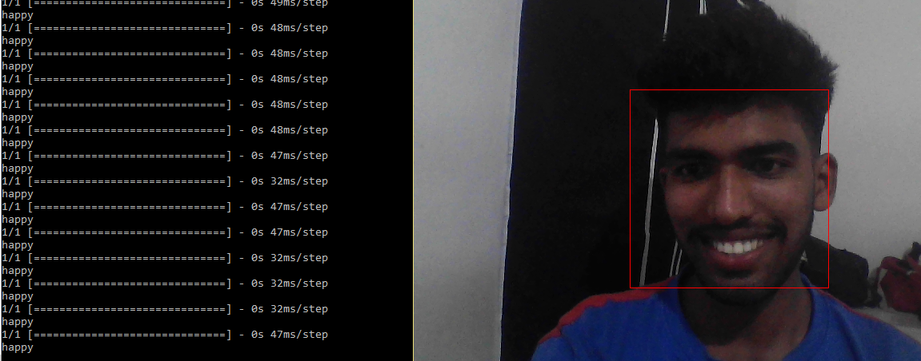
Fig. 1.1 Happy
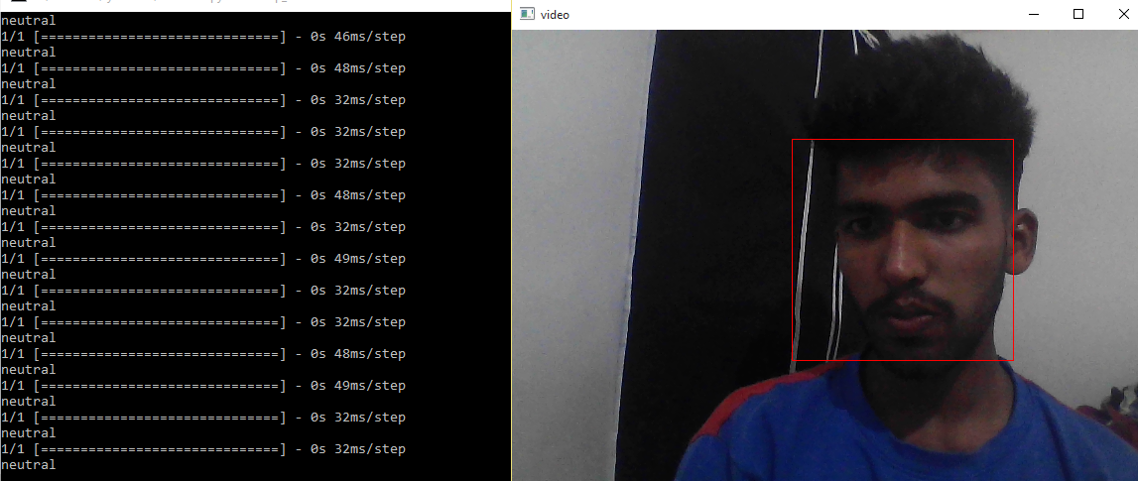
Fig. 1.2 Neutral 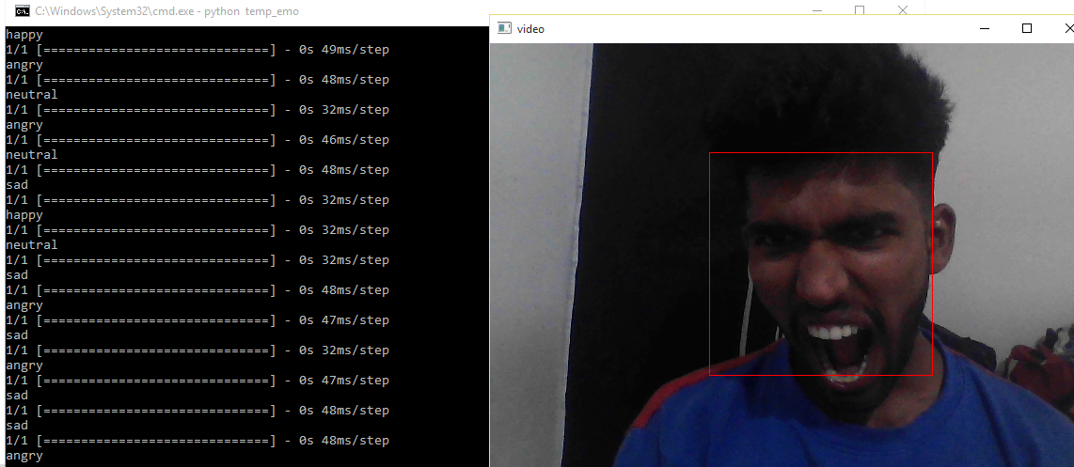
Fig. 1..3 Angry

II. Literature Survey

Title | Proposed methodology | Advantages and Dis-Advantages
Image based Static Facial Expression Recognition with Multiple Deep Network Learning  Author - Zhiding Yu ,Cha Zhang (2015) | It starts off with a face detection module using an ensemble of three cutting-edge face detectors, then moves on to a classification module using an ensemble of several deep CNNs. | Advantage – more accurate results because it combines multiple CNN modules  Dis-Advantage –  Not suitable for the realtime face  Expression recognition
Baseline CNN structure analysis for facial expression recognition  Author – Minchul Shin,Munsang Kim,Dong-Soo Kwon(2016) | 20 different CNN models (4 networks and 5 data input types) were trained, and the effectiveness of each network was assessed using test photos from five different databases. | Advantages –  Improving facial recognition algorithm and providing better performance in facial expression recognition.  Dis-Advantage –  High specifications machines,more models,more databses are required
Dominant and Complementary Emotion Recognition From Still Images of Faces  Author – Jianzhu Guo,Zhen Lei, Jun Wan(2018) | Facial expression recognition is carried out through Machine learning and iCV-MEFED data set. | Advantage – It can predict compound emotions like (e.g.surprisingly-happy,happily-surprised)  Dis-advantage – The image should be still.
The Facial Emotion Recognition (FER) Dataset for Prediction System of Micro-Expressions Face Using the Convolutional Neural Network (CNN)  Author - Purnawarman Musa (2021) | Using the Convolution Neural Network (CNN) algorithm in real-time with OpenCV, TensorFlow, and Keras, predict and recognise the classification of face emotions based on feature extraction. | Advantage –  Realtime face detection using CNN library.  Dis-Advantage-  It limited to only five emotions i.e. Happy,Sad,Angry  ,Surprise,Neutral

III. Topics
- Prerequisites:

1) DeepFace – A Facebook research team developed the deep learning facial recognition algorithm known as DeepFace. In digital photos, it recognises human faces. The programme was trained on four million photographs shared by Facebook users and uses a nine-layer neural network with approximately 120 million connection weights. According to the Facebook Research team, the DeepFace approach achieves an accuracy of 97.35% 0.25% on the Labeled Faces in the Wild (LFW) data set, compared to humans who have a 97.53% accuracy rate. This implies that DeepFace occasionally outperforms people.
Face Recognition - The five common phases of a modern face recognition pipeline are detect, align, normalise, represent, and verify. While Deepface takes care of all these standard steps in the background, you don't need to become an expert in every step of the procedures involved. With only one line of code, you may simply call the function's verification, find, or analysis methods.

df = DeepFace.find('video',frame)

Face Verification - This feature determines whether two faces belong to the same person or to distinct people. It requires inputs that are exact picture paths. Passing base64- or numpy-encoded pictures is also acceptable. The dictionary that is returned after that should just have its confirmed key checked.

result = DeepFace.verify('video',frame)

2) FER-2013- Grayscale portraits of faces measuring 48 × 48 pixels make up the data. The faces have been automatically registered such that each one is roughly in the same location and takes up a similar amount of space. Each face must be assigned to one of seven categories, with 0 denoting anger, 1 disgust, 2 fear, 3 happiness, 4 sadness, 5 surprise, and 6 neutrality. The public test set has 3,589 examples, while the training set has 28,709 examples.
The 2013 Facial Expression Recognition dataset (FER-2013) was presented at the International Conference on Machine Learning (ICML) in 2013 by Pierre-Luc Carrier and Aaron Courvill. It is a dataset made available through Kaggle..

Plot of number of images in dataset -
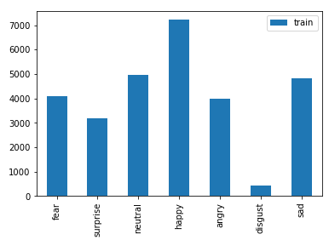Fig. 3.1 Plot of no. of images in dataset

3) Haarcascade – No matter where they are in the image or how big they are, objects can be found using the process known as the Haar cascade. This algorithm can operate in real-time and is not overly complex. Using haar-cascade we are able to detect various item and objects as it is trained for that. The cascading window is used by Haar cascade, which tries to compute features in each window and determine whether it might be an object.
To calculate and match features, sample haar features move in window-sized across the image. A classifier is used in the Haar cascade. It distinguishes between positive data points that are a part of the object we have discovered and negative data points that do not.

- Haar cascades can function effectively in real-time and are quick.
- Compared to current object detection methods, Haar cascade is less precise.
- The drawback of Haar cascade. It foretells a lot of false positives.
- Easy to implement, requires little processing power.

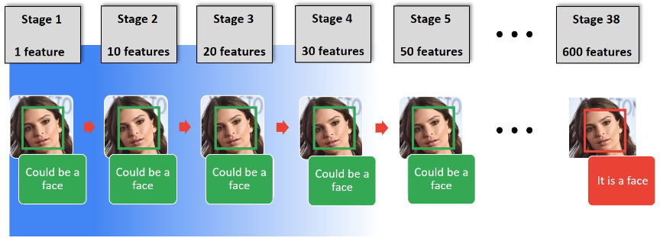
Fig 3.1 object detection in haarcascade [5]

IV. Implementation
Facial Emotion Recognition:

One of the most potent, inherent, and common ways for people to express their emotions and intentions is through their faces. It is a component of facial recognition that is becoming increasingly crucial as demand for it soars.

The flow of Logic: The first thing the programme does is load the image or video that has to be analysed. The face detection classifier is used to initialise the FER() function. The input object (image or video) is then passed to the detect emotions function in this function Object(). The end result is a spectrum of emotions, each with a value listed next to it. The 'dominant emotion' function can finally isolate the object's emotion with the highest value and return it.

i)OpenCVOpenCV is a free, open-source Python library used for image processing, machine learning, and computer vision.

import cv2
video = cv2.VideoCapture(0)

face_cascade=cv2.CascadeClassifier('haarcascade_frontalface_default.xml')

while video.isOpened():
_,frame = video.read()
gray = cv2.cvtColor(frame,cv2.COLOR_BGR2GRAY)

face=face_cascade.detectMultiScale(gray,scaleFactor=1.1,minNeighbors=5)

cv2.imshow('video',frame)
key = cv2.waitKey(1)

ii)Haarcascade : No matter where they are in the image or how big they are, objects can be found using the process known as the Haar cascade. This algorithm can operate in real-time and is not overly complex.
The cascading window is used by Haar cascade, which tries to compute features in each window and determine whether it might be an object.

face_cascade=cv2.CascadeClassifier('haarcascade_frontalface_default.xml')

while video.isOpened():
_,frame = video.read()
gray = cv2.cvtColor(frame,cv2.COLOR_BGR2GRAY)
face=face_cascade.detectMultiScale(gray,scaleFactor=1.1,minNeighbors=5)

iii) Deepface: An artificial intelligence research team at Facebook created Deepface. It is a Python framework for analysing properties and recognising faces. Keras and TensorFlow both make use of the fundamental library elements of Deepface.

from deepface import DeepFace

try:
analyze = DeepFace.analyze(frame,actions = ['emotion'])

print(analyze['dominant_emotion'])

except:
print("Please fit your face in rectangle")

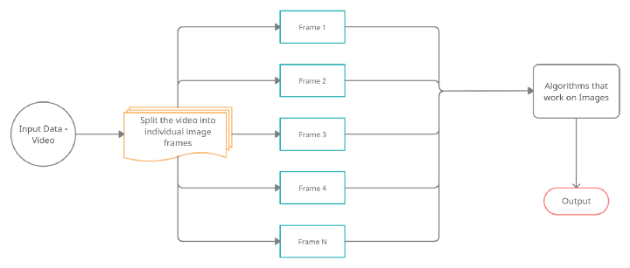
Fig. 4.1 System Architecure

V. Results
The system was tested in this work at various stages of the design recognition of facial microexpressions. The purpose of this test is to evaluate how well the system recognises learned facial expressions. The system successfully recognised the user's face 94.28% of the time, which leads us to believe that it performs well.
Ten analyses for each expression are the test results. The table will display which expressions are straightforward to predict, predictable frequently, and difficult to predict. The seven emotions—Neutral, Happy, Sad, Angry, Disgust, Surprise, and Fear—were examined to see how the results varied. The table that follows demonstrates that, in two out of every ten attempts to predict facial emotions, features of the disgust expression give incorrect results.

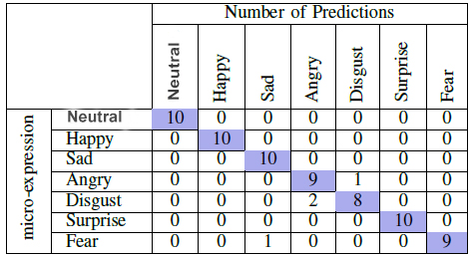

Fig. 5.1 – Result Table
The trained model's facial expression has an average accuracy of 65.97%. Analysis of the system's results after implementation is absolutely necessary.
VI. Conclusion
We used the Facebook-created Deepface framework to implement emotion recognition. The main drawback of all prior comparable models is that they are all dependent on the still image being transmitted. Our emotion detection model is able to recognise and report on the status of the emotions in real time. The system camera is used by emotion recognition models to take pictures of the user's face, which are then converted into frames and evaluated using pre-existing models. It then determines the feelings, categorises them, and selects one dominating emotion from the group. Deepface, which used the FER-2013 dataset, was used to develop the model.
On validation data, its accuracy was 87%. Overall, it has been determined from the outcomes of the studies that have been conducted that facial expression recognition is successful. selecting equipment, such as a digital camera, with a greater resolution and features like focusing to obtain a clean image even while the object is moving. Both detection and recognition benefit more from it.
References
- Y.-I. Tian, T. Kanade, and J. F. Cohn, “Recognizing action units for
facial expression analysis,” IEEE Transactions on pattern analysis and
machine intelligence, vol. 23, no. 2, pp. 97–115, 2001.
- G. Bradski and A. Kaehler, Learning OpenCV: Computer vision with
the OpenCV library. ” O’Reilly Media, Inc.”, 2008.
- https://www.kaggle.com/datasets/msambare/fer2013
- Y. Lecan, Y. Bengeo, and G. Hintin, “Deep learning,” Nature, vol. 521, no. 7553, pp. 436–444, 2015.
- https://towardsdatascience.com/the-ultimate-guide-to-emotion-recognition-from-facial-expressions-using-python-64e58d4324ff
- Image based Static Facial Expression Recognition with Multiple Deep Network Learning. Zhiding Yu ,Cha Zhang (2015)
[7] Baseline CNN structure analysis for facial expression recognition
Minchul Shin,Munsang Kim,Dong-Soo Kwon(2016)
[8] D. Duncan, G. Shine, and C. English, “Facial emotion recognition in
real time,” Stanford University, Tech. Rep., 2016.
[9] P. Ecman, “Micro Expressions,” 2017. [Online]. Available:
https://www.slideserve.com/tyrell/micro expressions

[10] The Facial Emotion Recognition (FER) Dataset for Prediction System of Micro-Expressions Face Using the Convolutional Neural Network (CNN) Purnawarman Musa (2021)

