# Program on Bootstrap/responsive web design using different components

## Problem Statement

Develop a responsive webpage using Bootstrap. Implement components like Navbar, Carousel, Forms, Buttons, and Cards. Ensure the layout adjusts smoothly on different screen sizes.

## Steps to Solve

1. Open your code editor and create a new HTML/PHP/JS file as required.

2. Write the necessary code based on the problem statement.

3. Test the code in a web browser or PHP server to ensure it works as expected.

4. Debug any issues encountered during testing.

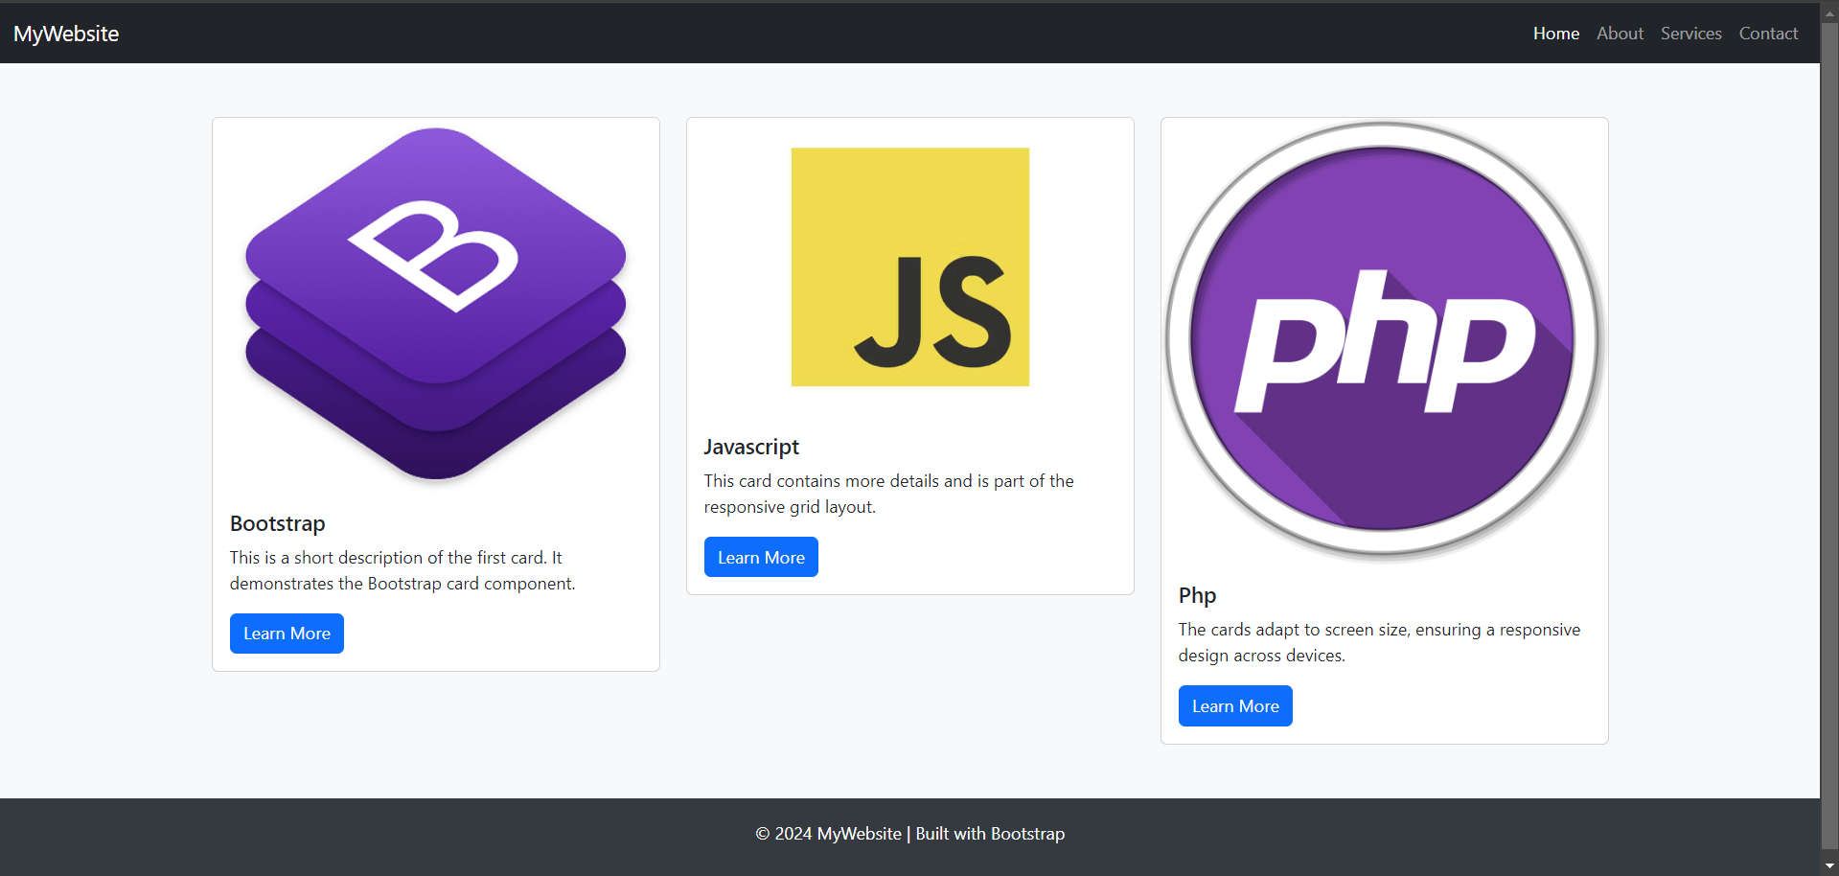5. Submit the code along with proper comments and documentation.