# Program on HTML basic tags to handle multimedia elements on web page

## Problem Statement

Create a webpage to display multimedia elements such as images, audio, and video using HTML tags like <img>, <audio>, and <video>. Ensure proper file formats are used.

## Steps to Solve

1. Open your code editor and create a new HTML/PHP/JS file as required.

2. Write the necessary code based on the problem statement.

3. Test the code in a web browser or PHP server to ensure it works as expected.

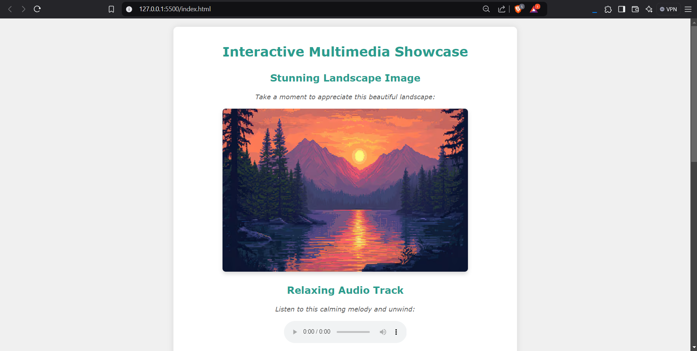4. Debug any issues encountered during testing.  
5. Submit the code along with proper comments and documentation.

