# Program on CSS properties for HTML web page

## Problem Statement

Create a CSS file to style an HTML webpage. Use properties like color, font-size, background-color, margin, padding, and border. Apply these styles to a sample HTML page.

## Steps to Solve

1. Open your code editor and create a new HTML/PHP/JS file as required.

2. Write the necessary code based on the problem statement.

3. Test the code in a web browser or PHP server to ensure it works as expected.

4. Debug any issues encountered during testing.

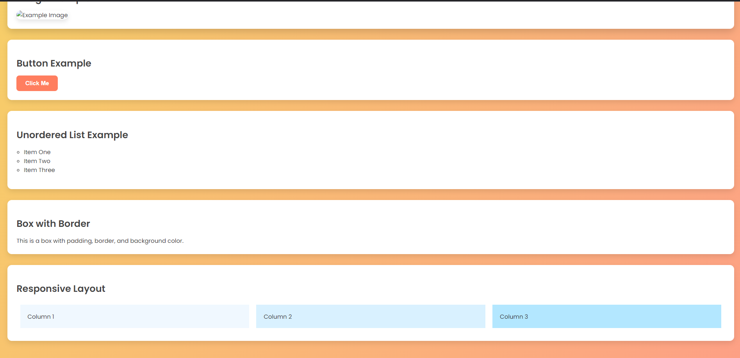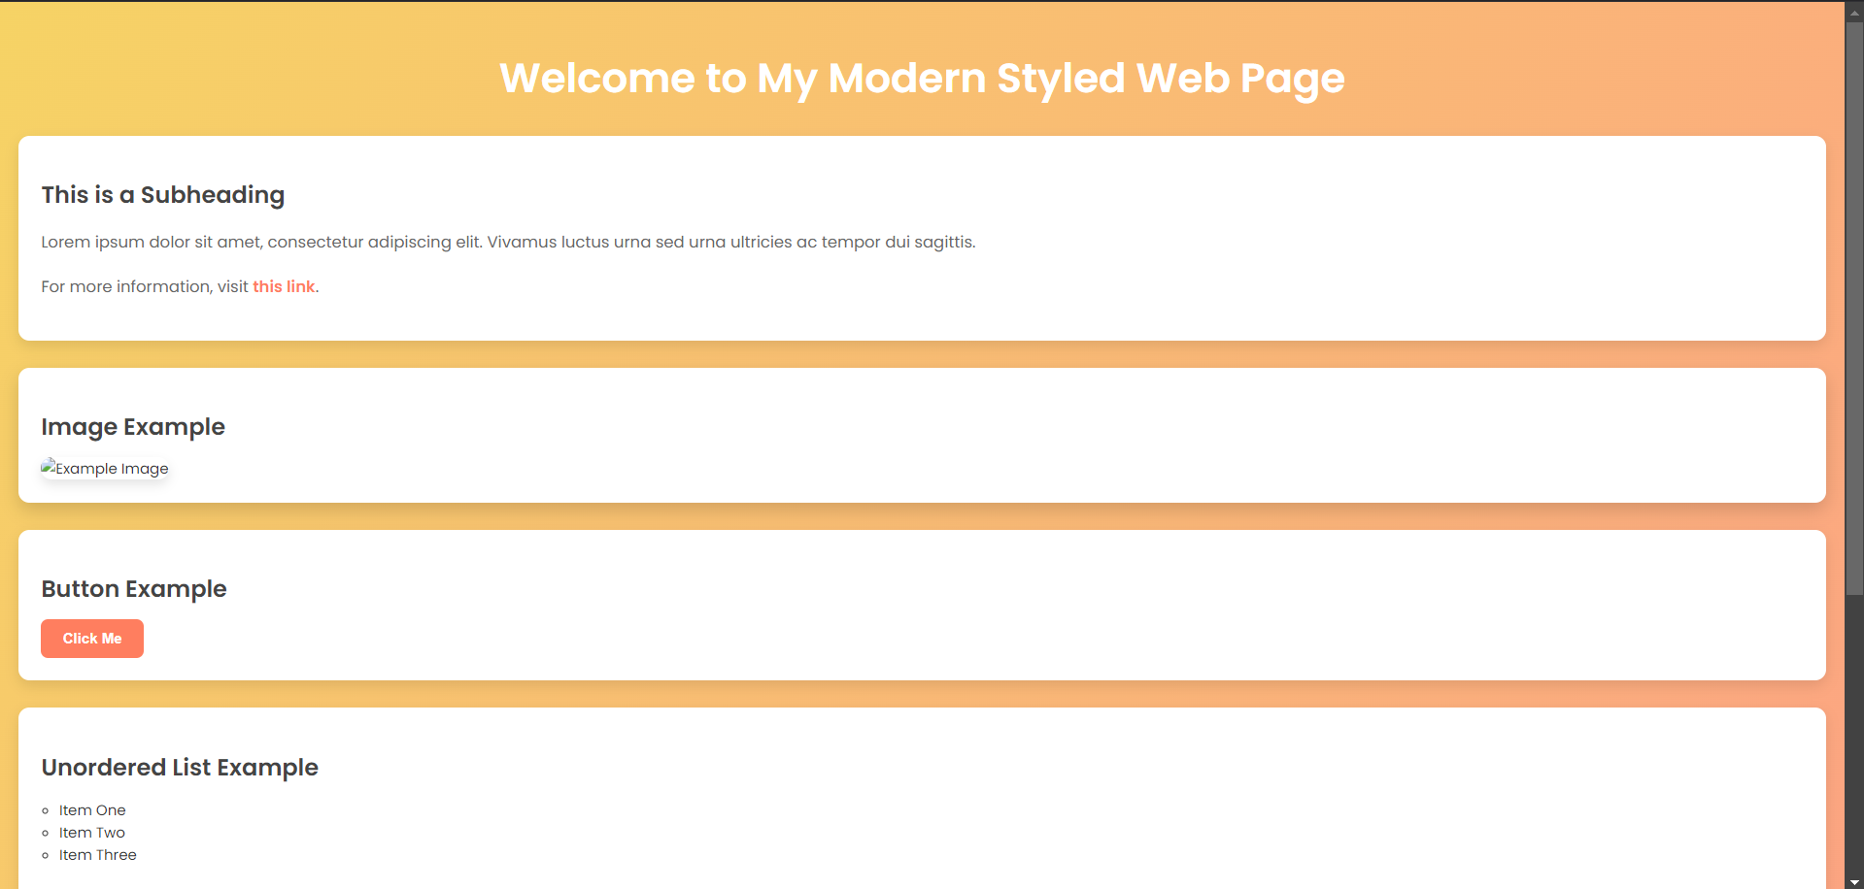5. Submit the code along with proper comments and documentation.