# Program on PHP control statements

## Problem Statement

Write a PHP program using control statements like if-else, switch, and loops to display different messages or perform calculations based on user input.

## Steps to Solve

1. Open your code editor and create a new HTML/PHP/JS file as required.

2. Write the necessary code based on the problem statement.

3. Test the code in a web browser or PHP server to ensure it works as expected.

4. Debug any issues encountered during testing.

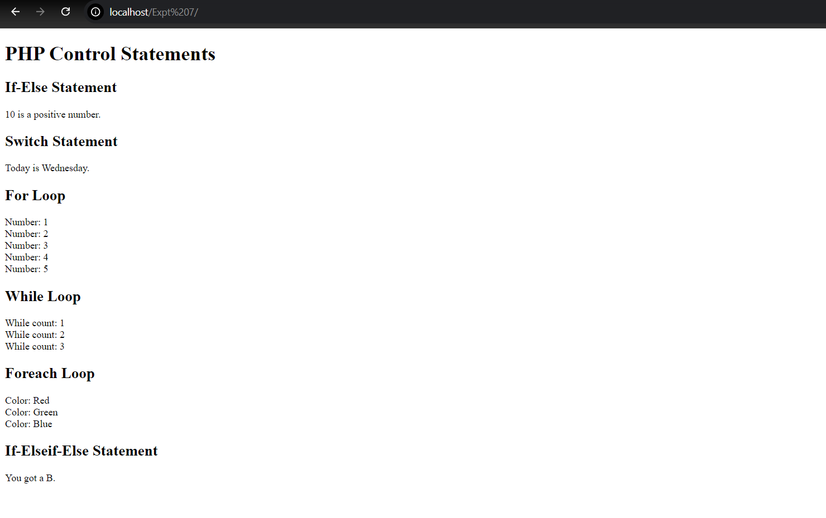5. Submit the code along with proper comments and documentation.