# Program on PHP form creation and data handling

## Problem Statement

Develop an HTML form and handle form submissions in PHP. Use the POST method to send form data to a PHP script that processes and displays the submitted information.

## Steps to Solve

1. Open your code editor and create a new HTML/PHP/JS file as required.

2. Write the necessary code based on the problem statement.

3. Test the code in a web browser or PHP server to ensure it works as expected.

4. Debug any issues encountered during testing.

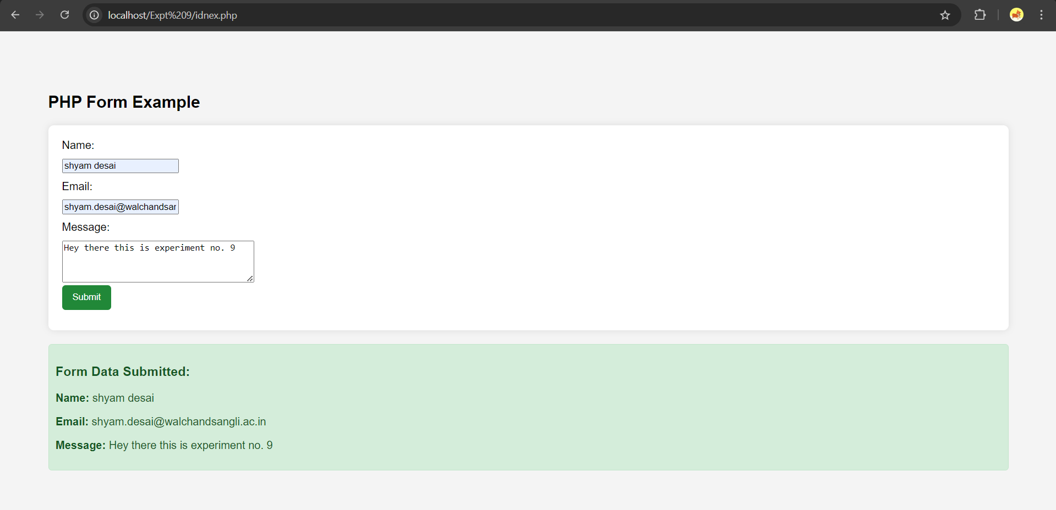5. Submit the code along with proper comments and documentation.