Assignment 1 - Web Development

1. Frontend, Backend, Full-stack
Frontend: Builds UI using HTML, CSS, JavaScript. Example: Amazon product pages.
Backend: Handles server logic, authentication, APIs, and database operations. Example: Amazon order processing.
Full-stack: Works on both frontend and backend to build complete applications.

2. Client-Server Model
[Client/Browser] --HTTP Request--> [Web Server] --HTTP Response--> [Client/Browser]

3. Browser Request Flow
Enter URL -> DNS lookup -> HTTP request -> Server processes -> Returns HTML/CSS/JS -> Browser renders page.

4. Development Tools
VS Code (editor), Browser (testing), Node.js (runtime), Git (version control), GitHub (repository), Chrome DevTools (debugging).

5. Web Server
Software that receives HTTP requests and serves web pages. Examples: Apache, Nginx, Microsoft IIS, LiteSpeed, Express.js.

6. Project Roles
Frontend Developer: User interface.
Backend Developer: Server logic & APIs.
Database Administrator: Database design, security, backup, optimization.

7. VS Code Setup
Install VS Code and extensions: Live Server, HTML CSS Support, Prettier, ESLint. Paste your screenshot here before submission.
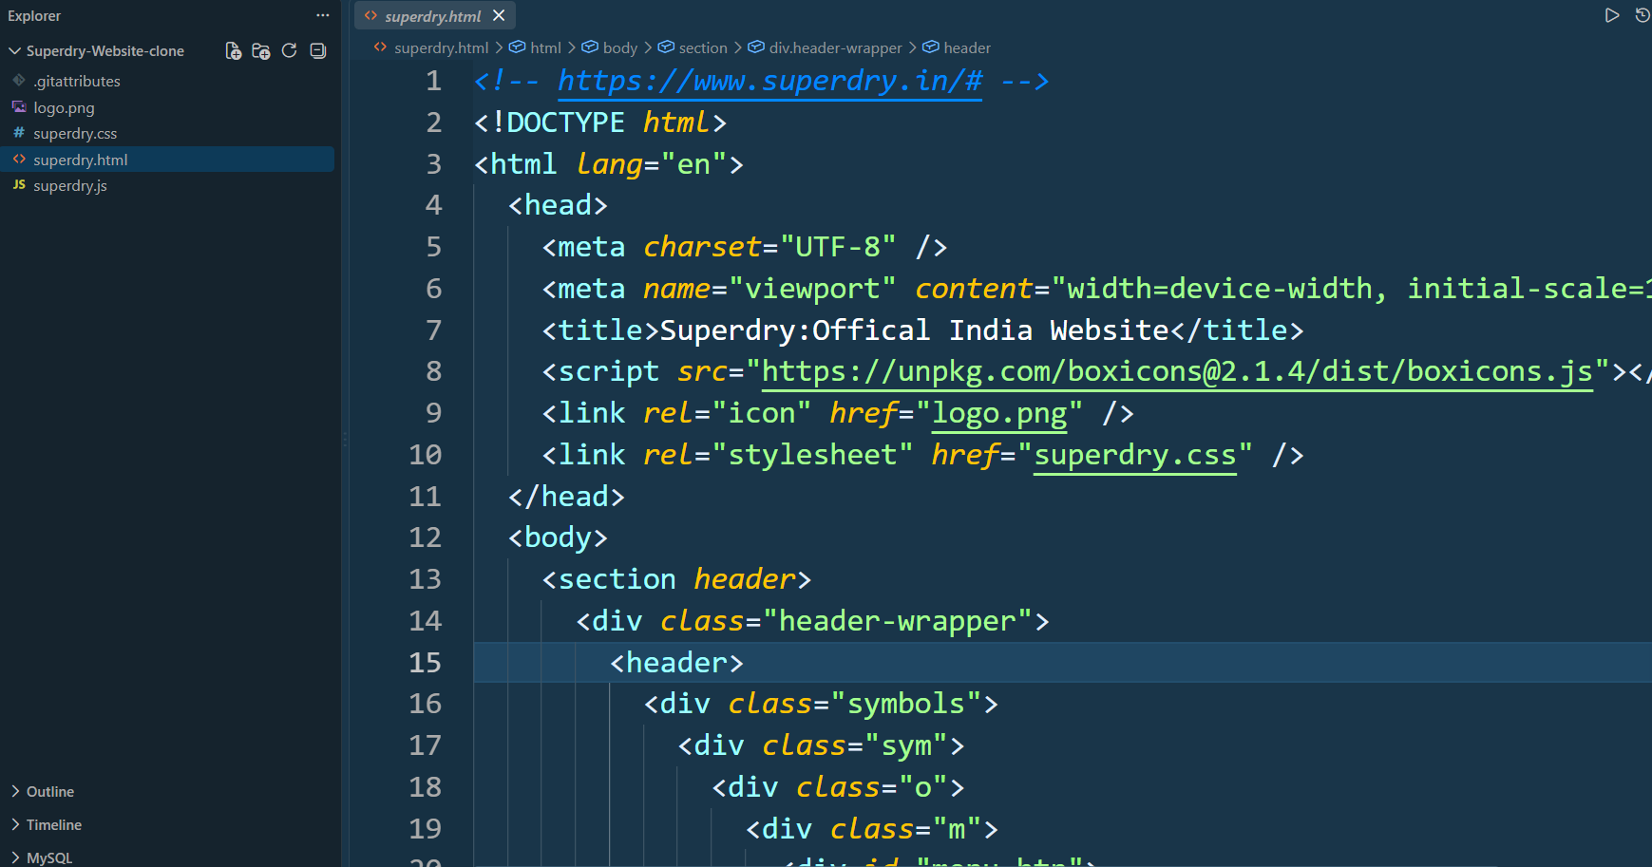

8. Static vs Dynamic
Static: Fixed content (example: personal portfolio).
Dynamic: Content changes based on data/user (example: Facebook).

9. Browsers & Engines
Chrome-Blink, Edge-Blink, Firefox-Gecko, Safari-WebKit, Opera-Blink. Rendering engines parse HTML/CSS and render pages differently.

10. Web Architecture
Client -> Server -> Database
|
-> APIs -> External Services

