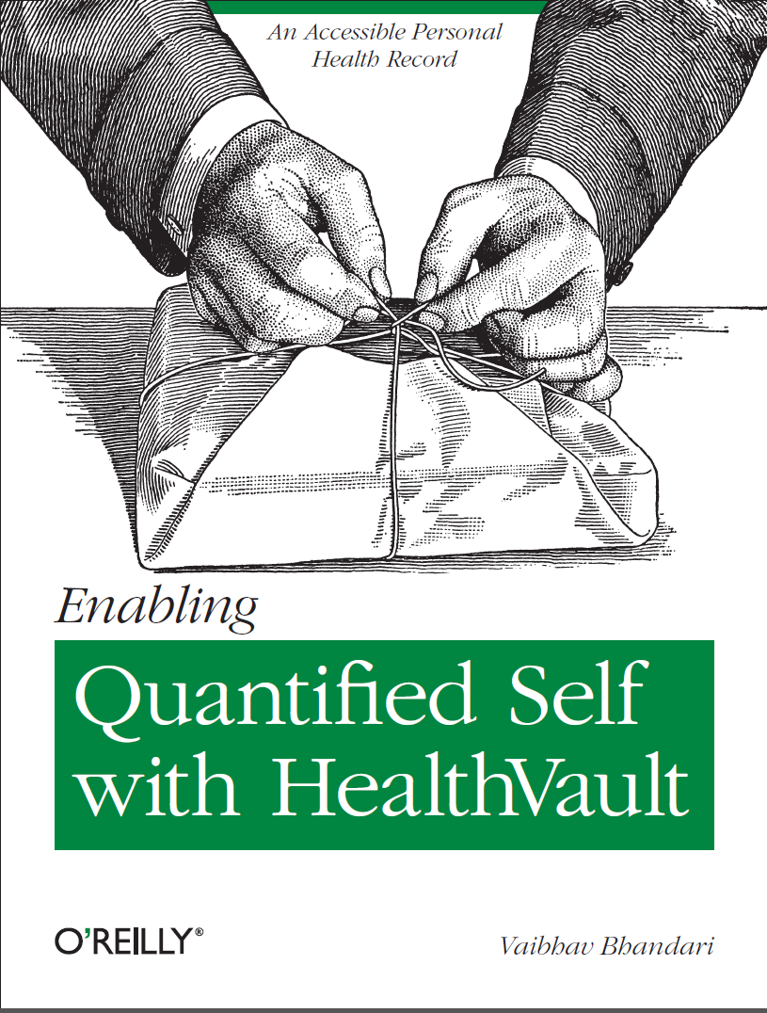

# Outline of the work

Microsoft HealthVault is the most prominent example of a personally controlled health record (PCHR). With its open API, flexibility and connections with multiple health care providers, it gives people interested in monitoring their own health an unprecedented opportunity to do their own research on their own data. This concise book will explain what you can store in HealthVault, how to enable automatic updates from well-known fitness devices, and how to use programming libraries to create reports and investigate trends of interest to you.