“*The groundwork of all happiness is health.*”  
Leigh Hunt

|  |  |
| --- | --- |
| *Concepts to cover*   * What is HealthVault? * Getting started with HealthVault * Creating an emergency profile * Kinds of data one can view or add through HealthVault * Working with Weight and downloading it to excel * HealthVault Applications – Mayo Clinic Health Manager | *To do* |

Health is critical to all of us. Healthcare and the infrastructure around it touches our lives and the lives of our loved ones. Many of us, in pursuit of long-term health, adopt goals ranging from controlling our weight to long-distance running. The Healthcare industry is in an early stage of realizing the power of the digital world, and the effectiveness of personal health tools in helping drive a change.

This chapter introduces HealthVault as a powerful tool for interacting with health data. It also provides a walkthrough of functionality available to the end user through HealthVault.

# What is HealthVault?

HealthVault is a personal data platform that allows a user to record, collect, and share all health information in a central location. A key benefit of using HealthVault is its application programming interface (API), which applications and devices can use to provide value for the end-user. As depicted in [Fig 1.1], HealthVault enables an ecosystem of devices and applications, with use cases ranging from tracking diet and nutrition to connecting to hospital or pharmacy systems. HealthVault currently supports more than 300 applications and 80 devices. Some devices connect to HealthVault via the HealthVault Connection Center; a complimentary client application that enables devices to upload information directly to HealthVault from a Windows PC.

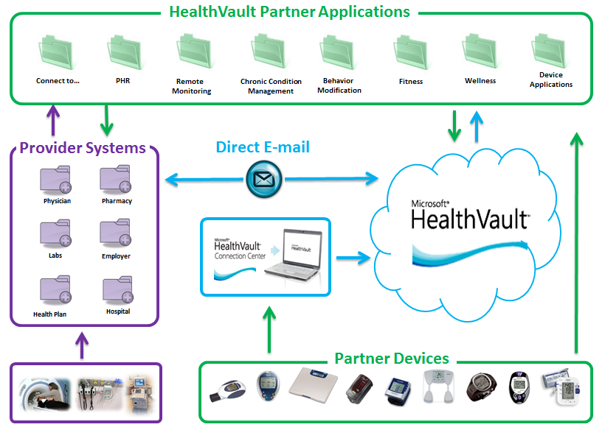

Fig 1.1 HealthVault Ecosystem with Devices and Applications

# Getting started with HealthVault

On the HealthVault website, <http://www.healthvault.com>, a user can create an account using an existing Windows Live ID, Facebook, or OpenID account, or choose to create a new Windows Live ID. Fig 1.2 shows the sign-up screen for HealthVault.

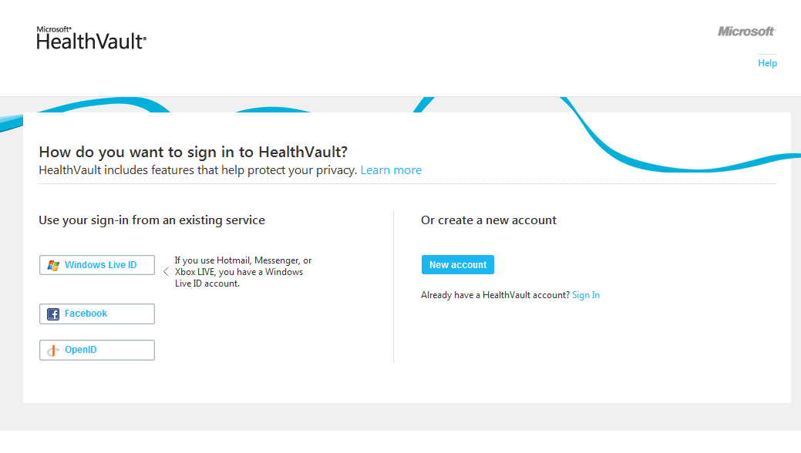

Fig 1.2. HealthVault sign-In page

HealthVault is currently publicly available in the United States and United Kingdom; you can create an account by entering basic demographic information and a proof of human computer interaction.

When a new user signs in to HealthVault, he is greeted with a new user wizard that enables him to select tasks and allows him to connect to various services [Fig 1.3].

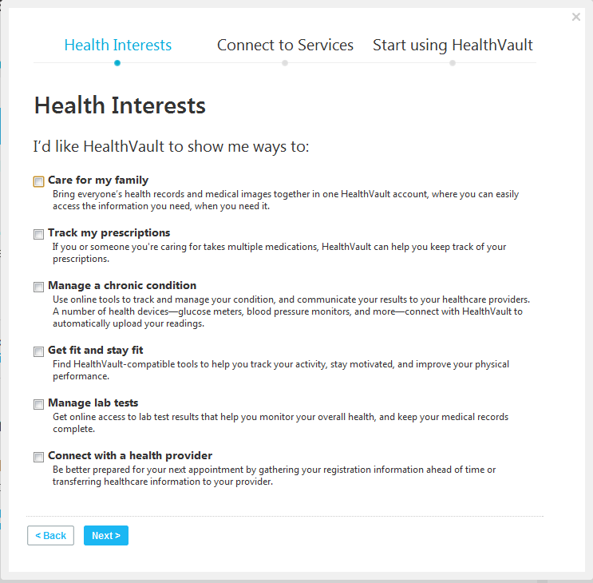

Fig 1.3. HealthVault new user wizard

# Overview of HealthVault Features

In this section I’ll go over a few of the most popular features in HealthVault, concentrating on ones that we’ll use in this book to collect, manipulate and share information.

## Health Information

The Health Information section of the health profile provides a view of all the information in the user’s Health record. HealthVault supports more than 80 discrete kinds of data, from Advance Directive to Weight Goals. Through the user interface, you can edit and add health information. As Fig 1.4 indicates, you can add allergies, conditions, various measurements (blood glucose, blood pressure, peak flow, weight, height and lab test results), files (CCR, CCD, etc.), health history (family, immunizations, procedures) and emergency provider contact information.

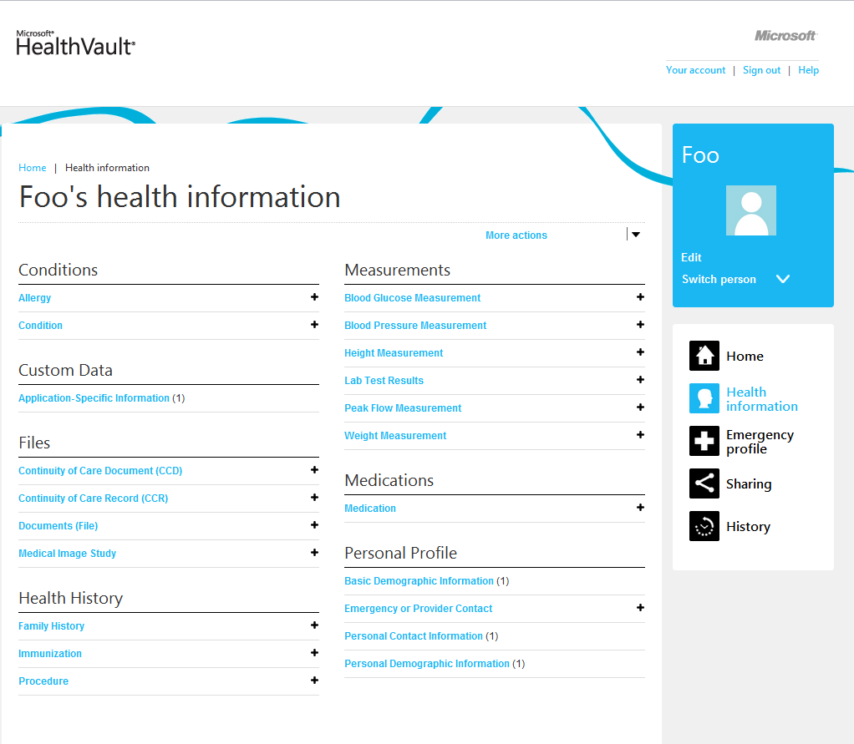

Fig 1.4. Health Information input support by HealthVault

You can also drill deeper and understand how the data entered your health profile, and see the audit trail to understand how the data evolved. [Fig 1.5] shows audit history of weight in HealthVault.

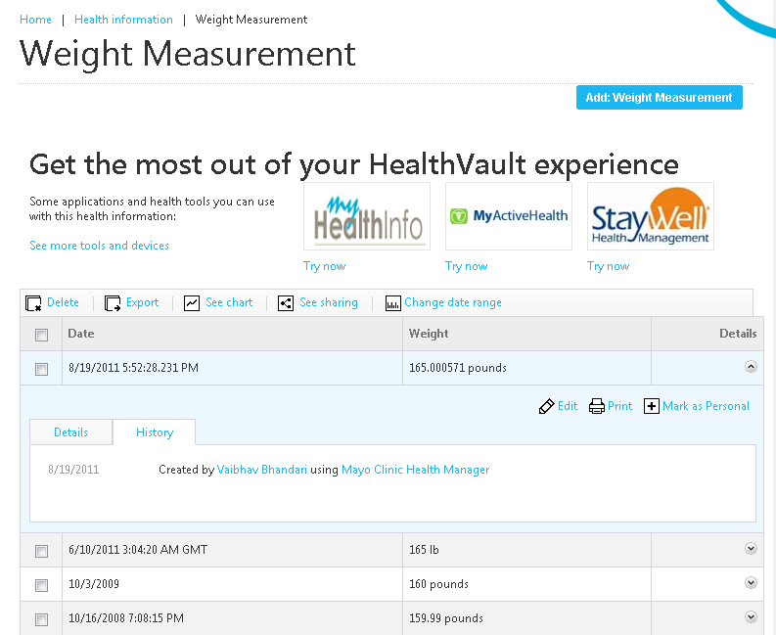

Fig 1.5. Viewing details of health data in HealthVault

## Creating an emergency profile

Out of the box, HealthVault provides each user account with an emergency profile consisting of current allergies, conditions, medications, medical devices, and emergency contact information. A user can print, share, and update her emergency profile.

With an emergency profile, the user gets an emergency access code that could provide timely and up-to-date medical information to an emergency responder through HealthVault.com.

[Fig 1.6] shows the emergency access profile. Note that in addition to printing and sharing it, a user can also access a number of HealthVault tools that provide plethora of emergency services.

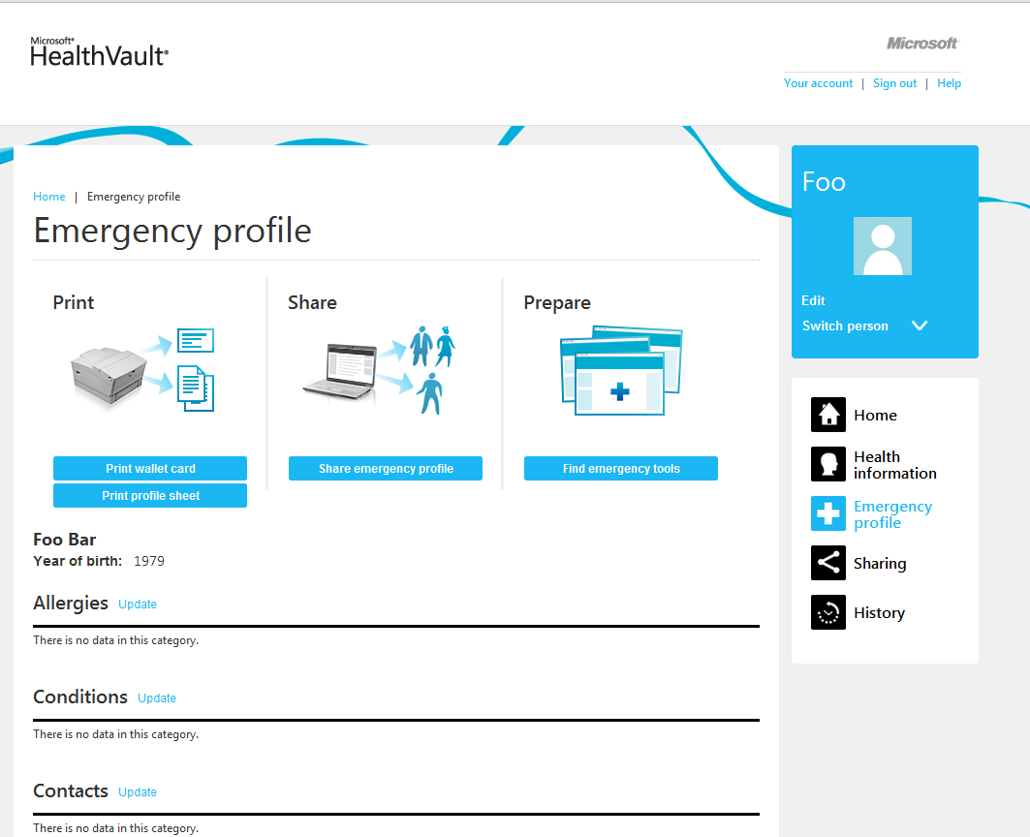

Fig 1.6.Emergency access profile

## Sharing

Using the sharing section of Health profile the user can view with whom and how his information is being shared. A user can invite people to view granular information in their health profile. The data used in this book was shared by gracious contributors by using this sharing functionality for specific types of health data. As Fig 1.7 shows using the sharing pane, users can review and revoke access to online health tools.

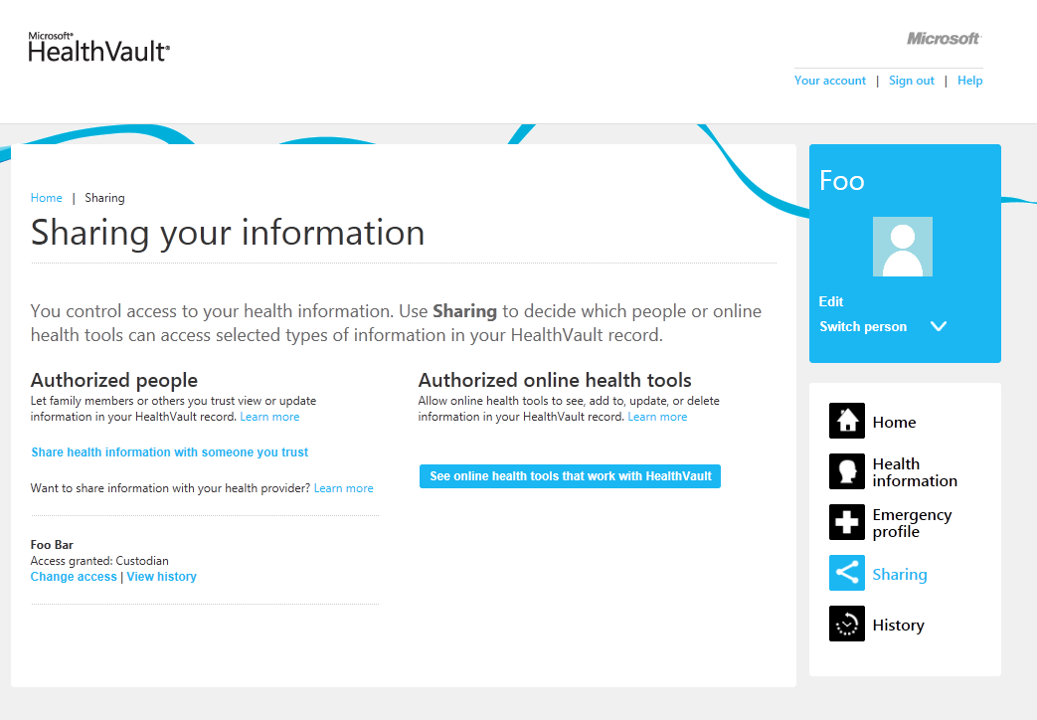

Fig 1.7. Sharing Health Information

## History

Having a granularly shareable health profile enables a plethora of care co-ordination scenarios. However we do want to know how and when our sensitive health information is being accessed and updated. As Fig 1.8 shows using the “History” pane of the Health Profile, a user can view the ways their health information has been accessed. I frequently look at the “Changes made in last 30 days” and review who has accessed and updated my record.

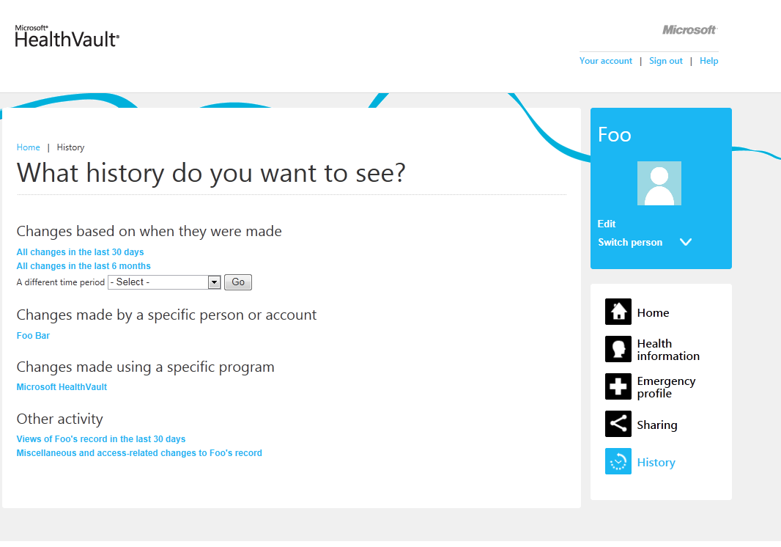

Fig 1.8. Reviewing History of Changes

# Working with Health Data

Data is a powerful tool to understand behaviors and trigger appropriate measured change. Users can find out interesting trends by running calculations on their data stored in HealthVault, as I’ll show throughout this book.

For instance, through the Health Information section, a user can chart his weight readings (Fig 1.9).

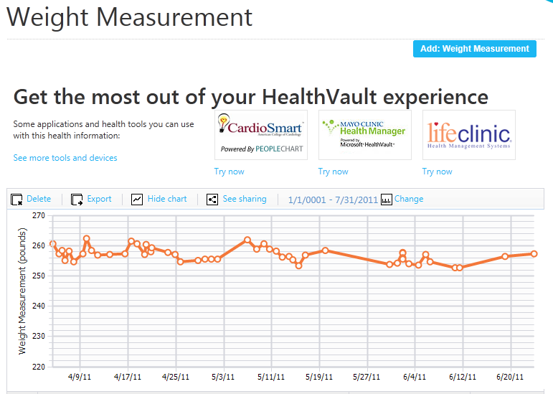

Fig 1.9. Tracking weight in HealthVault

You will see that over last several readings, weight has been stable around 257 pounds. Nonetheless, I would like to take this a bit further and analyze these readings. To do this I click on the “export” button in the Health Information section. This gives me the readings in a comma separated values (CSV) format, which I can then open in Microsoft Excel or any spreadsheet program (Fig 1.10). If you don’t have weight data, I encourage you to download the sample spreadsheet with weight data included as part of this book’s examples, and follow along.

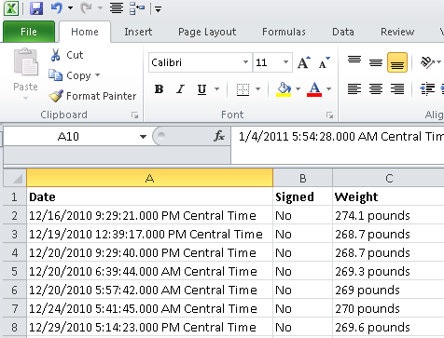

Fig 1.10. Weight readings in Microsoft Excel

Using Excel, I can clean the data so I can chart and analyze it further. I can add a series date attribute by just using the date from the first column (Fig 1.11).

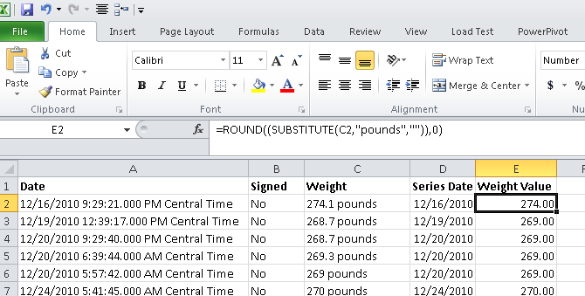

Fig 1.11. Using Excel to clean up the date

The formula DATEVALUE(LEFT(A2, FIND(“ “), A2))) , converts the cell to a date value by picking the left side of the date format before the first space in column A2. The formula ROUND(SUBSTITUTE(C2,”pounds”)),0), removes the pound unit in column C and rounds the value to nearest integer.

Using Excel I can find the average weight over the last set of readings (Fig 1.12), and in fact plot my weight over months to uncover the monthly trend (Fig 1.13).

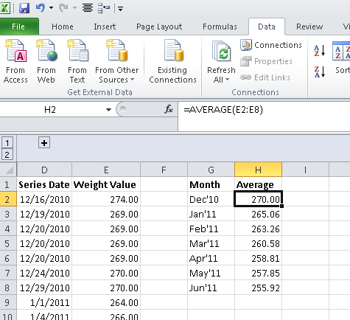

Fig 1.12. Average weight

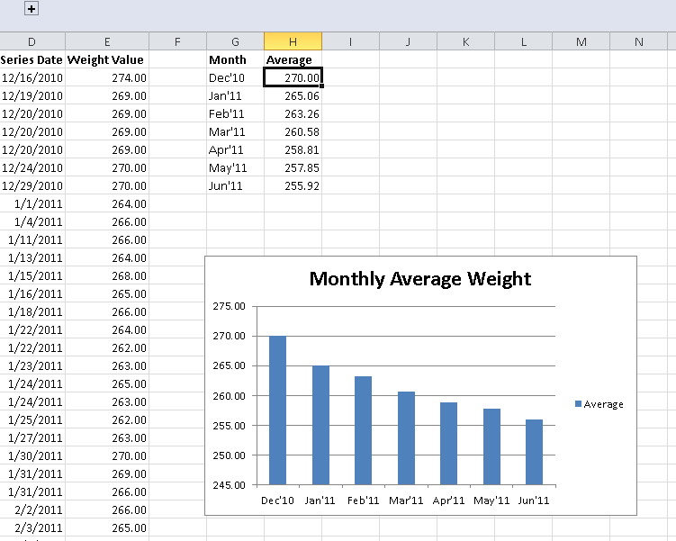

Fig 1.13. Monthly average weight as a bar chart

Managing weight is one scenario where you can use health tools to gain insights, the associated website with this book, enablingquantifiedself.com, has a repository of spreadsheets giving inspiration for additional care scenarios.

# Using partner applications

So far, we have looked at the mechanisms provided within HealthVault to track, update and visualize health information. Outside applications, however, offer even more information. For instance, the Mayo Clinic Health Manager application, https://healthmanager.mayoclinic.com, can track your weight toward an intended goal (Fig 1.14).

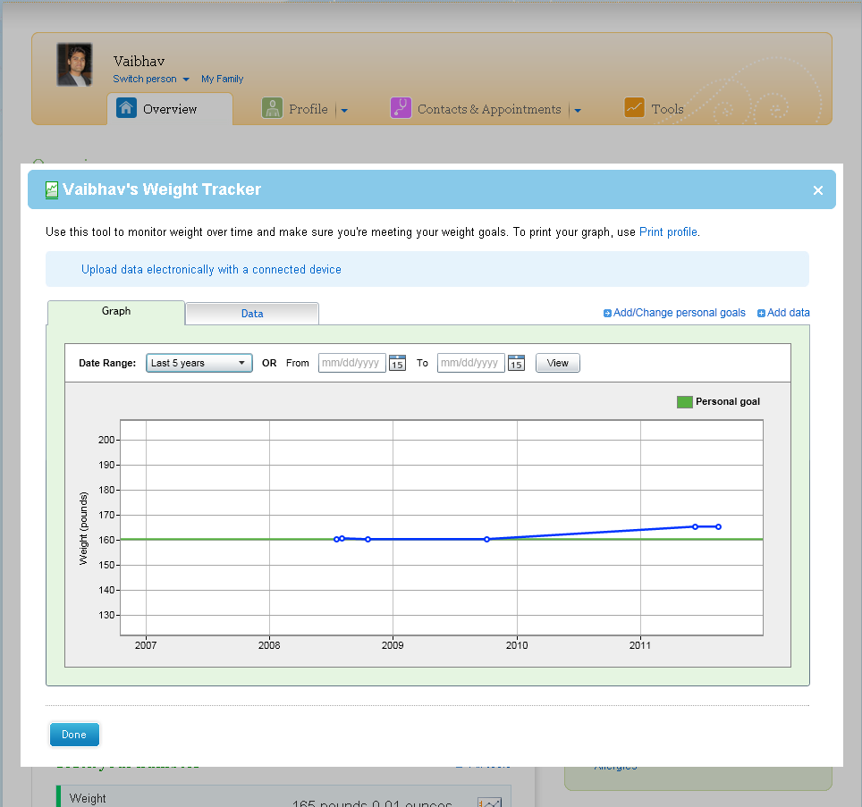

Fig 1.14. Tracking weight against a goal

The Mayo Clinic Health Manager is able to access all the weight information from a user’s HealthVault account using the HealthVault API. If you’re not a programmer you can benefit from many such applications that add value to HealthVault by allowing you to track and measure health data. If, however, you have modest programming skills in almost any modern language, this book will show you can create your own.

The HealthVault .NET Web SDK provides an abstraction on HealthVault APIs to simplify working with the platform. Listing 1.1 is a .Net program using the SDK to extract all the weights from a user’s HealthVault record into a dictionary.

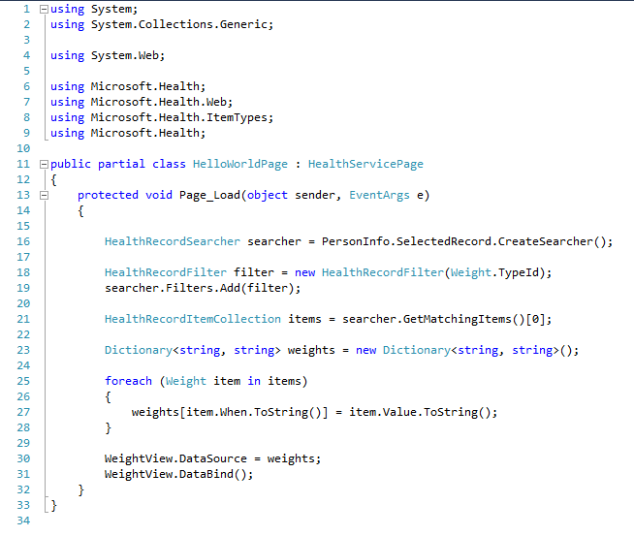

Listing 1.1. Accessing HealthVault through the .NET Web SDK to read weight measurements

The steps in extracting data are; create a searcher, add a filter to restrict the output to the field or rows you want, and then run a search. The searcher.GetMatchingItems() in Line 21 of Listing 0.1 actually issues a HealthVault GetThings API request with a query configured to fetch all the Weight items from the users HealthVault record. We will learn more about the API & account management in chapter 3, and the data types in Chapter 4.

In the next chapter, we will dive deeper into the HealthVault device and application ecosystem.