How the System Answers a Question
Chat AI · SQL · Document Search (RAG) · Knowledge Graph
Executive Overview
A user asks a single question in plain English. Chat AI reads the question and decides how best to answer it: from the structured tables of the database, from the indexed documents, or from the knowledge graph that connects them. This document presents Chat AI first, followed by each of the three approaches it can choose from, with a diagram and a step-by-step explanation for each.
The numbers shown in each diagram correspond to the numbered steps listed on the page that follows it.

1. Chat AI: Selecting the Right Approach Automatically
Chat AI is the single point of entry for every question. Users type their question in plain English; they do not choose a method, a table or a document, and they do not need to know how the information is stored.
Chat AI reads the question, considers the data currently available, and directs the question to whichever of the three approaches is best suited to answering it: SQL for information held in the database tables, document search for information stated in a document, and the knowledge graph for information that spans several sources. Each approach is described in the sections that follow. Every decision is recorded, and if the selected approach returns nothing useful, Chat AI automatically tries a second one before concluding that no answer is available.
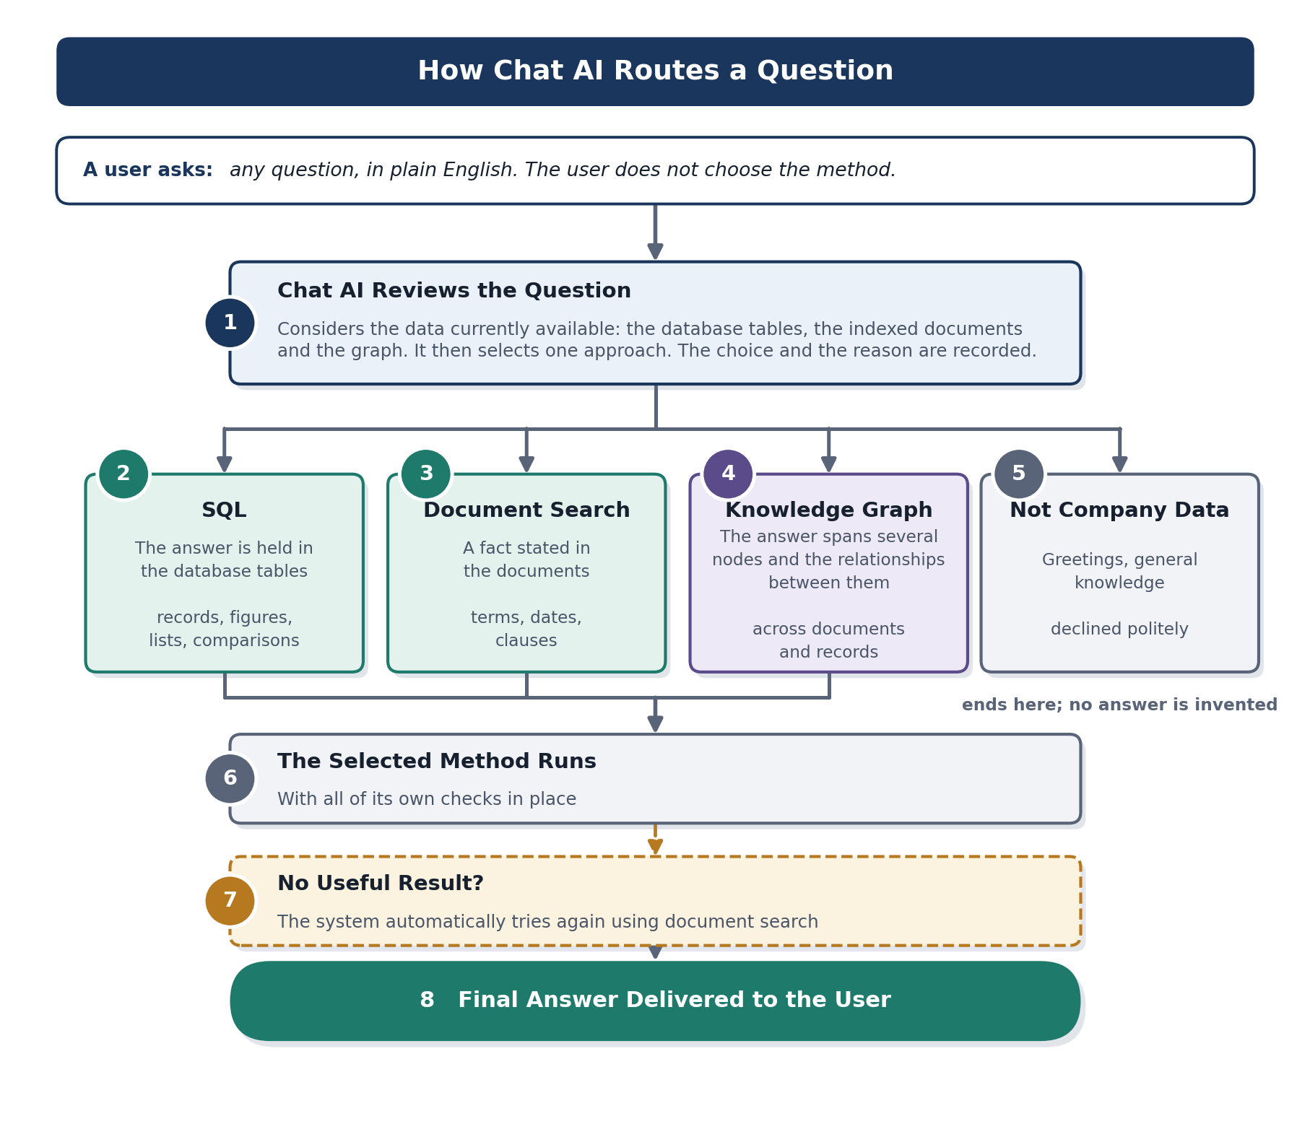

What Happens, Step by Step
Example: any question, asked in plain English.
1. Chat AI reviews the question. A single automated check considers the question alongside the data currently available: the database tables, the indexed documents and the knowledge graph. Chat AI then selects one approach. Both the choice and the reason for it are recorded.
2. SQL. Selected when the answer is held in the structured tables of the database — records, figures, lists and comparisons drawn from them — and the question can be matched to the existing schema.
3. Document search. Selected when the answer is a fact stated in the documents, such as terms, dates, clauses or specifications.
4. Knowledge graph. Selected when the answer spans several nodes and the relationships between them, across documents and records, and only becomes clear once those relationships are followed.
5. Not company data. Greetings, general knowledge questions and anything outside the company's data are identified and declined politely. No answer is invented.
6. The selected approach runs. The chosen approach then runs with all of its own checks in place, exactly as described in the sections that follow.
7. Automatic second attempt. If the selected approach returns no useful result, Chat AI does not stop there. It automatically tries again using document search before concluding that no answer is available.
8. The answer is delivered. One question is asked and one answer is returned. The user does not need to be aware of the process behind it.

Why it matters
The experience is the same for every question: the user asks in plain English and receives an answer. Behind that, Chat AI selects the appropriate approach on its own, adjusts automatically as further tables and documents are added, records every decision so that it can be reviewed later, and tries a second approach if the first returns nothing useful. No manual selection is required, and users are not left without a response.

2. SQL: Answering from the Database Tables
This approach is used when the information requested is held in the structured tables of the database. The system works against the schema that already exists: the tables, the columns within them and the relationships defined between them. It matches the question to that schema, builds a query from it, and returns the information the user asked for.
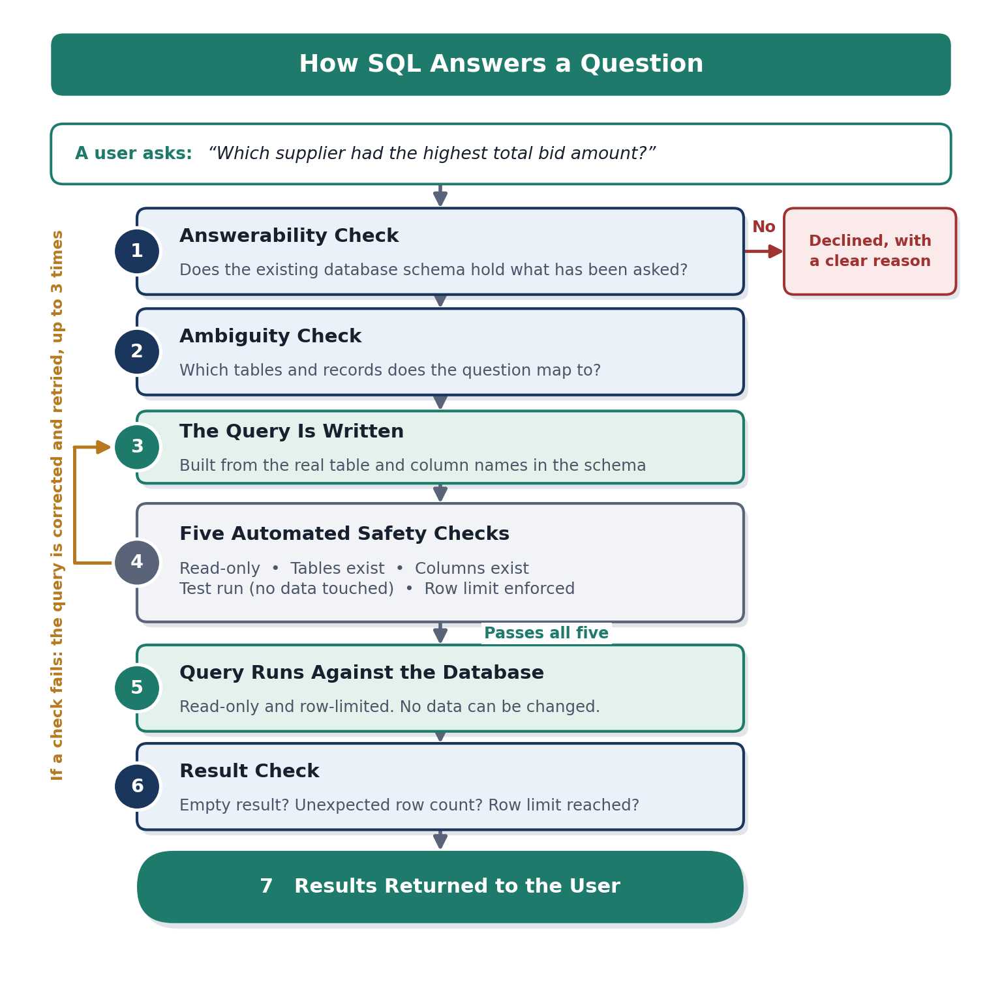

What Happens, Step by Step
Example question: “Which supplier had the highest total bid amount?”
1. Answerability check. The system reads the existing database schema: which tables are available, which columns they contain and how those tables relate to one another. The question is then matched against that schema. If nothing in the schema corresponds to what has been asked, the system stops at this point and explains why.
2. Ambiguity check. A question can sometimes be matched to the schema in more than one way, for example where the same information is held in more than one table. Rather than selecting one option without saying so, the system applies the agreed business rule, and applies it in the same way every time.
3. The query is written. A database query is then written against the schema, using the actual table and column names read from the database. Nothing about the structure is assumed.
4. Five automated safety checks. Before the query is allowed to run, it must pass five separate checks. It must be read-only; every table it refers to must exist; every column it refers to must exist; it must pass a test run through the database's own planner without touching any data; and it must include a limit on the number of rows returned.
5. The query runs. The query runs in read-only mode, with the row limit applied. The system cannot change or delete company data under any circumstances.
6. Result check. The result is reviewed before it is shown to the user. An empty result, an unexpected number of rows, or a result that has reached the row limit is reported clearly rather than presented as a complete answer.
7. The result is returned. The user receives the requested information as a results table, within seconds and without anyone needing to write a query by hand.

If a safety check fails
The system reviews the reason for the failure, corrects the query and tries again, up to three times. Only if all three attempts fail is the request referred to a person.

Why It Matters
- The approach works against the schema that already exists. No new data structures, copies or exports are required.
- The database structure is read directly at the time the question is asked, so the system remains correct as tables and columns change.
- Business rules are applied automatically and consistently, so two people asking the same question receive the same result.
- All queries are read-only and limited in size. There is no possibility of company data being changed or deleted, or of the database being overloaded.
- Questions that the schema cannot support are declined with a clear explanation, rather than answered with an estimate.

3. Document Search (RAG): Answering from the Company's Documents
This approach is used when the information requested is already recorded in a document, such as a clause in a contract, a date on a certificate or a term in a bid submission. Documents are indexed in advance, so that a question can be matched to the relevant passages within seconds and answered from those passages alone.
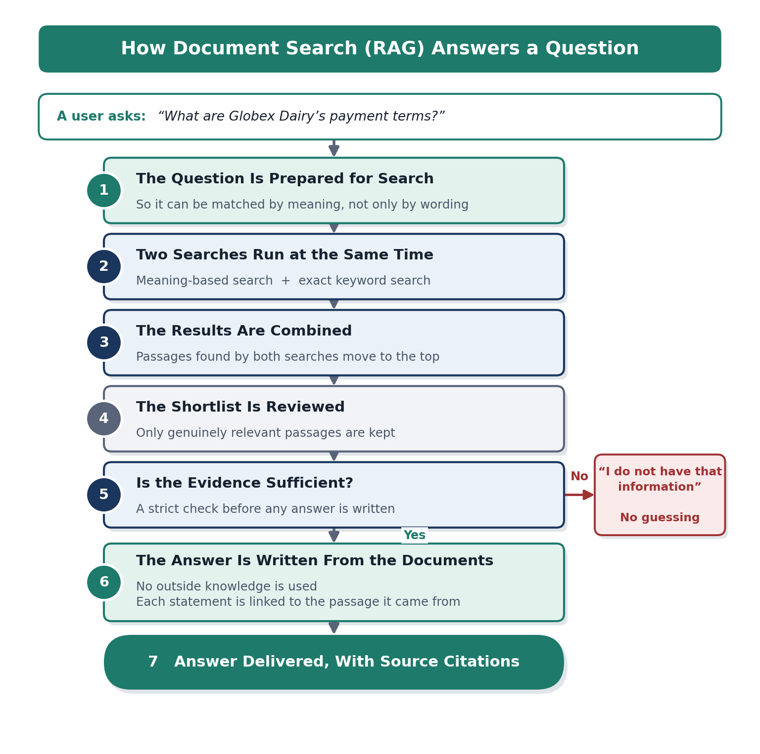

What Happens, Step by Step
Example question: “What are Globex Dairy's payment terms?”
1. The question is prepared for search. The question is converted into a form that allows the system to match it by meaning rather than by exact wording. As a result, “payment terms”, “when do we pay them” and “credit period” all lead to the same passage.
2. Two searches run at the same time. The first search looks for meaning, including rephrased wording. The second looks for exact terms such as supplier names, reference codes, figures and dates. Running both covers the two different ways in which people ask questions.
3. The results are combined. The two sets of results are merged into a single ranked shortlist. Passages found by both searches move to the top, since agreement between two different methods is a strong indication of relevance.
4. The shortlist is reviewed. Each shortlisted passage is checked again against the question, so that only genuinely relevant material is carried forward.
5. Is the evidence sufficient? This is a strict check. If none of the shortlisted passages answers the question, the system replies that it does not hold that information. It is not permitted to draw on knowledge from outside the company's documents.
6. The answer is written. The answer is written using only the selected passages. Nothing is added from any other source, and each statement remains linked to the passage it came from.
7. The answer is delivered. The user receives the answer together with the source documents, so that any statement can be verified quickly.

Documents are indexed in advance
Documents are processed and indexed when they are added to the system, not when a question is asked. This is why answers are returned within seconds, even across a large document library.

Why It Matters
- Both types of question are supported: general questions expressed in a user's own words, and precise questions containing exact names, codes or figures.
- Every answer can be traced back to a named source document.
- The system cannot use outside knowledge. It either answers from the company's documents or states that the information is not available.
- Where the supporting evidence is weak, the system says so, rather than producing an answer that sounds confident but is incorrect.

4. Knowledge Graph: Answering Across Nodes and Relationships
A knowledge graph represents the business as a network. The things themselves — suppliers, contracts, certificates, clauses, bids — are held as nodes, and the connections between them are held as relationships, also called edges. A relationship states a fact: this certificate belongs to that supplier; that supplier holds this contract; this contract contains that clause.
This approach is used when no single document or table holds the full answer, and the answer only emerges once the relationships between several nodes are followed. Starting from the node the question refers to, the system traverses the graph a small number of steps, known as hops, and gathers the evidence attached to each node it reaches.
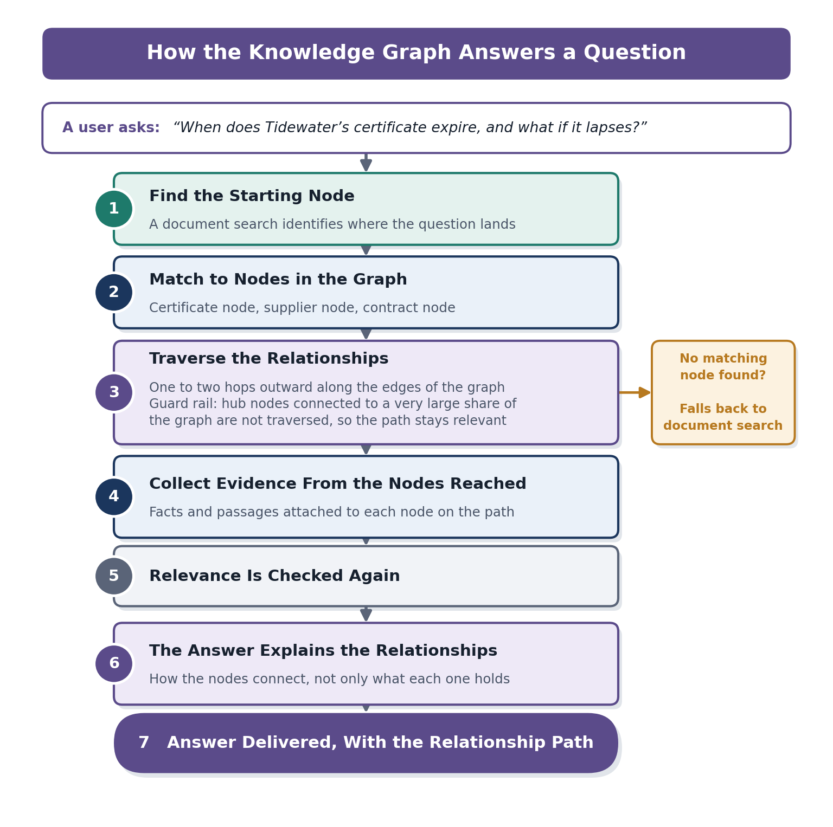

What Happens, Step by Step
Example question: “When does Tidewater's certificate expire, and what happens if it lapses?”
1. Find the starting node. A standard document search runs first and identifies the point the question refers to. That point is then matched to a node in the graph, in this example the certificate.
2. Match the question to nodes in the graph. The system identifies every node the starting point relates to: the certificate node, the supplier node and the contract node. These become the starting nodes for the traversal.
3. Traverse the relationships. From those nodes, the system follows the relationships that connect them, one or two hops outward: certificate to supplier, supplier to contract, contract to the clause covering lapsed certificates. A guard rail prevents traversal through hub nodes, meaning nodes that are connected to a very large share of the graph, so that the path followed remains relevant.
4. Collect evidence from the nodes reached. The facts and passages attached to each node on the path are collected, with nodes closer to the starting node given greater weight.
5. Relevance is checked again. As with document search, the collected material is checked once more against the question, and only the relevant parts are kept.
6. The answer explains the relationships. The answer sets out how the nodes connect to one another, rather than listing what each one holds separately.
7. The answer is delivered. The user receives the answer together with the relationship path used to produce it, so that the reasoning behind it can be reviewed.

How the graph is built
Nodes and relationships come from two sources, and both can be verified. The first is the relationships already defined between the tables of the database. The second is the relationships stated in the text of the documents themselves, which are extracted automatically. Every edge in the graph is a recorded fact that can be traced back to its source.

Why It Matters
- The graph makes relationships explicit, so questions that depend on how records connect can be answered directly rather than assembled by hand.
- It answers questions that no single document or table can answer on its own.
- Every relationship traversed can be shown, so the path behind an answer can be reviewed.
- The guard rail on hub nodes keeps the traversal focused and prevents loosely connected material from being drawn in.
- If no matching node is found, the system falls back to a standard document search rather than failing.

