p=imread('C:\Users\student\Downloads\images.jfif')

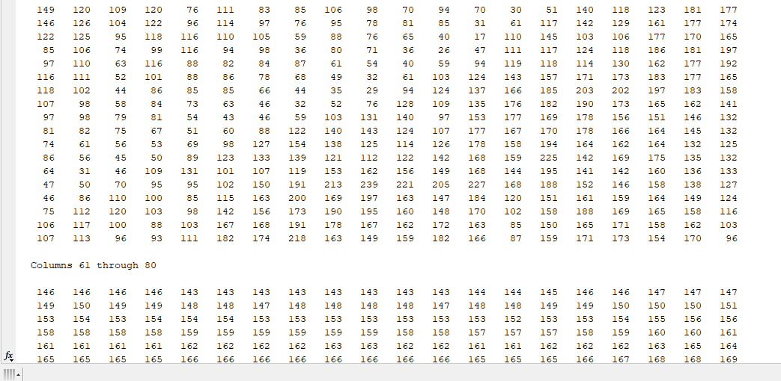

p=imread('C:\Users\student\Downloads\images.jfif')

imshow(p)

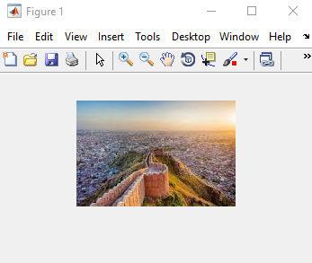

p=imread('C:\Users\student\Downloads\images.jfif')

imshow(p)

title("ola")

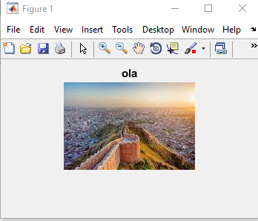

subplot(2,2,1)

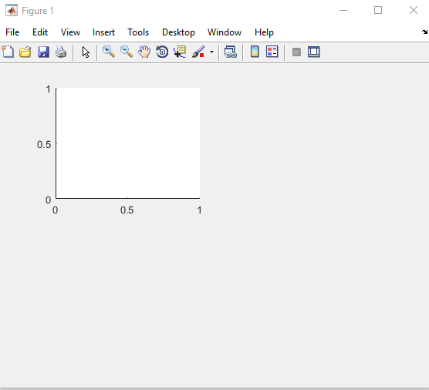

imfinfo('C:\Users\student\Downloads\images.jfif')

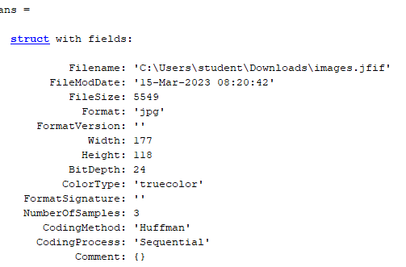

p=imread('C:\Users\student\Downloads\images.jfif')

imhist(p)

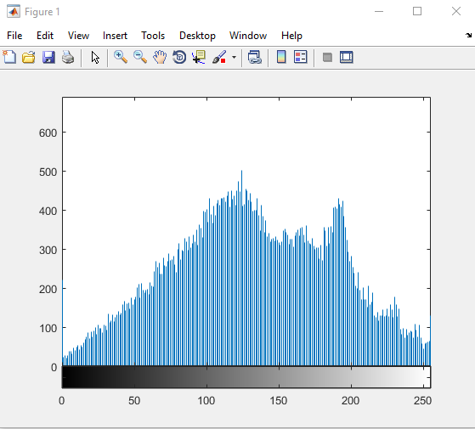

p=imread('C:\Users\student\Downloads\images.jfif')

k=histeq(p)

imhist(k)

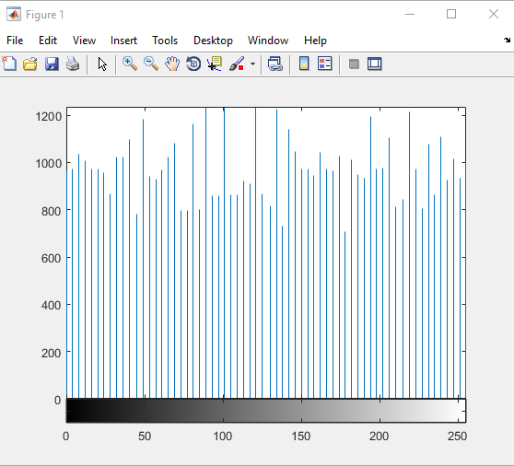

p=imread('C:\Users\student\Downloads\images.jfif')

b = imresize(p,[216,216])

imshow(b)

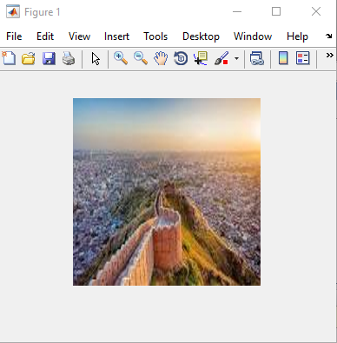

p=imread('C:\Users\student\Downloads\images.jfif')

n = rgb2gray(p)

imshow(n)

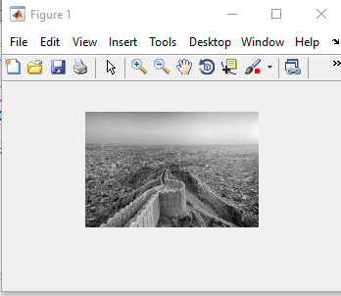

p=imread('C:\Users\student\Downloads\images.jfif')

n = rgb2gray(p)

j = imadjust(n)

imshow(j)

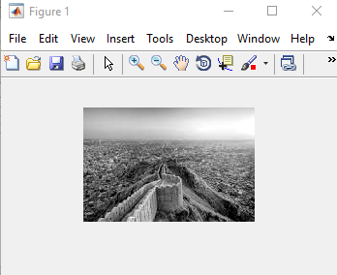

p=imread('C:\Users\student\Downloads\images.jfif')

g=imcomplement(p)

imshow(g)

