I=imread('D:\myimg.jpg');

figure,imshow(I);

title('original');

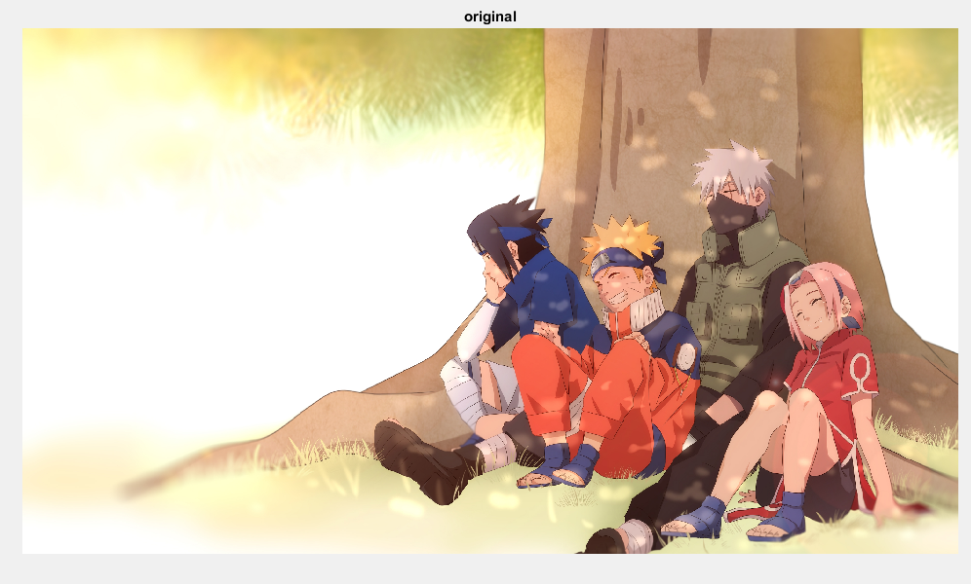

J=rgb2gray(I);

figure,imshow(J);

title('grayscale image');

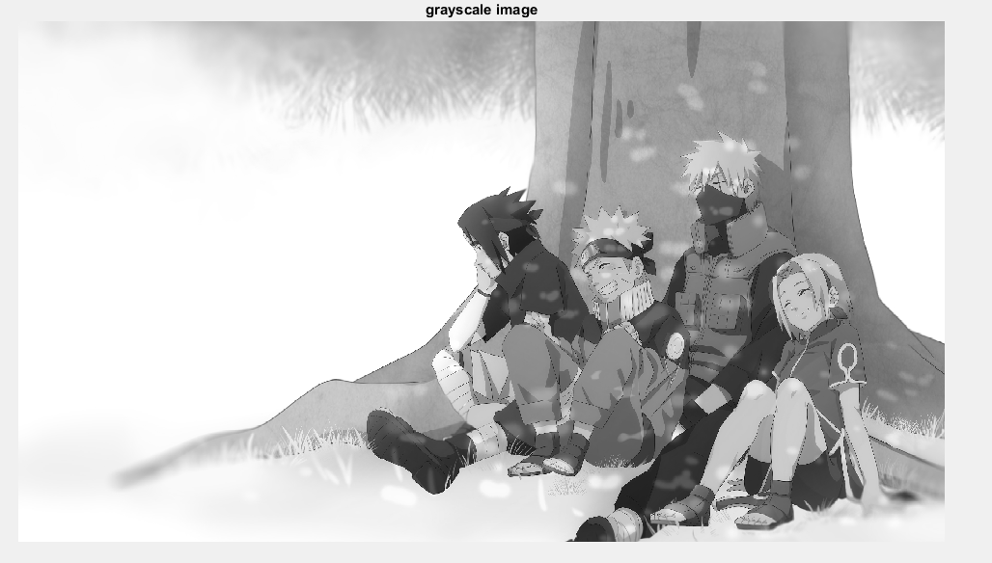

K=im2bw(J);

figure,imshow(K);

title('binary image');

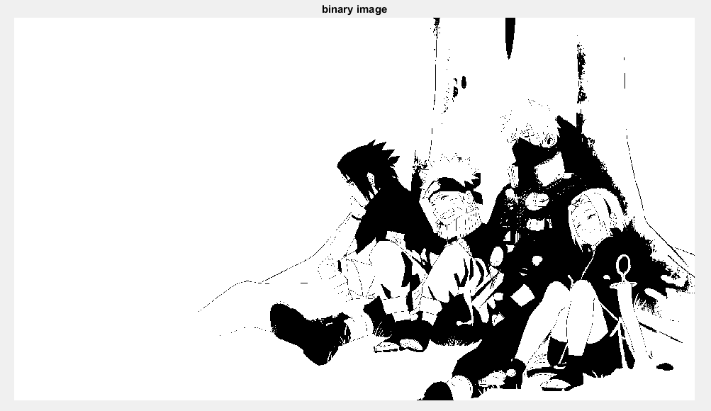

L=rgb2hsv(I);

figure,imshow(L);

title('HSV image');

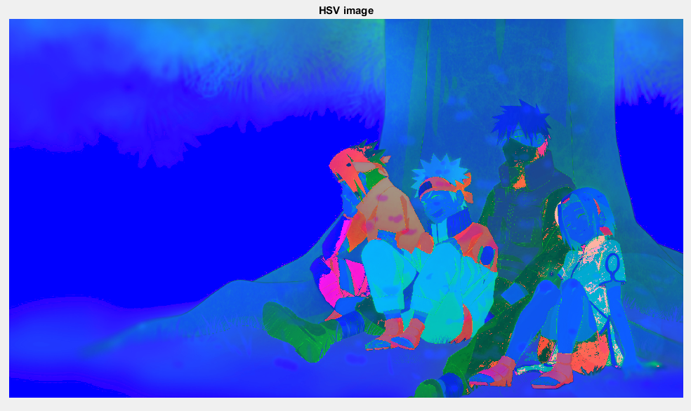

Q=imcomplement(I);

figure,imshow(L);

title('CMY image');

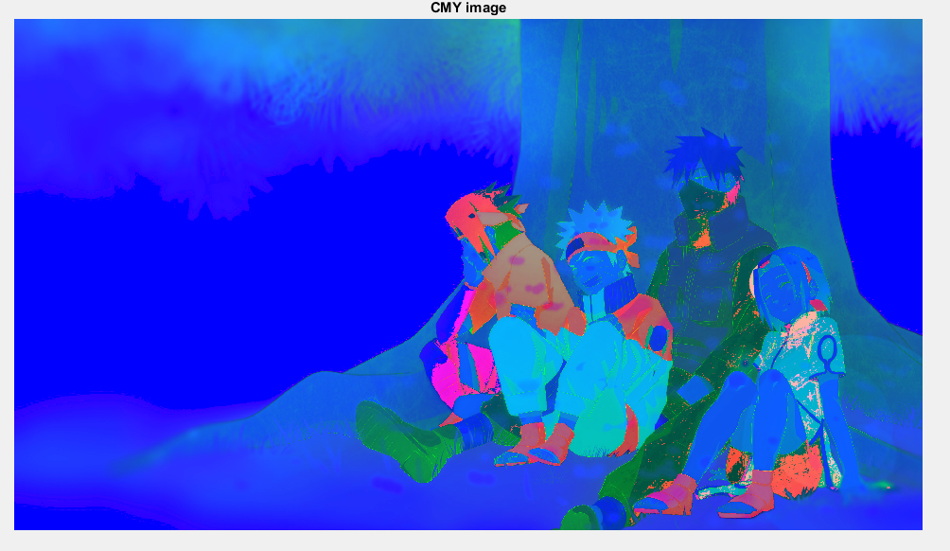

W=imcomplement(Q);

figure,imshow(W);

title('CMY to RGB')

