I=imread('D:\myimg.jpg');

J=imcomplement(I);

imhist(J,100);

imshow(I);

title('original');

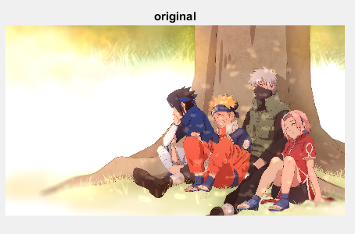

figure,imshow(J);

title('compliment')



I=histeq(I);

figure,imhist(I,64);

title('equalized')

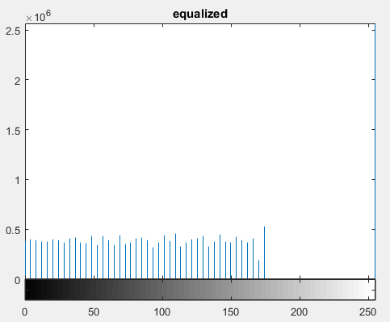

figure,imhist(J,64);

title('histogram');

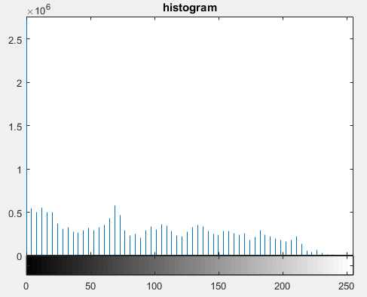

n=numel(I);

p=imhist(I)/n;

figure,plot(p);

title('normalized');

