METHOD-1

I=imread('C:\Users\student\Pictures\jon.jfif');

figure,imshow(I);

title('Original');



s=flip(I,2);

figure,imshow(s);

title('horizontal flip');



s1=flip(s,1);

figure,imshow(s1);

title('vertical flip');

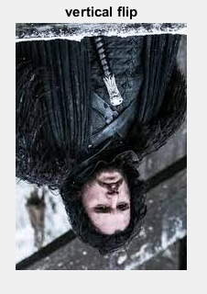

s2=flip(s,2);

figure,imshow(s2);

title('horizontal & vertical flip');



METHOD-2

I=imread('C:\Users\student\Pictures\jon.jfif');

figure,imshow(I);

title('Original');



s=I(:,end:-1:1,:);

figure,imshow(s);

title('horizontal flip');



s1=I(end:-1:1,:,:);

figure,imshow(s1);

title('vertical flip');

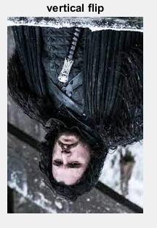

s2=I(end:-1:1,end:-1:1,:);

figure,imshow(s2);

title('horizontal & vertical flip');

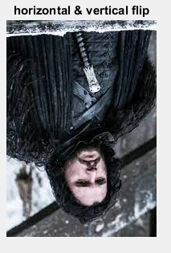

METHOD-3

img = imread('C:\Users\student\Pictures\jon.jfif');

figure,imshow(img);

title('Original');



[x, y, z] =size(img);

for plane = 1: z

for i = 1 : x

len = y;

for j = 1 : y

if j < y/2

temp = img(i, j, plane);

img(i, j, plane) = img(i, len, plane);

img(i, len, plane) = temp;

len = len - 1;

end

end

end

end

figure,imshow(img);

title('Mirror image');

