i= imread('img.jpeg');

figure,imshow(i);

title("Original Image");

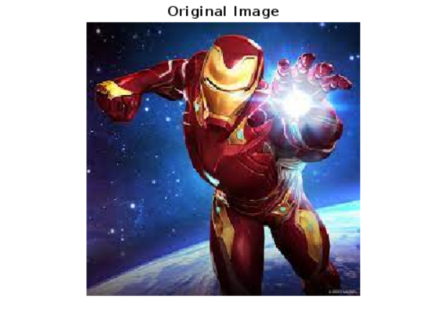

a = imnoise(i,'gaussian', .1, .01);

figure,imshow(a);

title('noisy image');



h=fspecial('gaussian', [15,15], 3);

out= imfilter(a,h,'conv');

figure,imshow(out);

title("Output Image")

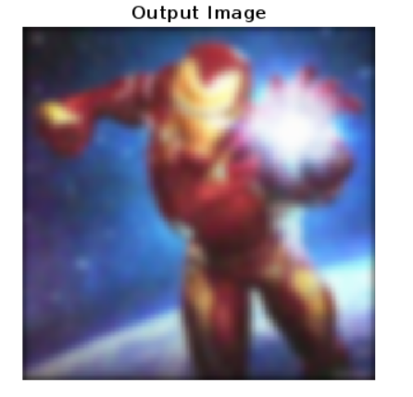

figure,surf(1:15, 1:15, h);

title("Point Split Function");

