**Assignment1**

1. Check if a year is leap year or not.

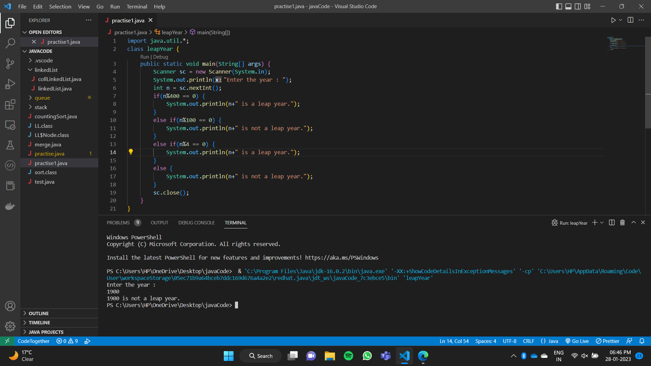

1. Print all prime numbers in a given range. Range will be taken from user input.

1. Count number of digits in a number.

1. Count number of zeros in a digit.

