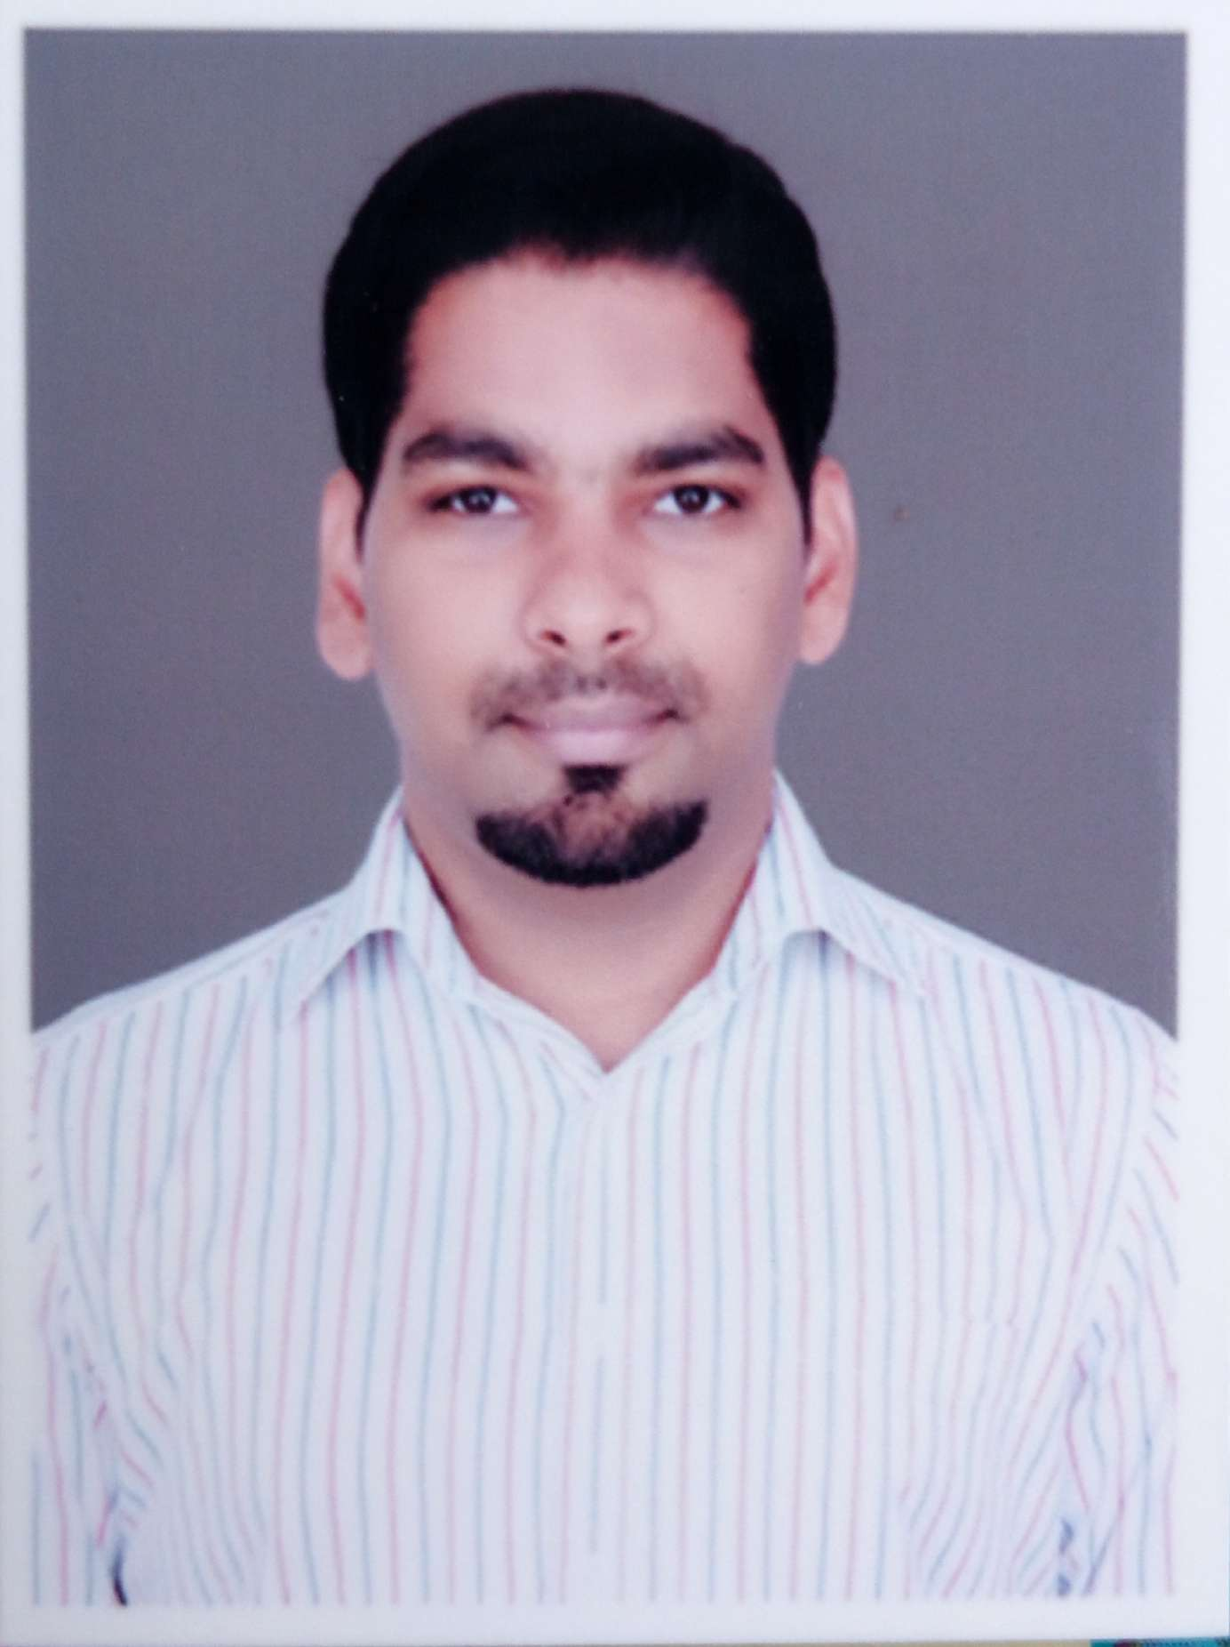
  Vaibhav Behre
  Python Automation Engineer
  IT-experience since 2010
  Expertise
  - Automation using Python and Perl
  - Memory Compiler designer
  - Machine learning
  - C, C++
  - OOPs
  Expertise in problem
  solving and bug fixing
  Certifications:
  - Preparation and Execution of Test Cases
  Curriculum vitae
  Vaibhav Behre is an IT professional with 7 years and 4 months of experience as an Automation Engineer.
  He is an Enthusiastic Automation with extensive knowledge in Embedded Domain. Technical expertise in Python, Perl programming, Data Structure, Algorithm and also have Hands-On experience in Machine Learning.
  Striving for knowledge and the willingness to work is his passion. Contributing individually and as well as in a team for the task at hand. He is a very energetic, capable and task oriented professional with self-initiative and problem solving skills.
  Vaibhav proficiency spreads across the development life cycle ranging from requirement analysis, design, implementation, testing, evolution, debugging root cause analysis, test script development.
  Vaibhav has gained his knowledge mainly from the projects he has been part of where he trained himself on automation development with Python and Perl.
  Vaibhav in his spare time likes to play chess, solve puzzles whenever possible, Listening to music, watching movies and creative stuffs. He also likes to drive car or ride a bike to go for long trips.
  Vaibhav is quick and open to learn any new technology. He is also known for his determined effort, proactive approach, and promptness with coordination skills. He is keen on upgrading himself on new technologies that he hasn't worked earlier, thereby wishing to build his career as an architect.


With the task of automating existing manual backup solution using Python as proposed, Vaibhav has provided automated backup solution to back up the data from N number of server. The benefit of this approach is that it allows the user to inputs the sever details dynamically,  and plus it preserve date time stamp and also take care to delete oldest files automatically in case if server is out of memory.  Done the prediction of CPU usages using Machine learning algorithm in Python as proposed.  Vaibhav has provided the solution to foreseen the results  which help the client to plan for his server requirement and also reduce its cost.  Python, Machine learning, AWS , Splunk
  Consultant
  Capgemini
  Jan 2017 – Present
  AIG
  Software Engineer III
  Intel Corp
  Feb 2015 – Dec 2016
  Memory Compiler Designer
  December 2017 – April 2017
  Intel offer a broad range of internally-developed IP that includes a library of Standard Cells, a full array of Memory Compilers, feature-rich Analog Cells and the world’s leading serializer/deserializer (SerDes). They have been optimized for power, performance, and area through numerous generations of refinement and production hardened in volume manufacture by our own products. Standard cell libraries come in a variety of track heights with extensive channel length, Vt and Vdd options. Memory SRAMs, ROMs, TCAMs and register files include a number of PORT configurations and power and area options.
  Vaibhav was mainly involved in developing new memory compiler work. He also provided some compiler design concepts like donut structure which help a lot to designer to foreseen results and also reduces time around half.
  Vaibhav also contributed in writing the test script development and execution of them for memory compiler. He has also involved in developing tools set for designer to automate their manual efforts.
  Python, Perl, SVN
  Vaibhav Behre
  Automation Test Engineer
  IT-experience since 2010
  Birthdate: Jan 26, 1987
  Location: Pune, India
  Recent experience
  2017/01 – Present Capgemini Technology Services
  2015/02 -- 2016/12 Intel Corp
  2011/11 – 2015/02 Hewlett Packard
  2010/09 – 2011/10 Provanic
  Education
  Education
  Bachelor’s in Computer Applications from Rajiv Gandhi Proudyogiki Vishwavidyalaya University.
Sogeti is specialized in the design, implementation, testing and maintenance of ICT solutions.
Sogeti Nederland B.V. | Lange Dreef 17 4131 NJ Vianen | +31 (0)88 660 66 00 | KvK Utrecht nr. 30200252

Application Developer (Tech Consultant)
Hewlett Packard
Nov 2011 - Feb 2015
Application Modernization & Cloud Computing
Hybrid cloud is a catalyst for IT transformation, providing the flexibility to combine your preferred clouds and existing on-premises infrastructure in the ratio best suited for your workloads. In a multi-cloud environment, you can rapidly provision infrastructure and apps, increase scalability, improve efficiency through automation and virtualization, and reduce costs. HPE hybrid cloud solutions provide simplicity, security, governance, and control to support your IT and business goals.

Application Modernization team is to automate the process of migration of data and application from existing server like HP-UX, HP-AIX to HP cloud solution. Migration include the automation of prepartion of enviroment which replicate the existing enviroment. And take care of existing code of C, C++ which are running in 32bit enviromnet to 64 bit.
Vaibhav involved in writing the automation script in Python for silent installing and configuration of application. Preparation of build scripts and doing the code analysis.
Vaibhav learned the art of automation with Python and perl himself and proved to be usefull for the project which was becoming critical with time.

With lots of ideas and interest he joined the cloud automation team. Seeing his dedication and interest for automation he was then provided an individual task for taking up one of the difficult modules called SAP where he created his own script for it and later merged with the CDA (Continous Delivery Automation tool)

. He supported the implementation of USB switching mechanism using Arduino Board with Python serial programming. He was involved in generating CAN messages to be sent to the target(Ford Sync Gen3). He was involved in Test case preparation, planning and control, test case execution and reporting, finding defects and failures of the product and reporting them with required logs and other information’s.
Manual and Automation testing of different modules within Diagnostics namely four(VMCU, Bezel Diagnostics, Diagnostics and Power Management).
He took complete ownership of VMCU and Diagnostics testing.

Python, Squish GUI testing tool, HPALM, Tortoise SVN, Arduino programming, Hardware setup and inventory, CANoe and AutoIT.
2. HP Kahuna-INK
September 2013 - March 2014

Kahuna-Ink project involves the manual testing of printer drivers and automation testing of printer drivers with different applications using the tools like Perl, Tomcat, uispy, and power shell.
Frequent build changes, changes in requirement, changes in verification data are the major challenges faced in this project.

Girish was involved in the Manual test case development and execution. He also took care of Automation test script development using Python and its execution.
His major activities included on time deliveries- reports, status update, and effort logins etc. defect reporting using Bugzilla, ensured there are zero test escapes and defect slippages from the tests executed, and there were no instances of rejection/slippage of delivered work items. Rework was attributable to only customer requested changes and project requirement changes.
Manual testing, automation using python, JIRA.

3. Cisco CCBU_CIS_SUST
December 2011 - February 2012

ICM: Cisco Intelligent Contact Management (ICM) provides network-based contact routing capabilities. It builds an enterprise wide customer contact platform by integrating multiple carrier networks and vendor switches, automatic call distribution system (ACD), interactive voice response (IVR), Web-servers, and desktop applications.

The Cisco CIUS is a business-oriented, Android-based tablet computer from Cisco Systems. It is an android powered mobile collaboration device that allows you to work and communicate from anywhere. The CIUS acts as an IP-Phone or RT but has many more capabilities than them. It has 3G & 4G video calling, WebEx application, Cisco Jabber application, AppHq application and many more features. Routing mechanisms of calls, frequent request for changes in the ICM product, testing of android platform and its integration with the tablet were the major challenges faced in this project.

Girish had proposed innovative solutions an automation framework to increase the scope of the application testing. He was involved in upgrading the Test Beds with latest builds and performing Regression and Functional testing of the product. His major activities included raising defects in Bugzilla and confirming the issues, interaction with Clients on a daily basis for solving issues related to the product, testing of features like: Cisco Bundled Applications: Cisco Any Connect, Secure Mobility Client (VPN), Cisco AppHQ Marketplace, Cisco Jabber IM, and Automation of test cases using Perl.

Girish was involved in Cooperate Training while in his early career in Wipro from the time period - August 2011 - December 2011.

