**Component singlecheckbox and checkboxgroup**

### **Document Properties**

| Item | Details |
| --- | --- |
| Document | Technical Specification Document |
| Application | Checkbox and Checkbox Group |
| Author | Vaibhav Pandurang Bhandare |
| Creation Date | 09/20/2020 |
| Last Updated | 09/23/2020 |
| Status | Completed |

**Contents**

Document Properties

**1. Component Overview**

**1.1 Objective**

**1.2 Use Cases**

**1.3 Risks**

**1.4 Out of Scope**

**2. Technical Specifications**

**2.1 NPM details**

**2.2 NPM repo**

**3.Unit Testing**

**4. Assumptions**

**5.Concerns and Issue**s

1. Component Overview

Checkbox button permits the user to make a binary choice, i.e. a choice between one of two possible, mutually exclusive options.

For example, the user may have to answer 'yes' (checked) or 'no' (unchecked) on a simple yes/no question.

Two-way user can select checkbox either single checkbox or group selected checkbox (multiple).

Two Component are used that is singlecheckbox for render single checkbox either select or deselect. And another is checkbox group to select multiple option.

1.1 Objective

It consists mainly three parts of checkbox button.

* As a standalone component, to allow the users to select single checkbox.
* In a group of two or more options where one needs to be selected.
* Checkbox is in disabled state then can’t select or deselect.

**1.2 Use Cases**

There are three uses cases are present in checkbox component.

Single Checkbox - User can select a single checkbox in selected state and other one is deselected state.



Single Checkbox Disable - User can select a single checkbox in selected state and other one is deselected state.



**Checkbox Group –** User can select multiple options from checkboxgroup component.

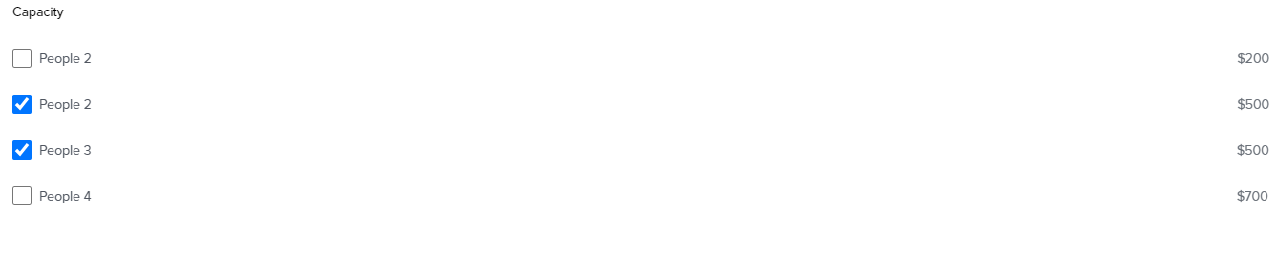

* 1. Risks

NA.

1.4 Out of Scope

Defined certain styles for alignment and positioning for creating the base component.

2. Technical Specifications

Checkbox button with Text Label is used for enabling the user to acknowledge a piece of information, accept terms and conditions, or select one or more options from a list of options.

1. User can change the state of single checkbox either select or deselect of checkbox and clicking on container box.
2. User can’t select and deselect of checkbox if checkbox is in disabled sate.

Following Attribute is used for checkbox: -

|  |  |  |  |
| --- | --- | --- | --- |
| **name** | **Attribute** | **Access Modifier** | **Description** |
| checked | checked | Public | This property is used to change the state of a checkbox. |
| disabled | disabled | Public | This property is used to disable the checkbox. |
| name | name | Public | This property is used to set the name of a control, which is submitted with the form data. |
| value | value | Public | Checkbox value property in HTML DOM is used to set or return the value of the value attribute of an input checkbox field, however, the contents of the value attribute do not shown to user. When the form is submitted by the user, the value and the other information sent to the server. But when the checkbox is an unchecked state, therefore, no information will be sent. |
| required | required | Public | This propert is used to check if checkbox is a required field or not |

* Aria-checked set true or false based on visual state of checkbox.

Accessibility Roles And Attributes

|  |  |  |  |
| --- | --- | --- | --- |
| **Sr. No.** | **Attribute** | **Element** | **Usage** |
| 1 | aria-checked | Input | Set true when the checkbox is checked otherwise set false |

2.1 NPM details

Following packages are installed for project:

* “lit-element” – “^2.2.1”
* “lit-html” – “^1.1.2”
* “Orxe/cli version” - v2.0.20

Following command creating and running the component:

* Installing orxe/cli - npm install -g @orxe3/cli
* Create a new component workspace - orxe new component-workspace <name>
* Create a component – orxe g c singlecheckbox / checkboxgroup
* Serving the component – orxe serve

2.2 NPM Repository

1. Npm repository link -

[https://packages.common.cnxloyalty.com/service/rest/repository/browse/npm-stage- hosted/%40checkbox/](https://packages.common.cnxloyalty.com/service/rest/repository/browse/npm-stage-%20%20hosted/%40checkbox/)

2**.** npm package for singlecheckbox –npm install @checkbox/singlecheckbox@0.0.6

npm package for checkboxgroup - npm install @checkbox/checkboxgroup@0.0.1

3. Used Render single Checkbox used Selector like below –

<! -- Default -->

<orxe-singlecheckbox checkbox-state='checkbox-enable'

name="checkbox-unselect" value="true" required>

People 1

</orxe-singlecheckbox>

<! -- checked -->

<orxe-singlecheckbox checkbox-state='checkbox-enable' checked

name="checkbox-select" value="true" required>

People 2

</orxe-singlecheckbox>

<! -- Checkbox Unselect Disabled -->

<orxe-singlecheckbox name="checkbox-unselect-disabled" value="true"

required disabled>

People 3

</orxe-singlecheckbox>

<! -- Checkbox select Disabled -->

<orxe-singlecheckbox name="checkbox-select-disabled" value="true"

checked required disabled>

People 4

</orxe-singlecheckbox>

1. Used Render group Checkbox used Selector like below –

<! -- checkbox for group -->

<orxe-singlecheckbox checkbox-state='checkbox-group'

name="checkbox-unselect" value="true" required>

People 5

<span slot="data">$200</span>

</orxe-singlecheckbox>

<orxe-singlecheckbox checkbox-state='checkbox-group'

name="checkbox-unselect" value="true" required>

People 6

<span slot="data">$600</span>

</orxe-singlecheckbox>

3.Unit Testing

The test cases written for orxe-singlecheckbox component it consists two test suites. One is default checkbox axe file and another checkbox spec file. All function and line coverage are done with spec file.

* All test cases of orxe-checkbox component are written in singlecheckbox.axe.ts and singlecheckbox.spec.ts file. Test cases are available below.

1. Should create.
2. Should support all WCAG Accessibility Rules. When Default is rendered.
3. Should function render is call.
4. Should function checkbox is call and checkbox state false.
5. Should function checkbox is call and checkbox state true.
6. Should function checkboxDisabled is call.
7. Should checkbox have attribute checkbox unable.
8. should function checkboxSelect is call and state select false.
9. should function checkboxSelect is call and state select true.

The unit test cases and coverage report of **singlecheckbox** is available below.

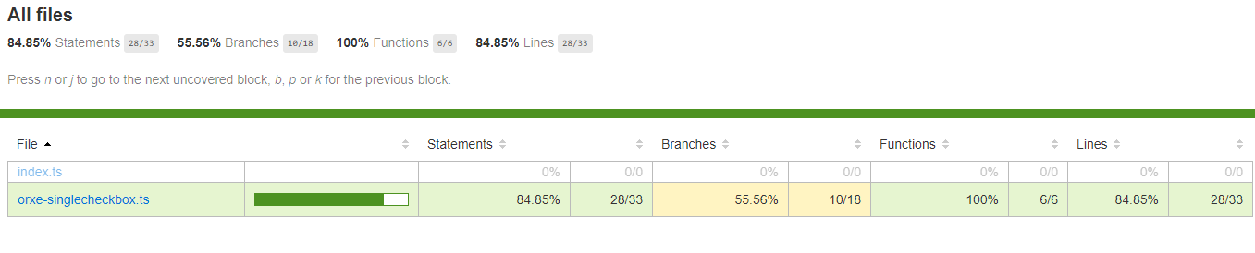

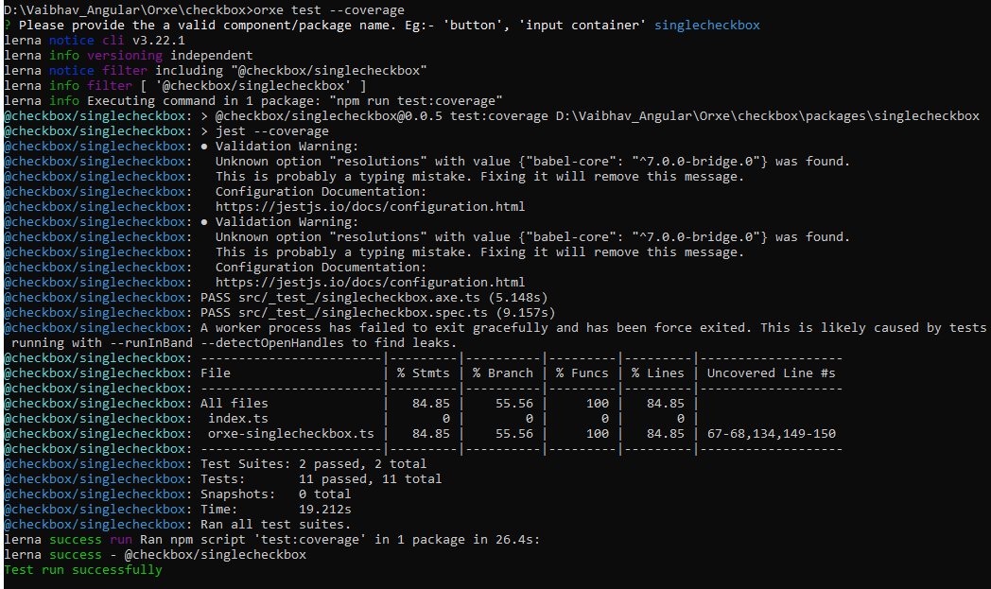

* All test cases of orxe-checkboxgroup component are written in checkboxgroup.axe.ts and checkboxgroup.spec.ts file.

Test cases are available below.

1. Should create.
2. Should support all WCAG Accessibility Rules. When Default is rendered.
3. Should function render is call.

The Unit test cases and coverage report for **checkboxgroup** is available below.

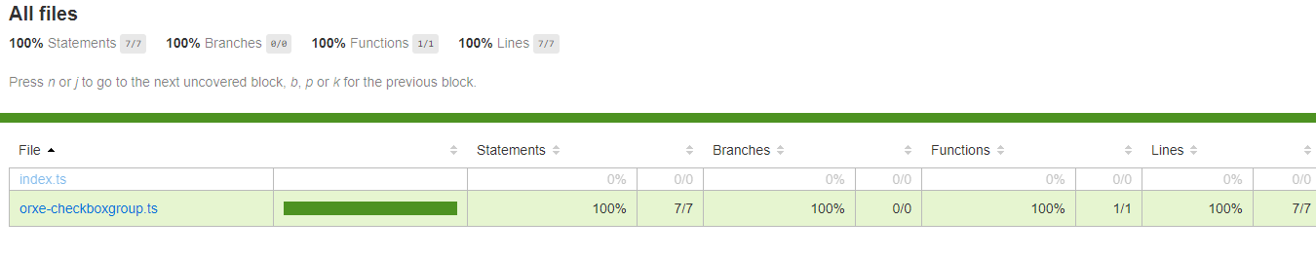

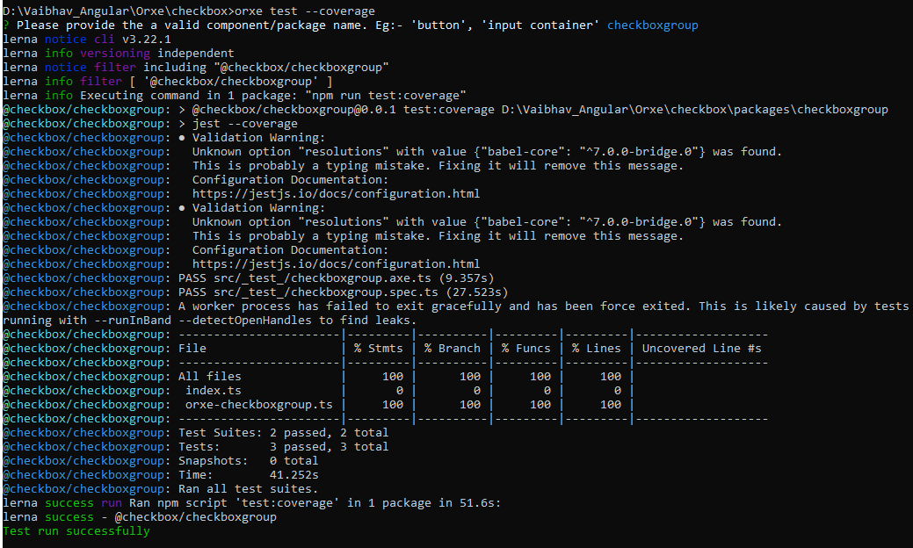

4. Assumptions

This component is developed based on the design guidelines provided by Tavisca on the confluence page.

5. Concerns and Issues

NA.