**Component checkbox**

### **Document Properties**

| Item | Details |
| --- | --- |
| Document | Technical Specification Document |
| Application | Checkbox |
| Author | Vaibhav Pandurang Bhandare |
| Creation Date | 09/20/2020 |
| Last Updated | 09/20/2020 |
| Status | Completed |

**Contents**

Document Properties

**1. Component Overview**

**1.1 Objective**

**1.2 Use Cases**

**1.3 Risks**

**1.4 Out of Scope**

**2. Technical Specifications**

**2.1 NPM details**

**2.2 NPM repo**

**3.Unit Testing**

**4. Assumptions**

**5.Concerns and Issue**s

1. Component Overview

Checkbox button permits the user to make a binary choice, i.e. a choice between one of two possible, mutually exclusive options.

For example, the user may have to answer 'yes' (checked) or 'no' (unchecked) on a simple yes/no question.

Two-way user can select checkbox either single checkbox or group selected checkbox (multiple).

1.1 Objective

It consists mainly three parts of checkbox button.

* As a standalone component, to allow the users to select single checkbox.
* In a group of two or more options where one needs to be selected.
* Checkbox is in disabled state then can’t select or deselect.

**1.2 Use Cases**

There are three uses cases are present in checkbox component.

Single Checkbox - User can select a single checkbox in selected state and other one is deselected state.

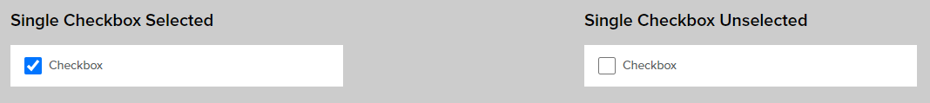

Single Checkbox Disable - User can select a single checkbox in selected state and other one is deselected state.

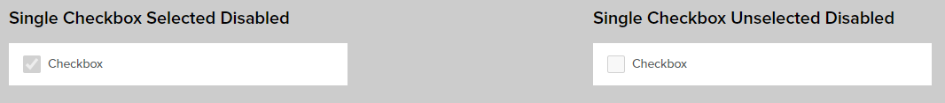

**Group Checkbox –** User can select one or two option from checkbox button.

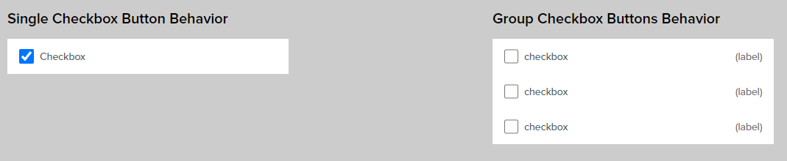

* 1. Risks

NA.

1.4 Out of Scope

Defined certain styles for alignment and positioning for creating the base component.

2. Technical Specifications

Checkbox button with Text Label is used for enabling the user to acknowledge a piece of information, accept terms and conditions, or select one or more options from a list of options.

1. User can change the state of single checkbox either select or deselect of checkbox and clicking on container box.
2. User can’t select and deselect of checkbox if checkbox is in disabled sate.
3. User can select group of options from checkbox list. When clicking on checkbox or container.

2.1 NPM details

Following packages are installed for project:

* “lit-element” – “^2.2.1”
* “lit-html” – “^1.1.2”
* “Orxe/cli version” - v2.0.20

Following command creating and running the component:

* Installing orxe/cli - npm install -g @orxe3/cli
* Create a new component workspace - orxe new component-workspace <name>
* Create a component – orxe g c checkbox
* Serving the component – orxe serve

2.2 NPM Repository

1. Npm repository link -

[https://packages.common.cnxloyalty.com/service/rest/repository/browse/npm-stage- hosted/%40checkbox/](https://packages.common.cnxloyalty.com/service/rest/repository/browse/npm-stage-%20%20hosted/%40checkbox/)

2**.** npm package **–** npm install @checkbox/singlecheckbox@0.0.3

3. Used Render Selector - <orxe-singlecheckbox></orxe-singlecheckbox>

3.Unit Testing

The test cases written for orxe-singlecheckbox component it consists two test suites. One is default checkbox axe file and another checkbox spec file. All function and line coverage are done with spec file.

All test cases of orxe-checkbox component are written in singlecheckbox.axe.ts and singlecheckbox.spec.ts file. Test cases are available below.

1. Should create.
2. Should support all WCAG Accessibility Rules. When Default is rendered.
3. Should function render is call.
4. Should metadata have value (label).
5. Should function checkbox is call and checkbox state false.
6. Should function checkbox is call and checkbox state true.
7. Should function checkboxDisabled is call.
8. Should function checkboxDisabled is call and state select false.
9. Should function checkboxDisabled is call and state select true.
10. Should check default value of isCheckboxSelected is undefined.
11. Should checkbox have attribute checkbox-disabled.

The unit test cases coverage report is available below.

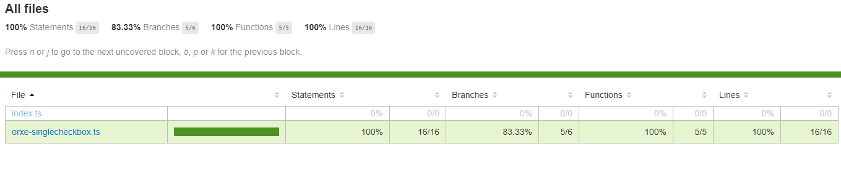

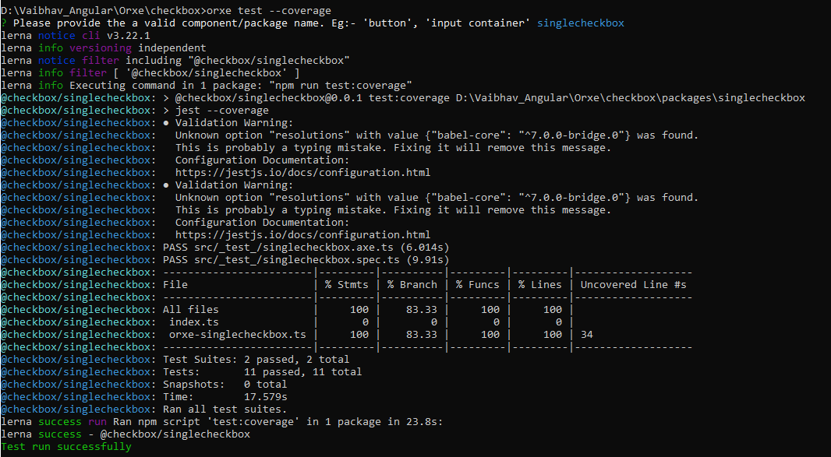

4. Assumptions

This component is developed based on the design guidelines provided by Tavisca on the confluence page.

5. Concerns and Issues

NA.