Commitment Tracker
Technical Handover Guide
How the code works, end to end — flows, every function, data, security, ML, testing and debugging
Item | Value
Application version | 0.7.3 (see APP_VERSION in app.py and CHANGELOG.md)
Date | 2 October 2026
Written for | A senior engineer (10+ years) who is newer to Python and to AI/ML, taking over development
Repository | C:\PersonalDevelopment\commitment-tracker (local; last pushed commit 0b5e703 — most work since 0.2.0 is not committed yet)
Companion documents | prd.md / Commitment_Tracker_PRD_v0.7.2.pdf (what and why) · readme.md (how to run) · CHANGELOG.md (history)
Contains secrets? | No. Every credential is described by location only — never by value.

Contents
How to use this guide 4
1 System at a glance 5
1.1 What the application does 5
1.2 Technology stack 5
1.3 Repository map 5
1.4 What is real and what is still a mock 6
1.5 Python idioms you'll meet in this codebase 8
2 Code flow 9
2.1 Startup and the life of a request 9
2.2 From uploaded transcript to commitments 11
2.3 All the ways a meeting can arrive 13
2.4 Status changes and the two-way Google Sheet sync 13
2.5 Reminders (nudges) 15
2.6 Frontend pages 17
2.7 Error-handling philosophy 17
3 Function and class reference 18
3.1 app.py — routes and glue 18
3.2 transcript_parser.py — the built-in extractor 22
3.3 ai_extraction.py — optional LLM engine 23
3.4 people_directory.py, notifications.py, google_sheets.py 24
3.5 Offline ML scripts (ml/) 25
3.6 Frontend helpers (static/app.js) 25
4 Encryption and cryptography 27
4.1 Encryption vs. signing vs. hashing — 60-second primer 27
4.2 What protects each piece of data 27
4.3 Recommended changes, in order 28
5 How chunking works 30
5.1 The worked example in numbers 30
5.2 How to change chunking safely 31
6 Databases and data access 33
6.1 How the code talks to the database 33
6.2 Transactions and locking 34
6.3 Changing the schema (migrations) 34
6.4 Other data stores 34
6.5 Looking inside the database 34
7 How credentials are maintained 37
7.1 Rules that are already followed — keep them 37
7.2 Google OAuth specifics that bite 37
7.3 Environment variables 38
8 Security measures and known gaps 40
8.1 Measures in place 40
8.2 Known gaps (ranked) 40
9 Edge cases and testing 42
9.1 The test suite 42
9.2 Edge-case catalogue 42
9.3 How to prove an edge case doesn't break the code 43
9.4 Data-breach checks — run after any change to routes, settings or the UI 43
10 ML primer for this project 44
10.1 The five ideas 44
10.2 Where the model stands (honest numbers) 44
10.3 Retraining safely 44
11 Diagnose and debug 47
11.1 First five minutes on any problem 47
11.2 Where to look 47
11.3 Tracing the extraction pipeline 47
11.4 Debugging with VS Code 48
11.5 Incidents from this project's history 48
12 Working conventions 50
12.1 Adding a feature — the checklist 50
13 Open decisions and backlog 51
Appendix A — Route catalogue 52
Appendix B — Tunable constants 54
Appendix C — Glossary 55
List of figures 55

If page numbers show as missing, right-click the table and choose Update Field → Update entire table.

How to use this guide
This is the document I would want on my first day. It is written to be read in order once, then used as a reference. Every function name, table, setting and number in it was taken from the code at version 0.7.3 — where the code and this guide ever disagree, the code wins and this guide should be updated.
If you have… | Read | You will be able to…
2 hours (day 1) | 1 System at a glance · 2 Code flow · 11 Diagnose & debug | run the app, follow a transcript through the code, fix the common breakages
Before changing extraction | 5 Chunking · 10 ML primer · 3.2 transcript_parser.py | change parsing or the model without silently making results worse
Before touching data or schema | 6 Databases · 12 Working conventions | add a column or table with a safe migration
Before exposing it beyond a laptop | 4 Encryption · 7 Credentials · 8 Security · 9 Edge cases & testing | know exactly what is protected, what isn't, and how to prove a change didn't open a hole
A specific question | 3 Function reference · Appendix A routes · Appendix C glossary | look up any function, route or term

Conventions. monospace is code, a file or a command. Line numbers like app.py:567 refer to version 0.7.3 and will drift as the code changes — search for the function name if they no longer match. Boxes marked ⚠ or ✖ are known weak spots; ✔ boxes are things done deliberately that should be kept.
ℹ Diagrams
The 11 diagrams are on landscape pages so they stay readable. They are generated by python docs/make_guide_diagrams.py (SVG + PNG in docs/guide_diagrams/), so edit that script rather than the pictures.

1 System at a glance

1.1 What the application does
Commitment Tracker turns meeting transcripts into a tracked list of who promised to do what, by when — then keeps that list in sync with a Google Sheet and reminds people before things slip. Five jobs, in the order data flows:
- Capture a transcript — manual upload of a .txt file, a generic JSON webhook, or Fathom's webhook (real, via an ngrok tunnel).
- Extract commitments — a small trained neural network (built-in) or, per account, an LLM (Claude or any OpenAI-compatible API such as Gemini).
- Tag owners — turn a spoken name ("Bhuvan") into an email using the account's People directory.
- Track & sync — status pending / in progress / done in the app, mirrored both ways with a Google Sheet.
- Nudge — email, Slack, Teams or a custom webhook reminder the day before, on the day, or daily once overdue.

1.2 Technology stack
Layer | Technology | Notes for a newcomer
Web server | Python 3 · Flask (dev server, debug=True) | One process, one file of routes (app.py). No ORM, no blueprints except the optional AI feature.
Frontend | Static HTML pages + vanilla JavaScript (static/) | No build step, no framework. Each page calls JSON APIs through api() in app.js.
Database | SQLite file commitment_tracker.db via the sqlite3 standard library | Plain SQL with ? parameters. Schema in schema.sql, upgrades in migrate_db().
NLP / ML | spaCy en_core_web_sm · sentence-transformers all-MiniLM-L6-v2 · TensorFlow/Keras · pandas | Loaded lazily on the first extraction (20–60 s once), then cached in memory.
LLM (optional) | Anthropic Python SDK · or raw HTTPS to any /chat/completions endpoint | Per-account choice with explicit consent; failures fall back to the built-in model.
Google | google-api-python-client + google-auth-oauthlib (OAuth Desktop flow) | Token cached in google_token.json; Sheets API v4 values.get / values.update.
Messaging | smtplib + urllib (standard library only) | Email, Slack, Teams Workflows, custom JSON webhook.
Tunnel | ngrok (free plan) | Gives the laptop a public https URL so Fathom / Apps Script can reach it.
Tests | Plain Python scripts in tests/ (no pytest needed) | python tests/run_all.py — 119 checks, temporary DBs, fake external services.

1.3 Repository map
Path | What lives there | How often you'll touch it
app.py (2,152 lines) | All Flask routes and the glue: DB helpers, upload, extraction hand-off, sync, nudges, webhooks | Constantly
transcript_parser.py | Transcript → turns → sentences → ML classifier → owner/task/due rules | When extraction quality matters
ai_extraction.py | Optional LLM engine, its 3 tables and its routes (marked [ai-extraction v0.5.0]) | Rarely; it is self-contained
people_directory.py | CSV parsing and name → email matching | Rarely
notifications.py | One sender per nudge channel; never raises | When adding a channel
google_sheets.py · google_oauth_setup.py | Sheets API calls · one-time OAuth consent script | Rarely
schema.sql | CREATE TABLE IF NOT EXISTS for the 11 core tables | With every new column (plus migrate_db)
static/ | 5 pages (index, dashboard, people, settings, ai-extraction) + app.js + style.css | For any UI change
ml/ | Training/retraining scripts, the live model action_detector.keras, a not-deployed candidate, embedding cache | Only when retraining
training_data/ | Labelled lines from the team's transcripts (labelled_utterances.csv, labels.py) | When labelling more data
tests/ | 4 suites + run_all.py + _support.py (temp app, fake Google Sheet) | With every change
docs/ | PRD PDF, status diagram, this guide and the scripts that build them | When documenting
_snapshots/ | Copies of files before risky changes, plus a revert script (gitignored) | Before risky work
CHANGELOG.md | Every change, by version — the project's history while git is not being used | Every change

1.4 What is real and what is still a mock
Area | Real (talks to the outside world) | Mock / not built
Transcript in | Upload · generic capture webhook · Fathom webhook (HMAC-verified) | "Check now" pull for Zoom / Meet / Teams / Otter only writes a log line
Extraction | Built-in model · Claude · OpenAI-compatible (Gemini tested) | Demo meetings use fixed sample data, not the model
Tracker | Google Sheets both directions (API out, Apps Script webhook in) | Jira and Custom tracker: log only
Reminders | Email (SMTP) · Slack · Teams · custom webhook · 15-minute scheduler | —
People | CSV upload, auto-tagging, manual override | No sync with a corporate directory (AD/Okta)
Sign-in | — | No password / SSO: an email address is the whole identity

⚠ Stale comment to know about
The big docstring at the top of app.py still says nudges and Google Sheets are mocked. That was true at 0.1.0; both are real now. Trust the code and CHANGELOG.md, and fix that docstring when you next edit the file.

The picture of how these pieces connect is Figure 1 — system architecture.

Figure 1 — System architecture
How to read it: left to right is browser → Flask routes → helper modules → outside world. Solid arrows are calls the app makes; red dashed arrows are inbound webhooks that arrive through the ngrok tunnel. Grey boxes are files on disk.
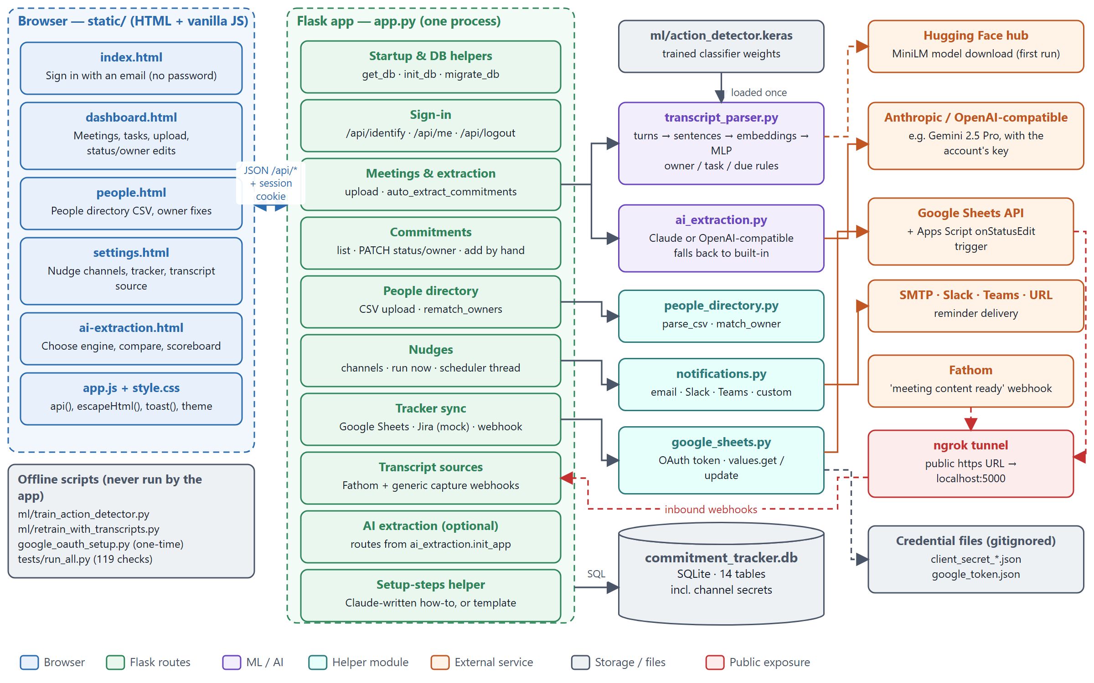

1.5 Python idioms you'll meet in this codebase
You know how to program; these are the Python-specific patterns that make this code read differently from Java/C#/JS.
Idiom | Example here | What it means
Decorator | @app.route("/api/meetings", methods=["POST"]) | Registers the function below it as the handler for that URL + method. No routing table elsewhere.
Optional import | try: import transcript_parser / except ImportError: transcript_parser = None | The app starts even if heavy ML libraries are missing; callers check for None.
Lazy singleton | global _model … if _model is None: _model = load() | Module-level cache: the first call pays the load cost, later calls reuse it. Lives until the process restarts.
Tuple return for errors | count, error = auto_extract_commitments(...) | Instead of throwing, many helpers return (value, error_or_None) so a failure can be shown without aborting the request.
Truthy defaults | (data.get("title") or "").strip() | dict.get returns None if missing; or "" turns None/empty into a safe string.
Context manager | with sqlite3.connect(DB_PATH) as conn: | Commits (or rolls back) automatically at the end of the block. Note: it does not close the connection.
Comprehension | {row[1] for row in conn.execute("PRAGMA table_info(x)")} | Builds a set/list/dict in one expression — like a map/filter.
f-string | f"row-{first_row + i}" | String interpolation. Never used to build SQL values (that's what ? is for).
__main__ guard | if __name__ == "__main__": | Code that runs only when the file is executed directly, not when imported by tests.
pandas DataFrame | df[df.text.str.len() > 0] | A table in memory; boolean masks filter rows. Used only in the parser and ML scripts.
Compiled regex | HEADER = re.compile(r"...") | r"" is a raw string (backslashes kept). .match anchors at the start, .search scans.

2 Code flow
This section follows the code the way the data moves. Read it with the diagrams open; the function reference in section 3 has the detail.

2.1 Startup and the life of a request
Figure 2 — startup and request lifecycle shows both. In words:
- python app.py imports the helper modules. transcript_parser and google_sheets are optional imports — if their libraries are missing the variable is None and the feature reports "not installed" instead of crashing.
- At module level: APP_VERSION, the Flask object (serving static/ at the site root) and app.secret_key are set, then ai_extraction.init_app() registers the optional AI routes unless AI_EXTRACTION_ENABLED=0.
- In __main__: init_db() creates the database from schema.sql if the file doesn't exist, then migrate_db() always runs (it is safe to repeat) to add any newer columns.
- Flask's debug reloader starts a second copy of the process. Only that child (env WERKZEUG_RUN_MAIN=true) starts the nudge scheduler thread, so reminders aren't sent twice.
- Each browser action calls api(path, {method, body}) in app.js → the matching route → require_email() reads the signed session cookie (401 if absent) → input validation (400) → get_db() → parameterised SQL scoped to that email → commit/close → side effects such as Sheet sync → jsonify(...).
✔ Pattern worth keeping
Side effects that call the internet (Sheets, LLM, email) happen after the main commit, and return an error string rather than raising. A Google outage can therefore never lose an upload — the user sees tracker_sync_error instead.

Figure 2 — Startup and the life of every API request
How to read it: left column runs once when you start the app; right column runs for every click in the UI. Grey boxes touch the database.
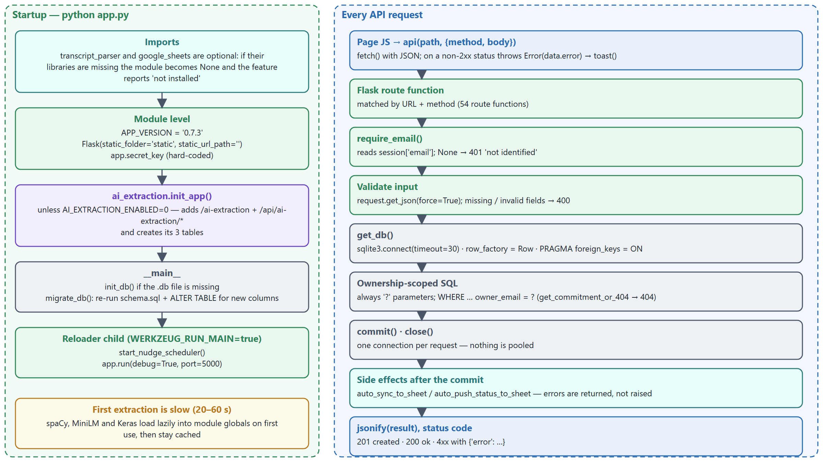

2.2 From uploaded transcript to commitments
This is the core flow. Figure 3 — upload sequence draws it as a sequence diagram; the numbers below match the arrows.
# | What happens | Where
1 | Dashboard posts {title, meeting_date, transcript_excerpt}. The browser has already refused non-.txt files. | dashboard.html → create_meeting app.py:567
2–3 | No session → 401. Text that looks like a ZIP/.docx or is >1 % replacement characters → 400. | require_email, looks_like_binary_text app.py:550
4 | The meeting row is inserted. This opens SQLite's write transaction, which stays open until step 14. | create_meeting_row app.py:413
5–7 | If the account chose an AI engine and gave consent, the transaction is committed early, the LLM is called and its items returned. Any failure or the built-in choice returns None. | ai_extraction.try_extract ai_extraction.py:313
8–10 | Built-in path: the transcript runs through the parser and classifier (section 5) and comes back as a list of dicts. | transcript_parser.extract_commitments
11–12 | Each spoken owner name is matched against the People directory → email + match status. | people_directory.match_owner
13 | Commitments are inserted with status pending. A sentence already saved for this meeting is skipped, so re-running extraction never duplicates. | _insert_extracted_commitments app.py:477
14 | Commit and close. From here the upload is permanent whatever happens next. | create_meeting
15–17 | If the Sheets tracker has auto-sync on: take the write lock, append the new rows, store external_ref = row-n. | auto_sync_to_sheet app.py:1454
18 | Response 201 with counts and any extraction_error / tracker_sync_error; the page shows a toast and reloads the list. | create_meeting

⚠ Performance trap
With the built-in engine, steps 8–13 run while the write transaction from step 4 is still open. A long transcript (or the 20–60 s model load on the first extraction after a restart) holds SQLite's write lock that long, and another write in that window waits up to 30 s and then fails with "database is locked". The AI path avoids this by committing first. A good next refactor: commit the meeting row before calling the built-in parser too.

Figure 3 — Upload → commitments, as a sequence
How to read it: time runs downwards; each vertical dashed line is a module. Purple messages are extraction, orange is Google, dashed arrows are return values. The dotted box is the optional AI path.
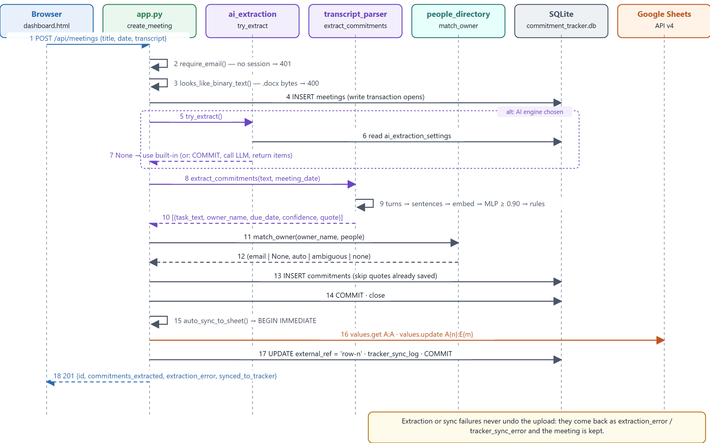

2.3 All the ways a meeting can arrive
Entry point | Route → function | Runs extraction? | Auth
Manual upload | POST /api/meetings → create_meeting | Yes (text pipeline) | session
Generic capture webhook | POST /api/webhooks/transcript-capture/<token> → transcript_capture_webhook | Yes (text pipeline) | URL token
Fathom webhook | POST /api/webhooks/fathom/<token> → fathom_webhook | Yes (turns pipeline — skips to_turns) | URL token + HMAC
"Simulate incoming capture" button | POST /api/meetings/simulate-incoming-capture | Yes (same code as a webhook) | session
Re-extract an existing meeting | POST /api/meetings/<id>/extract-commitments | Yes, adds only new sentences | session
Demo data | POST /api/meetings/seed-demo → seed_demo | No — fixed DEMO_MEETINGS rows | session
Add one task by hand | POST /api/commitments → create_commitment | No (confidence NULL) | session

2.4 Status changes and the two-way Google Sheet sync
Figure 4 — two-way Sheets sync shows both directions. Key design points:
- Outbound writes use an explicit range A{n}:E{m} after reading column A to find the next empty row. values.append was tried first and shifted rows right whenever a due date cell was empty.
- Locking: auto_sync_to_sheet and sync_all_to_tracker start with BEGIN IMMEDIATE, so two near-simultaneous requests can't both send the same unsynced rows (this bug happened; test "two simultaneous syncs write exactly one row" guards it).
- The link between a task and its sheet row is commitments.external_ref = 'row-<n>'. Inserting or sorting rows by hand in the sheet breaks that link — tell users not to sort the sheet.
- Inbound: an installable Apps Script trigger onStatusEdit posts {email, external_ref, status} to /api/webhooks/tracker-update through ngrok; normalize_tracker_status accepts synonyms such as Closed, WIP, To do.
- No echo loop: edits made through the API don't fire the sheet's On-edit trigger, so an app → sheet update never bounces back.

Figure 4 — Two-way Google Sheets sync
How to read it: top half is app → sheet, bottom half is sheet → app. Red boxes are where things are exposed or most often break (ngrok URL, missing webhook secret).
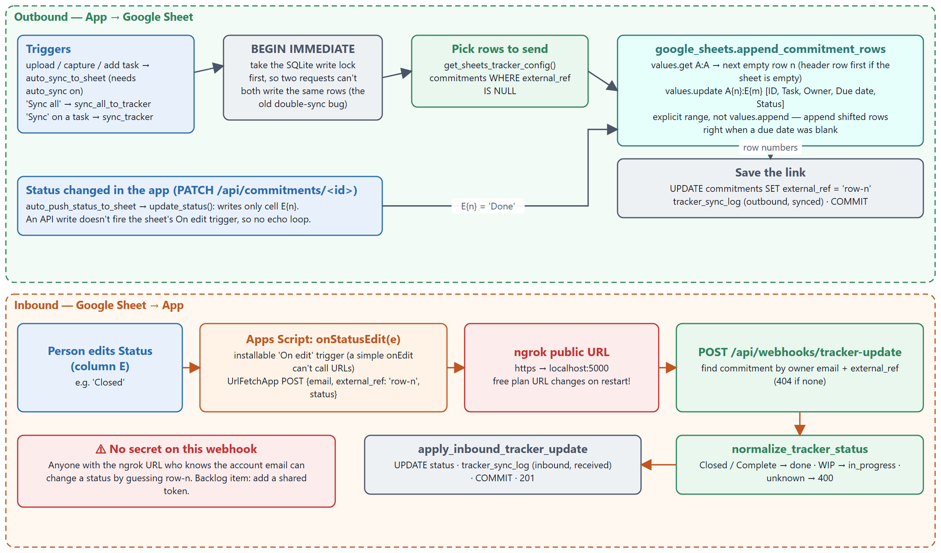

2.5 Reminders (nudges)
Figure 5 — nudge scheduler. A daemon thread wakes every NUDGE_CHECK_INTERVAL_SECONDS (default 900). For each account that switched automatic nudges on, due_nudges pairs every enabled channel with every open task that has a due date and keeps the ones whose cadence matches today:
Cadence (UI label) | Fires when | Repeats?
day_before (1 day before due) | due_date = tomorrow | Once; also not retried within 20 h
on_due (On the due date) | due_date = today | Once; also not retried within 20 h
daily_after_overdue (reason overdue) | due_date < today | At most once per 20 h per task and channel

send_and_log then calls notifications.deliver, which never raises and always returns (status, detail); the result goes into nudge_log. Tasks without a due date, done tasks, and (for email) tasks without an owner_email are never sent — the last one is logged as skipped with a reason.

Figure 5 — Reminder scheduler
How to read it: start top-left; the two diamonds decide whether a (channel, task) pair is sent. Everything ends in a nudge_log row, which is the first place to look when a reminder 'didn't arrive'.
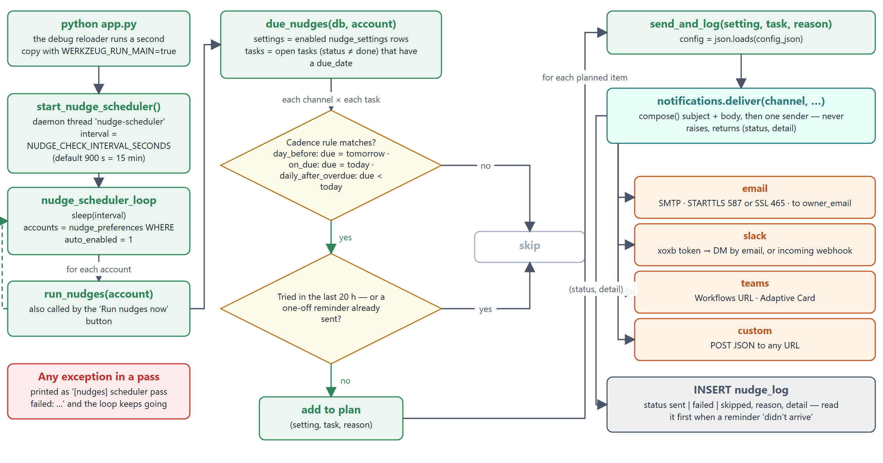

2.6 Frontend pages
Page | Purpose | Main API calls
index.html | Enter an email to start a session | /api/identify, /api/me
dashboard.html | Meetings list, transcript upload, task list, status/owner edits, per-task history and sync | /api/meetings, /api/commitments, /api/commitments/<id>, /sync-tracker, /send-test-nudge
people.html | Upload the directory CSV, edit people, see tagging counts | /api/people*
settings.html | Nudge channels, tracker, transcript source, webhook URLs, Apps Script snippet | /api/nudge-settings, /api/tracker-settings, /api/transcript-source-settings, /api/setup-steps/suggest
ai-extraction.html | Pick an engine, consent, test, compare engines on a meeting, score them | /api/ai-extraction/*
app.js | Shared helpers: api(), toast(), escapeHtml(), date formatting, requireIdentified(), nav + theme | —

✖ Rule for any UI change
Any text that came from the server or a user (task text, names, error detail, a provider's label) must go through escapeHtml() before it is put into innerHTML. Version 0.7.3 fixed five places that missed this. toast() is safe because it uses textContent.

2.7 Error-handling philosophy
- 4xx are expected: every route returns JSON {"error": "…"} with 400 (bad input), 401 (no session), 404 (not yours / not found). The frontend shows data.error in a toast.
- Never-raise wrappers around anything external: notifications.deliver, ai_extraction.try_extract, auto_sync_to_sheet, auto_push_status_to_sheet, _fathom_speaker_turns. They return an error string or None.
- Keep the primary write: a meeting is kept even if extraction or sync fails; the failure is reported in the response and in a log table.
- Background thread catches everything per pass and prints [nudges] scheduler pass failed: … so one bad row can't stop future reminders.

3 Function and class reference
Every function and class in the Python code, grouped by module and by feature, with its line number, the route that calls it (if any) and what it does. The Auth in brackets is how a route identifies the caller: session (signed cookie), URL token, token + HMAC signature, or none. 157 definitions in total: 154 functions (54 of them routes) and 3 exception classes.
✔ Reading order for the code
schema.sql → get_db → create_meeting → auto_extract_commitments → transcript_parser.extract_commitments_from_turns → _insert_extracted_commitments → people_directory.match_owner → auto_sync_to_sheet. That chain is 80 % of what the app is.

3.1 app.py — routes and glue

Core helpers
Function :line | Route [auth] | What it does
get_db() :118 | — | Opens a new SQLite connection: 30 s lock timeout, rows readable by column name, foreign keys enforced. Callers must close it.
init_db() :125 | — | Creates a brand-new database by running schema.sql. Only called when the .db file doesn't exist.
migrate_db() :130 | — | Brings an older database up to date: re-runs schema.sql (all CREATE IF NOT EXISTS) then adds missing columns with ALTER TABLE after checking PRAGMA table_info. Safe to run any number of times.
now_iso() :179 | — | Current UTC time as YYYY-MM-DDTHH:MM:SS — the format of every *_at column.
today_str() :183 | — | Today's local date as YYYY-MM-DD — default meeting date.
current_email() :187 | — | The email stored in the signed session cookie, or None.
require_email() :191 | — | Same as current_email; every protected route calls it first and returns 401 when it is None.

Pages
Function :line | Route [auth] | What it does
index() :202 | GET / [none] | Serves the sign-in page.
dashboard_page() :207 | GET /dashboard [none] | Serves the dashboard page.
settings_page() :212 | GET /settings [none] | Serves the settings page.
people_page() :217 | GET /people [none] | Serves the People directory page.

People directory
Function :line | Route [auth] | What it does
_person_fields(data) :223 | — | Cleans and validates one person from a request body (email required, plus at least one name or user name).
_after_directory_change(db, email) :237 | — | Re-runs owner matching for the account's tasks and commits; returns counts per match status.
list_people() :244 | GET /api/people [session] | Lists the account's directory plus counts of tasks by owner-match status.
people_template() :259 | GET /api/people/template.csv [none] | Downloads the sample CSV header (First Name, Last Name, Email ID, Corporate User Name).
upload_people() :267 | POST /api/people/upload [session] | Imports a directory CSV in merge or replace mode, reports row errors, then re-matches task owners.
add_person() :306 | POST /api/people [session] | Adds one person (400 on duplicate email) and re-matches owners.
change_person(person_id) :328 | PATCH/DELETE /api/people/<int:person_id> [session] | Edits (PATCH) or deletes (DELETE) one person — scoped to the signed-in account — and re-matches owners.
load_people(db, account_email) :506 | — | The account's People directory as a list of dicts.
load_people_for_meeting(db, meeting_id) :513 | — | The directory of whichever account owns a meeting.
rematch_owners(db, account_email) :518 | — | Re-tags owners after the directory changes; never overwrites a manual pick.

Sign-in & version
Function :line | Route [auth] | What it does
version() :357 | GET /api/version [none] | Returns APP_VERSION (shown in the nav bar).
identify() :364 | POST /api/identify [none] | "Sign-in": validates the email has an @, upserts it into users, stores it in the session. No password.
me() :384 | GET /api/me [none] | Returns the session email or 401 — pages use it to check they are signed in.
logout() :392 | POST /api/logout [none] | Removes the email from the session.

Meetings & extraction
Function :line | Route [auth] | What it does
list_meetings() :400 | GET /api/meetings [session] | The account's meetings with commitment counts, newest first.
create_meeting_row(db, owner_email, title, meeting_date, transcript_excerpt, source, transcript_provider) :413 | — | Single INSERT point for a meeting (upload, webhooks, simulate). Returns the new id; does not commit.
auto_extract_commitments(db, meeting_id, meeting_date, transcript_excerpt) :424 | — | Hands a transcript to the AI engine (if chosen) or the built-in parser and inserts the results. Returns (count, error); never raises.
auto_extract_commitments_from_turns(db, meeting_id, meeting_date, turns) :455 | — | Same as above for sources that already give speaker turns (Fathom), skipping to_turns.
_insert_extracted_commitments(db, meeting_id, extracted) :477 | — | Inserts extracted items as pending commitments, skipping quotes already saved for the meeting, and tags owners via match_owner.
log_inbound_capture(db, user_email, provider, meeting_id, detail) :539 | — | Writes a transcript_sync_log row (direction inbound) linked to the meeting a webhook created.
looks_like_binary_text(text, sample_size) :550 | — | Detects a .docx/.pdf pasted as text: ZIP magic PK\x03\x04 or >1 % replacement characters in the first 2,000 chars.
create_meeting() :567 | POST /api/meetings [session] | Manual upload: validate → insert meeting → extract → commit → auto-sync to the sheet → 201 with counts and errors.
get_meeting(meeting_id) :601 | GET /api/meetings/<int:meeting_id> [session] | One meeting (owner-scoped) with its commitments and overdue flags.
extract_commitments_for_meeting(meeting_id) :625 | POST /api/meetings/<int:meeting_id>/extract-commitments [session] | Re-runs extraction on a saved transcript; only new sentences are added.
seed_demo() :739 | POST /api/meetings/seed-demo [session] | Creates sample meetings and commitments from the fixed DEMO_MEETINGS list (no ML).

Commitments
Function :line | Route [auth] | What it does
with_overdue_flag(row_dict) :789 | — | Adds is_overdue at read time (due date passed and not done) — overdue is never stored.
list_commitments() :799 | GET /api/commitments [session] | The account's commitments across meetings, with optional status/meeting filters.
create_commitment() :828 | POST /api/commitments [session] | Adds a task by hand to one of the account's meetings; tags the owner; triggers auto-sync.
get_commitment_or_404(db, email, commitment_id) :872 | — | Fetches a commitment only if its meeting belongs to the email — the ownership check used by every per-task route.
get_commitment(commitment_id) :885 | GET /api/commitments/<int:commitment_id> [session] | Task detail: nudge history, tracker history, owner candidates for the dropdown.
update_commitment(commitment_id) :920 | PATCH /api/commitments/<int:commitment_id> [session] | PATCH status and/or owner_email (a manual owner is marked manual), then mirrors a status change to the sheet.

Nudges
Function :line | Route [auth] | What it does
send_test_nudge(commitment_id) :958 | POST /api/commitments/<int:commitment_id>/send-test-nudge [session] | Sends a real reminder for one task now over one configured channel.
send_and_log(setting, commitment, reason) :991 | — | Delivers one reminder through notifications.deliver and records it in nudge_log.
due_nudges(db, account_email, today) :1005 | — | Builds the list of (channel, task, reason) reminders due now for one account (cadence + 20 h repeat rule).
run_nudges(account_email, today) :1044 | — | Sends every due reminder for one account and returns the results.
nudge_scheduler_loop(interval_seconds) :1057 | — | Background loop: sleep, find accounts with automatic nudges on, run their nudges; never dies.
start_nudge_scheduler() :1074 | — | Starts the daemon thread with the configured interval.
_mask(value) :1081 | — | Turns a secret into •••• + last 4 characters for display.
list_nudge_settings() :1087 | GET /api/nudge-settings [session] | The account's channels with secrets masked and the SMTP password replaced by has_password.
save_nudge_settings() :1111 | POST /api/nudge-settings [session] | Validates and upserts one channel; a blank secret field keeps the saved one; Teams must be https.
delete_nudge_setting(channel) :1177 | DELETE /api/nudge-settings/<channel> [session] | Removes one channel.
test_nudge_channel(channel) :1189 | POST /api/nudge-settings/<channel>/test [session] | Sends a sample reminder to the signed-in account's own address.
nudge_preferences() :1211 | GET/POST /api/nudge-preferences [session] | GET/POST the account's automatic-nudges switch (off by default).
run_nudges_now() :1230 | POST /api/nudges/run-now [session] | Sends whatever is due right now, regardless of the automatic switch.
nudge_activity() :1241 | GET /api/nudges/log [session] | Recent nudge_log rows for the account's tasks.

Tracker (Google Sheets / Jira mock)
Function :line | Route [auth] | What it does
get_tracker_settings() :1269 | GET /api/tracker-settings [session] | Returns the tracker provider and its config (⚠ config is not masked).
save_tracker_settings() :1289 | POST /api/tracker-settings [session] | Validates required fields per provider and upserts the account's tracker settings.
sync_tracker(commitment_id) :1325 | POST /api/commitments/<int:commitment_id>/sync-tracker [session] | Per-task "Sync": Google Sheets is real (append or update the row), Jira/Custom only log.
get_sheets_tracker_config(db, email) :1405 | — | The account's Sheets config, or None unless Sheets is the enabled provider.
push_unsynced_to_sheet(db, email, config, meeting_id) :1416 | — | Writes every not-yet-synced task in one API call, stores row-n refs and logs; the caller must hold the write lock.
auto_sync_to_sheet(email, meeting_id) :1454 | — | After a write: if auto-sync is on, takes the lock and pushes unsynced tasks. Returns (count, error); never raises.
auto_push_status_to_sheet(email, commitment_id) :1472 | — | Mirrors an in-app status change into column E of the task's row.
sync_all_to_tracker() :1497 | POST /api/tracker/sync-all [session] | "Sync all" button: pushes the whole backlog even if auto-sync is off.
normalize_tracker_status(value) :1531 | — | Maps a typed status ("Closed", "In Progress", "to-do") to pending / in_progress / done, or None.
apply_inbound_tracker_update(db, commitment_id, new_status, provider, source_label) :1538 | — | Applies a status that came from the tracker and logs it as inbound.
simulate_inbound_update(commitment_id) :1558 | POST /api/commitments/<int:commitment_id>/simulate-inbound-update [session] | UI button that exercises the inbound path without a real tracker.
tracker_webhook() :1598 | POST /api/webhooks/tracker-update [none] | Real inbound endpoint for Apps Script/Jira: finds the task by owner email + external_ref. ⚠ No secret.

Transcript sources & webhooks
Function :line | Route [auth] | What it does
get_or_create_webhook_token(db, email) :1658 | — | Returns the account's capture token, creating one with secrets.token_urlsafe(24) if needed.
get_transcript_source_settings() :1678 | GET /api/transcript-source-settings [session] | Returns the transcript source config and webhook token (⚠ config incl. Fathom secret not masked).
save_transcript_source_settings() :1702 | POST /api/transcript-source-settings [session] | Validates required fields per provider and upserts; keeps the existing token.
regenerate_transcript_webhook_token() :1738 | POST /api/transcript-source/regenerate-token [session] | Rotates the token — old webhook URLs stop working immediately.
check_transcript_source() :1756 | POST /api/transcript-source/check-now [session] | Mock "Check now": writes a log line only.
transcript_source_log() :1794 | GET /api/transcript-source/log [session] | Recent transcript sync/capture log rows for the account.
transcript_capture_webhook(token) :1822 | POST /api/webhooks/transcript-capture/<token> [URL token] | Generic real inbound endpoint: token → create meeting → extract → sync.
verify_fathom_signature(secret, req) :1870 | — | Svix-style check: HMAC-SHA256 of id.timestamp.body with the whsec secret, compared with hmac.compare_digest.
_fathom_speaker_turns(payload) :1894 | — | Pulls (speaker, text) turns out of Fathom's payload defensively; returns [] on an unknown shape.
fathom_webhook(token) :1919 | POST /api/webhooks/fathom/<token> [token + HMAC signature] | Real Fathom endpoint: token → provider check → signature → turns → meeting → extract → sync.
simulate_incoming_capture() :1971 | POST /api/meetings/simulate-incoming-capture [session] | UI button that runs the capture-webhook code path with a sample transcript.

Setup-steps helper
Function :line | Route [auth] | What it does
_template_setup_steps(app_name, category) :2044 | — | Generic "how to get these credentials" steps used when no Claude key is set.
_ai_setup_steps(app_name, category) :2057 | — | Asks Claude (via ANTHROPIC_API_KEY) for setup steps for a custom app; None on any failure.
suggest_setup_steps() :2105 | POST /api/setup-steps/suggest [session] | Route that returns AI or template setup steps with a disclaimer.

3.2 transcript_parser.py — the built-in extractor
Pure functions plus three lazily-loaded models. Constants worth knowing: DEFAULT_THRESHOLD = 0.90, MODEL_PATH = ml/action_detector.keras, EMBEDDING_MODEL_NAME = all-MiniLM-L6-v2, and the regexes HEADER, TS_HEADER, TS_INLINE, INLINE, CUE_SCAFFOLD, SECTION_HEADING, SELF, OTHER, YOU, CUE, DUE, SPLIT_AT (explained in section 5).
Function :line | Route | What it does
normalize_text(text) :69 | — | Replaces curly quotes and non-breaking spaces so the regexes see plain ASCII.
class ModelNotReadyError() :82 | — | Raised when ml/action_detector.keras is missing; app.py turns it into extraction_error.
_get_nlp() :91 | — | Lazily loads spaCy en_core_web_sm (sentence splitter).
_get_embedder() :99 | — | Lazily loads the MiniLM sentence-embedding model (downloads it on first ever use).
_get_model() :107 | — | Lazily loads the Keras classifier; raises ModelNotReadyError if the file is missing.
to_turns(raw) :119 | — | Splits raw transcript text into (speaker, text) turns by classifying each line (see 5.2).
to_utterances(turns) :156 | — | Splits turns into sentences, breaks >40-word ASR sentences at discourse words, drops pieces under 4 words.
owner_of(text, speaker, roster) :167 | — | Decides who owns a sentence: a named roster member before will/to/should, else the speaker for I'll/I will, else UNRESOLVED for can you/please.
task_of(text) :178 | — | Strips everything up to the first commitment cue word and trims to 120 characters.
due_of(text) :183 | — | Returns the first due phrase (after by/before/on, or today/tomorrow/eod/asap/this week/next week).
resolve_due_date(due_phrase, meeting_date) :188 | — | Turns a due phrase into an ISO date relative to the meeting date (weekdays and relative words only); None otherwise.
extract_commitments(transcript_text, meeting_date, threshold) :217 | — | Full pipeline from raw text; returns dicts ready to insert.
extract_commitments_from_turns(turns, meeting_date, threshold) :230 | — | Pipeline from turns: sentences → embeddings (batch 128) → probabilities → keep ≥ threshold → rules.

3.3 ai_extraction.py — optional LLM engine
Self-contained feature (v0.5.0). Everything between the [ai-extraction v0.5.0] markers in app.py plus this file can be removed to revert it (_snapshots/v0.4.0/revert_ai_extraction.py does exactly that). Route functions are nested inside init_app.
Function :line | Route [auth] | What it does
class AIExtractionError() :119 | — | Any engine failure; its message is shown to the user and triggers fallback.
_now() :123 | — | UTC timestamp helper.
ensure_schema(db) :127 | — | Creates the three ai_extraction tables if missing.
get_settings(db, email) :135 | — | Account's engine, per-engine configs and consent time (defaults to built-in).
_masked(config) :147 | — | Copy of a config with the API key masked for the browser.
_model_for(engine, config) :155 | — | The model to call for an engine: saved value, ANTHROPIC_MODEL, or the default.
_user_message(transcript_text, meeting_date) :167 | — | Builds the prompt body: meeting date + whole transcript.
_call_anthropic(config, transcript_text, meeting_date) :171 | — | Claude call with JSON-schema structured output, 16,000 max tokens, 300 s timeout; maps SDK errors to friendly messages.
_call_openai_compatible(config, transcript_text, meeting_date) :217 | — | POST {base_url}/chat/completions with response_format: json_object; sends both Bearer and api-key headers.
_parse_items(text) :261 | — | Validates the model's JSON into the parser's dict shape (ISO due dates, confidence clamped 0–1, task ≤300 chars).
run_engine(engine, config, transcript_text, meeting_date) :300 | — | Dispatches to the right engine; returns (items, model_used).
try_extract(db, meeting_id, meeting_date, transcript_text) :313 | — | Hook used by app.py: returns items when an AI engine is chosen, consented and works; otherwise None (fallback). Commits the caller's transaction before the network call.
try_extract_from_turns(db, meeting_id, meeting_date, turns) :348 | — | Same, joining Fathom turns into Speaker: text lines first.
_log_run(db, email, meeting_id, engine, model, status, count, detail) :354 | — | Records each AI attempt (ok / fell_back) in ai_extraction_runs; never raises.
init_app(app, get_db, require_email, transcript_parser) :369 | — | Registers the page and API routes below on the Flask app and creates the tables.
unauthorized() :373 | — | Shared 401 response for the feature's routes.
page() :377 | GET /ai-extraction [none] | Serves ai-extraction.html.
status() :381 | GET /api/ai-extraction/status [none] | Whether the feature is available and which engines exist.
read_settings() :385 | GET /api/ai-extraction/settings [session] | The account's AI settings with keys masked.
save_settings() :399 | POST /api/ai-extraction/settings [session] | Saves engine + config; requires consent before an external engine is used; blank key keeps the saved one.
test_connection() :442 | POST /api/ai-extraction/test [session] | Runs the saved engine on a 4-line sample transcript.
recent_runs() :459 | GET /api/ai-extraction/runs [session] | Recent AI runs for the account.
compare() :474 | POST /api/ai-extraction/compare [session] | Runs both engines on a saved meeting and stores the results as a comparison (meeting untouched).
save_verdicts(comparison_id) :521 | POST /api/ai-extraction/comparisons/<int:comparison_id>/verdicts [session] | Stores a reviewer's real/not-real verdicts for a comparison.
scoreboard() :540 | GET /api/ai-extraction/scoreboard [session] | Precision per engine across reviewed comparisons.

3.4 people_directory.py, notifications.py, google_sheets.py
Function :line | Module | What it does
_norm(value) :31 | people_directory | Lower-cases and strips punctuation for name comparison.
_username_forms(username) :36 | people_directory | Accepts DOMAIN\\jsmith, jsmith@corp and jsmith as the same user name.
parse_csv(text) :45 | people_directory | Reads the directory CSV with flexible headers; returns (people, row errors); ValueError if there's no email column.
match_owner(name, people) :87 | people_directory | Name → email in three tiers (email/user name, full name, single first/last name). Returns auto, ambiguous (never guesses) or none.
full(p) :105 | people_directory | Inner helper: a person's normalised full name.
compose(commitment, reason) :38 | notifications | Subject and plain-text body for one reminder.
_payload(commitment, reason, subject, body) :54 | notifications | JSON body shared by Teams/custom webhooks.
_post_json(url, payload, headers) :68 | notifications | POSTs JSON with a 15 s timeout; returns (status, detail).
send_email(config, to_email, subject, body) :80 | notifications | SMTP with STARTTLS (587) or SSL (465), verified certificates, optional login, to the owner's email.
send_slack(value, commitment, subject, body) :113 | notifications | Bot token → look up the owner by email and DM them; or incoming webhook → post in a channel.
send_teams(url, commitment, reason, subject, body) :145 | notifications | Posts an Adaptive Card to a Teams Workflows URL (https only), plus recipient fields for custom flows.
send_custom(url, commitment, reason, subject, body) :172 | notifications | POSTs the reminder JSON to any URL.
deliver(channel, webhook_or_key, config, commitment, reason) :182 | notifications | Picks the sender for the channel; catches everything and returns (sent|failed|skipped, detail).
class GoogleAuthNotReadyError() :24 | google_sheets | Raised when the client secret or google_token.json is missing.
find_client_secret_path() :29 | google_sheets | Finds client_secret_*.json in the project folder.
get_credentials() :39 | google_sheets | Loads the cached OAuth token and refreshes it silently, rewriting the file.
_values_api() :60 | google_sheets | Builds the Sheets v4 spreadsheets().values() client.
status_label(status) :66 | google_sheets | pending → Pending, in_progress → In progress, done → Done.
append_commitment_rows(spreadsheet_id, commitments) :70 | google_sheets | Finds the next empty row via column A, writes the header if needed, writes A{n}:E{m}; returns row-n refs.
append_commitment_row(spreadsheet_id, commitment) :109 | google_sheets | Single-row wrapper.
update_status(spreadsheet_id, external_ref, status) :113 | google_sheets | Overwrites column E of a known row.
main() :22 | google_oauth_setup | One-time OAuth consent: opens a browser (InstalledAppFlow.run_local_server) and writes google_token.json.

3.5 Offline ML scripts (ml/)
Function :line | Script | What it does
load(path) :44 | train_action_detector.py | Reads a labelled CSV into speaker: text strings and 0/1 labels.
embed(embedder, texts, tag) :51 | train_action_detector.py | Embeds texts with MiniLM (batch 256), caching the matrix as .npy.
main() :66 | train_action_detector.py | Trains the original model from the balanced CSVs and saves ml/action_detector.keras.
docx_text(path) :38 | prepare_transcript_dataset.py | Reads paragraphs from a .docx transcript.
reflowed_vtt_text(path) :45 | prepare_transcript_dataset.py | Repairs the lecture's damaged WebVTT line breaks.
split_corpus(path) :58 | prepare_transcript_dataset.py | Splits the 180-meeting corpus file into one block per meeting.
sources() :64 | prepare_transcript_dataset.py | Yields (family, source, text) for every transcript file.
mask_names(text, names) :76 | prepare_transcript_dataset.py | Replaces names with placeholders so training doesn't learn specific names.
main() :82 | prepare_transcript_dataset.py | Builds utterances_for_labelling.csv from the team's transcripts.
set_seeds() :54 | retrain_with_transcripts.py | Fixes Python/NumPy/TensorFlow seeds so runs are repeatable.
build_model(dim) :60 | retrain_with_transcripts.py | The 256→Dropout→128→1 MLP.
train(X, y, w) :72 | retrain_with_transcripts.py | Trains with sample weights and early stopping.
scores(y, prob, threshold) :84 | retrain_with_transcripts.py | Precision, recall, F1 and counts at a threshold.
best_threshold(y, prob) :94 | retrain_with_transcripts.py | Picks the threshold with the best F1 on a validation slice.
main() :99 | retrain_with_transcripts.py | Leave-one-family-out evaluation, final training, report — and auto-deploy if macro-F1 improves (⚠).

3.6 Frontend helpers (static/app.js)
Function | What it does
api(path, options) | fetch() wrapper: JSON in/out; throws Error(data.error) on a non-2xx response so callers can toast(e.message).
toast(message) | Shows a 2.6 s notification using textContent (safe for any text).
escapeHtml(str) | Escapes text for use inside innerHTML by round-tripping through a div's textContent. Use it for every server value.
formatDate · formatDateTime | Display formatting; treats stored UTC timestamps as UTC.
requireIdentified() | Redirects to the sign-in page if /api/me returns 401; returns the email.
initNav() and theme functions | Highlights the current page, shows the version, adds the AI-extraction link when that feature is on, light/dark theme.

4 Encryption and cryptography
Short answer for the new owner: this application does not encrypt anything itself. It relies on TLS for data in transit to outside services, uses HMAC signatures (not encryption) for its session cookie and the Fathom webhook, and stores every secret in plain text on the local disk. That is acceptable for a single-user laptop prototype and is the first thing to change before it serves anyone else.

4.1 Encryption vs. signing vs. hashing — 60-second primer
Term | Question it answers | Used here?
Encryption (e.g. AES, TLS) | Can anyone else read this? | Only via TLS, done by libraries — never by app code
Signature / MAC (e.g. HMAC-SHA256) | Did someone with the key produce exactly this content? | Yes: session cookie (itsdangerous) and Fathom webhooks
Hashing (e.g. SHA-256, bcrypt) | One-way fingerprint — same input, same output | Only inside HMAC; no passwords exist to hash
Random token | Hard-to-guess identifier | Yes: secrets.token_urlsafe(24) for webhook URLs (192 bits)

4.2 What protects each piece of data
Data / channel | Protection | Mechanism and code | Status
Browser ↔ app on localhost | None needed locally | Plain HTTP on 127.0.0.1:5000 | ✔ locally · ✖ if exposed
Session cookie {email} | Integrity, not secrecy | Flask signs it with HMAC using app.secret_key (hard-coded in app.py). Readable by anyone holding the cookie. | ⚠ key hard-coded
Internet caller → ngrok | TLS | ngrok terminates https; ngrok → localhost is plain HTTP on the same machine | ✔
Fathom webhook body | Authenticity | verify_fathom_signature: HMAC-SHA256(secret, id.timestamp.body), base64, hmac.compare_digest (constant-time) | ✔ · ⚠ no replay window
Generic capture webhook | Secret URL | Unguessable token in the path; no body signature | ⚠
Tracker webhook | None | email + row-n in the JSON body | ✖
App → Google Sheets | TLS + OAuth 2.0 bearer token | google-api-python-client over HTTPS; token auto-refreshed | ✔
App → Claude / OpenAI-compatible | TLS + API key header | Anthropic SDK / urllib HTTPS; the full transcript leaves the machine | ✔ (+ consent gate)
App → SMTP server | TLS | starttls(context=ssl.create_default_context()) on 587 or SMTP_SSL on 465 — certificates verified | ✔
App → Slack / Teams / custom | TLS | HTTPS URLs; Teams URLs must start with https:// | ✔ (custom may be http)
Secrets at rest (DB, token files) | None | Plain text in commitment_tracker.db and google_token.json | ✖
Transcripts and tasks at rest | None | Full transcript text in meetings.transcript_excerpt | ✖ (OS disk encryption only)

app.py:1870 verify_fathom_signature — the only cryptographic check written in app code
secret_bytes = base64.b64decode(secret.split("_", 1)[1]) if secret.startswith("whsec_") else secret.encode()
signed_content = f"{webhook_id}.{webhook_timestamp}.{req.get_data(as_text=True)}"
expected = base64.b64encode(hmac.new(secret_bytes, signed_content.encode(), hashlib.sha256).digest()).decode()
for part in signature_header.split(): # header may hold several "v1,<sig>" values
sig = part.split(",", 1)[1] if "," in part else part
if hmac.compare_digest(sig, expected): # constant-time compare: no timing leak
return True
Figure 6 — webhook verification compares the three inbound webhooks side by side.

4.3 Recommended changes, in order
- Read app.secret_key from an environment variable (generate with python -c "import secrets; print(secrets.token_hex(32))"). Changing it signs everyone out — harmless here.
- Turn on OS disk encryption (BitLocker) on any machine holding the .db or token files; keep backups encrypted.
- Encrypt secret columns with a key outside the DB — e.g. cryptography.fernet.Fernet with the key in Windows Credential Manager via keyring. Touches the save/get settings routes and every reader of config_json / webhook_or_key.
- Reject Fathom requests whose webhook-timestamp is more than 5 minutes old (stops replays).
- Add a shared secret header to the tracker webhook and the Apps Script snippet.
- If ever deployed: HTTPS in front of a real WSGI server, SESSION_COOKIE_SECURE=True, SESSION_COOKIE_HTTPONLY (Flask default) and SAMESITE=Lax.

Figure 6 — How each inbound webhook decides whether to trust a request
How to read it: each column is one endpoint, top to bottom in code order. A red box is the HTTP status returned when that check fails. The notes underneath give the residual risk.
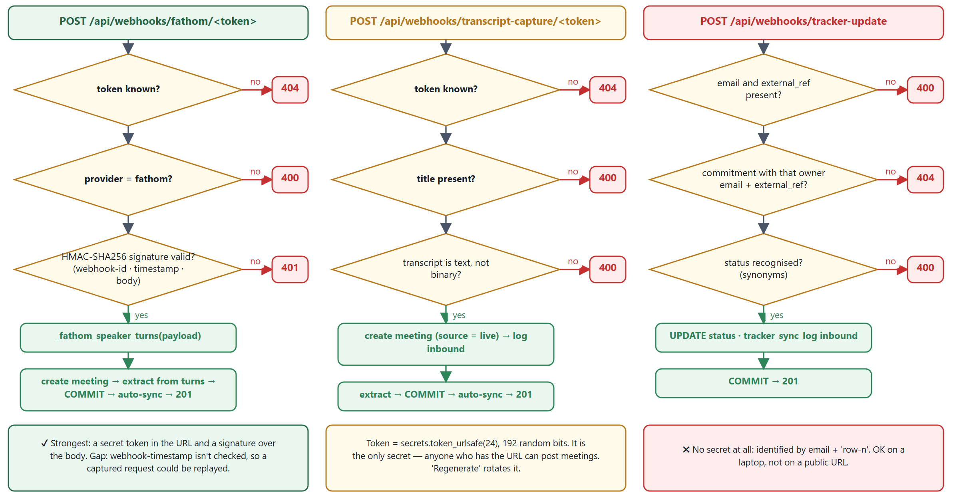

5 How chunking works
"Chunking" in this project means splitting a long transcript into pieces small enough to classify one at a time. There is no vector database and no retrieval (RAG) here, so there are no overlapping token windows. The built-in model classifies one sentence at a time; the LLM engine sends the whole transcript in one request. Here is every level of splitting, with the rule and the reason:
Level | Where | Rule / size | Why
Lines | to_turns (normalize_text(raw).splitlines()) | Each non-blank line, after curly quotes are fixed | Transcript exports are line-oriented
Speaker turns | to_turns | A header line ([10:00 AM] Name:, 0:00 - Name) starts a turn; Name: text or [09:00] Name: text is a turn on one line; plain lines are appended to the current turn; WebVTT cue numbers/timings are skipped; Date:/Participants: style labels are dropped; an ALL-CAPS heading starts an UNKNOWN turn | Ownership needs the speaker
Sentences | to_utterances → spaCy nlp(text).sents | Linguistic sentence boundaries | One commitment ≈ one sentence
Long-sentence split | to_utterances with SPLIT_AT | If a sentence has > 40 words, split before so / and then / but / because / okay / now / then / also | Speech-to-text output has no punctuation, so spaCy returns 200-word "sentences"
Noise filter | to_utterances | Drop pieces with < 4 words | "Okay sure.", "Thanks, Bhuvan." are never commitments
Embedding batches | embedder.encode(..., batch_size=128) | 128 sentences per forward pass (256 in training) | Memory/speed only — results are identical
Task text | task_of | Cut at 120 characters | Keeps the sheet readable (⚠ can cut mid-word)
LLM request | _user_message in ai_extraction.py | Whole transcript, max_tokens 16,000, 300 s timeout — no chunking | Keeps cross-sentence context; a cut-off reply raises and falls back to the built-in model
Sheets writes | append_commitment_rows | All unsynced rows in one values.update | One API call, consistent row numbers

Figure 7 — extraction pipeline draws the stages and then follows two real lines of the FY2027 transcript through them, with the actual model output.

5.1 The worked example in numbers
Output of the real pipeline, 2 Oct 2026 (script in section 11.3)
[11:28 AM] Sarah Xian:
Understood, Bhuvan. I'll track everyone's deliverables from the 26th through the 29th, ... master feedback report on the 30th.
[11:29 AM] Bhuvan:
Once I receive Sarah's feedback on the 30th, I will immediately issue a Calendar invite by Friday.

TURNS 2 (TS_HEADER matched both header lines)
UTTERANCES 2 ('Understood, Bhuvan.' = 2 words < 4 -> dropped)
EMB shape (2, 384)
PROBS [1.0, 0.9999] -> both >= 0.90
COMMITMENT owner 'Sarah Xian' task 'track everyone's deliverables ... and give y' due None
COMMITMENT owner 'Bhuvan' task 'immediately issue a Calendar invite by Friday' due None
⚠ Three limitations this example exposes
First due phrase wins: DUE.search finds "on the 30th" before "by Friday", and resolve_due_date only understands weekdays and relative words, so the due date is lost. Fix: try every match (finditer) and add day-of-month parsing ("the 30th" → next date with day 30).
Hard 120-character cut produces "…and give y". Fix: cut at the last word boundary.
Turn text spans lines: a speaker's paragraph broken across lines is joined with spaces, which is right for prose but merges list items in written notes.

5.2 How to change chunking safely
- Add the new transcript shape as a check in tests/test_transcript_parsing.py first (copy an existing format test).
- Change the regex or rule in transcript_parser.py.
- Run python tests/run_all.py parsing, then the whole suite.
- Run the FY2027 transcript through the trace script (11.3) and compare the commitment list before and after — a small regex change can move dozens of sentences.

Figure 7 — Extraction pipeline and a real worked example
How to read it: the top row turns text into a probability per sentence; the second row turns each kept sentence into a commitment row. The panel underneath is a real run, including the limitations it reveals.
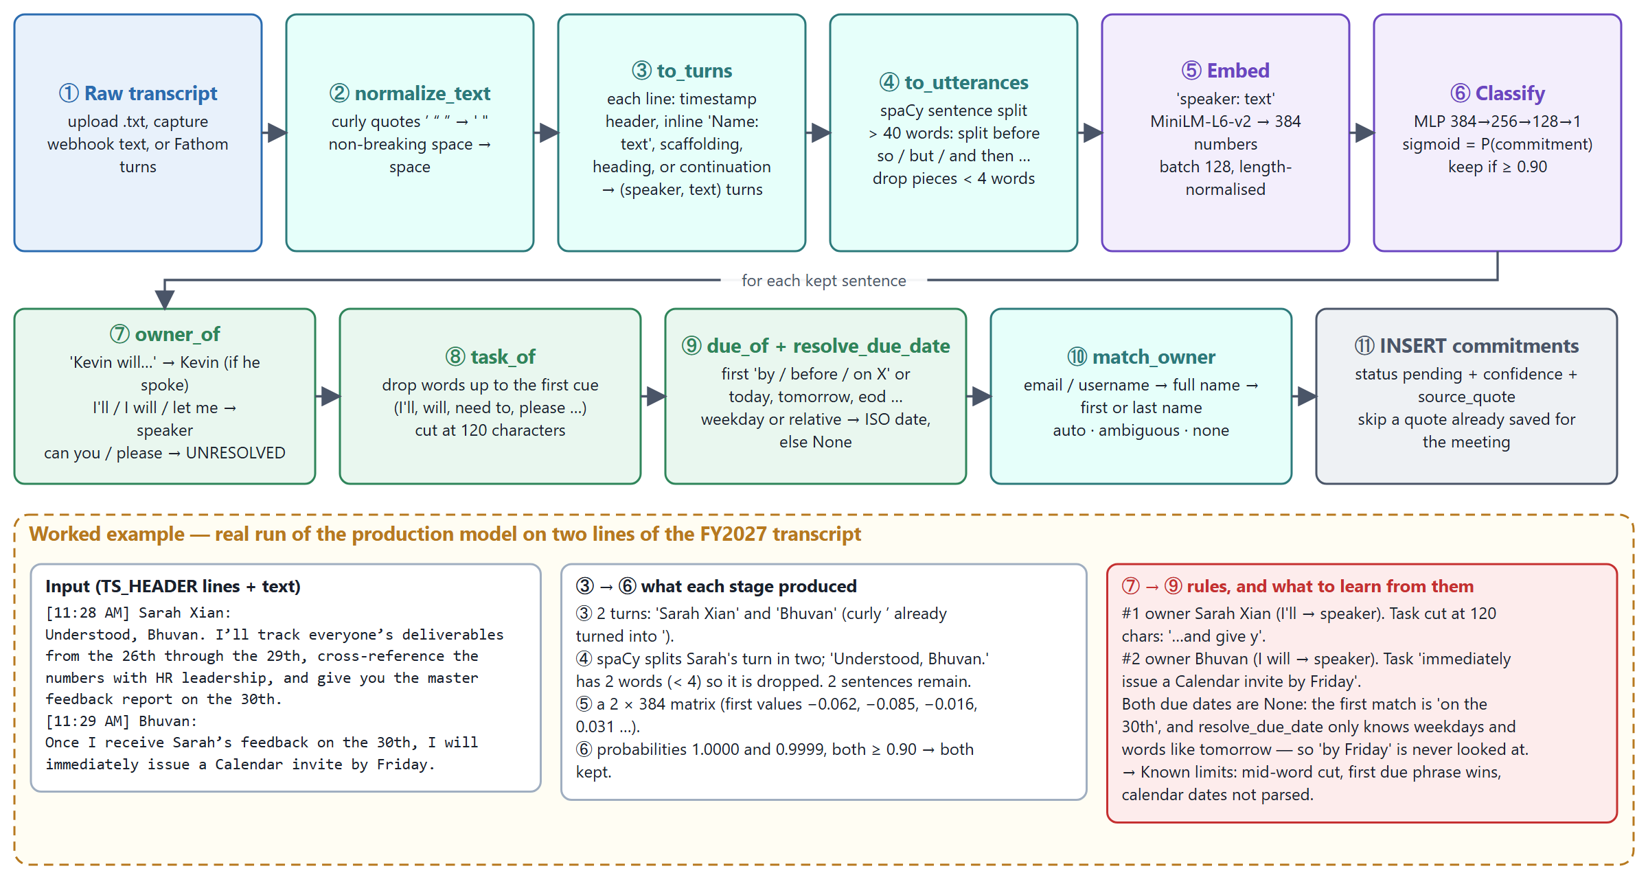

6 Databases and data access
There is one database: a SQLite file, commitment_tracker.db, next to app.py. SQLite is a library, not a server — the file is the database, and anyone who can read the file can read everything in it. There are 14 tables: 11 from schema.sql and 3 created by ai_extraction.ensure_schema. Figure 8 — entity relationships shows them all.
Table | Holds | Written by | Read by
users | One row per email that ever signed in | identify | —
meetings | A meeting and its full transcript text (transcript_excerpt holds the whole text despite the name) | upload, webhooks, demo | dashboard, extraction
commitments | The tasks: text, owner name/email, match status, due date, status, confidence, quote, sheet row | extraction, manual add, PATCH, inbound tracker | almost everything
people | Per-account directory for owner matching (UNIQUE owner_email + email) | People page | match_owner via load_people
nudge_settings | One row per account × channel; secrets in webhook_or_key and config_json | Settings | scheduler, test buttons
nudge_log | Every reminder attempt with status, reason and detail | send_and_log | repeat rule, history UI
nudge_preferences | Automatic-nudges switch per account | Settings | scheduler loop
tracker_settings | Tracker provider + config (spreadsheet id, auto_sync) | Settings | sync functions
tracker_sync_log | Every push/receive with the tracker | sync functions, webhook | task history
transcript_source_settings | Transcript provider, config (Fathom secret), webhook token | Settings | webhooks
transcript_sync_log | Inbound captures and mock checks | webhooks, check-now | Integrations activity
ai_extraction_settings | Engine choice, per-engine config with API key, consent time | AI page | try_extract
ai_extraction_runs | Each AI attempt: ok or fell_back, count, detail | _log_run | AI page
ai_extraction_comparisons | Side-by-side engine results and reviewer verdicts | compare | scoreboard

6.1 How the code talks to the database
The pattern used in every route (app.py:118 and e.g. update_commitment)
def get_db():
conn = sqlite3.connect(DB_PATH, timeout=30) # wait up to 30 s for a lock, then 'database is locked'
conn.row_factory = sqlite3.Row # row["title"] instead of row[2]
conn.execute("PRAGMA foreign_keys = ON") # SQLite ignores FOREIGN KEY unless told per connection
return conn

db = get_db()
row = db.execute("SELECT ... WHERE meetings.owner_email = ? AND commitments.id = ?", (email, commitment_id)).fetchone()
db.execute("UPDATE commitments SET status = ? WHERE id = ?", (status, commitment_id))
db.commit()
db.close()
- Always `?` placeholders for values. Table/column names are never taken from user input (the only f-string SQL is in migrate_db with hard-coded table names).
- Ownership is a WHERE clause: every query on user data joins to meetings.owner_email = ? or filters user_email = ?. get_commitment_or_404 returns None (→ 404) for someone else's task, so you can't even learn that it exists.
- One connection per request, opened and closed explicitly. No pool, no ORM. If you add an early return, close the connection first (look at existing routes — every error branch does).
- JSON in TEXT columns: settings live in config_json and are read with json.loads. They are not queryable by SQL — fine at this scale.
- Timestamps are ISO strings in UTC (now_iso); dates are YYYY-MM-DD. Overdue is computed when reading (with_overdue_flag), never stored.

6.2 Transactions and locking
SQLite allows many readers but one writer at a time. Python's sqlite3 opens a transaction automatically at the first INSERT/UPDATE and holds the write lock until commit(). Three places matter:
Where | What it does | Why
auto_sync_to_sheet, sync_all_to_tracker | BEGIN IMMEDIATE before reading unsynced rows | Takes the write lock up front so two syncs can't both send the same rows
ai_extraction.try_extract | db.commit() before the network call | A slow LLM call must not hold the lock
create_meeting (built-in engine) | Meeting INSERT … ML … commitments INSERT … commit | ⚠ Lock held during ML inference — see 2.2

6.3 Changing the schema (migrations)
There is no migration framework. The rule: new databases get the column from `schema.sql`; existing databases get it from `migrate_db()`. Both are needed.
- Snapshot first: copy commitment_tracker.db (and any file you'll change) into _snapshots/v<next>/.
- Add the column to the CREATE TABLE in schema.sql (or a new CREATE TABLE IF NOT EXISTS).
- In migrate_db(), read PRAGMA table_info(<table>) and ALTER TABLE … ADD COLUMN if missing. SQLite can't add a UNIQUE or PRIMARY KEY column this way — enforce in code or rebuild the table.
- Add a check to tests/test_people_and_nudges.py section 6 (it upgrades a frozen 0.5.0 schema in tests/fixtures/ and checks the migration runs twice safely).
- Restart the app (migrate runs at startup), bump APP_VERSION, add a CHANGELOG entry.

6.4 Other data stores
Store | What | Notes
ml/action_detector.keras | Live classifier weights (1.6 MB) | Identical to _snapshots/v0.6.0/ml/ (verified by hash on 2 Oct 2026)
ml/action_detector_candidate.keras | Retrained model, not in use | Pending a decision — section 10
ml/emb_cache/*.npy | Cached training embeddings | Gitignored; delete to force re-embedding
Hugging Face cache (user profile) | MiniLM download | First run needs internet
The Google Sheet | External copy of tasks (ID, Task, Owner, Due date, Status) | Row number = link back (external_ref)
google_token.json | OAuth refresh token | Credential — section 7

6.5 Looking inside the database
python -c "import sqlite3; c=sqlite3.connect('commitment_tracker.db'); print([r[0] for r in c.execute('select name from sqlite_master where type=\"table\"')])"

-- in any SQLite tool (close it before running the app, it can hold locks):
SELECT id, owner_name, owner_email, owner_match, due_date, status, external_ref FROM commitments ORDER BY id DESC LIMIT 20;
SELECT triggered_at, channel, status, reason, detail FROM nudge_log ORDER BY id DESC LIMIT 20;
SELECT triggered_at, provider, direction, status, detail FROM tracker_sync_log ORDER BY id DESC LIMIT 20;
SELECT created_at, engine, model, status, commitments, detail FROM ai_extraction_runs ORDER BY id DESC LIMIT 10;

Figure 8 — Database tables and relationships
How to read it: each box is a table with its main columns. Blue arrows are declared foreign keys; ✉ marks the email columns that scope data to an account; red 🔑 columns hold secrets in plain text.
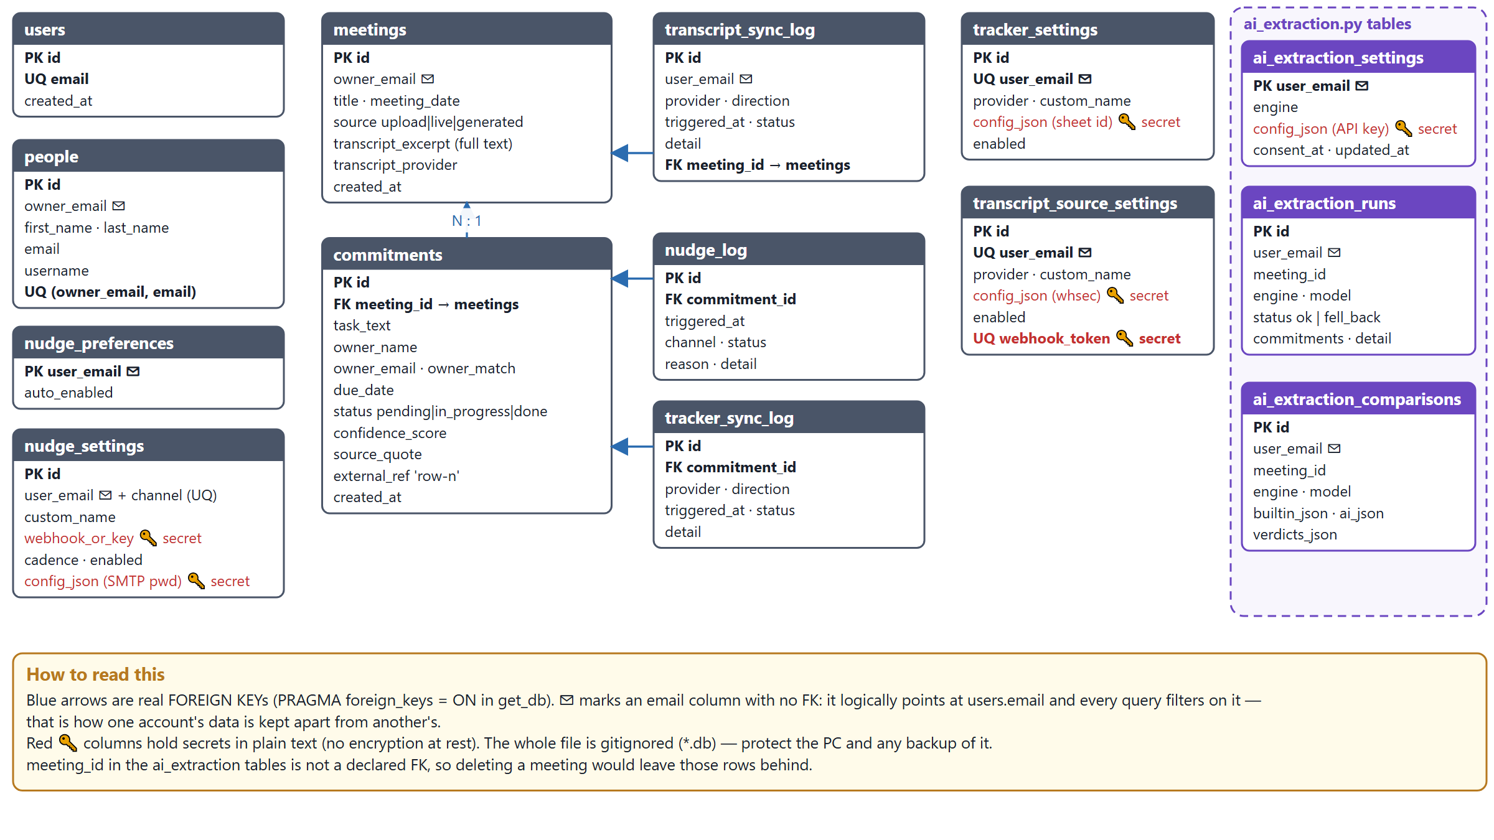

7 How credentials are maintained
There is no secrets manager. Credentials live in three places: files in the project folder, rows in the SQLite database and environment variables. Figure 9 — trust boundaries shows where each sits and what protects it.
Credential | Stored in | Created by | Read by | Sent to browser? | How to rotate
Google OAuth client id/secret | client_secret_*.json (gitignored) | Download from Google Cloud console (Desktop app) | google_sheets.find_client_secret_path | No | New client in the console, replace file, rerun setup
Google refresh/access token | google_token.json (gitignored) | python google_oauth_setup.py | get_credentials (auto-refresh, rewrites file) | No | Delete file + rerun setup; revoke at myaccount.google.com/permissions
SMTP password (e.g. Gmail app password) | nudge_settings.config_json | Settings → Email | send_email | No (has_password only) | Generate a new app password, save; blank field keeps old
Slack bot token / webhook URLs (Slack, Teams, custom) | nudge_settings.webhook_or_key | Settings | notifications.deliver | Masked ••••abcd | Regenerate in Slack/Teams, save
AI API keys (Anthropic / OpenAI-compatible) | ai_extraction_settings.config_json | AI extraction page | _call_* | Masked | Create new key at the provider, save, delete the old one
Fathom webhook secret (whsec_…) | transcript_source_settings.config_json | Settings → Fathom | verify_fathom_signature | ⚠ Yes, unmasked | Recreate the Fathom webhook, paste the new secret
Webhook URL token | transcript_source_settings.webhook_token | get_or_create_webhook_token | capture + Fathom webhooks | Yes (needed to build the URL) | "Regenerate" button
Tracker config (spreadsheet id etc.) | tracker_settings.config_json | Settings | sync functions | ⚠ Yes, unmasked | —
Flask session signing key | Hard-coded app.secret_key | — | Flask | No | Move to env var (section 4.3)
ANTHROPIC_API_KEY | Environment variable | You | _ai_setup_steps only | No | Change env var, restart

7.1 Rules that are already followed — keep them
- .gitignore excludes *.db, client_secret*.json, google_token.json, _snapshots/, ml/emb_cache/. Before any commit run git status and check none of these appear.
- Secrets are never written to logs or detail columns; error messages describe the failure ("Anthropic rejected the API key") without echoing the key.
- Saving a form with a blank secret field keeps the stored value, so the browser never needs the real secret back.
- Each account's secrets are only readable through routes that filter on that account's session email.
- The LLM engines require explicit consent (consent_at) before any transcript is sent to a third party.

7.2 Google OAuth specifics that bite
- The OAuth consent screen is in Testing mode: only listed test users can authorise, and refresh tokens expire after 7 days. Symptom: invalid_grant in tracker_sync_log. Fix: rerun python google_oauth_setup.py, or publish the app.
- Scope is https://www.googleapis.com/auth/spreadsheets — read/write to every sheet that Google account can open, not just the tracker sheet. Treat google_token.json like a password.
- The Sheets API must be enabled in the same Google Cloud project as the client, or calls fail with 403.

7.3 Environment variables
Variable | Default | Effect
AI_EXTRACTION_ENABLED | 1 | 0 removes the AI-extraction page and routes entirely (v0.4.0 behaviour)
ANTHROPIC_API_KEY | unset | Enables Claude-written setup steps for custom apps (not used for extraction — that key is per account)
ANTHROPIC_MODEL | claude-opus-5 | Default model for the Claude engine when the account hasn't chosen one
NUDGE_CHECK_INTERVAL_SECONDS | 900 | How often the reminder thread wakes
WERKZEUG_RUN_MAIN | set by Flask | Do not set by hand; marks the reloader child that runs the scheduler

Figure 9 — Where credentials live and what protects them
How to read it: each dashed zone is a trust boundary. ✔ marks a control in place, ✖ a known gap. Anything inside 'Your PC' is only as safe as the PC and its backups.
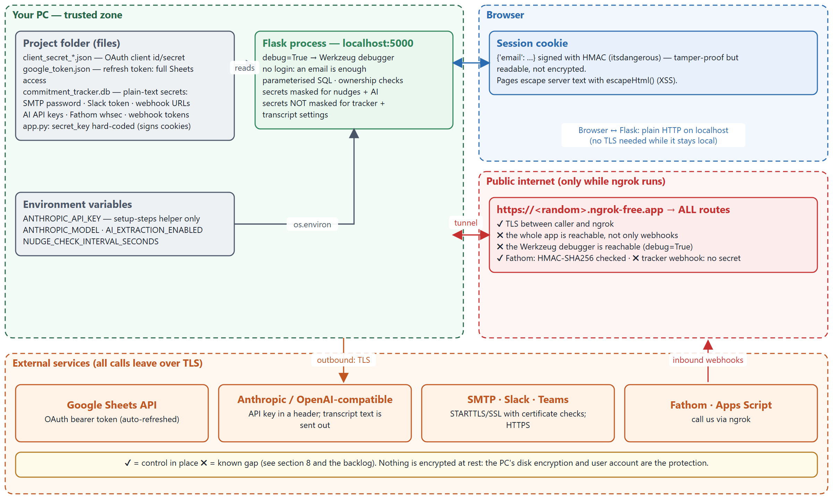

8 Security measures and known gaps

8.1 Measures in place
Threat | Measure | Where in code | Proven by test?
SQL injection | Parameterised queries everywhere | every db.execute(..., (params)) | Implicitly (all suites)
Reading another account's data | Ownership filter on every query; 404 not 403 | get_commitment_or_404, owner_email = ? filters | Yes — test_people_and_nudges
Cross-site scripting (stored) | escapeHtml() on server text; toast uses textContent | static/*.html, app.js | Manual review (0.7.3 fixed 5 spots)
Malicious / wrong uploads | Extension check in browser + binary sniff on server | looks_like_binary_text | Yes — parsing suite
Forged Fathom webhook | HMAC-SHA256 with constant-time compare | verify_fathom_signature | Yes — valid / tampered / missing / empty secret
Guessing a capture URL | 192-bit random token, rotatable | get_or_create_webhook_token | Yes — unknown token → 404
Secret disclosure to browser | Masking for nudge and AI secrets; blank = keep | _mask, _masked, has_password | Yes — 4c, B4
Third-party outage breaking writes | Never-raise wrappers; primary write committed first | deliver, try_extract, auto_sync_to_sheet | Yes — fallback tests
Data sent to an LLM without agreement | Consent gate | ai_extraction.save_settings, try_extract | Yes
Duplicate rows / race | BEGIN IMMEDIATE | auto_sync_to_sheet | Yes — two simultaneous syncs
Wrong person nudged | Ambiguous names are never auto-tagged | match_owner | Yes — 3c
Credentials in git | .gitignore entries | .gitignore | Check git status

8.2 Known gaps (ranked)
# | Gap | Why it matters | Fix
S-1 | No authentication — any email signs in | Anyone who can reach the app can act as anyone | SSO (Google/Microsoft OIDC) or at least magic-link email
S-2 | debug=True + ngrok | The Werkzeug debugger allows code execution if reached publicly | Never run ngrok with debug on; use debug=False or a production server
S-3 | Tracker webhook has no secret | Status of any synced task can be changed by guessing | Shared secret header checked with hmac.compare_digest
S-4 | Secrets unencrypted at rest | A copy of the .db leaks every integration | Fernet + keyring; BitLocker meanwhile
S-5 | Hard-coded secret_key | Anyone with the code can forge a session for any email | Env var
S-6 | Tracker & transcript settings returned unmasked | Fathom whsec visible in the browser / to XSS | Mask like list_nudge_settings
S-7 | No CSRF protection (get_json(force=True) accepts any content type) | Another site could post as a signed-in user | Require application/json + SameSite=Lax/Strict cookie, or CSRF tokens
S-8 | Custom webhook / base URL can be any address | Server-side request forgery to internal services | Allow-list https and block private IP ranges
S-9 | Fathom replay | A captured request can be replayed to duplicate a meeting | Reject timestamps older than 5 minutes
S-10 | No rate limiting | Webhook and sign-in endpoints can be hammered | flask-limiter or proxy limits

✖ Checklist before exposing the app beyond one laptop
S-1, S-2, S-3 and S-5 fixed · served over HTTPS by a production WSGI server (waitress/gunicorn) · secrets encrypted or in a vault · database backed up and encrypted · python tests/run_all.py green · the data-breach checks in 9.4 repeated against the deployed URL.

9 Edge cases and testing

9.1 The test suite
Tests are plain Python scripts — each check prints PASS/FAIL and the script exits non-zero if anything failed. No pytest, no network, no real Google account: _support.fresh_app() points the app at a temporary database, and FakeSheet replaces the Google client.
python tests/run_all.py # all 4 suites, ~2–4 minutes (the parsing suite loads the ML models)
python tests/run_all.py sheets # only suites whose file name contains 'sheets'
python tests/test_transcript_parsing.py # run one suite directly to see every PASS line
Suite | Checks | What it covers
test_transcript_parsing.py | 28 | All transcript formats (header-only, inline, [09:00] Name: text, WebVTT, numeric speakers, preamble labels, section headings), curly quotes, due-date resolution, binary-upload guard, Fathom signature valid/invalid/tampered/missing/empty, unknown token → 404
test_sheets_sync.py | 15 | Auto-sync on/off, explicit A{n}:E{m} ranges, blank due date alignment, header row, concurrent syncs write once, status synonyms, inbound update not echoed back
test_people_and_nudges.py | 54 | CSV parsing and errors, name-matching tiers, ambiguity, re-matching, manual override, replace mode; every nudge channel against fake SMTP / local receivers; cadence and repeat rules; secrets never returned; migration from a 0.5.0 database, twice
test_ai_extraction.py | 22 | Settings and masking, consent, fallback on any failure, Fathom turns path, comparison leaves the meeting untouched, bad JSON, Anthropic request shape; one live call with a deliberately invalid key (skipped offline)
Total | 119 | All passing at 0.7.3

9.2 Edge-case catalogue
Area | Edge case | Expected behaviour | Test?
Upload | .docx/.pdf bytes submitted as text | 400 with "convert it to .txt" | ✔
Upload | Empty transcript / only scaffolding lines | Meeting created, 0 commitments, no error | ✔
Parsing | Curly apostrophes (I’ll) | Normalised; ownership still detected | ✔
Parsing | Speaker name is a number / a timestamp fragment | Becomes UNKNOWN | ✔
Parsing | "Date:", "Participants:" preamble | Dropped, not treated as speakers | ✔
Parsing | ASR text with no punctuation | Split at discourse words once > 40 words | Partly
Parsing | Two due phrases ("on the 30th … by Friday") | ⚠ first wins; date often None | ✖ add one
Owners | Two people share a first name | ambiguous, no email, nobody nudged | ✔
Owners | "Can you …" with no name | UNRESOLVED | ✔
Owners | Directory changes after extraction | Auto/ambiguous/none re-matched; manual kept | ✔
Model | Model file missing | Upload works; extraction_error explains | ✔
AI | Bad key, timeout, refusal, cut-off, invalid JSON | Logged as fell_back; built-in result used | ✔
Sheets | Blank due date | Columns stay aligned | ✔
Sheets | Two syncs at the same moment | Rows written once | ✔
Sheets | Someone sorts/inserts rows in the sheet | ⚠ row-n links point at the wrong tasks | ✖ document/guard
Sheets | Token expired (7-day test mode) | Upload kept; tracker_sync_error shown | Partly
Webhooks | Unknown token / wrong provider / bad signature | 404 / 400 / 401 | ✔
Webhooks | Fathom payload shape changes | 0 turns, logged, no 500 | Partly
Nudges | Task done / no due date / no owner email | Not sent / skipped with reason | ✔
Nudges | Scheduler pass throws | Printed, next pass runs | ✖
Access | Another account's task id in the URL | 404 | ✔
Migration | Old DB from 0.5.0, run twice | Columns added once, data intact | ✔

9.3 How to prove an edge case doesn't break the code
- Write the edge case as a failing check first in the right suite (pattern below).
- Fix the code until it passes.
- Run the whole suite — fixes in parsing often change owner/due results elsewhere.
- For extraction changes, also compare the FY2027 commitment list before/after (11.3). Tests prove rules; this proves quality didn't drop.
- Add the change to CHANGELOG.md with the test name.
Shape of a new check (see tests/_support.py for the exact helpers)
from _support import fresh_app, ok # puts the project on sys.path, temp DB per call

app_module, client = fresh_app("alice@example.com") # signed-in test client
r = client.post("/api/meetings", json={"title": "t", "transcript_excerpt": "PK\x03\x04..."})
ok(r.status_code == 400, "binary upload rejected")

_, bob = fresh_app("bob@example.com")
ok(bob.get("/api/commitments/1").status_code == 404, "bob can't see alice's task")

9.4 Data-breach checks — run after any change to routes, settings or the UI
Check | How | Pass when
No session → no data | Private window: open /api/commitments, /api/nudge-settings, /api/ai-extraction/settings | Every one returns 401
Account isolation | Sign in as B, request A's /api/commitments/<id>, /api/meetings/<id>, PATCH it | 404 for all, nothing changed
Secrets stay server-side | DevTools → Network → GET settings responses; search for xoxb, whsec, sk-, your SMTP password | Only masked values (tracker/transcript config is a known exception — S-6)
XSS | Create a task / person / custom app named <img src=x onerror=alert(1)>, open every page | Text shows literally, no alert
Webhook trust | POST to the Fathom URL with a wrong signature; to capture URL with a wrong token | 401 / 404, no meeting created
Nothing secret in git | git status --ignored and git diff --stat | No .db, token, client_secret or snapshot files staged
Nothing secret in logs | Search the console output and *_log.detail columns for keys/passwords | None found
LLM consent | Choose an AI engine without consenting, upload | Built-in engine used; no outbound call (ai_extraction_runs has no row)

10 ML primer for this project
You don't need deep ML knowledge to maintain this. You need five ideas and the discipline to measure before deploying.

10.1 The five ideas
Idea | In this codebase | Analogy
Embedding | MiniLM turns "Bhuvan: I will send the deck by Friday" into 384 numbers; sentences with similar meaning get nearby vectors. It is a pre-trained, frozen model. | A hash that preserves meaning instead of destroying it
Classifier (MLP) | A small network (384 → 256 → 128 → 1) trained to map an embedding to P(commitment). This is the only part we trained. | A learned scoring function
Threshold | Keep sentences with P ≥ 0.90. Higher = fewer, surer results (precision); lower = catch more (recall). | An alerting threshold
Precision / recall / F1 | Precision: of what we flagged, how much was right. Recall: of the real commitments, how many we found. F1 balances both. | False-positive vs false-negative rate
Generalisation | Doing well on training data proves little; we test on transcript *families* the model never saw. | Testing on production-like data, not fixtures

10.2 Where the model stands (honest numbers)
Held-out transcript family | Current model F1 (P / R) | Retrained candidate F1 (P / R)
FY2027 (the one real business meeting) | 0.417 (0.29 / 0.77) | 0.381 (0.50 / 0.31)
Template, numbered | 0.250 (0.15 / 0.68) | 0.627 (0.55 / 0.73)
Template corpus | 0.279 (0.22 / 0.37) | 0.447 (0.48 / 0.42)
Workshop — clustering | 0.194 (0.12 / 0.58) | 0.500 (1.00 / 0.33)
Workshop — validation | 0.256 (0.15 / 1.00) | 0.640 (0.57 / 0.73)
Real lecture recording | 0.027 | 0.029
Average (macro-F1) | 0.237 | 0.437

Reading this: the current model finds most real commitments (high recall) but buries them in false positives (low precision) — reviewers must prune. The candidate is much cleaner on synthetic families but misses most commitments in the real meeting, so it was not deployed. The training data is mostly template-generated (the 180-meeting corpus has only 273 distinct sentences); real transcripts are the bottleneck, not the algorithm.
ℹ When to use the LLM engine instead
For accuracy today, an LLM (Claude or Gemini via the AI-extraction page) understands context, dates ("the 30th") and implied owners far better. Use the Compare and Scoreboard features to measure it against the built-in model on your own meetings before switching an account. Cost and data-sharing consent are the trade-offs.

10.3 Retraining safely
- Snapshot ml/action_detector.keras into _snapshots/v<next>/ml/ — retrain_with_transcripts.py overwrites it automatically when macro-F1 improves.
- Add transcripts → python ml/prepare_transcript_dataset.py → label new lines in training_data/labels.py (ACTION set) → regenerate labelled_utterances.csv.
- python ml/retrain_with_transcripts.py and read ml/retrain_report.json per family, not just the average. Real meetings matter most.
- If it was auto-deployed but a real family regressed, restore the snapshot (this happened on 2026-10-01).
- Run the full test suite and the FY2027 trace; note the decision and numbers in CHANGELOG.md.

Figure 10 — How the model was trained, and the retraining decision
How to read it: panel A is the original training that produced the model in use. Panel B is the retraining run on the team's transcripts and why its result is parked.
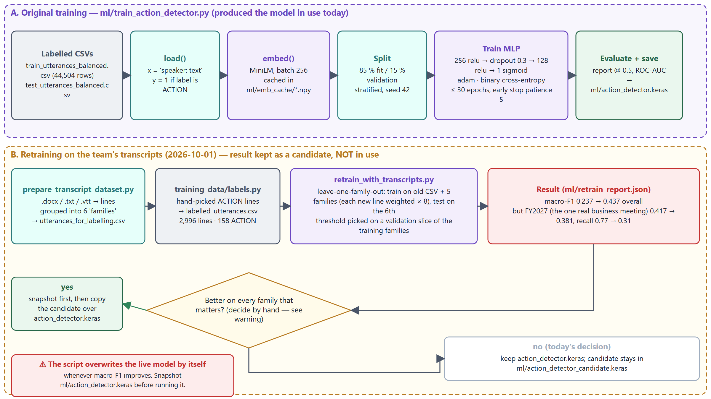

11 Diagnose and debug
Start with Figure 11 — triage table: find the symptom, look where it says, apply the usual fix. The rest of this section gives the tools.

11.1 First five minutes on any problem
- Read the response in the browser: DevTools → Network → the failing request → Response. App errors are always {"error": "…"} and usually name the cause.
- Read the console where python app.py runs: Python tracebacks, [nudges] lines and Flask's request log (method, path, status) are all there.
- Check the relevant log table (11.4) — every integration writes a row with a detail column on success *and* failure.
- Confirm only one app is running: netstat -ano | findstr :5000 (PowerShell: Get-NetTCPConnection -LocalPort 5000). Stale copies from earlier runs have caused "my change didn't apply" more than once.
- Reproduce in a test with fresh_app() — then the fix comes with a regression check.

11.2 Where to look
Source | Shows | How to open
App console | Tracebacks, request log, scheduler messages | The terminal running python app.py
nudge_log | Every reminder attempt: sent/failed/skipped + reason + detail | Task detail panel, or SQL
tracker_sync_log | Sheet pushes and inbound updates | Task detail panel, or SQL
transcript_sync_log | Webhook captures (with turn counts) and mock checks | Settings → Integrations activity
ai_extraction_runs | AI attempts: ok / fell_back + reason | AI extraction page → Recent runs
Apps Script executions | Whether the sheet trigger fired and what HTTP code it got | Sheet → Extensions → Apps Script → Executions
ngrok inspector | Every request through the tunnel, with body and response; can replay | http://127.0.0.1:4040
Werkzeug debugger | Interactive traceback in the browser on a 500 | Local only — never through ngrok (S-2)

11.3 Tracing the extraction pipeline
When extraction gives surprising results, run the stages by hand to see which one went wrong. This is the script that produced the worked example in section 5:
Run from the project folder with PYTHONIOENCODING=utf-8 set if the console shows encoding errors
import transcript_parser as tp
raw = open("FY2027_Financial_Planning_Meeting_Transcript.txt", encoding="utf-8").read()
turns = tp.to_turns(raw); print(turns.speaker.value_counts()) # all UNKNOWN? format not recognised
utts = tp.to_utterances(turns); print(len(utts)) # far fewer than expected? <4-word filter
emb = tp._get_embedder().encode((utts.speaker + ": " + utts.text).tolist(), normalize_embeddings=True)
utts["prob"] = tp._get_model().predict(emb, verbose=0).ravel()
print(utts.sort_values("prob", ascending=False).head(30)) # what scored high, what just missed 0.90
for c in tp.extract_commitments(raw, meeting_date="2026-09-23"): print(c)

11.4 Debugging with VS Code
- Set breakpoints and run app.py under the debugger with use_reloader=False (temporarily change app.run) — the reloader's second process otherwise ignores your breakpoints. Remember the scheduler only starts in the reloader child, so start it by hand if you need it.
- To debug one endpoint without the browser, call it from a test with fresh_app() and set a breakpoint in the route.
- To debug a webhook, replay the captured request from the ngrok inspector after setting the breakpoint.

11.5 Incidents from this project's history
Symptom | Root cause | Fix (version)
Uploaded .docx produced garbage tasks | Binary file read as text | Browser .txt-only check + looks_like_binary_text (0.2.x)
Transcript produced 0 or wrong turns | [10:00 AM] Name: and [09:00] Name: text formats not recognised | TS_HEADER, TS_INLINE (0.2.x–0.4.x)
"I’ll" not detected as a commitment owner | Curly apostrophe from Word/Zoom | normalize_text (0.4.x)
Sheet rows shifted one column right | values.append table detection broken by blank due date | Explicit A{n}:E{m} ranges (0.3.x)
Same task written to the sheet twice | Two syncs racing | BEGIN IMMEDIATE (0.3.x)
Apps Script TypeError … reading 'range' | Running onStatusEdit from the editor (no event object) or as a simple trigger | Installable On-edit trigger; never run it by hand
Sheet edits stopped arriving | ngrok free URL changed after restart | Update the URL in Apps Script / Fathom
Google 403 / invalid_grant | API not enabled, user not a test user, or 7-day test token expiry | Enable Sheets API, add test user, rerun google_oauth_setup.py
"database is locked" | A second app copy or a DB viewer holding a write transaction | Stop stale processes; close viewers
Changes "not applied" | An old Flask process still owning port 5000 | Kill stale PIDs, start once
Model got worse after retraining | Script auto-deployed on macro-F1 while FY2027 regressed | Restored snapshot; candidate kept separately (0.7.0)
PDF export produced no file | Edge returns before writing; needed its own profile dir | docs/build_prd_pdf.py polls and uses --user-data-dir (0.7.2)

Figure 11 — Triage table — symptom → where to look → usual fix
How to read it: find the row closest to what you see; the middle column is the cheapest check, the right column the cause it usually reveals.
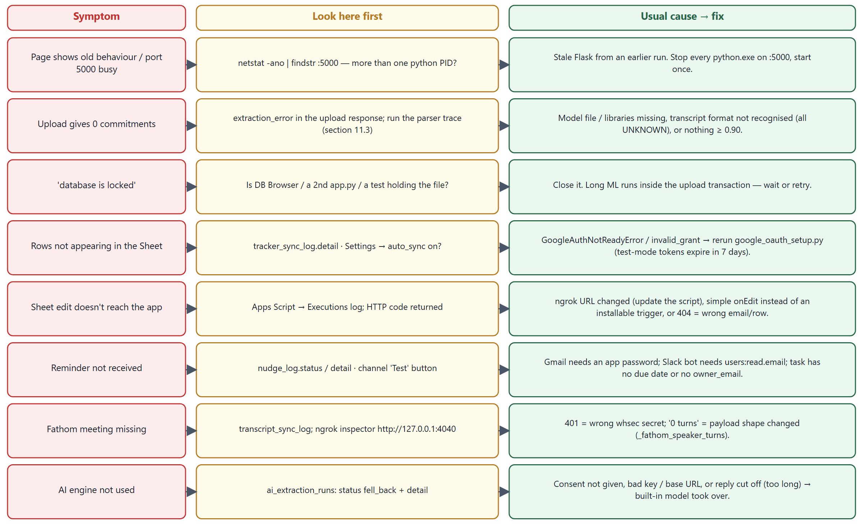

12 Working conventions
Convention | What to do | Why
Version + changelog | Every change: bump APP_VERSION in app.py and add a CHANGELOG.md entry (Added / Changed / Fixed / Security / Known issues) | The changelog is the project history while git isn't being used
No git commits without approval | Local main is 1 commit ahead of origin; everything since 0.2.0 is uncommitted. Don't commit or push until the owner decides what goes in. | Owner's explicit instruction
Snapshot before risky work | Copy files you'll change into _snapshots/v<version>/ | Fast, reliable revert without git
Revertible trial features | Wrap glue code in [feature vX] … [/feature vX] markers, keep the logic in its own module, add an env switch | AI extraction can be removed cleanly (_snapshots/v0.4.0/revert_ai_extraction.py)
Tests with every change | Add a check, run python tests/run_all.py | 119 checks keep regressions out
Docs regenerate from scripts | python docs/make_status_diagram.py · python docs/build_prd_pdf.py · python docs/make_guide_diagrams.py + node docs/build_technical_guide.js <inventory.json> | Diagrams and PDFs never drift from their source
Escape on output | escapeHtml() for any server/user text placed in HTML | XSS (section 8)
Never-raise integrations | External calls return (status, detail) or an error string | One flaky service can't break the app

12.1 Adding a feature — the checklist
- Snapshot the files you'll touch.
- Schema: schema.sql + migrate_db() (6.3).
- Backend: route with require_email(), input validation, ? parameters, ownership filter, close the connection on every path.
- Frontend: call through api(), show errors with toast(e.message), escape every value placed in HTML.
- Tests: happy path, bad input (400), no session (401), other account (404).
- Version bump + CHANGELOG entry; update readme/PRD if behaviour visible to users changed.
- Run the full suite and the data-breach checks in 9.4.

13 Open decisions and backlog
Item | Type | Notes
Deploy the retrained candidate model? | Decision (owner) | Recommendation: no, until more real transcripts are labelled (section 10.2)
Keep or revert the AI-extraction feature? | Decision (team) | Revert script ready; currently on, test account uses Gemini 2.5 Pro
Review the 158 ACTION labels | Data | Labels drive every number in 10.2
What to commit to git | Decision (owner) | Exclude .db, tokens, client secrets, snapshots (already gitignored)
Real transcripts from the team | Data | Needed for meaningful retraining
S-1 … S-10 security gaps | Engineering | Section 8.2, in that order
Commit meeting before built-in extraction | Engineering | Removes the lock held during ML (2.2)
Due-date parsing: all matches + calendar dates | Engineering | Section 5.1
Word-boundary task truncation | Engineering | Section 5.1
Guard row-n links against sheet sorting | Engineering | Store the task ID column as the key instead of the row number
Update stale app.py module docstring | Housekeeping | Section 1.4
Real Jira sync; real Zoom/Meet/Teams pull | Feature | Currently mocks
Real sign-in (SSO) | Feature | Prerequisite for any shared deployment

Appendix A — Route catalogue
All 54 route functions, in source order. Auth: session = signed cookie from /api/identify; URL token = secret in the path; token + HMAC signature = token plus Fathom signature; none = open.
Method | Path | Function | Auth
GET | / | index (app.py:202) | none
GET | /dashboard | dashboard_page (app.py:207) | none
GET | /settings | settings_page (app.py:212) | none
GET | /people | people_page (app.py:217) | none
GET | /api/people | list_people (app.py:244) | session
GET | /api/people/template.csv | people_template (app.py:259) | none
POST | /api/people/upload | upload_people (app.py:267) | session
POST | /api/people | add_person (app.py:306) | session
PATCH/DELETE | /api/people/<int:person_id> | change_person (app.py:328) | session
GET | /api/version | version (app.py:357) | none
POST | /api/identify | identify (app.py:364) | none
GET | /api/me | me (app.py:384) | none
POST | /api/logout | logout (app.py:392) | none
GET | /api/meetings | list_meetings (app.py:400) | session
POST | /api/meetings | create_meeting (app.py:567) | session
GET | /api/meetings/<int:meeting_id> | get_meeting (app.py:601) | session
POST | /api/meetings/<int:meeting_id>/extract-commitments | extract_commitments_for_meeting (app.py:625) | session
POST | /api/meetings/seed-demo | seed_demo (app.py:739) | session
GET | /api/commitments | list_commitments (app.py:799) | session
POST | /api/commitments | create_commitment (app.py:828) | session
GET | /api/commitments/<int:commitment_id> | get_commitment (app.py:885) | session
PATCH | /api/commitments/<int:commitment_id> | update_commitment (app.py:920) | session
POST | /api/commitments/<int:commitment_id>/send-test-nudge | send_test_nudge (app.py:958) | session
GET | /api/nudge-settings | list_nudge_settings (app.py:1087) | session
POST | /api/nudge-settings | save_nudge_settings (app.py:1111) | session
DELETE | /api/nudge-settings/<channel> | delete_nudge_setting (app.py:1177) | session
POST | /api/nudge-settings/<channel>/test | test_nudge_channel (app.py:1189) | session
GET/POST | /api/nudge-preferences | nudge_preferences (app.py:1211) | session
POST | /api/nudges/run-now | run_nudges_now (app.py:1230) | session
GET | /api/nudges/log | nudge_activity (app.py:1241) | session
GET | /api/tracker-settings | get_tracker_settings (app.py:1269) | session
POST | /api/tracker-settings | save_tracker_settings (app.py:1289) | session
POST | /api/commitments/<int:commitment_id>/sync-tracker | sync_tracker (app.py:1325) | session
POST | /api/tracker/sync-all | sync_all_to_tracker (app.py:1497) | session
POST | /api/commitments/<int:commitment_id>/simulate-inbound-update | simulate_inbound_update (app.py:1558) | session
POST | /api/webhooks/tracker-update | tracker_webhook (app.py:1598) | none
GET | /api/transcript-source-settings | get_transcript_source_settings (app.py:1678) | session
POST | /api/transcript-source-settings | save_transcript_source_settings (app.py:1702) | session
POST | /api/transcript-source/regenerate-token | regenerate_transcript_webhook_token (app.py:1738) | session
POST | /api/transcript-source/check-now | check_transcript_source (app.py:1756) | session
GET | /api/transcript-source/log | transcript_source_log (app.py:1794) | session
POST | /api/webhooks/transcript-capture/<token> | transcript_capture_webhook (app.py:1822) | URL token
POST | /api/webhooks/fathom/<token> | fathom_webhook (app.py:1919) | token + HMAC signature
POST | /api/meetings/simulate-incoming-capture | simulate_incoming_capture (app.py:1971) | session
POST | /api/setup-steps/suggest | suggest_setup_steps (app.py:2105) | session
GET | /ai-extraction | page (ai_extraction.py:377) | none
GET | /api/ai-extraction/status | status (ai_extraction.py:381) | none
GET | /api/ai-extraction/settings | read_settings (ai_extraction.py:385) | session
POST | /api/ai-extraction/settings | save_settings (ai_extraction.py:399) | session
POST | /api/ai-extraction/test | test_connection (ai_extraction.py:442) | session
GET | /api/ai-extraction/runs | recent_runs (ai_extraction.py:459) | session
POST | /api/ai-extraction/compare | compare (ai_extraction.py:474) | session
POST | /api/ai-extraction/comparisons/<int:comparison_id>/verdicts | save_verdicts (ai_extraction.py:521) | session
GET | /api/ai-extraction/scoreboard | scoreboard (ai_extraction.py:540) | session

Appendix B — Tunable constants
Constant | Value | Where | Effect
DEFAULT_THRESHOLD | 0.90 | transcript_parser.py | Minimum probability to keep a sentence
Long-sentence split | > 40 words | to_utterances | When ASR sentences are split at discourse words
Minimum utterance | 4 words | to_utterances | Shorter pieces are dropped
Inference batch | 128 | extract_commitments_from_turns | Embedding batch size
Task length | 120 chars (built-in) / 300 (AI) | task_of / _parse_items | Truncation
NUDGE_REPEAT_WINDOW_HOURS | 20 | app.py | Minimum gap between attempts per task/channel/reason
NUDGE_CHECK_INTERVAL_SECONDS | 900 | env | Scheduler period
HTTP_TIMEOUT | 15 s | notifications.py | Webhook/Slack/Teams timeout
REQUEST_TIMEOUT_SECONDS | 300 s | ai_extraction.py | LLM call timeout
max_tokens | 16,000 | _call_anthropic | Longest Claude reply
SQLite lock timeout | 30 s | get_db | Wait before "database is locked"
Binary-guard sample | 2,000 chars, 1 % | looks_like_binary_text | Replacement-character ratio
Webhook token | 24 bytes (urlsafe) | get_or_create_webhook_token | Token length
NEW_DATA_WEIGHT | 8 | retrain_with_transcripts.py | Weight of each labelled transcript line vs a CSV row

Appendix C — Glossary
Term | Meaning here
Commitment / task | A promise extracted from a meeting: task text, owner, due date, status
Turn | A block of speech by one speaker
Utterance | One sentence (or ASR fragment) of a turn — the unit the classifier scores
ACTION / DIALOG | The two labels the classifier was trained on: a commitment vs ordinary talk
Embedding | Fixed-length vector of numbers representing a sentence's meaning (384 numbers here)
MLP | Multi-layer perceptron — a small fully-connected neural network
Threshold | Probability cut-off for keeping a sentence (0.90)
Precision / recall / F1 | Share of flagged items that are right / share of real items found / their harmonic mean
Family | A group of near-duplicate transcripts, held out together during evaluation
owner_match | How an owner email was set: auto, ambiguous, none, manual (NULL = before 0.6.0)
external_ref | Link from a task to its tracker item — row-<n> for Google Sheets
Nudge | A reminder sent to a task owner
Webhook | An HTTP POST another service makes to us when something happens
HMAC | A keyed hash proving a message came from someone with the shared secret and wasn't changed
ngrok | A tunnel giving localhost a temporary public https URL
Apps Script | Google's JavaScript automation inside a Sheet; onStatusEdit posts edits to the app
Snapshot | Copies of files in _snapshots/ taken before a risky change
Fallback | Using the built-in model when the AI engine fails

List of figures
Figure 1 — System architecture
Figure 2 — Startup and the life of every API request
Figure 3 — Upload → commitments, as a sequence
Figure 4 — Two-way Google Sheets sync
Figure 5 — Reminder scheduler
Figure 6 — How each inbound webhook decides whether to trust a request
Figure 7 — Extraction pipeline and a real worked example
Figure 8 — Database tables and relationships
Figure 9 — Where credentials live and what protects them
Figure 10 — How the model was trained, and the retraining decision
Figure 11 — Triage table — symptom → where to look → usual fix

