|  |  |  |  |  |
| --- | --- | --- | --- | --- |
|  | **Title:** **Project Registration & Progress Review** | |  |  |
|  | | | | | |
|  | | | | | |
| **Department:** Multidisciplinary Engineering | | **Academic Year:** 2023-24 | | | |
| **Semester:** II | | **Group No. :** MECH-B-10 | | | |
| **Project Title:** Hypertension predictor using R. | | | | | |
| **Project Area:** | | | | | |
| **Group Members Details:** | | | | | |

|  |  |  |  |  |  |  |  |  |  |  |  |
| --- | --- | --- | --- | --- | --- | --- | --- | --- | --- | --- | --- |
| Class & Div. | | Roll No. | | G.R.No. | | Name of Student | | Contact No. | | Email ID | |
| 1 | SY B | | 40 | | 12211492 | | Pradnya Magar | | 8605677929 | | pradnya.magar22@vit.edu | |
| 2 | SY B | | 45 | | 12211158 | | Tushar Mane | | 9322996944 | | tushar.mane 22@vit.edu | |
| 3 | SY B | | 53 | | 12210065 | | Kripa Naik | | 9112449840 | | kripa.naik22@vit.edu | |
| 4 | SY B | | 55 | | 12210415 | | Apurva Nanekar | | 9028311061 | | apurva.nanekar22@vit.edu | |
| 5 | SY B | | 57 | | 12211749 | | Adithya Krishna | | 8767149085 | | Adithyakrishna.nauttuvetty22@vit.edu | |

**Project Synopsis**

**INTRODUCTION**

In today's fast-paced world, many individuals have overlooked the significance of maintaining a healthy lifestyle. While money is undoubtedly important, good health should never be undervalued. Young people frequently experience depression, hypertension, and stress, among other things. Fortunately, technological advancements are quietly enhancing our daily lives in a variety of ways. However, people often struggle to find time for themselves. That's why we've developed a hypertension predictor that can determine whether or not an individual has hypertension based on straightforward and well-known health conditions. The most critical advancements are those designed to assist individuals with busy schedules in overcoming obstacles and adapting to changes while also gaining a better understanding of their health status.

**REVIEW OF LITERATURE:**

**[1] Prediction of Factors for Patients with Hyper with Hypertension and Tension and Dyslipidemia Using Multila Dyslipidemia Using Multilayer Feedforward Neural Networks and al Networks and Ordered Logistic Regression Analysis: A Robust Hybrid**

**Methodology** This research aims to predict factors associated with hypertension in patients involving multilayer feedforward neural networks and ordered logistic regression. The study combines multiple logistic regression and neural networks to model seven traits linked with hypertension The hybrid methodology, tested with 1000 data entries, identifies significant variables such as total cholesterol, diabetes status, diastolic reading, height, coronary heart disease incidence, triglyceride reading, and waist measurement

**[2] Risk factor analysis of hypertension with logistic regression and Classification and Regression Tree 1 Department of D3 Medical Records and Health Information Management, Faculty of Health Science, Institute of Health Sciences Bhakti Wiyata Kediri Jl. Wachid KH Hasyim 65, Bandar Lor, 64114 Kediri, East Java, Indonesia**

This study investigates hypertension risk factors, including age, heart rate, family history of hypertension, salty food consumption, and smoking or exposure to cigarette smoke. Logistic regression was utilized to analyze the influence of these factors on hypertension and non-hypertension, comparing logit. The classification accuracy percentages were 85.2% for logit and 81.5% for Gompit, indicating logit's superiority. Age and heart rate were identified as significant factors influencing hypertension risk.

**[3] Predicting Hypertension using Machine Learning: A Case Study at Petra University Yasmin Sakka1, Dina Qarashai2, Ahmad Altarawneh3 Faculty of Administrative and Financial Sciences-Management Information Systems Department, University of Petra, Amman, Jordan1, 3 Healthcare Center, University of Petra, Amman, Jordan2**This research paperaims to predict hypertension risks using machine learning, particularly the SMOTE-k-nearest neighbour model. The study utilized medical records of 31,500 patients, with 12,658 hypertensive cases and 18,842 non-hypertensive cases.

# [4] Modelling of Hypertension Risk Factors Using Logistic Regression to Prevent Hypertension in Indonesia Putri Andriani1 and Nur Chamidah2

CART yielded better predictive accuracy (AUC = 0.584) compared to logistic regression. The study combines multiple logistic regression and neural networks to model seven traits linked with hypertension. identifying high-risk individuals for cardiovascular diseases, emphasizing the potential of predictive models for early diagnosis and preventive measures.

**FF No** **180**

**PROBLEM STATEMENT:**

**-**hypertension predictor is designed to assist individuals with busy schedules in overcoming obstacles

and adapting to changes while also gaining a better understanding of their health status.

-this predictor straightforwardly predicts whether an individual has or does

not have hypertension.

-The available aids and technologies in the market nowadays are expensive to

the normal or low level of income people which are the majority of the users,

therefore new devices with similar tasks and cheaper prices are needed.

**Project Components**

Logistic regression

Decision tree

Train and test

Naive Bayes

**Project Objective:**

Our predictor can determine whether an individual has hypertension or not.. Taking into account some crucial factors like name, sex, age, bp, chol, chest pain, blood sugar level, etc and through the research finding the range for these and more parameters.

Hypertension person

* Age:
* Sex:
* Blood pressure:
* Cholesterol:
* Chest pain:
* Blood sugar level:
* Max heart range:

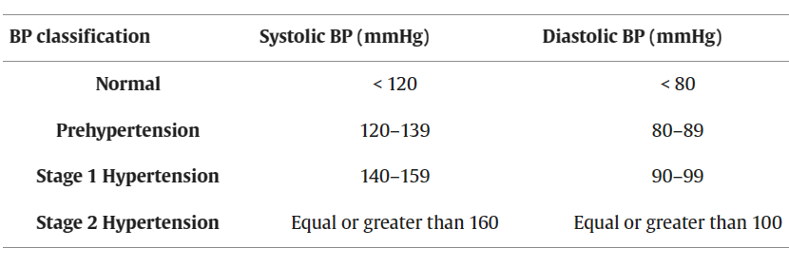

Input: name, age, chol, cp,bp, etc

user

no

Finding range for parameters

yes