Quickstart: Connect to data in Power BI Desktop
In this quickstart, you connect to data using Power BI Desktop, which is the first step in building data models and creating reports.
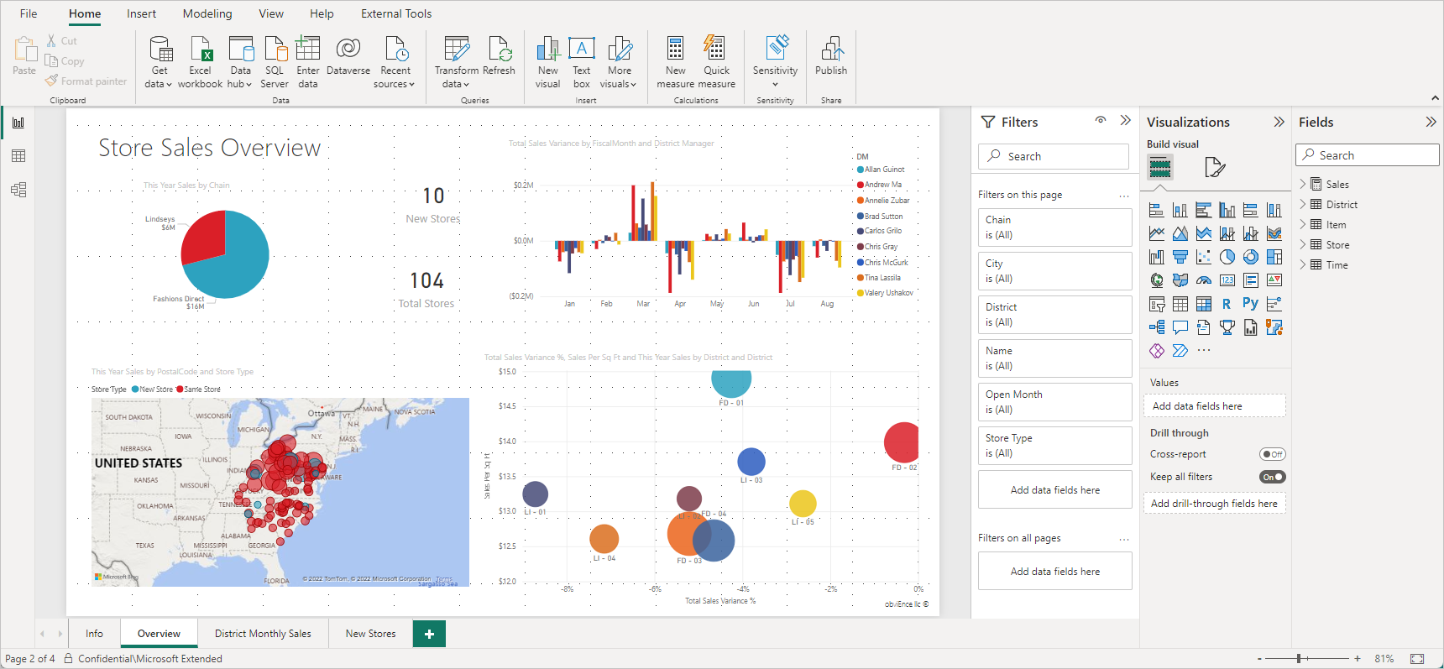
If you're not signed up for Power BI, sign up for a free trial before you begin.

Prerequisites
To complete the steps in this article, you need the following resources:
- Download and install Power BI Desktop, which is a free application that runs on your local computer. You can download Power BI Desktop directly, or you can get it from the Microsoft Store.
- Download this sample Excel workbook, and create a folder called C:\PBID-qs where you can store the Excel file. Later steps in this quickstart assume that is the file location for the downloaded Excel workbook.
- For many data connectors in Power BI Desktop, Internet Explorer 10 (or newer) is required for authentication.

Launch Power BI Desktop
Once you install Power BI Desktop, launch the application so it's running on your local computer. You're presented with a Power BI tutorial. Follow the tutorial or close the dialog to start with a blank canvas. The canvas is where you create visuals and reports from your data.
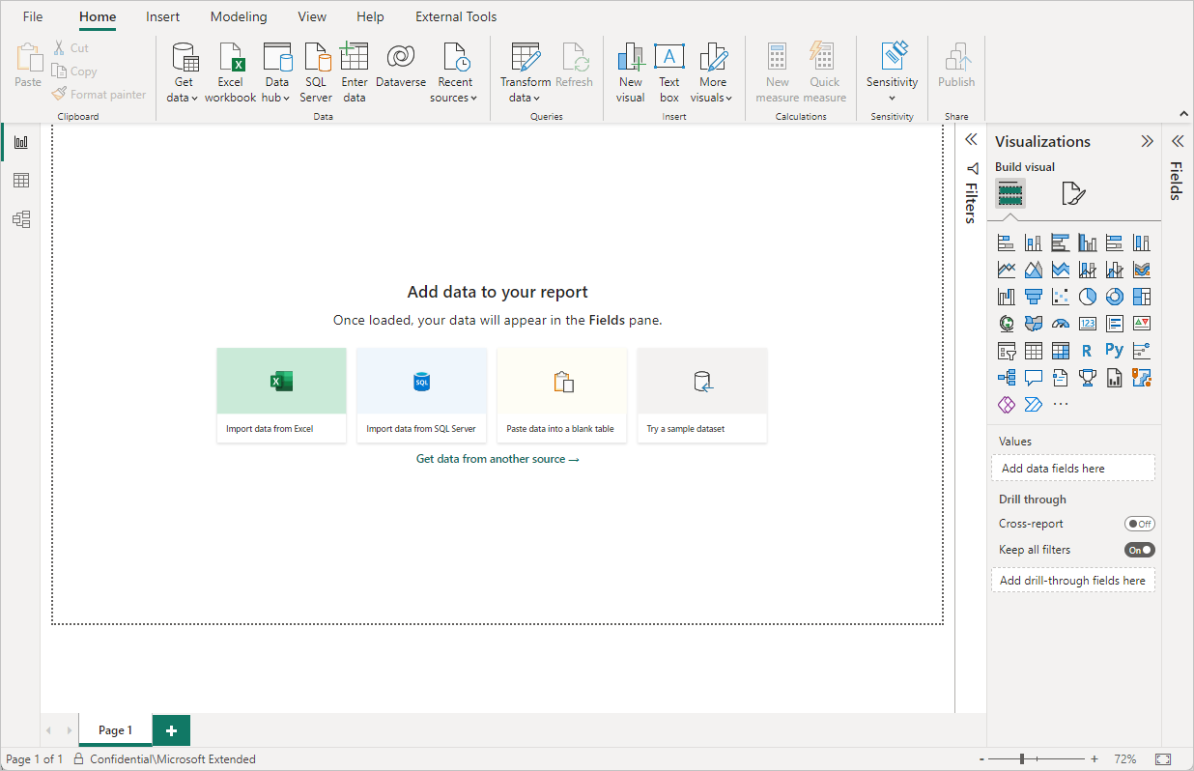

Connect to data
With Power BI Desktop, you can connect to many different types of data. These sources include basic data sources, such as a Microsoft Excel file. You can connect to online services that contain all sorts of data, such as Salesforce, Microsoft Dynamics, Azure Blob Storage, and many more.
To connect to data, from the Home ribbon select Get data.
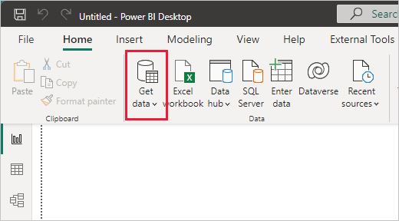
The Get Data window appears. You can choose from the many different data sources to which Power BI Desktop can connect. In this quickstart, use the Excel workbook that you downloaded in Prerequisites.
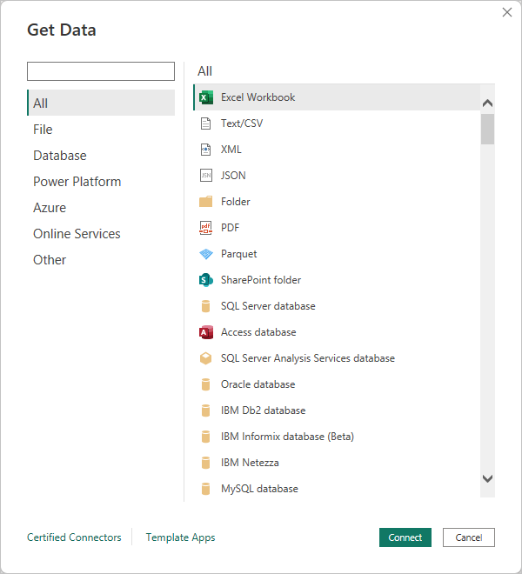
Since this data source is an Excel file, select Excel from the Get Data window, then select the Connect button.
Power BI prompts you to provide the location of the Excel file to which to connect. The downloaded file is called Financial Sample. Select that file, and then select Open.
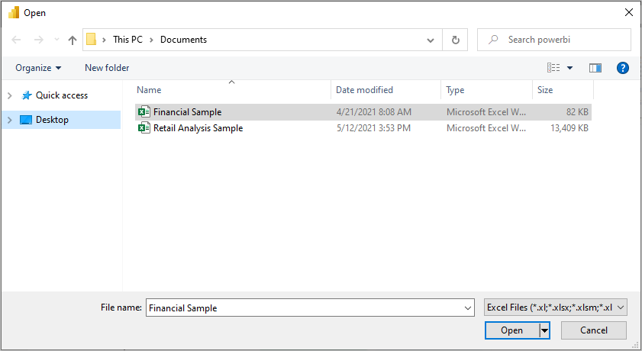
Power BI Desktop then loads the workbook and reads its contents, and shows you the available data in the file using the Navigator window. In that window, you can choose which data you would like to load into Power BI Desktop. Select the tables by marking the checkboxes beside each table you want to import. Import both available tables.
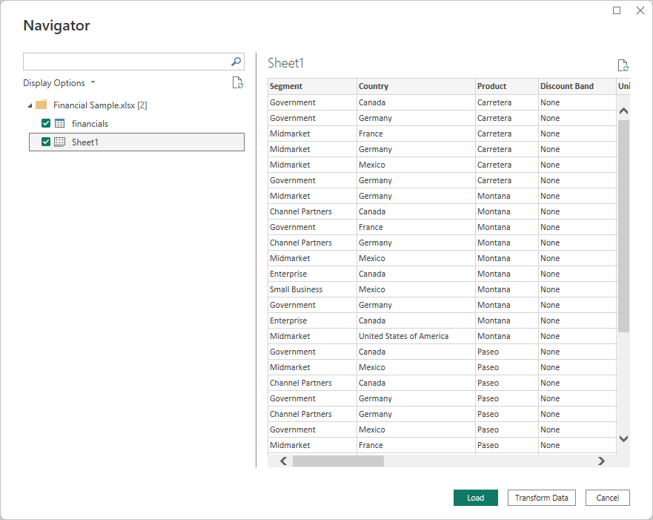
Once you make your selections, select Load to import the data into Power BI Desktop.

View data in the Fields pane
Once you load the tables, the Fields pane shows you the data. You can expand each table by selecting the arrow beside its name. In the following image, the financials table is expanded, showing each of its fields.
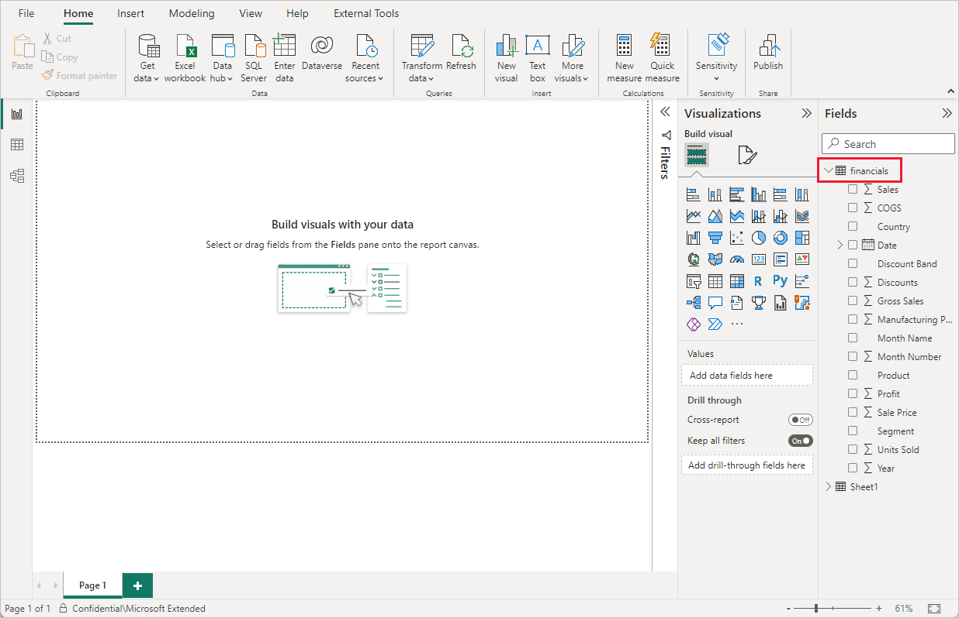
And that's it! You've connected to data in Power BI Desktop, loaded that data, and now you can see all the available fields within those tables.

1.1 Power BI Desktop Overview & Introduction to Data Visualization Tools

Power BI Desktop Overview
Power BI Desktop is a business intelligence (BI) and data visualization tool developed by Microsoft. It allows users to:
- Connect to multiple data sources
- Transform and clean data
- Create interactive reports and dashboards
- Publish reports to Power BI Service

Power BI Desktop offers three core views on the left navigation pane—Report, Data, and Model—along with a Home ribbon for data acquisition and publishing. Report view creates visuals, Data view inspects table data, and Model view manages relationships and data structures (star schema).
Key Views in Power BI Desktop:
- Report View (Icon: Graph): The primary canvas for building, designing, and arranging visualizations and reports.
- Data View (Icon: Table): Displays loaded data in a table format, allowing for sorting, filtering, and creating DAX measures.
- Model View (Icon: Diagram): Visualizes and manages data relationships, tables, measures, and data model layouts.
Key Functional Areas:
- Home Ribbon: Accessible in all views, it is used to Get Data, refresh data, publish reports to Power BI Service, and access the Query Editor.
- Model View Capabilities: Enables creating separate, smaller diagrams for complex models, managing direct relationships, and defining data types or hierarchies.
- Data Transformation: While the Data view shows the data, the underlying structure and relationships are refined here for performance.
These views allow users to navigate from data loading (Home) to modeling (Model), inspection (Data), and visualization (Report).
Key Components of Power BI Desktop:
- Home Tab – Get Data, Transform Data, Refresh
- Data View – View and manage data tables
- Model View – Define relationships between tables
- Report View – Create visualizations and reports

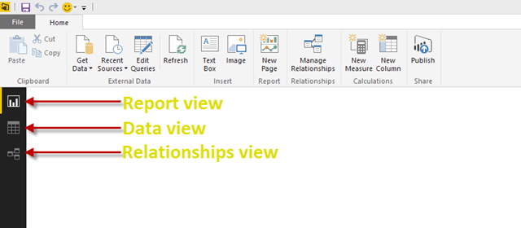
Advantages of Power BI:
- Easy drag-and-drop interface
- Strong integration with Microsoft tools (Excel, Azure, SQL Server)
- Real-time dashboards
- Cost-effective compared to other BI tools

Introduction to Data Visualization Tools

1. Tableau
- Powerful data visualization tool
- Excellent for advanced analytics and storytelling
- Supports large datasets
- User-friendly dashboards
- High licensing cost

2. Qlik Sense
- Associative data model
- Enables self-service analytics
- Fast and interactive dashboards
- Strong data discovery capabilities

3. Microsoft Power BI
- Cloud-based and desktop-based BI solution
- Best suited for Microsoft ecosystem users
- Strong DAX language support
- Affordable and scalable

4. Looker
- Google Cloud-based BI tool
- Uses LookML for data modeling
- Best for real-time analytics
- Strong governance features

5. Google Charts
- JavaScript-based charting library
- Used for web applications
- Lightweight and customizable
- Requires coding knowledge

What is Power BI Desktop?
Power BI Desktop is a free Windows application that lets you connect to data, transform it, and create interactive visual reports. It’s part of the Power BI suite, which also includes the Power BI service (online) where you can publish and share your reports.
With Power BI Desktop, you can:
- Import data from Excel, databases, web sources, and more
- Clean and shape your data using Power Query
- Build visuals like charts, maps, and tables
- Publish your reports to the Power BI service for sharing

What Is Power BI Architecture?


Power BI architecture is crafted to enable seamless integration of data transformation, collection, sharing and visualization processes into a single platform. It amalgamates both cloud-based and on-premises elements to offer a flexible and scalable solution for business intelligence. The architecture enables data ingestion from multiple sources to ensure that raw data is efficiently processed and transformed.

The architecture utilizes an extremely robust data processing engine. This helps clean and structure data, which renders it ready for analysis. Processed data is consequently used to create dynamic and interactive dashboards and reports. The visualizations are utilized in a user-friendly interface. This facilitates intuitive analysis and exploration of data.
After creation, these dashboards and reports can be shared and published through the Power BI Service. Hence enabling collaboration throughout the organization. The architecture seamlessly supports real-time data streaming, offering updated analytics and insights. Power BI's architecture promises data compliance and security via stringent encryption and access controls. Hence, making it an apt choice for organizations looking to extract actionable insights from data.

Components of Power BI Architecture
Power BI architecture components make up a comprehensive ecosystem. These help in data collection, visualization, sharing and transformation. The top components include to know about are-
- Power BI Desktop: It's the main development tool employed for creating data visualizations and reports. It enables users to join with multiple data sources, build complicated data models, and clean and transform data.
- Power BI Service: It's a cloud-based platform. It is where the users share and publish dashboards and reports. It offers collaboration features and facilitates access to reports through mobile devices and web browsers.
- Power BI Gateway: It acts like a bridge between the Power BI Service and on-premises data sources. It enables secure data transfer and ensures that data is updated.
- Power BI Mobile: Mobile apps for Android, Windows and iOS devices that enable users to interact with and access Power BI dashboards and reports on the go.
- Power BI Report Server: It's an on-premises report server wherein the users can easily share and publish Power BI reports. The data is kept within the local network.
- Power Query: It's a data preparation and connectivity tool that's embedded in Microsoft Excel and Power BI Desktop. It allows users to seamlessly connect, refine and combine data from various sources.
- Power Pivot: It is an in-memory data modeling component that enables users to create relationships, define calculations using DAX and build data models.

Working of Power BI Architecture
Power BI architecture works flawlessly by integrating multiple components. This helps in transforming raw data into highly interactive and visually appealing insights. Data is ingested from various sources. It is then cleaned and transformed via Power Query. Once done, this processed data is loaded into Power BI Desktop for visualization and modeling.
Users can create interactive dashboards and reports. These are published to the Power BI Service for collaboration and sharing. Power BI Gateway enables data transfer from all on-premises sources to the cloud. This architecture renders support to real-time data streaming. All this enables up-to-date insights and robust security measures to ensure data compliance and integrity.
In Power BI, the canvas is the main working area of a report page where you create and arrange visualizations.
In simple terms:
The canvas is the blank space where you add charts, tables, cards, slicers, images, and text to design your report or dashboard.
Key points:
- It represents one report page.
- You can drag and drop visuals onto the canvas.
- You can resize, move, and format visuals on the canvas.
- You can change canvas size and background from page settings.
Example:
When you open Power BI Desktop and insert a bar chart, it appears on the canvas, and you arrange multiple visuals there to build a dashboard.

Fundamental Data Transformation Techniques in Power BI.
To create powerful and insightful reports and dashboards, you often need to clean and shape your data to make it suitable for analysis. Explore some essential data transformation techniques in Power BI as below:
Data Source Connection:
First topic is Data Source Connection. While you may already be familiar with this, it remains at the core of reporting. Initiate the process by connecting to your data source, which encompasses a wide range of options, including databases, Excel files, web services, and more. Power BI's intuitive interface simplifies the establishment of these connections.
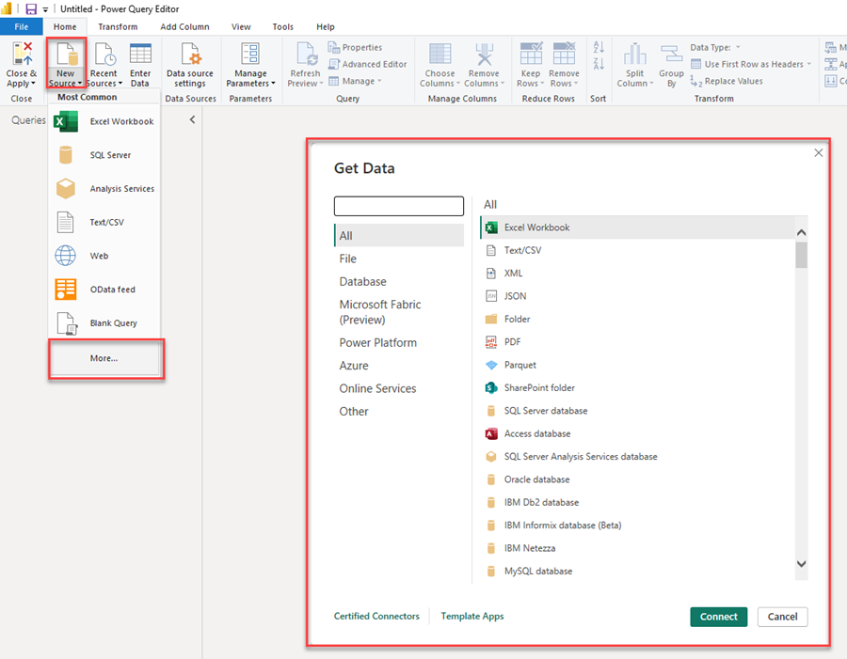

Data Cleaning:
Data cleaning stands as an essential step in working with data, as it often arrives with inconsistencies, missing values, and errors. Some fundamental functionalities you should master in Power BI for data cleaning include removing duplicates, filling in missing values, and correcting data types.
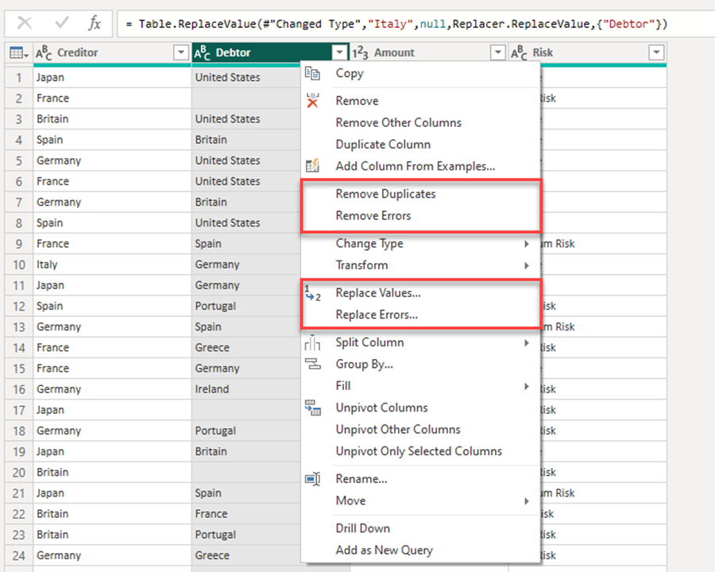
Column Renaming:
Column renaming can be a cumbersome task, but it can significantly enhance the clarity of your reports. In Power Query Editor, rename columns to make them more comprehensible. Simply right-click on a column header and select "Rename..." (Refer to the image above for guidance).

Data Type Conversion:
Power BI generally does a commendable job of recognizing data types during the initial data source load. However, in cases where this information is incorrect, it is advisable to navigate to the "Change Type" option in your Change Pane, located on the rightmost side of the screen. Ensure you are at this step and update any incorrect data types. This is especially crucial if you have numeric fields that should be text-based, such as when you need to retain leading zeros. Use the "Change Type" feature in Power Query Editor to convert columns to the appropriate data types, like changing a text column to a date.
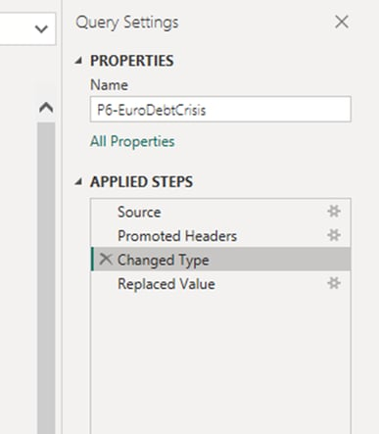
Filtering Data:
Remove unnecessary rows or filter data based on specific criteria. Apply filters to select the relevant data for your analysis. This is particularly valuable when dealing with large datasets, where you may only be interested in specific data subsets. Additionally, when working with extensive datasets, you may not immediately see the desired filter, especially when filtering for specific values. In such cases, it can be advantageous to select a value first and then subsequently refine it to your specific criteria within the formula.
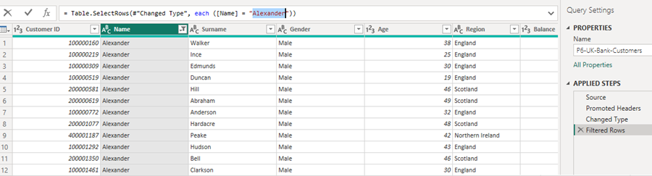
Sorting Data:
Arrange data in ascending or descending order to enhance readability and analysis. You can sort columns by clicking the dropdown menu for the specific column and choosing "Sort Ascending" or "Sort Descending."
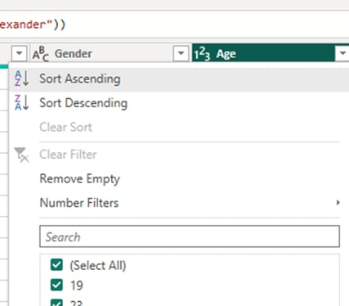

Adding Custom Columns:
Create new columns based on existing data using Power Query's "Add Column" feature. This is especially useful for calculated columns or for merging data from multiple columns. This feature will quickly become one of your most frequently used tools for data transformation. It's essential to consider when and where to use this; sometimes, creating measures instead of columns may be more advantageous. Below is an example that demonstrates how to segment your data into age buckets.
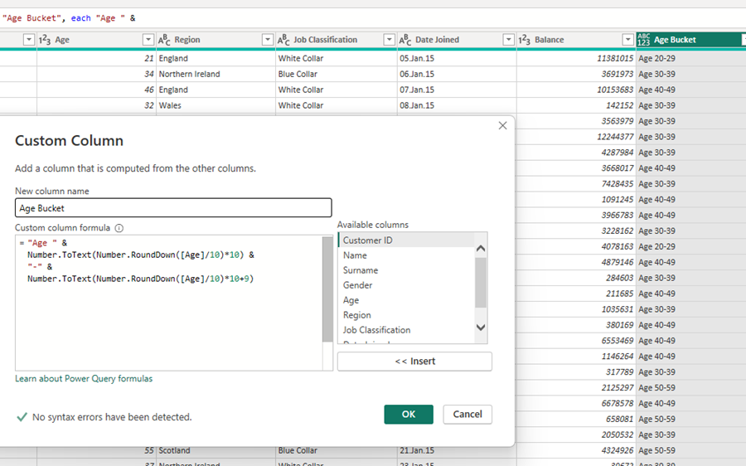
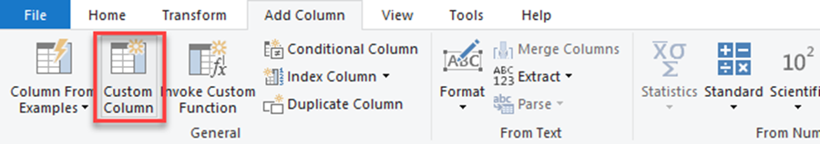
Merging Queries:
Combine data from multiple sources or tables through query merging. Power BI offers various join types, such as inner join and left outer join, among others. It's crucial to assess whether your goal can be achieved through your data model, as this can help reduce the data load on your report. However, it's not always possible to achieve the desired result solely through data modeling. Merging and appending data is a straightforward process. One thing to note is that sometimes you must create a new query for the merge to be executed correctly. Also, if you intend to append queries, ensure that the columns have the same naming conventions.
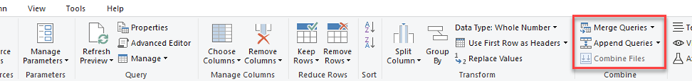
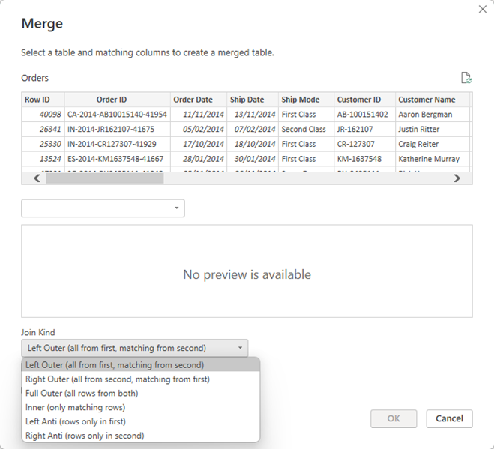
Aggregating Data:
Group data by specific columns and perform aggregations like sum, average, or count using the "Group By" function. This is particularly useful for summarizing data. You can access the "Group By" feature either in the Ribbon or by right-clicking on a column. If you need to group by multiple columns, either highlight all of them or add them to your grouping in the pop-up window.
Pivot and Unpivot:
Reshape your data using the "Pivot" and "Unpivot" transformations. Pivot allows you to convert columns into rows, while Unpivot accomplishes the reverse. To pivot, select the column you want to use for column headers and press the pivot option in the Ribbon under the Transform Tab. In the pop-up window, select the column you want to use for values. All other columns will remain as they are. To unpivot, select all the columns you want to transform from pivot to row structure. This process will create two columns: "Attribute" with the column header and "Value."
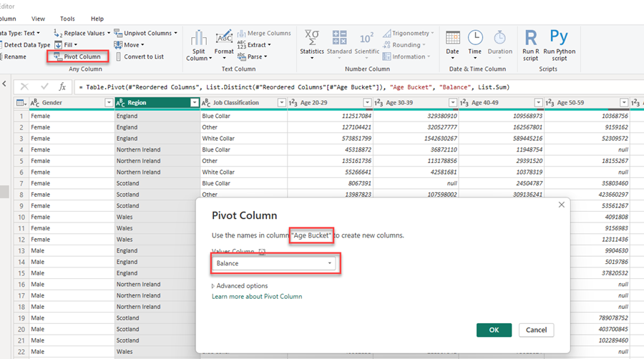
This is all about basic of data transformation in Power BI.

Slicers in Power BI
APPLIES TO: Power BI Desktop Power BI service
Suppose you want readers to view overall sales metrics and highlight performance by district manager and time frame. You could create separate reports, build comparative charts, or add filters in the Filters pane. Or use slicers. Slicers filter data directly on the report page. They narrow the portion of the semantic model shown in the other visuals.
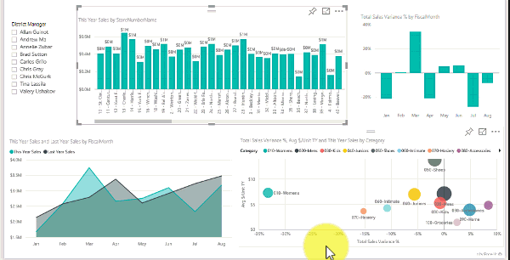
Power BI offers several slicer visuals, each designed for different filtering scenarios. This article shows you how to create and format the original slicer visual by using the free Retail Analysis Sample. It also covers controlling which visuals a slicer affects, syncing slicers across pages, and filtering and formatting slicers.

Types of slicers
Power BI provides multiple slicer visuals to meet different filtering needs:
Slicer type | Description | Best for
Slicer | The original slicer visual with vertical list, tile, and dropdown styles. | General-purpose filtering with familiar controls.
Button slicer | Interactive buttons with customizable styles, grid layouts, and image support. | Visually appealing filtering with button-based interactions.
List slicer (preview) | Vertical list with hierarchies, search functionality, and conditional formatting. | Filtering large datasets with search and hierarchy support.
Text slicer (preview) | Free-form text input for custom filter criteria. | Exact string matching and flexible text-based filtering.
In addition to slicers, you can use the Filters pane to apply filters at the visual, page, or report level. The Filters pane provides a centralized location for managing all filters in your report. For more information, see Format filters in Power BI reports.
When to use a slicer
Use slicers to:
- Show commonly used filters on the report canvas for quick access
- Show the current filter state without opening a drop-down list
- Filter by columns that are hidden in data tables
- Create focused reports by placing slicers next to key visuals

Create a slicer
- Power BI Desktop
- Power BI service
This slicer filters data by district manager. To follow along, download the Retail Analysis Sample PBIX file.
- Open Power BI Desktop, and from the menu bar, select File > Open report.
- Browse to the Retail Analysis Sample PBIX.pbix file and select Open.
- In the navigation pane, select the Report icon to open the file in report view.
- On the Overview page, with nothing selected on the report canvas, select the Slicer icon in the Visualizations pane to create a slicer.
- With the slicer selected, in the Fields pane, expand the District table and select DM to populate it.
- Resize or move elements on the canvas to make room for the slicer. If the slicer is too small, items are cut off.
The new slicer is now populated with a list of district manager names and their selection boxes.
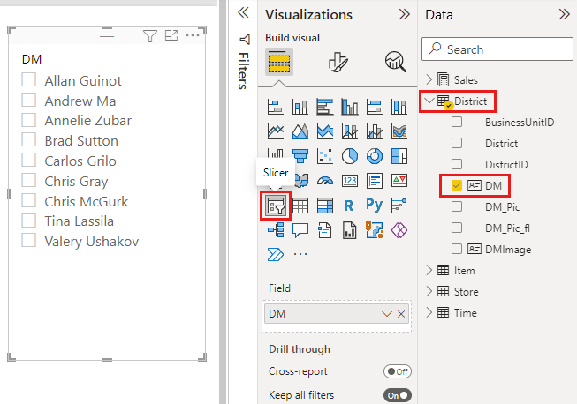
- Select names on the slicer to filter other visuals. Select a name again to clear it, or hold Ctrl to select multiple names. Selecting all names has the same effect as selecting none.
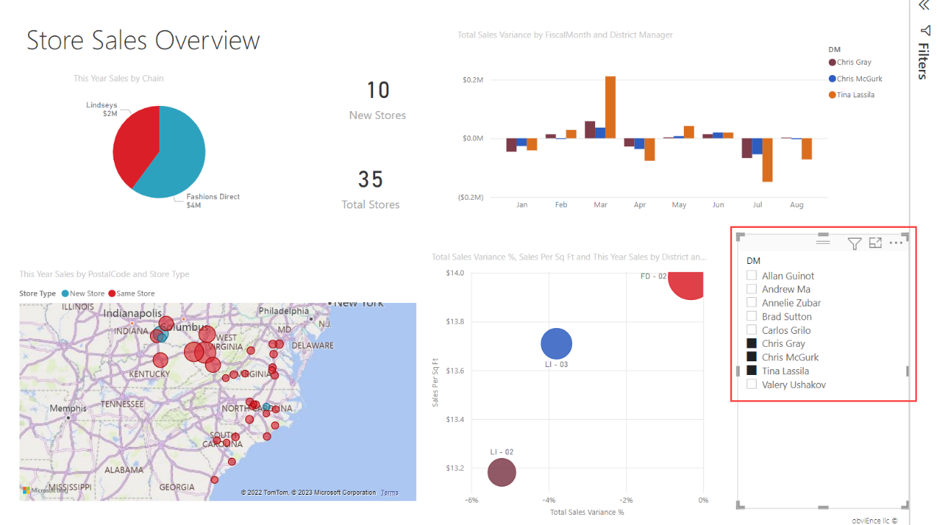

Control which page visuals slicers affect
By default, slicers on a report page filter all other visuals on that page, including other slicers. When you choose values in the list and date slicers, the other visuals update. Power BI filters data to the intersection of the selected slicer values.
Use visual interactions to exclude some page visualizations from being affected by others. For example, in the Retail Analysis sample on the Overview page, the Total Sales Variance by FiscalMonth and District Manager chart shows comparative data for district managers by month that you might want to keep visible. Use visual interactions to keep slicer selections from filtering this chart.
- Power BI Desktop
- Power BI service
- Select the District Manager slicer on the Overview page of the Retail Analysis sample report.
- On the ribbon, go to Format, and then select Edit interactions.
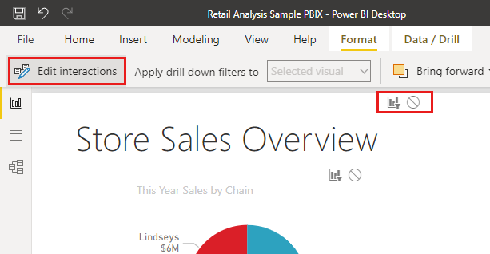
Filter controls  with Filter and None options appear above the other visuals on the page. The Filter option is selected by default.
- Select None in the filter control above the Total Sales Variance by FiscalMonth and District Manager chart to stop the District Manager slicer from filtering it.
Learn more in Change how visuals interact in a Power BI report.

Sync and use slicers on other pages
You can sync a slicer and use it on any or all pages in a report.
The District Monthly Sales page has a District Manager (or DM) slicer. You might also want that slicer on the New Stores page. The New Stores page has a slicer, but it provides only Store Name information. With the Sync slicers pane, you can sync the District Manager slicer to these pages, so that slicer selections on any page affect visualizations on all three pages.
- Power BI Desktop
- Power BI service
- In Power BI Desktop on the View ribbon, select Sync slicers.
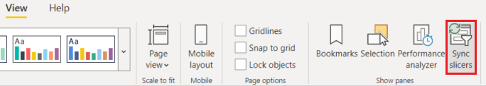
The Sync slicers pane appears between the Filters and Visualizations panes.
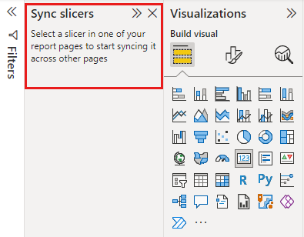
- On the District Monthly Sales page of the report, select the District Manager slicer.
Because you already created a District Manager slicer on the Overview page, the Sync slicers pane appears like this:
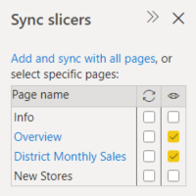
- In the Sync column of the Sync slicers pane, select the Overview, District Monthly Sales, and New Stores pages.
This selection causes the District Monthly Sales slicer to sync across these three pages.
- In the Visible column of the Sync slicers pane, select the New Stores page.
This selection makes the District Monthly Sales slicer visible on these three pages. The Sync slicers pane now appears like this:
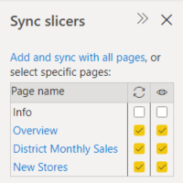
- Observe the effects of syncing. On the District Monthly Sales page, the District Manager slicer shows the same selections as on the Overview page. On the New Stores page, the District Manager slicer is visible, and its selections affect what's shown in the Store Name slicer.

Sync separate slicers
You can also sync two or more separate slicers. Syncing slicers is useful when working with composite models, as you might want to make the same selection across sources without relying on cross-source group relationships. To sync two or more separate slicers, you mark them as being part of a group.
- Make sure the Sync slicers pane is visible by selecting it from the View menu.
- Select one of the slicers that you want in the group. In the Sync slicers pane, expand Advanced options, and enter a name for the group. You can name it anything you want.
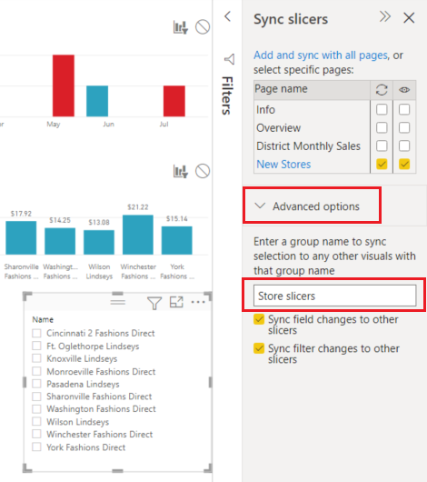
- Then select another slicer you want to sync with the first, and enter the same name in the group name box. Be sure to enter it exactly the same.
- Make sure to select either Sync field changes to other slicers, Sync filter changes to other slicers, or both depending on your scenario.
  - If you just want to keep the slicers in sync so filters set by the slicers are kept in sync, select Sync filter changes to other slicers.
  - If you also want to make sure that any changes you make to the field on which the slicers are based get synced across the group, select Sync field changes to other slicers.
- Test that the sync works the way you want by changing the selection in one of the slicers. Observe that it gets updated in the other slicer in the group.

Filter slicers
Apply visual-level filters to a slicer to reduce the list of values it shows. For example, filter out blank values from a list slicer or certain dates from a range slicer. Filtering a slicer only changes the values shown in the slicer, not the filter it applies to other visuals when you make a selection. For example, apply a filter to a range slicer to show only certain dates. The selection in the slicer only shows the first and last dates from that range, but you still see other dates in your other visuals. When you change the selected range in the slicer, you see the other visuals update. Clear the slicer to show all dates again.
Learn more about visual-level filters in Filter types.

Format slicers
Different formatting options are available, depending on the slicer type. For Style, Vertical list is the default. Select Tile to produce a slicer with tiles or buttons arranged horizontally, and scroll arrows to access items that don't fit in the slicer. By using the Tile style with Responsive layout and Background coloring, you can produce buttons or tiles rather than standard list items, and make slicer items resize to fit different screen sizes and layouts.

Visual options
- Select the District Manager slicer, and select the Format icon in the Visualizations pane.
- Resize the slicer so it's wide, not tall.
- In the Format pane, under Visual, expand Slicer settings > Options, and select Tile.
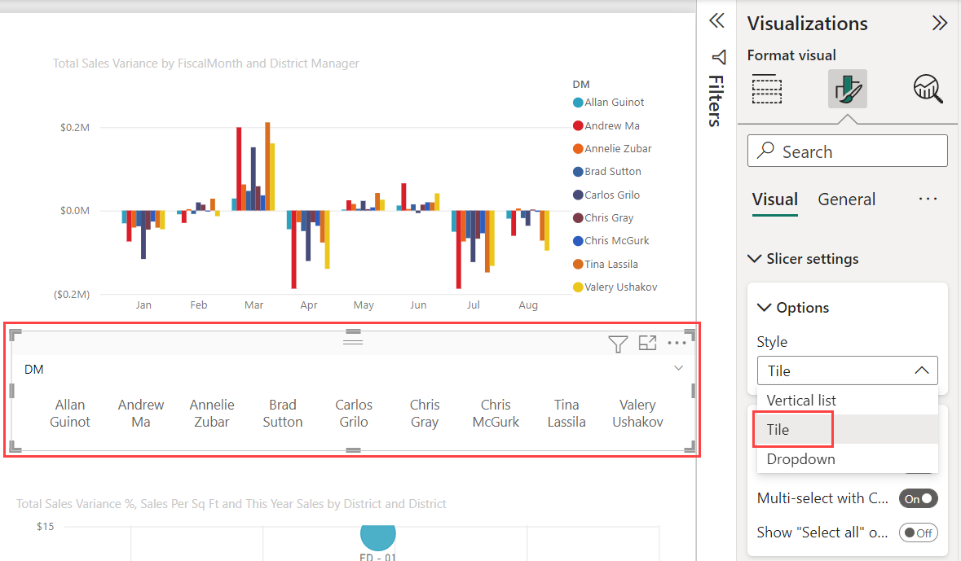
- Expand Values and select a Background Color. This color is one of the theme colors, #abdae5.
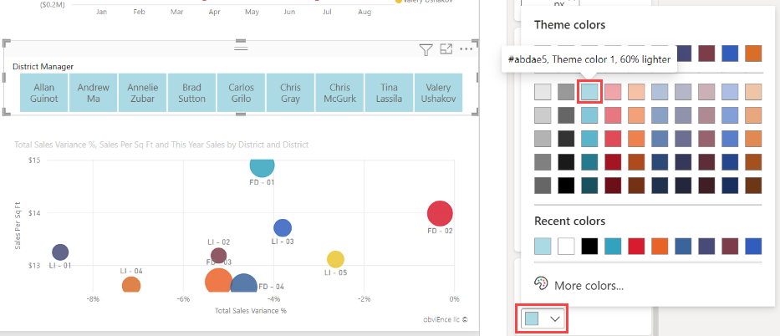

Responsive layout
After you select the Tile style, turn On Responsive layout to change the size and arrangement of slicer items based on the view screen and slicer size.
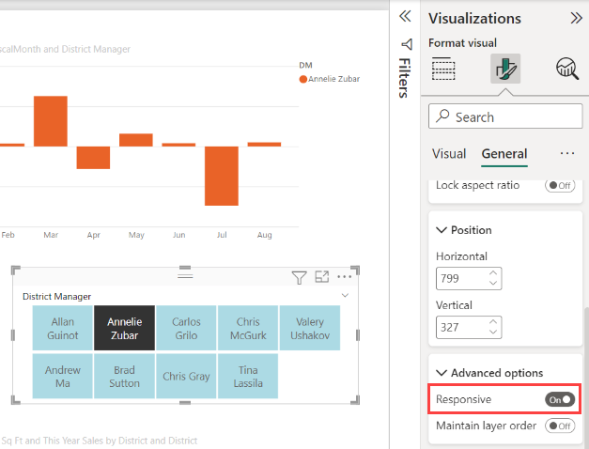
Responsive layout works only for tile and numeric range slicers, not for vertical list slicers. For more information about responsive layouts, see Create a responsive slicer you can resize.
For range slicers, responsive formatting changes the slider style and lets you resize more flexibly. Read more about numeric range slicers.

Selection controls
- The Show "Select all" option is Off by default. Under Selection, turn Show "Select all" option to On to add a Select all item to the slicer. Use it to select or deselect all items at once. When all items are selected, selecting one item deselects it, which allows an is-not filter.
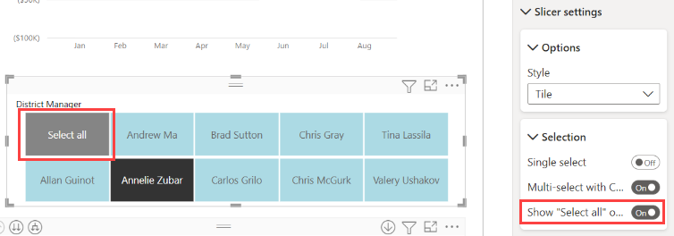
- Single select is Off by default. Select an item to select it. Hold Ctrl to select multiple items. Select an item again to deselect it.
When Single select is On, you can select only one item. In vertical list slicers, the check boxes become radio buttons.

Title options
The Title text in Slicer header is On by default. This selection shows the data field name at the top of the slicer. You can edit the title text, which is especially useful for hierarchy slicers. See Change the title text in the article "Add multiple fields to a hierarchy slicer" for details.
Title on the General tab is another option. It's Off by default.

Other formatting options
Other formatting options are Off by default. Turn On these options to control them:
- Lock aspect: Keep the relative height and width of the slicer if it's resized. Under General > Properties > Size.
- Background: Add a background color to the slicer and set its transparency. Under General > Effects.
- Border: Add a border around the slicer and set its color. Under General > Effects.
There's also a Border option on the Visual tab. It adds a border either over, under, or next to each option in the slicer. It's separate from and unaffected by the General settings.
- Shadow: Add a drop shadow to the slicer. Under General > Effects.

Search in slicers
When working with slicers that contain many values, searching helps you quickly locate specific items without scrolling through the entire list.
To enable and use search in a slicer:
- Select the ellipsis (...) in the top-right corner of the slicer, and then select Search from the dropdown menu. Alternatively, select the slicer and press Ctrl+F.
- A search bar appears at the top of the slicer. Type a name or keyword in the search bar. The slicer instantly filters to show only matching entries.
For example, entering the letter "C" filters the slicer to show only items that begin with or contain that letter.
For more information about List slicer search capabilities, see Search and filter list slicer.

Intro to the Filters pane
You can apply filters in the Filters pane, or make selections in slicers directly on the report page itself. The Filters pane shows the fields in individual visuals and any other filters the report designer adds.
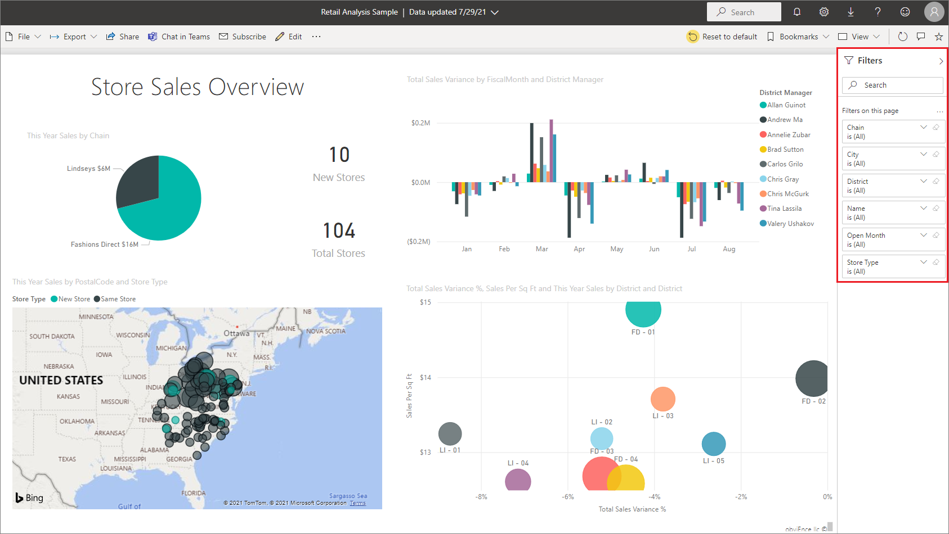
There are four standard types of filters that you create in the Filters pane.
- Visual filter applies to a single visual on a report page. You see visual-level filters when you select a visual on the report canvas. Even if you can't edit a report, you can select a visual and filter it.
- Page filter applies to all the visuals on the report page.
- Report filter applies to all pages in the report.
- Drillthrough filter With drillthrough in the Power BI service and Power BI Desktop, you create a destination report page that focuses on a specific entity, such as a supplier. From the other report pages, users can right-click a data point for that entity and drill through to the focused page.
To create the visual, page, and report filters, see Add a filter to a report in Power BI.
To create drillthrough filters, see Set up drillthrough in Power BI reports.

Basic and advanced filtering
By default, report readers can switch from Basic to Advanced filtering.
Basic filters show a list of all the values in the field. You can search in page, visual, and report filters, in Reading or Editing view, to find and select the value you want.
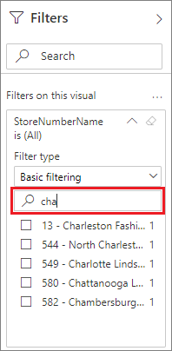
A filter with the word All next to it is unfiltered, showing all the values in the field. For example, Chain is (All) means the report page includes data about all the store chains. In contrast, the report-level filter FiscalYear is 2013 or 2014 means the report is only showing data for the fiscal years of 2013 and 2014.
Advanced filters let you use more complicated filters. For example, you could search for values that contain or don't contain, start with or don't start with, a specific value.
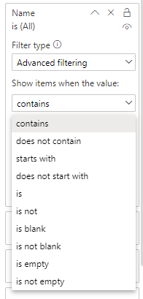
When you create a report, you can turn off switching and not allow report readers to change filter types. You can also turn off searches in the filter pane.

Add a filter to an entire page
To apply a filter to all visuals on a page, you can add a page-level filter.
- Power BI Desktop
- Power BI service
- In Power BI Desktop, open the Retail Analysis report.
- Select Report view , and then go to the District Monthly Sales page.
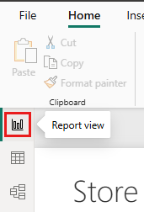
- Open the Filters, Visualizations, and Data panes, if they're not already open.
- On the Data pane, locate the field that you want to add as a new page-level filter. Drag that field to the Filters pane, into the area under Filters on this page that's labeled Add data fields here. In this example, the District Manager field is added to that area.
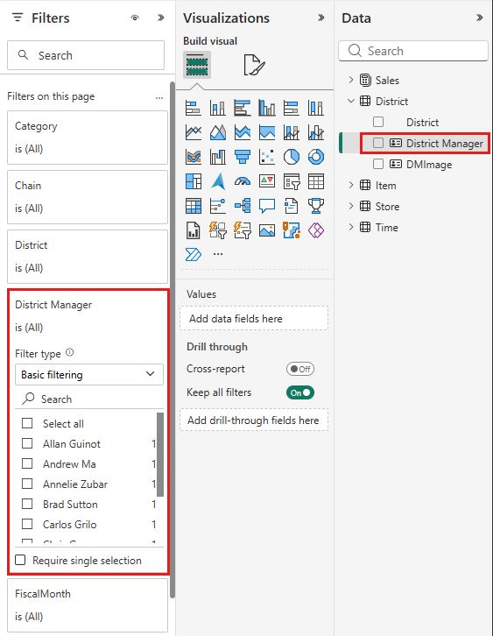
- On the Filters pane, go to the filter for the District Manager field. Under Filter type, select Advanced filtering or Basic filtering, and then set the values or conditions you want to use in your filter.
All the visualizations on the page are redrawn to reflect the change.
If you save your report with the filter, report readers can interact with the filter in Reading view by selecting or clearing values.

Add a report-level filter for an entire report
To apply a filter to all visuals in a report, you can add a report-level filter.
- Power BI Desktop
- Power BI service
- In Power BI Desktop, select Report view .
- Open the Filters, Visualizations, and Data panes, if they're not already open.
- On the Data pane, locate the field that you want to add as a new report-level filter. Drag that field to the Filters pane, into the area under Filters on all pages that's labeled Add data fields here.
- Select the values you want to use in your filter.
The visuals on the active page, and on all pages in the report, change to reflect the new filter. If you save your report with the filter, report readers can interact with the filter in Reading view by selecting or clearing values.

Filters in Reading or Editing view
There are two modes for interacting with reports in the Power BI service: Reading view and Editing view. The filtering capabilities available to you depend on which mode you're in.
- In Reading view, you can interact with any filters that already exist in the report and save the selections you make. You can't add new filters.
- In Editing view, you can add all kinds of filters. When you save the report, the filters are saved with the report even if report readers open it in a mobile app. People looking at the report in Reading view interact with the filters you added, but they can't add new filters.

Filters in Reading view
In the Power BI service, if you select a visual in Reading view, the Filters pane looks similar to this example:
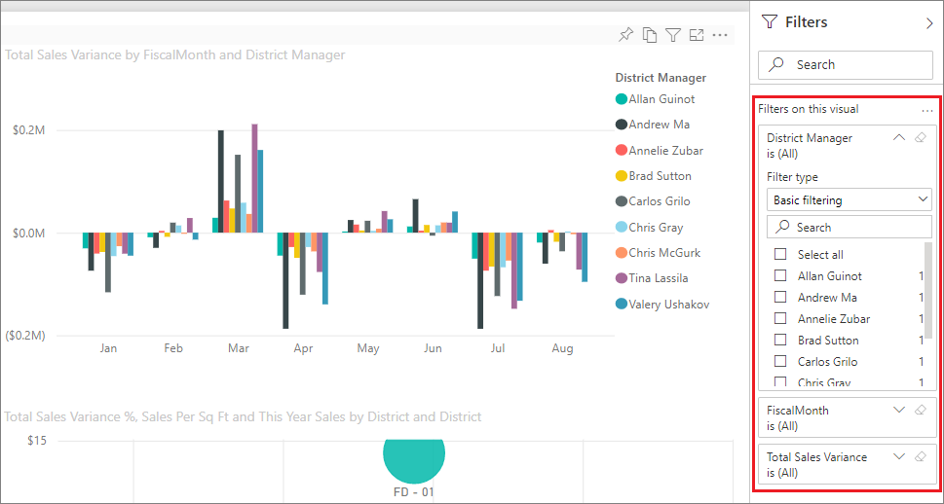
Each visual has filters for all of the fields in the visual. When you create a report, you can add more. In this Filters pane, the visual has three filters.
In Reading view, you explore the data by modifying the existing filters. You're only filtering your view of the report. When you exit the report, the changes you make are saved with your view of the report even if you open the report in a mobile app. To undo your filtering and return to the defaults set by the report author, select Reset to default from the top menu bar.
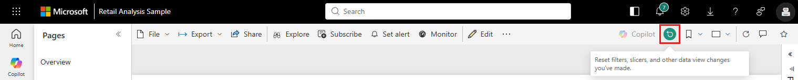

Filters in Editing view
When you open a report in Power BI Desktop, you see that Filters is just one of several editing panes available. You see the same panes if you open a report in Editing view in the Power BI service.
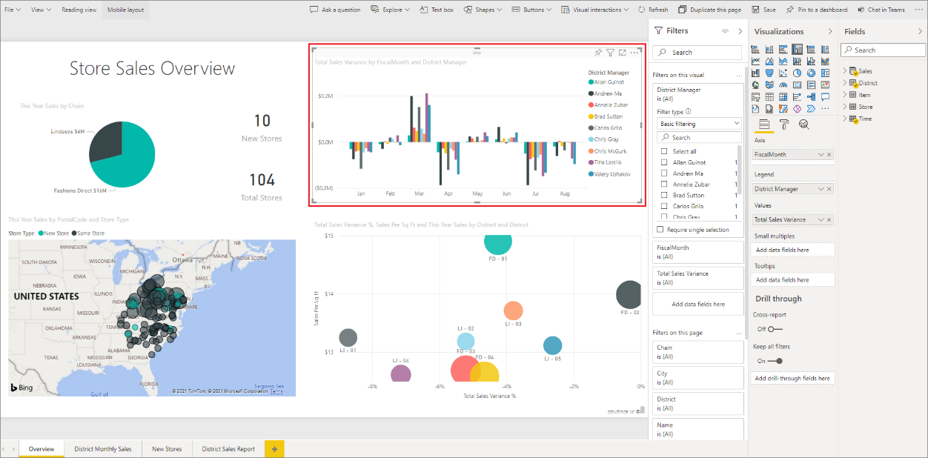
This page of the report has four page-level filters. By selecting the column chart, we see it also has three visual-level filters.

Work with filters in Editing view
- Learn how to Add filters to a report in Power BI Desktop and in Editing view in the Power BI service.
- After you add filters, you have lots of formatting options for them. For example, you can hide, lock, or reorder filters, or format them to match the rest of the report. Learn how to format filters in a report.
- You can also change the way the visuals interact. To fine-tune cross-highlighting and cross-filtering, see Change how visuals interact in reports.

Cross-filter and cross-highlight visuals
You can explore the relationships between the visuals in your report without using filters or slicers. Select a value or axis label in one visual to cross-filter or cross-highlight the related values in other visuals on the page. They don't all behave the same.
- Cross-highlighting Selecting a value in one visual highlights the related data in visuals such as column and bar charts. Cross-highlighting doesn't remove the unrelated data from those visuals. The unrelated data is still visible but dimmed.
- Cross-filtering Selecting a value in one visual acts more like a filter in other visuals, such as line charts, scatter charts, and maps. In those visuals, only the related data remains visible. The unrelated data isn't visible, just as you'd see with a filter.
To remove the highlighting, select the value again, or select any empty space in the same visual. For more examples, see the Cross-filtering and cross-highlighting section of "How visuals cross-filter each other in a Power BI report."
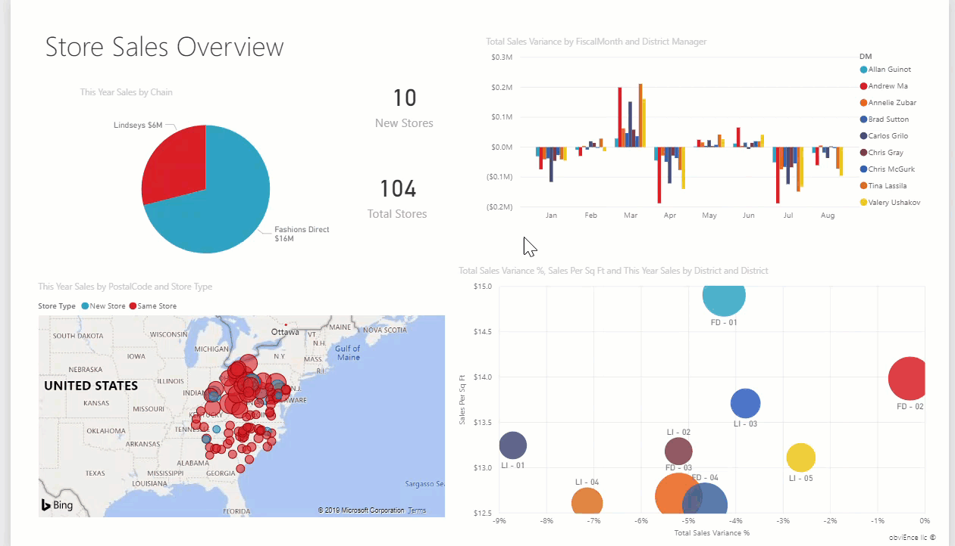

Types of filters in Power BI reports
Filters don't all behave the same way because they're not created the same way. How you create them influences how they behave in the filter pane in editing mode. This article describes the different kinds of filters, the different ways you create them, and the different things they're good for. For more information, see add filters to reports.
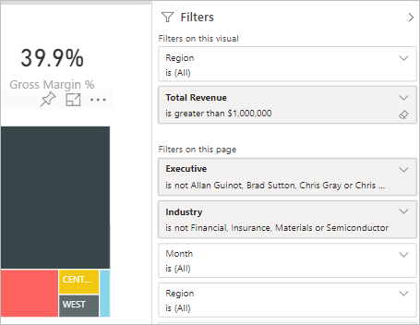

Compare filter types
This table compares what authors can do with the different types of filters. Select a link to read more about each type.
Filter type | Edit | Clear | Delete | Hide | Lock | Sort | Rename
Automatic filters | Y | Y | N | Y | Y | Y | Y
Manual filters | Y | Y | Y | Y | Y | Y | Y
Include/Exclude filters | N | N | Y | Y | Y | Y | N
Drill-down filters | Y | Y | N | N | N | N | N
Cross-drill filters | N | N | N | N | N | N | N
Drillthrough filters (Invokes drillthrough) | Y | Y | Y | Y | Y | N | N
Drillthrough filters (Transient) | Y | Y | Y | N | N | N | N
URL filters - transient | Y | Y | Y | N | N | N | N
Pass-through filters | N | N | Y | Y | N | Y | N
Start with the two most common filter types: automatic and manual.

Automatic filters
Automatic filters are automatically added to the visual level of the filter pane when you build a visual. These filters are based on the fields that make up your visual. Users with edit permission to the report can edit, clear, hide, lock, rename, or sort this filter in the pane. They can't delete automatic filters because the visual refers to those fields.

Manual filters
Manual filters are the filters that you drag and drop in any section of the filter pane when you're editing a report. If you have edit permission to the report, you can edit, delete, clear, hide, lock, rename, or sort these filters in the pane.

More advanced filters
These next filter types are less common, but you still want to understand them if they're displayed in your report. You might find them useful in creating the ideal filter for your report.

Include and exclude filters
Include and exclude filters are automatically added to the filter pane when you use the include or exclude functionality for a visual. If you can edit a report, you can delete, lock, hide, or sort this filter in the pane. You can't edit, clear, or rename an include or exclude filter because it's associated with the include and exclude functionality of visuals.
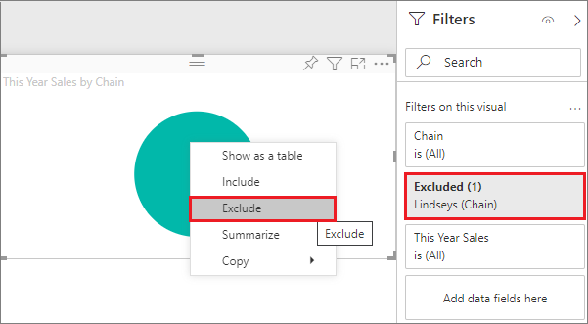

Drill-down filters
Drill-down filters are automatically added to the filter pane when you use the drill-down functionality for a visual in your report. If you can edit a report, you can edit or clear the filter in the pane. You can't delete, hide, lock, rename, or sort this filter because it's associated with the drill-down functionality of visuals. To remove the drill-down filter, select the drill-up button for the visual.
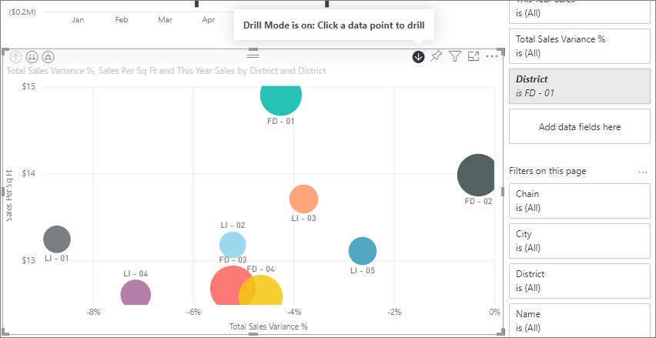

Cross-drill filters
Cross-drill filters are automatically added to the pane when a drill-down filter is passed to another visual on the report page via the cross-filter or cross-highlight feature. Even if you can edit a report, you can't delete, clear, hide, lock, rename, or sort this filter because it's associated with the drill-down functionality of visuals. You also can't edit this filter because it comes from drilling down in another visual. To remove the drill-down filter, select the drill-up button for the visual that's passing the filter.

Drillthrough filters
Drillthrough filters get passed from one page to another via the drillthrough feature. They show in the Drillthrough pane. There are two types of drillthrough filters. The first type invokes the drillthrough. If you can edit a report, you can edit, delete, clear, hide, or lock this type of filter. The second type gets passed to the target, based on the page-level filters of the source page. You can edit, delete, or clear this transient type of drillthrough filter. You can't lock or hide this filter for end users.
Read about creating drillthrough filters.

URL filters
URL filters get added to the pane by adding a URL query parameter. If you can edit a report, you can edit, delete, or clear the filter in the pane. You can't hide, lock, rename, or sort this filter because it's associated with the URL parameter. To remove the filter, you remove the parameter from the URL. Here's an example URL with a parameter:
app.powerbi.com/groups/me/apps/app-id/reports/report-id/ReportSection?filter=Stores~2FStatus%20eq%20'Off'
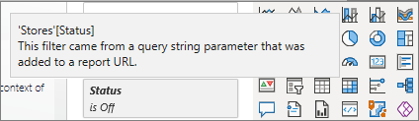
For more information, see setting up URL filters.

Pass-through filters
Pass-through filters are visual-level filters created through Q&A. If you can edit a report, you can delete, hide, or sort these filters in the pane. However, you can't rename, edit, clear, or lock these filters.
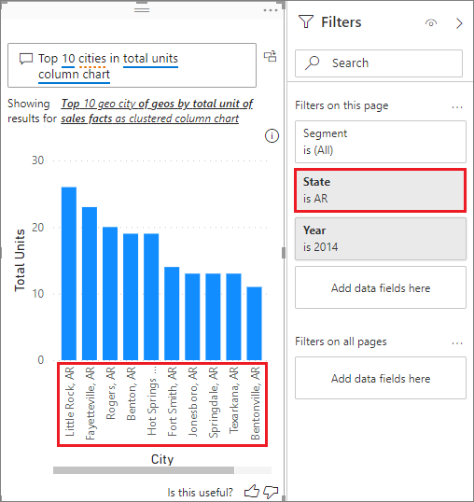

What are relationships in Power BI?
In Power BI, relationships are the links between tables. They’re created when two tables share a common key, such as a date, campaign ID, or account ID, and they tell Power BI how data should be combined and how filters should propagate.
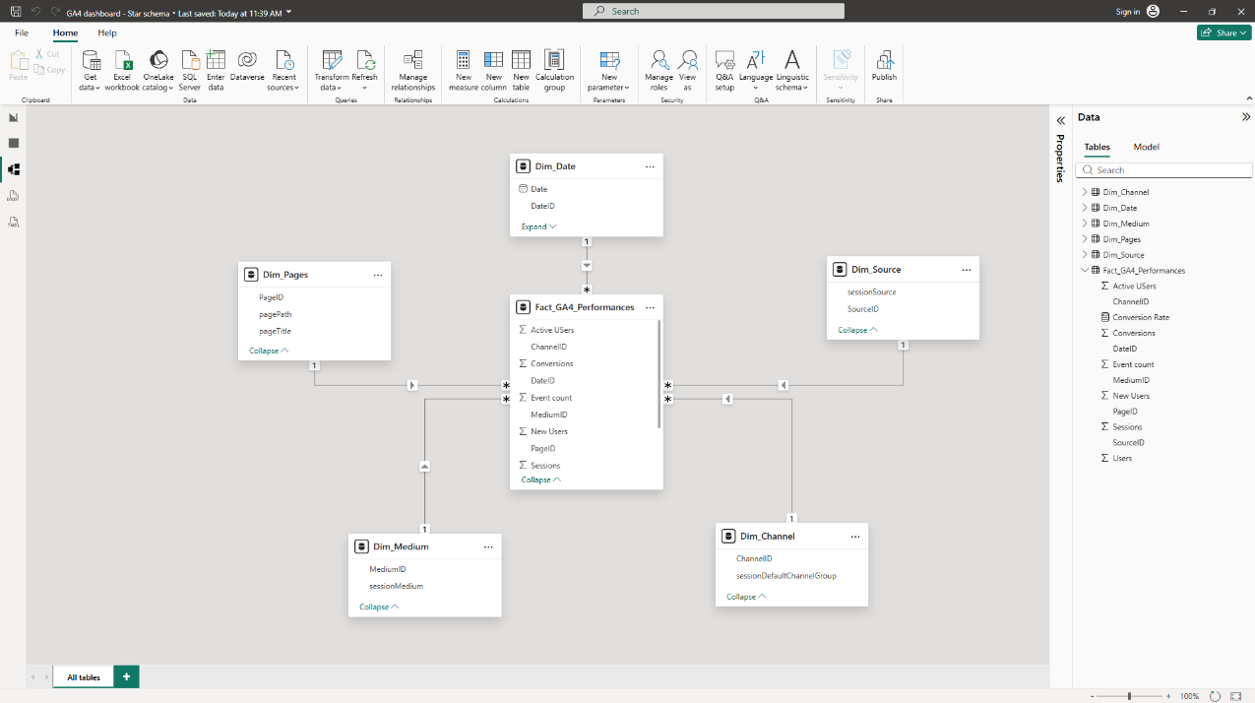
You’ll mainly see and manage relationships in the Model view, where tables are connected by lines. Power BI may create some relationships automatically, but it’s important to review them, because relationships directly determine whether your KPIs react correctly when you filter by date, campaign, channel, or country.

How relationships work in Power BI
A relationship connects two tables through a shared key and defines how filters move between them. When a filter is applied to one table, Power BI uses relationships to determine which rows in other tables should be included.
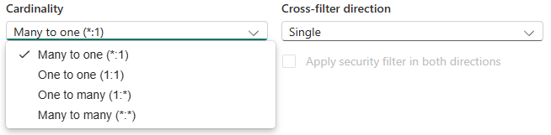
In a marketing context, relationships are what make it possible to filter performance metrics by date, campaign, channel, country, or any other dimension. Without correct relationships, KPIs lose their meaning.

One-to-many relationships (the default and safest option)
A one-to-many relationship is the most common and recommended relationship type in Power BI. It means that one row exists on the “one” side (usually a dimension table), while many rows exist on the “many” side (usually a fact table). Filters flow from the one side to the many side.
In the Power BI interface, you may also see this relationship displayed as many-to-one, depending on which table is selected first. Both represent the same underlying structure and behave identically.
Typical marketing examples include:
- Date → daily performance data
- Campaign → ad performance
- Channel → sessions or conversions
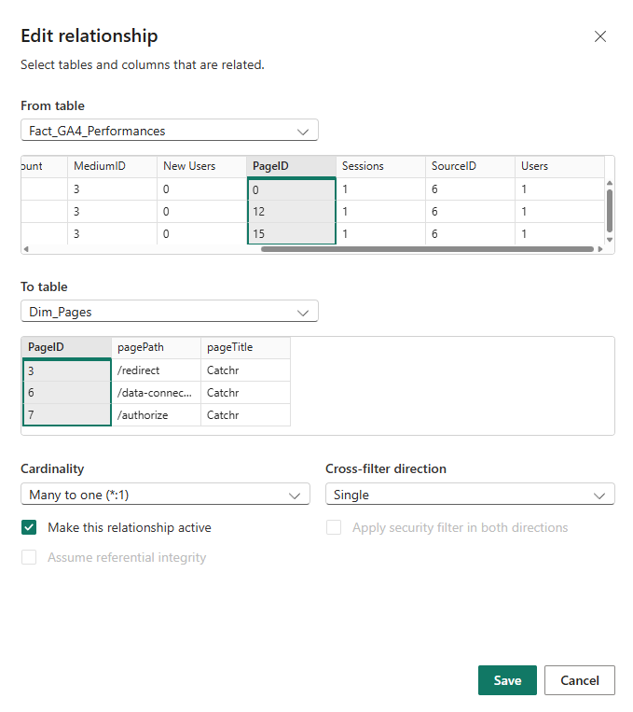
This relationship type aligns perfectly with a star schema and produces predictable filtering and aggregation.

Many-to-many relationships (use with caution)
A many-to-many relationship occurs when both tables contain multiple rows for the same key.
While Power BI supports this type of relationship, it often introduces ambiguity:
- Filters may apply in unexpected ways
- Totals can be duplicated or inflated
- KPI logic becomes harder to reason about
Marketing scenarios that can trigger many-to-many relationships include:
- Campaigns associated with multiple tags or categories
- Users belonging to multiple segments
In many cases, many-to-many relationships are a signal that the data model needs to be restructured, often by introducing a proper dimension table or adjusting granularity.

One to one (1:1)
A one-to-one relationship means:
- Each row in one table matches exactly one row in the other table
This is less common in marketing, but it can happen when:
- A table is split for technical or organizational reasons
- Additional attributes are separated into a secondary table
Because both tables have the same granularity, this relationship is usually safe, but often unnecessary unless there is a clear reason to separate the data.

Relationship cardinality recap
Cardinality | What it means | Typical marketing usage | Recommendation
One to many (1:*) | One dimension row links to many fact rows. | Date → daily performance, Campaign → ad metrics, Channel → sessions/conversions | ✅ Recommended
Many to one (*:1) | Same structure as 1:*, shown from the opposite side in the UI. | Same use cases as one-to-many. | ✅ Safe
One to one (1:1) | One row matches one row on both sides. | Split tables, auxiliary attributes at the same granularity. | ⚠ Use only if needed
Many to many (*:*) | Multiple rows can match on both sides. | Rare edge cases; often signals a modeling issue. | ❌ Avoid if possible

Cross-filter direction (how filters propagate)
Cross-filter direction determines how filters move between tables.
- Single direction means filters flow from the dimension table to the fact table.
- Both directions allow filters to flow both ways between tables.
Single direction is recommended in most marketing models because it is:
- easier to understand
- less error-prone
- aligned with star schema logic
Bidirectional filtering can be useful in specific scenarios, but it also increases the risk of ambiguous filter paths and unexpected results.

Active vs inactive relationships
Power BI allows multiple relationships between the same tables, but only one can be active at a time.
- Active relationships are used automatically by visuals
- Inactive relationships exist in the model but are ignored unless explicitly activated in a measure
Marketing examples include:
- Click date vs conversion date
- Order date vs attribution date
Inactive relationships are not a problem by themselves, but they require deliberate use and clear intent.
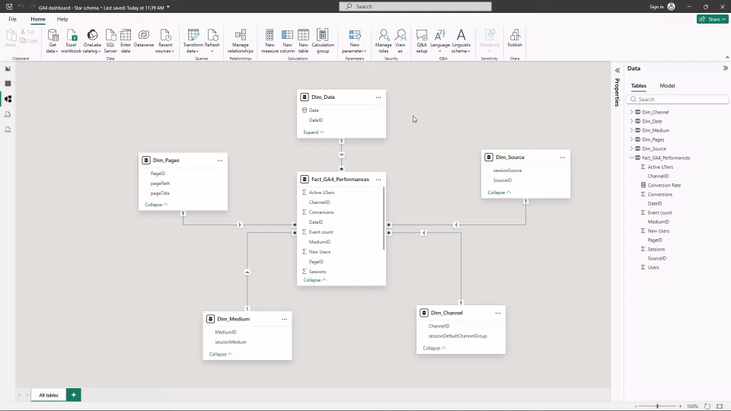
You can quickly manage relationships from the Properties tab.

Common relationship mistakes marketers make
Some mistakes appear frequently in marketing dashboards:
- Linking fact tables directly together
- Using many-to-many relationships without understanding the impact
- Enabling bidirectional filtering to “fix” incorrect numbers
- Assuming that matching column names automatically creates a relationship
These issues rarely cause visible errors, but they often lead to incorrect KPIs and misleading insights.

Dimensions and fact tables – what is it and how to work with them in Power BI
This (very simplistic) article describes what a dimension and a fact table are, how they differ from each other, and especially how to work with them in Power BI.
In our example, we will start from these tables – in the left there are items on orders, then there are orders and products. We can see that:
- Tables can be logically connected, using numbers of orders and numbers of products (red and green color).
- The table on the left side is called “Fact table”, the smaller tables are called “Dimensions”.
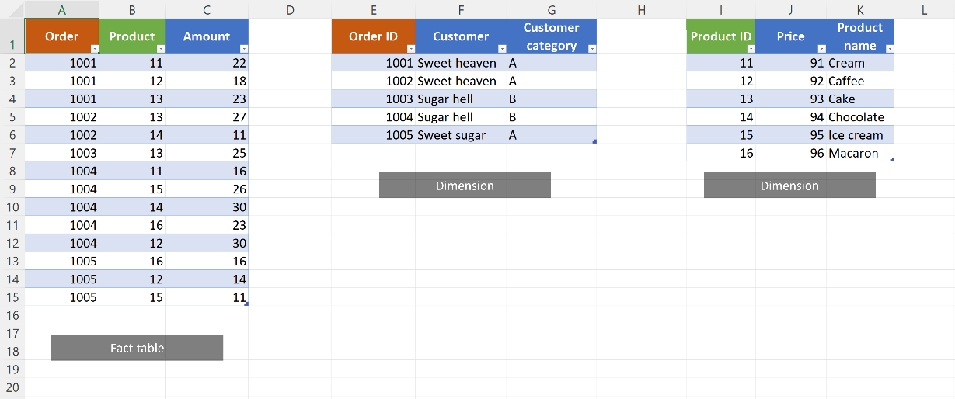
So what is the difference between fact tables and dimensions?

Fact table
Fact table is a table, which typically:
- contains values we want to calculate
- is longer than dimension, because it repeats values that are unique in dimensions (like order ID´s, product ID´s…).

Dimension
Dimenzson is a table, which adds some additional info to a fact table information. For example to ID product 11 it provides the info about price (91) and name (Cream).

Power BI
In reports generated from data models we normally use columns from both dimensions and fact tables.
When loaded to Power BI, the tables look like this:
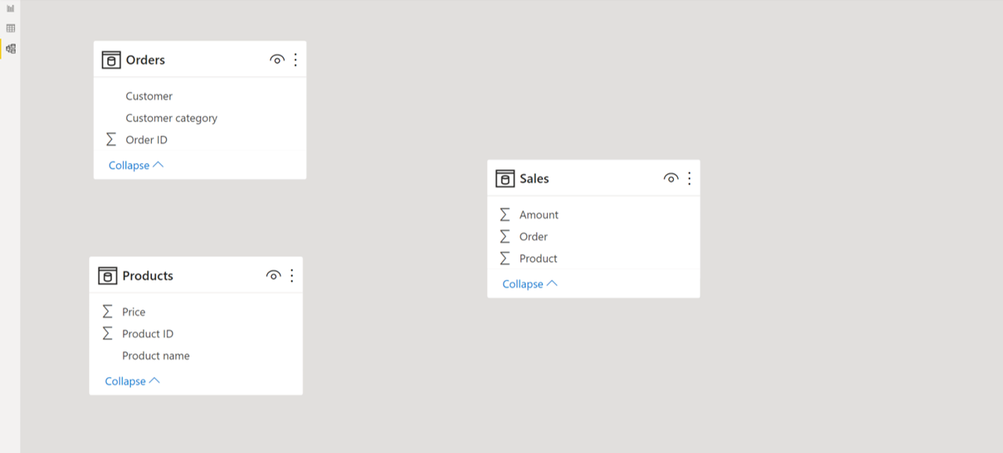
Now lets define which columns are connected. These connections are called “relationships” and can be simply done by dragging of column from one table to another.
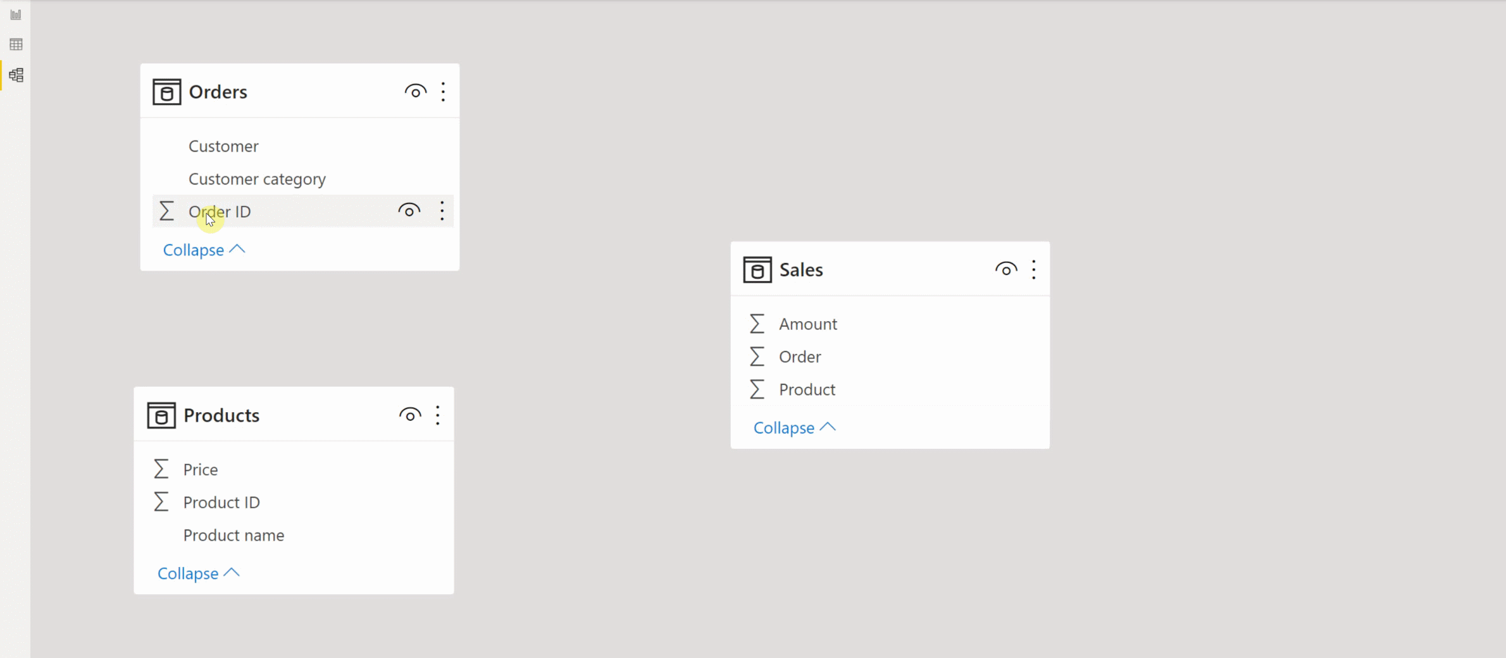These columns are called “keys”. The key column must have unique values in dimension, but usually it has repeated values in a fact table.
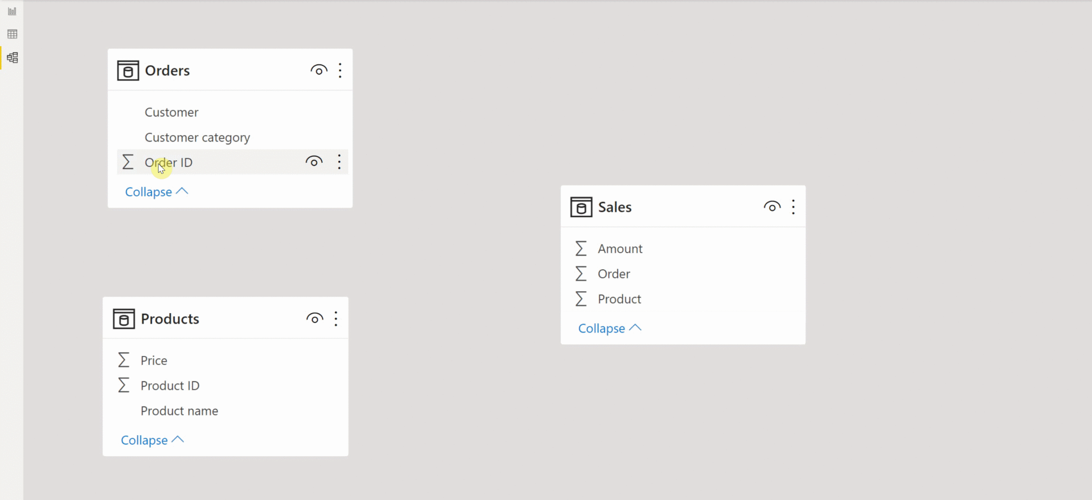
The relationship line has “1” on one side and star on the other. The star is on the of fact table side (repeated values), number 1 is on the side of dimension (unique values).
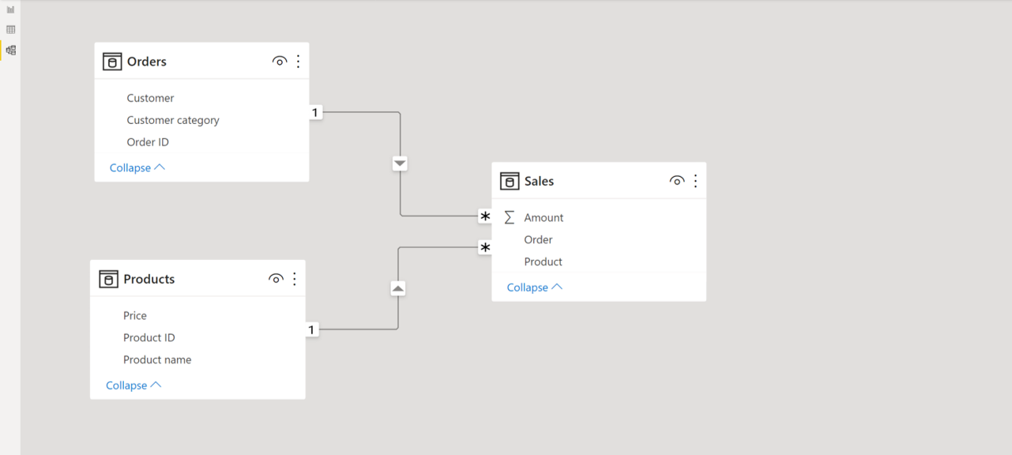

Reports
What does it mean for report creation (or Pivot tables in Power Pivot)?
- Usually, the columns from fact tables take place in fields like “Values” – they contain numbers we want to calculate.
- Columns from dimensions usually belong to fields for grouping – like “Rows”, “X Axis”, “Category”…

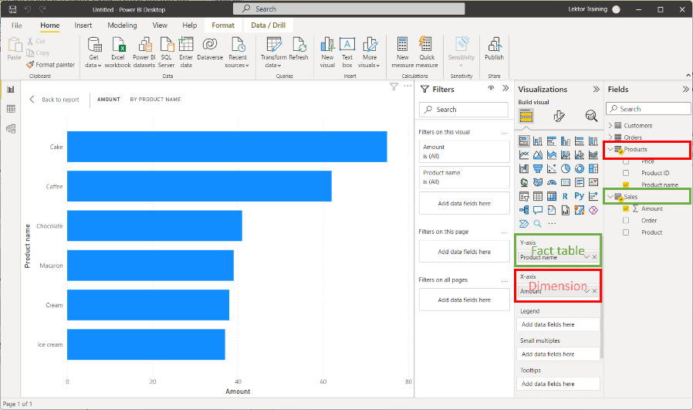

Something more about dimensions
- Some table can be a dimension and fact table in one moment (however, it is not recommended in Power BI). For example here the “Orders” table is a dimension for “Sales” and a fact table for “Customers”.
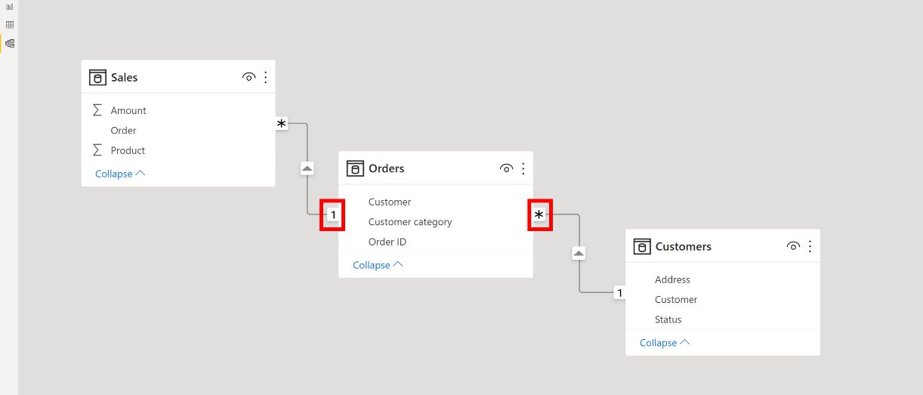
- Dimension is quite often connected to multiple fact tables
Example:
To clean and transform raw sales data using Power Query, you would typically follow a structured process involving connecting to the data source, applying various transformation steps within the Power Query Editor, and then loading the cleaned data.
Here is a breakdown of the typical steps:
Phase 1: Connect and Load Data
- Open Power Query Editor: Launch Excel or Power BI, go to the Data tab, and select Get Data (or New Query) to open the Power Query Editor.
- Connect to your Source: Choose your data source (e.g., CSV file, Excel workbook, SQL database) and import the raw sales data into the editor [1].
Phase 2: Cleaning and Transformation Steps
Once in the Power Query Editor, you will use various functions to clean and shape the data. Key steps often include:
- Remove or Filter Unnecessary Rows/Columns: Identify and eliminate irrelevant columns or filter out rows that contain errors, blanks, or data you do not need (e.g., test sales data) [2].
- Handle Missing Values: Deal with null or empty values by either removing the corresponding rows, replacing them with a specific value (like zero or "N/A"), or using more advanced imputation methods [1, 2].
- Standardize Data Types: Ensure that columns are set to the correct data type (e.g., 'Date' for date columns, 'Decimal Number' for price, 'Text' for product names). Incorrect types can cause errors in later analysis [1, 2].
- Clean Text Data:
  - Trim Whitespace: Remove leading/trailing spaces from text entries.
  - Standardize Case: Change text to proper case, uppercase, or lowercase for consistency [1].
  - Replace Values: Correct common misspellings or use the same term for similar items (e.g., replacing "USA" with "United States") [2].
- Split or Merge Columns:
  - Split: Separate combined data, such as splitting a full name column into "First Name" and "Last Name" [2].
  - Merge: Combine related columns, like merging "Street Address", "City", and "Zip Code" into a single "Full Address" column.
- Transform and Shape Data:
  - Pivot/Unpivot Columns: Transform the layout of the data (e.g., convert data where each month is a column into a structure where all months are in a single "Month" column with corresponding "Sales" values) [1].
  - Create Custom Columns: Add new columns based on calculations or conditions (e.g., a "Profit Margin" column calculated from 'Price' and 'Cost' columns, or a "Sales Tier" column using conditional logic) [1].
- Remove Duplicates: Ensure data integrity by removing duplicate rows based on all columns or specific key columns (e.g., Order ID) [1, 2].
Phase 3: Load the Cleaned Data
- Apply and Close: Once all transformations are complete, click Close & Load in the Power Query Editor.
- Load to Destination: The cleaned and transformed data will be loaded into your desired destination (e.g., a new sheet in Excel, or directly into the Power BI data model), ready for analysis or reporting [1].

Create a card visual in Power BI
APPLIES TO: Power BI Desktop Power BI service
The card visual in Power BI is a versatile tool for presenting summary measures in a visually appealing format. Each card can display a specific measure, such as total sales or profit growth, and you can customize it to reflect your objectives and key results (OKRs). This flexibility allows you to group multiple cards within a single visual, format them to match your report, and share a comprehensive overview in each card.
Combining multiple measures and reference labels in one visual improves the report performance by reducing visual load time and optimizing underlying queries to the semantic model.
.

Prerequisites
In the following guide, you use the Retail Analysis Sample file. Use the steps for your environment:
- Power BI Desktop
- Power BI service

- Launch Power BI Desktop.
- From the left-side navigation pane, select Open, or select File > Open from the menu.
- Locate and select your copy of the Retail Analysis Sample PBIX. The file opens in report view.

Create a card visual
You can create a card visual in several ways:
- Start from the Visualizations pane and select the card visual icon.
- Expand the Data pane, select the necessary data fields, then select the card visual icon from the Visualizations pane.
- In Power BI Desktop, you can also start from the Insert ribbon, select New visual, then select the card visual icon from the Visualizations pane.
For this article, use the first option:
- From the Visualizations pane, make sure the Build visual tab is selected, then select the card visual icon in the visual gallery.
- Use the Data pane to add data to the visual. You can add data by selecting each field in the Data pane, dragging the fields to the field wells on the Visualizations pane, or dragging the fields directly to the visual placeholder on the report canvas. Expand the Sales group, then drag StoreCount and TotalSalesLY to the Value field well. You see that each data field you added is displayed as its own card.
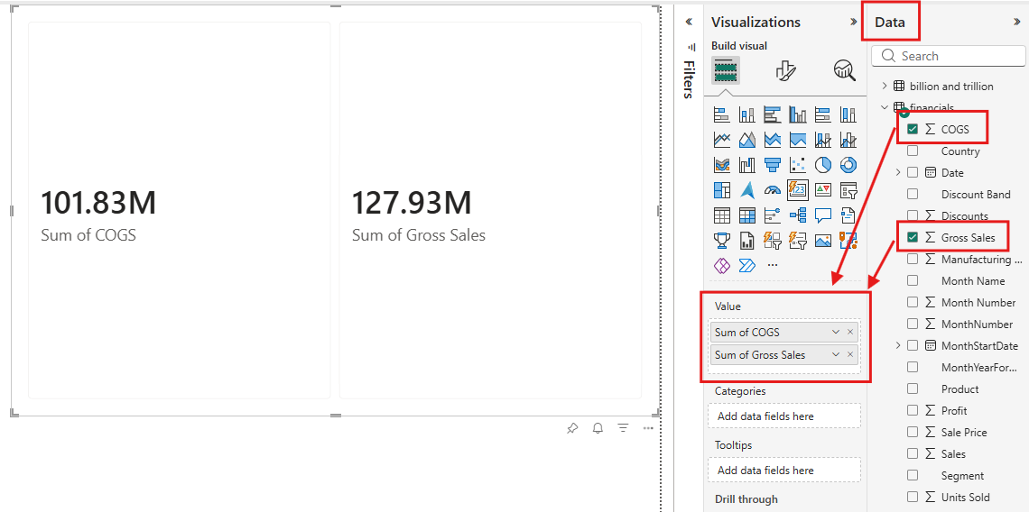
- To customize your visual, select the Format visual icon in the Visualizations pane. You can access all available settings under the Visual and General tabs. This access allows you to tailor the chart's appearance and functionality to your specific requirements.
You successfully created a card visual with Power BI. Now that you understand how to build a card visual, let's explore some of the other key features that this visual offers.

Customize the card visual layout
Let's dive into layout features that make your visuals more organized and visually appealing. Under the Visual tab, you can find different parts of the card visual to customize. The Multicategory layout formats the organization of the category headers (such as Canada, Germany). The Multicard layout customizes the layout of the cards within each category. Each card can have three sections: callout, hero image, and reference label. To understand the difference between callouts and hero images, see the Add an image section. Reference labels layout controls how the reference labels are organized.
Within each of these parts of the card, you can further customize the look and feel including gaps, padding, backgrounds, and more.
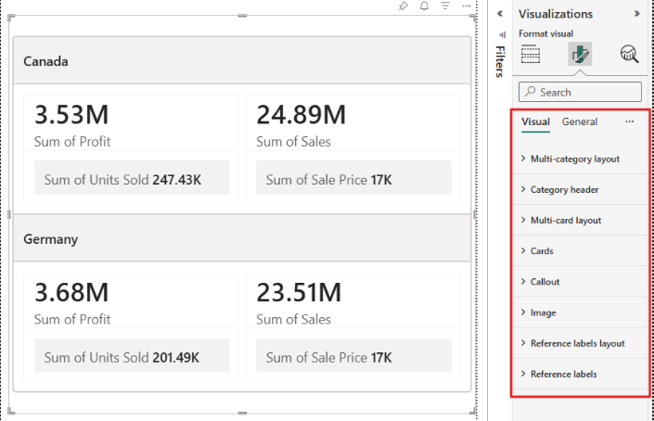

Add an image
The card visual in Power BI lets you create visually appealing cards that combine metrics with two image options for better context and branding:
- Callout: A value, label, or image that provides subtle enhancements that work well for branding elements or small visual cues without overwhelming the metric display.
- Hero image: A large, prominent image that can showcase product photos, campaign graphics, or branded imagery directly within the card.
To add images to your card visual:
- Add a hero image: With the card visual selected, select the Format visual icon in the Visualizations pane. Under the Visual tab, expand the Image card. Select your card in the Cards dropdown, and then set the Image toggle to on.
- Add a callout image: From the Visualizations pane, select the Format visual icon. Under the Visual tab, expand the Callout card. Ensure your card is selected in the Apply settings, expand the Image controls, and then set the Image toggle to on.
For both image types, you can add it by uploading from your local device, pasting an image URL, or selecting an image from a data column. You can also customize the fit of the image and choose different image effects to enhance its appearance.
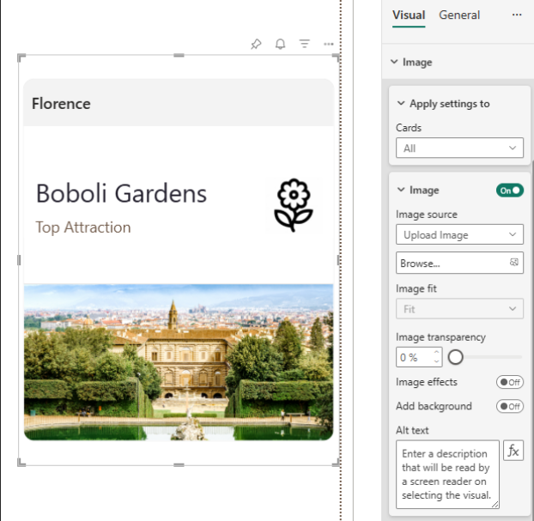

Apply enhanced formatting customizations
The card visual introduces a dynamic collage layout, letting you highlight one section while the other two share the remaining space. You can also customize the display order of the callout, reference label, and hero image and give them each different background colors.
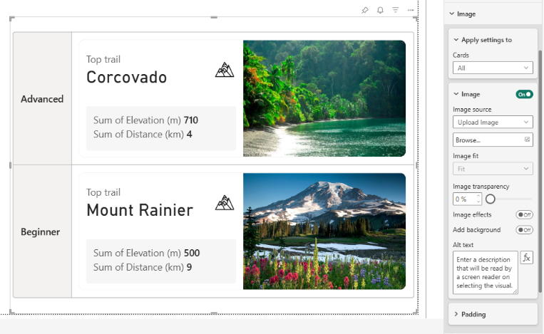

What Are Power BI Visuals?
Power BI visuals are graphical representations of data within the Power BI platform. They are designed to help users gain insights from data by making complex information more accessible and understandable. Visuals make it easier to digest large volumes of data in a simplified format.
Visuals in Power BI can be categorized into three main types.
- Built-in visuals: Built-in visuals are the standard chart and graph types that come with Power BI, such as bar charts, pie charts, tables, and line graphs. These are commonly used in most reports and are essential for basic analysis.
- Advanced visuals: Advanced visuals offer more specialized capabilities, such as the decomposition tree and KPI visuals, which provide additional analytical power and interactivity.
- Custom visuals: Custom visuals are developed by the community or third-party vendors and can be imported into Power BI for unique use cases that go beyond what built-in visuals can offer.
Built-in visuals are helpful for quick analysis of data, while advanced visuals allow for more unique and specific analysis of data. Custom visuals provide an easy way for users to tap into the community to better make use of Power BI without manual creation of visuals.

Why Use Specific Power BI Visuals?
Choosing the right visual is just as important as the data itself. A well-selected visual enhances comprehension, directs attention to critical insights, and facilitates quicker decision-making. Different visuals are suited to different kinds of data and questions, and using the wrong visual can mislead users or obscure key information.
For example, a line chart is excellent for showing trends over time, while a bar chart is better for comparing different categories. Pie charts are useful for showing proportions, but can become confusing when there are too many segments.
The goal is always to match the visual to the analytical need. Tailored visuals not only enhance clarity but also improve engagement and help tell a more compelling data story.

Core Visualization Types in Power BI
Power BI offers a rich array of visualization types, each suited for specific types of analysis. Knowing which visuals to use and when can greatly enhance the effectiveness of your reports.
Before we begin, to effectively demonstrate Power BI visuals, we’ll use a mock finance dataset that simulates monthly financial performance for several departments in a company. This dataset includes metrics such as revenue, expenses, and profit across a 12-month period.
Here's the Python script to generate the dataset
import pandas as pd
import numpy as np

np.random.seed(42)
months = pd.date_range(start="2023-01-01", periods=12, freq='M')
departments = ['Sales', 'Marketing', 'IT', 'HR', 'Operations']

data = []
for dept in departments:
revenue = np.random.randint(100000, 500000, size=12)
expenses = revenue * np.random.uniform(0.6, 0.9, size=12)
profit = revenue - expenses
for i in range(12):
data.append({
'Department': dept,
'Month': months[i],
'Revenue': round(revenue[i], 2),
'Expenses': round(expenses[i], 2),
'Profit': round(profit[i], 2)
})

df = pd.DataFrame(data)
df.to_csv("mock_finance_data.csv", index=False)
Powered By

Basic charts and graphs
Now that you have your dataset, let’s work on importing it into Power BI Desktop.
Here’s how you can do that:
- Open Power BI Desktop.
- Click on the “Get Data” button in the Home tab.
- Select “Text/CSV” as the data source and click “Connect.”
- Navigate to your mock_finance_data.csv file and select it.
- Click “Load” to import the data into Power BI.
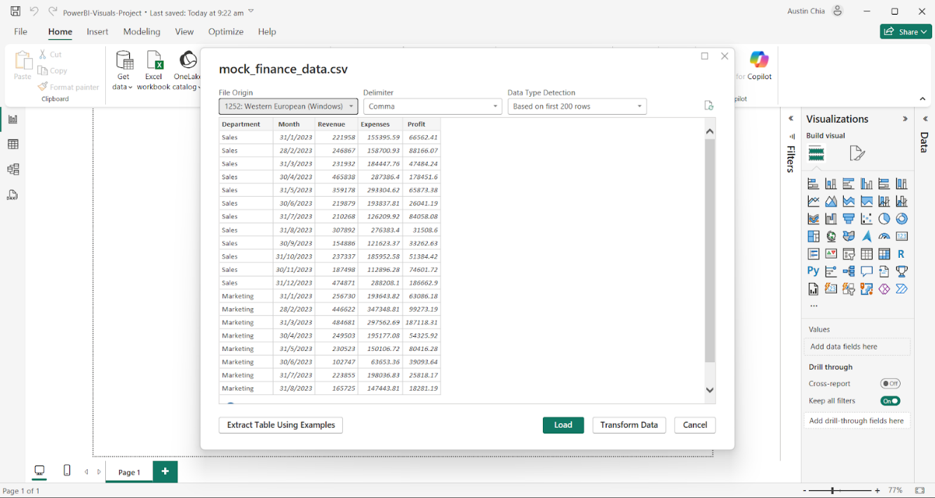
Congratulations, you have successfully imported your dataset! Now let’s move on to creating some basic charts and graphs to visualize this data.

1. Bar charts
Bar charts are among the most widely used visuals in Power BI. They provide a straightforward way to compare values across different categories, such as revenue by department.
To create a Bar Chart in Power BI:
- In the "Visualizations" pane, select the "Stacked Bar chart" icon.
- Drag a categorical field (e.g., Department) into the Y-axis field.
- Drag a numerical field (e.g., Revenue) into the X-axis field.
- Use the Format pane to customize colors, labels, and the title if required.
Here’s what your bar chart visual should look like:
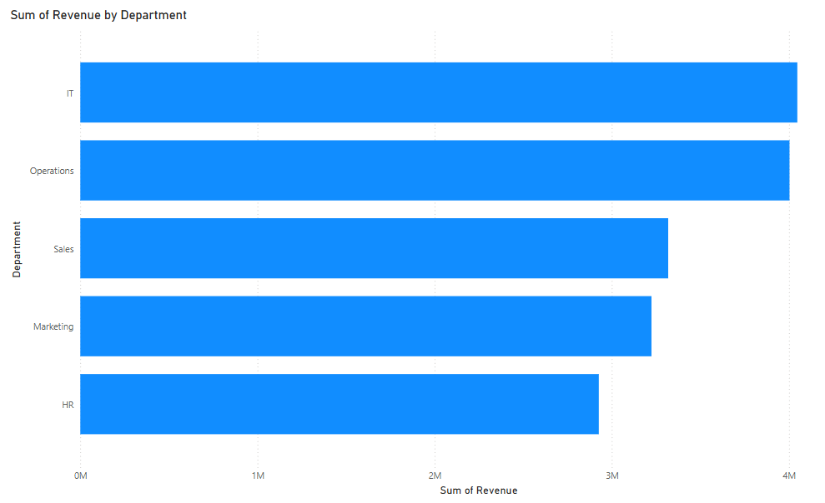

2. Column charts
Column charts serve a similar purpose, with vertical bars offering a quick view of magnitude.
To create a Column Chart in Power BI:
- In the "Visualizations" pane, select the "Clustered Column chart" icon.
- Drag a date field (e.g., Month) into the X-axis field.
- Drag a numerical field (e.g., Revenue) into the Y-axis field.
- Remove the “Quarter” and “Day” fields from the X-axi,s as our data only contains month information.
Here’s what your column chart visual should look like:
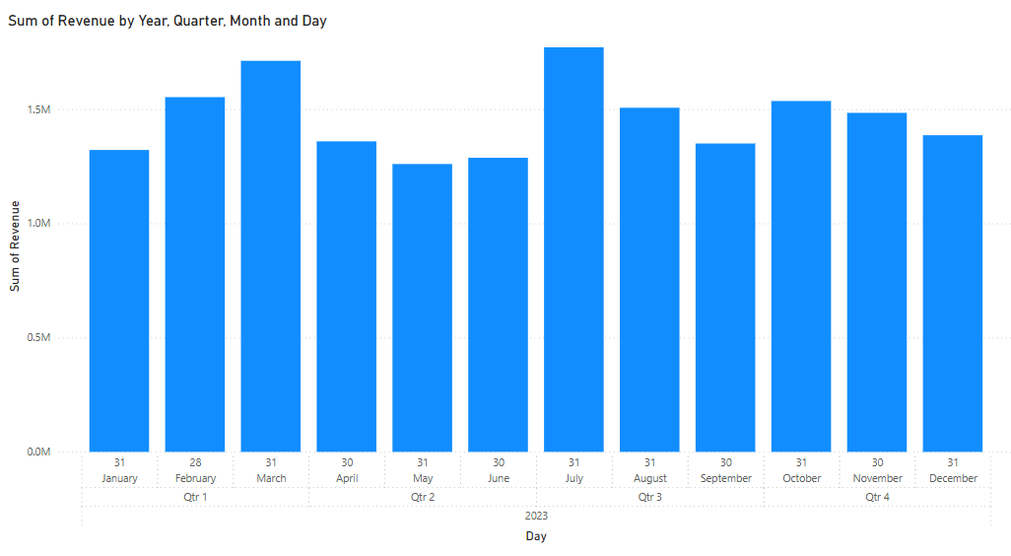

3. Line charts
Line charts are essential for displaying data trends over time and are particularly effective for showing month-by-month changes in key metrics such as revenue or profit.
To create a Line Chart in Power BI:
- In the "Visualizations" pane, select the "Line chart" icon.
- Drag a date field (e.g., Month) into the X-axis field.
- Drag a numerical field (e.g., Expenses) into the Y-axis field.
- In the X-axis field, click on the dropdown arrow and select “Month”.
Here’s what your line chart visual should look like:
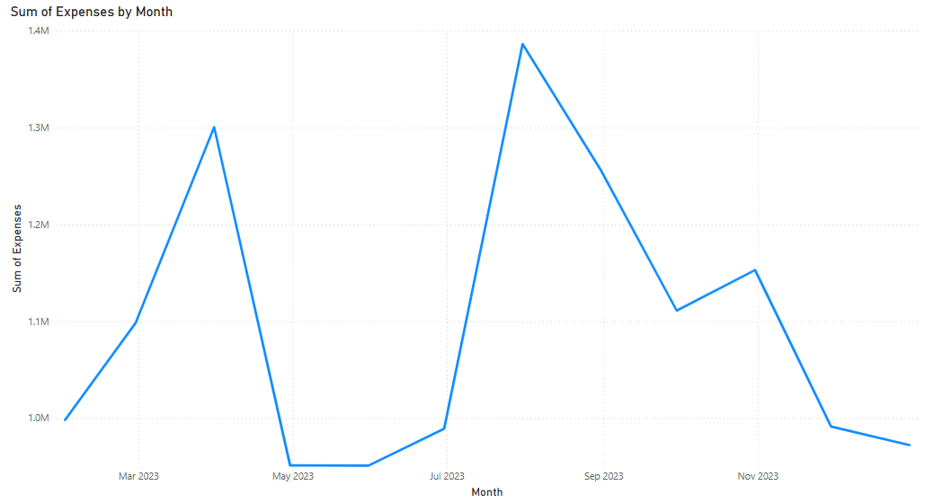

4. Area charts
Area charts build upon line charts by shading the space beneath the line, which can help emphasize volume.
To create a Area Chart in Power BI:
- In the "Visualizations" pane, select the "Area chart" icon.
- Drag a date field (e.g., Month) into the X-axis field.
- Drag a numerical field (e.g., Expenses) into the Y-axis field.
- In the X-axis field, click on the dropdown arrow and select “Month”.
Here’s what your area chart visual should look like:
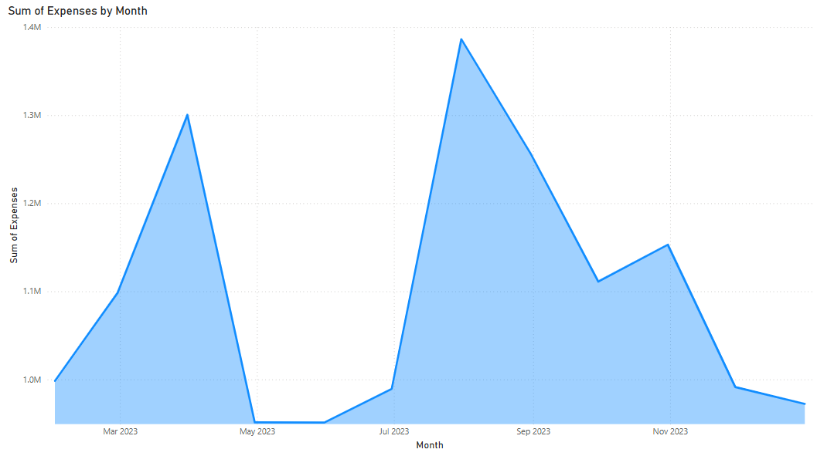

5. Pie charts
Pie and doughnut charts are best for showing proportions, like how much each department contributes to the overall profit. However, they should be used sparingly due to limitations in precision and scalability.
To create a Pie Chart in Power BI:
- In the "Visualizations" pane, select the "Pie chart" icon.
- Drag a categorical field (e.g., Department) into the Legend field.
- Drag a numerical field (e.g., Expenses) into the Values field.
- Use the Format pane to customize colors, labels, and the title.
Here’s what your pie chart visual should look like:
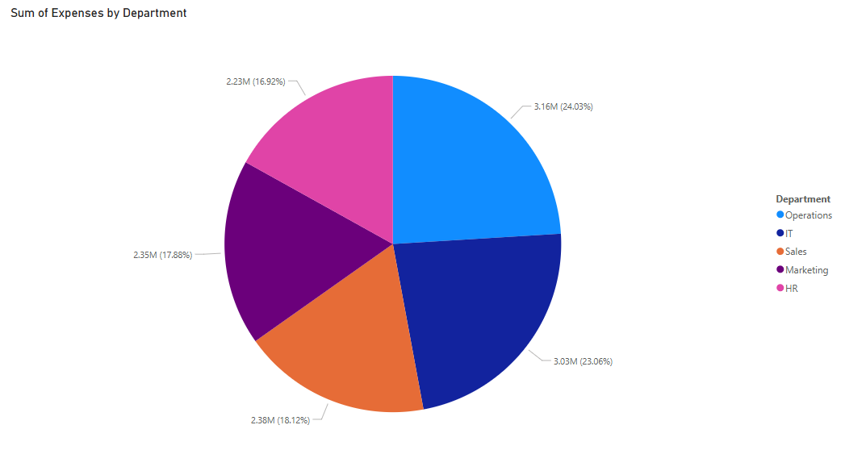

Hierarchical and Comparative Visuals

6. Matrix visual
Power BI matrix visuals expand upon tables by allowing users to drill down and analyze data at different levels of granularity. They are particularly useful for cross-tabulated data, such as tracking monthly revenue by department.
To create a Matrix visual:
- Click on the "Matrix" visual in the Visualizations pane.
- Drag "Department" to Columns, "Month" to Rows, and "Profit" to Values.
- Remove the “Day” fields from the Rows.
- Go to the Format pane, select the Values section, and increase the font size to 14.
- Go to the Format pane, select the Row Headers section, and increase the font size to 14.
- Go to the Format pane, select the Column Headers section, and increase the font size to 14.
- Try expanding the date sections on the matrix.
Here’s what your matrix visual should look like:
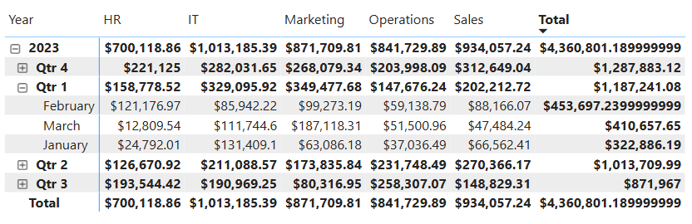

7. Tree maps
Tree maps represent hierarchical data through nested rectangles, where each box size corresponds to a value like total profit.
To create a Tree map:
- Select the Tree map icon from Visualizations.
- Drag "Department" into Category and "Revenue" into Values.
- Go to the Format pane, select the Category labels section, and increase the font size to 14.
- Enable data labels from the Format pane for better readability.
- Go to the Format pane, select the Data labels section, and increase the font size to 14.
Here’s what your tree map should look like:
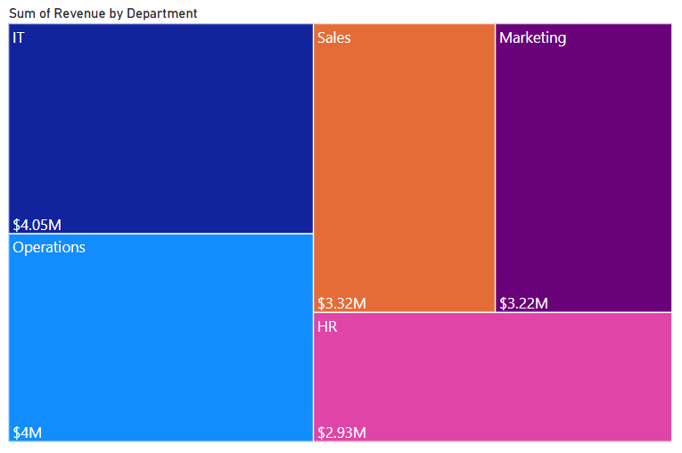

8. Waterfall charts
Waterfall charts, on the other hand, are ideal for illustrating how sequential values—such as revenue, expenses, and profit—build up or reduce an overall figure.
To create a Waterfall chart:
- Select the Waterfall icon from Visualizations.
- Drag "Department" into Category and "Profit" into Y-axis.
- Enable data labels from the Format pane for better readability.
Here’s what your waterfall chart visual should look like:
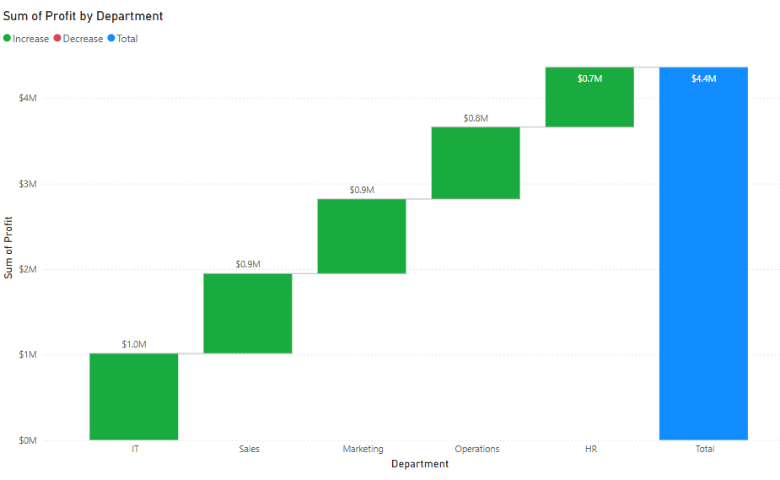

Geospatial Visuals
Power BI’s map visuals enable you to plot geographic data. The standard map visual places data points based on latitude and longitude or geographic fields like country and city.

9. Filled maps
Filled maps color in geographical regions, allowing you to visualize metrics like sales volume or expenses by region. Azure Maps provides even more advanced capabilities, including layered location intelligence.

