Vaibhav
24033
Cse-A
1.WRITE C PROGRAM TO FIND THE LaRGEST and smallest elements of an array using pointers
#include <stdio.h>
int main() {
int n, i;
int arr[100];
int *ptr;
int largest, smallest;
printf("Enter the number of elements: ");
scanf("%d", &n);
printf("Enter %d elements:\n", n);
for (i = 0; i < n; i++) {
scanf("%d", &arr[i]);
}
ptr = arr;
largest = smallest = *ptr;
for (i = 1; i < n; i++) {
ptr++; // move pointer to next element
if (*ptr > largest)
largest = *ptr;
if (*ptr < smallest)
smallest = *ptr;
}
printf("Largest element = %d\n", largest);
printf("Smallest element = %d\n", smallest);
return 0;
}
Output
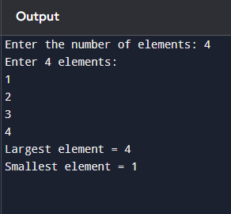
2.WRITE C PROGRAM TO FIND sum of elements in an array using pointers
#include <stdio.h>
int main() {
int n, i, sum = 0;
int arr[100];
int *ptr;

printf("Enter the number of elements: ");
scanf("%d", &n);

printf("Enter %d elements:\n", n);
for (i = 0; i < n; i++) {
scanf("%d", &arr[i]);
}

ptr = arr; // pointer points to the first element of array

for (i = 0; i < n; i++) {
sum += *ptr; // add value pointed by pointer
ptr++; // move pointer to next element
}

printf("Sum of array elements = %d\n", sum);

return 0;
}
Output
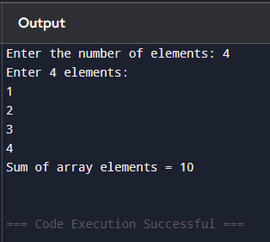

3.WRITE C PROGRAM TO search the target element in ana array using pointers
#include <stdio.h>
int main() {
int n, i, target, found = 0;
int arr[100];
int *ptr;
printf("Enter the number of elements: ");
scanf("%d", &n);
printf("Enter %d elements:\n", n);
for (i = 0; i < n; i++) {
scanf("%d", &arr[i]);
}
printf("Enter the element to search: ");
scanf("%d", &target);
ptr = arr; // pointer to first element of array
for (i = 0; i < n; i++) {
if (*ptr == target) {
printf("Element %d found at position %d.\n", target, i + 1);
found = 1;
break;
}
ptr++; // move pointer to next element
}
if (!found)
printf("Element %d not found in the array.\n", target);
return 0;
}
Output
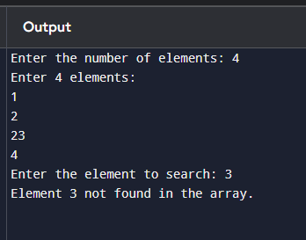

4.WRITE C PROGRAM TO reverse anaarray using pointers
#include <stdio.h>
int main() {
int n, i;
int arr[100];
int *start, *end, temp;
// Input number of elements
printf("Enter the number of elements: ");
scanf("%d", &n);
// Input array elements
printf("Enter %d elements:\n", n);
for (i = 0; i < n; i++) {
scanf("%d", &arr[i]);
}
// Initialize pointers
start = arr; // Points to the first element
end = arr + n - 1; // Points to the last element
// Reverse the array using pointers
while (start < end) {
temp = *start;
*start = *end;
*end = temp;
start++; // Move start pointer forward
end--; // Move end pointer backward
}
// Display reversed array
printf("Reversed array:\n");
for (i = 0; i < n; i++) {
printf("%d ", arr[i]);
}
printf("\n");
return 0;
}
Output
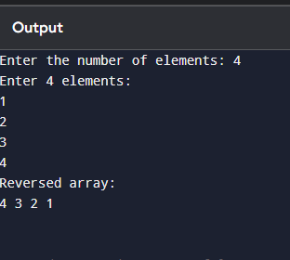

5.WRITE C PROGRAM TO print transpose of an matrix using pointers
#include <stdio.h>

int main() {
int rows, cols, i, j;
int matrix[10][10];
int *ptr;
// Input matrix dimensions
printf("Enter number of rows and columns: ");
scanf("%d %d", &rows, &cols);
// Input matrix elements
printf("Enter elements of the matrix:\n");
for (i = 0; i < rows; i++) {
for (j = 0; j < cols; j++) {
scanf("%d", &matrix[i][j]);
}
}
// Display original matrix
printf("\nOriginal Matrix:\n");
for (i = 0; i < rows; i++) {
for (j = 0; j < cols; j++) {
printf("%d\t", matrix[i][j]);
}
printf("\n");
}
// Print transpose using pointers
printf("\nTranspose of the Matrix:\n");
ptr = &matrix[0][0]; // pointer to the first element
for (i = 0; i < cols; i++) {
for (j = 0; j < rows; j++) {
printf("%d\t", *(ptr + j * cols + i));
}
printf("\n");
}
return 0;
}
output
