Diwali Sales Analysis
Exploratory Data Analysis Project Report (Excel)
Dataset: 11,239 transactions | 16 states | India
Tools: Excel Tables, Formulas, PivotTables, Charts, Slicers

Table of Contents

1. Executive Summary
This report documents an exploratory data analysis (EDA) of Diwali-season retail sales, carried out in Microsoft Excel using an Excel Table, formulas, PivotTables, charts and slicers. The dataset has 11,239 transactions from 3,752 customer IDs across 16 Indian states.
- Total revenue is ₹106.25M from 27,981 units, giving ₹3,797 per unit and ₹9,454 per transaction.
- Women generate 70% of revenue (₹74.3M) and ages 26–35 are the largest group (40.1%).
- Food is the top category (31.9%); Food, Clothing, Electronics and Footwear together contribute 77%.
- Uttar Pradesh, Maharashtra, Karnataka and Delhi provide 55% of revenue; IT, Healthcare and Aviation are the top occupations.
- Data audit found 8 duplicate rows, 22 age-group mismatches, 502 User_IDs with two genders, a hidden non-breaking space in “Andhra Pradesh” and two #VALUE! cells on the dashboard.

2. Objectives & Scope
- Measure overall festive sales performance with KPIs.
- Profile customers by gender, age, marital status and occupation.
- Find the best products, states and zones.
- Build an interactive Excel dashboard and document the workflow.
- Provide data-driven recommendations for the next festive season.
Out of scope: time trends (no date column) and profitability (no cost column).

3. Dataset Description
Column | Description | Type
User_ID, Cust_name | Customer identifier and name | ID / text
Product_ID | Product code (2,350 unique) | Text
Gender | F or M | Category
Age Group, Age | 7 age bands; exact age 12–92 (mean 35.4) | Category / number
Marital_Status | 0 = unmarried, 1 = married | Binary
State, Zone | 16 states in 5 zones | Category
Occupation | 15 occupations | Category
Product_Category | 18 categories | Category
Orders | Units in the transaction (1–4) | Number
Amount | Transaction value in ₹ (188 – 23,952) | Number

4. Excel Project Structure
Sheet | Content
Diwali_Data | Excel Table “Diwali_Data” with 11,239 rows × 13 columns
Analysis | Four KPI cells: Total Revenue, Total Orders, Total Customers, Average Order Value
Analysis_2 | Six PivotTables and five charts, each headed by a business question
Dashboard | Five more charts linked to the pivots plus five slicers (Gender, Age Group, State, Occupation, Product Category)

4.1 KPI formulas
KPI | Formula | Value
Total Revenue | =SUM(Diwali_Data[Amount]) | ₹106.25M
Total Orders (units) | =SUM(Diwali_Data[Orders]) | 27,981
Total Customers | =COUNTA(UNIQUE(Diwali_Data[User_ID])) | 3,752
Average Order Value | =SUM(Amount)/SUM(Orders) | ₹3,797
The cached values in the workbook match the values recomputed from the raw file for all four KPIs. Note that “Average Order Value” is revenue per unit ordered; revenue per transaction is ₹9,454.

4.2 PivotTables and charts
PivotTable | Measure | Chart
Gender wise Revenue | Sum of Amount | Doughnut
AgeGroup Wise Revenue | Sum of Amount | Pie
Revenue by states | Sum of Amount | Bar
Revenue by occupation | Sum of Amount | Bar
Product Category Orders | Sum of Orders | Bar
Revenue by Product Categories | Sum of Amount | Bar

5. Data Quality Audit & Cleaning
Check | Result | Recommended action
Blank cells | None in 13 columns | None
Exact duplicate rows | 8 rows (₹70,304) | Remove Duplicates; impact is 0.07% of revenue
Age vs Age Group | 22 rows in “36-45” have age 26–35 | Recompute group from Age using IFS
User_ID consistency | 502 of 3,752 IDs have both genders | Use transaction-level analysis; treat customer count as approximate
State text | “Andhra Pradesh” contains CHAR(160) | SUBSTITUTE(x,CHAR(160)," ")
Outliers (Amount) | 19 rows above ₹23,523 | Keep: valid high-value purchases
Extra columns | Empty columns N and O in the range | Delete

5.1 Dashboard issues
- Cells Dashboard!A2 and AK11 hold #VALUE! errors.
- Slicer selections were saved as active filters, so the Analysis_2 pivots (for example “Age group spends the most”) currently show a single item instead of the full distribution. Clear all slicers before saving.
- Two sets of slicers exist (Analysis_2 and Dashboard); a stray formula text with the name DiwaliData (no underscore) sits in Analysis!N8, and there is stray text in Dashboard!A49.
- UNIQUE() needs Excel 2021 or 365.
All analysis below uses all 11,239 rows so that totals match the workbook KPIs.

6. Overall Performance
Metric | Value
Total revenue | ₹106.25M
Units ordered | 27,981
Transactions | 11,239
Customer IDs | 3,752
Revenue per unit | ₹3,797
Mean / median transaction | ₹9,454 / ₹8,109
Repeat customers (2+ transactions) | 62.7%
Top 20% of customer IDs share of revenue | 51.3%

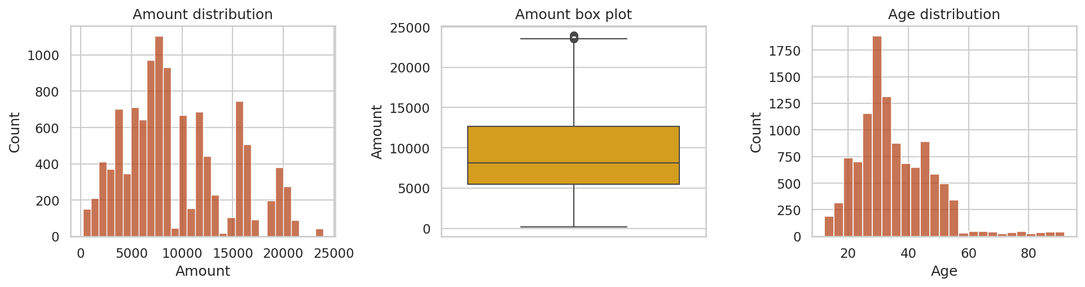
Figure 1: Distribution of Amount and Age
Amount is right-skewed (mean above median). Order quantities are evenly spread: 1 unit 25%, 2 units 26%, 3 units 25%, 4 units 25%. Age is concentrated between 26 and 43.

7. Customer Analysis

7.1 Gender
Gender | Revenue | Share | Transactions | Units | Avg / txn
Female | ₹74.34M | 70.0% | 7,832 | 19,548 | ₹9,491
Male | ₹31.91M | 30.0% | 3,407 | 8,433 | ₹9,367

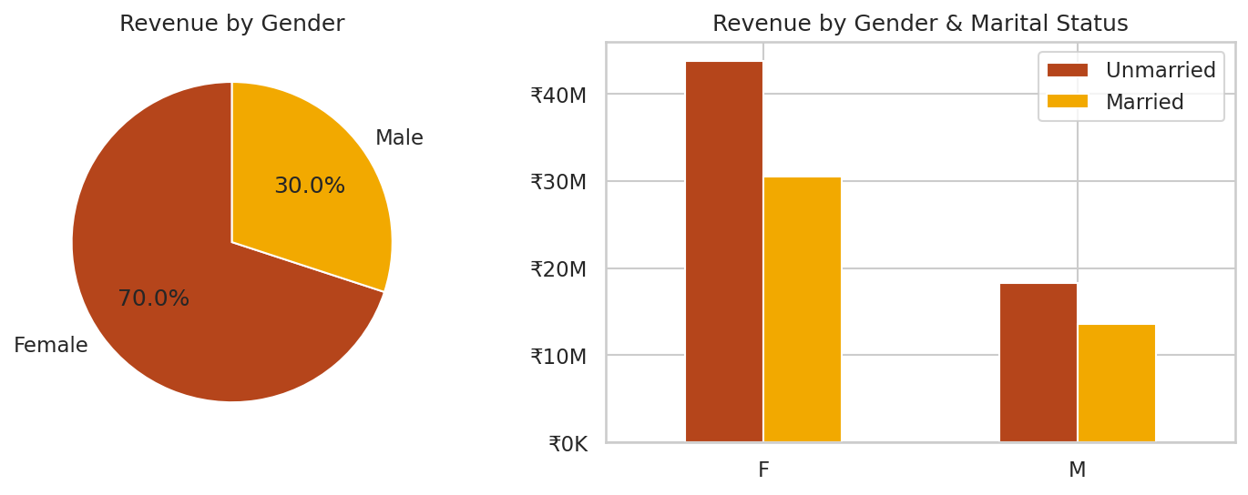
Figure 2: Revenue by gender and by gender and marital status
Women account for 70% of transactions and 70% of revenue. Average spend per transaction is almost identical (₹9,491 for women vs ₹9,367 for men), so the gap comes from the number of buyers, not basket size.

7.2 Marital status
Marital status | Revenue | Share | Transactions | Units | Avg / txn
Unmarried | ₹62.13M | 58.5% | 6,518 | 16,249 | ₹9,531
Married | ₹44.12M | 41.5% | 4,721 | 11,732 | ₹9,346

Unmarried customers generate 58.5% of revenue. Unmarried women alone contribute 41.2%.

7.3 Age group
Age Group | Revenue | Share | Transactions | Units | Avg / txn
26-35 | ₹42.61M | 40.1% | 4,541 | 11,395 | ₹9,384
36-45 | ₹22.14M | 20.8% | 2,283 | 5,687 | ₹9,700
18-25 | ₹17.24M | 16.2% | 1,879 | 4,650 | ₹9,175
46-50 | ₹9.21M | 8.7% | 983 | 2,371 | ₹9,367
51-55 | ₹8.26M | 7.8% | 830 | 2,112 | ₹9,954
55+ | ₹4.08M | 3.8% | 427 | 1,076 | ₹9,557
0-17 | ₹2.70M | 2.5% | 296 | 690 | ₹9,120

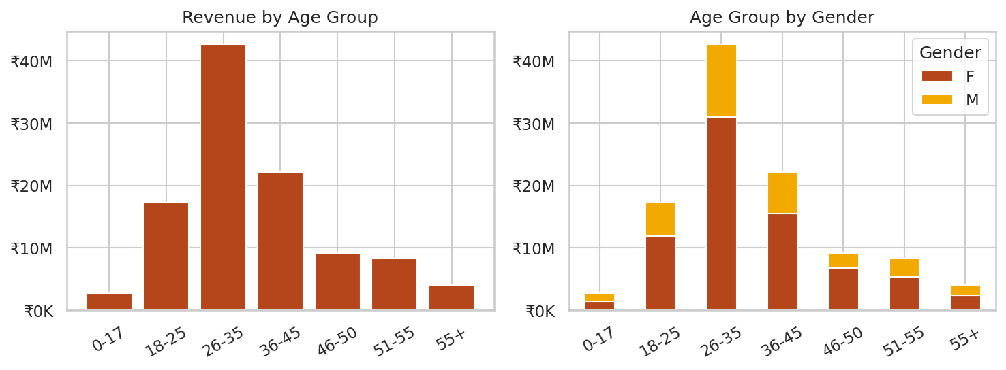
Figure 3: Revenue by age group and gender
Ages 26–35 contribute ₹42.6M (40.1%), followed by 36-45 (20.8%) and 18-25 (16.2%). Together ages 18–45 give 77%. Spend per transaction is similar across age groups (₹9.1K–₹10.0K).

7.4 Occupation
Occupation | Revenue | Share | Transactions | Units | Avg / txn
IT Sector | ₹14.76M | 13.9% | 1,583 | 3,997 | ₹9,321
Healthcare | ₹13.03M | 12.3% | 1,408 | 3,455 | ₹9,258
Aviation | ₹12.60M | 11.9% | 1,310 | 3,215 | ₹9,620
Banking | ₹10.77M | 10.1% | 1,137 | 2,817 | ₹9,473
Govt | ₹8.52M | 8.0% | 854 | 2,155 | ₹9,973
Hospitality | ₹6.38M | 6.0% | 703 | 1,739 | ₹9,070
Media | ₹6.30M | 5.9% | 637 | 1,596 | ₹9,884
Automobile | ₹5.37M | 5.0% | 565 | 1,371 | ₹9,502
Chemical | ₹5.30M | 5.0% | 541 | 1,309 | ₹9,792
Lawyer | ₹4.98M | 4.7% | 531 | 1,344 | ₹9,382
Retail | ₹4.78M | 4.5% | 501 | 1,270 | ₹9,547
Food Processing | ₹4.07M | 3.8% | 423 | 1,073 | ₹9,623
Construction | ₹3.60M | 3.4% | 414 | 1,025 | ₹8,690
Textile | ₹3.20M | 3.0% | 349 | 893 | ₹9,183
Agriculture | ₹2.59M | 2.4% | 283 | 722 | ₹9,163

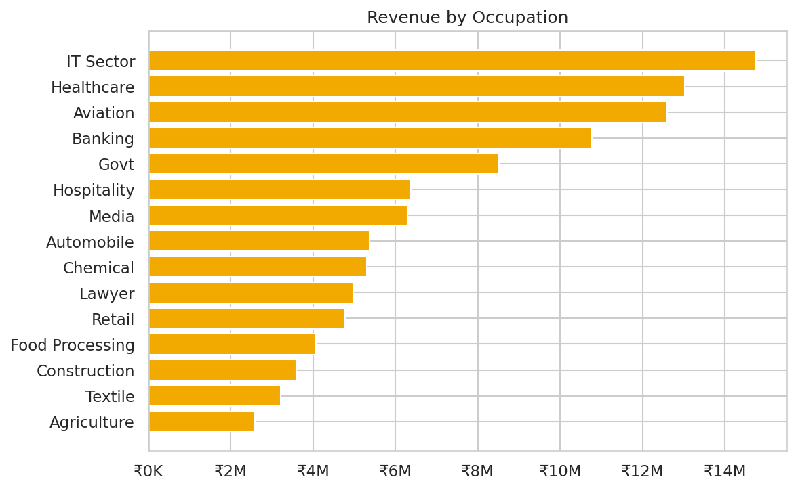
Figure 4: Revenue by occupation
IT Sector, Healthcare, Aviation and Banking together give 48% of revenue; the top three alone give 38%. Agriculture, Textile and Construction contribute least.

8. Product Analysis
Category | Revenue | Share | Transactions | Units | Avg / txn
Food | ₹33.93M | 31.9% | 2,490 | 6,110 | ₹13,628
Clothing & Apparel | ₹16.50M | 15.5% | 2,655 | 6,634 | ₹6,213
Electronics & Gadgets | ₹15.64M | 14.7% | 2,087 | 5,226 | ₹7,496
Footwear & Shoes | ₹15.58M | 14.7% | 1,059 | 2,646 | ₹14,707
Furniture | ₹5.44M | 5.1% | 352 | 889 | ₹15,455
Games & Toys | ₹4.33M | 4.1% | 386 | 940 | ₹11,222
Sports Products | ₹3.64M | 3.4% | 356 | 870 | ₹10,213
Beauty | ₹1.96M | 1.8% | 422 | 1,086 | ₹4,643
Auto | ₹1.96M | 1.8% | 97 | 239 | ₹20,192
Stationery | ₹1.68M | 1.6% | 112 | 281 | ₹14,965
Household items | ₹1.57M | 1.5% | 520 | 1,331 | ₹3,018
Tupperware | ₹1.16M | 1.1% | 72 | 166 | ₹16,051
Books | ₹1.06M | 1.0% | 103 | 245 | ₹10,306
Decor | ₹0.73M | 0.7% | 96 | 235 | ₹7,608
Pet Care | ₹0.48M | 0.5% | 212 | 536 | ₹2,275
Hand & Power Tools | ₹0.41M | 0.4% | 26 | 80 | ₹15,601
Veterinary | ₹0.11M | 0.1% | 81 | 206 | ₹1,391
Office | ₹0.08M | 0.1% | 113 | 261 | ₹725

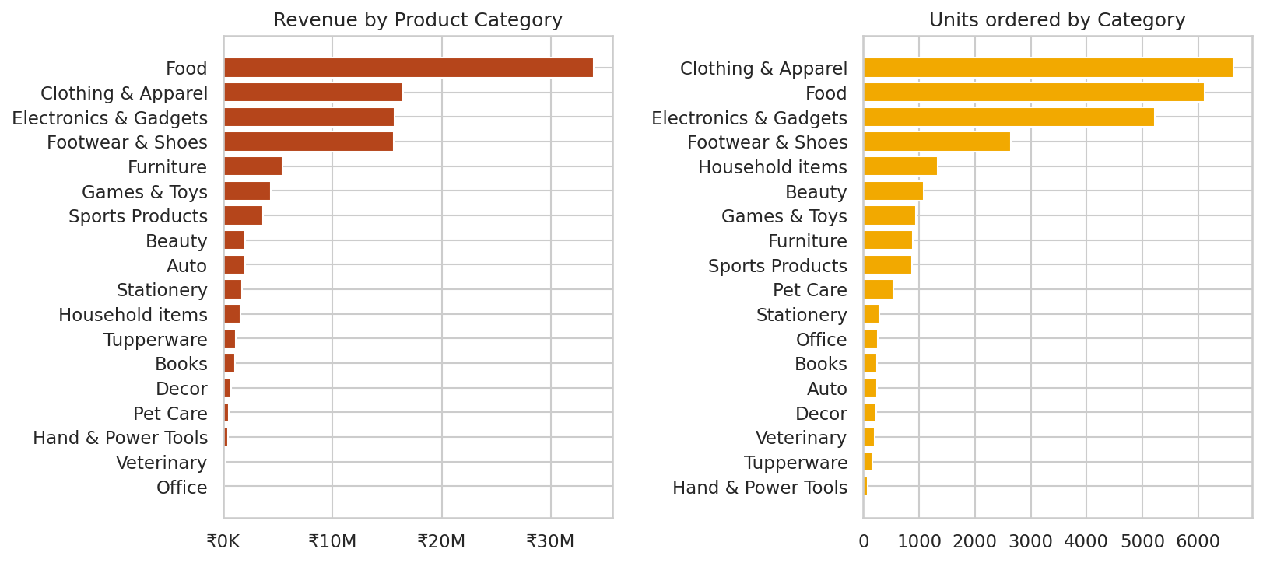
Figure 5: Revenue and units by product category
Food generates ₹33.9M (31.9%) from 2,490 transactions. Clothing & Apparel has the most transactions (2,655) but lower revenue than Food. The top four categories contribute 77% of revenue; five categories (Decor, Pet Care, Hand & Power Tools, Veterinary, Office) are each below 1%.
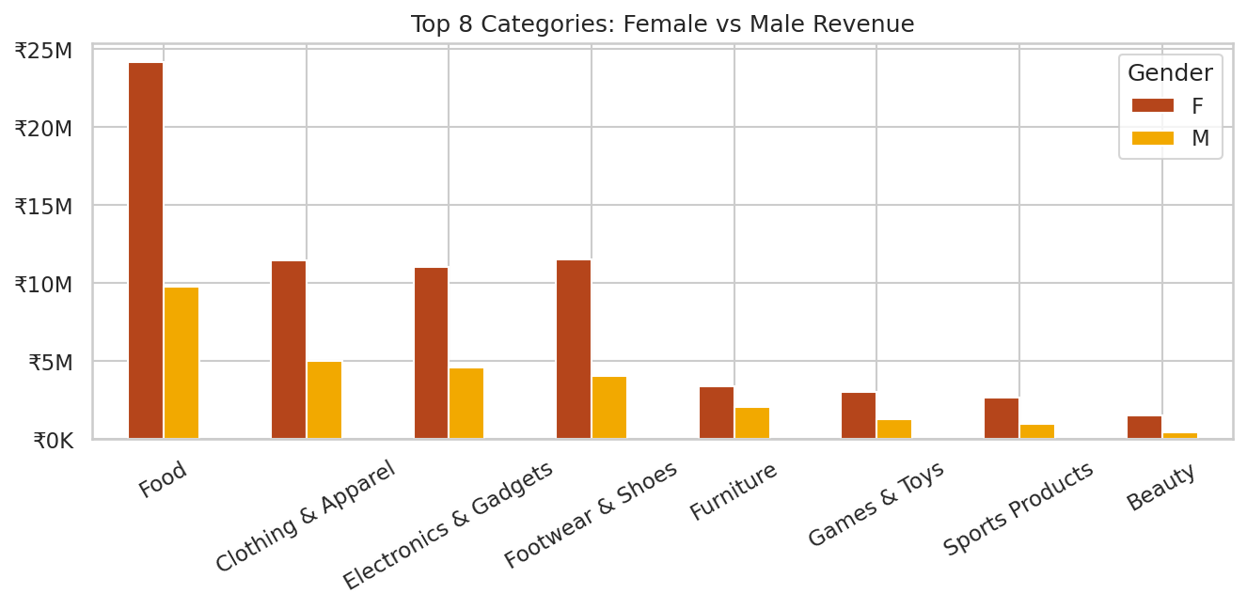
Figure 6: Top 8 categories by gender
Women spend more than men in every top category, with the widest gap in Food (₹24.2M vs ₹9.8M) and Beauty (₹1.5M vs ₹0.4M). Men spend more than women only in Books and Hand & Power Tools.

9. Geographic Analysis
Zone | Revenue | Share | Transactions | Units | Avg / txn
Central | ₹41.60M | 39.1% | 4,289 | 10,623 | ₹9,699
Southern | ₹26.61M | 25.0% | 2,693 | 6,740 | ₹9,880
Western | ₹18.37M | 17.3% | 1,952 | 4,876 | ₹9,413
Northern | ₹12.62M | 11.9% | 1,491 | 3,727 | ₹8,463
Eastern | ₹7.05M | 6.6% | 814 | 2,015 | ₹8,660

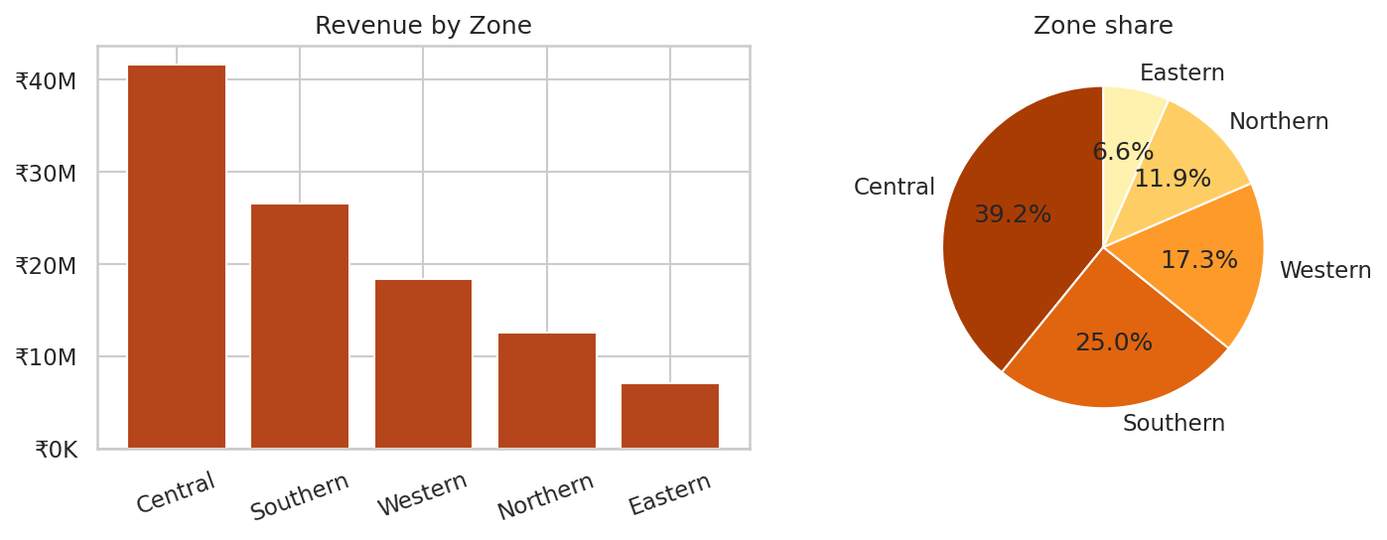
Figure 7: Revenue by zone
State | Revenue | Share | Transactions | Units | Avg / txn
Uttar Pradesh | ₹19.37M | 18.2% | 1,944 | 4,807 | ₹9,967
Maharashtra | ₹14.43M | 13.6% | 1,525 | 3,810 | ₹9,461
Karnataka | ₹13.52M | 12.7% | 1,304 | 3,240 | ₹10,371
Delhi | ₹11.60M | 10.9% | 1,104 | 2,740 | ₹10,511
Madhya Pradesh | ₹8.10M | 7.6% | 921 | 2,252 | ₹8,796
Andhra Pradesh | ₹8.04M | 7.6% | 811 | 2,051 | ₹9,910
Himachal Pradesh | ₹4.96M | 4.7% | 608 | 1,568 | ₹8,163
Haryana | ₹4.22M | 4.0% | 452 | 1,109 | ₹9,337
Bihar | ₹4.02M | 3.8% | 434 | 1,062 | ₹9,269
Gujarat | ₹3.95M | 3.7% | 427 | 1,066 | ₹9,241
Kerala | ₹3.89M | 3.7% | 453 | 1,137 | ₹8,597
Jharkhand | ₹3.03M | 2.9% | 380 | 953 | ₹7,964
Uttarakhand | ₹2.52M | 2.4% | 320 | 824 | ₹7,878
Rajasthan | ₹1.91M | 1.8% | 231 | 555 | ₹8,266
Punjab | ₹1.53M | 1.4% | 200 | 495 | ₹7,629
Telangana | ₹1.15M | 1.1% | 125 | 312 | ₹9,212

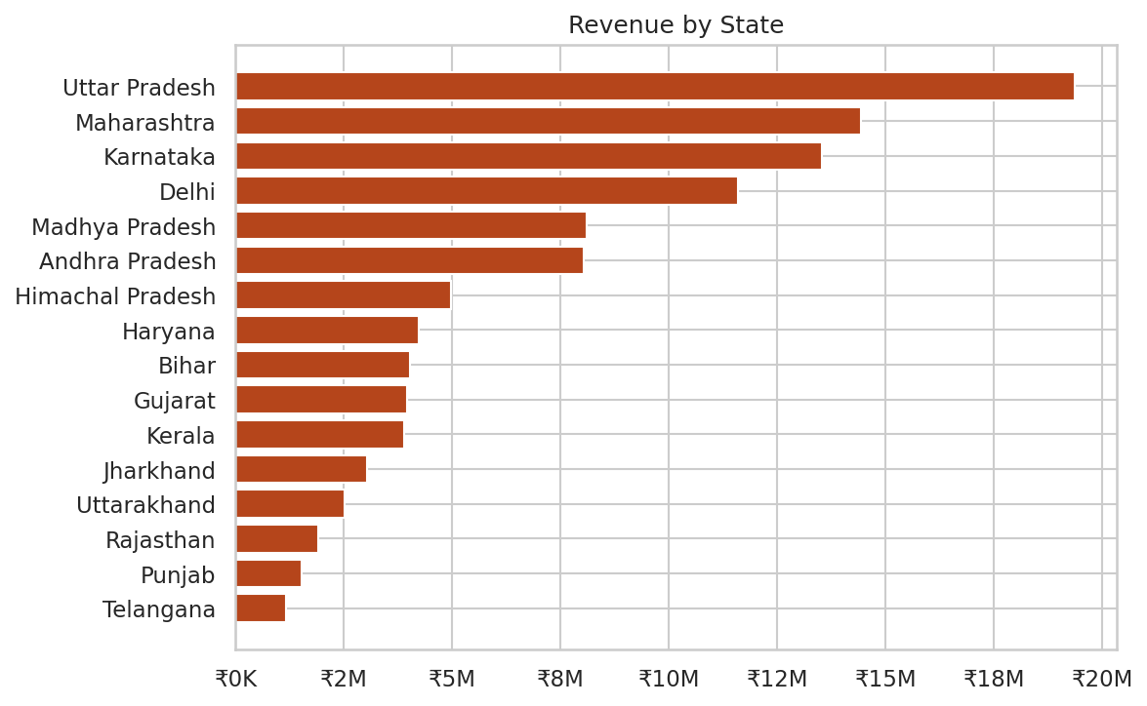
Figure 8: Revenue by state
Uttar Pradesh leads with ₹19.4M (18.2%), followed by Maharashtra, Karnataka and Delhi; the top five states give 63.1%. The Central zone (Uttar Pradesh, Delhi, Madhya Pradesh, Uttarakhand as mapped in the data) contributes 39.2%. Telangana, Punjab and Rajasthan contribute least.

10. Correlation Analysis
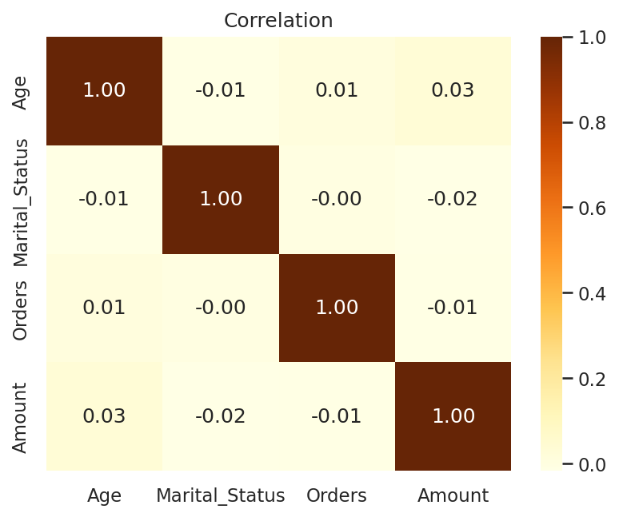
Figure 9: Correlation of numeric columns
Age, marital status and quantity have almost no linear relationship with transaction amount (all |r| < 0.04). Segment differences therefore come from how many customers each segment has, not from higher spending per purchase.

11. Key Insights
- Sales are driven by volume of buyers: women aged 26–35 are the core segment.
- Revenue is concentrated: four categories give 77%, four states give 55%.
- Basket size is nearly flat across gender, age, marital status and occupation.
- Male, 46+ and smaller-state customers are the main untapped segments.

12. Recommendations
# | Recommendation | Evidence
1 | Personalised campaigns for women aged 26–35 | 70% of revenue by gender; 40.1% by age
2 | Stock and promote Food, Clothing, Electronics, Footwear early | 77% of revenue
3 | Gifting bundles to grow male and 46+ buyers | Men 30%, ages 46+ 20% of revenue
4 | Concentrate ads on UP, Maharashtra, Karnataka, Delhi; test in Punjab, Rajasthan, Telangana | Top 4 states 55%; smallest states under 2%
5 | Corporate offers for IT, Healthcare, Aviation, Banking | 48% of revenue
6 | Fix data quality and dashboard issues before publishing | Section 5

13. Limitations & Next Steps
- Single season with no date column; time trends cannot be analysed.
- No cost data; profit and margin cannot be analysed.
- User_ID is not fully reliable as a customer key.
- Next: add dates, RFM segmentation, profitability, and a Power BI version of the dashboard.

