E-Commerce Sales Dashboard
Exploratory Data Analysis Project Report (Power BI)
Dataset: 15,000 orders | 3,000 customers | Jan 2024 – Dec 2025 | India
Tools: Power BI Desktop, data model, calculated column, slicers

Table of Contents

1. Executive Summary
This report documents an exploratory data analysis (EDA) and Power BI dashboard for an e-commerce company. The project combines two tables, SALES (15,000 orders) and CUSTOMER (3,000 customers), covering January 2024 to December 2025 across 16 Indian cities and 12 states.
- Total sales are ₹287.23M with ₹66.48M profit (23.1% margin) from 28,408 units and 15,000 orders.
- Electronics gives 62.9% of sales but has the lowest category margin (17.6%); Laptop alone is 26.7% of sales.
- Sales are flat year over year (+0.2%); October is the peak month and February the weakest.
- Margin falls from 38.9% with no discount to 22.3% at 20–25% discount.
- 85% of buying customers ordered more than once and the top 20% give 52.2% of sales.
- The dashboard review found four fixes: the AOV card sums a column, month charts merge two years, the customer chart uses non-unique names, and 21.5% of orders predate customer signup.

2. Objectives & Scope
- Build a Power BI dashboard tracking sales, quantity, profit and average order value.
- Analyse performance by category, product, time, channel, payment method, geography and customer segment.
- Measure the impact of discounts on profitability.
- Review the dashboard for accuracy and recommend improvements.
Out of scope: returns, targets and forecasts (not present in the data).

3. Dataset Description

3.1 SALES table (15,000 rows × 15 columns)
Column | Description
OrderID, OrderDate | Unique order id; date from 2024-01-01 to 2025-12-31
CustomerID | Link to the CUSTOMER table
Product, Category | 18 products in 5 categories (each product belongs to one category)
Quantity, UnitPrice, DiscountPct | 1–5 units; ₹250 – ₹59,390 per unit; discount 0–25%
SalesAmount, CostAmount, Profit | Order value, cost and profit in ₹
Channel, PaymentMethod | Online / Store / Marketplace; UPI, Credit Card, Debit Card, Net Banking, Cash
City, Region | 16 cities and 5 regions of delivery

3.2 CUSTOMER table (3,000 rows × 8 columns)
Column | Description
CustomerID, CustomerName | Unique id; name (478 distinct names)
Gender, Age | Male / Female / Other; age 18–65
City, State | 16 cities, 12 states
CustomerSegment | Consumer, Corporate, Small Business
SignupDate | 2023-01-01 to 2025-06-18

4. Power BI Project Structure

4.1 Data model
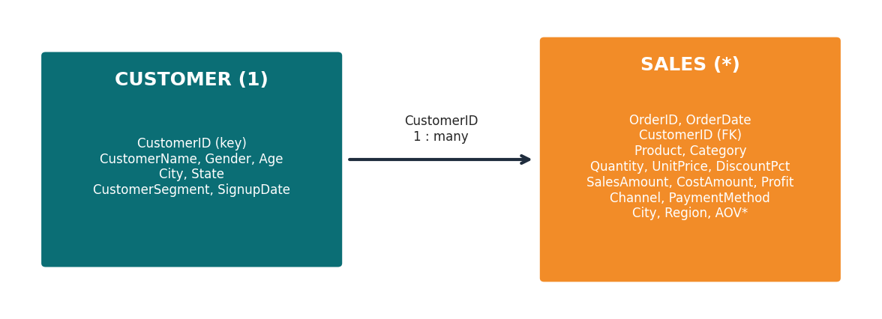
Figure 1: Data model (relationship inferred from CustomerID)
The report file contains two tables, SALES and CUSTOMER. A relationship on CustomerID is needed for the State chart (State comes from CUSTOMER, sales from SALES) and was validated on the data: every order has a matching customer and 324 customers have no orders. SALES also contains a calculated column AOV that is not in the source CSV. The compressed data model was not opened, so DAX and relationship properties were not inspected.

4.2 Report page
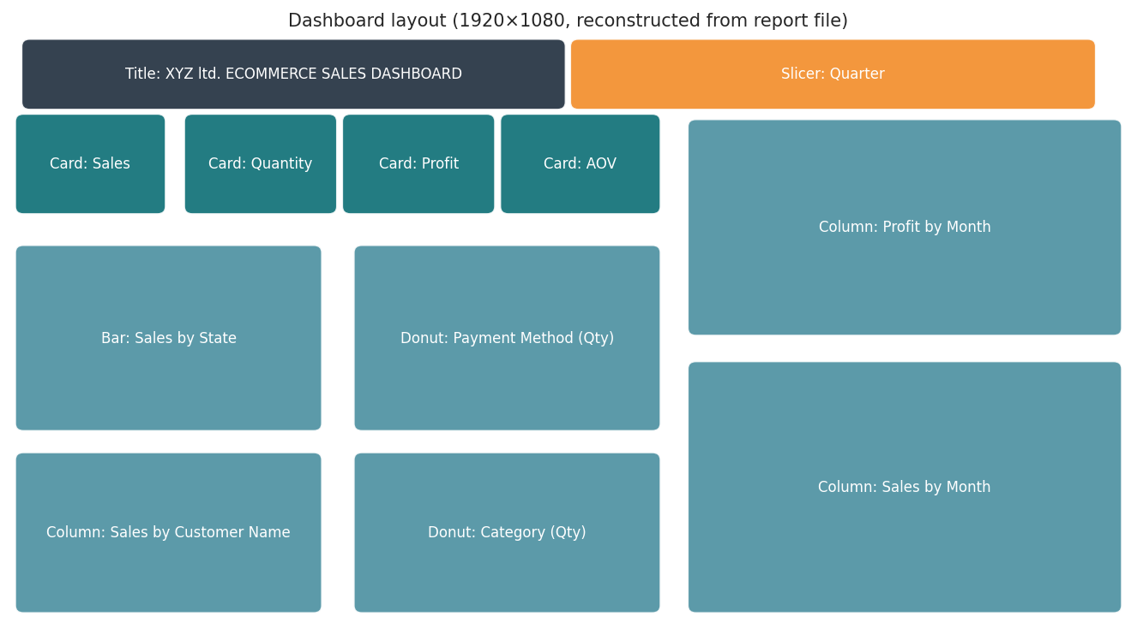
Figure 2: Dashboard layout reconstructed from visual positions in the .pbix
Visual | Type | Fields
Sales | Card | Sum of SalesAmount
Quantity | Card | Sum of Quantity
Profit | Card | Sum of Profit
AOV | Card | Sum of AOV (calculated column)
Sales by State | Clustered bar | CUSTOMER[State], Sum of SalesAmount
Payment Method | Donut | PaymentMethod, Sum of Quantity
Product Category | Donut | Category, Sum of Quantity
Sales by Customer | Column | CUSTOMER[CustomerName], Sum of SalesAmount
Sales by Month | Column | OrderDate (Month level), Sum of SalesAmount
Profit by Month | Column | OrderDate (Month level), Sum of Profit
Quarter filter | Slicer | OrderDate (Quarter level)
The page is 1920 × 1080 with a custom background image, the title “XYZ ltd. ECOMMERCE SALES DASHBOARD” and the Fluent 2 base theme.

5. Data Quality Audit
Check | Result
Nulls | None in either table
Duplicates | No duplicate rows; OrderID and CustomerID unique
Referential integrity | 0 orders without a customer; 324 customers without orders
SalesAmount = Qty × Price × (1 − Discount) | True for 100% of rows
Profit = Sales − Cost | True for 100% of rows
Loss-making orders | 61 orders (₹1,32,350 total loss)
Orders before SignupDate | 3,226 orders (21.5%)
Outliers (SalesAmount, IQR rule) | 1,262 orders: high-priced laptops and smartphones; kept
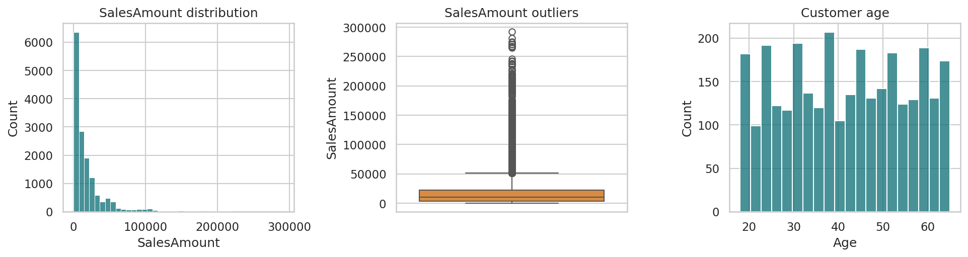
Figure 3: Distribution of SalesAmount and customer age

6. Overall Performance
KPI | Value
Total sales | ₹287.23M
Total cost | ₹220.75M
Total profit | ₹66.48M
Profit margin | 23.15%
Units sold | 28,408
Orders | 15,000
Customers who ordered | 2,676 of 3,000
Average order value (Sales ÷ Orders) | ₹19,149
The dashboard AOV card uses Sum of AOV, which adds a per-row value across all orders and is not an average. The correct company-level AOV is ₹19,149.

7. Product & Category Analysis
Category | Sales | Share | Profit | Margin | Orders
Electronics | ₹180.61M | 62.9% | ₹31.89M | 17.6% | 4,157
Furniture | ₹40.54M | 14.1% | ₹13.11M | 32.3% | 2,486
Home Appliances | ₹29.99M | 10.4% | ₹9.92M | 33.1% | 2,518
Office Supplies | ₹19.46M | 6.8% | ₹5.11M | 26.3% | 2,572
Accessories | ₹16.63M | 5.8% | ₹6.46M | 38.8% | 3,267

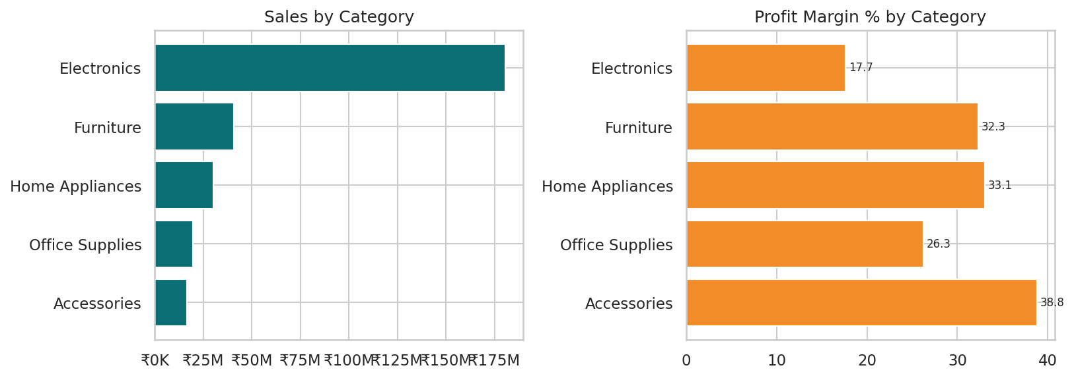
Figure 4: Sales and profit margin by category
Electronics gives ₹180.6M (62.9%) at a 17.6% margin, while Accessories earn 38.8% on ₹16.6M. Units sold by category on the dashboard donut: Electronics 7,822, Accessories 6,216, Office Supplies 4,859, Home Appliances 4,822 and Furniture 4,689.
Product | Sales | Share | Profit | Margin | Orders
Laptop | ₹76.57M | 26.7% | ₹11.15M | 14.6% | 794
Smartphone | ₹41.62M | 14.5% | ₹7.01M | 16.9% | 869
Tablet | ₹32.87M | 11.4% | ₹6.52M | 19.8% | 870
Monitor | ₹24.75M | 8.6% | ₹5.66M | 22.9% | 805
Printer | ₹18.59M | 6.5% | ₹4.66M | 25.1% | 891
Office Chair | ₹17.53M | 6.1% | ₹5.25M | 29.9% | 828
Desk | ₹12.91M | 4.5% | ₹4.20M | 32.5% | 809
Air Fryer | ₹12.37M | 4.3% | ₹3.83M | 31.0% | 805
Bookshelf | ₹10.10M | 3.5% | ₹3.67M | 36.3% | 849
Coffee Maker | ₹9.85M | 3.4% | ₹3.45M | 35.0% | 845
Watch | ₹9.25M | 3.2% | ₹3.46M | 37.4% | 807
Mixer Grinder | ₹7.77M | 2.7% | ₹2.64M | 34.0% | 868
Headphones | ₹4.80M | 1.7% | ₹1.54M | 32.0% | 819
Backpack | ₹3.20M | 1.1% | ₹1.26M | 39.5% | 847
Keyboard | ₹2.54M | 0.9% | ₹1.03M | 40.5% | 817
Mouse | ₹1.65M | 0.6% | ₹0.71M | 43.2% | 796
Notebook | ₹0.48M | 0.2% | ₹0.24M | 50.4% | 804
Pen Set | ₹0.39M | 0.1% | ₹0.21M | 53.8% | 877

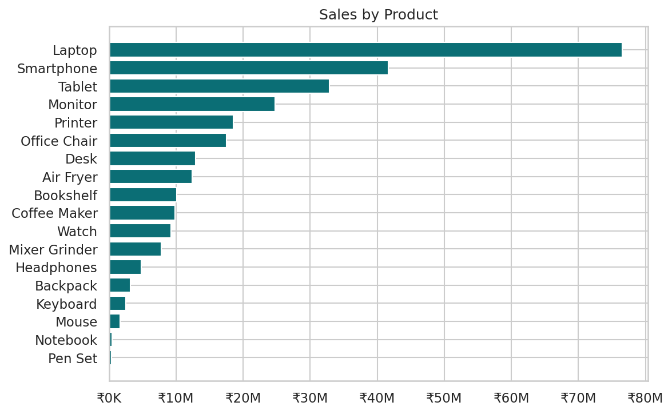
Figure 5: Sales by product
Laptop (₹76.6M, 14.6% margin), Smartphone (₹41.6M, 16.9%) and Tablet (₹32.9M, 19.8%) give 52.6% of sales. Low-ticket items such as Pen Set and Notebook have the highest margins (over 50%) but under 1% of sales.

8. Time Analysis
Year | Sales | Share | Profit | Margin | Orders
2024 | ₹143.50M | 50.0% | ₹32.82M | 22.9% | 7,449
2025 | ₹143.73M | 50.0% | ₹33.66M | 23.4% | 7,551

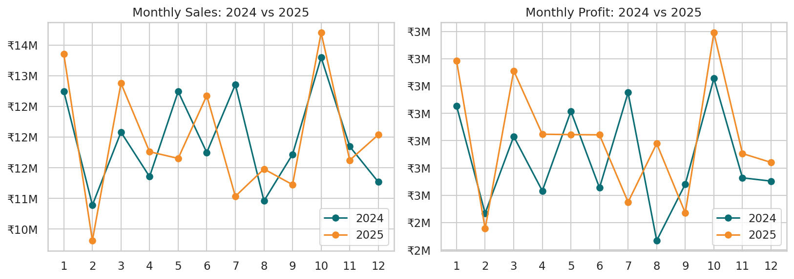
Figure 6: Monthly sales and profit, 2024 vs 2025
- 2025 sales are +0.2% versus 2024 and margin rose from 22.9% to 23.4%.
- Peak month: 2025-10 (₹13.70M); lowest month: 2025-02 (₹10.31M).
- October is the strongest calendar month in both years; February is the weakest.
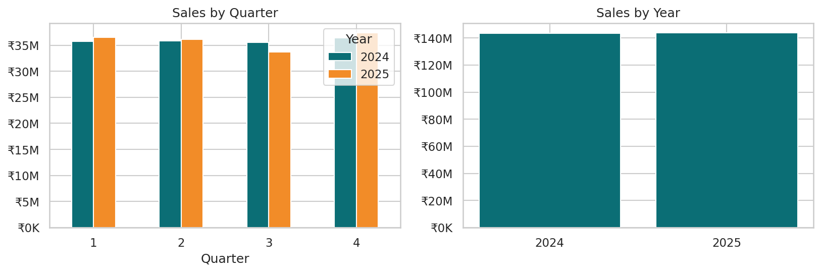
Figure 7: Sales by quarter and year
Quarterly sales are balanced (Q4 25.7%, Q1 25.2%, Q2 25.0%, Q3 24.1%), so seasonality is mild.

9. Channel & Payment Analysis
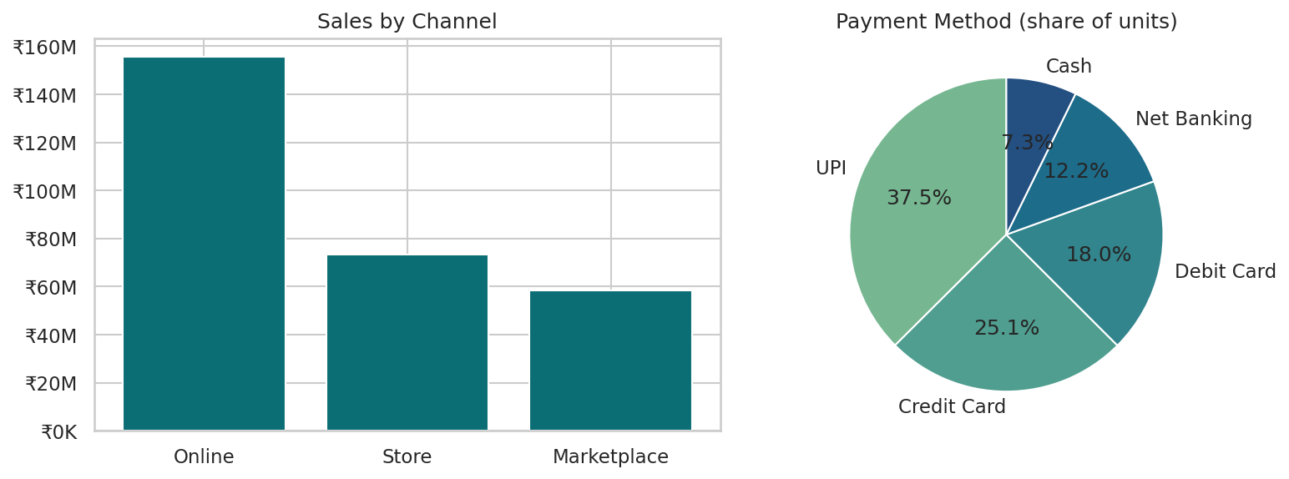
Figure 8: Sales by channel and payment method
Channel | Sales | Share | Profit | Margin | Orders
Online | ₹155.50M | 54.1% | ₹36.42M | 23.4% | 8,264
Store | ₹73.43M | 25.6% | ₹16.71M | 22.8% | 3,759
Marketplace | ₹58.30M | 20.3% | ₹13.36M | 22.9% | 2,977

PaymentMethod | Sales | Share | Profit | Margin | Orders
UPI | ₹107.24M | 37.3% | ₹24.32M | 22.7% | 5,607
Credit Card | ₹72.03M | 25.1% | ₹16.90M | 23.5% | 3,755
Debit Card | ₹53.18M | 18.5% | ₹12.37M | 23.3% | 2,704
Net Banking | ₹34.44M | 12.0% | ₹8.12M | 23.6% | 1,824
Cash | ₹20.33M | 7.1% | ₹4.78M | 23.5% | 1,110

Online gives 54.1% of sales, followed by Store (25.6%) and Marketplace (20.3%). UPI is the leading payment method (37.3% of sales). Margins differ by less than one point across channels and payment methods.

10. Geographic Analysis
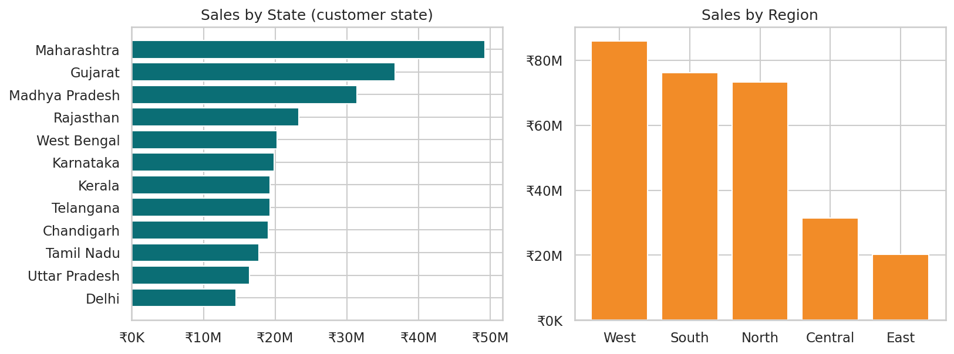
Figure 9: Sales by state and region
State | Sales | Share | Profit | Margin | Orders
Maharashtra | ₹49.25M | 17.1% | ₹11.46M | 23.3% | 2,573
Gujarat | ₹36.72M | 12.8% | ₹8.27M | 22.5% | 1,837
Madhya Pradesh | ₹31.42M | 10.9% | ₹7.44M | 23.7% | 1,770
Rajasthan | ₹23.32M | 8.1% | ₹5.40M | 23.1% | 1,248
West Bengal | ₹20.25M | 7.0% | ₹4.62M | 22.8% | 1,022
Karnataka | ₹19.87M | 6.9% | ₹4.41M | 22.2% | 908
Kerala | ₹19.29M | 6.7% | ₹4.56M | 23.6% | 1,032
Telangana | ₹19.29M | 6.7% | ₹4.43M | 23.0% | 1,045
Chandigarh | ₹19.07M | 6.6% | ₹4.43M | 23.2% | 939
Tamil Nadu | ₹17.76M | 6.2% | ₹4.22M | 23.8% | 1,003
Uttar Pradesh | ₹16.42M | 5.7% | ₹3.74M | 22.8% | 787
Delhi | ₹14.57M | 5.1% | ₹3.50M | 24.1% | 836

Region | Sales | Share | Profit | Margin | Orders
West | ₹85.97M | 29.9% | ₹19.73M | 22.9% | 4,410
South | ₹76.22M | 26.5% | ₹17.62M | 23.1% | 3,988
North | ₹73.37M | 25.6% | ₹17.07M | 23.3% | 3,810
Central | ₹31.42M | 10.9% | ₹7.44M | 23.7% | 1,770
East | ₹20.25M | 7.0% | ₹4.62M | 22.8% | 1,022

Maharashtra leads with ₹49.3M (17.1%), followed by Gujarat (12.8%) and Madhya Pradesh (10.9%). By region, West gives 29.9% and South 26.5%. East and Delhi are the smallest markets. State is taken from the customer record; the order city matches the customer city for every order.

11. Customer Analysis
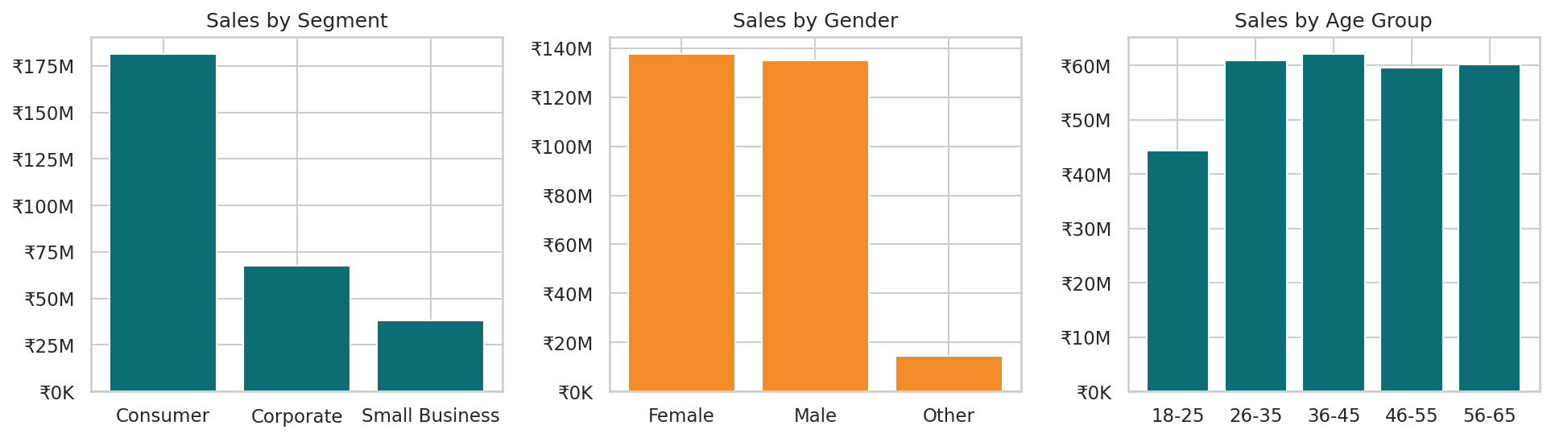
Figure 10: Sales by segment, gender and age group
CustomerSegment | Sales | Share | Profit | Margin | Orders
Consumer | ₹181.43M | 63.2% | ₹41.77M | 23.0% | 9,402
Corporate | ₹67.69M | 23.6% | ₹15.76M | 23.3% | 3,536
Small Business | ₹38.11M | 13.3% | ₹8.95M | 23.5% | 2,062

Consumers give 63.2% of sales, Corporate 23.6% and Small Business 13.3%. Gender and age groups contribute almost equally (Female 47.9%, Male 47.0%; each age group from 26 to 65 about 21%, 18-25 at 15.4%); margins are the same across all groups.

11.1 Customer behaviour
85.1% of buying customers placed more than one order (average 5.6 orders, maximum 41). The top 20% of customers account for 52.2% of sales.
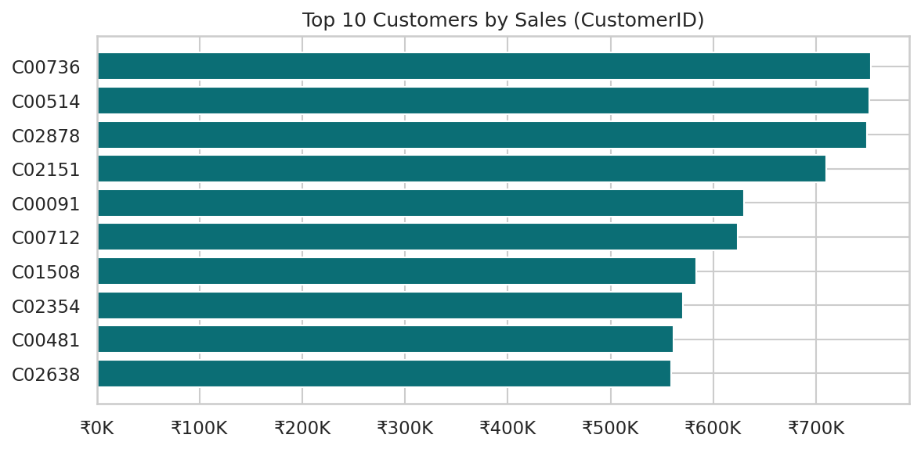
Figure 11: Top 10 customers by sales (CustomerID)
The dashboard chart “Sales by Customer Name” groups by name rather than ID. With 478 distinct names for 3,000 customers, the top name (Arjun Das, ₹2.23M) combines 11 different customers, so the chart overstates single-customer sales.

12. Discount & Profitability
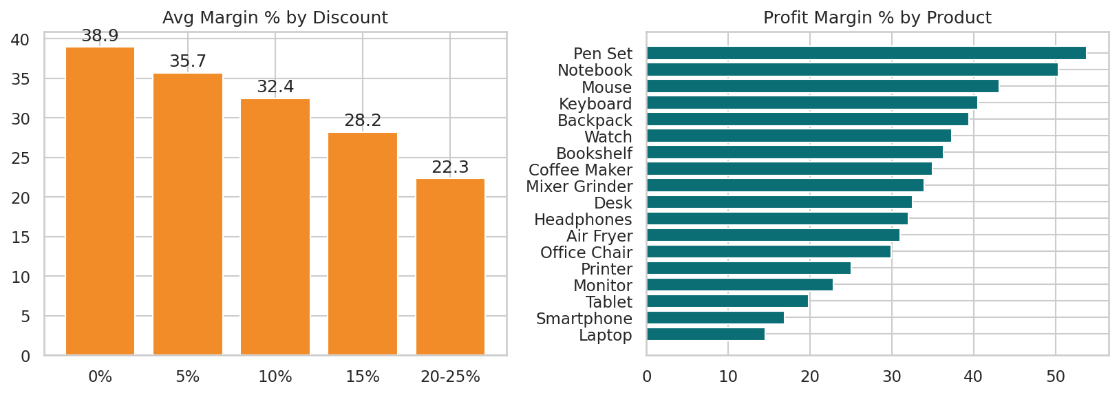
Figure 12: Average margin by discount level and by product
Discount | Orders | Avg margin | Total profit
0% | 2,975 | 38.93% | ₹18.91M
5% | 3,735 | 35.66% | ₹19.49M
10% | 4,188 | 32.43% | ₹17.51M
15% | 2,293 | 28.18% | ₹7.44M
20-25% | 1,809 | 22.33% | ₹3.13M

The correlation between discount and margin % is -0.439. Orders with 15% or higher discount (4,102 orders, 27% of orders) have margins below 28%. Discounts do not raise order value (correlation with SalesAmount is −0.06).

Correlation
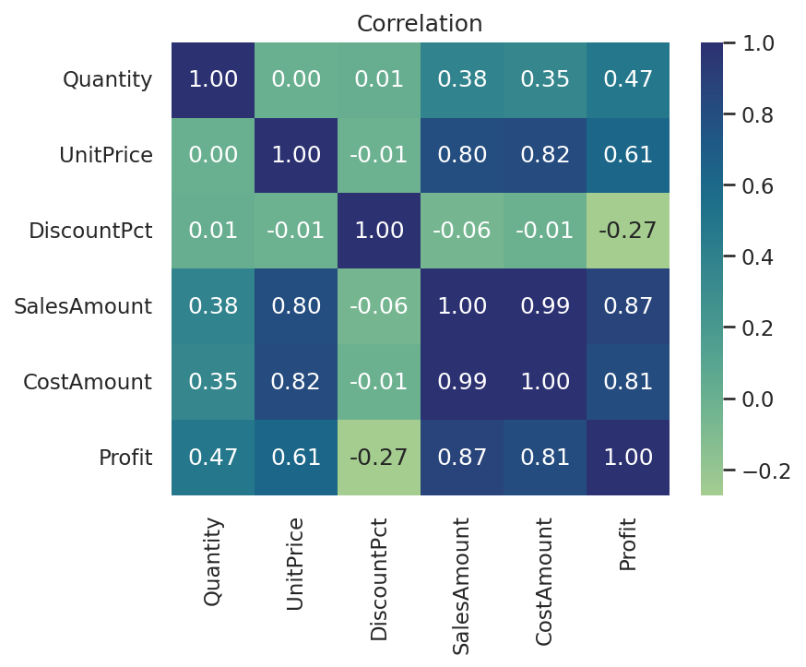
Figure 13: Correlation of numeric columns
SalesAmount depends mainly on UnitPrice (r = 0.80) and Quantity (r = 0.38); Profit follows SalesAmount (r = 0.87).

13. Dashboard Review & Improvements
# | Finding | Recommended fix
1 | AOV card uses Sum of AOV | Create measure: AOV = DIVIDE(SUM(SALES[SalesAmount]), DISTINCTCOUNT(SALES[OrderID]))
2 | Month charts use the Month level only, merging 2024 and 2025 | Use Year-Month axis or add a Year slicer
3 | Customer chart groups by CustomerName (non-unique) | Group by CustomerID or add a unique label; use Top N filter
4 | 21.5% of orders are before the customer signup date | Validate source dates
5 | Only one Quarter slicer and one page | Add Year, Region, Category slicers; add drill-through and tooltips
6 | Donuts show units, not sales | Add sales value or percentages in labels

14. Key Insights
- Revenue is concentrated in Electronics, which has the lowest margin.
- Discounts are the clearest controllable lever on profit.
- Sales are flat and only mildly seasonal; growth needs new demand.
- Margins are uniform across channels, regions and customers, so product mix and discounts drive profit.
- The business relies on repeat buyers: 85% repeat rate, with the top 20% giving 52% of sales.

15. Recommendations
# | Recommendation | Evidence
1 | Shift mix toward Accessories, Home Appliances and Furniture | 32–39% margins vs 17.6% for Electronics
2 | Cap blanket discounts near 10% | Margin drops from 38.9% to 22.3%
3 | Loyalty programme for top customers; reactivate 324 inactive customers | Top 20% = 52% of sales
4 | Invest in Online and UPI journeys | 54% and 37% of sales
5 | Grow East and smaller states | East 7%, Delhi 5% of sales
6 | Fix dashboard measures before sharing | Section 13

16. Limitations & Next Steps
- No order status, returns, targets or marketing data.
- The compressed Power BI data model was not inspected, so DAX and relationship settings are inferred.
- Next: DAX measures (YoY, margin %, running totals), RFM segmentation, forecasting and publishing to Power BI Service.

